BigQuery
SELECT * FROM `shining-relic-508714-i0.learning_analytics.students_performance` LIMIT 1000
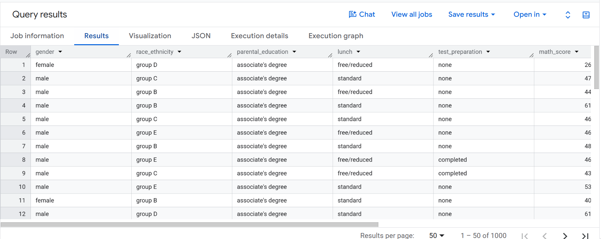
SELECT
COUNT(*) AS students_count,
ROUND(AVG(math_score), 2) AS avg_math_score,
ROUND(AVG(reading_score), 2) AS avg_reading_score,
ROUND(AVG(writing_score), 2) AS avg_writing_score
FROM `shining-relic-508714-i0.learning_analytics.students_performance`
WHERE parental_education = 'high school';
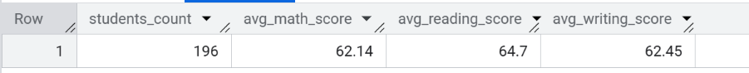
SELECT lunch,
COUNT(*) AS students_count,
AVG(math_score) AS avg_math_score,
STDDEV(math_score) AS stddev_math_score
FROM `shining-relic-508714-i0.learning_analytics.students_performance`
WHERE parental_education = 'high school'
GROUP BY lunch;
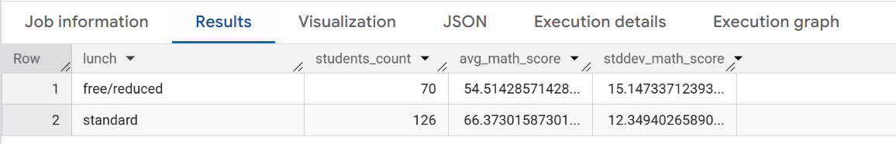
Результаты BigQuery совпали с результатами Colab

