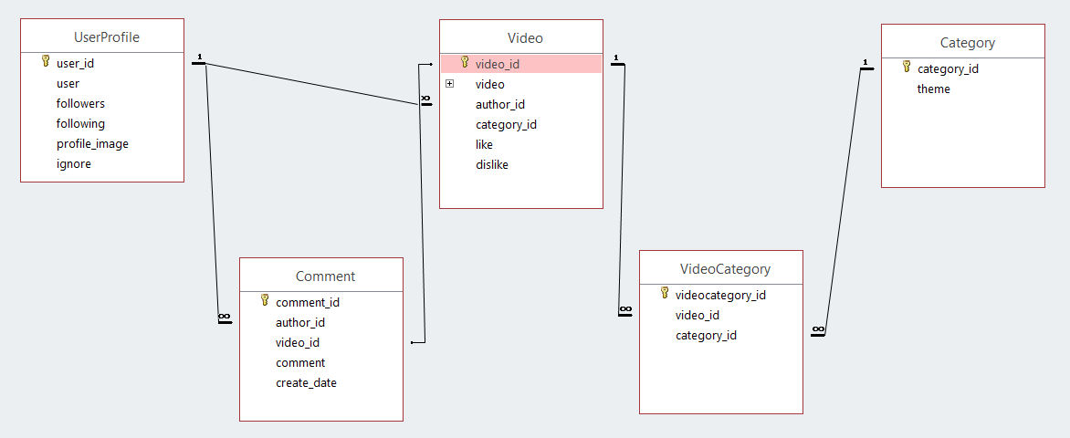

|  |  |
| --- | --- |
| **UserProfile** | |
| user_id | Primary key |
| user | Foreign key (User) |
| followers | Many to many field (self) |
| following | Many to many field (self) |
| ignore | Yes/no |
| profile_image | Image field |

|  |  |
| --- | --- |
| **Video** | |
| video_id | Primary key |
| video | RichTextUploadingField |
| author_id | Foreign key (UserProfile) |
| category_id | Many to many field (Category through VideoCategory) |
| rate_video | Integer field |
| like | Method “+” |
| dislike | Method “-“ |

|  |  |
| --- | --- |
| **Category** | |
| category_id | Primary key |
| theme | Char field |

|  |  |
| --- | --- |
| **VideoCategory** | |
| videocategory_id | Primary key |
| video_id | Foreign key (Video) |
| category_id | Foreign key (Category) |

|  |  |
| --- | --- |
| **Comment** | |
| comment_id | Primary key |
| author_id | Foreign key (UserProfile) |
| video_id | Foreign key (Video) |
| comment | Char field |
| create_date | Date field |