Course Name: | Digital Design Laboratory | Semester: | III
Date of Performance: | 26 / 08 / 2024 | Batch No: | D3
Faculty Name: | Mansi Kambli | Roll No: | 16010123294
Faculty Sign & Date: |  | Grade/Marks: | ___/25

Experiment No: 4
Title: 4-bit magnitude comparator

Aim and Objective of the Experiment:
To design and implement 1-bit comparator using logic gates and verify 4-bit magnitude comparator using IC 7485

COs to be achieved:
CO2: Use different minimization techniques and solve combinational circuits.

Tools used:
Trainer kits

Theory:
Comparator: The comparison of two numbers is an operator that determines one number is greater than, less than (or) equal to the other number. A magnitude comparator is a combinational circuit that compares two numbers A and B and determines their relative magnitude. The outcome of the comparator is specified by three binary variables that indicate whether A>B, A=B (or) A<B.

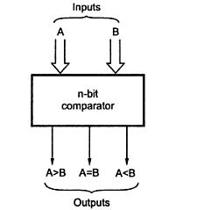

1-bit Comparator Implementation Details:
Truth Table

A | B | A>B | A<B | A=B
0 | 0 | 0 | 0 | 1
0 | 1 | 0 | 1 | 0
1 | 0 | 1 | 0 | 0
1 | 1 | 0 | 0 | 1

From the Truth Table:

(A<B)= A.B|

(A=B)=A|B| +AB => (A⊕B)|

(A>B)= A|B

Logic Diagram of 1-bit Comparator
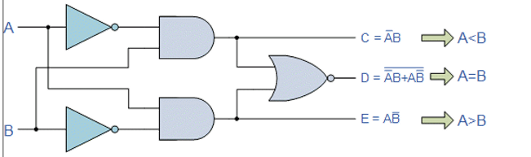

Four Bit Magnitude Comparator Implementation Details:

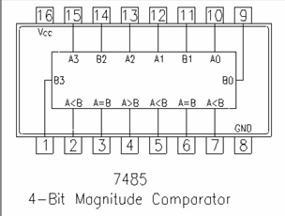
Pin Diagram of IC 7485

Logic Diagram of IC 7485
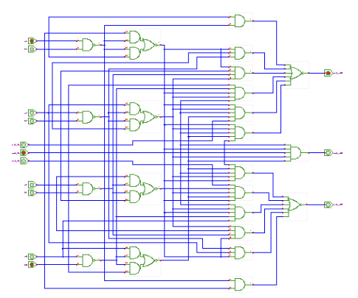
Comparing Table
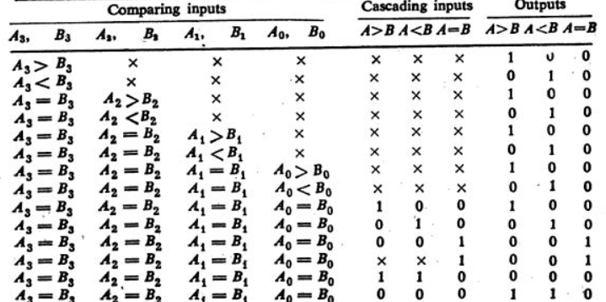

Implementation Details
Procedure:

- Locate the IC 7485 on the trainer kit.

- Connect 1st input no. to A3-A0 input slot and 2nd to B3-B0.

- Connect the output Y_{A>B} , Y_{A<B} and Y_{A=B} to the output indicators.

- Switch ON the power supply and monitor the output for various input combinations.

Post Lab Subjective/Objective type Questions:
- Design 2-bit magnitude comparator.
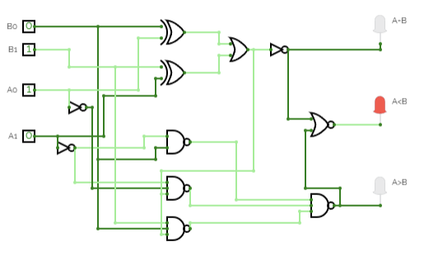
- How can we implement 5-bit magnitude comparator using IC 7485.

IC 7485 compares 4 bit inputs. If we want 5 bit magnitude comparator then we have to adjust one input line.
Every 7485 IC has three cascading input lines which can used in this case because we are using only one IC to make 7485 comparator. So, as shown in above diagram A>B is grouped with one of the input and A
The output side will have EX- NOR gate between two OUTPUTS A>B and A.
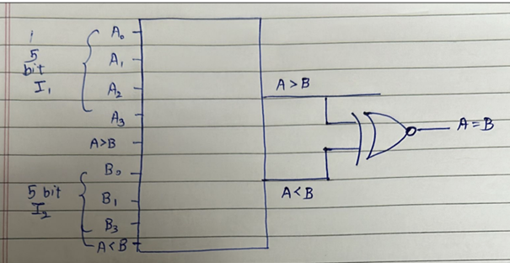

- Virtual lab:

A=B

A>B

Conclusion:
Learned abou the logic of bit comparator and also made circuit on circuit verse also used virtual lab for the same.

Signature of faculty in-charge with Date:

