1. network front_back (front container, back container )

2. network back_database (back container, database container)

2. Create a nginx container in the network 1:

3. Create a container form your flask app in network 1, and network 2



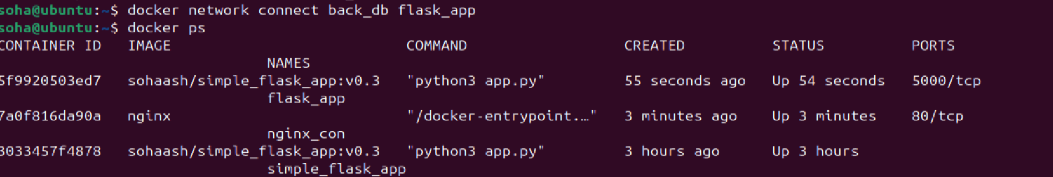

4. Create a Maria db container in network 2



5. verify with screenshots:

- docker inspect flask_app:

- docker inspect nginx_con:

- docker inspect mariadb_db:

- docker network inspect front_back:

- docker network inspect back_db:

6. exec in the nginx container, curl the ip:port of your flask app:



