Task 1:

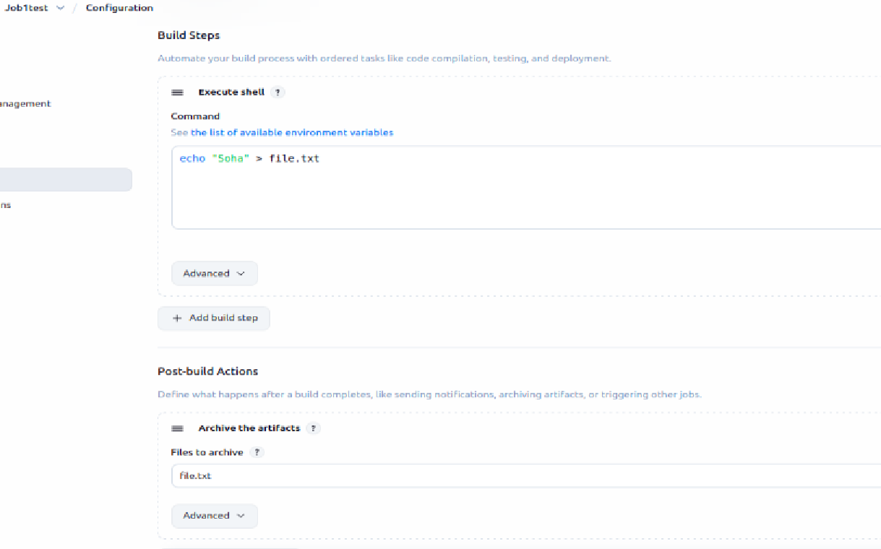

Task2:



