Task 1:

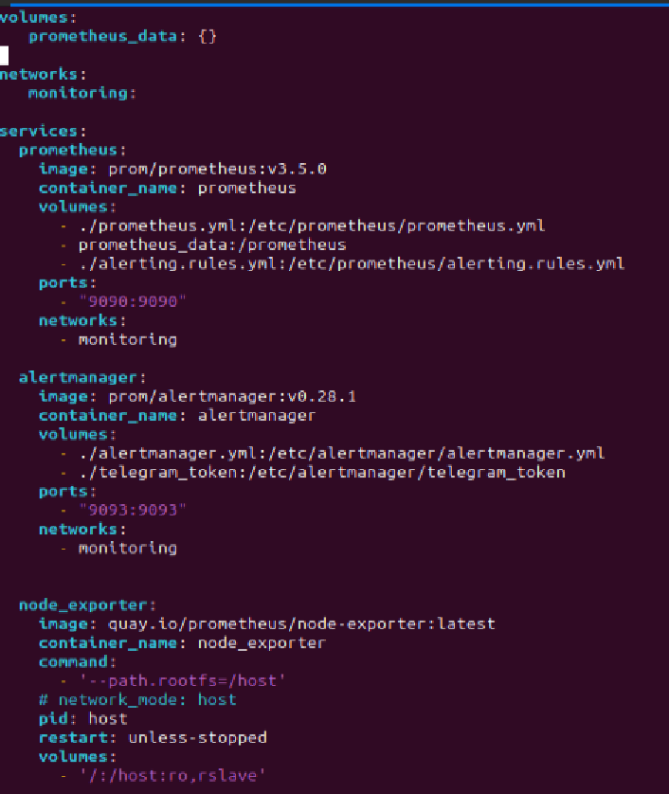

Task2:

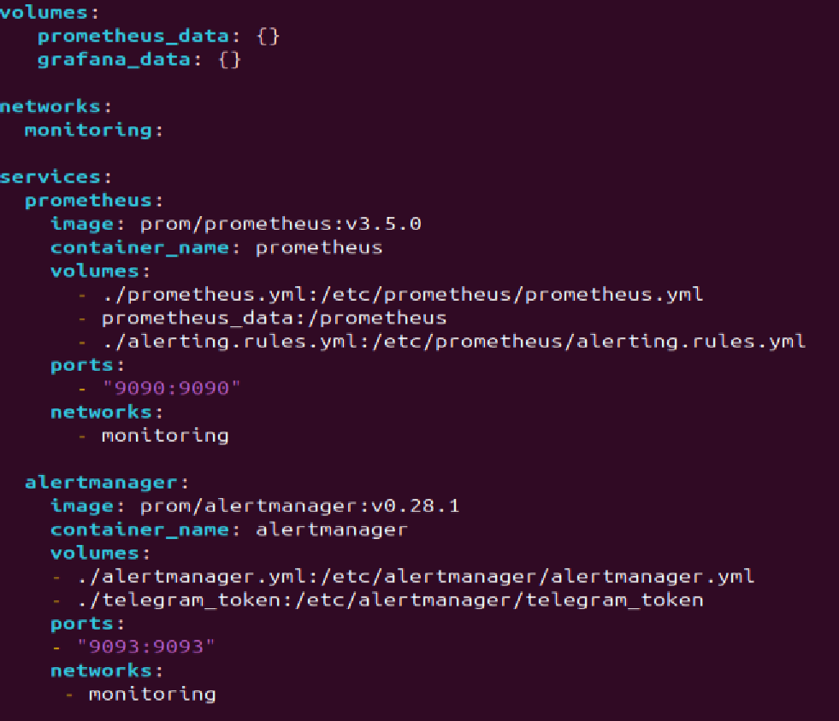

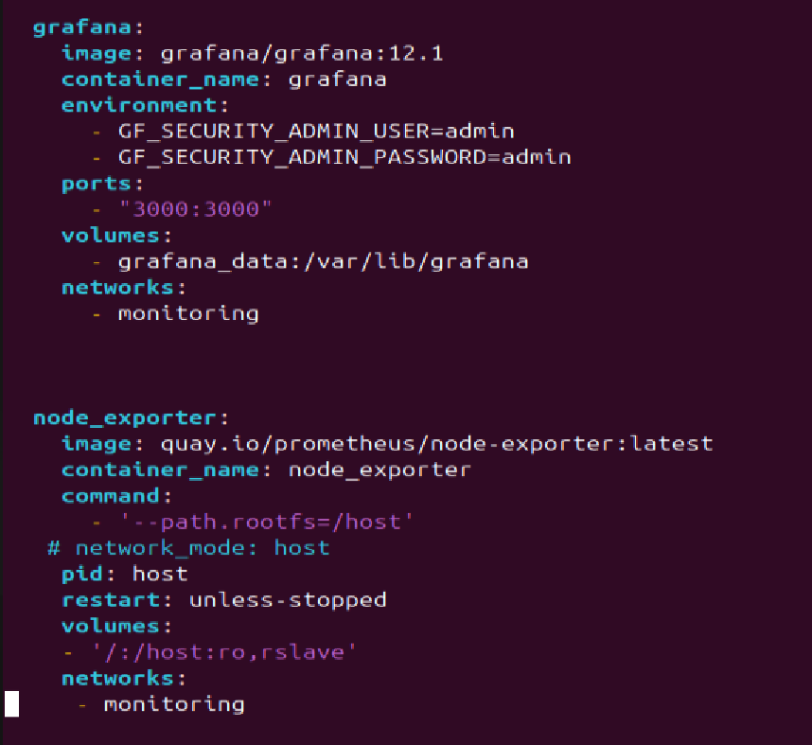

Cadvisor dashboard:

Haproxy dashboard:



