**Introduction To Data Science:**

**21CSAI01I**

**Project: Crime and Socioeconomic Indicators.**

**Group (14).**

|  |  |
| --- | --- |
| **Name:** | **ID:** |
| Soha Ashraf | 205001 |
| Maryam Saeed | 203891 |

* **Datasets:**

1. Crimes - 2001 to present (Chicago) (Press "Export").
2. Census Data - Selected socioeconomic indicators in Chicago, 2008 – 2012.
3. Crime in the United States (USA).
4. Public School in Chicago.

* **Dataset Description:**

**1**. **Crime 2001 present:**

This dataset contains reported crime incidents in the City of Chicago from 2001 to the present.  The data comes from the CLEAR (Citizen Law Enforcement Analysis and Reporting) system of the Chicago Police Department. Addresses are only shown at the block level to secure the privacy of crime victims, and specific locations are not revealed.

* **Dataset Size:** **Rows:** 7.5M, **Columns**: 22.
* **Simple of the Dataset:**

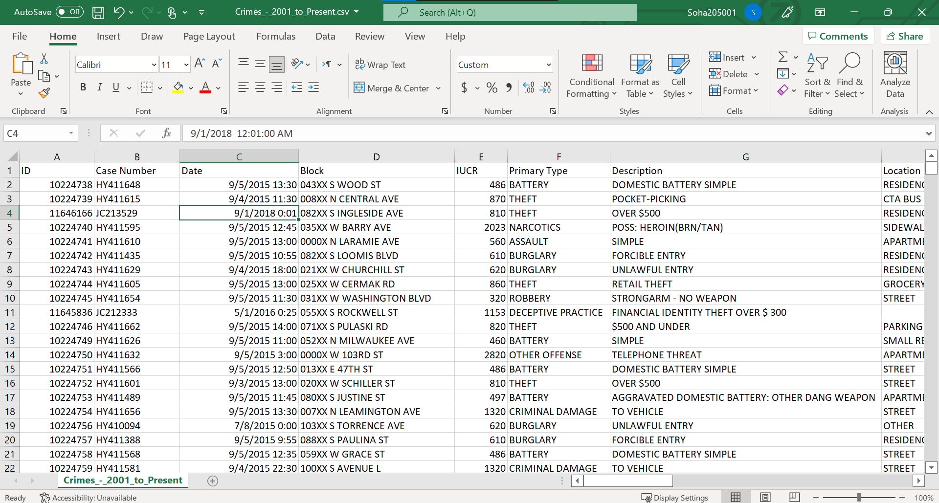

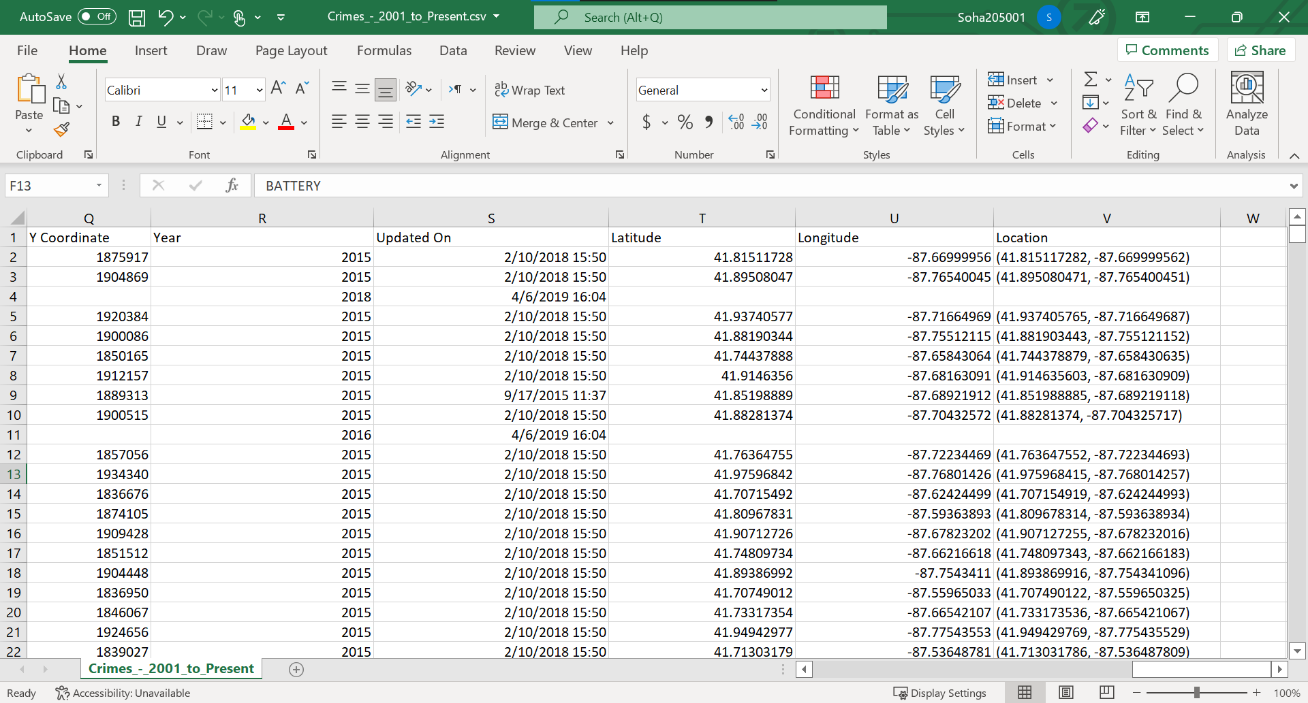

**2**. **Crime in the United States (USA) “SCARPPED”:**

Crimes rating from 1994 – 2013 in USA.

* **Dataset Size:** **Rows:** 24, **Columns**: 20.
* **Simple of the Dataset:**

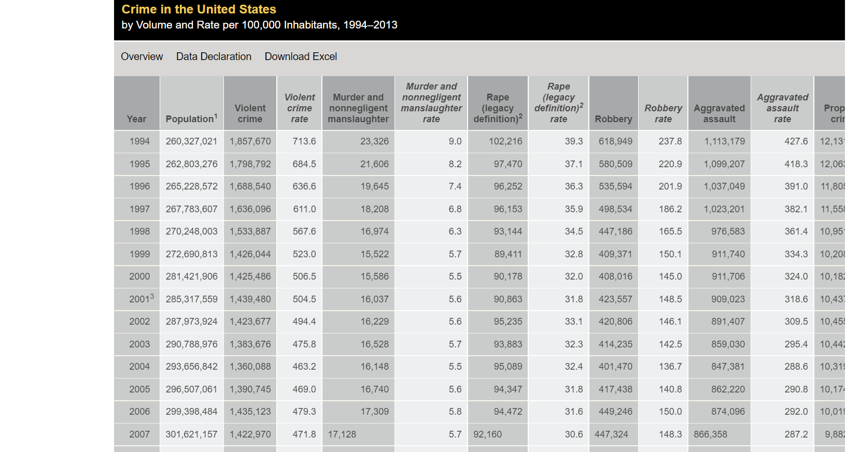

**3**. **Public School in Chicago:**

From the 2011-2012 school year, this dataset contains all school-level performance data used to create CPS School Report Cards.

* **Dataset Size:** **Rows:** 566, **Columns**: 79.

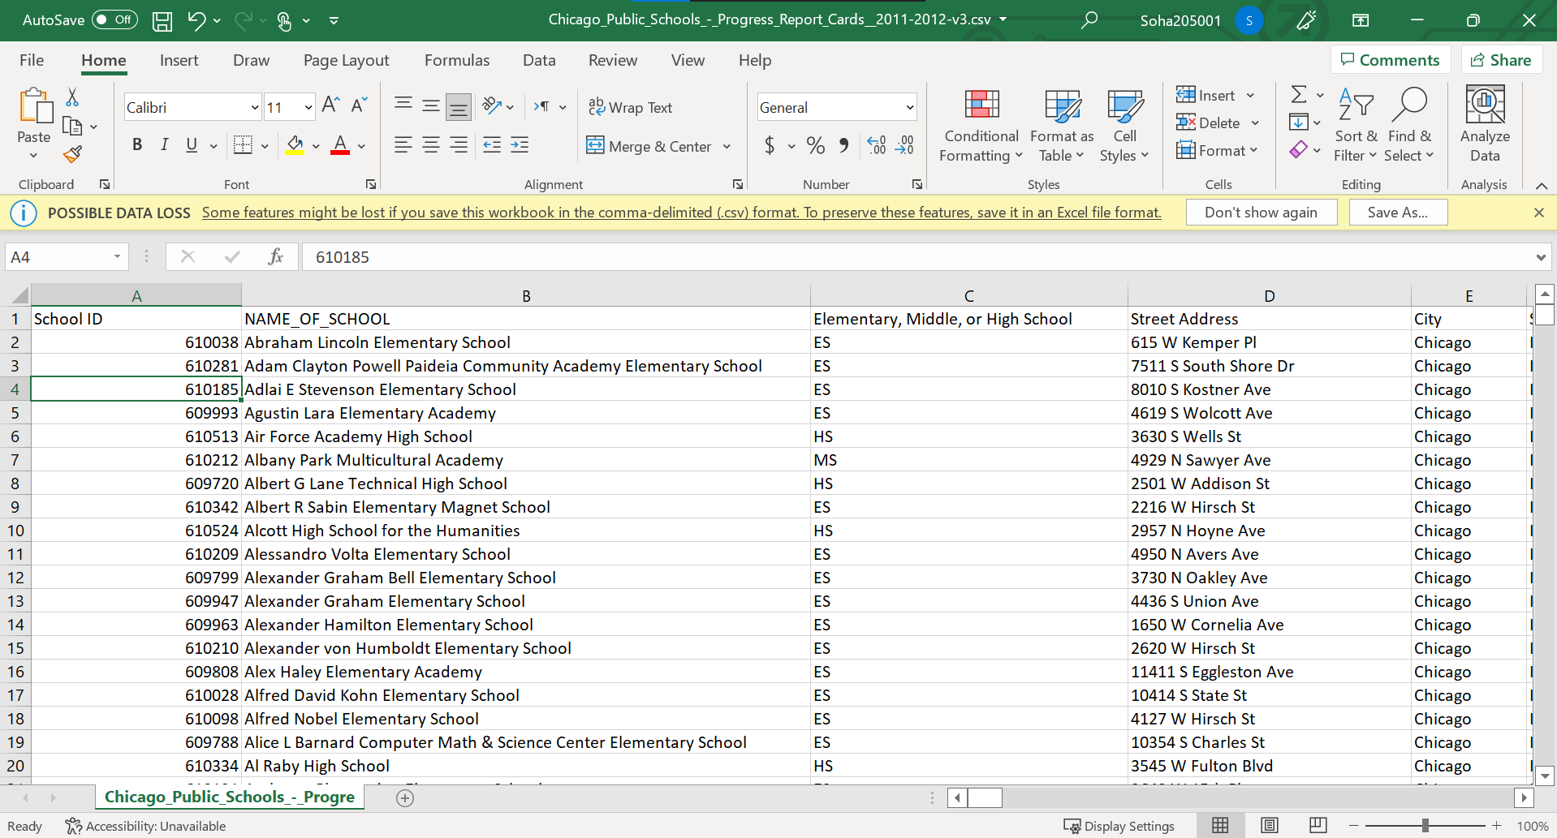

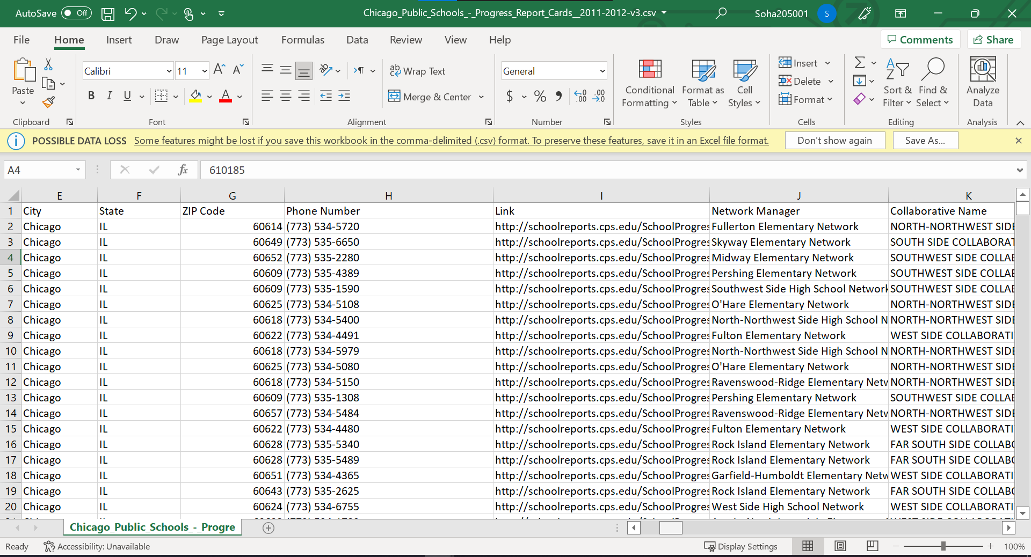

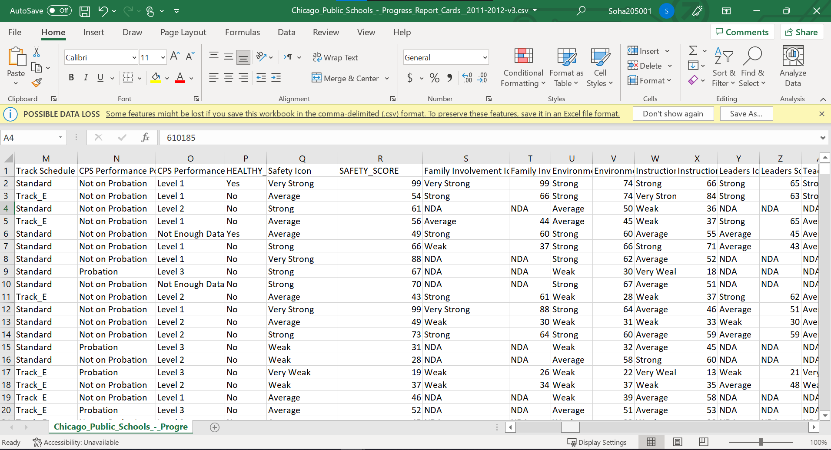

* **Goals:**

**Q1)** Are the number of the crimes increases at late time (from 00:00:00 to 05:00:00) through years?

**Q2)** What is the ratio of crime based on crime types?

**Q3)** What is the period between the date of the crime and the date it was updated?

**Q4)** During the summer months, what the higher rate of crimes happened this time?

**NOTE: There are some researchers about it, as the people in the summer leave their homes because of the increase of the temperature, so there a lot of crimes happen this time.**

* **Public school:**

**Q5)** How did the crimes effect on safety score in the community area? And what are the safety icon?

**Q6)** What is the location in every community area that a crime happened in it?

* **FBI:**

**Q7)** Are the changes that done from 2001 to 2013 affected on property crime and in which community area?

**Q8)** What is the ratio or rate of crimes based on the robbery rate that the criminals successful arrested?

**Q9)** Which year has more crime rate?

**Q2) What is the ratio of criminal arrested based on crime types?**

The criminal arrested means that to keep people in place, limit their movements, and detain them with valid legal authority. Also, Arrest can be done to prevent a crime or, if the suspect is known, after the crime has been committed. In the project according to the visualization, the theft has the most percentage of the ratio, and the 2nd one is the Battery (illegal abusive physical contact). This question shows that if the city is safe for us to travel to it or no and the law is applied or not.

As in this plot, we can see that the primary type of crimes which have higher rate is “Theft”. And the lowest rate is “Rituausm”.

**Q3) What is the period between the date of the crime and the date it was updated?**

The time period between the date of the crime and its update date is needed to know what are the cases that took much time and if there are cases still in progress.

**Q4) During the summer months, what the higher rate of crimes happened this time?**

According to the visualization, in August the rate of crimes is increased because this month in the summer and people went out to the beach to take their vacation. So, the criminals appear currently. There are some researchers about it, as the people in the summer leave their homes because of the increase of the temperature, so there a lot of crimes happen this time. In my opinion, this will help me not to live the home at these days or not to travel to this city at these months.

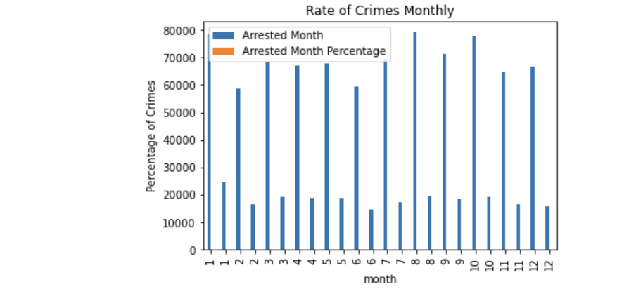

**Q5) How did the crimes effect on safety score in the community area? And what are the safety icon?**

-Crime was a bad thing and it affects all the society by negative. Crime affects the community in many ways. At the individual level, crime makes people feel dangerous. Especially if you witness a crime. In areas with higher-than-average crime rates, residents face lower housing capital and real estate values. Each community area has its own safety score. The safety icons have many types each one of them has its own meaning.

**Q6) What is the location in every community area that a crime happened in it?**

-Each community area has its location. It may be many different crimes occurs at the same community area. But it different from each other by its own code or crime code. It helps us to see if this community area is not safe to live in it or it safe.

**Q7) Are the changes that done from 2001 to 2013 affected on property crime and in which community area?**

Property crime This includes crimes that are not specifically targeted at individuals. Rather, these crimes target property. In property crimes, property can be destroyed or defaced in some way. People are usually harmless because the purpose is usually to acquire or pollute the property in question, but it can harm individuals, as in the case of arson. Types of property crimes: Theft, burglary, shoplifting, larceny, arson, etc. Community area is a part or area inside the house. This crimes or changes show that the city is safe to live or to travel to it or not. So, everyone needs to visit any city or stay in it he must see and search about this city very carefully to see if it safe or not and the shown by the rate of crimes that done in it.

**Q8) What is the ratio or rate of crimes based on the robbery rate that the criminals successful arrested?**

The robbery means that the action that takes property unlawfully from person or place by force or threat of force. The ratio of rate of crimes that the criminals arrested the number of it shown that the city is safe, and the law is applying or not.

**Q9) Which year has more crime rate?**

The crime in many cities is sometimes increases or decreases. So, it shows that in which year the crimes rate increases. Also, it shows that if the crime still increases or decreases.

* **References:**

1. Crimes - 2001 to present (Chicago) (Press "Export").

<https://data.cityofchicago.org/Public-Safety/Crimes-2001-to-present/ijzp-q8t2> [Accessed in 2.3.2022].

1. Crime in the United States (USA).

<https://www.fbi.gov/about-us/cjis/ucr/crime-in-the-u.s/2013/crime-in-the-u.s.-2013/tables/1tabledatadecoverviewpdf/table_1_crime_in_the_united_states_by_volume_and_rate_per_100000_inhabitants_1994-2013.xls>[Accessed in 9.3.2022].

1. Public School in Chicago.

<https://data.cityofchicago.org/Education/Chicago-Public-Schools-Progress-Report-Cards-2011-/9xs2-f89t>[Accessed in 9.3.2022].