Institute of Science Trade and Technology (ISTT)
Department of Computer Science & Engineering
Mirpur-13, Dhaka
Project Report
Software Engineering Lab
Course Code: 530220
OSINT Aggregator
A Passive Open-Source Intelligence Platform for Domain Reconnaissance using Node.js, Express and SQLite
Submitted By | Submitted To
Name: [Your Name]  Semester: [Semester]  Class ID: [Class ID]  NU Registration No: [Reg. No.]  Session: [Session] | Shekh Tanjil Sharif  Lecturer, Department of Computer Science & Engineering  Institute of Science Trade and Technology, Mirpur-13, Dhaka  Signature & Date
November 2026

Acknowledgement
I would like to express my sincere gratitude to everyone who helped me complete this project.
First of all, I am deeply grateful to my supervisor, Shekh Tanjil Sharif, Lecturer, Department of Computer Science & Engineering, Institute of Science Trade and Technology (ISTT). His guidance, valuable suggestions and encouragement made this work possible.
I am also thankful to all the teachers, lab assistants and staff of the department for their cooperation throughout the project.
I would like to thank the open-source developers of Node.js, Express, Axios, Cheerio and SQLite, and the organizations that provide free public data, such as the Certificate Transparency log operators, RIPE NCC, the Internet Archive and CISA, whose services form the foundation of this system. Finally, I am grateful to my family and friends for their patience and support.
[Your Name]

Abstract
The OSINT Aggregator is a web-based software application that automates passive Open-Source Intelligence (OSINT) reconnaissance of a domain. The user enters a domain name and the system queries many free public sources in parallel: DNS, WHOIS and RDAP, certificate-transparency logs and other subdomain sources, the target's own website, TLS and HTTP security headers, SPF and DMARC records, IP and ASN data, open-port and CVE data, the CISA Known Exploited Vulnerabilities list, the Wayback Machine and public phishing feeds. The system is built with a Node.js and Express back end, a SQLite database and a single-page front end written in HTML, CSS and JavaScript.
The main idea of the system is honest evidence. Every module result is classified as VERIFIED, UNVERIFIED, NOT FOUND, FAILED, PARTIAL or SOURCE UNAVAILABLE, and every finding carries its source, time, confidence and a recommended fix. A failed source is never reported as a clean result, and an unverified lead cannot raise the overall risk level to High. The system is passive only: it requires consent before each scan, refuses private and internal addresses (SSRF protection), and does not collect personal data.
The platform supports registered users and guests, per-user quota and a 24-hour cache, background scan jobs, a dashboard, an audit log, saved reports, and export as DOCX, PDF, JSON and HTML. This report presents the requirement analysis, the selection of the SDLC model, system diagrams, database design, implementation, testing, cost estimation using the COCOMO model, a maintenance plan, and the limitations and future work. All 68 automated tests passed on an offline network mock; verification against the live sources remains future work.
Keywords: OSINT, Passive Reconnaissance, Node.js, Express, SQLite, SSRF Protection, Evidence Classification, Risk Summary, Incremental Model, COCOMO.

Table of Contents
Acknowledgement i
Abstract ii
Chapter 1: Introduction 1
1.1 Project Background 1
1.2 Problem Statement 1
1.3 Objectives 2
1.4 Scope of the Project 2
1.5 Legal and Ethical Considerations 3
1.6 Report Organization 3
Chapter 2: Requirement Analysis and SDLC 4
2.1 Existing and Proposed System 4
2.2 Feasibility Study 4
2.3 Functional Requirements 5
2.4 Non-Functional Requirements 6
2.5 Project Requirement Specification 6
2.6 SDLC Model and Justification 7
2.7 Risk Analysis 8
Chapter 3: System Design 9
3.1 System Architecture 9
3.2 Context Diagram 10
3.3 Data Flow Diagram 10
3.4 Use Case Diagram 12
3.5 ER Diagram 13
3.6 Database Tables 14
3.7 Collectors, Classification and Business Rules 15
3.8 API Design 18
Chapter 4: Implementation, Testing and Output 20
4.1 Implementation 20
4.2 Method of Testing 22
4.3 Test Cases and Results 22
4.4 Test Evaluation 24
4.5 Output 25
Chapter 5: Maintenance and Pricing 28
5.1 Estimation using the COCOMO Model 28
5.2 Estimated Cost 28
5.3 Cost-Benefit Analysis 29
5.4 Maintenance 29
5.5 Maintenance Cost 29
Chapter 6: Conclusion 30
6.1 Limitations 30
6.2 Future Work 30
6.3 Conclusion 30
References 32

List of Figures
Figure 2.1: The three increments of the project under the Incremental Model 8
Figure 3.1: Three-tier architecture of the OSINT Aggregator 9
Figure 3.2: Context diagram of the system 10
Figure 3.3: Level-0 Data Flow Diagram 11
Figure 3.4: Level-1 Data Flow Diagram of the scan process 12
Figure 3.5: Use case diagram 13
Figure 3.6: Entity-Relationship (ER) diagram 14
Figure 3.7: Flowchart of the domain scan request 18
Figure 3.8: State diagram of the circuit breaker for third-party sources 18
Figure 4.1: Public home page of the OSINT Aggregator 25
Figure 4.2: Login and registration page 25
Figure 4.3: Scan page in guest mode: domain input, consent checkbox and remaining quota 26
Figure 4.4: Responsive design on a mobile screen (390 px) 26

List of Tables
Table 2.1: Comparison of the existing and proposed systems 4
Table 2.2: Functional requirements 5
Table 2.3: Non-functional requirements 6
Table 2.4: Hardware requirements 7
Table 2.5: Software requirements 7
Table 2.6: Comparison of SDLC models 7
Table 2.7: Risk analysis 8
Table 3.1: Data dictionary: users, sessions, scans and reports 14
Table 3.2: Data dictionary: investigation tables, audit log and jobs 15
Table 3.3: Collectors and public sources 16
Table 3.4: Six-status classification of module results 16
Table 3.5: List of API routes 19
Table 4.1: Project structure and purpose of the main files 20
Table 4.2: Source size of the system 22
Table 4.3: Distribution of the automated tests 22
Table 4.4: Selected test cases and results 23
Table 4.5: Screens of the application 27
Table 5.1: COCOMO (Organic) calculation 28
Table 5.2: Estimated cost breakdown 28
Table 5.3: Maintenance plan 29

Chapter 1: Introduction
This chapter describes the background of the project, the problem statement, the main and supporting objectives, the scope of the work, and the legal and ethical principles that guided the design of the system.

1.1 Project Background
Every organization today has a public face on the internet: a domain name, a website, e-mail servers, DNS records, security certificates and a trail of old pages in web archives. All of this information is open to anyone, and it is exactly the information that an attacker studies first when planning an attack. Collecting and analyzing such publicly available information is called Open-Source Intelligence (OSINT) [1]. In a professional security assessment, OSINT is the first phase of reconnaissance, and it is normally performed before any technical testing begins [2].
The difficulty is that this information is scattered over many places. The owner of a domain has to open a WHOIS website, a DNS tool, a certificate-transparency search page, a Shodan page, a web-archive page and several other tools, copy the results by hand, and then compare them. This takes hours, depends on the skill of the person, and is rarely repeated, so changes are not noticed.
The OSINT Aggregator was developed to solve this problem. The user gives one domain name and the system queries many free public sources in parallel, combines the answers into a single evidence-based report, ranks the findings by severity, and exports the report as Word, PDF, JSON or HTML. The server is written in Node.js using the Express framework [3], and all data is stored in a single SQLite file [4], so the whole system can run on an ordinary computer without any paid service or API key.

1.2 Problem Statement
Manual public-source reconnaissance suffers from the following problems:
- Scattered sources: WHOIS, DNS, certificate logs, IP data, web archives and threat feeds are on different websites with different formats, so one complete picture takes a long time to build.
- No evidence and no confidence level: a result copied from a third-party website looks the same as a result observed directly, so the reader cannot tell what is reliable.
- False certainty: many tools report a missing record or an empty result as if it proved that nothing exists, although the source may simply have been unreachable.
- Not repeatable: manual work is not saved, so changes between two checks (new subdomains, new open ports) are not detected.
- Risk of misuse: tools that scan or attack targets can harm third parties and break the law when used without permission.

1.3 Objectives
Main Objective
To develop a secure, passive-only and low-cost web-based OSINT Aggregator that collects public information about a domain from many free sources, verifies and classifies it honestly, and presents it as a prioritized, exportable report.

Supporting Objectives
- Aggregation: to collect WHOIS/RDAP, DNS, subdomains, website and company information, e-mail security, TLS and header data, IP/ASN data, web-archive history and threat-feed data in one scan.
- Honest classification: to label every result as VERIFIED, UNVERIFIED, NOT FOUND, FAILED, PARTIAL or SOURCE UNAVAILABLE, so that a failed source is never presented as a clean result.
- Prioritized findings: to turn the evidence into findings with severity, confidence, source, time and a recommended fix, and to compute an overall risk level.
- Secure multi-user platform: to provide accounts, guest mode, per-user quota, background jobs, a dashboard and an audit log, with SSRF protection and consent before every scan.
- Reporting: to export the result as DOCX, PDF, JSON and HTML, and to keep the last 30 reports of every user.

1.4 Scope of the Project
In Scope
- Domain-level and organization-level passive reconnaissance using free public sources only.
- Sign-up, login, sessions, guest access, per-account quota, 24-hour result cache and background scan jobs.
- Dashboard, scan workspace with relationship graph, Google Dork query builder, IP lookup and company-name to domain finder.
- Optional integration of Subfinder, Amass (passive), theHarvester, SpiderFoot (passive) and Recon-ng, and a built-in fallback engine.
- Report export in four formats and an offline automated test suite of 68 tests.
Out of Scope
- Any active or intrusive activity: port scanning, brute forcing, vulnerability exploitation or sending attack traffic.
- Person-level investigation: phone-number search, profiling of individuals or scraping of personal social-media data.
- Scraping Google or other search engines. The tool only builds search links that the user opens manually.
- Paid data sources, payment gateways, e-mail or SMS alerts and multi-tenant organization management.

1.5 Legal and Ethical Considerations
OSINT is legal because it uses information that anybody may access, but the way the information is collected and used can still cause harm. Therefore the following principles were built into the software itself and not only written in a policy:
- Passive only: the system never port-scans, brute-forces or exploits. The only traffic sent to the target is an ordinary HTTPS visit and a TLS handshake, similar to a normal browser.
- Consent before scan: the user must tick a statement that he or she owns the domain or has permission to assess it. A request without consent is rejected by the server.
- No personal data: the tool collects only information that the organization itself publishes (for example a contact e-mail on its contact page). Team pages are not mined for personal data.
- Protection of third parties: private, loopback and internal addresses are refused, so the tool cannot be used to probe internal networks (SSRF protection).
- Privacy of users: IP addresses are stored only as salted hashes, and the audit log records what happened but never the content of a report.
The tool should be used only against domains owned by the user, against targets with explicit written authorization (for example a bug-bounty scope or a signed engagement), or against public practice targets. The user remains responsible for following the cyber-security laws that apply in his or her country.

1.6 Report Organization
Chapter 2 presents the requirements and the SDLC, Chapter 3 the system design and diagrams, Chapter 4 the implementation, testing and output, Chapter 5 the cost estimation and maintenance, and Chapter 6 the limitations, future work and conclusion. References are given at the end in IEEE style.

Chapter 2: Requirement Analysis and SDLC
This chapter compares the existing and proposed systems, studies feasibility, lists the functional and non-functional requirements and the hardware and software needs, justifies the choice of the SDLC model, and analyzes the risks. The IEEE 830 guideline was followed while specifying the requirements [5].

2.1 Existing and Proposed System
Existing system: At present a person who wants to know the public footprint of a domain opens many separate websites and command-line tools, copies the results into a document and compares them manually. Some popular tools combine many sources, but they are often paid, need many API keys, run active scans, or show raw lists without telling how reliable each item is.
Proposed system: The OSINT Aggregator performs all passive checks in one request, applies a fixed verification rule to every result, ranks the findings, remembers previous scans to show what changed, and produces a ready report. It needs no API key for its core work.
Table 2.1: Comparison of the existing and proposed systems
Aspect | Existing (manual / separate tools) | Proposed OSINT Aggregator
Data collection | Many websites and tools, one by one | 19 collectors run in parallel from one domain input
Reliability | No distinction between direct and third-party data | Six status labels and VERIFIED / UNVERIFIED rule
Failures | Empty result looks like "nothing found" | Unreachable source is shown as SOURCE UNAVAILABLE
Prioritization | Reader must judge importance | High / Medium / Low findings with fix suggestions
Change tracking | None | Diff with the previous scan (subdomains, ports, CVEs)
Reporting | Manual copy-paste | DOCX, PDF, JSON and HTML export
Safety | Some tools scan actively | Passive only, consent, SSRF guard, rate limit
Cost | Paid plans or many API keys | Free sources, open-source stack

2.2 Feasibility Study

2.2.1 Technical Feasibility
The system uses Node.js, Express, Axios, Cheerio and SQLite, all of which are free and widely used. SQLite is used through the better-sqlite3 package or, if that is not installed, through the built-in node:sqlite driver of Node.js 22.5 and later, so no separate database server is needed. All external data comes from free public APIs. The project is therefore technically feasible.

2.2.2 Economic Feasibility
All development tools and data sources are free, so license cost is zero. The only running cost is a small server with a persistent disk. The estimated development cost by the COCOMO model is given in Chapter 5 and is affordable for a student project and for a small company.

2.2.3 Operational Feasibility
The interface has a simple sidebar and one main action: enter a domain, tick the consent box and press Run report. A user does not need any security training to read the summary cards, while a specialist can open the detailed workspace tabs and the evidence table.

2.2.4 Schedule Feasibility
The system was built in three increments (core checks, security intelligence, platform features). Each increment was small enough to be completed and tested separately, so the schedule was manageable for a single developer.

2.2.5 Legal Feasibility
Because only public sources are read and no intrusive traffic is sent, the tool is legally feasible when used on authorized targets. The consent step and the terms and privacy pages make the permitted use explicit.

2.3 Functional Requirements
Table 2.2: Functional requirements
ID | Module | Requirement
FR-01 | Authentication | The system shall allow sign-up and login with e-mail and password, create a session, and allow logout.
FR-02 | Guest mode | The system shall allow a limited number of scans without an account when guest mode is enabled; nothing is saved to any account.
FR-03 | Target validation | The system shall accept only a valid public domain name and refuse IP literals and internal or reserved names.
FR-04 | Consent | The system shall refuse a scan unless the user confirms ownership or permission.
FR-05 | Collection | The system shall collect WHOIS/RDAP, DNS, subdomains, website, robots.txt, sitemap, TLS, headers, e-mail security, IP/ASN, archive, company profile and threat-feed data.
FR-06 | Classification | The system shall label each module result with one of six statuses and each finding as verified, partially verified or unverified.
FR-07 | Risk summary | The system shall produce findings with severity, source, confidence, time and a recommended fix, and one overall risk level.
FR-08 | Quota and cache | The system shall limit scans per account or guest per time window and shall serve a same-domain result from cache for 24 hours without using quota.
FR-09 | Background jobs | The system shall queue scans in the background, allow cancel, and report job progress.
FR-10 | Reports | The system shall save the last 30 reports per user and allow open and delete.
FR-11 | Export | The system shall export a report as DOCX, PDF, JSON and HTML.
FR-12 | Dashboard | The system shall show scan counts, severity totals, latest findings, source health and failed tasks.
FR-13 | IP lookup | The system shall look up an IP address (ASN, prefix, location, reverse DNS, ports, CVEs, botnet list).
FR-14 | Company finder | The system shall find the official website of a company name through Wikidata.
FR-15 | Dork builder | The system shall build categorized Google Dork links for the domain without retrieving any search result.
FR-16 | Account | The system shall allow the user to change name and password and to delete the account with all its data.
FR-17 | Audit | The system shall keep a per-user audit log of actions without storing report content.

2.4 Non-Functional Requirements
Table 2.3: Non-functional requirements
Attribute | Requirement
Security | Passwords hashed with scrypt; HttpOnly SameSite sessions; CSP and security headers; cross-site request blocking; SSRF guard on every outbound request.
Reliability | A failing collector never breaks the report; each collector has a 60-second timeout and one retry; a circuit breaker skips a source that keeps failing.
Honesty | No result may be called VERIFIED unless the system observed it directly; a failed or empty check is never reported as clean.
Performance | Collectors run in parallel; a typical scan completes in about one minute depending on source speed.
Privacy | IP addresses stored only as salted hashes; no personal data collected from target sites.
Usability | Responsive interface (320 px to 1920 px), dark and light theme, no horizontal overflow.
Portability | Runs on Windows, Linux and macOS with Node.js 20+; setup scripts provided; Dockerfile available.
Maintainability | One module per data source; configuration through the .env file; automated tests with an offline network mock.
Safety of use | Passive traffic only; legal notice, terms and privacy pages; consent checkbox.

2.5 Project Requirement Specification
The hardware and software needed to develop and to run the system are listed below. The system is light: it does not need a GPU or a database server.
Table 2.4: Hardware requirements
Item | Minimum | Recommended
Processor | Dual-core 2 GHz | Quad-core 2.5 GHz
Memory (RAM) | 2 GB | 4 GB
Storage | 500 MB free (more for saved reports) | 5 GB persistent disk
Network | Stable internet connection | Broadband with outbound HTTPS and DNS

Table 2.5: Software requirements
Item | Requirement
Operating system | Windows 10/11, Linux or macOS
Runtime | Node.js 20 or later (22.5+ also provides the built-in SQLite driver)
Libraries | express, axios, cheerio, whois, docx, pdf-lib; optional better-sqlite3
Database | SQLite (single file, data/softinza.db)
Browser | Any modern browser (Chrome, Edge, Firefox, Safari)
Optional tools | Subfinder, Amass, theHarvester, SpiderFoot, Recon-ng (installed separately)
Development tools | Visual Studio Code, Git, npm

2.6 SDLC Model and Justification
Five common SDLC models were compared [6], [7]. The criteria were the clarity of requirements at the start, the possibility of delivering a working system early, the ability to accept change, and the suitability for a single developer.
Table 2.6: Comparison of SDLC models
Model | Strength | Weakness for this project | Suitability
Waterfall | Simple, well documented | No working system until the end; hard to change | Low
Prototype | Quick feedback on the interface | Back-end rules need more than a prototype | Medium
Incremental | Working system after each increment; easy to add features | Needs a clear core design at the start | High (chosen)
Spiral | Strong risk analysis [8] | Too heavy for a small single-developer project | Medium
Agile / Scrum | Flexible, fast iteration | Needs a team and a product owner | Medium

The Incremental Model was selected. The project grew naturally from a small domain checker (version 1) to a security and intelligence tool (versions 2.x) and then to a multi-user platform (versions 3.x). Each stage produced a working and tested system and added new capability on top of the previous one, which is exactly the idea of incremental development.
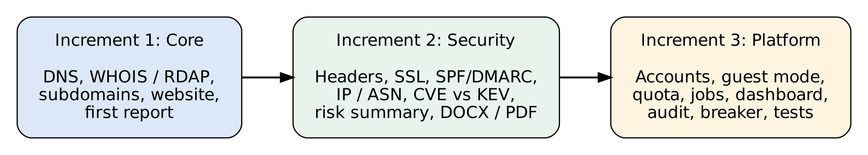
Figure 2.1: The three increments of the project under the Incremental Model
Increment 1 (core): DNS, WHOIS and RDAP, subdomains from certificate-transparency logs, website analysis and the first report. Increment 2 (security and intelligence): security headers, SSL, SPF/DMARC, IP and ASN data, CVE matching with the CISA list, risk summary, and Word/PDF export. Increment 3 (platform): accounts, guest mode, quota and cache, background jobs, dashboard, audit log, circuit breaker and the automated test suite.

2.7 Risk Analysis
Table 2.7: Risk analysis
# | Risk | Likelihood | Impact | Mitigation
1 | Misuse against a target without permission | Medium | High | Consent checkbox, passive-only design, rate limit, audit log, terms page
2 | SSRF: attacker makes the server call internal addresses | Medium | High | Domain validation, private-IP check, connection-time DNS guard, redirect guard
3 | A free public source is slow, blocked or changes format | High | Medium | Timeout, retry, circuit breaker, honest SOURCE UNAVAILABLE label
4 | Third-party data (for example Shodan) is outdated and misleads the user | High | Medium | Marked UNVERIFIED; cannot raise the overall level to High alone
5 | Brute-force login or fake sign-ups | Medium | Medium | Login throttle, sign-up limit, scrypt hashing, same error for wrong user or password
6 | Overload from many scans at once | Medium | Medium | Quota, job queue limit, worker pool, guest concurrency cap
7 | Loss of data on ephemeral hosting disks | Medium | High | Deployment note: use a persistent disk and back up DATA_DIR
8 | Cross-site scripting through hostile page titles or tags | Low | High | Output escaping in the interface; tested with hostile data
9 | Optional external tools return untrusted output | Medium | Medium | No shell, strict domain check, output cap, only on-target names kept
10 | Legal issues of the user's country | Low | High | Legal notice and the rule to scan only authorized targets

Chapter 3: System Design
This chapter presents the architecture of the system, the context diagram, the data flow diagrams, the use case diagram, the database design, the business rules and the API. The diagrams show how a request moves through the system and which public sources are used.

3.1 System Architecture
The system follows a three-tier architecture. The presentation tier is a set of HTML pages (public home page, login page and a single-page application) that run in the browser. The application tier is a Node.js server with Express; it contains the security layer, the REST API, the reconnaissance orchestrator, the report engine and the job queue. The data tier is one SQLite database file and a few JSON files for quota, cache and scan history. The orchestrator is the only part that talks to the public internet, and the guard against server-side request forgery follows the OWASP recommendations [15].
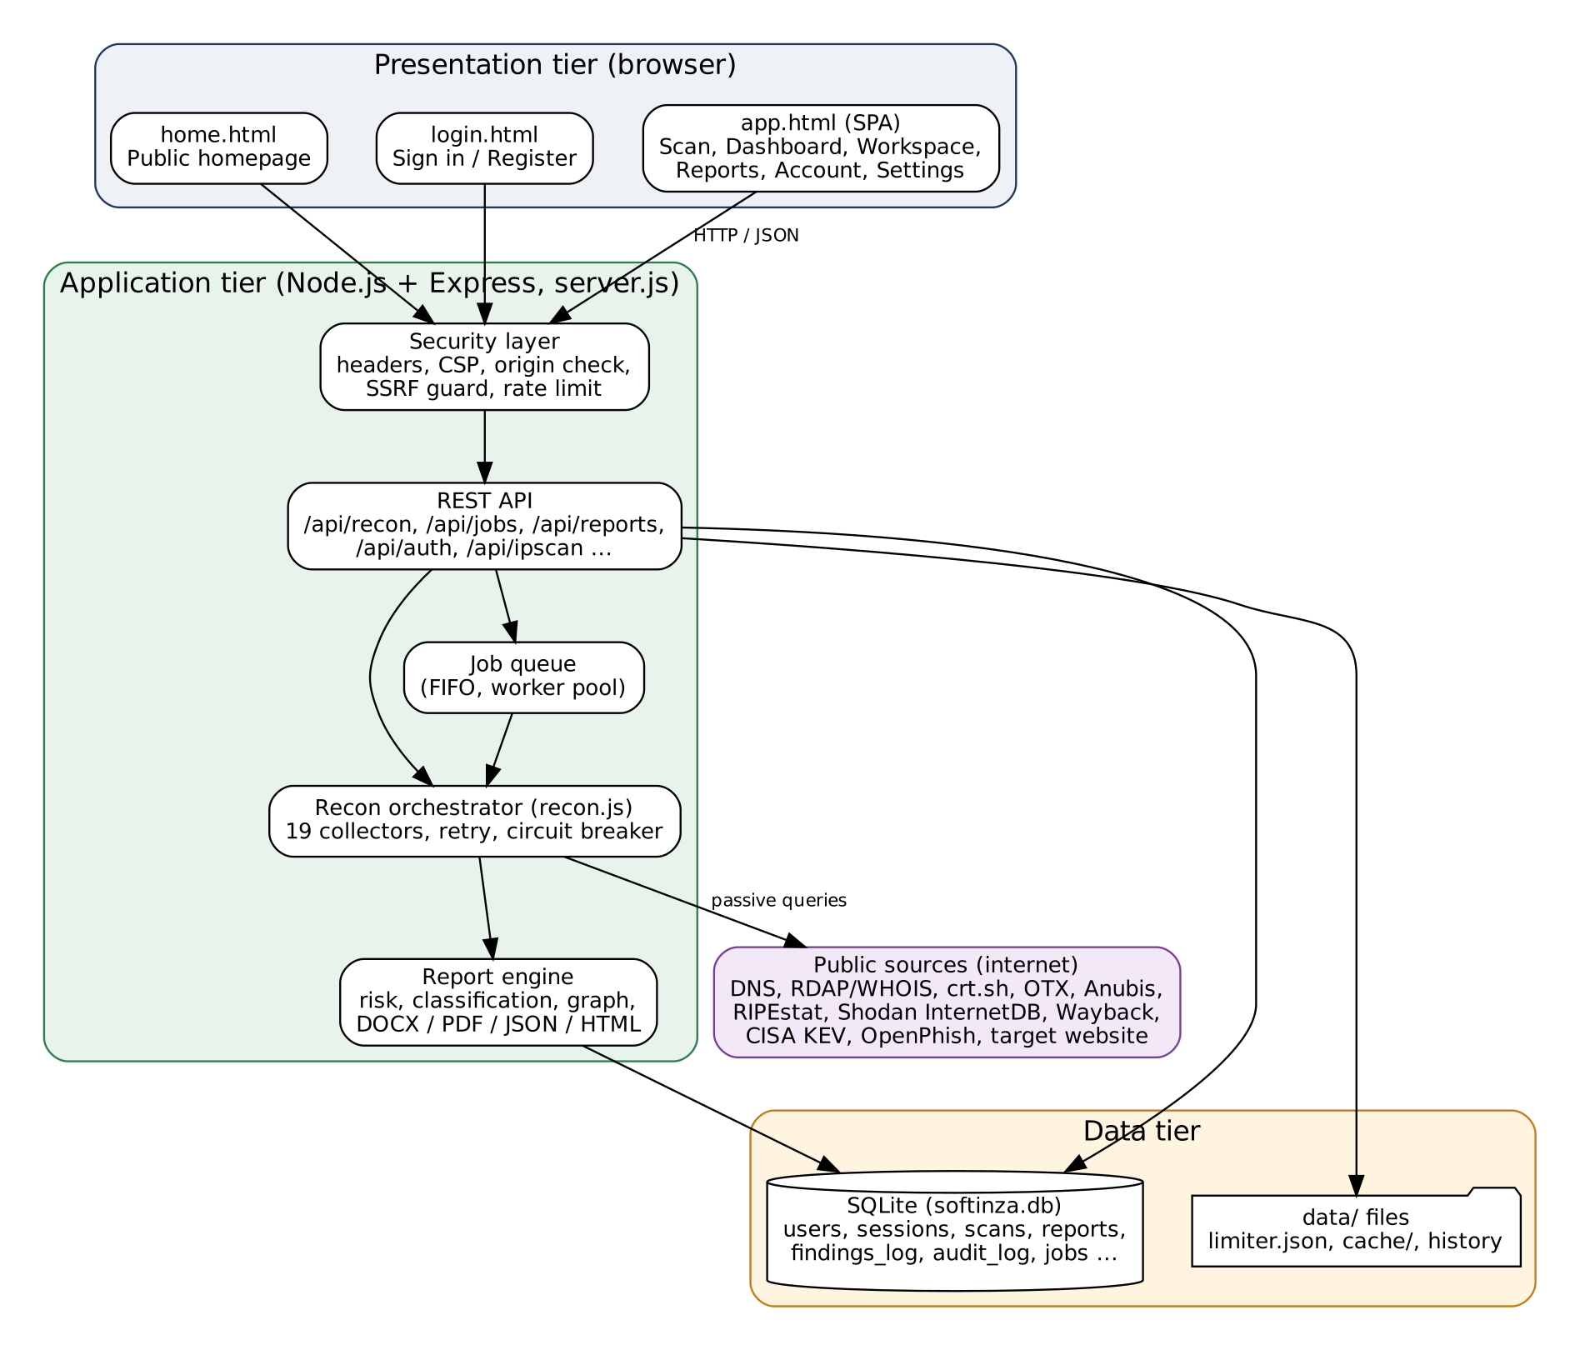
Figure 3.1: Three-tier architecture of the OSINT Aggregator
The security layer runs before every route. It adds security headers, blocks cross-site state-changing requests whose Origin does not match the host, reads the session cookie, and decides whether the caller is a signed-in user or a guest. The orchestrator uses a shared, guarded HTTP client, so every outbound connection is checked against private addresses even if a DNS answer changes after the first check.

3.2 Context Diagram
The context diagram shows the system as one process and the outside entities that exchange data with it: the registered user, the guest, the public data sources, the target website itself and the optional external tools.
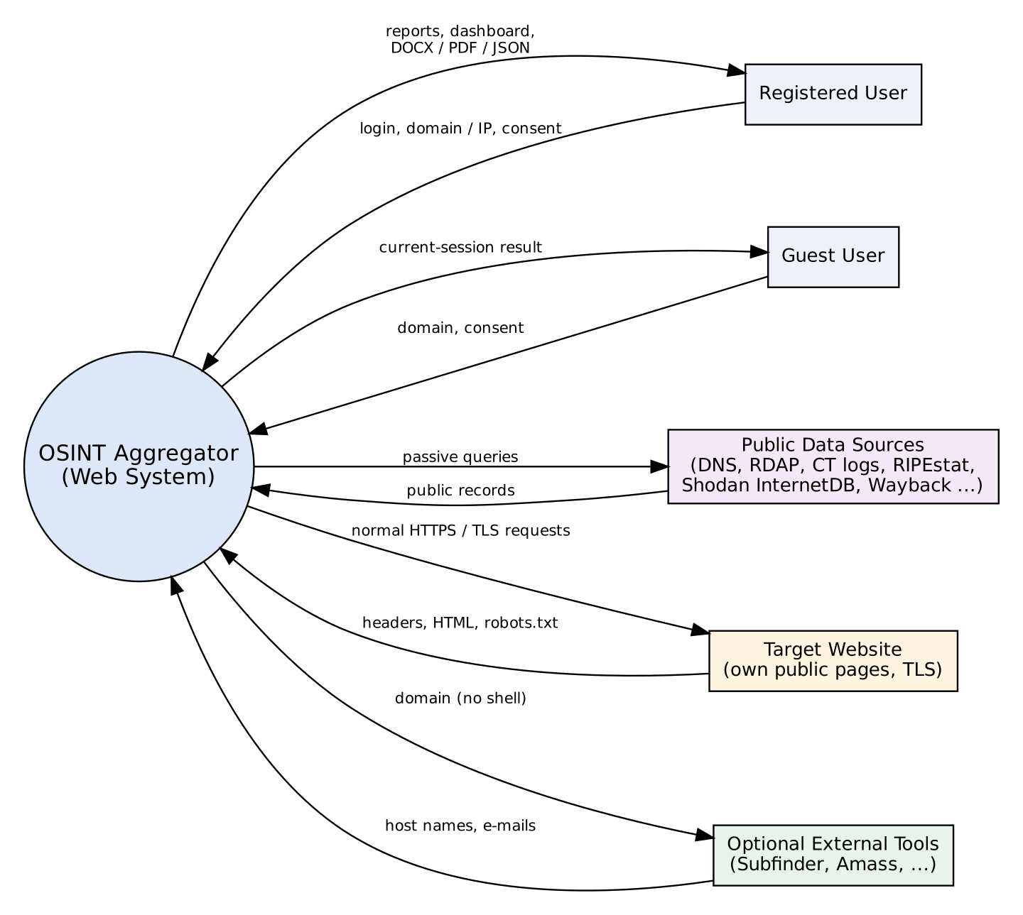
Figure 3.2: Context diagram of the system

3.3 Data Flow Diagram
The Level-0 DFD splits the system into five main processes: authentication, target validation and quota check, data collection, analysis and scoring, and report generation. Three data stores are used: users and sessions (D1), reports, findings and audit log (D2), and quota and cache (D3).
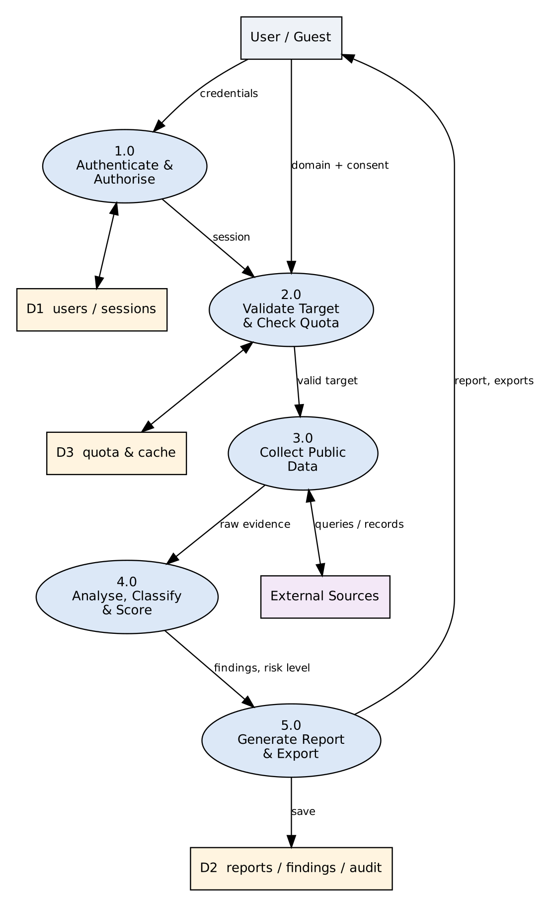
Figure 3.3: Level-0 Data Flow Diagram
Figure 3.4 expands process 3.0 (collect public data) and the steps that follow it. The order of these steps is the same as the order of execution inside the function runRecon of the file lib/recon.js.
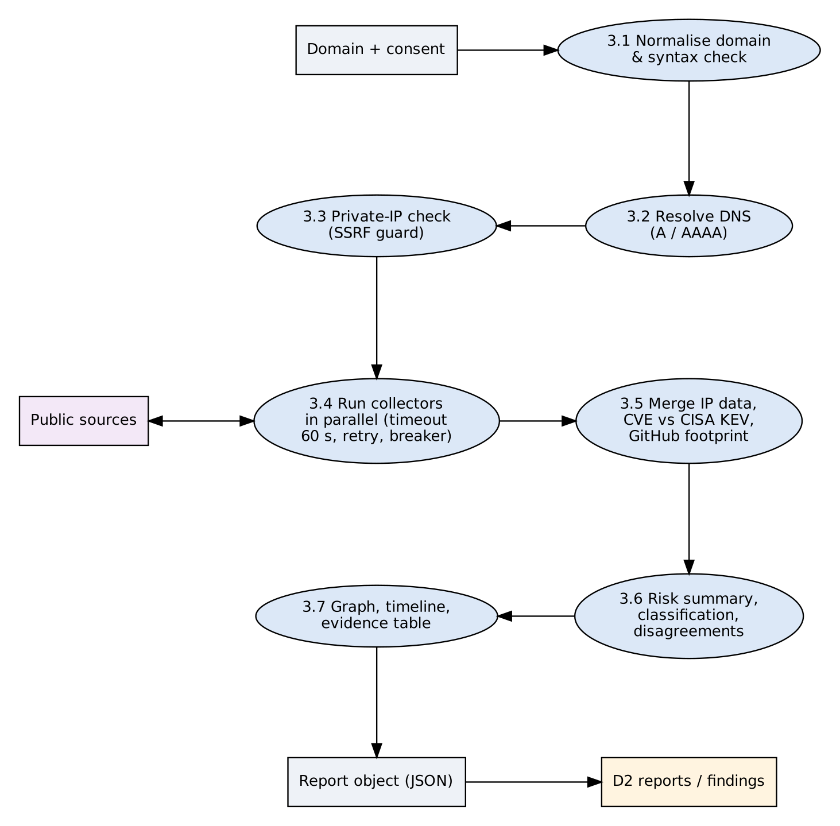
Figure 3.4: Level-1 Data Flow Diagram of the scan process

3.4 Use Case Diagram
There are two human actors. A guest can run a domain report, use the IP lookup and export the current result, but nothing is saved. A registered user can do everything a guest can and also use the dashboard, the scan workspace, saved reports, background scans, the audit log and account management. The public data sources appear as a system actor that supplies data to the "Collect public data" use case.
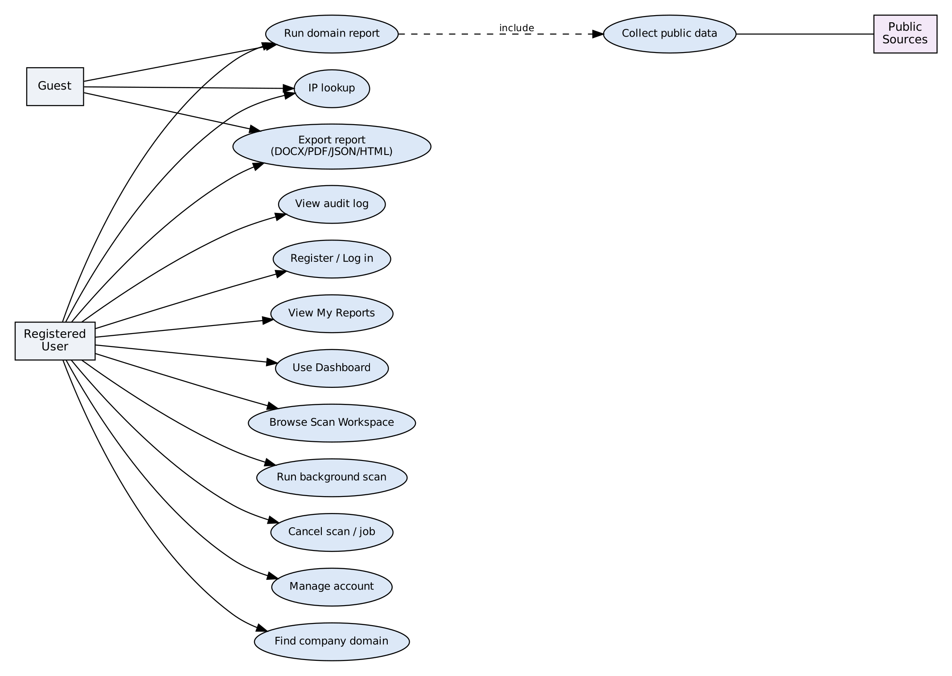
Figure 3.5: Use case diagram

3.5 ER Diagram
The Entity-Relationship model [9] has one central entity, users. All other tables belong to a user and are deleted together with the user (ON DELETE CASCADE), except the audit log, whose user reference is set to NULL so that the history of actions is not lost when an account is deleted.
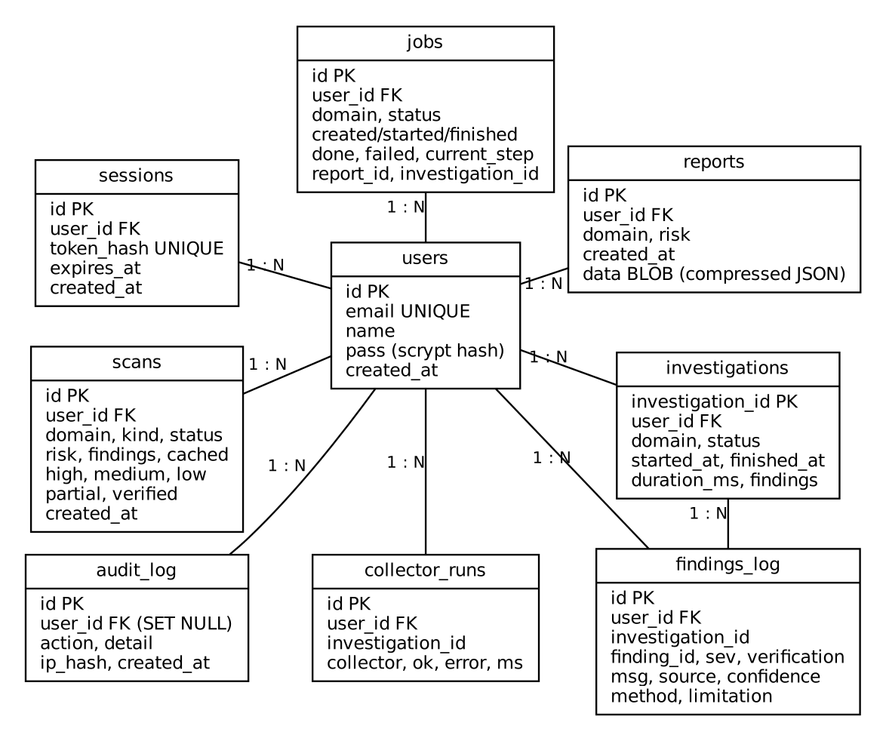
Figure 3.6: Entity-Relationship (ER) diagram

3.6 Database Tables
The schema is created automatically at start-up. WAL journal mode and foreign keys are enabled. Reports are stored as a compressed JSON object in a BLOB column, because their structure is large and changes with new modules.
Table 3.1: Data dictionary: users, sessions, scans and reports
Table | Column | Type | Description
users | id | INTEGER PK | Unique user identifier
 | email | TEXT UNIQUE | Login name, stored in lower case
 | name | TEXT | Display name (up to 60 characters)
 | pass | TEXT | scrypt hash with salt and parameters; never plain text
sessions | user_id | INTEGER FK | Owner of the session (cascade delete)
 | token_hash | TEXT UNIQUE | SHA-256 of the cookie token; the token itself is not stored
 | expires_at | INTEGER | Session expiry (14 days)
scans | domain, kind | TEXT | Scanned target and kind of scan (domain or IP)
 | status, risk | TEXT | Completed or failed; overall risk level
 | findings, high, medium, low, partial, verified | INTEGER | Counters used by the dashboard
 | cached | INTEGER | 1 if the result came from the cache
reports | user_id, domain, risk | FK, TEXT | Owner, target and risk level
 | data | BLOB NOT NULL | Compressed JSON of the full report

Table 3.2: Data dictionary: investigation tables, audit log and jobs
Table | Column | Type | Description
investigations | investigation_id | TEXT PK | Report identifier such as INV-XXXXXXXXXX
 | started_at, finished_at, duration_ms | INTEGER | Real execution times of the scan
findings_log | finding_id, sev, verification | TEXT | Finding number (F-001), severity and verification label
 | msg, source, confidence | TEXT | What was found, where it came from and how sure the system is
 | method, limitation | TEXT | How it was collected and what its weakness is
collector_runs | collector, ok, error, ms | TEXT, INTEGER | Outcome and duration of every collector run
audit_log | action, detail, ip_hash | TEXT | What happened (never the report content); salted IP hash
jobs | id, domain, status | TEXT | Background job and its state: queued, running, done, failed, cancelled, interrupted
 | done, failed, current_step | INTEGER, TEXT | Progress counters shown in the interface
 | report_id, investigation_id | INTEGER, TEXT | Link to the finished report

3.7 Collectors, Classification and Business Rules

3.7.1 Collectors
Each source is wrapped in a collector. All collectors start at the same time, and a failure in one of them is converted into an error object so that the report is still produced. Table 3.3 lists the collectors and the public source used by each. The checks follow public standards: SPF and DMARC [16], security.txt [17], the CISA Known Exploited Vulnerabilities list [18], RIPEstat [19] and Certificate Transparency logs [20].
Table 3.3: Collectors and public sources
Collector | Source | Type | Data collected
Domain & DNS | Public DNS resolution | Direct | A, AAAA, MX, NS, TXT, SOA, CNAME
WHOIS / RDAP | WHOIS servers, rdap.org | Third party | Registrar, dates, name servers, status
Subdomains | crt.sh, AlienVault OTX, Anubis | Third party | Names, live/dead check, takeover hint
Website | Target's own homepage | Direct | Title, meta, technology hints, social links
robots.txt / Sitemap | Target's own site | Direct | Disallowed paths, published URLs
TLS & headers | TLS handshake, HTTP response | Direct | Certificate dates, trust, security headers, cookies
Email security | Public DNS TXT records | Direct | SPF, DMARC (policy)
DNS hardening | Public DNS | Direct | CAA, DKIM, MTA-STS
security.txt | /.well-known/security.txt | Direct | Security contact (RFC 9116)
IP & ASN | RIPEstat, Shodan InternetDB | Third party | Prefix, ASN, open ports, CVE ids
Exploited CVEs | CISA Known Exploited list | Third party | Match of CVE ids with the KEV list
Archives | Wayback Machine (CDX) | Third party | First/latest snapshot, historical URLs
Lookalikes | Public DNS permutation | Direct | Typo and homoglyph domains that resolve
Company & social | JSON-LD, Open Graph, public pages | Direct | Published e-mails/phones, official social links
Threat feeds | OpenPhish; URLhaus (if key set) | Third party | Phishing or malware URLs on the domain
GitHub footprint | GitHub public API | Third party | Public organization data (if officially linked)

3.7.2 Status classification
The rule in lib/classification.js converts the real outcome of a collector into one of six labels. The rule is documented in the code and is not an independent audit; it exists to prevent a result from looking more certain than it is.
Table 3.4: Six-status classification of module results
Status | Meaning
VERIFIED | Data collected and observed directly by the system (own DNS, TLS or HTTP checks).
UNVERIFIED | Data collected from a third-party index or from a claim published by the target itself.
NOT FOUND | The source was reached but returned nothing. This does not prove that the information does not exist.
FAILED | The check could not run or a prerequisite was missing; nothing was checked.
PARTIAL | Some commands or sources worked and some did not.
SOURCE UNAVAILABLE | The source could not be reached (blocked, rate limited, timeout, DNS or network error).

3.7.3 Business rules
- A scan is allowed only for a valid public domain; IP literals and names ending in local, localhost, internal, lan, corp, test, example, arpa and similar are refused before any network call.
- If the domain resolves to a private, loopback, link-local or reserved address, the scan is refused.
- A signed-in user may run 3 scans per 60 minutes (RATE_LIMIT, RATE_WINDOW_MIN). A guest may run at most 2, and never more than the account limit.
- A report of the same domain younger than 24 hours is served from the cache and does not use quota. A failed scan returns the quota.
- Every collector has a 60-second timeout and one retry. A source that fails 3 times in a row with a reachability error is skipped for 300 seconds (circuit breaker).
- A High finding that is not of High confidence (for example Shodan data) counts as Medium for the overall level, so an unverified lead can never raise the overall level to High alone.
- Closing the browser during a normal scan cancels it: nothing is saved and the quota is not refunded. A background job continues without the browser; a job cancelled while waiting gets its quota back.
- A user keeps at most 30 saved reports; the oldest is removed when the limit is exceeded.
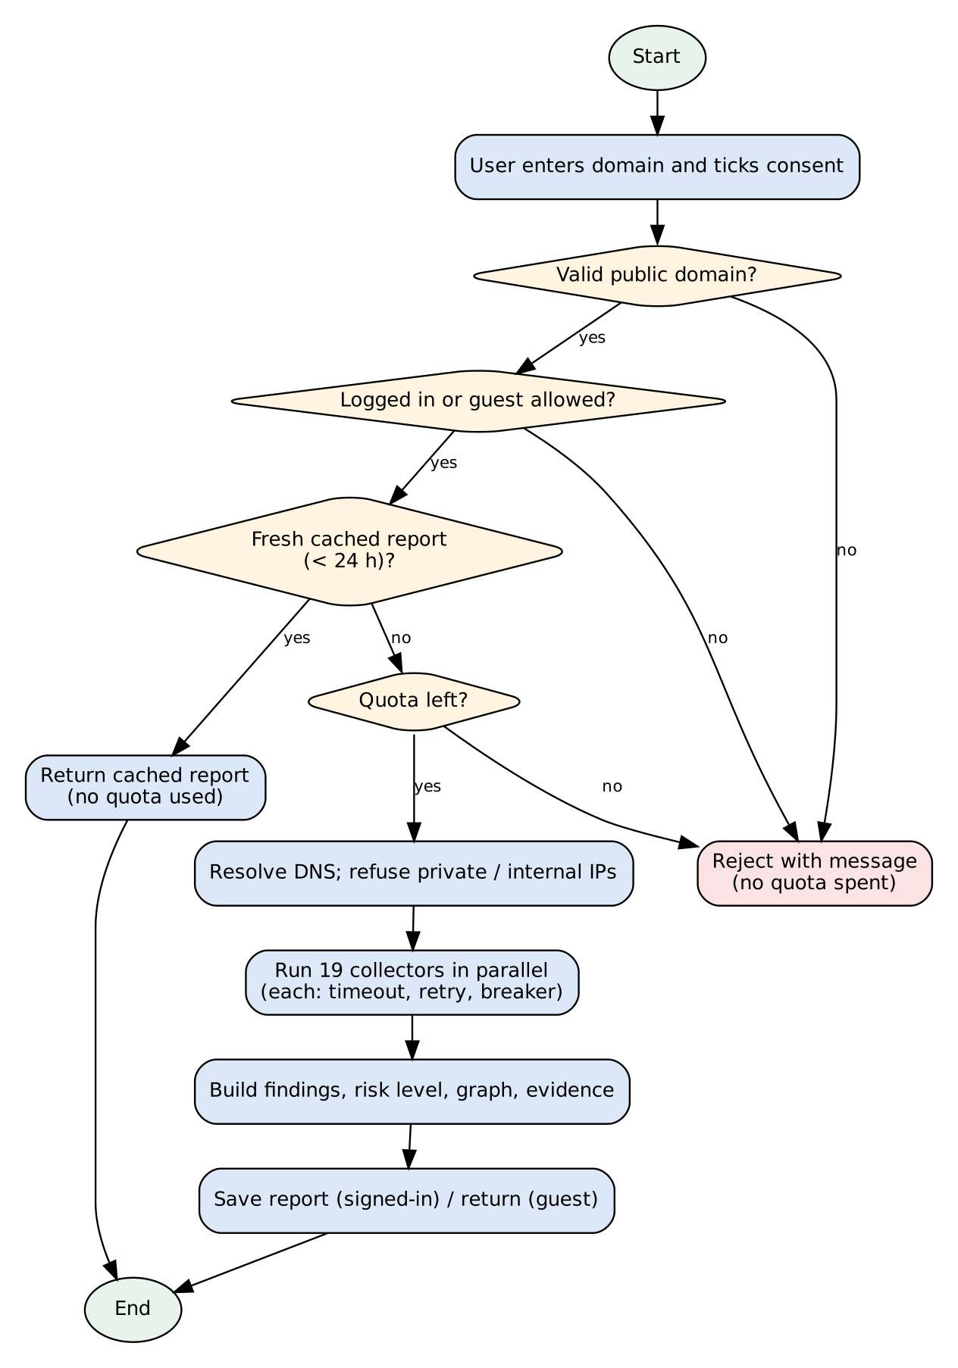
Figure 3.7: Flowchart of the domain scan request
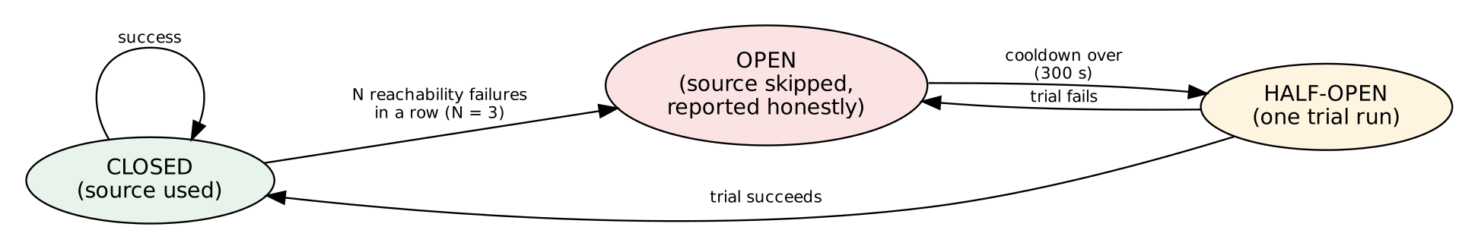
Figure 3.8: State diagram of the circuit breaker for third-party sources

3.8 API Design
The server exposes a JSON REST API. All state-changing requests must come from the same origin. Routes marked "account" need a session; routes marked "any" also accept a guest when guest mode is on.
Table 3.5: List of API routes
Method | Route | Access | Purpose
GET | /api/health | public | Health check
GET | /api/session | public | Session type (guest or user) and quota
POST | /api/auth/register | public | Create an account and start a session
POST | /api/auth/login | public | Log in
POST | /api/auth/logout | public | Destroy the session
GET | /api/auth/me | account | Current user and quota
POST | /api/account/profile | account | Change the display name
POST | /api/account/password | account | Change password (other sessions are signed out)
POST | /api/account/delete | account | Delete the account and all its data
POST | /api/recon | any | Run a domain scan and return the report
POST | /api/recon/stream | any | Run a scan with live progress events
POST | /api/jobs | account | Queue a background scan
GET | /api/jobs, /api/jobs/:id | account | List jobs / read one job
POST | /api/jobs/:id/cancel | account | Cancel a job
GET | /api/reports, /api/reports/:id | account | List / open saved reports
DELETE | /api/reports/:id | account | Delete a saved report
POST | /api/export/:fmt | any | Export as DOCX, PDF, JSON or HTML
POST | /api/ipscan | any | IP lookup
POST | /api/company-lookup | account | Company name to official domain
GET | /api/dashboard | account | Statistics, latest findings, source health
GET | /api/findings | account | Stored findings with filters and paging
GET | /api/sources, /api/engines | account | Source health and optional tool status
GET | /api/audit | account | Own audit log entries

Example request and response (abridged):
POST /api/recon
{ "domain": "example.com", "consent": true }

200 OK
{ "investigationId": "INV-3F9A1C07BE", "domain": "example.com",
"risk": { "level": "Medium", "findings": [ { "id": "F-001", "sev": "medium",
"verification": "VERIFIED", "msg": "No DMARC record", ... } ] },
"dns": {...}, "subdomainStatus": [...], "evidence": [...], "graph": {...} }

Chapter 4: Implementation, Testing and Output
This chapter presents the implementation structure of the system, the key security and logic code, the method of testing, the test results, and the output of the running software.

4.1 Implementation
The back end is written in Node.js. The entry point server.js registers the security layer and the routes; the folder lib/ holds one file per data source or function; views/ and public/ hold the browser pages; tests/ holds the automated tests. The system starts with npm start and listens on 127.0.0.1:5100 by default. The database file is created automatically in the data/ folder.
Table 4.1: Project structure and purpose of the main files
File / folder | Lines | Purpose
server.js | 198 | Express app, security headers, auth and report routes, guest gate, quota check
lib/recon.js | 125 | Orchestrator: validation, DNS, SSRF guard, 18 parallel collectors, report assembly
lib/riskModule.js | 46 | Findings, severity, confidence and overall risk level
lib/classification.js, disagreements.js | 33 | Six-status rule; WHOIS versus RDAP disagreement check
lib/auth.js | 86 | scrypt hashing, sessions, login throttle, report storage, account deletion
lib/safeHttp.js | 25 | Connection-time SSRF guard and redirect guard for Axios
lib/breaker.js, jobs.js, limiter.js | 110 | Circuit breaker, background job queue, quota and cache
lib/*Module.js (data sources) | about 1,000 | WHOIS, RDAP, DNS, subdomains, website, security, IP, wayback, threat, dorks, etc.
lib/reportModel.js, reportExport.js | 140 | Report model and DOCX / PDF / JSON / HTML export
views/app.html, home.html, public/*.html | 1,106 | Single-page application, public home page, login, privacy and terms pages
tests/, scripts/selfcheck.js | 674 | 14 automated test files, offline network mock, live self-check script

The following parts of the real source code show how the main safety and reliability rules were implemented.
(a) SSRF guard: the function isPrivateIp (in lib/recon.js) marks loopback, private, link-local and reserved addresses. It is used on the DNS answer of the target before the scan, and again at connection time inside lib/safeHttp.js.
function isPrivateIp(ip) {
if (net.isIPv4(ip)) {
const [a, b] = ip.split(".").map(Number);
return a === 0 || a === 10 || a === 127 || a >= 224 ||
(a === 169 && b === 254) || (a === 172 && b >= 16 && b <= 31) ||
(a === 192 && b === 168) || (a === 100 && b >= 64 && b <= 127);
}
const l = ip.toLowerCase();
return l === "::1" || l === "::" || l.startsWith("fc") || l.startsWith("fd") ||
l.startsWith("fe80") || l.startsWith("::ffff:");
}

(b) Password hashing: passwords are never stored in clear text. The scrypt function of the Node.js crypto module is used with a random 16-byte salt, and verification uses a constant-time comparison [10].
async function hashPassword(pw) {
const salt = crypto.randomBytes(16), h = await scrypt(pw, salt, 64, OPT);
return `scrypt$${OPT.N}$${OPT.r}$${OPT.p}$${salt.toString("base64")}$${h.toString("base64")}`;
}
// verifyPassword(): recompute with the stored parameters, then
// crypto.timingSafeEqual(got, want)

(c) Honest status rule: the function classify in lib/classification.js turns the outcome of a collector into one of the six labels. A source that could not be reached is never reported as NOT FOUND, and only the system's own checks can be VERIFIED.
function classify(e) {
const s = String((e && e.status) || "");
if (/^(failed|blocked)/i.test(s)) return UNREACHABLE.test(s) ? "SOURCE UNAVAILABLE" : "FAILED";
if (/^not run/i.test(s)) return "FAILED";
if (/no data/i.test(s)) return "NOT FOUND";
if (/partial|some (commands|sources)/i.test(s)) return "PARTIAL";
if (/^ok/i.test(s)) return DIRECT.has(e.module) ? "VERIFIED" : "UNVERIFIED";
return "UNVERIFIED";
}

(d) Circuit breaker: a third-party source that fails repeatedly is skipped for a cooldown instead of being called again and again. Only reachability errors count; a 404 for one domain says nothing about the source.
const isOpen = (k, now = Date.now()) => {
const s = cur(k); return s.fails >= N() && s.openUntil > now; };
const failure = (k, now = Date.now()) => {
const s = cur(k); s.fails++;
if (s.fails >= N()) s.openUntil = now + COOL(); S.set(k, s); };

Other protections are built in the same way: all SQL statements use ? parameters, the interface escapes user-controlled text before it is inserted into the page, external tools are started with execFile and an argument array (no shell), and the output of external tools is treated as untrusted text from which only on-target host names and e-mails are kept.
Table 4.2: Source size of the system
Component | Files | Physical lines | Characters (bytes)
Back end (server.js, cli.js, lib/) | 40 | 1,788 | 155,355
Front end (views/, public/) | 5 | 1,106 | 137,402
Tests and self-check | 17 | 674 | 76,911

4.2 Method of Testing
The project contains 68 automated tests in 14 files, run with the built-in Node.js test runner (npm test) [11]. Because the system depends on the internet, the tests use a deterministic offline network mock (tests/helpers/netmock.js) that replaces DNS, TLS, WHOIS and HTTP calls with fixed test data. External tools are tested with fake executables. The tests run on a temporary database so that real data is not touched. The following kinds of testing were used:
- Unit testing: single functions such as normalizeDomain, isPrivateIp, typosquat variants, the classification rule and the risk summary.
- Integration testing: a full scan through the real HTTP server, followed by saved report, dashboard, export and ownership checks.
- Security testing: SSRF variants, unauthorized access (401), cross-user access, login throttling, hostile page titles (XSS) and unsafe values passed to external tools.
- Behavioural testing: cancel in the middle of a scan, queue order of jobs, server restart, circuit-breaker cooldown and quota refund.
- Black-box approach: the result is decided only by comparing the input with the expected output [12].
In addition, scripted browser runs (Playwright) checked the interface at 320, 375, 414, 768, 1024, 1440 and 1920 px for horizontal overflow, and a stored smoke test (tests/browser/smoke.js) covers ten tabs and an XSS check.

4.3 Test Cases and Results
Table 4.3 shows how the 68 tests are distributed over the test files. Table 4.4 lists selected test cases from these files. In the last recorded run all 68 tests passed [13].
Table 4.3: Distribution of the automated tests
Test file | Tests | Area
unit.test.js | 15 | Validation, SSRF helpers, risk, dorks, graph, export, limiter, history
api.test.js | 7 | Full scan, ownership, findings, execution timeline, evidence, dashboard
auth.test.js | 7 | Hashing, register, login, throttle, password change, report storage
external.test.js | 8 | Subfinder, Amass, theHarvester, SpiderFoot, Recon-ng adapters, input safety
guest.test.js | 5 | Guest session, quota, export, ALLOW_GUEST and GUEST_EXPORT switches
engine.test.js | 4 | Built-in fallback engine and its rules
jobs.test.js | 4 | Queue order, cancel and refund, ownership, restart
safehttp.test.js | 4 | Reserved suffixes, connection-time guard, redirect guard
classification, disagreements, scanlog | 9 | Status rule, WHOIS versus RDAP, dashboard counts
breaker, breaker.server, cancel | 5 | Circuit breaker unit and server tests; cancel and refresh
Total | 68 | All passed in the recorded run

Table 4.4: Selected test cases and results
ID | Module | Test case | Expected result | Result
T01 | Validation | Scheme, port, path and case in the input domain | Normalised to a plain lower-case domain | Pass
T02 | SSRF | localhost.localdomain, decimal/hex IP, 169.254.169.254, [::1], 10.x, 192.168.x | Rejected with an error | Pass
T03 | SSRF | Name that resolves to loopback at connection time | Connection refused (EBLOCKED) | Pass
T04 | SSRF | Redirect to an internal IP literal | Redirect aborted; public hosts pass | Pass
T05 | Consent | Scan request without consent | 400 error, nothing started | Pass
T06 | Auth | Wrong password versus unknown e-mail | Same message; repeated failures throttled | Pass
T07 | Auth | Password hashing | Right password verifies, wrong fails, no plain text stored | Pass
T08 | Auth | Password change; account delete | Other sessions signed out; data deleted by cascade | Pass
T09 | Reports | Save, list, open, delete; 30-report cap | Round trip works; oldest removed above 30 | Pass
T10 | Isolation | User B opens User A's report or dashboard | Not found / no data of A | Pass
T11 | Report ids | Invalid or traversal-style report id | 400 or 404 | Pass
T12 | Classification | Failed or empty module | Never VERIFIED | Pass
T13 | Classification | Check that never ran | FAILED, not NOT FOUND | Pass
T14 | Disagreement | Different registrar and expiry in WHOIS and RDAP | Both shown, labelled CONTRADICTED | Pass
T15 | Risk | Unverified Shodan-style finding | Cannot make the level High | Pass
T16 | Breaker | Source fails N times, then cooldown | Skipped, reported, one trial after cooldown | Pass
T17 | Breaker | 404 or parse error; target-facing collectors | Not counted / never guarded | Pass
T18 | Cancel | Disconnect in the middle of a scan | Nothing saved; quota not refunded; counted as cancelled | Pass
T19 | Cache | Repeat scan with and without refresh:true | Cache served free / fresh scan | Pass
T20 | Quota | Guest makes a third scan | 429 after the limit of 2; cache hits free | Pass
T21 | Guest | Guest opens private routes | 401; nothing reaches any account | Pass
T22 | Jobs | Three queued jobs | Run in order, save normal reports | Pass
T23 | Jobs | Cancel a waiting job and a running job | Waiting: quota back; running: not | Pass
T24 | Jobs | Server restart with active jobs | Marked interrupted | Pass
T25 | External | Tool output with off-target names; missing binary | Only on-target names kept; missing tool reported | Pass
T26 | External | Unsafe domain or environment value | Never reaches a process; default used | Pass
T27 | Engine | Search-engine block in a tool result | Detected; built-in engine takes over | Pass
T28 | Dashboard | Empty account; cached scans; two users | Zeros not invented numbers; counted once; isolated | Pass
T29 | Export | Word and PDF export | Valid files with methodology and summary | Pass
T30 | Interface | Hostile title / JSON-LD / og tags | No script executed; no overflow at 320 px | Pass

4.4 Test Evaluation
All 68 automated tests passed in the recorded run, and the scripted browser checks reported no overflow and no script execution. One real weakness was found and corrected during testing: reserved suffixes such as .localdomain were first accepted as public names and were then added to the blocked list.
It is important to state what the tests do not prove. The test environment had no internet connection, so every scan used the offline mock. The following items were therefore not verified:
- the live sources (crt.sh, Shodan InternetDB, Wayback, OpenPhish, CertSpotter, HackerTarget, urlscan.io) and the real format of their current answers;
- the real external tools (Subfinder, Amass, theHarvester, SpiderFoot, Recon-ng); only fake binaries were used;
- the better-sqlite3 driver path (only node:sqlite was exercised), rate-limit enforcement under heavy load, cookie flags in production, and hosting behind a real proxy;
- the persistence of the SQLite file on free hosting with ephemeral disks.
The repository provides a script, npm run selfcheck, which checks every live source and runs a full server test when internet is available. Running it on a connected machine is the correct next step before real use.

4.5 Output
This section shows the pages of the running application. The pages were rendered from the real HTML files of the project in a headless browser. The figures show the public home page, the login page, the scan page in guest mode and the same page on a mobile screen.
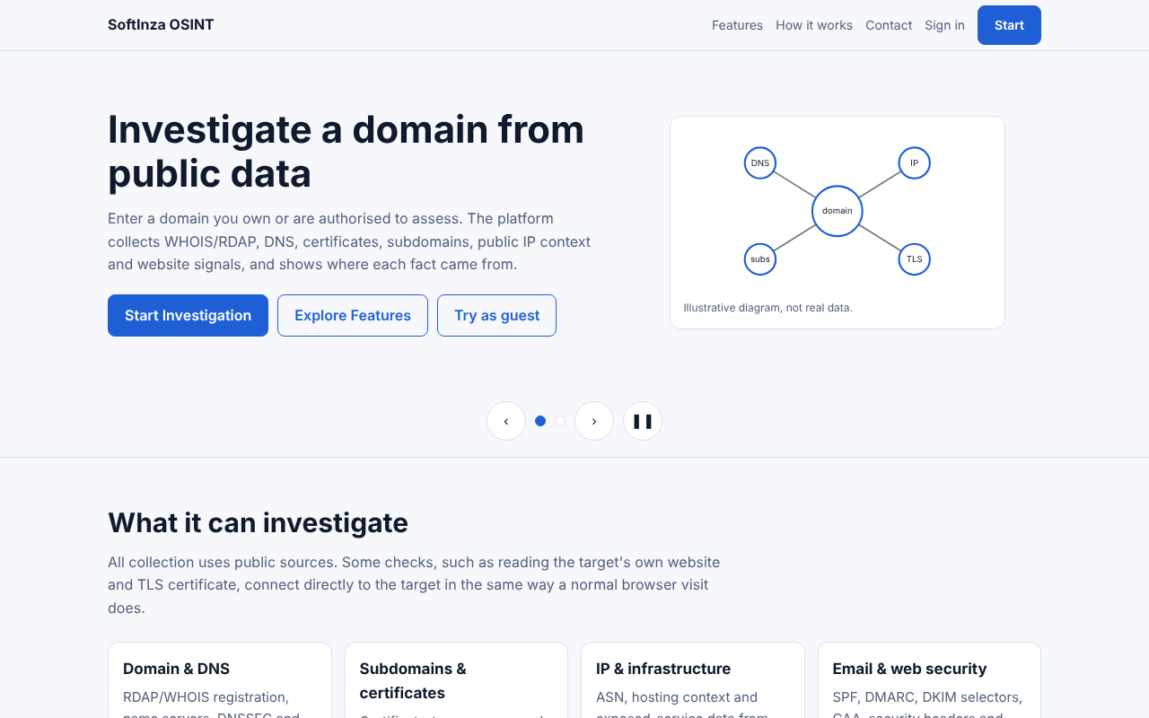
Figure 4.1: Public home page of the OSINT Aggregator
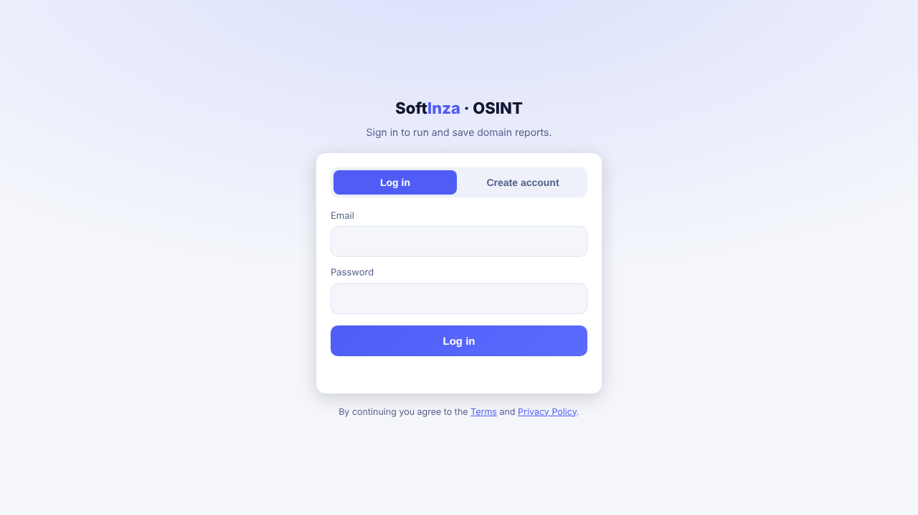
Figure 4.2: Login and registration page
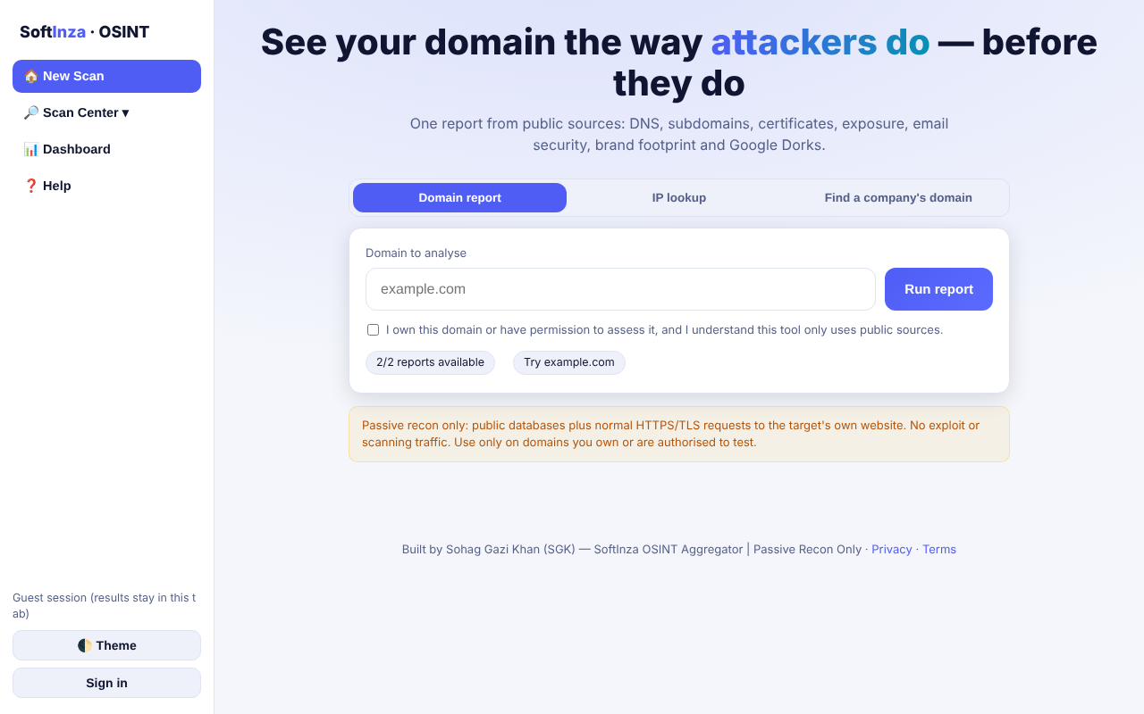
Figure 4.3: Scan page in guest mode: domain input, consent checkbox and remaining quota
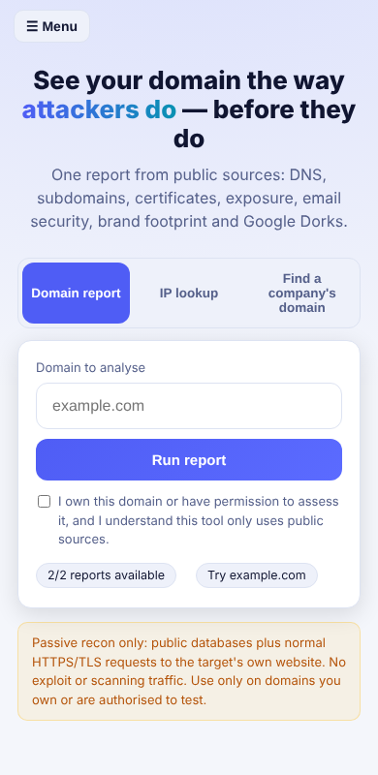
Figure 4.4: Responsive design on a mobile screen (390 px)
After a scan the application shows the screens described in Table 4.5.
Table 4.5: Screens of the application
Screen | What it shows
New Scan | Domain report, IP lookup and company finder tabs; consent box; remaining quota; progress of every collector.
Report summary | Overall risk level, summary cards, 14 module tiles with Loading / OK / Warning / Unavailable status, prioritized findings with fixes.
Scan Workspace | Ten tabs: Domain, Subdomains, Email & FQDN, Social, Historical, Search & Dorks, Relationship Graph, Google Dorking, Threat and Reports; interactive graph with pan, zoom, search and SVG/PNG download.
Dashboard | Scan counts, severity totals, verified findings, latest findings, module usage, source health, failed tasks, activity log and background jobs.
My Reports | Last 30 saved reports with open and delete.
Account and Settings | Name, password change, account deletion, theme and saved preferences.
Help | Explanation of statuses, dorks and the legal notice.

Screenshots of the report, workspace and dashboard screens require real scan data and should be taken by running the application on a computer with internet access (see Chapter 6).

Chapter 5: Maintenance and Pricing
This chapter estimates the effort, time and cost of the project using the COCOMO model, and discusses the maintenance plan and maintenance cost.

5.1 Estimation using the COCOMO Model
Because the project is small, uses familiar technology and was built by a single developer, the Organic mode of the Basic COCOMO model was used [14]. The constants of this mode are a = 2.4, b = 1.05, c = 2.5 and d = 0.38.
Determining the size (KLOC): the back end (server.js, cli.js and lib/) has 1,788 lines and 155,355 characters, an average of 86.89 characters per line. The front end has 1,106 lines but 137,402 characters, because its lines are very long. As in the reference method, the front end was converted to the density of the back end: 137,402 ÷ 86.89 ≈ 1,581 lines. The total size is 1,788 + 1,581 ≈ 3,369 lines, i.e. 3.369 KLOC. Test code was not counted.
Table 5.1: COCOMO (Organic) calculation
Quantity | Formula | Result
Size (KLOC) | (1,788 + 137,402 ÷ 86.89) ÷ 1000 | 3.369
Effort (E) | 2.4 × (KLOC)^1.05 | ≈ 8.59 person-months
Development time (D) | 2.5 × (E)^0.38 | ≈ 5.66 months
Average staff | E ÷ D | ≈ 1.52 persons

5.2 Estimated Cost
The monthly labor cost is assumed to be 15,000 BDT for a junior developer. Hosting and other costs are assumptions and may differ in practice. A small virtual server with a persistent disk is assumed, because free hosting with a temporary disk can erase the database.
Table 5.2: Estimated cost breakdown
Item | Description | Unit cost (BDT) | Total (BDT)
Development (effort) | 8.59 person-months | 15,000 | 128,893
Hardware | Existing computer is used | 0 | 0
Software / tools | Node.js, Express, SQLite, VS Code (open source) | 0 | 0
Data sources | Free public sources, no API key | 0 | 0
Server hosting (1 year) | Small VPS with persistent disk (assumption) | 12,000 | 12,000
Domain name (1 year) | Assumption | 1,500 | 1,500
Other | Internet, documentation, printing (assumption) | 5,000 | 5,000
Grand total |  |  | 147,393

Sensitivity analysis: if the work takes 20% more than estimated, the effort becomes 10.31 person-months, the development cost about 154,672 BDT and the grand total about 173,172 BDT. The figures are an academic estimate for the size of the code; in practice the real effort of a student project is spread over a longer time at a lower intensity.

5.3 Cost-Benefit Analysis
- Direct benefits: no license fee for commercial reconnaissance tools, a complete report in about one minute instead of hours of manual work, and repeated scans without extra effort.
- Indirect benefits: change tracking between scans, honest labels that reduce wrong decisions, and a fix suggestion attached to every finding, which helps small organizations that have no security team.
- Educational value: the project demonstrates passive reconnaissance, secure web development, testing without a network, and responsible disclosure of limits.
Compared with the one-time development cost and the yearly running cost, the benefit is larger in the long run for an institution or a small company that checks its own domains regularly.

5.4 Maintenance
After the software goes live, four types of maintenance are needed [6]:
Table 5.3: Maintenance plan
Type | Activity | Example in this project
Corrective | Fix defects found in use | A parser breaks on a new answer format of a source
Adaptive | Adjust to a changing environment | A free API changes URL, limits or terms; Node.js release update
Perfective | Add or improve features | ASN range lookup, PDF history diff, more report languages
Preventive | Reduce future problems | Update dependencies, run npm audit, backup of data/, run npm run selfcheck

Because the system depends on many free third-party services, adaptive maintenance is the most frequent. The circuit breaker and the SOURCE UNAVAILABLE label limit the damage of a broken source, and the selfcheck script shows quickly which source needs attention.

5.5 Maintenance Cost
Yearly maintenance is assumed at about 15% of the development cost (19,334 BDT) for updates and bug fixes, plus 12,000 BDT for hosting renewal, giving about 31,334 BDT per year. The domain renewal is included in the hosting assumption.

Chapter 6: Conclusion
This chapter lists the limitations of the current system, the possible future work and the final conclusion.

6.1 Limitations
- Not yet verified on the live internet: all recorded tests used an offline mock. The live sources and the real external tools must be checked with npm run selfcheck and real scans before production use.
- Dependence on free third-party services: a source may change its format, limit its use, or disappear. Some data (for example Shodan InternetDB) can be old and is therefore marked UNVERIFIED.
- Persistence: SQLite on a host with an ephemeral disk loses users and reports on restart. Job queues and circuit-breaker state are in memory and do not survive a restart (jobs are marked interrupted).
- Rate limit by IP: an attacker who rotates IP addresses can still use the guest quota. Behind a proxy the setting TRUST_PROXY=1 is required.
- Coverage: the system is domain-oriented. It does not search Google, does not collect person-level data, and its Google Dork module only builds links.
- Reporting: the DOCX report has no watermark and no graph picture; the PDF uses standard Latin-1 fonts, so non-Latin text is shown only in the Word file.
- Single administrator model: there is no separate administrator role or organization-level management.

6.2 Future Work
- Run the live self-check, fix any parser differences, and store real screenshots and sample reports.
- Add ASN and IP-range expansion, scheduled re-scans with e-mail alerts, and historical WHOIS/DNS diff charts.
- Move to a server database (for example PostgreSQL) and a shared queue for larger deployments.
- Add an administrator role, API keys for programmatic use, and optional two-factor login.
- Add more languages to the interface and the report (including Bengali) and a PDF font with full Unicode support.
- Add optional, clearly labelled paid or keyed sources for deeper coverage while keeping the free core.

6.3 Conclusion
The OSINT Aggregator shows that the first phase of a security assessment, public-source reconnaissance of a domain, can be automated safely and cheaply with a small open-source stack (Node.js, Express and SQLite). Its main contribution is not only the amount of data it gathers, but the way it treats the data: every result carries a source, a time and a confidence label, a failed source is reported as failed, and an unverified lead can never raise the overall risk level on its own.
Step-by-step development with the Incremental Model, a passive-only design, consent, SSRF protection, hashed passwords, quota and an audit log make the system suitable for authorized use. The 68 automated tests passed on an offline mock, and the COCOMO estimate shows that the project can be built at low cost. When the remaining verification on live sources is completed and the limitations are addressed, the system will be ready for real use. Overall, the project meets its academic goals and has real potential to help small organizations understand their public footprint before an attacker does.

References
[1] M. Bazzell, Open Source Intelligence Techniques: Resources for Searching and Analyzing Online Information. IntelTechniques, self-published.
[2] K. Scarfone, M. Souppaya, A. Cody and A. Orebaugh, "Technical Guide to Information Security Testing and Assessment," NIST Special Publication 800-115, Sep. 2008.
[3] OpenJS Foundation, "Express: Fast, unopinionated, minimalist web framework for Node.js." [Online]. Available: https://expressjs.com/
[4] SQLite Consortium, "SQLite Documentation." [Online]. Available: https://www.sqlite.org/docs.html
[5] "IEEE Recommended Practice for Software Requirements Specifications," IEEE Std 830-1998, 1998.
[6] I. Sommerville, Software Engineering, 10th ed. Boston, MA, USA: Pearson, 2016.
[7] R. S. Pressman and B. R. Maxim, Software Engineering: A Practitioner's Approach, 9th ed. New York, NY, USA: McGraw-Hill Education, 2020.
[8] B. W. Boehm, "A spiral model of software development and enhancement," Computer, vol. 21, no. 5, pp. 61-72, May 1988.
[9] P. P. Chen, "The entity-relationship model: Toward a unified view of data," ACM Trans. Database Syst., vol. 1, no. 1, pp. 9-36, Mar. 1976.
[10] C. Percival and S. Josefsson, "The scrypt Password-Based Key Derivation Function," RFC 7914, Aug. 2016.
[11] OpenJS Foundation, "Node.js Documentation: Test runner." [Online]. Available: https://nodejs.org/api/test.html
[12] G. J. Myers, C. Sandler and T. Badgett, The Art of Software Testing, 3rd ed. Hoboken, NJ, USA: Wiley, 2011.
[13] Project repository, "TEST-REPORT.md" and "tests/" folder, OSINT Aggregator v3.1.2, 2026.
[14] B. W. Boehm, Software Engineering Economics. Englewood Cliffs, NJ, USA: Prentice-Hall, 1981.
[15] OWASP Foundation, "Server-Side Request Forgery Prevention Cheat Sheet." [Online]. Available: https://cheatsheetseries.owasp.org/
[16] S. Kitterman, "Sender Policy Framework (SPF)," RFC 7208, Apr. 2014; M. Kucherawy and E. Zwicky, "DMARC," RFC 7489, Mar. 2015.
[17] E. Foudil and Y. Shafranovich, "A File Format to Aid in Security Vulnerability Disclosure," RFC 9116, Apr. 2022.
[18] CISA, "Known Exploited Vulnerabilities Catalog." [Online]. Available: https://www.cisa.gov/known-exploited-vulnerabilities-catalog
[19] RIPE NCC, "RIPEstat Data API." [Online]. Available: https://stat.ripe.net/docs/data_api
[20] B. Laurie, A. Langley and E. Kasper, "Certificate Transparency," RFC 6962, Jun. 2013.

