
Institute of Science Trade and Technology (ISTT)
Department of Computer Science & Engineering
Mirpur-13, Dhaka
Project Report
Software Engineering Lab
Course Code: 530220
Library Management System
A Web-Based Library Management System using Flask and SQLite
Submitted By | Submitted To
Name:  Semester: 6th  Class ID: 108  NU Registration No:  Session: | Shekh Tanjil Sharif  Lecturer, Department of Computer Science & Engineering  Institute of Science Trade and Technology, Mirpur-13, Dhaka  Signature & Date

Acknowledgement
I would like to express my sincere gratitude to everyone who helped me complete this project.
First of all, I am deeply grateful to my supervisor, Shekh Tanjil Sharif, Lecturer, Department of Computer Science & Engineering, Institute of Science Trade and Technology (ISTT). His guidance, valuable suggestions and encouragement made this work possible.
I am also thankful to all the teachers, lab assistants and staff of the department for their cooperation throughout the project.
I would also like to thank the open-source developers of Flask, SQLite and the Python community, whose free tools form the foundation of this system. Finally, I am grateful to my family and friends for their patience and support.

Abstract
The Library Management System is a web-based software application that digitizes and automates the management of books, members, book issue and return, and late-fine calculation for a school, college or small library. The system consists of a REST API built with the Python Flask framework, a SQLite database, and a Single Page Application front end written in HTML, CSS and JavaScript. The system supports two types of users: the Librarian (Admin) and the Student. The librarian can add, edit and delete books and members, issue and receive books, and view statistics on a dashboard. A student can log in using his or her Student ID, browse the book list, and see personal issued books, due dates and fines. The loan period is 14 days, and a fine of 5 BDT per late day is calculated automatically. This report presents the requirement analysis, selection of the SDLC model, system diagrams, database design, implementation, testing, cost estimation using the COCOMO model, a maintenance plan, and the limitations and future work of the system. All 25 automated test cases executed against the system passed successfully.

Keywords: Library Management System, Flask, SQLite, REST API, Role-Based Access, Fine Calculation, Incremental Model, COCOMO.
Table of Contents
Acknowledgement i
Abstract ii
Chapter 1: Introduction 1
1.1 Project Background 1
1.2 Problem Statement 1
1.3 Objectives 2
1.4 Scope of the Project 2
1.5 Report Organization 2
Chapter 2: Requirement Analysis and SDLC 4
2.1 Existing and Proposed System 4
2.2 Feasibility Study 4
2.3 Functional Requirements 6
2.4 Non-Functional Requirements 7
2.5 Project Requirement Specification 7
2.6 SDLC Model and Justification 8
2.7 Risk Analysis 10
Chapter 3: System Design 11
3.1 System Architecture 11
3.2 Context Diagram 11
3.3 Data Flow Diagram 12
3.4 Use Case Diagram 13
3.5 ER Diagram 14
3.6 Database Tables 14
3.7 Business Rules and Flowchart 16
3.8 API Design 17
Chapter 4: Implementation, Testing and Output 19
4.1 Implementation 19
4.2 Method of Testing 20
4.3 Test Cases and Results 20
4.4 Test Evaluation 22
4.5 Output 22
Chapter 5: Maintenance and Pricing 26
5.1 Estimation using the COCOMO Model 26
5.2 Estimated Cost 26
5.3 Cost-Benefit Analysis 27
5.4 Maintenance 27
5.5 Maintenance Cost 28
Chapter 6: Conclusion 29
6.1 Limitations 29
6.2 Future Work 29
6.3 Conclusion 30
References 31

Chapter 1: Introduction
This chapter describes the background of the project, the problem statement, the main and supporting objectives, and the scope of the work.

1.1 Project Background
A library is the center of learning in every educational institution. However, in many institutions the list of books, member information and the records of lending and returning books are still maintained in notebooks or Excel files. As a result, finding out who holds a particular book takes time, due dates are forgotten, and mistakes can occur in fine calculation. Students also have to visit the librarian just to know which books are issued in their name or how much fine they owe.
The Library Management System was developed to solve these problems. It runs in a web browser and does not need any expensive software or server. Because the back end uses the Flask framework [1] and the database is SQLite [2], the entire system can run on an ordinary computer.

1.2 Problem Statement
The manual method of running a library mainly suffers from the following problems:
- Instant information about how many copies of a book exist and how many are issued is not available.
- Fines for late returns are calculated by hand, which leaves room for errors and disputes.
- Students cannot see their own issued books and fines by themselves.
- The same data may be written several times or entered incorrectly in the book and member lists.
- Preparing weekly or monthly statistics (books issued, books overdue) is time-consuming.

1.3 Objectives
Main Objective
To develop a secure, easy-to-use and low-cost web-based Library Management System that automates the management of books, members, issue and return, and fines in a library.

Supporting Objectives
- Secure role-based access: To provide separate logins for the librarian and the student, with hashed passwords and Role-Based Access Control.
- Book and member management: To allow adding, editing and deleting books and members, together with search and filter facilities.
- Automated issue, return and fine handling: To verify copy availability, set a 14-day due date, and automatically calculate a fine of 5 BDT for every late day.
- Informative dashboard and student portal: To give the librarian statistics and an overdue list, and to let each student view his or her own books and fines.

1.4 Scope of the Project
In Scope
- Login and logout of the librarian and the student, with session management.
- CRUD (Create, Read, Update, Delete) operations for books and members; a student account is created automatically when a member is added.
- Book issue, return, due date and fine calculation.
- A dashboard (statistics, charts, overdue list), CSV export of books, Dark/Light theme and a responsive, mobile-friendly design.
Out of Scope
- Online payment gateway, e-books or reading PDF books online.
- E-mail or SMS notifications, barcode/QR scanners.
- Multiple branches or management of multiple librarian accounts.

1.5 Report Organization
Chapter 2 presents the requirements and the SDLC, Chapter 3 the system design and diagrams, Chapter 4 the implementation, testing and output, Chapter 5 maintenance and pricing, and Chapter 6 the limitations, future work and conclusion. References are given at the end in IEEE style.

Chapter 2: Requirement Analysis
This chapter compares the existing and proposed systems, studies feasibility, lists the functional and non-functional requirements and the hardware and software needs, justifies the choice of the SDLC model, and analyzes the risks. The idea of the IEEE 830 guideline was followed while specifying the requirements [8].

2.1 Existing and Proposed System
Existing system: At present many institutions keep the list of books and issue records in a notebook or an Excel file. There is no automatic validation, so the same book may be issued twice, dates may be wrong, and fines may be miscalculated.
Proposed system: The proposed Library Management System keeps all data in one central database, applies the business rules (copy check, 14-day loan period, fine) on the server, and lets students view their own information.
Table 2.1: Comparison of the existing and proposed systems
Aspect | Existing (notebook/Excel) | Proposed system
Book availability | Must be counted or searched manually | Automatic, from copies and issued count
Fine | Calculated by hand; error-prone | Late days × 5 BDT, automatic
Search | Slow and manual | Instant by title/author and category
Student access | None | View own books and fine using Student ID
Reports | Prepared separately | Directly on the dashboard; CSV export
Data integrity | Risk of duplicate or wrong data | UNIQUE, CHECK and FOREIGN KEY constraints
Cost | Paper and time cost | Open-source tools, very low cost

2.2 Feasibility Study
2.2.1 Technical Feasibility
The system is built with Python, Flask and SQLite, all of which are free and widely used. SQLite ships with Python [3], so no separate database server has to be installed. The project has only one external dependency (flask), which is installed with the command pip install flask. Therefore the project is fully feasible technically.
2.2.2 Economic Feasibility
All development tools are open source, so the license cost is zero. The estimated development cost using the COCOMO model and other expenses are given in Chapter 5; the total is easily affordable for a small institution.
2.2.3 Operational Feasibility
The interface is simple and based on a sidebar menu, so a librarian with basic computer skills can use it. Students have only two menus (Books and My Books), so no separate training is needed.
2.2.4 Schedule Feasibility
According to COCOMO, the project can be completed in about 3.4 months (Chapter 5), which fits within the time frame of a semester project.

2.3 Functional Requirements
Table 2.2: Functional requirements
ID | User | Requirement
FR-01 | Admin / Student | Log in and log out with a username and password; access is denied for wrong credentials.
FR-02 | Admin | Add, edit and delete books (title, author, category, number of copies ≥ 1).
FR-03 | Admin | Add, edit and delete members (name, Student ID, phone); a student login is created automatically (username and password = Student ID).
FR-04 | Admin | Issue a book: choose the issue date, check that a copy is available, due date = issue date + 14 days.
FR-05 | Admin | Receive a returned book and calculate the fine (late days × 5 BDT).
FR-06 | Admin | View the dashboard: book titles, available copies, members, books issued now, overdue count, charts and the overdue list.
FR-07 | Admin / Student | Search books, filter by category, switch between Grid and Table view, and export to CSV.
FR-08 | Student | View personal issued books, due dates, status and fines on the My Books page.
FR-09 | Admin | Reload the demo data (Reset demo data).

2.4 Non-Functional Requirements
Table 2.3: Non-functional requirements
Category | Requirement | How it is achieved
Security | Passwords must not be stored as plain text; unauthorized access must be blocked | Werkzeug password hashing [4], sessions, @need(role) decorator (401/403)
Data integrity | Wrong or duplicate data must not be saved | UNIQUE, CHECK (copies ≥ 1), FOREIGN KEY, input validation
Performance | Instant response for normal operations | Local SQLite and a lightweight JSON API
Usability | Easy to learn in a short time | Sidebar menu, toast messages, confirmation dialogs
Portability | Runs on Windows, macOS and Linux | Python and a modern browser, responsive CSS [5]
Maintainability | Code is easy to read and change | Only two main files; organized routes and small functions

2.5 Project Requirement Specification
2.5.1 Hardware Requirements
Table 2.4: Hardware requirements
Component | Minimum | Recommended
Processor | Dual-core 2 GHz | Intel Core i3 or higher
RAM | 2 GB | 4 GB or more
Storage | 500 MB free space | 10 GB (including data and backups)
Display | 1024 × 768 | 1366 × 768 or higher

2.5.2 Software Requirements
Table 2.5: Software requirements
Component | Version | Purpose
Python | 3.9 or higher | Main programming language
Flask | 3.x (pip install flask) | Web framework and REST API
SQLite (sqlite3) | Built into Python | Database (library.db)
HTML, CSS, JavaScript | — | Front end (static/index.html)
Web browser | Modern Chrome / Edge / Firefox | Using the system
Operating system | Windows / macOS / Linux | Runtime environment

2.6 SDLC Model and Justification
The Incremental Model was selected for this project [6]. In this model the system is not built all at once; it is built in small increments, and in every increment requirement, design, coding and testing are carried out to obtain a working version. The increments of this project are shown in the figure below.
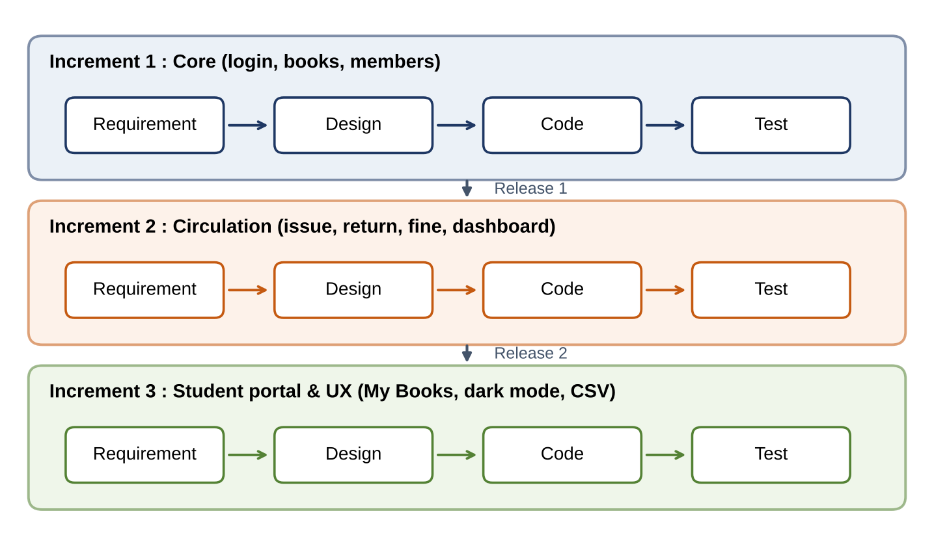
Figure 2.1: The three increments of the project under the Incremental Model
Justification for choosing the model
- Evidence of step-by-step development: The README of the project states that an older library.db from the previous version is upgraded automatically. The init_db() function in the code adds the role and member_id columns to an old users table. This shows that the system first started with a librarian login only and later grew by adding the student login, which is a characteristic of the incremental approach.
- Early working version: Book and member management can be released in the first increment, which gives an early usable result.
- Reduced risk: Each increment is tested separately, so defects are found early.
- Ease of change: New features (such as the student portal) can be added without breaking earlier work.
- Small team and clear requirements: For a small one-developer project, the rigid phases of Waterfall or the heavy risk analysis of Spiral would be unnecessary overhead.
Table 2.6: Comparison of SDLC models
Model | Characteristic | Suitability for this project
Waterfall | Phases are done once, one after another | Little room for change; not suitable
Incremental | Working versions released in small steps | Selected: ideal for adding features step by step
Spiral [9] | Repeated cycles with risk analysis | Meant for large, risky projects; excessive here
Agile (Scrum) | Team-based sprints | Full Scrum is not practical for a single developer

2.7 Risk Analysis
Table 2.7: Risk analysis
ID | Risk | Probability | Impact | Prevention and solution
R1 | Default password (admin123) is left unchanged | High | High | Change the password and secret key before deployment
R2 | The library.db file is damaged or lost | Medium | High | Regular file backup (Chapter 5)
R3 | Wrong or invalid input | High | Medium | Server-side validation and database constraints
R4 | SQLite becomes slow with many simultaneous users | Low | Medium | Move to PostgreSQL if needed
R5 | Schedule delay due to a single developer | Medium | Medium | Small increments and regular milestones

Chapter 3: System Design
This chapter discusses the system architecture, the Context Diagram, Data Flow Diagrams, the Use Case Diagram, the ER Diagram, the database tables and the API design. All diagrams were drawn from the actual source code.

3.1 System Architecture
The system follows a three-tier structure. The static/index.html file running in the browser provides the user interface and sends requests in JSON form to the /api/... routes of Flask using the fetch API [5]. The Flask application verifies login and role, applies the business rules, and reads and writes data in library.db through the sqlite3 module.
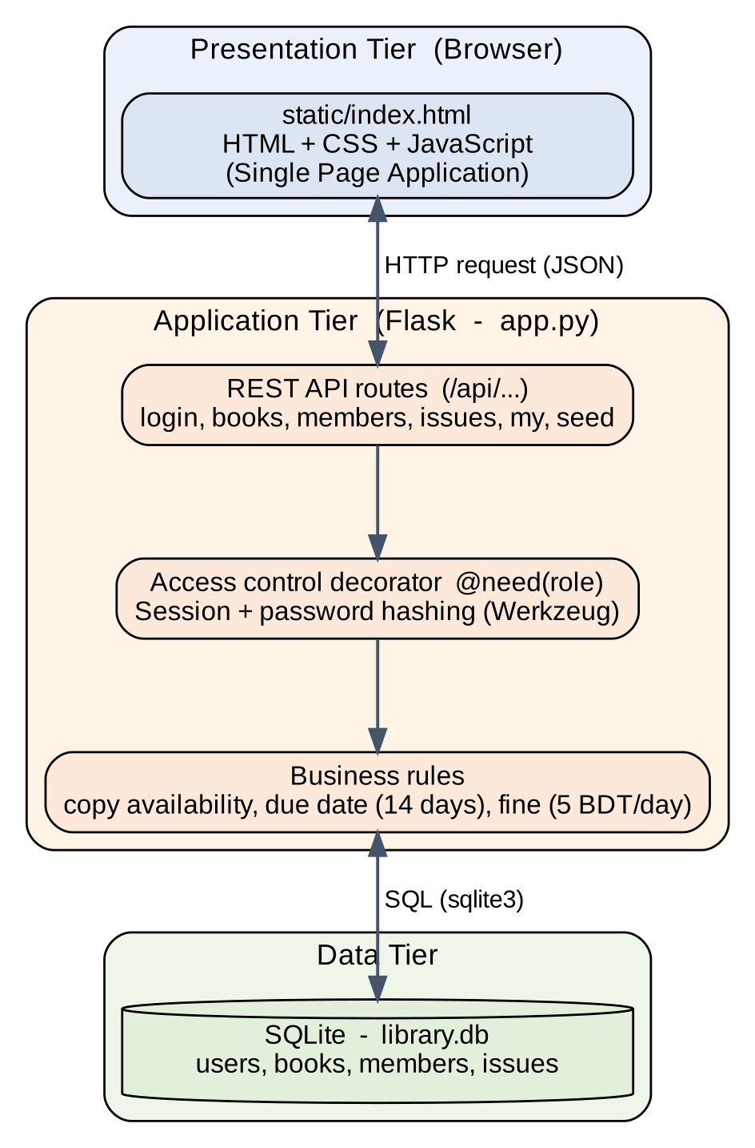
Figure 3.1: Three-tier architecture of the system

3.2 Context Diagram
The Context Diagram shows the whole system as a single process and shows the data exchanged with the two external entities, the Librarian and the Student.
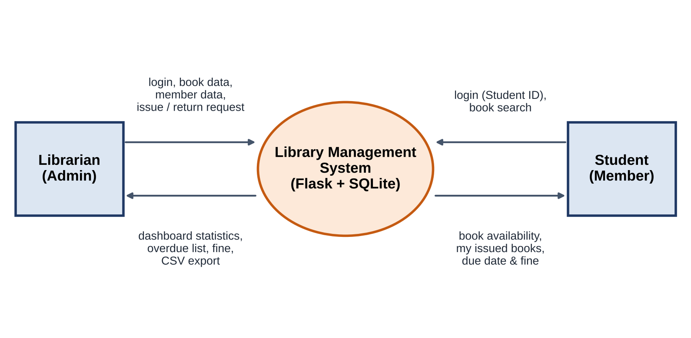
Figure 3.2: Context Diagram of the system

3.3 Data Flow Diagram
The Level-0 DFD shows the six main processes of the system and the four data stores (users, books, members, issues).
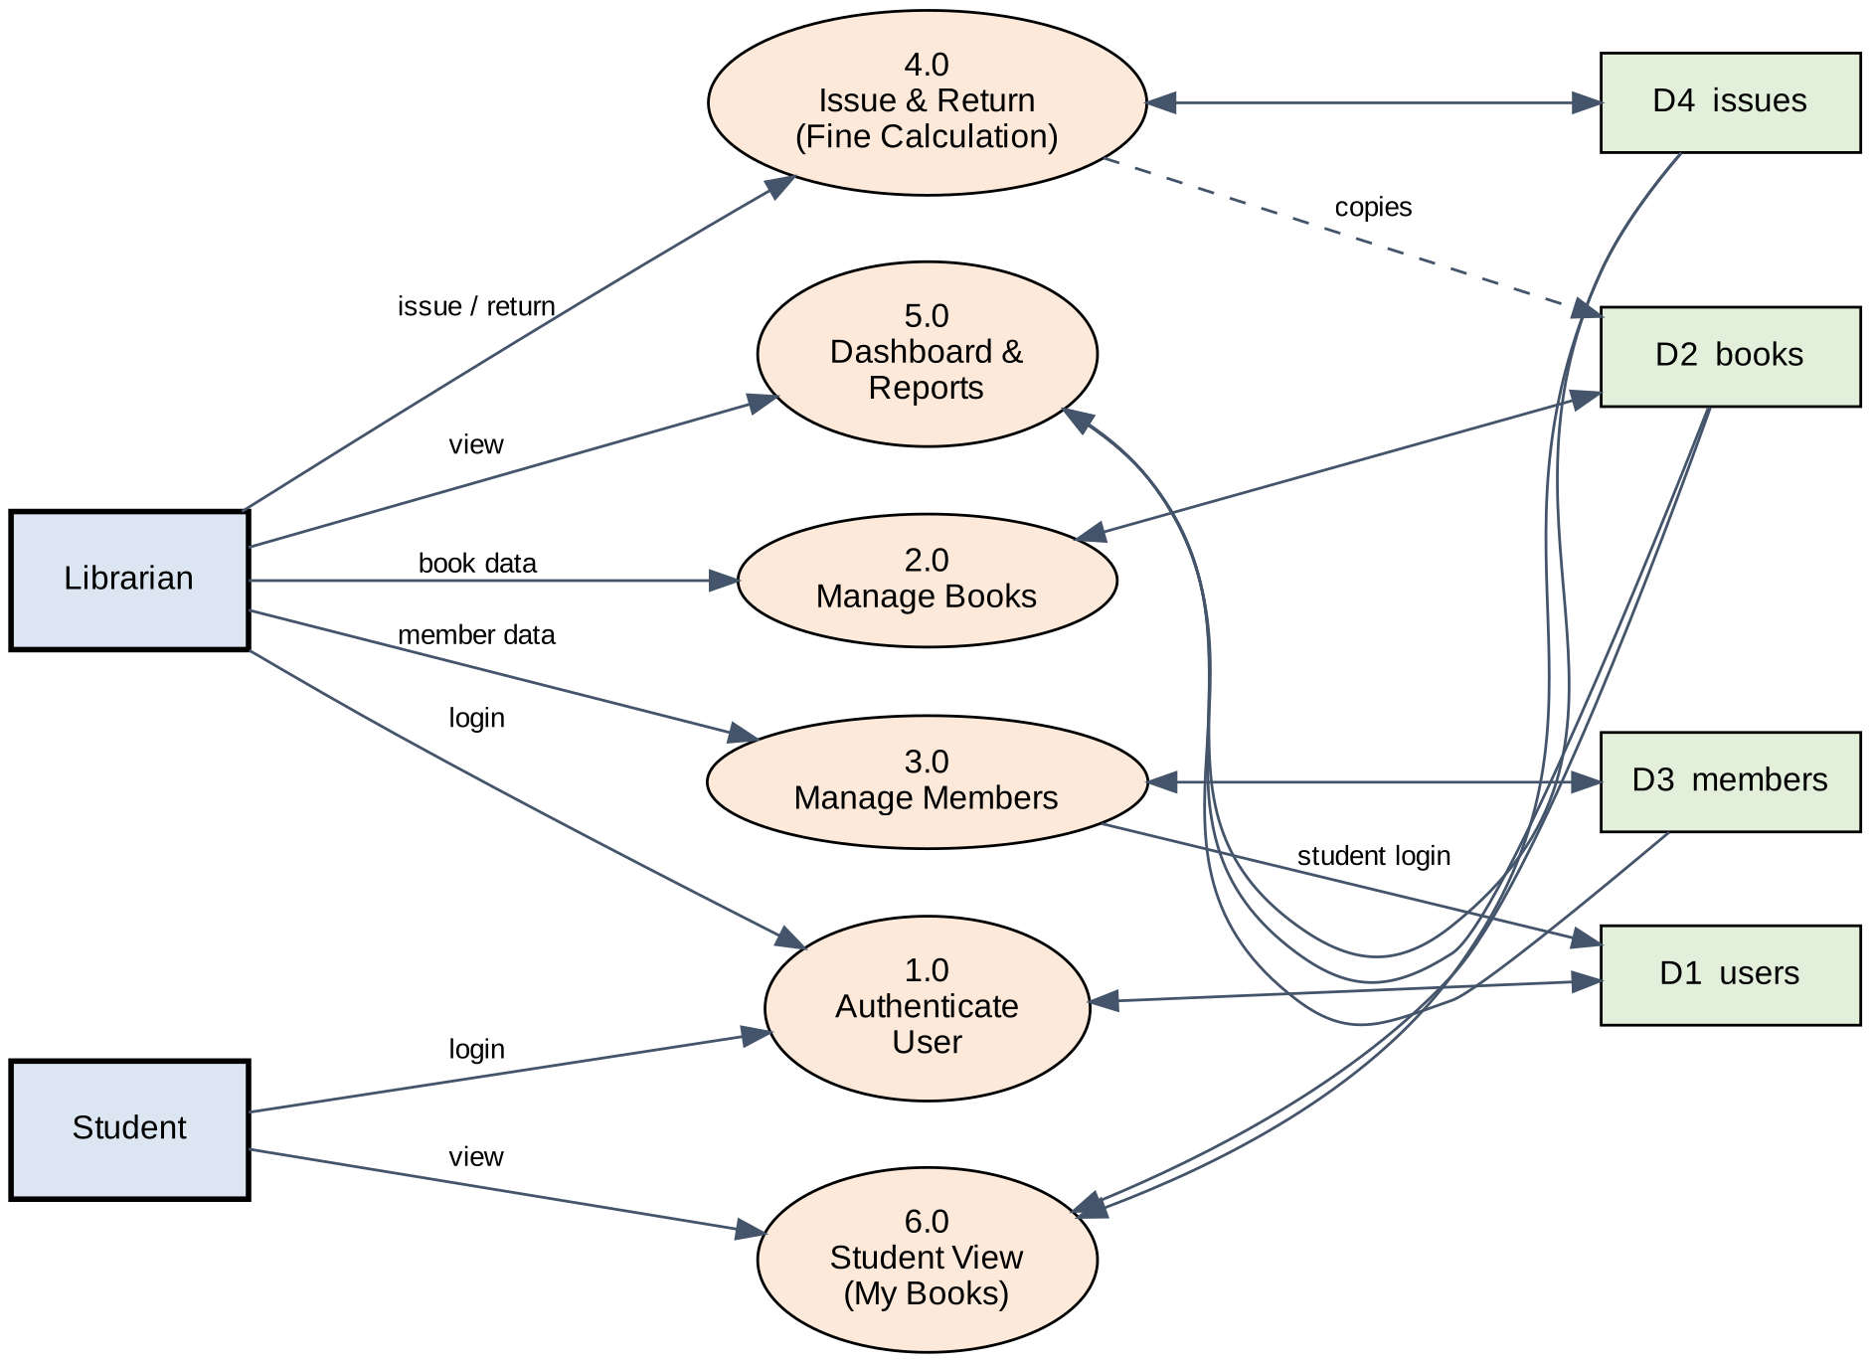
Figure 3.3: Level-0 Data Flow Diagram
The Level-1 DFD breaks down the most important process, 4.0 (Issue & Return), into five sub-processes: validating the issue request, checking copy availability, creating the issue record, validating the return, and calculating the fine.
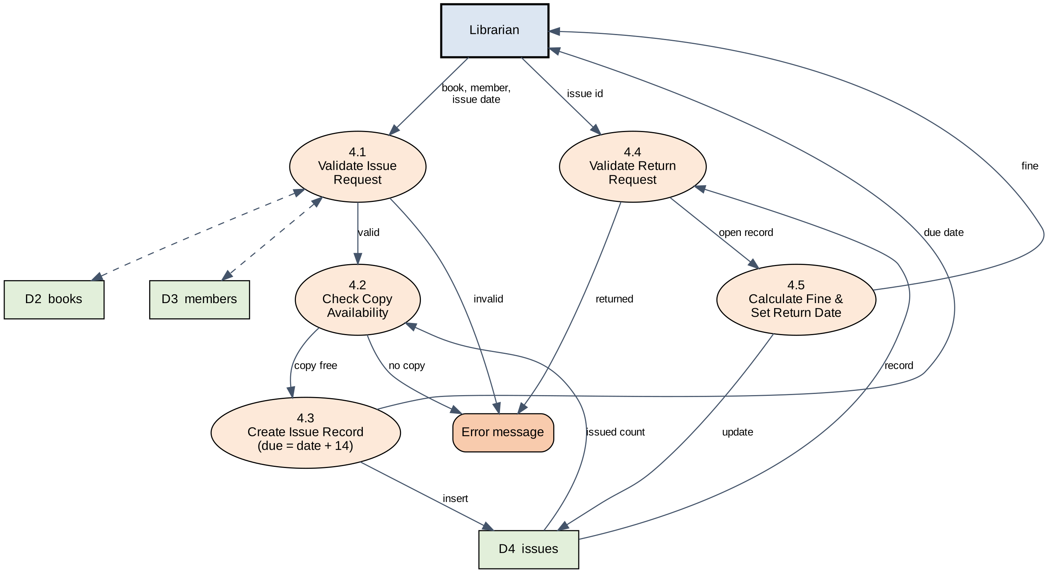
Figure 3.4: Level-1 Data Flow Diagram (Issue & Return process)

3.4 Use Case Diagram
The system has two actors. The Librarian can perform every task. The Student can log in, search books, export CSV, change the theme, and view only his or her own issued books and fines. Changing books or members, issue and return, and the dashboard are available only to the Librarian.
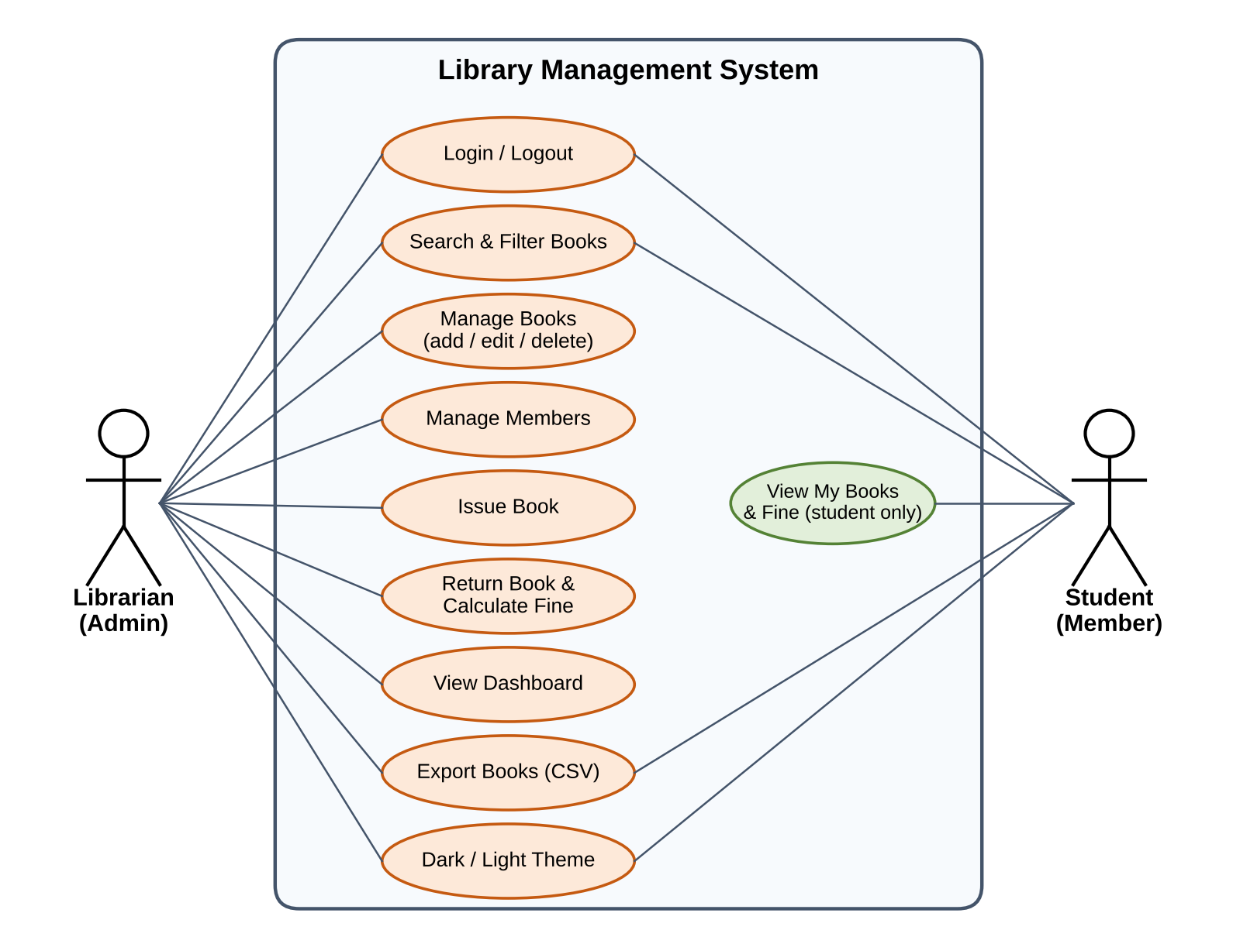
Figure 3.5: Use Case Diagram

3.5 ER Diagram
The ER Diagram [10] shows the entities of the database and their relationships. The relationship between BOOKS and MEMBERS is many-to-many (M:N), because a book can go to many members (at different times) and a member can borrow many books. This relationship is implemented through the ISSUES table, which stores the issue, due and return dates. Each MEMBER has at most one USERS account (1:1).
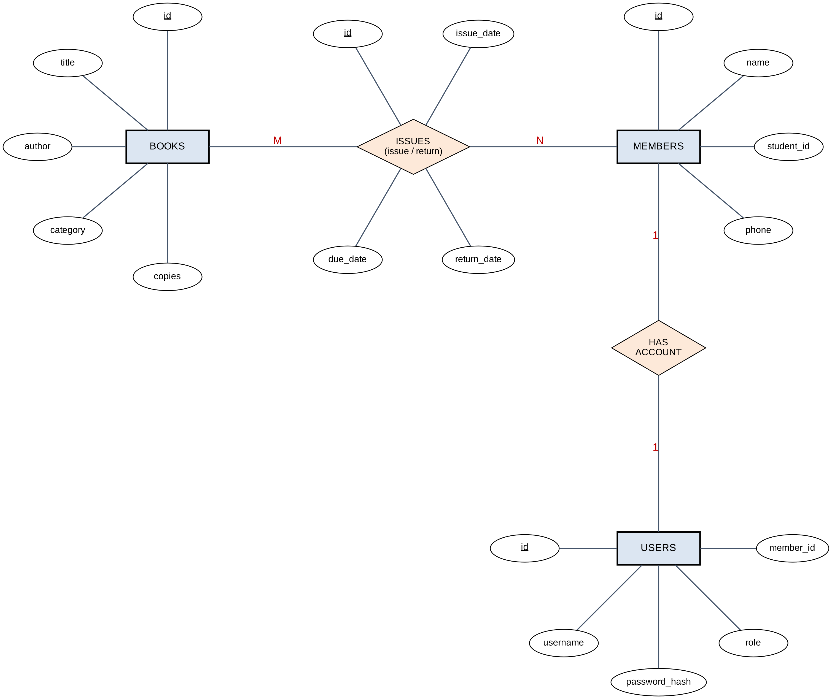
Figure 3.6: Entity-Relationship (ER) Diagram
3NF check: Every column holds a single value (1NF); every table has a single-column primary key, so there is no partial dependency (2NF); book data is stored only in books and member data only in members, while issues stores only their ids (foreign keys), so there is no transitive dependency (3NF).

3.6 Database Tables
The figure below shows the structure of the four tables and the foreign-key relationships. The data dictionary follows.
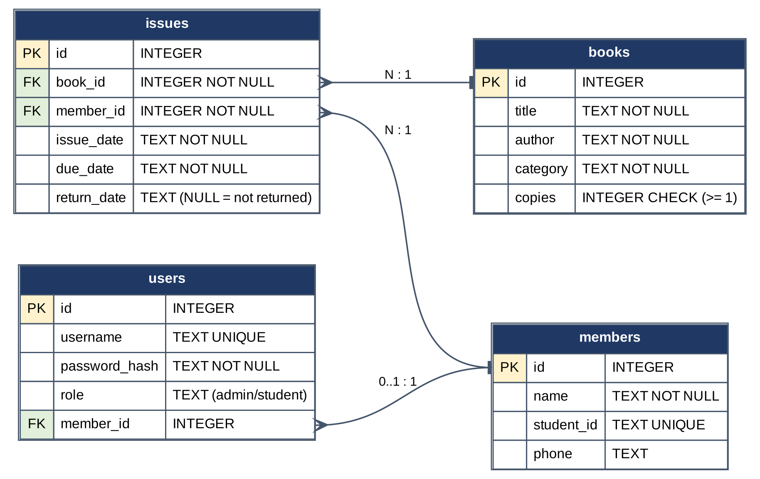
Figure 3.7: Relational schema (tables and relationships)
Table 3.1: Data dictionary: books and members
Table | Column | Description and constraint
books | id | Primary key
 | title, author | Title and author of the book (NOT NULL)
 | category | Category: Computer, Database, Software, Math, Other
 | copies | Total copies; CHECK (copies ≥ 1)
members | id | Primary key
 | name | Name of the member (NOT NULL)
 | student_id | Student ID (UNIQUE, NOT NULL)
 | phone | Phone number (optional)

Table 3.2: Data dictionary: users and issues
Table | Column | Description and constraint
users | id | Primary key
 | username | Login name (UNIQUE); the Student ID for students
 | password_hash | Hashed password (not plain text)
 | role | 'admin' or 'student' (default 'admin')
 | member_id | Foreign key → members.id (NULL for admin)
issues | id | Primary key
 | book_id, member_id | Foreign keys → books.id, members.id (NOT NULL)
 | issue_date, due_date | Issue date and last date for return (ISO format)
 | return_date | Return date; NULL means the book has not been returned yet

3.7 Business Rules and Flowchart
The complete issue and return process is shown in the flowchart below. The main rules are: (a) a book cannot be issued beyond its total copies, (b) due date = issue date + 14 days, and (c) fine = max(0, late days) × 5 BDT.
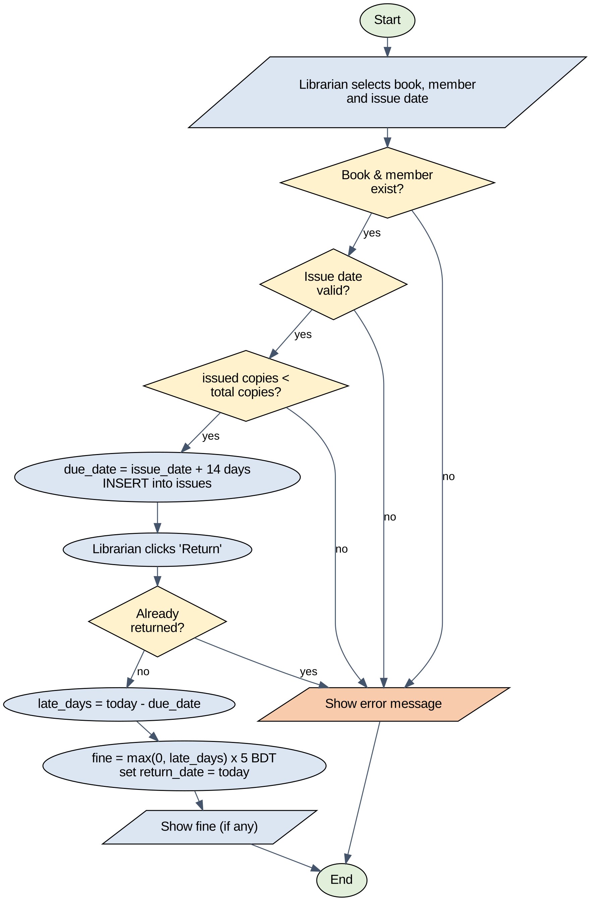
Figure 3.8: Flowchart of book issue and return

3.8 API Design
The front end and the back end communicate through a REST-style JSON API. The system has 17 routes in total; protected routes return 401 if the user is not logged in and 403 if the role is not permitted.
Table 3.3: List of API routes
Method | Route | Purpose | Access
GET | / | Front-end page | Everyone
POST | /api/login, /api/logout | Log in, log out | Everyone
GET | /api/me | Role of the current user | Logged in
GET | /api/my | Own issued books and fines | Logged in
GET | /api/books | List of books | Logged in
POST, PUT, DELETE | /api/books[/id] | Add, edit, delete a book | Admin
GET, POST | /api/members | List members, add a member | Admin
PUT, DELETE | /api/members/id | Edit, delete a member | Admin
GET, POST | /api/issues | List issues, issue a book | Admin
POST | /api/issues/id/return | Return a book and fine | Admin
POST | /api/seed | Load demo data | Admin

Chapter 4: Implementation, Testing and Output
This chapter presents the implementation structure of the system, the actual test cases and their results, and the output (screenshots) of the running software.

4.1 Implementation
The file structure of the project is very simple: app.py (289 lines) contains the back end and the database logic, static/index.html (157 lines) contains the whole front end, and requirements.txt lists only flask. To start the system, run py app.py; the library.db file is created automatically and the application is available at http://127.0.0.1:5000.
(a) Security and role checking: The need(role) decorator checks login and role on every protected route. Passwords are hashed with Werkzeug's generate_password_hash before being stored [4].
def need(role=None):
def deco(f):
@wraps(f)
def wrapper(*a, **k):
if not session.get("user"):
return err("Please log in", 401)
if role and session.get("role") != role:
return err("Not allowed ...", 403)
return f(*a, **k)
return wrapper
return deco

(b) Fine calculation: The number of late days is found by subtracting the due date from the return date (or from today's date if the book has not been returned), and it is multiplied by 5.
def fine_of(due, ret):
end = date.fromisoformat(ret) if ret else date.today()
return max(0, (end - date.fromisoformat(due)).days) * FINE

(c) Copy availability check: Before issuing, the copies that have not been returned are counted and compared with the total number of copies.
used = db().execute("SELECT COUNT(*) FROM issues WHERE "
"book_id=? AND return_date IS NULL",
(b["book_id"],)).fetchone()[0]
if used >= book["copies"]:
return err("No copy of this book is available")

All SQL queries use ? parameters, which reduces the risk of SQL injection, and the esc() function in the front end escapes special HTML characters in user-supplied text to prevent XSS.

4.2 Method of Testing
For testing, 25 automated test cases were written using Flask's built-in test_client. Every test was executed against a temporary database so that real data was not affected. The tests are of the following kinds:
- Unit/Functional testing: individual routes and business rules (for example fine calculation and validation).
- Integration testing: several modules working together (add member → student login → issue → return).
- Security/Authorization testing: access without login (401), a role that is not permitted (403), and password hash verification.
- Black-box approach: the result is decided only by comparing the input with the expected output [7].

4.3 Test Cases and Results
Of the 25 test cases listed below, 25 passed and none failed. In every case the actual result matched the expected result.
Table 4.1: Test cases and results
ID | Module | Test case | Expected result | Result
T01 | Authentication | Log in with correct admin credentials | HTTP 200 | Pass
T02 | Authentication | Log in with a wrong password | HTTP 401 | Pass
T03 | Authorization | Access the book list without logging in | HTTP 401 | Pass
T04 | Book | Add a new book with valid data | HTTP 201 | Pass
T05 | Book | Add a book with copies = 0 | HTTP 400 (validation) | Pass
T06 | Book | Add a book with an empty title | HTTP 400 (validation) | Pass
T07 | Member | Add a member; student account is created automatically | HTTP 201 | Pass
T08 | Authentication | Student logs in using the Student ID | HTTP 200 | Pass
T09 | Authorization | Student tries to add a book | HTTP 403 | Pass
T10 | Authorization | Student tries to view the member list | HTTP 403 | Pass
T11 | Member | Add a second member with a duplicate Student ID | HTTP 400 (duplicate) | Pass
T12 | Issue | Issue an available book (due = issue date + 14 days) | HTTP 201, due = issue date + 14 | Pass
T13 | Issue | Issue a book when all copies are already issued | HTTP 400 (no copy) | Pass
T14 | Issue | Issue with an invalid issue date | HTTP 400 | Pass
T15 | Issue | Issue a non-existent book | HTTP 404 | Pass
T16 | Book | Reduce copies to 0 while a copy is issued | HTTP 400 | Pass
T17 | Book | Delete a book that is currently issued | HTTP 400 | Pass
T18 | Member | Delete a member who still holds a book | HTTP 400 | Pass
T19 | Return | Return a book on time (no fine) | HTTP 200, fine = 0 | Pass
T20 | Return | Return the same book a second time | HTTP 400 | Pass
T21 | Fine | Issued 20 days ago, 6 days late, 6 × 5 BDT | fine = 30 BDT | Pass
T22 | Student View | Student sees own issue records and current fine | HTTP 200; fine = 30 on the open record | Pass
T23 | Authorization | Student tries to reset all data (seed) | HTTP 403 | Pass
T24 | Security | Password is stored as a hash, not plain text | 'admin123' is not stored directly | Pass
T25 | Authentication | Access a protected API after logout | HTTP 401 | Pass

4.4 Test Evaluation
The results show that login, role-based access control, copy checking, due date and fine calculation, and validation work as expected. For example, a book issued 20 days ago and returned today was 6 days late and produced exactly 30 BDT of fine (T21). Note that these tests verify the back-end API and database logic; the browser interface (buttons, dialogs) was checked manually as shown in the output section below. A large-scale user acceptance test (UAT) has not been carried out yet and is proposed as future work.

4.5 Output
Actual screenshots of the running software are shown below. The application loads 8 books and 4 members as demo data. In Figure 4.4 a new book (Computer Networks) is added, so the later screenshots show 9 books.
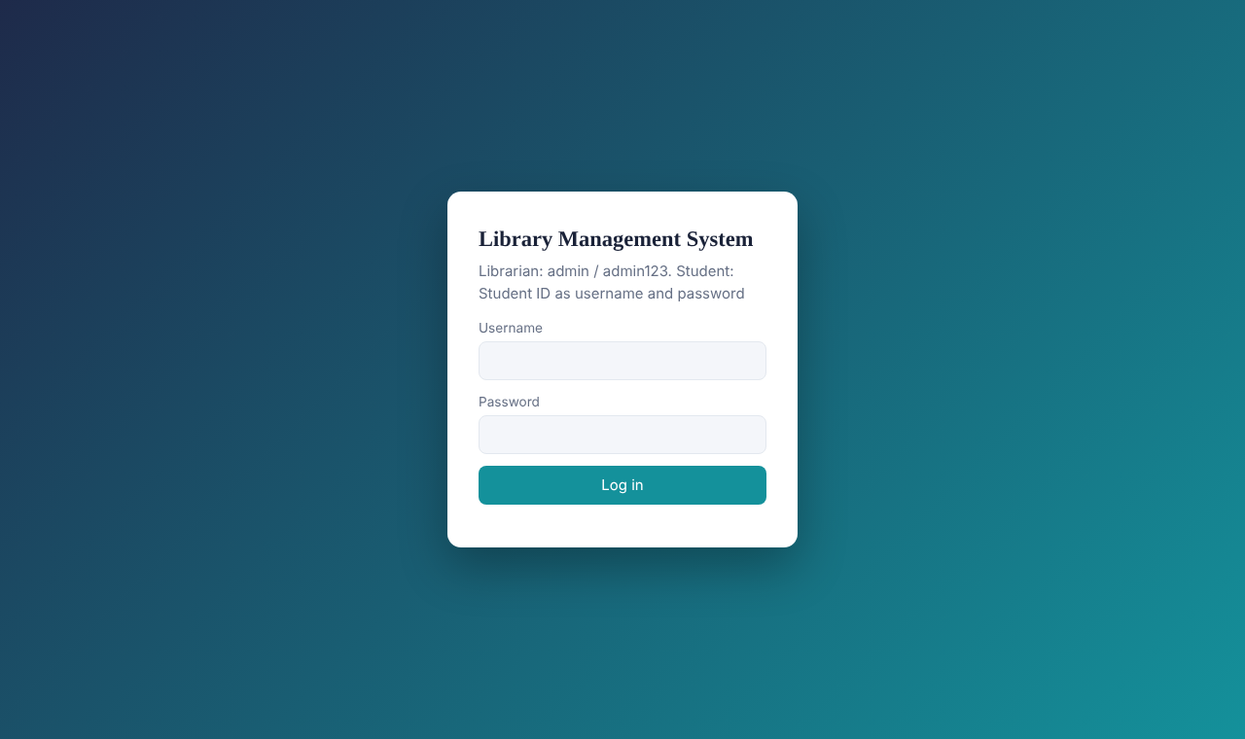
Figure 4.1: Login page (Librarian and Student log in from the same page)
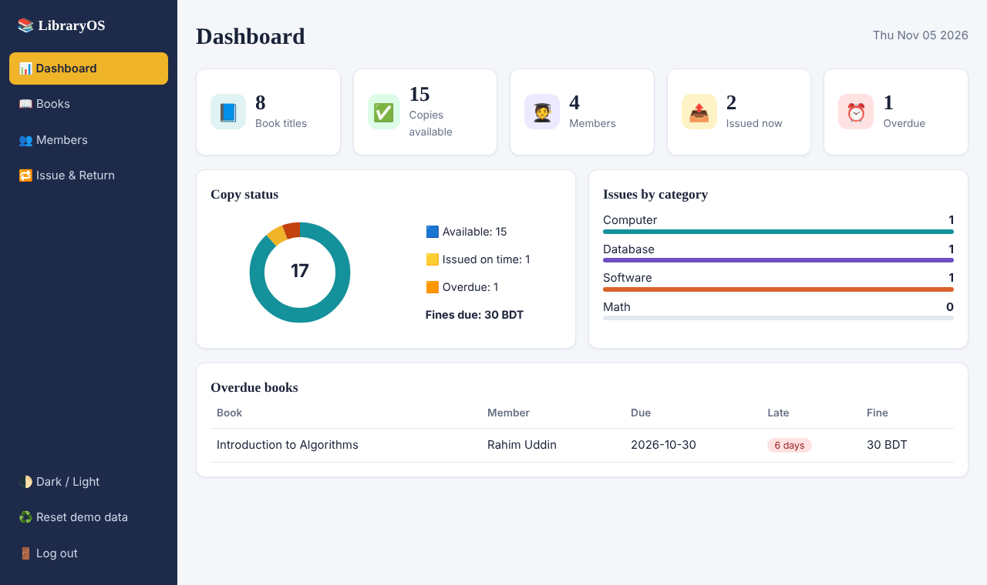
Figure 4.2: Librarian dashboard: statistics, copy status and overdue books
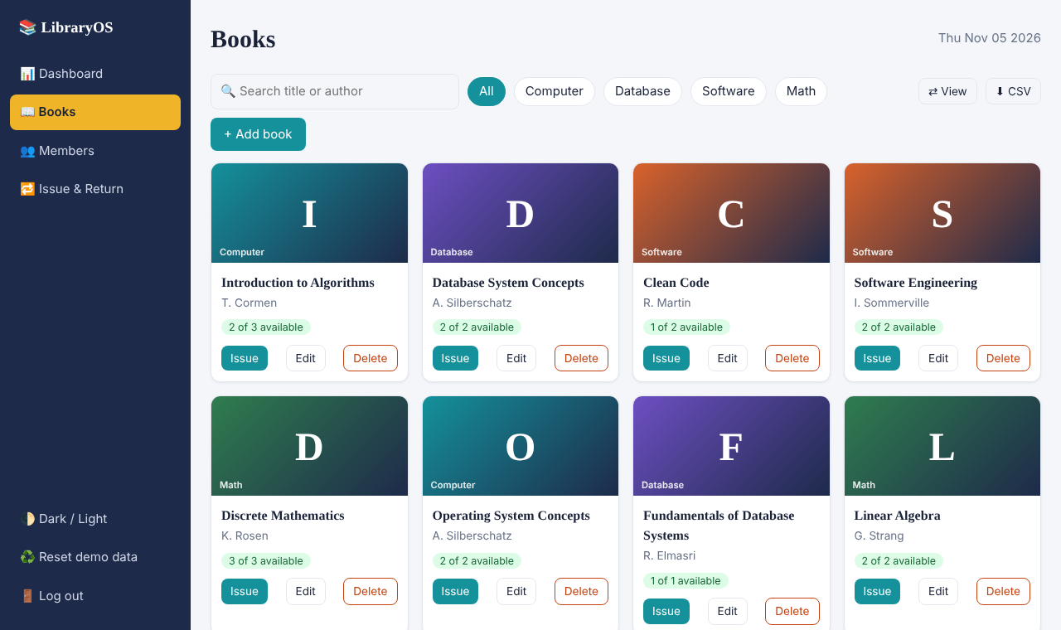
Figure 4.3: Books page (Grid view): search, category filter and availability
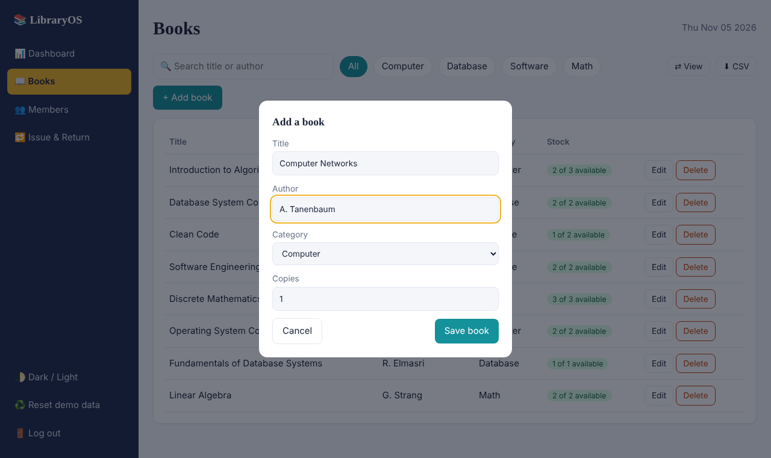
Figure 4.4: Dialog for adding a new book
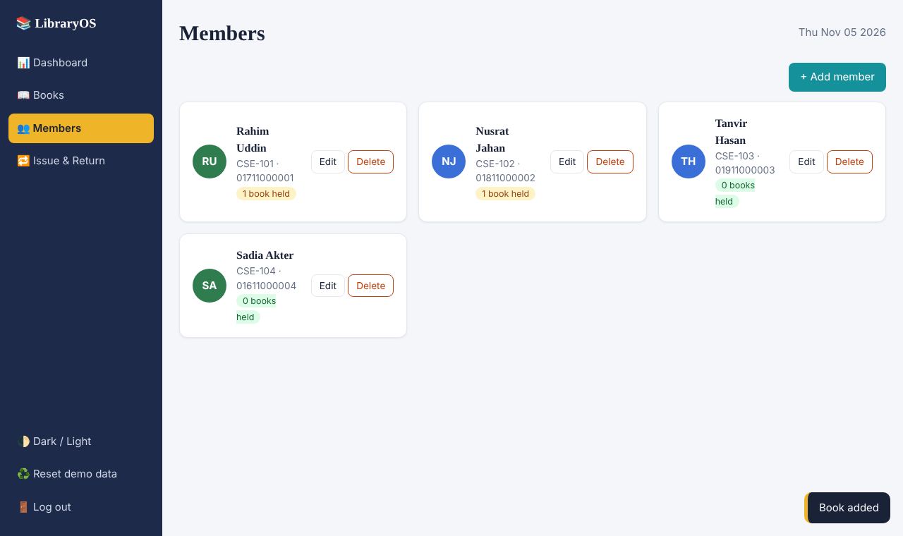
Figure 4.5: Members page: member list and books held by each member
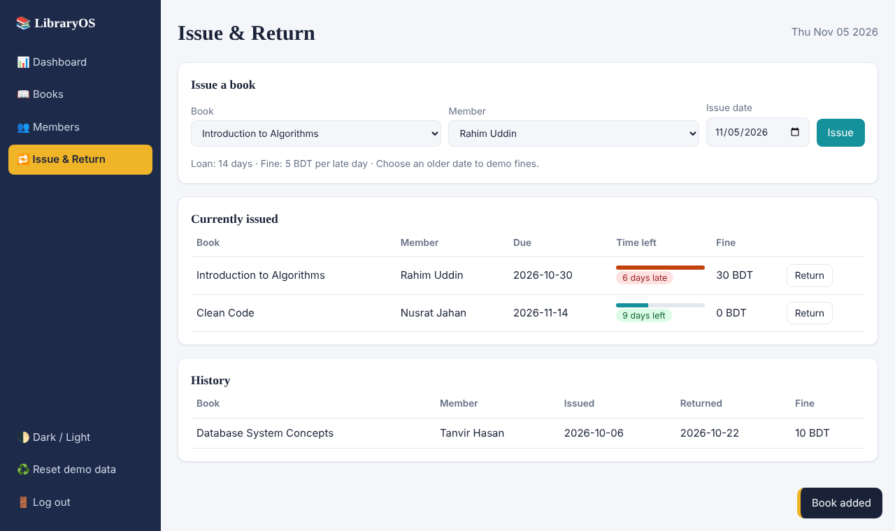
Figure 4.6: Issue & Return page: issue a book, current issues (with delay) and history
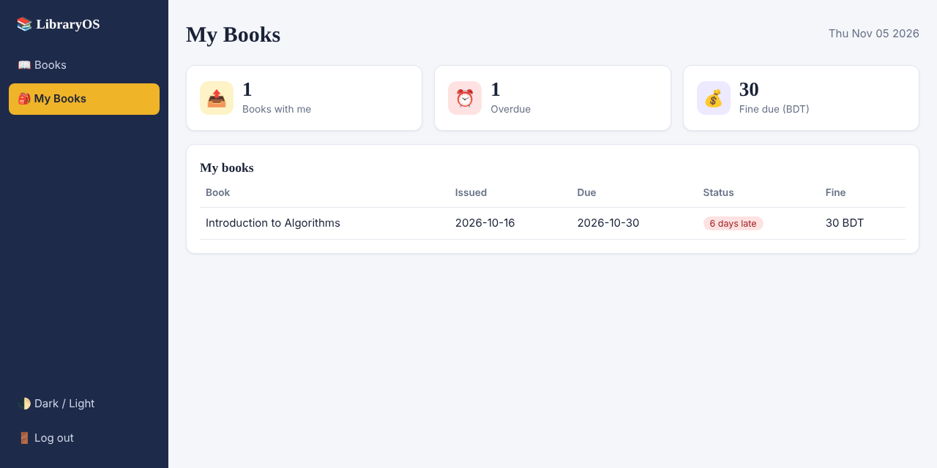
Figure 4.7: Student's My Books page: own books, due date and fine
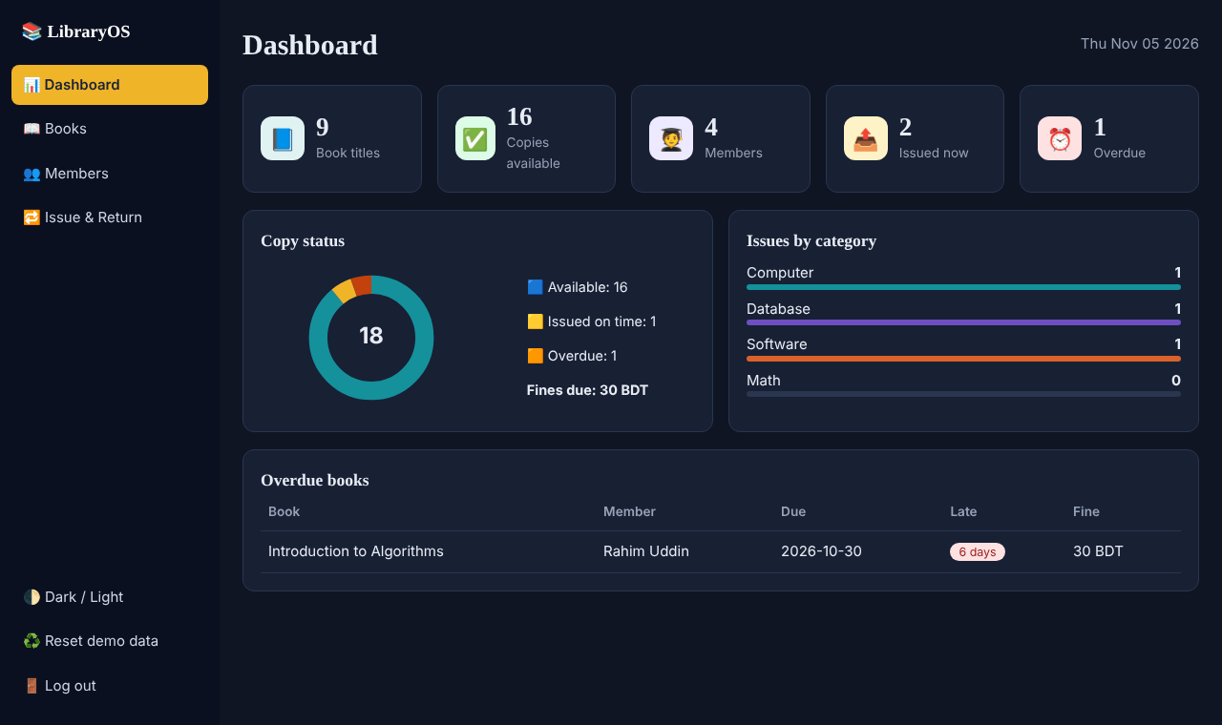
Figure 4.8: Dashboard in Dark theme
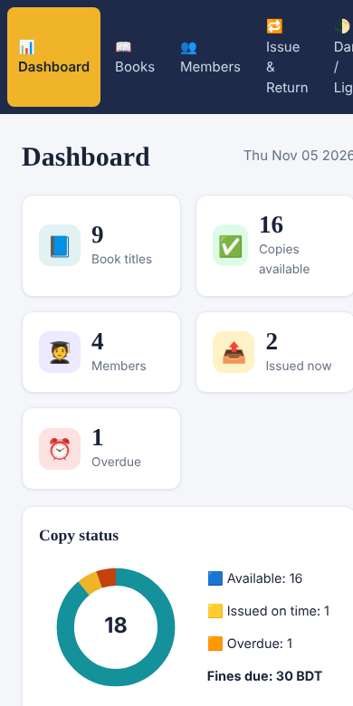
Figure 4.9: Responsive design on a mobile screen (390 px)

Chapter 5: Maintenance and Pricing
This chapter estimates the effort, time and cost of the project using the COCOMO model, and discusses the maintenance plan and maintenance cost.

5.1 Estimation using the COCOMO Model
Because the project is small, uses familiar technology and is built by a single developer, the Organic mode of the Basic COCOMO model was used [11]. The constants of this mode are a = 2.4, b = 1.05, c = 2.5 and d = 0.38.

Determining the size (KLOC): app.py and index.html together contain 446 lines (0.446 KLOC). However, the lines of index.html are very long (about 153 characters on average), whereas the average for app.py is 38 characters. For a fair estimate, index.html was converted to the same density as app.py: 24,058 ÷ 38.4 ≈ 627 lines. The total size is therefore 289 + 627 ≈ 916 lines, i.e. 0.916 KLOC.
Table 5.1: COCOMO (Organic) calculation
Quantity | Formula | Result
Size (KLOC) | (289 + 24,058 ÷ 38.4) ÷ 1000 | 0.916
Effort (E) | 2.4 × (KLOC)^1.05 | ≈ 2.19 person-months
Development time (D) | 2.5 × (E)^0.38 | ≈ 3.37 months
Average staff | E ÷ D | ≈ 0.65 persons

5.2 Estimated Cost
The monthly labor cost is assumed to be 15,000 BDT for a junior developer. Hosting and other costs are given as assumptions; in practice they may vary from one institution to another.
Table 5.2: Estimated cost breakdown
Item | Description | Unit cost (BDT) | Total (BDT)
Development (effort) | 2.19 person-months | 15,000 | 32,850
Hardware | Existing computer is used | 0 | 0
Software/tools | Python, Flask, SQLite, VS Code (open source) | 0 | 0
Hosting/domain (1 year) | Small cloud hosting (assumption) | 5,000 | 5,000
Other | Internet, documentation, printing (assumption) | 3,000 | 3,000
Grand total |  |  | 40,850

Sensitivity analysis: If the work takes 20% more than estimated, the effort becomes 2.63 person-months, the development cost about 39,420 BDT and the grand total about 47,420 BDT. The project remains economically feasible.

5.3 Cost-Benefit Analysis
- Direct benefits: Less spending on notebooks and printed forms, no errors in fine calculation, and time saved in searching books and in issue and return.
- Indirect benefits: Students can see their own books and fines, which increases transparency; and the dashboard shows which books are in demand, making purchase decisions easier.
Compared with the one-time cost of about 40,850 BDT and the yearly maintenance cost, the benefits are larger in the long run, because once built the software serves many years and many batches of students.

5.4 Maintenance
After the software goes live, four types of maintenance may be needed [6]:
- Corrective: fixing defects found during use (for example a missing validation).
- Adaptive: adapting to new versions of Python or Flask, or to browser changes.
- Perfective: adding new features (for example e-mail reminders and password change).
- Preventive: cleaning the code, adding tests and making sure data backups are taken.
Table 5.3: Maintenance plan
Task | Schedule | Responsible and method
Database backup | Daily/weekly | Administrator; keep a copy of the library.db file
Change password and secret key | At deployment, then regularly | Administrator
Update dependencies | Monthly | Developer; pip install --upgrade flask
Review user feedback | Monthly | Librarian and developer
Performance check and data cleanup | Quarterly | Developer

5.5 Maintenance Cost
As a general planning assumption, the yearly maintenance cost can be taken as about 20% of the development cost (this is an estimate). On that basis, 32,850 × 20% = 6,570 BDT. Adding 5,000 BDT for hosting renewal gives a yearly cost of approximately 11,570 BDT.

Chapter 6: Conclusion
This chapter presents the limitations of the system, the future work and the overall conclusion.

6.1 Limitations
The following limitations were identified by reviewing the code. Several of them are security-related and must be resolved before real-world use [12]:
- Default and weak passwords: The default admin password is admin123 and a student's password equals his or her Student ID. Users cannot change their own passwords.
- Hard-coded secret key and debug mode: The session secret key is written inside the code and app.run(debug=True) is enabled; in real use the secret key must be changed and a production server must be used.
- No CSRF protection: The session-cookie-based JSON API does not use a separate CSRF token.
- Single admin account: There is no way to add a new librarian from the UI.
- Powerful Reset button: Reset demo data deletes all books, members and issues and inserts demo data; although a confirmation is shown, it is risky on a real database.
- Limited scale and features: SQLite is limited for many simultaneous writes; book search is done in the browser (no pagination); there are no e-mail/SMS reminders, book reservation or renewal, or record of fine payment.
- Scope of testing: The automated tests cover only the back end; there are no automated front-end tests and no UAT with real users.

6.2 Future Work
- Password change and reset, multiple librarian accounts, CSRF protection, and a production server with HTTPS (for example gunicorn or waitress).
- E-mail or SMS reminders for due dates, and book reservation and renewal.
- Barcode/QR code for fast issue and return, and a record of fine payments.
- Migration to PostgreSQL for larger institutions, with server-side pagination and search.
- PDF/Excel reports, a Bengali interface and a mobile application.
- Automated front-end tests and UAT with real users.

6.3 Conclusion
The Library Management System project shows that the management of books, members, issue and return, and fines in an institution's library can be digitized effectively using only small, open-source technologies (Flask and SQLite). Step-by-step development with the Incremental Model, role-based security, database constraints and server-side checking of business rules make the system reliable. All 25 automated tests passed, and according to the COCOMO estimate the project can be implemented at low cost and in a short time.
If the identified limitations, especially the security-related ones, are addressed, the system will be suitable for use in a real institution. Overall, the project not only meets its academic goals but also shows real potential to simplify the daily work of a small library.

References
[1] Pallets, Flask Documentation. [Online]. Available: https://flask.palletsprojects.com/
[2] SQLite Consortium, SQLite Documentation. [Online]. Available: https://www.sqlite.org/docs.html
[3] Python Software Foundation, sqlite3: DB-API 2.0 interface for SQLite databases, Python 3 Documentation. [Online]. Available: https://docs.python.org/3/library/sqlite3.html
[4] Pallets, Werkzeug Documentation: Utilities (password hashing). [Online]. Available: https://werkzeug.palletsprojects.com/
[5] Mozilla, MDN Web Docs: Fetch API. [Online]. Available: https://developer.mozilla.org/en-US/docs/Web/API/Fetch_API
[6] I. Sommerville, Software Engineering, 10th ed. Boston, MA, USA: Pearson, 2016.
[7] R. S. Pressman and B. R. Maxim, Software Engineering: A Practitioner's Approach, 9th ed. New York, NY, USA: McGraw-Hill Education, 2020.
[8] IEEE Recommended Practice for Software Requirements Specifications, IEEE Std 830-1998, 1998.
[9] B. W. Boehm, A spiral model of software development and enhancement, Computer, vol. 21, no. 5, pp. 61–72, May 1988.
[10] P. P. Chen, The entity-relationship model—Toward a unified view of data, ACM Trans. Database Syst., vol. 1, no. 1, pp. 9–36, Mar. 1976.
[11] B. W. Boehm, Software Engineering Economics. Englewood Cliffs, NJ, USA: Prentice-Hall, 1981.
[12] OWASP Foundation, OWASP Top Ten. [Online]. Available: https://owasp.org/www-project-top-ten/

