## CS-116 - Object Oriented Programming

## Complex Engineering Problem

## FE Batch 2019, Spring Semester 2020

## Term Project – Report

## Sohaib Ahmed Abbasi – CS-19096

# Term Project Title

Tic-Tac-Toe

# Problem Description

A command-line/text-based tic-tac-toe game with options to play in single player mode (human user vs computer(AI)) or in two player mode (2 humans).

# Distinguishing Features

1. An optimally playing AI that can never be beaten (it’ll always either win or draw).
2. Plenty of customizations: play in single player or two player mode, decide marker, let user decide if they want to make the first move or let computer play first, etc.
3. Type hints for (most) methods/functions indicating type of arguments and return value.

# Program Flow

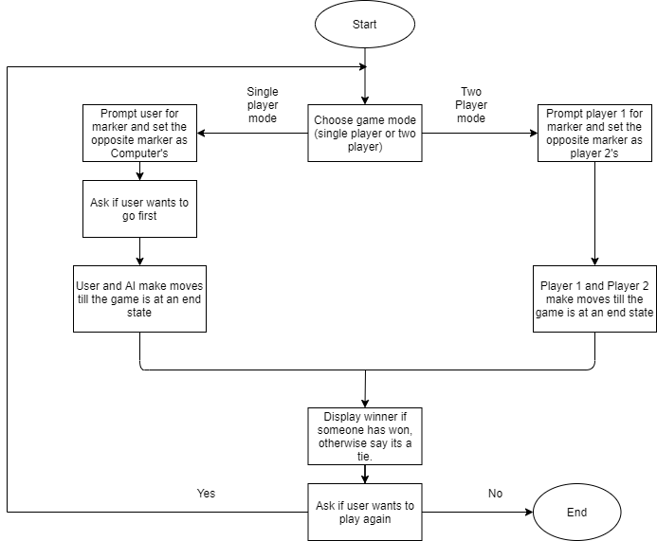

# Class Diagram

Most Challenging Part

Getting different parts/functions/classes of the program to work together/interact with each other properly.

# New Things Learnt in Python:

1. Type hints/annotations.
2. How to implement the AI algorithm “minimax” in python

# Future Expansions

1. Make the interface graphical.
2. In single player mode, give options for varying difficulty so that sometimes the human user can win. (currently it is impossible for human to win vs computer)