INDEX :

**Introduction2**

**Gmail3**

Evolution of Gmail4

Key Features of Gmail 5

Future prospects and chalenges6

conlusion7

**AMOZON**7

Introduction7

Advantages7

Usage statistics7

**Devlopment and programming 9**

**Conclusion12**

**Introduction :**

Imagine a world where information flows with the speed of light, where knowledge is a boundless ocean, and communication bridges every corner of the globe. This is the world woven by the intricate threads of Information and Communication Technologies (ICTs). In our hands, these technologies are not mere tools, but instruments of profound change, reshaping societies, economies, and the very fabric of human experience. Our project embarks on a journey to explore this tapestry of technology. We will delve into the intricate connections between information creation, communication channels, and societal impact. We will trace the evolution of ICTs, from the hum of early telegraph wires to the pulsating glow of smartphones. We will examine their influence on industries, from education and healthcare to finance and entertainment. But this is not merely a chronicle of past innovations. We will also gaze into the future, charting the emerging trends that promise to revolutionize ICTs once again. Artificial intelligence, virtual reality, and the Internet of Things – these are not just buzzwords, but potent forces poised to redefine our relationship with information, communication, and ultimately, ourselves. Through research, analysis, and critical thinking, we will explore the opportunities and challenges presented by this ever-evolving landscape. We will grapple with issues of access, ethics, and security, questioning how to harness the power of ICTs for good while mitigating their potential harm. Ultimately, our project aims to do more than understand the present and predict the future. We seek to contribute to shaping it. By fostering informed discussion, critical analysis, and creative solutions, we hope to weave a tapestry of ICTs that benefits all, promoting a future where information empowers, communication connects, and technology serves as a tool for progress and human flourishing .

**GMAIL:**

Gmail, developed by Google, stands as one of the pioneering email services that revolutionized digital communication. Launched in 2004, Gmail has undergone significant transformations over the years, shaping the way individuals and businesses manage their correspondence. This report provides a comprehensive analysis of Gmail, covering its evolution, key features, and potential future developments.



**Evolution of gmail :**

2.1 Inception and Early Years Gmail was introduced as an invitation-only beta release in April 2004, marking Google's entry into the email service domain. Known for its groundbreaking 1 GB storage capacity, an unprecedented amount at the time, Gmail quickly gained popularity.

2.2 User Interface and Design Changes Over the years, Gmail has witnessed several design changes, transitioning from its classic look to the more modern and minimalist interface we see today. These updates aimed to enhance user experience and adapt to evolving design trends.

2.3 Integration with Google Services One of Gmail's strengths lies in its seamless integration with other Google services, such as Google Drive, Google Calendar, and Google Meet. This integration enhances productivity and facilitates a unified digital workspace.

2.3 gmail’s impact and importance one of the main reasons of its importance is its integration with Google Workspace, formerly G Suite, has transformed it into a multifaceted productivity tool. Users can seamlessly collaborate on documents, spreadsheets, and presentations within the Gmail ecosystem, fostering efficient teamwork, and that’s shown on last statistics



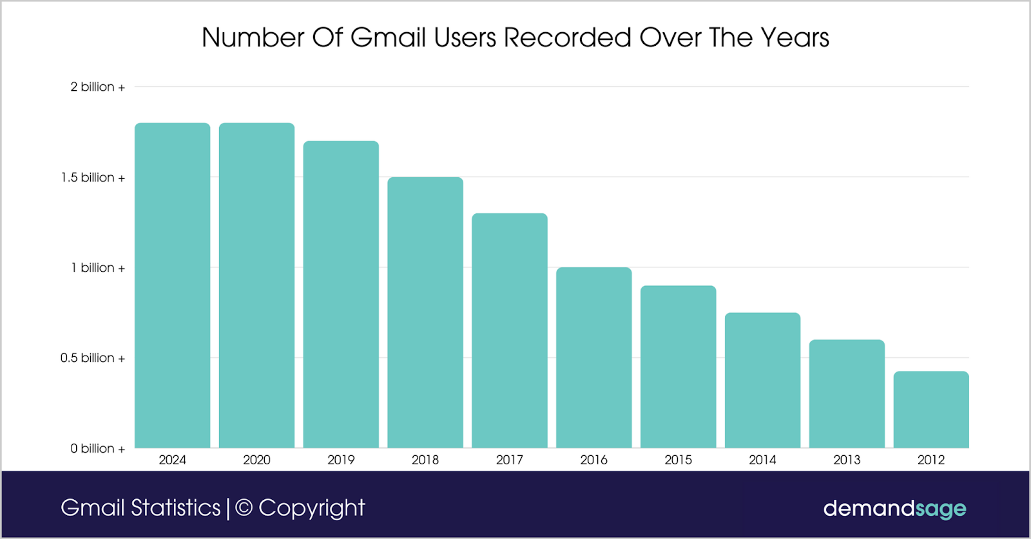

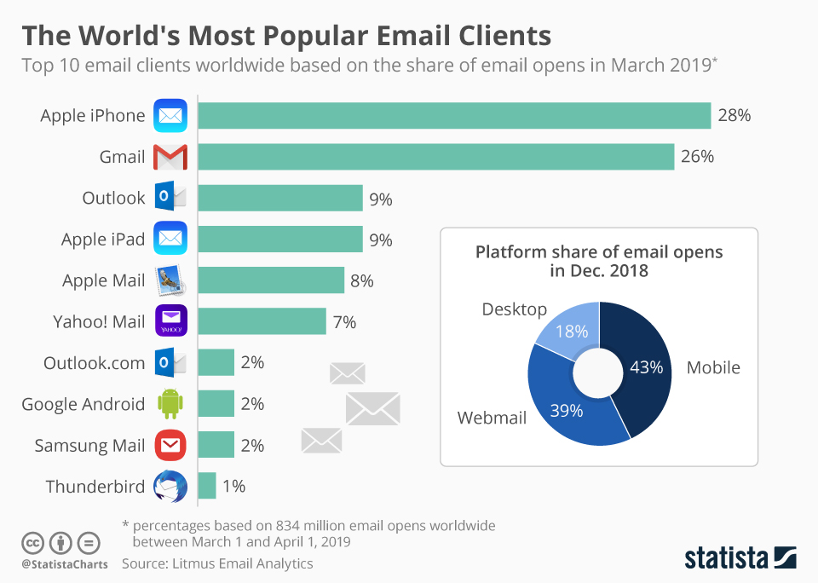 **Key Features of Gmail:**

3.1 Advanced Search and Organization Gmail's robust search capabilities allow users to efficiently locate emails using keywords, sender information, or date ranges. The introduction of labels, categories, and the Priority Inbox feature further assists in organizing and prioritizing emails.

3.2 Security and Privacy Measures Security features like two-factor authentication, automatic phishing detection, and encrypted connections contribute to Gmail's reputation as a secure email service. The confidential mode adds an extra layer of privacy, allowing users to set expiration dates for sent emails.

3.3 Collaboration and Productivity Tools Gmail has evolved beyond a simple email platform, incorporating collaborative features such as Google Workspace (formerly G Suite). Users can seamlessly collaborate on documents, spreadsheets, and presentations directly within the Gmail interface.

3.4 Mobile Accessibility With the increasing reliance on mobile devices, Gmail's mobile app has become a critical component of the user experience. The app is regularly updated to provide a consistent and intuitive interface across various devices.

**Future Prospects and Challenges:**

4.1 Artificial Intelligence Integration As artificial intelligence continues to advance, Gmail is likely to incorporate more AI-driven features. This could include enhanced email categorization, smart replies, and predictive analytics to streamline communication.

4.2 Continued Focus on Security Given the persistent threats in the digital landscape, Gmail will likely invest further in security measures. This may involve the implementation of advanced threat detection, improved encryption methods, and additional tools to combat phishing and cyber threats.

4.3 User Interface Refinements Gmail is expected to undergo further refinements in its user interface to stay aligned with contemporary design trends and user preferences. The emphasis will likely be on maintaining a balance between aesthetics and functionality.

**Conclusion:**

In conclusion, Gmail has evolved from a groundbreaking email service to a comprehensive communication and collaboration platform. Its continuous innovation, integration with other Google services, and commitment to security and privacy have contributed to its enduring popularity. As technology advances, Gmail is poised to adapt and evolve, remaining a central tool in the digital communication landscape.

Haut du formulaire

# AMAZON:

# Introduction:

Amazon Web Services (often abbreviated as AWS) is a cloud computing platform provided by AWS, It offers an array of cloud services such as file storage, data storage (in the form of databases), and computing power (CPU and GPU farms),content delivery, and more.

## Advantages:

* This service allows companies and users to take advantage of the latest and most powerful hardware without needing to buy it and maintain it, which grants them the ability to expand their business greatly.
* It is reliable since there is a team of highly skilled engineers who maintain it.
* Easily scalable, for example, when traffic gets high for an application you can automatically increase the computing power dedicated for it, and when traffic decreases the computing power will decrease.
* Secure, AWS includes a range of software measures that prevent attackers from penetrating their servers.
* A rich and understandable documentation which makes it easy to use.

## Usage Statistics:

AWS is the most used cloud computing service, and is well ahead of its competitors

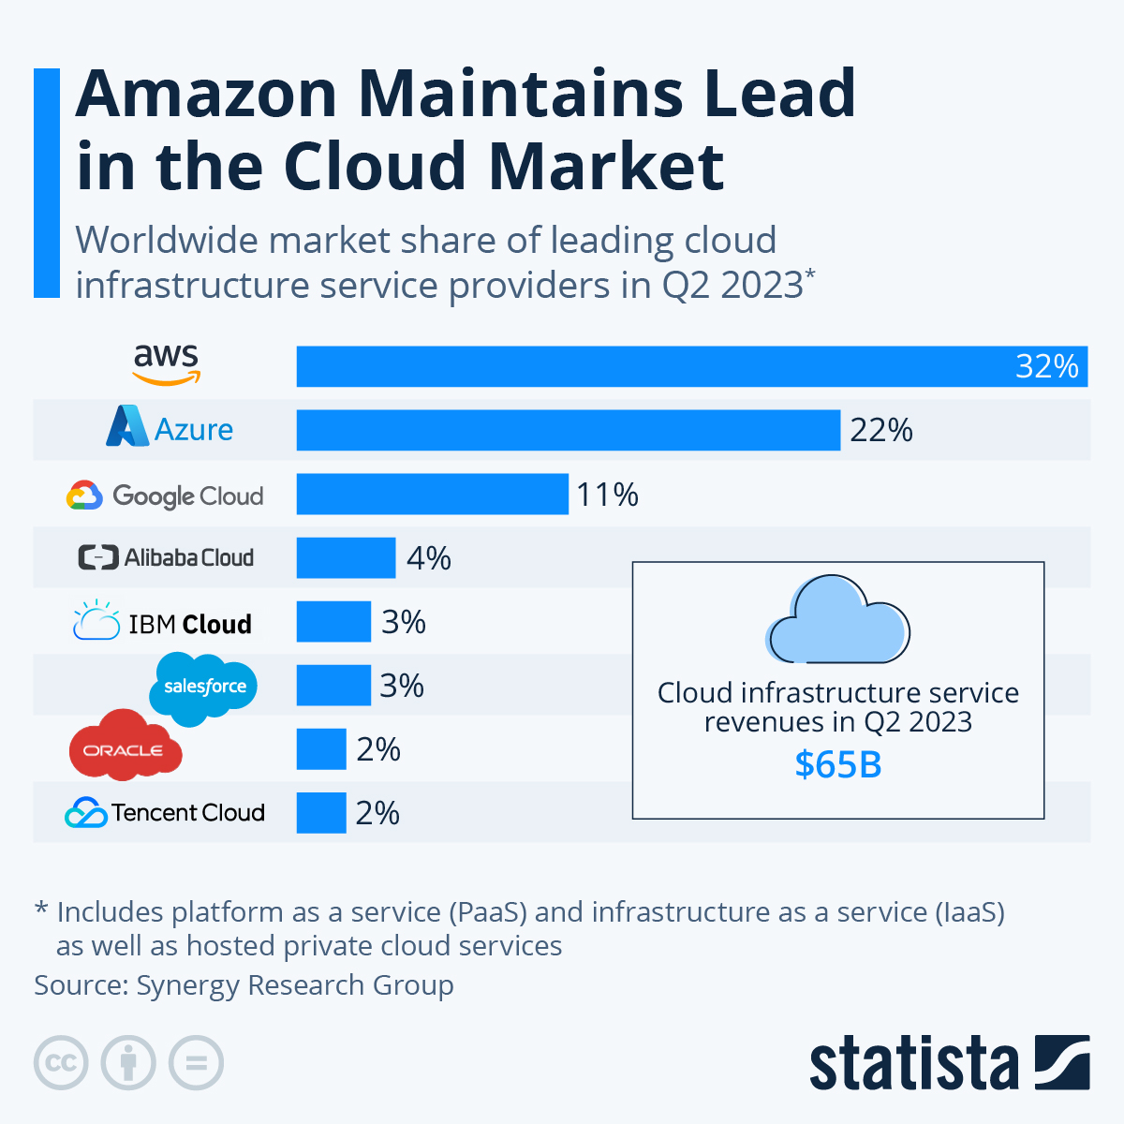

Source : <https://www.statista.com/chart/18819/worldwide-market-share-of-leading-cloud-infrastructure-service-providers/>

## Most Important Services

AWS offers hundreds of different webservices, but here are the most important ones:

|  |  |  |
| --- | --- | --- |
| Category | Service | Description |
| **Compute** | Amazon EC2 | Virtual servers in the cloud with scalable compute capacity. |
| **Storage** | Amazon S3 | Scalable object storage for data storage and retrieval. |
| **Database** | Amazon RDS | Managed relational database service. |
| **Machine** **Learning** | Amazon Sage Maker | Fully managed service for building, training, and deploying machine learning models. |
| **Networking** | Amazon VPC | Isolated cloud resources within a virtual network. |
| **Security** | AWS IAM | Identity and Access Management for securely managing access to AWS services and resources. |

**Development and Programming:**

Code editors are essential tools for software builders and programmers. They provide a platform for writing, enhancing, and organizing code, facilitating the introduction of software applications and systems that shape the spine of Information and Communication Technologies.

**Efficiency and Speed:**

Code editors decorate the efficiency and pace of software program improvement by using supplying functions such as code final touch, syntax highlighting, and automated formatting. These functions lessen the chance of mistakes and streamline the coding procedure.

**Collaborative Development:**

Collaboration is a key issue of TIC initiatives. Code editors, especially those incorporated with version manipulate structures, allow a couple of builders to paintings on the equal codebase simultaneously. This promotes teamwork and ensures that everybody is running with the modern day model of the code.

**Compatibility and Language Support:**

TIC tasks regularly involve a combination of programming languages and technology. Code editors that guide an extensive variety of languages contribute to the flexibility of development environments, allowing builders to paintings on numerous additives of a TIC device.

**Debugging and Testing:**

Debugging gear integrated into code editors resource builders in identifying and solving problems of their code. This is crucial for keeping the reliability and functionality of TIC systems.

**Integration with Build and Deployment Tools:**

TIC tasks typically involve complex build and deployment tactics. Code editors that seamlessly integrate with construct structures and deployment equipment contribute to the automation and efficiency of these tactics.

**Security Considerations:**

Code editors can play a role in selling steady coding practices. Some editors offer features that highlight ability protection vulnerabilities, assisting builders write more secure code.

**Customization for TIC Requirements:**

TIC projects often have precise necessities and coding requirements. Code editors which might be customizable and extensible allow builders to tailor their improvement environment to satisfy the unique desires of the TIC region.

**Documentation and Knowledge Sharing:**

Code editors can assist in documenting code, making it easier for developers to apprehend and preserve the software program. Additionally, a few editors assist integrations with documentation tools, contributing to knowledge sharing inside improvement groups.

**Adaptability to Rapid Technological Changes:**

The TIC zone is dynamic, with fast changes in technology and frameworks. Code editors that adapt speedy to those changes, thru either built-in features or plugin ecosystems, help developers stay contemporary and paintings with the contemporary equipment and libraries.

In summary, code editors play a pivotal role within the TIC quarter by way of supplying the gear and functions vital for green, collaborative, and steady software development. The preference of a code editor inside the TIC context have to align with the specific wishes of the task, the development crew, and the technologies involved.

**Some of the most used IDE’s:**

**Visual Studio Code (VS Code):**

Visual Studio Code, developed by Microsoft, is a highly popular and versatile code editor. It supports a wide range of programming languages, features a rich extension ecosystem, and is known for its speed and efficiency.

**IntelliJ IDEA:**

IntelliJ IDEA, developed by Jet Brains, is a powerful IDE primarily used for Java development. It offers intelligent code assistance, advanced refactoring tools, and strong support for various Java frameworks.

**Eclipse:**

Eclipse is an open-source IDE that supports multiple programming languages, with a strong focus on Java development. It's known for its extensibility through plugins and has a large and active community.

**Visual Studio:**

Visual Studio, developed by Microsoft, is a comprehensive IDE widely used for Windows application development. It supports multiple languages and provides a rich set of tools for debugging, profiling, and building applications.

**PyCharm:**

PyCharm, developed by JetBrains, is a popular IDE specifically designed for Python development. It offers features like intelligent code completion, powerful navigation, and integration with popular Python frameworks.

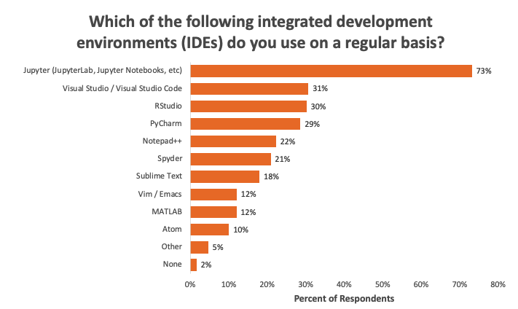

**CONCLUSION :**

In the end, computers and tech change how we live our lives and talk with each other. The quick growth of technology has brought amazing gains and made many things that are important to our modern life. But, because they have such a deep impact on our lives, we need to realize how much power these technologies hold over us and the difficulties this brings. On one side, computers and internet have changed industries. They give us new ways to do things as people but also let anyone get or share information right away no matter where they are at the moment. But on the other side, concerns about privacy and safety have been raised. This is because ICTs we use in our daily lives can gather lots of information about us while some companies are already caught collecting and selling their user's data without permission. These ICTs also have another danger when they spread false information and propaganda by users or states. This is because anyone can post whatever they want on these platforms. Because of these dangers, we must be careful and responsible when using ICTs. We also need to learn about them so that we can avoid any possible problems they might cause.