Image Curation
[Your Name] · [Date] · Week 3 — Curate Your Images

1. What the content map actually needs
Where (content map) | Image needed | Source | Why that call
Home hero | Claim + whitespace (no photo) | Real capture: N/A | No image needed — typography carries it
Work — case 1 proof | Screenshot of executed w02 notebook cell | REAL CAPTURE (kept) | Actual work beats any generated mockup, no contest
Work — section icon (ranking) | Small bar-chart glyph, connective tissue | AI-generated (kept, iteration 2) | Decorative only — fine to generate once style is locked
Work — section icon (verified) | Checkmark glyph, connective tissue | AI-generated (kept, iteration 2) | Same reasoning — pure connective tissue
Contact — section icon (mail) | Mail glyph, connective tissue | AI-generated (kept, iteration 2) | Same reasoning
About — portrait | Photo of me | REAL PHOTO REQUIRED — not yet taken | A generated face would be actively dishonest here; placeholder used instead

2. Real capture — the work itself
This is a genuine screenshot of an executed cell from my actual w02 notebook (the honest 0.70→0.64 catch), not a mockup or a generated approximation of “code on a screen.” This is the single most important image in the whole portfolio, and it's real for that reason.
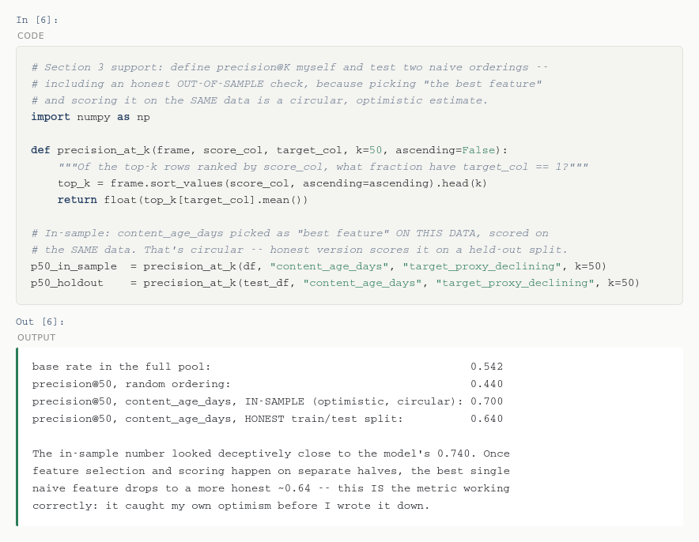

3. Connective tissue — held to one style
Iterated the icon prompt twice to lock a consistent style before keeping anything.

Iteration 1 — rejected

Rejected as a set. Three different visual languages in one strip: a thin outlined check, solid filled bars, and a double-stroked envelope. Mixed stroke weights, mixed colors, mixed fill-vs-outline logic — exactly the “three fonts, colors that clash” problem the brief warns about, just applied to icons instead of type. Individually each icon is fine; together they read as three different portfolios.

Iteration 2 — kept

Locked stroke width (14px), single outline logic (no fills except the checkmark's own stroke), and the same two-color rule as the identity kit (navy for structural glyphs, green reserved for the one “verified/positive” icon). This is the set that goes in the build.

4. Real photo, where the subject is me

No portrait exists yet. I generated zero candidate face images for this slot on purpose — a generated photo standing in for a real person is the one substitution this brief calls out as actively wrong, not just lower-quality. A plain placeholder blocks the layout honestly until a real photo is taken; it will never make it into the actual site.

5. Final kept set
1 real notebook screenshot · 3 icons (one consistent style, iteration 2) · 1 hero (typography-only, no image, from the Week 3 identity-kit exercise) · 1 honest placeholder pending a real photo. Nothing generated made it in as a stand-in for real work or a real person.

