Portfolio Content Map & Identity Kit
[Your Name] · [Date] · Week 3 — Map It & Give It a Face

1. The one-line claim
Ten options, generated from my FL-02 proof statement, then narrowed by hand — the choosing is mine, not AI's.
- 1. I ship ranking models I've already tried to break.
- 2. I don't trust a model's number until I've tried to break it.
- 3. I build ranking models, then find their weak spot before you do.
- 4. Real data is messy. I validate before I ship, not after.
- 5. I catch my own inflated metrics before they leave my laptop.
- 6. I build ML that ranks priorities — and survives a fair test.
- 7. Junior ML engineer who checks the math before you have to.
- 8. I turn messy data into a ranking model you can actually trust.
- 9. I ship validated ranking models, not demo-day numbers.
- 10. I don't ship a metric I haven't tried to disprove.

Chosen and sharpened
“I ship ranking models I've already tried to break.”
Why this one, not #2 or #10: it names the skill (ranking models) AND the proof (I break my own work first) in one clause, without the word "validated" or "trust," both of which every competing ML portfolio also uses. It reads as a claim a specific person made, not a category of person.

2. Content map
Four pages from the FL-02 sitemap. Every section ladders toward the one action: email me directly.

Home / Hero
Section (in order) | Content | Named CTA
1. Hero | One-line claim + “email me” button | Email me
2. Proof strip | One-sentence result from the strongest case (FlyRank ranking work) | See the work ↓

Work
Section (in order) | Content | Named CTA
1. Case 1 (lead, strongest) | FlyRank content-refresh ranking model — problem, decision, result, the 0.70→0.64 catch | Email me about this
2. Case 2 (once it exists) | Placeholder — flagged on gather-list, not filled with a fake project | Email me about this

About
Section (in order) | Content | Named CTA
1. Bio | 3-4 sentences: who I am, what I'm building now, why it's credible | Email me

Contact
Section (in order) | Content | Named CTA
1. Direct ask | Restate the claim once + one email link, no form | Email me (mailto: link)

Still need to gather (honest list, so build week isn't blocked)
- A second real case study — only one project exists right now (FlyRank ranking model); a second piece is needed before Work fully earns its plural.
- Clean screenshots of the actual notebook run (w01/w02) — none captured yet, needed for the Work page's proof section.
- A real professional headshot or photo for About — not yet taken.
- A live/updated GitHub repo link with the finished capstone — currently mid-build, link exists but content is incomplete.
- A final precision@50 number from my own trained model (not just the starter baseline) once I finish training — needed to replace “in progress” language on Work with a real result.
- A real contact email address to replace the [your email] placeholder used throughout every FL deliverable so far.

3. Identity kit

Type
One font, two weights — per the brief's own guidance for non-design tracks (“go even calmer”). Inter, free on Google Fonts: weight 700 for headings, weight 400 for body. One font removes an entire category of amateur mistakes (font clash) before it can happen.

Palette
Reused, on purpose, from the same navy/near-black/near-white/green system already used across every FL deliverable so far (FL-01 audit, FL-04 case study, the prompt logs) — consistency across the whole track, not just within the site.
Main · #1F3A5F | Text · #16181D | Background · #FAFAF8 | Accent · #2E7D5B
Contrast, checked (WCAG relative-luminance formula, computed directly — not eyeballed): text-on-background 16.99:1, accent-on-background 4.78:1, white-on-navy 11.48:1. WCAG AA requires 4.5:1 for body text — every pairing clears it, including the accent used for links.

Logo / favicon
A checkmark inside a rounded square — chosen because it's literally what the proof statement is about (verifying before trusting), not decoration for its own sake. Flat, two colors, reads at 16px.


Style note
Inter (700 for headings, 400 for body). Navy #1F3A5F for primary UI and headings, near-black #16181D for body text, near-white #FAFAF8 background, one green accent #2E7D5B for links and verified-result callouts only. Mood: calm, technical, evidence-first — the site should feel like a lab notebook that happens to be well-typeset, not a landing page.

4. Image curation

Images the content map actually needs
- Hero: no photo. Typography + one accent rule on whitespace (see chosen option below).
- Work — case study 1: real screenshot of the executed w01/w02 notebooks and the precision@50 comparison — real capture, not generated, once screenshots are taken (see gather-list).
- About: one real photo of me — not yet taken (see gather-list). No generated headshot; a fake photo of a real person is worse than no photo.
- Contact: no image — a page with one action doesn't need decoration competing with the action.
- Favicon: the checkmark mark above — the only truly “generated” graphic element on the whole site, and it's a simple flat vector, not an AI photo-style image.

Generated option — rejected
Generated one hero-background option in the classic gradient-orb style to test it against the palette above.

Rejected. This is textbook AI slop — the melted, glossy-orb look the brief names directly — and it uses none of my actual palette (purple/magenta instead of navy/green), so it would fight the identity kit before a visitor even reads a word. More importantly, a gradient blob proves nothing about my claim; it's decoration standing where evidence should be.

Chosen instead
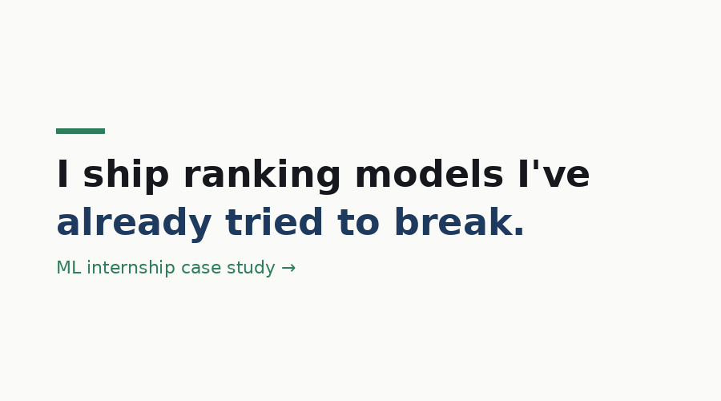
A clean claim, set in the actual identity kit's type and color, over whitespace. It's less “impressive” than the gradient in isolation, and that's correct — the portfolio rule this week is that design frames the work, and this version leaves all the room for the case study that follows it to be the loudest thing on the page.

