SOHAIB AAMIR

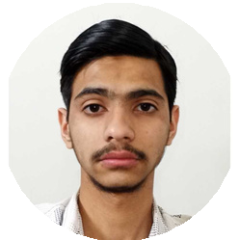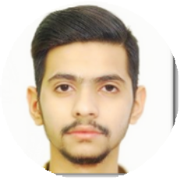

Computer Science Student

# Education



**About Me**

Throughout my educational journey, maintaining high academic standards has been a priority. With a robust foundation in AI, web development, and IoT, I am enthusiastic about expanding my knowledge and applying my skills in a real-world setting. I am eager to bring my leadership qualities and technical expertise to the Internship, contributing to innovative projects and gaining invaluable experience in a dynamic environment.

**Contact**

+92 300 0000000

sohaibaamir[@gmail.com](mailto:sohaibaamir00@gmail.com) [sohaib-aamir](https://pk.linkedin.com/in/sohaib-aamir) Rawalpindi, Pakistan

**Skills**

Desktop Application Developer. C++, Java, Python, Typescript

Machine & Deep learning , Computer Vision (A.I) Data Structures.

Communication and Leadership

Internet of Things Expert (IoT)

Generative A.I embeded with

web Application (Next j.s)

**Language**

PTE scores (64/90) English

Urdu (Proficient)

## (2021 - 2024)



INTERNATIONAL ISLAMIC UNIVERSITY, ISLAMABAD

Bachelor in Computer Science 5 semesters passed with CGPA: 3.51/4.0

## (2019 -2021)



ARMY PUBLIC SCHOOL AND COLLEGE, WESTRIDGE, RAWALPINDI.

F. Sc (Pre-Engineering). 832/1100 Marks.

# Certification

### (5 MAR 2022 - 28 SEP 2022)



**Artificial Intelligence**

**(Robotics),**

**NUST, Islamabad.**

**(31 JULY 2023)**



**Data Structures and Algorithms Specialization (Coursera)** [**University of California San Diego**](https://www.coursera.org/specializations/data-structures-algorithms)

 **Honors & Awards**

## ( Nov 2023)

PRIME MINISTER YOUTH LAPTOP SCHEME 2023 (LENOVO LAPTOP)

## (Aug 2023)

FINALIST IN THE WEBGPU HACKATHON ORGANIZED BY LABLAB.AI (ONLINE)

 **Internship Experience**

## (6-26 AUG 2022)



WEB DEVELOPER

ZEKAB, Bahria Town, Islamabad.

Worked on React Framework. Skilled in HTML, CSS, JavaScript and PHP.

Responsive Design and development