**Intro:**

General signal generator

Mini project

|  |  |
| --- | --- |
| Abdalla Magdy Abdelazem Elgohary | 20010900 |
| Sohaib Alaraby Ali AbdElhafez | 20010751 |
| Abdalla Ashraf Mohamed Melad | 20012318 |
| Mohamed Nagy Mabrouk | 20012409 |

A signal generator is one of a class of electronic devices that generates electrical signals with set properties of amplitude, frequency, and wave shape. These generated signals are used as a stimulus for electronic measurements, typically used in designing, testing, troubleshooting, and repairing electronic or electroacoustic devices, though it often has artistic uses as well.

Here is a MATLAB code to implement it

**Code explanation:**

* Ask the user for sampling frequency, start, and end of time scale. Then check that data is valid.

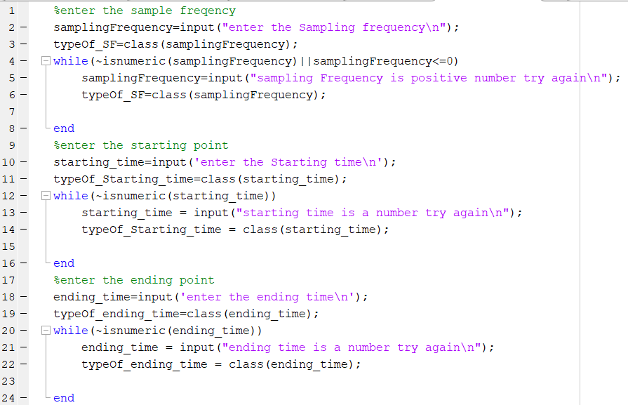

* Ask the user the number of break points and their position

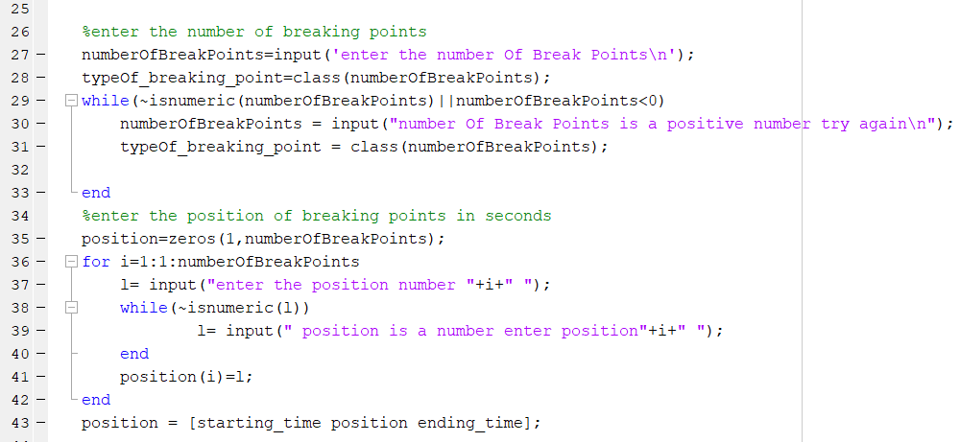

* Generate the signal: Ask the user the type of signal at each region according to the number of break point.

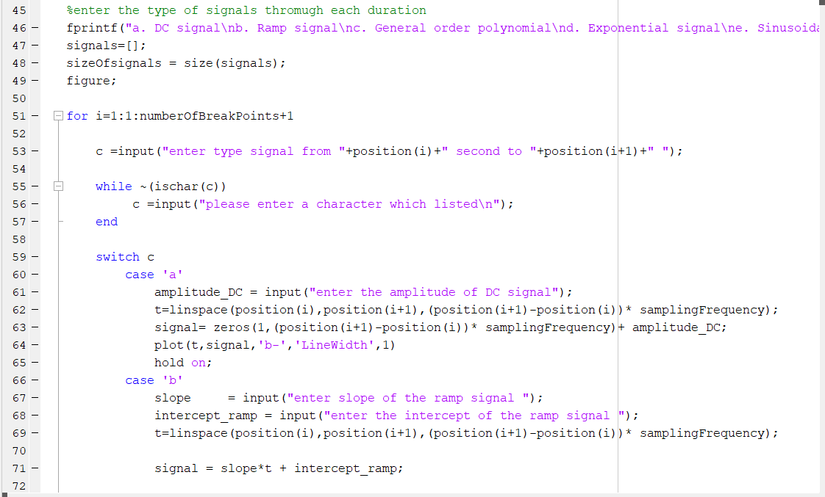

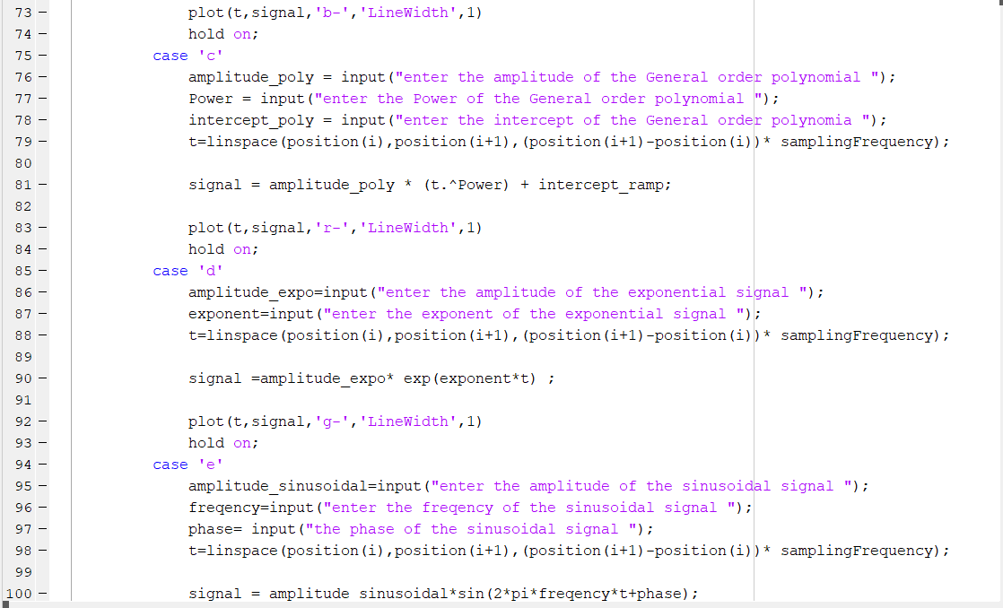

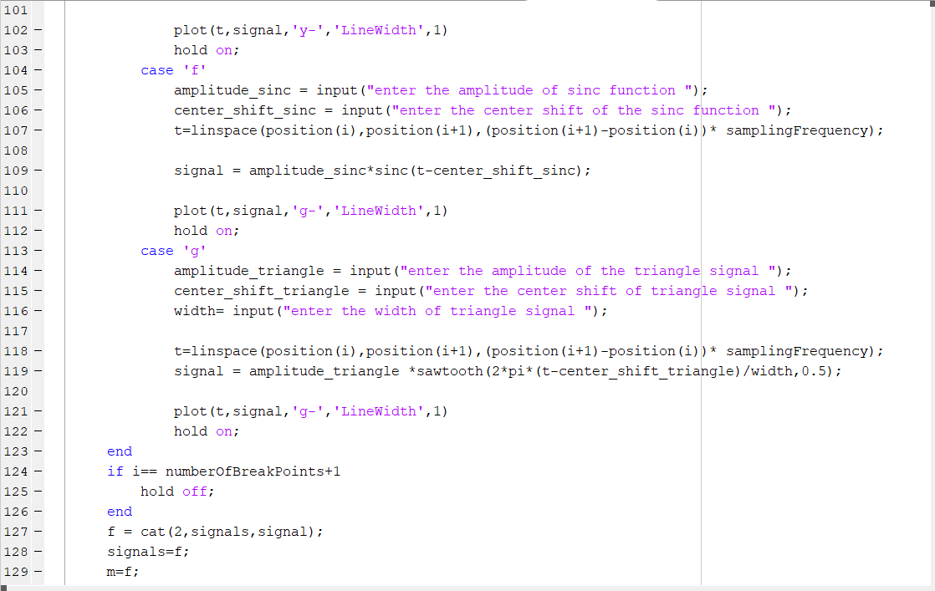

-The program asks the user the type of signals he wants at each region

-For each type, the program asks the user for the signals specification like amplitude for dc signal or slope for ramp signal

-the number of iterations of for loop = no. of break points+1

* Ask the user if he wants to perform any operation on the signal  
  -After choosing the operation, the user enters the c/cs of the operation (like shift value for time shift) and the programs displays the new signal in time domain.

________________________________________________________

**Screenshots of output:**

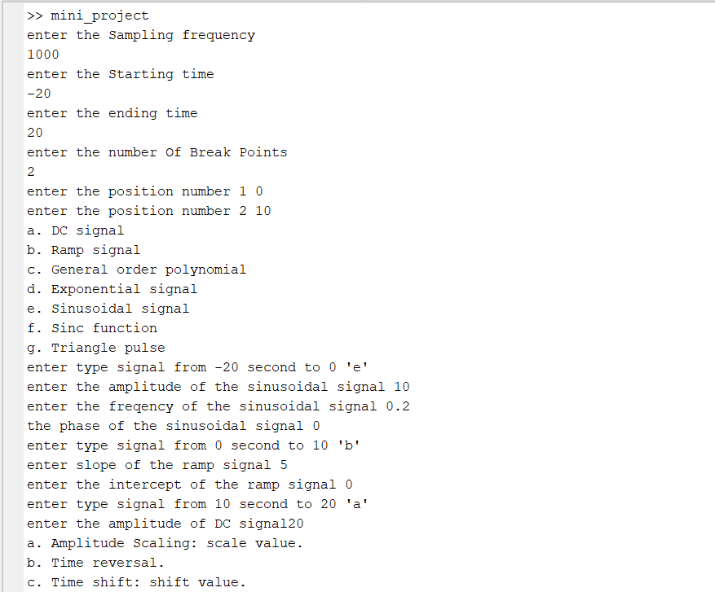  
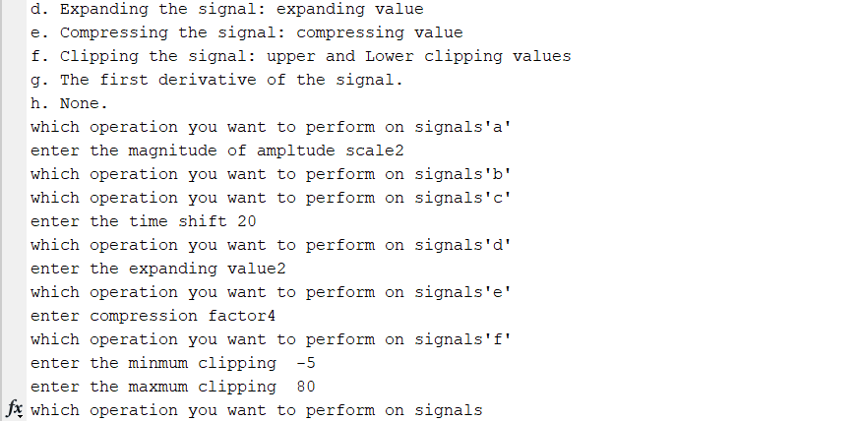

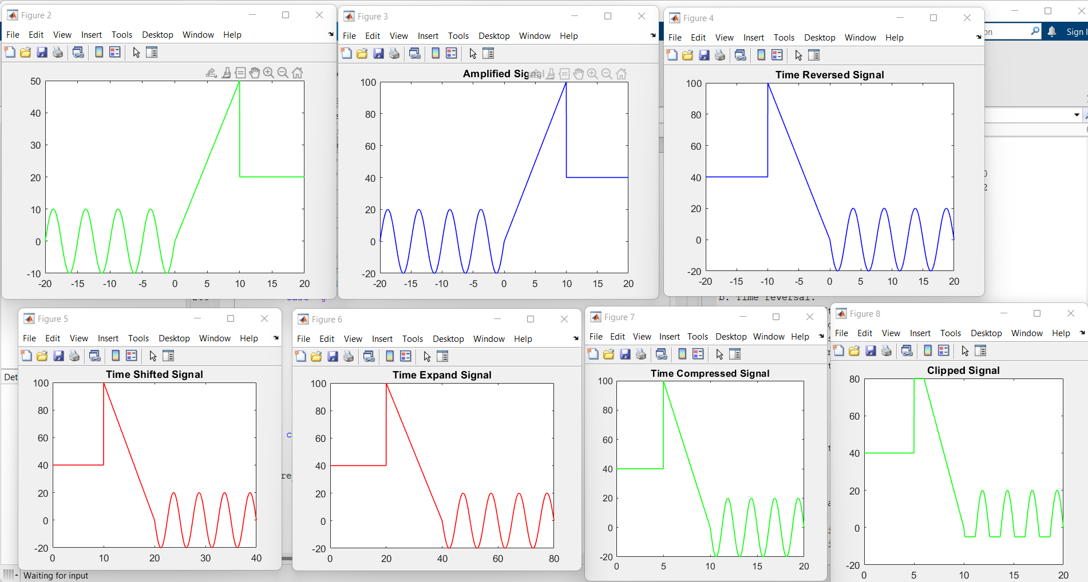

-differentiate signal:

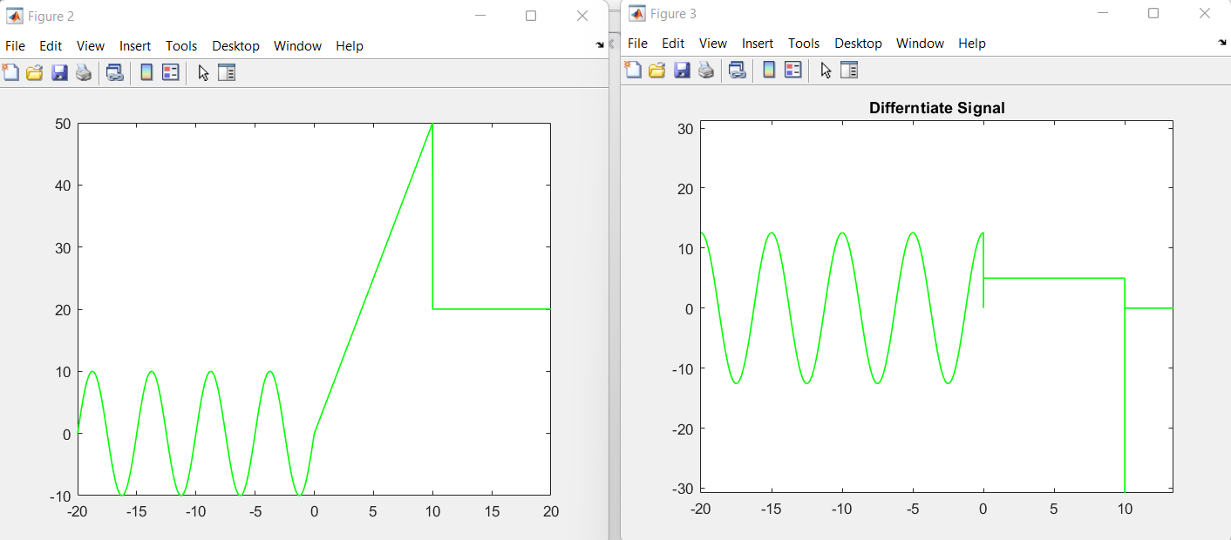

Note that the function is Dirichlet at t=10