EQUITY RESEARCH | Philippines · Utilities  2024-11-14
Manila Water Company, Inc.
PSE: MWC · Bloomberg: MWC PM · Regulated water utility
BUY Target ₱27.35 (+22%)  Investment thesis  - Robust earnings momentum — 9M-2024 net income to parent rose to ₱10.10bn from ₱7.26bn, a ~39% increase, driven by a 20% Parent Company average tariff hike and steady billed-volume growth.  - Diversified revenue base — Non-East Zone revenues grew 23% on 6% billed-volume growth and 20% tariff increases across several business units, complementing the core Metro Manila East Zone concession.  - Attractive valuation — Our DCF (WACC 8.4%, terminal growth 2.5%) yields a fair value of ₱27.35 against a price of ₱22.36, implying ~22% upside and an enterprise value of ₱167.9bn.  - Scheduled tariff visibility — Contracted adjustments from 2023 to 2027, an indicative 2028 Wawa Bulk Water adjustment, and a rising environmental charge underpin a predictable revenue trajectory.  - Ownership transition — Enrique Razon's Trident Water acquired the Ayala group's entire stake in 2024 and now holds majority control, with Ayala no longer a related party.  - Concession extension catalyst — The pending application to extend the Revised Concession Agreement term to 2047, aligning with the franchise, would lengthen the asset-life horizon supporting valuation. | Company data  Price (₱): 22.36  Fair value (₱): 27.35  Upside: +22%  Market cap (₱bn): 58.1  52-wk range (₱): 16.5–27.0  Shares (m): 2,597  Beta: 0.46  WACC: 8.4%

₱m unless stated | 2024E | 2025E | 2026E | 2027E
Revenue | 36,729 | 40,402 | 43,635 | 46,689
Net income (parent) | 13,470 | 14,817 | 16,003 | 17,123
EPS (₱) | 5.19 | 5.71 | 6.16 | 6.59
EPS growth | — | +10% | +8% | +7%

Key highlights
Interim results (₱m)
 | Q3'24 | Q3'23 | 9M'24 | 9M'23
Revenue | 9,193 | 7,753 | 27,547 | 23,144
Gross profit | 6,412 | 5,119 | 19,097 | 15,487
Operating income | 4,982 | 3,851 | 15,065 | 11,553
Pre-tax income | 4,356 | 3,123 | 13,708 | 9,703
Net income | 3,329 | 2,305 | 10,489 | 7,524
of which: to parent | 3,188 | 2,214 | 10,103 | 7,262
EPS (₱) | 1.08 | 0.67 | 3.43 | 2.21
Valuation summary (DCF)
 | ₱m / x
Enterprise value | 167,909
Less: net debt | (94,514)
Less: NCI | (1,973)
Less: preferred | (400)
Equity value | 71,021
Fair value / share (₱) | ₱27.35
WACC | 8.4%
Terminal growth | 2.5%
Beta | 0.46
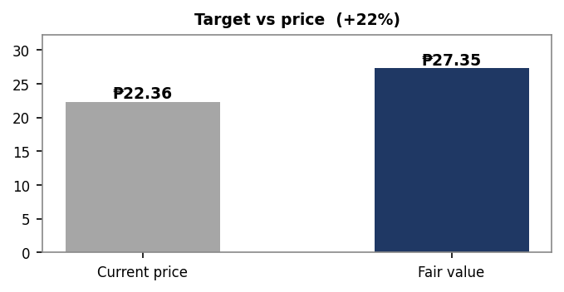

Earnings recap
For 9M-2024, Manila Water reported revenue of ₱27.5bn versus ₱23.1bn a year earlier, while net income attributable to parent rose to ₱10.10bn from ₱7.26bn, translating to 9M EPS of ₱3.43. Q3-2024 net income to parent reached ₱3.19bn against ₱2.21bn. Growth was led by a 20% Parent Company average tariff increase, 2% billed-volume growth, and a 23% rise in Non-East Zone revenues, partly offset by higher personnel, premises, and regulatory-related costs.
Sector context
Philippine regulated water utilities operate under long-dated concession and franchise frameworks featuring periodic, regulator-approved tariff resets that support cash-flow predictability. Sector demand is underpinned by urbanization, network expansion, and growing sewerage-coverage mandates, while capital intensity remains high. Operators face exposure to supply variability from weather patterns such as El Niño, alongside power, chemical, and inflation-linked cost pressures.
Outlook
We expect earnings to be supported by scheduled tariff adjustments running through 2027 and an indicative 2028 adjustment tied to the Wawa Bulk Water Supply Project. The environmental charge rises from 25% to 30% beginning January 2026, with a sewer-charge increase contingent on attaining 30% sewer coverage by end-2025. The pending concession-term extension to 2047 is a key catalyst, while capital expenditures are to be funded through internally generated funds and debt.
Recent developments (live, as of 2026-06-09)
- Manila Water reported a net income of "15.8 billion in 2025, marking a 51% increase (GMA Network).
- The company has bolstered alternative supply sources in anticipation of a severe El Ni
o (Manila Standard).
- The 60-Million-Liters-Per-Day Aglipay Sewage Treatment Plant was inaugurated by President Ferdinand R. Marcos Jr. (pbbm.com.ph).
- Manila Water has switched to 100% renewable energy for its retail supply (Inquirer.net).
- The PPP Center conducted a knowledge session for Manila Water on the new PPP Code and its Implementing Rules and Regulations (PPP Center of the Philippines).
Key risks
- Regulatory risk — Delays or unfavorable outcomes in tariff approvals or the concession-extension application could compress revenue and valuation.
- Supply risk — Severe El Niño or drought conditions could constrain raw-water availability and pressure service reliability despite alternative-supply investments.
- Cost inflation — Rising personnel, premises, power, chemical, and regulatory costs may erode margins if not offset by tariff recovery.
- Ownership transition risk — The change of control to Trident Water introduces uncertainty around strategy, governance, and capital allocation.

Financial highlights
₱m | 2024E | 2025E | 2026E | 2027E
Revenue | 36,729 | 40,402 | 43,635 | 46,689
EBIT | 20,087 | 22,095 | 23,863 | 25,533
NOPAT | 15,065 | 16,571 | 17,897 | 19,150
D&A | 4,977 | 5,475 | 5,913 | 6,327
CapEx | 23,511 | 23,114 | 21,995 | 20,358
Free cash flow | (3,469) | (1,104) | 1,783 | 5,088
Net income (parent) | 13,470 | 14,817 | 16,003 | 17,123
EPS (₱) | 5.19 | 5.71 | 6.16 | 6.59
2024E is FY2024 estimated from 9M-2024 actuals (annualized); 2025E–2027F are model forecasts off configurable assumptions. Figures are illustrative.
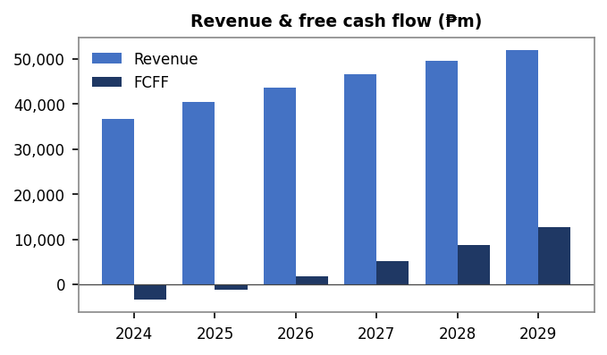

Rating definitions & disclaimer
Ratings (12-month total return): BUY > 10% · HOLD 0–10% · UNDERPERFORM < 0%.
This document is an automated draft produced by a demonstration research-automation pipeline. Financial figures are extracted from the company's PSE filing and validated for internal consistency; market data is as of the stated date; forecasts derive from configurable assumptions and are illustrative, not house views. The terminal value uses a standard perpetuity, an approximation for a partly finite concession. This is not investment advice, an offer, or a solicitation. Sources: company SEC Form 17-Q (Q3 2024); public market data.

