Final Year Project Proposal

“AI-Based Personal Network Intrusion Detection and Prevention System (IDPS)”

Project supervisor
Mam Iqra Jamshed

Submitted to
Department of Information Technology
University of Gujrat

In Partial Fulfillment of
The requirements for the degree of
Bachelors of Information Technology
Submitted by:
Sr. No | Student Name | Roll No
01 | Neha | 22041556-009
02 | Sohaib Arshad | 22041556-046
03 | Shiza Nadeem | 22041556-060

APPROVAL
I Mam Iqra Jamshed am willing to guide these students in all phases of project titled “AI-Based Personal Network Intrusion Detection and Prevention System (IDPS)” as advisor/supervisor. I have carefully seen the title and description of the project and believe that it is of an appropriate difficulty level for the number of students named above.

Date Signature of Advisor

Submission Date:

TABLE OF CONTENTS
Final Year Project Proposal i
APPROVAL ii
1 Introduction 1
2 Project Overview statement: 1
3 Project Title 4
4 Proposed System 5
5 Project Goals & Objectives 5
5.1 Goals 5
5.2 Objectives 5
6 Major Functional Units 6
6.1 User Interface (UI) 6
6.2 Data Collection 6
6.3 Data Cleaning / Normalization 6
6.4 Detection Engine 6
6.5 Prevention & Alerts 6
6.6 Logging 7
6.7 Knowledge Storage / Rules 7
6.8 Learning / Model Update 7
6.9 Hardware and Software Specification 7
7 Used Technologies 7
7.1 Backend 7
7.2 Desktop GUI 8
7.3 `Packaging Tools 8
7.4 Database 8
8 Attacks Detected and Prevented by the System 8
8.1 Denial of Service (DoS) Attacks 8
8.2 Probing (Reconnaissance) Attacks 9
8.3 User to Root (U2R) Attacks 9
8.4 Remote to Local (R2L) Attacks 9
9 Gantt chart: 10

List of Tables
Table 1: Project Overview Statement 2

Figure 1: Gantt Chart 10
Figure 2:Diagmatric view of Project 11
Figure 3: Use Case Diagram 12

Introduction
Modern Intrusion Detection Systems (IDS) rely heavily on static rule sets, predefined signatures, and manual human response. While these systems were effective in earlier stages of network security, the rapid evolution of cyber threats and the rise of large-scale data breaches have exposed their limitations particularly their inability to identify and respond to new or undocumented attacks. To overcome these challenges, our project introduces an AI-based Intrusion Detection and Prevention System (IDPS) that combines intelligent detection with automated prevention. Instead of only alerting administrators, the system can also take direct actions such as blocking malicious IPs, limiting suspicious traffic, and issuing real-time alerts, providing both proactive and reactive defense. The proposed IDPS leverages machine learning algorithms to detect a wide range of network intrusions including Denial of Service (DoS), Probing, User to Root (U2R), and Remote to Local (R2L) attacks, this intelligent desktop-based system offers a lightweight yet comprehensive security solution. It ensures that once an attack is detected, it is immediately mitigated, minimizing system downtime and potential damage. The goal is to create a self-learning, automated defense mechanism that adapts to new threats and provides continuous protection for everyday network users.

Project Overview statement:
The AI-Based Personal Network Intrusion Detection and Prevention System (IDPS) aims to enhance the security of home and small office networks by using artificial intelligence to both detect and prevent cyber threats in real time. The system employs machine learning algorithms to identify abnormal traffic patterns that may indicate unauthorized access, malware, or network attacks. Key features include real-time traffic monitoring, automatic attack prevention, and user alerts through a simple, easy-to-use interface. The system requires minimal configuration and continuously learns from normal network behavior to improve detection and prevention accuracy over time. Unlike traditional IDS solutions that only identify threats, the proposed IDPS can take immediate preventive actions, such as blocking malicious IPs, limiting suspicious connections, or alerting the user before damage occurs. It is designed to handle multiple attack categories, including Denial of Service (DoS), Probing, User to Root (U2R) and Remote to Local (R2L). As personal and home networks continue to grow with more connected devices, the need for intelligent and automated protection is becoming critical. This AI-driven IDPS provides instant detection, real-time prevention, and minimal manual maintenance delivering reliable, automated cybersecurity for individuals and small businesses without requiring prior technical expertise.

Table 1: Project Overview Statement
Project Title:
AI-Based Personal Network Intrusion Detection and Prevention System (IDPS)
Project Manager: Sohaib Arshad
Project Members:
Name | Registration no # | Email Address | Signature
Neha | 22041556-009 | nehaimran418@gmail.com
Sohaib Arshad | 22041556-046 | sohaibarshad0046@gmail.com
Shiza Nadeem | 22041556-060 | shizanadeem60@gmail.com

Objectives:
1 | Detect and prevent unauthorized attempts to access system resources or sensitive data in real time.
2 | Continuously monitor user and network activity to identify and block suspicious or malicious behavior.
3 | Use anomaly-based technique to identify known and unknown attack patterns, including malware and network threats.
4 | Enhance overall network and system security by detecting vulnerabilities early and applying automated preventive actions.
5 | Utilize insights from detected and prevented incidents to improve system learning and strengthen future security policies.
6 | Maintain detailed logs and reports of detection and prevention activities for auditing, analysis, and compliance purposes.
7 | Regularly update and refine detection and prevention models to adapt to evolving cyber threats and attack patterns.

Project Goals:
1 | Detect and prevent unauthorized attempts to access systems, networks, or sensitive data in real time.
2 | Identify, analyze, and mitigate potential security threats to reduce or stop damage before it occurs.
3 | Facilitate a rapid, automated, and effective response to detected intrusions or malicious activities.
4 | Strengthen overall network and system security by identifying vulnerabilities and applying preventive measures.
5 | Ensure the integrity, confidentiality, and availability of data by blocking unauthorized access or tampering.
6 | Maintain a balanced detection approach to ensure high accuracy while minimizing false alerts and disruption.

Project Success criteria:
- User Engagement
- Goal: Ensure strong personal and small-network security through real-time detection and prevention of cyber threats.
- Success Criteria: Successfully detect, prevent, and alert users about unauthorized access attempts or suspicious network activity, maintaining reliable protection with minimal false alerts.
- System Efficiency
- Goal: Maintain fast and accurate intrusion detection and prevention performance.
- Success Criteria: Achieve a detection accuracy of 90% or higher and ensure that preventive actions (like blocking or rate-limiting) do not significantly affect network speed.
- User Satisfaction
- Goal: Provide an easy-to-use and automated system for non-technical users.
- Success Criteria: Attain a user satisfaction rate of 80% or higher, based on ease of setup, clear alerts, and minimal manual maintenance.

Assumptions
- The project is Windows-based and will operate as a desktop application for personal small office networks.
- The KDD99CUP dataset is sufficient for training and testing the model.
- The system will maintain a low false-positive rate while accurately detecting and preventing malicious activities.
- Real-time detection and prevention are feasible on average computer hardware without requiring specialized equipment.
Risks
- AI model accuracy
- Real-time performance
- System resource usage
- Third-Party Integrations
- Dataset Limitations
- System security
Organization Address (if any):
IT Department Government Graduate College Jhelum.
Type of project:
- Development
- Desktop Application
Target End users:
- IT Lab
Development Technology:
- Python
- Desktop GUI
Approved By:
Date:

Project Title
“AI-Based Personal Network Intrusion Detection and Prevention System (IDPS)”

Proposed System
The AI-Based Personal Network Intrusion Detection and Prevention System (IDPS) aims to enhance the security of home and small office networks by using artificial intelligence to detect and prevent threats in real time. The system applies machine learning algorithms to recognize unusual traffic patterns that may indicate unauthorized access, malware, or other cyber risks. Key features include real-time traffic monitoring, automatic prevention actions, and user alerts through a simple desktop-based graphical interface (GUI). The system requires minimal setup and continuously learns from regular network activity to improve both detection accuracy and prevention effectiveness over time. As device dependency increases, personal and small office networks have become more vulnerable to cyber threats. The proposed IDPS addresses this issue by providing intelligent, automated protection without requiring prior technical experience. It offers instant threat detection, active prevention, and protection against network attacks such as DoS, Probing, U2R and R2L. Ensuring stronger cybersecurity for individuals and small businesses.

Project Goals & Objectives
Goals and objectives of the project are mentioned below:

Goals
Goals of the project are mentioned below:
- Unauthorized Access Prevention
- Threat Identification & Mitigation
- Real-Time Automated Response
- Network Security Strengthening
- Data Integrity & Confidentiality Protection
- Balanced Detection & False Alert Control

Objectives
Objectives of the project are mentioned below:
- Identify and Prevent Intrusions
- Monitor Access
- Detect Known and Unknown Threats
- Continuous Improvement
- Log and Report
- Continuous Tuning
- Scalability

Major Functional Units
Following are the functional units of this project:

User Interface (UI)
The screen where users interact with the system. Shows alerts, detected
attacks, and actions taken.
Used for: Viewing results and managing the system easily.
Project Use: In our project, the UI displays model outputs, intrusion alerts, and prevention actions like temporary blocks.

Data Collection
Gathers network or system data from files or sources so the system can learn and check for attacks. In our project we are using dataset KDD99.
Used for: Providing the system with data to detect attacks.
Project Use: It loads the KDD99 dataset records for training/testing and prepares them for later stages.

Data Cleaning / Normalization
Organizes the collected data, removes unnecessary information, and converts it into a simple format that the system can understand.
Used for: Making the data ready for accurate detection.
Project Use: In our project, it converts features into numeric form and ensures consistent formatting for the ML model.

Detection Engine
The part that checks the data for unusual or suspicious activity and decides if it is normal or an attack.
Used for: Identifying potential attacks in the system.
Project Use: Our detection engine uses trained ML models to classify traffic as Normal or Attack based on KDD99 patterns.

Prevention & Alerts
Acts when suspicious activity is detected. Can warn the user, slow down harmful activity, or temporarily block it. Shows alerts on the screen and keeps a record.
Used for: Stopping attacks and notifying the user.
Project Use: It applies thresholds, blocks suspicious IPs temporarily, and sends alerts to the UI whenever an attack is found.

Logging
Keeps detailed records of all activities, alerts, and actions the system takes. Helps to review past attacks or system performance.
Used for: Saving history of attacks and system actions.
Project Use: Our system logs detection results, model scores, and prevention actions for auditing and future review.

Knowledge Storage / Rules
Stores learned patterns, rules, and settings so the system knows what is normal and what actions to take in the future.
Used for: Remembering rules and previous learning for better detection.
Project Use: It stores the trained model, whitelist/block list rules, and thresholds used for prevention decisions.

Learning / Model Update
Improves the system over time by learning from new data, updating rules, and reducing false warnings.
Used for: Making the system smarter and more accurate over time.
Project Use: It retrains the ML model using updated data and refreshes model files in the knowledge base when accuracy improves.

Hardware and Software Specification
Following are the hardware Specification
- RAM: 8 GB (Minimum)
- Processor: Intel Core i5 and Above, but GPU is Recommended
- Hard Disk: Minimum 128GB.
Following are the software Specification
- Operating System: Minimum Windows 10

Used Technologies

Backend
Following are the Backend technologies
- Python (3.9+) Libraries (Backend – Core programming language used for overall system implementation)
- Scikit-learn (Backend – Used for training and testing machine learning models)
- Pandas (Backend – Used for data loading, cleaning, and manipulation)
- NumPy (Backend – Used for numerical operations and array handling)
- Joblib (Backend – Used for saving and loading trained machine learning models efficiently)

Desktop GUI
Following tools are used for developing the Frontend (User Interface).
- PyQt5 & Qt Designer (Frontend – Used to create the desktop interface for user interaction)
- Message Box (Frontend – Used to display notifications, alerts, or system messages to the user)
- Tree View (for Tables)

`Packaging Tools
- PyInstaller OR CX_Freeze (for creating an executable)

Database
- SQLite(for databse)

Attacks Detected and Prevented by the System
Following are the attacks our AI-Based Intrusion Detection and Prevention System (IDPS) is designed to detect and prevent:

Denial of Service (DoS) Attacks
These attacks attempt to make a machine or network resource unavailable to its intended users by overwhelming it with excessive traffic or requests.
Detection:
The system detects abnormal network activity patterns such as excessive packets, connection requests, or traffic spikes using features like src_bytes, dst_bytes, and serror_rate.
Prevention:
When a DoS pattern is detected, the system limits or blocks traffic from the attacking IP temporarily to restore normal performance.
Examples:
Here are examples of DoS attacks
- Smurf: Floods the victim using broadcast ICMP packets.
- Neptune: Creates half-open TCP connections to exhaust server resources.
- Teardrop: Exploits packet reassembly flaws to crash systems.
- Pod: Sends oversized or corrupted ping packets causing system failure.

Probing (Reconnaissance) Attacks
These attacks gather information about networks to discover vulnerabilities and entry points.
Detection:
The model identifies scanning behaviors such as repeated host sweeps, port scans, or service queries using features like count and srv_count.
Prevention:
The system tracks and blocks repeated scanning attempts from suspicious sources to prevent further reconnaissance.
Examples:
Here are examples of Probing attacks
- Satan: Searches for known weaknesses in systems.
- Ipsweep: Identifies active hosts in a network.
- Portsweep: Scans for open ports on a target host.
- Nmap: Detects services running on a system.

User to Root (U2R) Attacks
These attacks start with a normal user account and escalate privileges to gain root or administrative control.
Detection:
The model monitors user activities and detects abnormal privilege escalation patterns using features like num_compromised and root_shell.
Prevention:
Once a U2R attempt is detected, the system logs the event, restricts access, and isolates the compromised user session to prevent root-level access.
Examples:
Here are examples of U2R attacks
- Buffer Overflow: Executes code by overwriting memory.
- Load Module: Exploits weak module loading controls.
- Perl: Runs unauthorized scripts to gain elevated privileges.
- Rootkit: Installs hidden tools for persistent admin access.

Remote to Local (R2L) Attacks
These attacks occur when an external attacker gains unauthorized local access through network vulnerabilities.
Detection:
The model analyzes login and access patterns to detect repeated failed logins or suspicious remote activity.
Prevention:
The system blocks repeated access attempts, flags suspicious login sources, and alerts the user for manual verification.
Examples:
Here are examples of R2L attacks
- Ftp_write: Uploads malicious files to a remote FTP server.
- Guess Password: Attempts multiple logins to find valid credentials.
- IMAP: Exploits weaknesses in email protocols.
- PHF: Exploits outdated web scripts on a server.
- Warez Client / Warez Master: Transfers or stores pirated data.

Gantt chart:
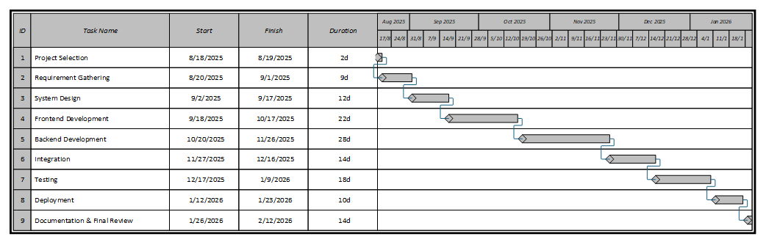

Figure 1: Gantt Chart

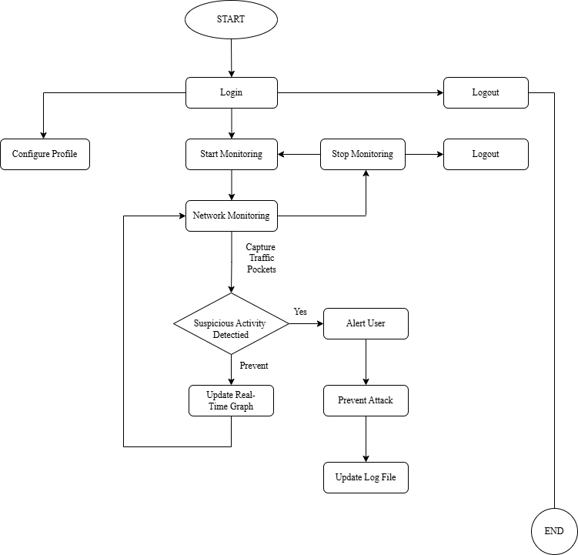

Figure 2:Diagmatric view of Project
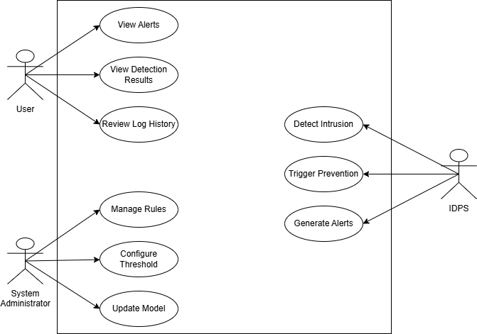

Figure 3: Use Case Diagram

