

|  |
| --- |
| ***BS Cyber Security Department AU*** |

|  |  |
| --- | --- |
| **Registration ID** | **233026, 232081 , 233004** |
| **Submitted By** | **Muhammad Sohaib Rafiq**  **Muhammad Ayan**  **Fahad Faisal** |
| **Submitted To** | **Sir Moshin Sarfraz** |
| **Date of Submission** | **18/12/2024** |
| **Assignment NO.** | **Configuration** |
| **Subject** | **Computer Networking** |

***Final Project Image:***

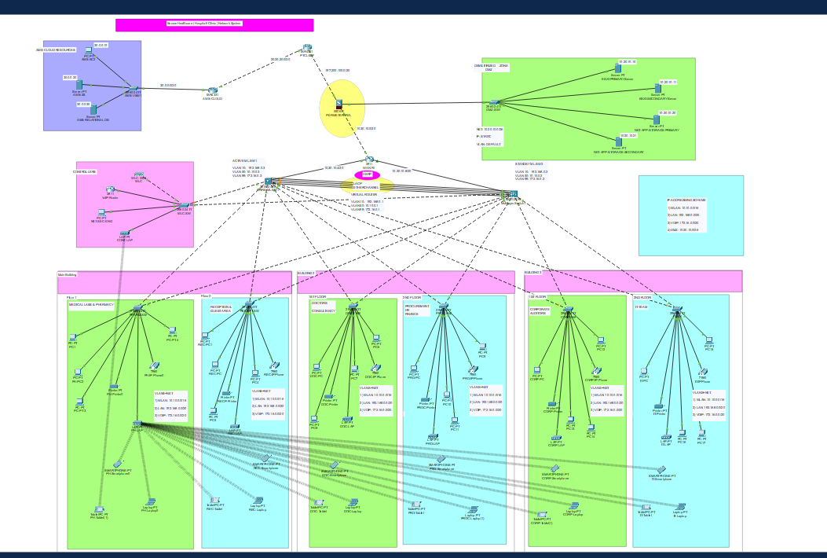

***AWS_CLoud Resources Configuration:***

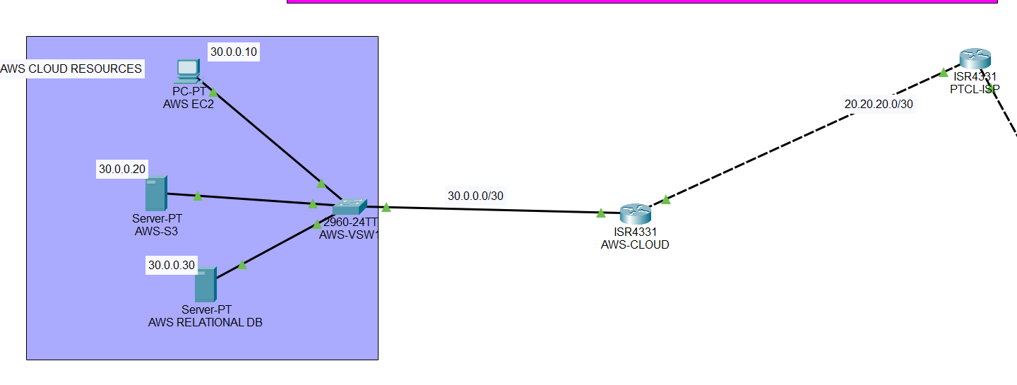

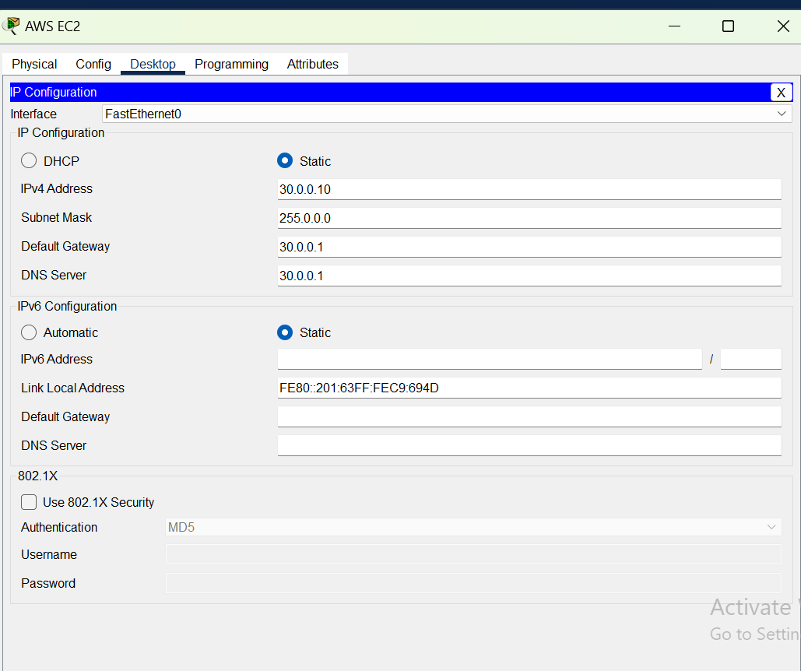

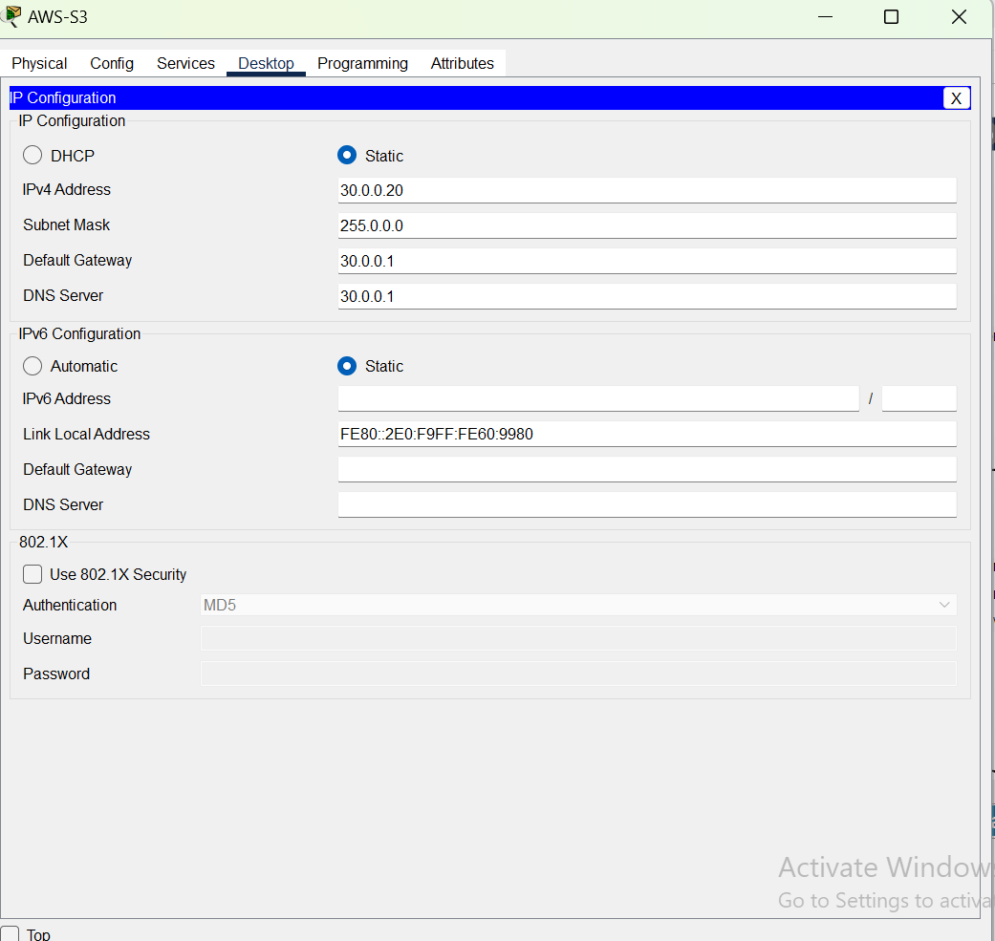

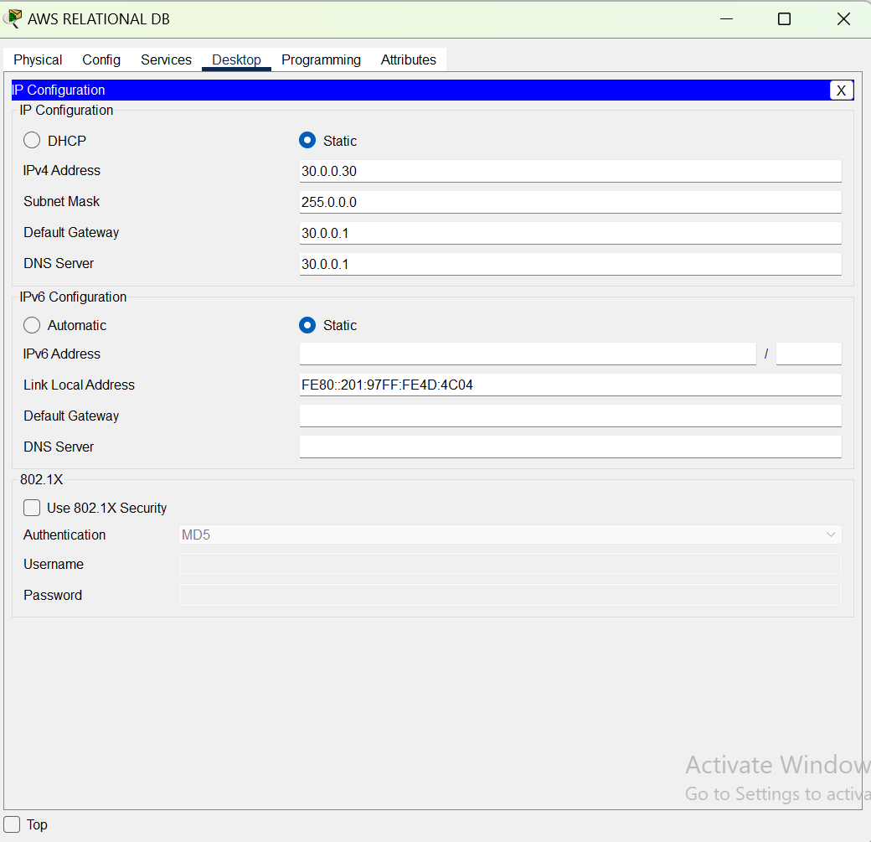

AWS-cloud Router Confiiguration:

outer(config)#

Router(config)#

Router(config)#

Router(config)#hostname AWS-CLOUD-Router

AWS-CLOUD-Router(config)#

AWS-CLOUD-Router(config)#

AWS-CLOUD-Router(config)#do show start

Using 797 bytes

!

version 15.4

no service timestamps log datetime msec

no service timestamps debug datetime msec

no service password-encryption

!

hostname Router

!

!

!

!

!

!

!

!

ip cef

no ipv6 cef

!

!

!

!

!

!

!

!

!

!

!

!

spanning-tree mode pvst

!

!

!

!

!

!

interface GigabitEthernet0/0/0

ip address 20.20.20.1 255.255.255.252

duplex auto

speed auto

!

interface GigabitEthernet0/0/1

ip address 30.0.0.1 255.0.0.0

duplex auto

speed auto

!

interface GigabitEthernet0/0/2

no ip address

duplex auto

speed auto

shutdown

!

interface Vlan1

no ip address

shutdown

!

router ospf 25

router-id 2.2.1.3

log-adjacency-changes

network 20.20.20.0 0.0.0.3 area 0

network 30.0.0.0 0.255.255.255 area 0

!

ip classless

!

ip flow-export version 9

!

!

!

!

!

!

!

line con 0

!

line aux 0

!

line vty 0 4

login

!

!

!

end

AWS-CLOUD-Router(config)#

PTCL-ISP-Router:

Router(config)#

Router(config)#hostname PTCL-ISP-Router

PTCL-ISP-Router(config)#

PTCL-ISP-Router(config)#

PTCL-ISP-Router(config)#do show start

Using 807 bytes

!

version 15.4

no service timestamps log datetime msec

no service timestamps debug datetime msec

no service password-encryption

!

hostname Router

!

!

!

!

!

!

!

!

ip cef

no ipv6 cef

!

!

!

!

!

!

!

!

!

!

!

!

spanning-tree mode pvst

!

!

!

!

!

!

interface GigabitEthernet0/0/0

ip address 197.200.100.1 255.255.255.252

duplex auto

speed auto

!

interface GigabitEthernet0/0/1

ip address 20.20.20.2 255.255.255.252

duplex auto

speed auto

!

interface GigabitEthernet0/0/2

no ip address

duplex auto

speed auto

shutdown

!

interface Vlan1

no ip address

shutdown

!

router ospf 25

router-id 2.1.2.1

log-adjacency-changes

network 20.20.20.0 0.0.0.3 area 0

network 197.200.100.0 0.0.0.3 area 0

!

ip classless

!

ip flow-export version 9

!

!

!

!

!

!

!

line con 0

!

line aux 0

!

line vty 0 4

login

!

!

!

end

PTCL-ISP-Router(config)#

PTCL-ISP-Router(config)#

***Configuration of the firewall:***

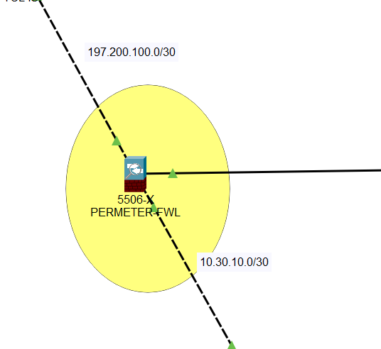

PERIMETER-FIREWALL#sh st

: Saved

: Written by enable_15 at 00:00:00 UTC Mar 1 1993

: Call-home enabled from prompt by enable_15 at 00:00:00 UTC Mar 1 1993

:

ASA Version 9.6(1)

!

hostname PERIMETER-FIREWALL

domain-name wr

names

!

interface GigabitEthernet1/1

nameif INSIDE

security-level 100

ip address 10.30.10.1 255.255.255.252

!

interface GigabitEthernet1/2

nameif DMZ

security-level 70

ip address 10.20.10.1 255.255.255.192

!

interface GigabitEthernet1/3

nameif OUTSIDE

security-level 0

ip address 197.200.100.2 255.255.255.252

!

interface GigabitEthernet1/4

no nameif

no security-level

no ip address

shutdown

!

interface GigabitEthernet1/5

no nameif

no security-level

no ip address

shutdown

!

interface GigabitEthernet1/6

no nameif

no security-level

no ip address

shutdown

!

interface GigabitEthernet1/7

no nameif

no security-level

no ip address

shutdown

!

interface GigabitEthernet1/8

no nameif

no security-level

no ip address

shutdown

!

interface Management1/1

management-only

no nameif

no security-level

no ip address

shutdown

!

object network DMZ-INTERNET

subnet 10.20.10.0 255.255.255.192

nat (DMZ,OUTSIDE) dynamic interface

object network LAN-INTERNET

subnet 192.168.0.0 255.255.240.0

nat (INSIDE,OUTSIDE) dynamic interface

object network WLAN-INTERNET

subnet 10.10.0.0 255.255.0.0

nat (INSIDE,OUTSIDE) dynamic interface

!

route OUTSIDE 0.0.0.0 0.0.0.0 197.200.100.1 1

!

access-list INSIDE-DMZ extended permit icmp any any

access-list INSIDE-DMZ extended permit tcp any any eq www

access-list INSIDE-DMZ extended permit udp any any eq bootps

access-list INSIDE-DMZ extended permit udp any any eq bootpc

access-list INSIDE-DMZ extended permit udp any any eq domain

access-list INSIDE-DMZ extended permit tcp any any eq domain

access-list INSIDE-OUTSIDE extended permit icmp any any

access-list INSIDE-OUTSIDE extended permit tcp any any eq www

!

!

access-group INSIDE-DMZ in interface DMZ

access-group INSIDE-OUTSIDE in interface OUTSIDE

!

!

class-map inspection_default

match default-inspection-traffic

!

policy-map type inspect dns preset_dns_map

parameters

message-length maximum 512

policy-map global_policy

class inspection_default

inspect dns preset_dns_map

inspect ftp

inspect tftp

!

service-policy global_policy global

!

telnet timeout 5

ssh timeout 5

!

!

!

!

router ospf 25

router-id 1.7.1.8

log-adjacency-changes

network 10.20.10.0 255.255.255.192 area 0

network 10.30.10.0 255.255.255.252 area 0

network 197.200.100.0 255.255.255.252 area 0

!

PERIMETER-FIREWALL#

PERIMETER-FIREWALL#

PERIMETER-FIREWALL#

PERIMETER-FIREWALL#

PERIMETER-FIREWALL#

***DMZ-Switch Configuration:***

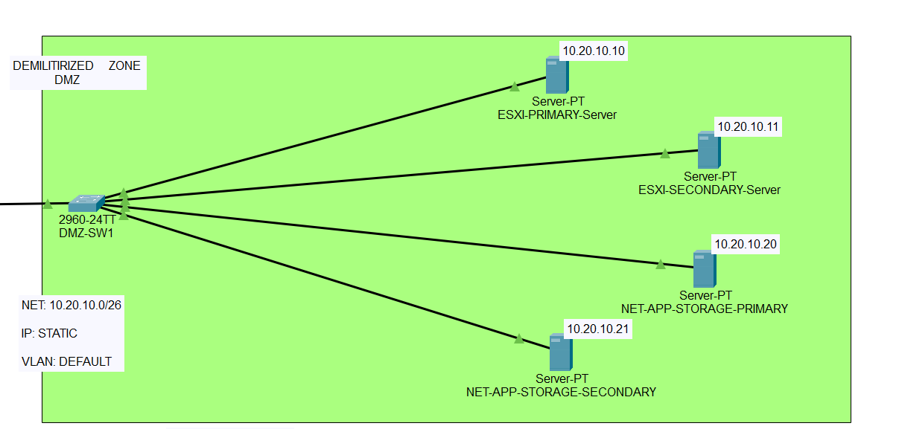

DMZ-SW1(config)#interface FastEthernet0/2

DMZ-SW1(config-if)#do show start

Using 1315 bytes

!

version 15.0

no service timestamps log datetime msec

no service timestamps debug datetime msec

service password-encryption

!

hostname DMZ-SW1

!

enable password 7 0822455D0A16

!

!

!

ip ssh version 2

no ip domain-lookup

ip domain-name hospital.org

!

username cisco privilege 1 password 7 0822455D0A16

!

!

!

spanning-tree mode pvst

spanning-tree extend system-id

!

interface FastEthernet0/1

!

interface FastEthernet0/2

!

interface FastEthernet0/3

!

interface FastEthernet0/4

!

interface FastEthernet0/5

!

interface FastEthernet0/6

!

interface FastEthernet0/7

!

interface FastEthernet0/8

!

interface FastEthernet0/9

!

interface FastEthernet0/10

!

interface FastEthernet0/11

!

interface FastEthernet0/12

!

interface FastEthernet0/13

!

interface FastEthernet0/14

!

interface FastEthernet0/15

!

interface FastEthernet0/16

!

interface FastEthernet0/17

!

interface FastEthernet0/18

!

interface FastEthernet0/19

!

interface FastEthernet0/20

!

interface FastEthernet0/21

!

interface FastEthernet0/22

!

interface FastEthernet0/23

!

interface FastEthernet0/24

!

interface GigabitEthernet0/1

!

interface GigabitEthernet0/2

!

interface Vlan1

no ip address

shutdown

!

banner motd ^CERROR!!!: UNAUTHORIZED ACCESS IS DENIED^C

!

!

!

line con 0

password 7 0822455D0A16

login

!

line vty 0 4

login

line vty 5 15

login

!

!

!

!

end

DMZ-SW1(config-if)#

DMZ-SW1(config-if)#

ESXI-Primary Server Configuration:

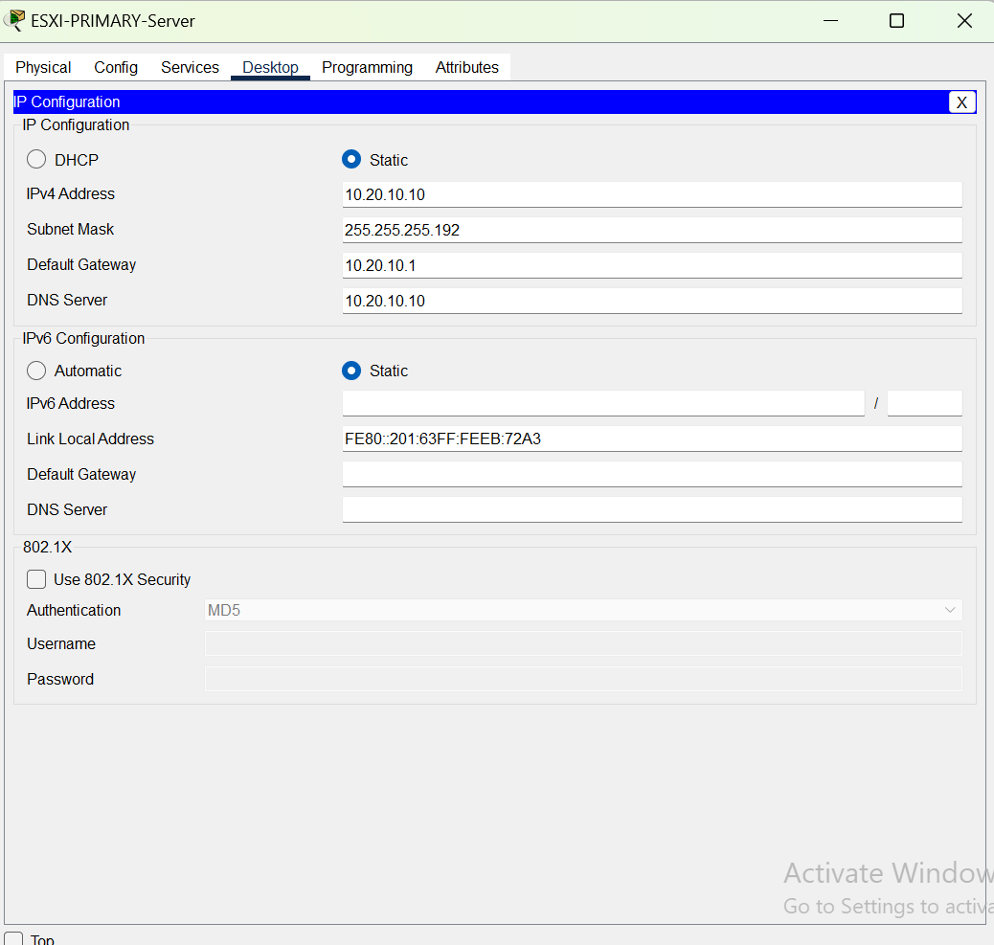

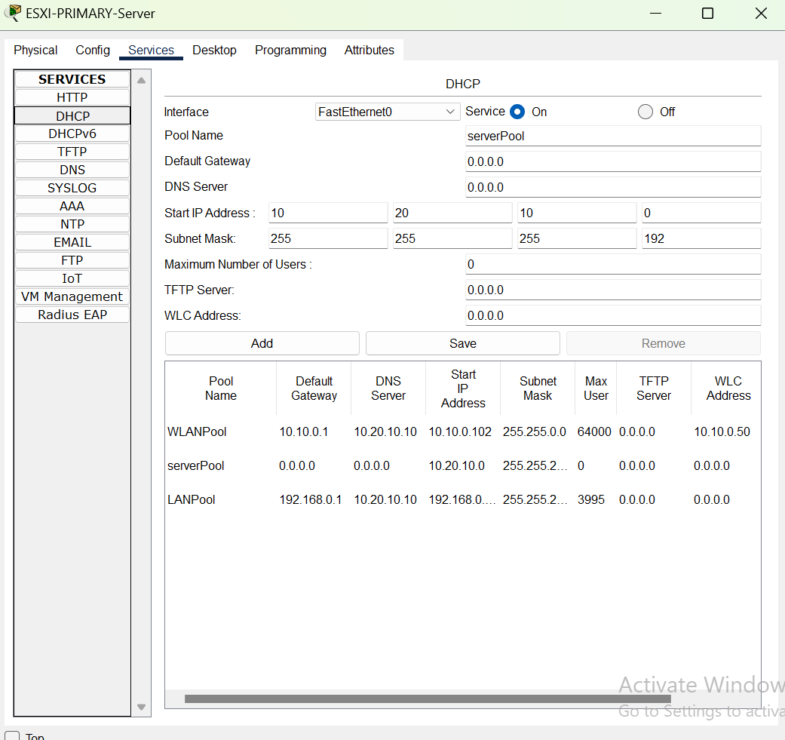

ESXI-Secondary Server Configuration:

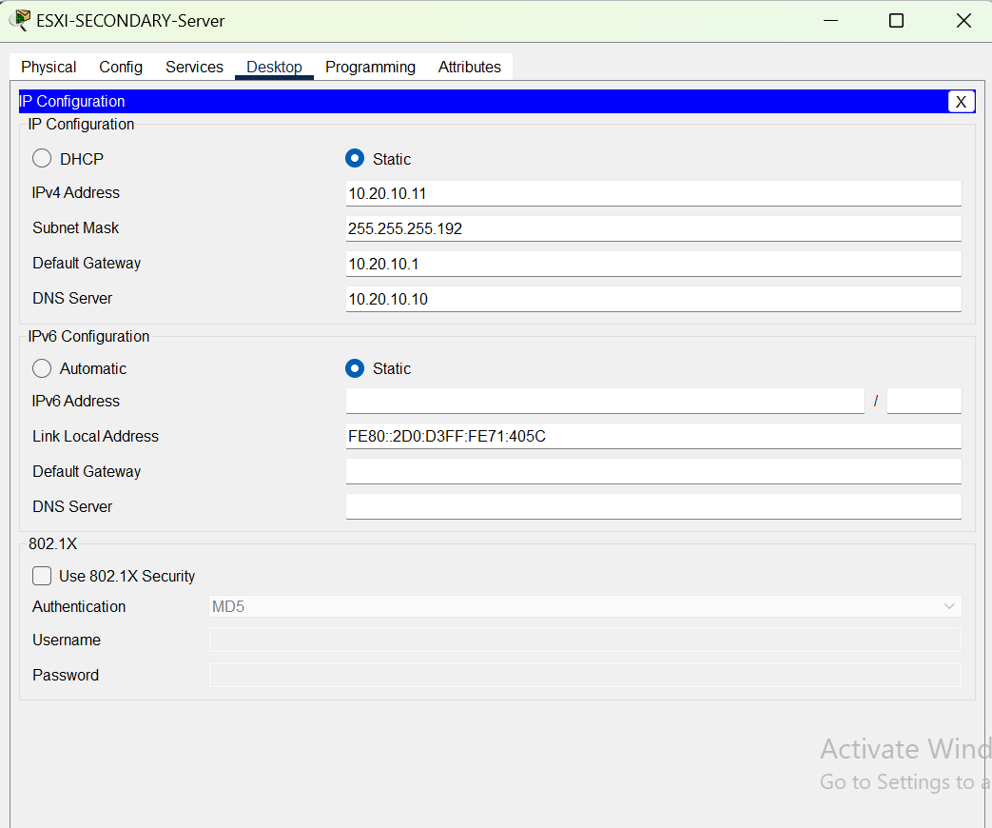

NET-APP-Storage-Primary server configuration:

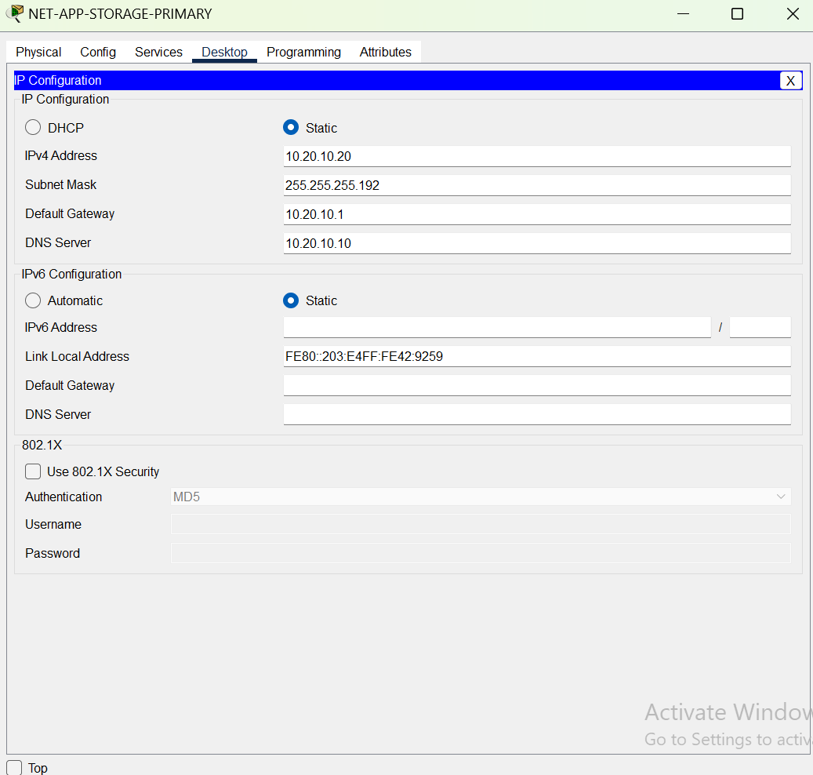

NET-APP-Storage-Primary server configuration:

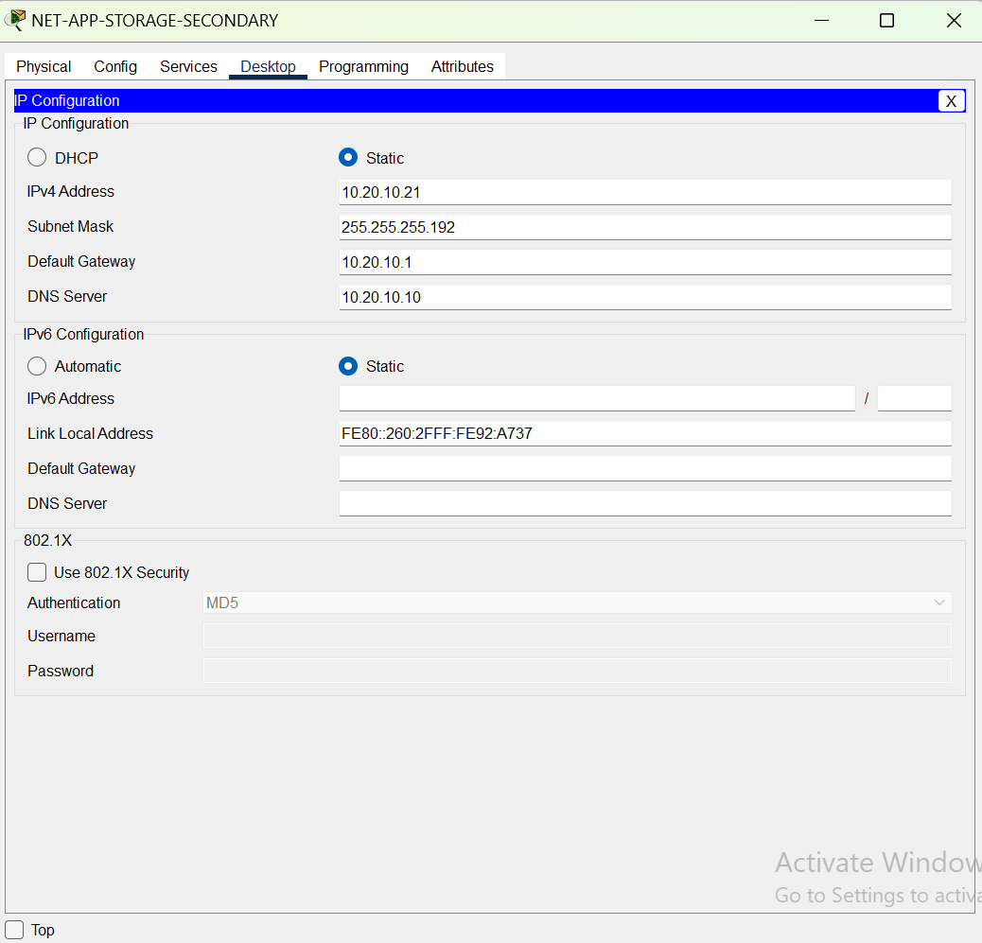

***NET-APP-Storage-Secondary server configuration:***

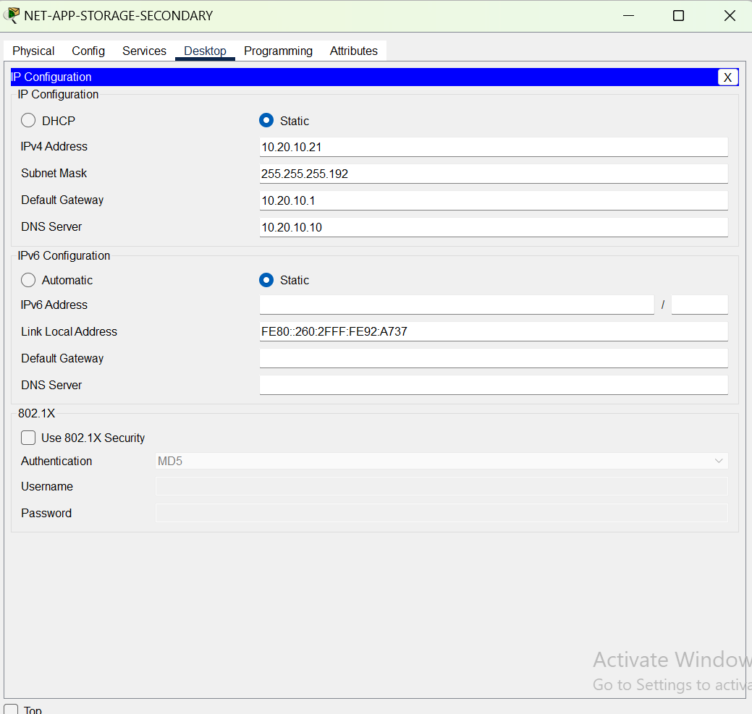

***WAN-Router-R1 configuration:***

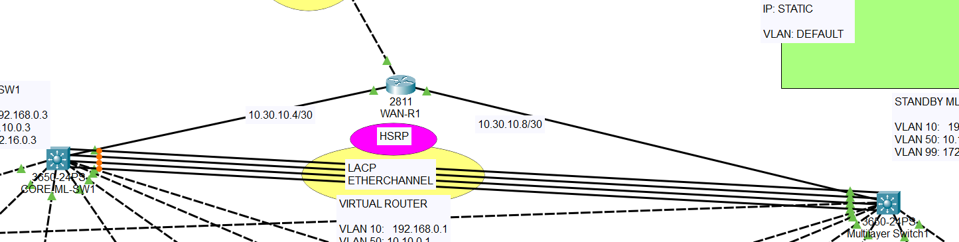

WAN-ROUTER(config-if)#do show start

Using 1231 bytes

!

version 15.1

no service timestamps log datetime msec

no service timestamps debug datetime msec

service password-encryption

!

hostname WAN-ROUTER

!

!

!

enable password 7 0822455D0A16

!

!

!

!

!

!

no ip cef

no ipv6 cef

!

!

!

username cisco password 7 0822455D0A16

!

!

license udi pid CISCO2811/K9 sn FTX101796H5-

!

!

!

!

!

!

!

!

!

ip ssh version 2

no ip domain-lookup

ip domain-name hospital.org

!

!

spanning-tree mode pvst

!

!

!

!

!

!

interface FastEthernet0/0

ip address 10.30.10.2 255.255.255.252

duplex auto

speed auto

!

interface FastEthernet0/1

ip address 10.30.10.6 255.255.255.252

duplex auto

speed auto

!

interface FastEthernet1/0

ip address 10.30.10.10 255.255.255.252

duplex auto

speed auto

!

interface FastEthernet1/1

no ip address

duplex auto

speed auto

shutdown

!

interface Vlan1

no ip address

shutdown

!

router ospf 25

router-id 1.4.1.4

log-adjacency-changes

network 10.30.10.4 0.0.0.3 area 0

network 10.30.10.8 0.0.0.3 area 0

network 10.20.10.0 0.0.0.255 area 0

network 10.30.10.0 0.0.0.3 area 0

!

ip classless

!

ip flow-export version 9

!

!

!

banner motd ^CERROR!!!: UNAUTHORIZED ACCESS IS DENIED^C

!

!

!

!

line con 0

password 7 0822455D0A16

login

!

line aux 0

!

line vty 0 4

login

!

!

!

end

WAN-ROUTER(config-if)#

WAN-ROUTER(config-if)#

***CORE-Ml-SW1 configuration:***

CORE-ML-SW1(config)#do show start

Using 2606 bytes

!

version 16.3.2

no service timestamps log datetime msec

no service timestamps debug datetime msec

service password-encryption

!

hostname CORE-ML-SW1

!

!

enable password 7 0822455D0A16

!

!

!

!

!

!

no ip cef

ip routing

!

no ipv6 cef

!

!

!

username cisco password 7 0822455D0A16

!

!

!

!

!

!

!

!

!

!

ip ssh version 2

no ip domain-lookup

ip domain-name hospital.org

!

!

spanning-tree mode pvst

!

!

!

!

!

!

interface Port-channel1

switchport mode trunk

!

interface GigabitEthernet1/0/1

no switchport

ip address 10.30.10.5 255.255.255.252

duplex auto

speed auto

!

interface GigabitEthernet1/0/2

switchport mode trunk

!

interface GigabitEthernet1/0/3

switchport mode trunk

!

interface GigabitEthernet1/0/4

switchport mode trunk

!

interface GigabitEthernet1/0/5

switchport mode trunk

!

interface GigabitEthernet1/0/6

switchport mode trunk

!

interface GigabitEthernet1/0/7

switchport mode trunk

!

interface GigabitEthernet1/0/8

switchport mode trunk

!

interface GigabitEthernet1/0/9

!

interface GigabitEthernet1/0/10

!

interface GigabitEthernet1/0/11

!

interface GigabitEthernet1/0/12

!

interface GigabitEthernet1/0/13

!

interface GigabitEthernet1/0/14

!

interface GigabitEthernet1/0/15

!

interface GigabitEthernet1/0/16

!

interface GigabitEthernet1/0/17

!

interface GigabitEthernet1/0/18

!

interface GigabitEthernet1/0/19

!

interface GigabitEthernet1/0/20

!

interface GigabitEthernet1/0/21

switchport mode trunk

channel-group 1 mode active

!

interface GigabitEthernet1/0/22

switchport mode trunk

channel-group 1 mode active

!

interface GigabitEthernet1/0/23

switchport mode trunk

channel-group 1 mode active

!

interface GigabitEthernet1/0/24

switchport mode trunk

channel-group 1 mode active

!

interface GigabitEthernet1/1/1

!

interface GigabitEthernet1/1/2

!

interface GigabitEthernet1/1/3

!

interface GigabitEthernet1/1/4

!

interface Vlan1

no ip address

shutdown

!

interface Vlan10

mac-address 0060.704e.7c01

ip address 192.168.0.3 255.255.240.0

ip helper-address 10.20.10.10

standby 10 ip 192.168.0.1

!

interface Vlan50

mac-address 0060.704e.7c02

ip address 10.10.0.3 255.255.0.0

ip helper-address 10.20.10.10

standby 50 ip 10.10.0.1

!

router ospf 25

router-id 1.2.1.2

log-adjacency-changes

network 10.10.0.0 0.0.255.255 area 0

network 192.168.0.0 0.0.15.255 area 0

network 172.16.0.0 0.0.15.255 area 0

network 10.30.10.4 0.0.0.3 area 0

network 10.20.10.0 0.0.0.255 area 0

!

ip classless

!

ip flow-export version 9

!

!

!

banner motd ^CERROR!!!: UNAUTHORIZED ACCESS IS DENIED^C

!

!

!

!

line con 0

password 7 0822455D0A16

login

!

line aux 0

!

line vty 0 4

login

!

!

!

!

end

CORE-ML-SW1(config)#

***Multilayer-Ml-SW1 configuration:***

!

version 16.3.2

no service timestamps log datetime msec

no service timestamps debug datetime msec

service password-encryption

!

hostname CORE-ML-SW2

!

!

enable password 7 0822455D0A16

!

!

!

!

!

!

no ip cef

ip routing

!

no ipv6 cef

!

!

!

username cisco password 7 0822455D0A16

!

!

!

!

!

!

!

!

!

!

ip ssh version 2

no ip domain-lookup

ip domain-name hospital.org

!

!

spanning-tree mode pvst

!

!

!

!

!

!

interface Port-channel1

switchport mode trunk

!

interface GigabitEthernet1/0/1

no switchport

ip address 10.30.10.9 255.255.255.252

duplex auto

speed auto

!

interface GigabitEthernet1/0/2

switchport mode trunk

!

interface GigabitEthernet1/0/3

switchport mode trunk

!

interface GigabitEthernet1/0/4

switchport mode trunk

!

interface GigabitEthernet1/0/5

switchport mode trunk

!

interface GigabitEthernet1/0/6

switchport mode trunk

!

interface GigabitEthernet1/0/7

switchport mode trunk

!

interface GigabitEthernet1/0/8

switchport mode trunk

!

interface GigabitEthernet1/0/9

!

interface GigabitEthernet1/0/10

!

interface GigabitEthernet1/0/11

!

interface GigabitEthernet1/0/12

!

interface GigabitEthernet1/0/13

!

interface GigabitEthernet1/0/14

!

interface GigabitEthernet1/0/15

!

interface GigabitEthernet1/0/16

!

interface GigabitEthernet1/0/17

!

interface GigabitEthernet1/0/18

!

interface GigabitEthernet1/0/19

!

interface GigabitEthernet1/0/20

!

interface GigabitEthernet1/0/21

switchport mode trunk

channel-group 1 mode active

!

interface GigabitEthernet1/0/22

switchport mode trunk

channel-group 1 mode active

!

interface GigabitEthernet1/0/23

switchport mode trunk

channel-group 1 mode active

!

interface GigabitEthernet1/0/24

switchport mode trunk

channel-group 1 mode active

!

interface GigabitEthernet1/1/1

!

interface GigabitEthernet1/1/2

!

interface GigabitEthernet1/1/3

!

interface GigabitEthernet1/1/4

!

interface Vlan1

no ip address

shutdown

!

interface Vlan10

mac-address 0001.c754.0901

ip address 192.168.0.4 255.255.240.0

ip helper-address 10.20.10.10

standby 10 ip 192.168.0.1

standby 10 priority 110

standby 10 preempt

!

interface Vlan50

mac-address 0001.c754.0902

ip address 10.10.0.4 255.255.0.0

ip helper-address 10.20.10.10

standby 50 ip 10.10.0.1

standby 50 priority 110

standby 50 preempt

!

router ospf 25

router-id 1.3.1.3

log-adjacency-changes

network 10.30.10.8 0.0.0.3 area 0

network 10.10.0.0 0.0.255.255 area 0

network 192.168.0.0 0.0.15.255 area 0

network 172.16.0.0 0.0.15.255 area 0

network 10.20.10.0 0.0.0.255 area 0

!

ip classless

!

ip flow-export version 9

!

!

!

banner motd ^CERROR!!!: UNAUTHORIZED ACCESS IS DENIED^C

!

!

!

!

line con 0

password 7 0822455D0A16

login

!

line aux 0

!

line vty 0 4

login

!

!

!

!

end

CORE-ML-SW2(config-if)#

***Controller Configuration:***

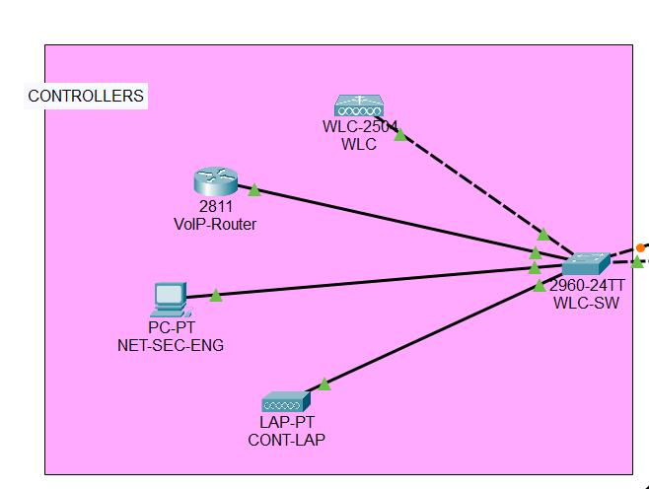

***WLC-SW:***

!

ip ssh version 2

no ip domain-lookup

ip domain-name hospital.org

!

username cisco privilege 1 password 7 0822455D0A16

!

!

!

spanning-tree mode pvst

spanning-tree extend system-id

!

interface FastEthernet0/1

switchport mode trunk

!

interface FastEthernet0/2

switchport mode trunk

!

interface FastEthernet0/3

switchport mode trunk

!

interface FastEthernet0/4

switchport access vlan 10

switchport mode access

switchport voice vlan 99

spanning-tree portfast

spanning-tree bpduguard enable

!

interface FastEthernet0/5

switchport access vlan 10

switchport mode access

switchport voice vlan 99

spanning-tree portfast

spanning-tree bpduguard enable

!

interface FastEthernet0/6

switchport access vlan 10

switchport mode access

switchport voice vlan 99

spanning-tree portfast

spanning-tree bpduguard enable

!

interface FastEthernet0/7

switchport access vlan 10

switchport mode access

switchport voice vlan 99

spanning-tree portfast

spanning-tree bpduguard enable

!

interface FastEthernet0/8

switchport access vlan 10

switchport mode access

switchport voice vlan 99

spanning-tree portfast

spanning-tree bpduguard enable

!

interface FastEthernet0/9

switchport access vlan 10

switchport mode access

switchport voice vlan 99

spanning-tree portfast

spanning-tree bpduguard enable

!

interface FastEthernet0/10

switchport access vlan 10

switchport mode access

switchport voice vlan 99

spanning-tree portfast

spanning-tree bpduguard enable

!

interface FastEthernet0/11

switchport access vlan 10

switchport mode access

switchport voice vlan 99

spanning-tree portfast

spanning-tree bpduguard enable

!

interface FastEthernet0/12

switchport access vlan 10

switchport mode access

switchport voice vlan 99

spanning-tree portfast

spanning-tree bpduguard enable

!

interface FastEthernet0/13

switchport access vlan 10

switchport mode access

switchport voice vlan 99

spanning-tree portfast

spanning-tree bpduguard enable

!

interface FastEthernet0/14

switchport access vlan 10

switchport mode access

switchport voice vlan 99

spanning-tree portfast

spanning-tree bpduguard enable

!

interface FastEthernet0/15

switchport access vlan 10

switchport mode access

switchport voice vlan 99

spanning-tree portfast

spanning-tree bpduguard enable

!

interface FastEthernet0/16

switchport access vlan 10

switchport mode access

switchport voice vlan 99

spanning-tree portfast

spanning-tree bpduguard enable

!

interface FastEthernet0/17

switchport access vlan 10

switchport mode access

switchport voice vlan 99

spanning-tree portfast

spanning-tree bpduguard enable

!

interface FastEthernet0/18

switchport access vlan 10

switchport mode access

switchport voice vlan 99

spanning-tree portfast

spanning-tree bpduguard enable

!

interface FastEthernet0/19

switchport access vlan 10

switchport mode access

switchport voice vlan 99

spanning-tree portfast

spanning-tree bpduguard enable

!

interface FastEthernet0/20

switchport access vlan 10

switchport mode access

switchport voice vlan 99

spanning-tree portfast

spanning-tree bpduguard enable

!

interface FastEthernet0/21

switchport access vlan 50

switchport mode access

spanning-tree portfast

spanning-tree bpduguard enable

!

interface FastEthernet0/22

switchport access vlan 50

switchport mode access

spanning-tree portfast

spanning-tree bpduguard enable

!

interface FastEthernet0/23

switchport access vlan 50

switchport mode access

spanning-tree portfast

spanning-tree bpduguard enable

!

interface FastEthernet0/24

switchport access vlan 50

switchport mode access

spanning-tree portfast

spanning-tree bpduguard enable

!

interface GigabitEthernet0/1

!

interface GigabitEthernet0/2

!

interface Vlan1

no ip address

shutdown

!

banner motd ^CERROR!!!: UNAUTHORIZED ACCESS IS DENIED^C

!

!

!

line con 0

password 7 0822455D0A16

login

!

line vty 0 4

login

line vty 5 15

login

!

!

!

!

end

CONTWLC-SW1(config-if)#

CONTWLC-SW1(config-if)#

CONTWLC-SW1(config-if)#

***VoIP Router Configuration:***

Router(config)#interface FastEthernet0/0

Router(config-if)#do show start

Using 1448 bytes

!

version 15.1

no service timestamps log datetime msec

no service timestamps debug datetime msec

no service password-encryption

!

hostname Router

!

!

!

!

!

ip dhcp pool VOIP

network 172.16.0.0 255.255.240.0

default-router 172.16.0.1

option 150 ip 172.16.0.1

!

!

!

ip cef

no ipv6 cef

!

!

!

!

license udi pid CISCO2811/K9 sn FTX1017EM3A-

!

!

!

!

!

!

!

!

!

!

!

spanning-tree mode pvst

!

!

!

!

!

!

interface FastEthernet0/0

no ip address

duplex auto

speed auto

shutdown

!

interface FastEthernet0/1

no ip address

duplex auto

speed auto

!

interface FastEthernet0/1.99

encapsulation dot1Q 99

ip address 172.16.0.1 255.255.240.0

!

interface Vlan1

no ip address

shutdown

!

ip classless

!

ip flow-export version 9

!

!

!

!

!

!

!

telephony-service

max-ephones 20

max-dn 20

ip source-address 172.16.0.1 port 2000

auto assign 1 to 20

!

ephone-dn 1

number 3001

!

ephone-dn 2

number 3002

!

ephone-dn 3

number 3003

!

ephone-dn 4

number 3004

!

ephone-dn 5

number 3005

!

ephone-dn 6

number 3006

!

ephone-dn 7

number 3007

!

ephone-dn 8

number 3008

!

ephone-dn 9

number 3009

!

ephone-dn 10

number 3010

!

ephone-dn 11

number 3011

!

ephone-dn 12

number 3012

!

ephone-dn 13

number 3013

!

ephone-dn 14

number 3014

!

ephone-dn 15

number 3015

!

ephone-dn 16

number 3016

!

ephone-dn 17

number 3017

!

ephone-dn 18

number 3018

!

ephone-dn 19

number 3019

!

ephone-dn 20

number 3020

!

line con 0

!

line aux 0

!

line vty 0 4

login

!

!

!

end

Router(config-if)#

Router(config-if)#

Router(config-if)#

***NET-SEC-ENG -PC configuration:***

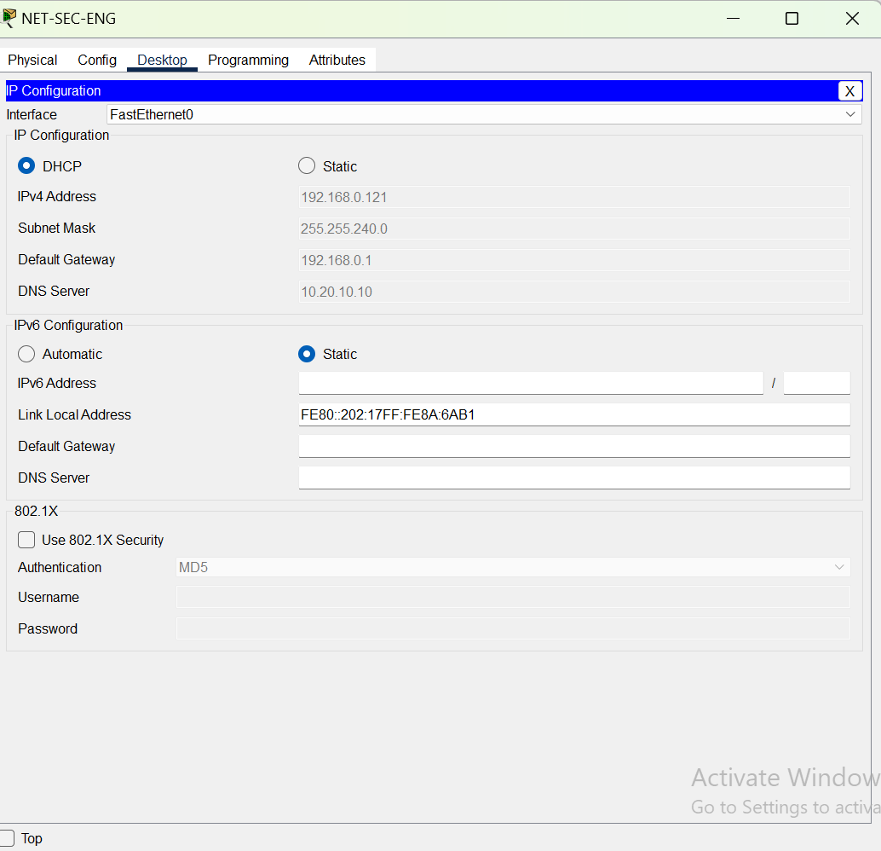

***PHARM-SW-Configuration:***

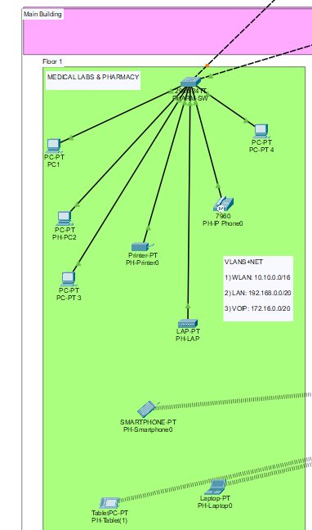

!

username cisco privilege 1 password 7 0822455D0A16

!

!

!

spanning-tree mode pvst

spanning-tree extend system-id

!

interface FastEthernet0/1

switchport mode trunk

!

interface FastEthernet0/2

switchport mode trunk

!

interface FastEthernet0/3

switchport access vlan 10

switchport mode access

switchport voice vlan 99

spanning-tree portfast

spanning-tree bpduguard enable

!

interface FastEthernet0/4

switchport access vlan 10

switchport mode access

switchport voice vlan 99

spanning-tree portfast

spanning-tree bpduguard enable

!

interface FastEthernet0/5

switchport access vlan 10

switchport mode access

switchport voice vlan 99

spanning-tree portfast

spanning-tree bpduguard enable

!

interface FastEthernet0/6

switchport access vlan 10

switchport mode access

switchport voice vlan 99

spanning-tree portfast

spanning-tree bpduguard enable

!

interface FastEthernet0/7

switchport access vlan 10

switchport mode access

switchport voice vlan 99

spanning-tree portfast

spanning-tree bpduguard enable

!

interface FastEthernet0/8

switchport access vlan 10

switchport mode access

switchport voice vlan 99

spanning-tree portfast

spanning-tree bpduguard enable

!

interface FastEthernet0/9

switchport access vlan 10

switchport mode access

switchport voice vlan 99

spanning-tree portfast

spanning-tree bpduguard enable

!

interface FastEthernet0/10

switchport access vlan 10

switchport mode access

switchport voice vlan 99

spanning-tree portfast

spanning-tree bpduguard enable

!

interface FastEthernet0/11

switchport access vlan 10

switchport mode access

switchport voice vlan 99

spanning-tree portfast

spanning-tree bpduguard enable

!

interface FastEthernet0/12

switchport access vlan 10

switchport mode access

switchport voice vlan 99

spanning-tree portfast

spanning-tree bpduguard enable

!

interface FastEthernet0/13

switchport access vlan 10

switchport mode access

switchport voice vlan 99

spanning-tree portfast

spanning-tree bpduguard enable

!

interface FastEthernet0/14

switchport access vlan 10

switchport mode access

switchport voice vlan 99

spanning-tree portfast

spanning-tree bpduguard enable

!

interface FastEthernet0/15

switchport access vlan 10

switchport mode access

switchport voice vlan 99

spanning-tree portfast

spanning-tree bpduguard enable

!

interface FastEthernet0/16

switchport access vlan 10

switchport mode access

switchport voice vlan 99

spanning-tree portfast

spanning-tree bpduguard enable

!

interface FastEthernet0/17

switchport access vlan 10

switchport mode access

switchport voice vlan 99

spanning-tree portfast

spanning-tree bpduguard enable

!

interface FastEthernet0/18

switchport access vlan 10

switchport mode access

switchport voice vlan 99

spanning-tree portfast

spanning-tree bpduguard enable

!

interface FastEthernet0/19

switchport access vlan 10

switchport mode access

switchport voice vlan 99

spanning-tree portfast

spanning-tree bpduguard enable

!

interface FastEthernet0/20

switchport access vlan 10

switchport mode access

switchport voice vlan 99

spanning-tree portfast

spanning-tree bpduguard enable

!

interface FastEthernet0/21

switchport access vlan 50

switchport mode access

spanning-tree portfast

spanning-tree bpduguard enable

!

interface FastEthernet0/22

switchport access vlan 50

switchport mode access

spanning-tree portfast

spanning-tree bpduguard enable

!

interface FastEthernet0/23

switchport access vlan 50

switchport mode access

spanning-tree portfast

spanning-tree bpduguard enable

!

interface FastEthernet0/24

switchport access vlan 50

switchport mode access

spanning-tree portfast

spanning-tree bpduguard enable

!

interface GigabitEthernet0/1

!

interface GigabitEthernet0/2

!

interface Vlan1

no ip address

shutdown

!

banner motd ^CUNAUTHORIZED ACCESS IS PRHOBITIED^C

!

!

!

line con 0

password 7 0822455D0A16

login

!

line vty 0 4

login

line vty 5 15

login

!

!

!

!

end

PHARMACY-SW1(config-if)#

PHARMACY-SW1(config-if)#

PHARMACY-SW1(config-if)#

PHARMACY-SW1(config-if)#

PHARMACY-SW1(config-if)#

PHARMACY-SW1(config-if)#

PHARMACY-SW1(config-if)#

PHARMACY-SW1(config-if)#

***Recept-SW-configuration:***

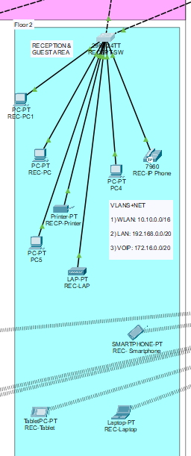

!

!

!

ip ssh version 2

no ip domain-lookup

ip domain-name hospital.org

!

username cisco privilege 1 password 7 0822455D0A16

!

!

!

spanning-tree mode pvst

spanning-tree extend system-id

!

interface FastEthernet0/1

switchport mode trunk

!

interface FastEthernet0/2

switchport mode trunk

!

interface FastEthernet0/3

switchport access vlan 10

switchport mode access

switchport voice vlan 99

spanning-tree portfast

spanning-tree bpduguard enable

!

interface FastEthernet0/4

switchport access vlan 10

switchport mode access

switchport voice vlan 99

spanning-tree portfast

spanning-tree bpduguard enable

!

interface FastEthernet0/5

switchport access vlan 10

switchport mode access

switchport voice vlan 99

spanning-tree portfast

spanning-tree bpduguard enable

!

interface FastEthernet0/6

switchport access vlan 10

switchport mode access

switchport voice vlan 99

spanning-tree portfast

spanning-tree bpduguard enable

!

interface FastEthernet0/7

switchport access vlan 10

switchport mode access

switchport voice vlan 99

spanning-tree portfast

spanning-tree bpduguard enable

!

interface FastEthernet0/8

switchport access vlan 10

switchport mode access

switchport voice vlan 99

spanning-tree portfast

spanning-tree bpduguard enable

!

interface FastEthernet0/9

switchport access vlan 10

switchport mode access

switchport voice vlan 99

spanning-tree portfast

spanning-tree bpduguard enable

!

interface FastEthernet0/10

switchport access vlan 10

switchport mode access

switchport voice vlan 99

spanning-tree portfast

spanning-tree bpduguard enable

!

interface FastEthernet0/11

switchport access vlan 10

switchport mode access

switchport voice vlan 99

spanning-tree portfast

spanning-tree bpduguard enable

!

interface FastEthernet0/12

switchport access vlan 10

switchport mode access

switchport voice vlan 99

spanning-tree portfast

spanning-tree bpduguard enable

!

interface FastEthernet0/13

switchport access vlan 10

switchport mode access

switchport voice vlan 99

spanning-tree portfast

spanning-tree bpduguard enable

!

interface FastEthernet0/14

switchport access vlan 10

switchport mode access

switchport voice vlan 99

spanning-tree portfast

spanning-tree bpduguard enable

!

interface FastEthernet0/15

switchport access vlan 10

switchport mode access

switchport voice vlan 99

spanning-tree portfast

spanning-tree bpduguard enable

!

interface FastEthernet0/16

switchport access vlan 10

switchport mode access

switchport voice vlan 99

spanning-tree portfast

spanning-tree bpduguard enable

!

interface FastEthernet0/17

switchport access vlan 10

switchport mode access

switchport voice vlan 99

spanning-tree portfast

spanning-tree bpduguard enable

!

interface FastEthernet0/18

switchport access vlan 10

switchport mode access

switchport voice vlan 99

spanning-tree portfast

spanning-tree bpduguard enable

!

interface FastEthernet0/19

switchport access vlan 10

switchport mode access

switchport voice vlan 99

spanning-tree portfast

spanning-tree bpduguard enable

!

interface FastEthernet0/20

switchport access vlan 10

switchport mode access

switchport voice vlan 99

spanning-tree portfast

spanning-tree bpduguard enable

!

interface FastEthernet0/21

switchport access vlan 50

switchport mode access

spanning-tree portfast

spanning-tree bpduguard enable

!

interface FastEthernet0/22

switchport access vlan 50

switchport mode access

spanning-tree portfast

spanning-tree bpduguard enable

!

interface FastEthernet0/23

switchport access vlan 50

switchport mode access

spanning-tree portfast

spanning-tree bpduguard enable

!

interface FastEthernet0/24

switchport access vlan 50

switchport mode access

spanning-tree portfast

spanning-tree bpduguard enable

!

interface GigabitEthernet0/1

!

interface GigabitEthernet0/2

!

interface Vlan1

no ip address

shutdown

!

banner motd ^CERROR!!!: UNAUTHORIZED ACCESS IS DENIED^C

!

!

!

line con 0

password 7 0822455D0A16

login

!

line vty 0 4

login

line vty 5 15

login

!

!

!

!

end

RECEPITION-SW1(config-if)#

RECEPITION-SW1(config-if)#

***DOCT-SW-configuration:***

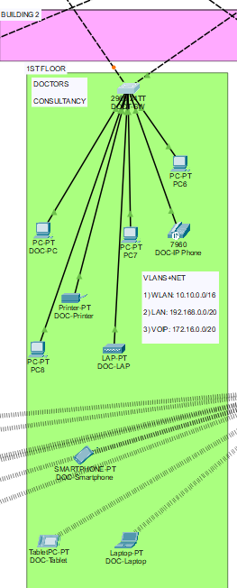

!

enable password 7 0822455D0A16

!

!

!

ip ssh version 2

no ip domain-lookup

ip domain-name hospital.org

!

username cisco privilege 1 password 7 0822455D0A16

!

!

!

spanning-tree mode pvst

spanning-tree extend system-id

!

interface FastEthernet0/1

switchport mode trunk

!

interface FastEthernet0/2

switchport mode trunk

!

interface FastEthernet0/3

switchport access vlan 10

switchport mode access

switchport voice vlan 99

spanning-tree portfast

spanning-tree bpduguard enable

!

interface FastEthernet0/4

switchport access vlan 10

switchport mode access

switchport voice vlan 99

spanning-tree portfast

spanning-tree bpduguard enable

!

interface FastEthernet0/5

switchport access vlan 10

switchport mode access

switchport voice vlan 99

spanning-tree portfast

spanning-tree bpduguard enable

!

interface FastEthernet0/6

switchport access vlan 10

switchport mode access

switchport voice vlan 99

spanning-tree portfast

spanning-tree bpduguard enable

!

interface FastEthernet0/7

switchport access vlan 10

switchport mode access

switchport voice vlan 99

spanning-tree portfast

spanning-tree bpduguard enable

!

interface FastEthernet0/8

switchport access vlan 10

switchport mode access

switchport voice vlan 99

spanning-tree portfast

spanning-tree bpduguard enable

!

interface FastEthernet0/9

switchport access vlan 10

switchport mode access

switchport voice vlan 99

spanning-tree portfast

spanning-tree bpduguard enable

!

interface FastEthernet0/10

switchport access vlan 10

switchport mode access

switchport voice vlan 99

spanning-tree portfast

spanning-tree bpduguard enable

!

interface FastEthernet0/11

switchport access vlan 10

switchport mode access

switchport voice vlan 99

spanning-tree portfast

spanning-tree bpduguard enable

!

interface FastEthernet0/12

switchport access vlan 10

switchport mode access

switchport voice vlan 99

spanning-tree portfast

spanning-tree bpduguard enable

!

interface FastEthernet0/13

switchport access vlan 10

switchport mode access

switchport voice vlan 99

spanning-tree portfast

spanning-tree bpduguard enable

!

interface FastEthernet0/14

switchport access vlan 10

switchport mode access

switchport voice vlan 99

spanning-tree portfast

spanning-tree bpduguard enable

!

interface FastEthernet0/15

switchport access vlan 10

switchport mode access

switchport voice vlan 99

spanning-tree portfast

spanning-tree bpduguard enable

!

interface FastEthernet0/16

switchport access vlan 10

switchport mode access

switchport voice vlan 99

spanning-tree portfast

spanning-tree bpduguard enable

!

interface FastEthernet0/17

switchport access vlan 10

switchport mode access

switchport voice vlan 99

spanning-tree portfast

spanning-tree bpduguard enable

!

interface FastEthernet0/18

switchport access vlan 10

switchport mode access

switchport voice vlan 99

spanning-tree portfast

spanning-tree bpduguard enable

!

interface FastEthernet0/19

switchport access vlan 10

switchport mode access

switchport voice vlan 99

spanning-tree portfast

spanning-tree bpduguard enable

!

interface FastEthernet0/20

switchport access vlan 10

switchport mode access

switchport voice vlan 99

spanning-tree portfast

spanning-tree bpduguard enable

!

interface FastEthernet0/21

switchport access vlan 50

switchport mode access

spanning-tree portfast

spanning-tree bpduguard enable

!

interface FastEthernet0/22

switchport access vlan 50

switchport mode access

spanning-tree portfast

spanning-tree bpduguard enable

!

interface FastEthernet0/23

switchport access vlan 50

switchport mode access

spanning-tree portfast

spanning-tree bpduguard enable

!

interface FastEthernet0/24

switchport access vlan 50

switchport mode access

spanning-tree portfast

spanning-tree bpduguard enable

!

interface GigabitEthernet0/1

!

interface GigabitEthernet0/2

!

interface Vlan1

no ip address

shutdown

!

banner motd ^CERROR!!!: UNAUTHORIZED ACCESS IS DENIED^C

!

!

!

line con 0

password 7 0822455D0A16

login

!

line vty 0 4

login

line vty 5 15

login

!

!

!

!

end

DOCTOR-SW1(config-if)#

***PROC-SW-configuration:***

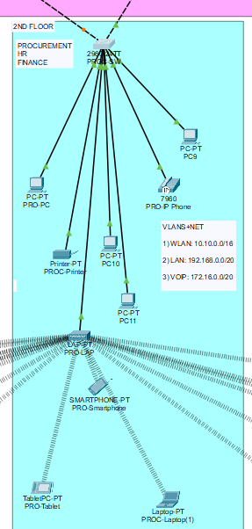

spanning-tree mode pvst

spanning-tree extend system-id

!

interface FastEthernet0/1

switchport mode trunk

!

interface FastEthernet0/2

switchport mode trunk

!

interface FastEthernet0/3

switchport access vlan 10

switchport mode access

switchport voice vlan 99

spanning-tree portfast

spanning-tree bpduguard enable

!

interface FastEthernet0/4

switchport access vlan 10

switchport mode access

switchport voice vlan 99

spanning-tree portfast

spanning-tree bpduguard enable

!

interface FastEthernet0/5

switchport access vlan 10

switchport mode access

switchport voice vlan 99

spanning-tree portfast

spanning-tree bpduguard enable

!

interface FastEthernet0/6

switchport access vlan 10

switchport mode access

switchport voice vlan 99

spanning-tree portfast

spanning-tree bpduguard enable

!

interface FastEthernet0/7

switchport access vlan 10

switchport mode access

switchport voice vlan 99

spanning-tree portfast

spanning-tree bpduguard enable

!

interface FastEthernet0/8

switchport access vlan 10

switchport mode access

switchport voice vlan 99

spanning-tree portfast

spanning-tree bpduguard enable

!

interface FastEthernet0/9

switchport access vlan 10

switchport mode access

switchport voice vlan 99

spanning-tree portfast

spanning-tree bpduguard enable

!

interface FastEthernet0/10

switchport access vlan 10

switchport mode access

switchport voice vlan 99

spanning-tree portfast

spanning-tree bpduguard enable

!

interface FastEthernet0/11

switchport access vlan 10

switchport mode access

switchport voice vlan 99

spanning-tree portfast

spanning-tree bpduguard enable

!

interface FastEthernet0/12

switchport access vlan 10

switchport mode access

switchport voice vlan 99

spanning-tree portfast

spanning-tree bpduguard enable

!

interface FastEthernet0/13

switchport access vlan 10

switchport mode access

switchport voice vlan 99

spanning-tree portfast

spanning-tree bpduguard enable

!

interface FastEthernet0/14

switchport access vlan 10

switchport mode access

switchport voice vlan 99

spanning-tree portfast

spanning-tree bpduguard enable

!

interface FastEthernet0/15

switchport access vlan 10

switchport mode access

switchport voice vlan 99

spanning-tree portfast

spanning-tree bpduguard enable

!

interface FastEthernet0/16

switchport access vlan 10

switchport mode access

switchport voice vlan 99

spanning-tree portfast

spanning-tree bpduguard enable

!

interface FastEthernet0/17

switchport access vlan 10

switchport mode access

switchport voice vlan 99

spanning-tree portfast

spanning-tree bpduguard enable

!

interface FastEthernet0/18

switchport access vlan 10

switchport mode access

switchport voice vlan 99

spanning-tree portfast

spanning-tree bpduguard enable

!

interface FastEthernet0/19

switchport access vlan 10

switchport mode access

switchport voice vlan 99

spanning-tree portfast

spanning-tree bpduguard enable

!

interface FastEthernet0/20

switchport access vlan 10

switchport mode access

switchport voice vlan 99

spanning-tree portfast

spanning-tree bpduguard enable

!

interface FastEthernet0/21

switchport access vlan 50

switchport mode access

spanning-tree portfast

spanning-tree bpduguard enable

!

interface FastEthernet0/22

switchport access vlan 50

switchport mode access

spanning-tree portfast

spanning-tree bpduguard enable

!

interface FastEthernet0/23

switchport access vlan 50

switchport mode access

spanning-tree portfast

spanning-tree bpduguard enable

!

interface FastEthernet0/24

switchport access vlan 50

switchport mode access

spanning-tree portfast

spanning-tree bpduguard enable

!

interface GigabitEthernet0/1

!

interface GigabitEthernet0/2

!

interface Vlan1

no ip address

shutdown

!

banner motd ^CERROR!!!: UNAUTHORIZED ACCESS IS DENIED^C

!

!

!

line con 0

password 7 0822455D0A16

login

!

line vty 0 4

login

line vty 5 15

login

!

!

!

!

end

HR-FINANCE-SW1(config-if)#

HR-FINANCE-SW1(config-if)#

HR-FINANCE-SW1(config-if)#

HR-FINANCE-SW1(config-if)#

***Corporate-Switch-Configuration:***

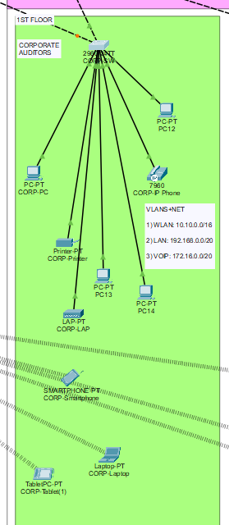

!

!

!

spanning-tree mode pvst

spanning-tree extend system-id

!

interface FastEthernet0/1

switchport mode trunk

!

interface FastEthernet0/2

switchport mode trunk

!

interface FastEthernet0/3

switchport access vlan 10

switchport mode access

switchport voice vlan 99

spanning-tree portfast

spanning-tree bpduguard enable

!

interface FastEthernet0/4

switchport access vlan 10

switchport mode access

switchport voice vlan 99

spanning-tree portfast

spanning-tree bpduguard enable

!

interface FastEthernet0/5

switchport access vlan 10

switchport mode access

switchport voice vlan 99

spanning-tree portfast

spanning-tree bpduguard enable

!

interface FastEthernet0/6

switchport access vlan 10

switchport mode access

switchport voice vlan 99

spanning-tree portfast

spanning-tree bpduguard enable

!

interface FastEthernet0/7

switchport access vlan 10

switchport mode access

switchport voice vlan 99

spanning-tree portfast

spanning-tree bpduguard enable

!

interface FastEthernet0/8

switchport access vlan 10

switchport mode access

switchport voice vlan 99

spanning-tree portfast

spanning-tree bpduguard enable

!

interface FastEthernet0/9

switchport access vlan 10

switchport mode access

switchport voice vlan 99

spanning-tree portfast

spanning-tree bpduguard enable

!

interface FastEthernet0/10

switchport access vlan 10

switchport mode access

switchport voice vlan 99

spanning-tree portfast

spanning-tree bpduguard enable

!

interface FastEthernet0/11

switchport access vlan 10

switchport mode access

switchport voice vlan 99

spanning-tree portfast

spanning-tree bpduguard enable

!

interface FastEthernet0/12

switchport access vlan 10

switchport mode access

switchport voice vlan 99

spanning-tree portfast

spanning-tree bpduguard enable

!

interface FastEthernet0/13

switchport access vlan 10

switchport mode access

switchport voice vlan 99

spanning-tree portfast

spanning-tree bpduguard enable

!

interface FastEthernet0/14

switchport access vlan 10

switchport mode access

switchport voice vlan 99

spanning-tree portfast

spanning-tree bpduguard enable

!

interface FastEthernet0/15

switchport access vlan 10

switchport mode access

switchport voice vlan 99

spanning-tree portfast

spanning-tree bpduguard enable

!

interface FastEthernet0/16

switchport access vlan 10

switchport mode access

switchport voice vlan 99

spanning-tree portfast

spanning-tree bpduguard enable

!

interface FastEthernet0/17

switchport access vlan 10

switchport mode access

switchport voice vlan 99

spanning-tree portfast

spanning-tree bpduguard enable

!

interface FastEthernet0/18

switchport access vlan 10

switchport mode access

switchport voice vlan 99

spanning-tree portfast

spanning-tree bpduguard enable

!

interface FastEthernet0/19

switchport access vlan 10

switchport mode access

switchport voice vlan 99

spanning-tree portfast

spanning-tree bpduguard enable

!

interface FastEthernet0/20

switchport access vlan 10

switchport mode access

switchport voice vlan 99

spanning-tree portfast

spanning-tree bpduguard enable

!

interface FastEthernet0/21

switchport access vlan 50

switchport mode access

spanning-tree portfast

spanning-tree bpduguard enable

!

interface FastEthernet0/22

switchport access vlan 50

switchport mode access

spanning-tree portfast

spanning-tree bpduguard enable

!

interface FastEthernet0/23

switchport access vlan 50

switchport mode access

spanning-tree portfast

spanning-tree bpduguard enable

!

interface FastEthernet0/24

switchport access vlan 50

switchport mode access

spanning-tree portfast

spanning-tree bpduguard enable

!

interface GigabitEthernet0/1

!

interface GigabitEthernet0/2

!

interface Vlan1

no ip address

shutdown

!

banner motd ^CERROR!!!: UNAUTHORIZED ACCESS IS DENIED^C

!

!

!

line con 0

password 7 0822455D0A16

login

!

line vty 0 4

login

line vty 5 15

login

!

!

!

!

end

AUDITIORS-SW1(config-if)#

AUDITIORS-SW1(config-if)#

AUDITIORS-SW1(config-if)#

AUDITIORS-SW1(config-if)#

***IT-SW-Configuration:***

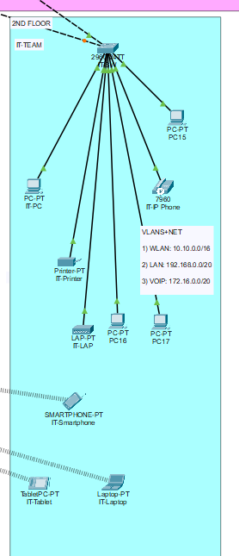

!

interface FastEthernet0/1

switchport mode trunk

!

interface FastEthernet0/2

switchport mode trunk

!

interface FastEthernet0/3

switchport access vlan 10

switchport mode access

switchport voice vlan 99

spanning-tree portfast

spanning-tree bpduguard enable

!

interface FastEthernet0/4

switchport access vlan 10

switchport mode access

switchport voice vlan 99

spanning-tree portfast

spanning-tree bpduguard enable

!

interface FastEthernet0/5

switchport access vlan 10

switchport mode access

switchport voice vlan 99

spanning-tree portfast

spanning-tree bpduguard enable

!

interface FastEthernet0/6

switchport access vlan 10

switchport mode access

switchport voice vlan 99

spanning-tree portfast

spanning-tree bpduguard enable

!

interface FastEthernet0/7

switchport access vlan 10

switchport mode access

switchport voice vlan 99

spanning-tree portfast

spanning-tree bpduguard enable

!

interface FastEthernet0/8

switchport access vlan 10

switchport mode access

switchport voice vlan 99

spanning-tree portfast

spanning-tree bpduguard enable

!

interface FastEthernet0/9

switchport access vlan 10

switchport mode access

switchport voice vlan 99

spanning-tree portfast

spanning-tree bpduguard enable

!

interface FastEthernet0/10

switchport access vlan 10

switchport mode access

switchport voice vlan 99

spanning-tree portfast

spanning-tree bpduguard enable

!

interface FastEthernet0/11

switchport access vlan 10

switchport mode access

switchport voice vlan 99

spanning-tree portfast

spanning-tree bpduguard enable

!

interface FastEthernet0/12

switchport access vlan 10

switchport mode access

switchport voice vlan 99

spanning-tree portfast

spanning-tree bpduguard enable

!

interface FastEthernet0/13

switchport access vlan 10

switchport mode access

switchport voice vlan 99

spanning-tree portfast

spanning-tree bpduguard enable

!

interface FastEthernet0/14

switchport access vlan 10

switchport mode access

switchport voice vlan 99

spanning-tree portfast

spanning-tree bpduguard enable

!

interface FastEthernet0/15

switchport access vlan 10

switchport mode access

switchport voice vlan 99

spanning-tree portfast

spanning-tree bpduguard enable

!

interface FastEthernet0/16

switchport access vlan 10

switchport mode access

switchport voice vlan 99

spanning-tree portfast

spanning-tree bpduguard enable

!

interface FastEthernet0/17

switchport access vlan 10

switchport mode access

switchport voice vlan 99

spanning-tree portfast

spanning-tree bpduguard enable

!

interface FastEthernet0/18

switchport access vlan 10

switchport mode access

switchport voice vlan 99

spanning-tree portfast

spanning-tree bpduguard enable

!

interface FastEthernet0/19

switchport access vlan 10

switchport mode access

switchport voice vlan 99

spanning-tree portfast

spanning-tree bpduguard enable

!

interface FastEthernet0/20

switchport access vlan 10

switchport mode access

switchport voice vlan 99

spanning-tree portfast

spanning-tree bpduguard enable

!

interface FastEthernet0/21

switchport access vlan 50

switchport mode access

spanning-tree portfast

spanning-tree bpduguard enable

!

interface FastEthernet0/22

switchport access vlan 50

switchport mode access

spanning-tree portfast

spanning-tree bpduguard enable

!

interface FastEthernet0/23

switchport access vlan 50

switchport mode access

spanning-tree portfast

spanning-tree bpduguard enable

!

interface FastEthernet0/24

switchport access vlan 50

switchport mode access

spanning-tree portfast

spanning-tree bpduguard enable

!

interface GigabitEthernet0/1

!

interface GigabitEthernet0/2

!

interface Vlan1

no ip address

shutdown

!

banner motd ^CERROR!!!: UNAUTHORIZED ACCESS IS DENIED^C

!

!

!

line con 0

password 7 0822455D0A16

login

!

line vty 0 4

login

line vty 5 15

login

!

!

!

!

end

IT-SW1(config-if)#

IT-SW1(config-if)#