**TASK 1**

### **Step 1: Download Kali Linux ISO**

1. **Visit the Kali Linux website**:  
   **Kali Linux Downloads**.
2. Select the appropriate version:
   1. **Installer ISO**: Ideal for VirtualBox installations.
   2. **64-bit (x64)**: Recommended unless you have older hardware.
3. Click on the download link to start downloading the ISO file.

### **Step 2: Download and Install VirtualBox**

1. Visit the VirtualBox website:  
   [VirtualBox Downloads](https://www.virtualbox.org/" \t "C:\\Users\\PERFEC~1\\AppData\\Local\\Temp\_new).
2. Download and install the version compatible with your operating system (Windows, macOS, or Linux).

### **Step 3: Create a Virtual Machine**

1. Open **VirtualBox**.
2. Click on **New** to create a new virtual machine.
3. Fill in the following details:
   1. **Name**: Give your virtual machine a name (e.g., Kali Linux).
   2. **Type**: Select **Linux**.
   3. **Version**: Choose **Debian (64-bit)**.
4. Click **Next**.

### **Step 4: Configure Virtual Machine Settings**

1. **Allocate Memory (RAM)**:
   1. Minimum: **2GB** (Recommended: **4GB or more** for better performance).
2. **Create a Virtual Hard Disk**:
   1. Select **Create a virtual hard disk now**.
   2. Choose **VDI (VirtualBox Disk Image)**.
   3. Select **Dynamically allocated**.
   4. Allocate at least **20GB** of storage.

### **Step 5: Attach Kali Linux ISO**

1. Select your newly created virtual machine and click on **Settings**.
2. Go to **Storage**.
3. Under **Controller: IDE**, click the empty disk icon.
4. On the right, click **Choose a disk file** and select the Kali Linux ISO you downloaded.
5. Click **OK**.

### **Step 6: Start the Virtual Machine**

1. Select your virtual machine and click **Start**.
2. The Kali Linux installer will boot.
3. Choose **Graphical Install** or **Install**.

### **Step 7: Install Kali Linux in VirtualBox**

1. Follow the installation process:
   1. Select your language, location, and keyboard layout.
   2. Configure the network (use a wired or NAT connection).
   3. Set up a root password (or a regular user in newer versions).
2. **Partition the Disk**:
   1. Use **Guided - use entire disk** for simplicity.
3. **Install GRUB Bootloader**:
   1. Install GRUB when prompted.

### **Step 8: Finalize and Start Using Kali**

1. Once installation is complete, restart the virtual machine.
2. Remove the ISO:
   1. Go to **Settings > Storage**, and remove the ISO file from the virtual optical drive.
3. Start Kali Linux and log in using the credentials you set.

***Relevant Screen shot:***

***Kali Linux installation:***

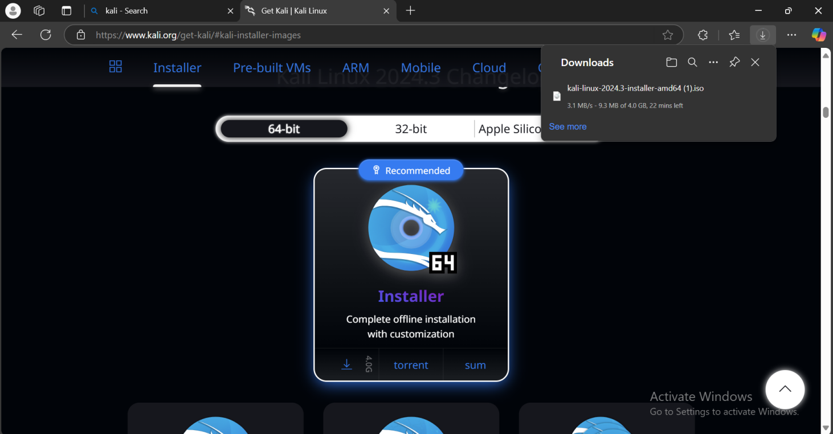

***Virtual Box installation***

### Steps to Perform an XSS Test:

#### 1. **Identify Potential Vulnerabilities**

* Look for input fields or URL parameters on the website where user input is reflected in the page output. Examples:
  + **Search bars**
  + **Comment boxes**
  + **Login forms**
  + **URL query strings**

#### 2. **Inject a Basic Payload**

* Use a simple JavaScript alert payload to test if the input field is vulnerable:

This is the JavaScript that I pasted in the search box of the testphp.vulnweb.com site and it shows that the website is vulnerable to the XSS attacks and shows me the pop-up

***<script>alert('The website is hacked!');</script>***

