sohaib haseeb

21F9312  assignment1

Web development

Task 2

<!DOCTYPE html>

<html lang="en">

  <head>

    <meta charset="UTF-8" />

    <meta name="viewport" content="width=device-width, initial-scale=1.0" />

    <title>Document</title>

    <style>

      table {

        border-collapse: collapse;

      }

      th,

      td {

        border: 2px solid #d8cfcf;

        text-align: center;

        padding: 48px;

      }

      h1,

      h3 {

        text-align: center;

      }

    </style>

  </head>

  <body>

    <h3>Department of Computer Science</h3>

    <h1>BCS-6E</h1>

    <table>

      <tr>

        <th></th>

        <th>8:45 - 9:15</th>

        <th>9:15 - 9:45</th>

        <th>9:45 - 10:10</th>

        <th>10:15 - 10:45</th>

        <th>10:45 - 11:15</th>

        <th>11:15 - 11:40</th>

        <th>11:45 - 12:15</th>

        <th>12:15 - 12:45</th>

        <th>12:45 - 1:15</th>

        <th>1:15 - 1:40</th>

        <th>1:45 - 2:15</th>

        <th>2:15 - 2:45</th>

        <th>2:45 - 3:15</th>

        <th>3:15 - 3:40</th>

        <th>3:45 - 4:15</th>

        <th>4:15 - 4:40</th>

      </tr>

      <tr>

        <td>Mo</td>

        <td></td>

        <td></td>

        <td></td>

        <td colspan="3">Web Programming</td>

        <td colspan="3">Parallel and distributed computing</td>

        <td></td>

        <td colspan="3">Artificial Intelligence</td>

        <td></td>

      </tr>

      <tr>

        <td>Tu</td>

        <td colspan="3">Computer Networks</td>

        <td colspan="3">Artificial Intelligence</td>

        <td></td>

        <td></td>

        <td></td>

        <td></td>

        <td colspan="6">Artificial Intelligence Lab</td>

      </tr>

      <tr>

        <td>We</td>

        <td></td>

        <td></td>

        <td></td>

        <td></td>

        <td></td>

        <td></td>

        <td></td>

        <td></td>

        <td></td>

        <td></td>

        <td colspan="6">Computer Network Lab</td>

      </tr>

      <tr>

        <td>Th</td>

        <td></td>

        <td></td>

        <td></td>

        <td colspan="3">Computer Networks</td>

        <td colspan="3">Software Design and Analysis</td>

        <td></td>

        <td colspan="3">Web programming</td>

        <td colspan="3">Parallel and distributed computing</td>

      </tr>

      <tr>

        <td>Fr</td>

        <td></td>

        <td></td>

        <td></td>

        <td colspan="3">Software Design and Analysis</td>

        <td></td>

        <td></td>

        <td></td>

        <td></td>

        <td></td>

        <td></td>

        <td></td>

        <td></td>

        <td></td>

        <td></td>

      </tr>

    </table>

  </body>

</html>

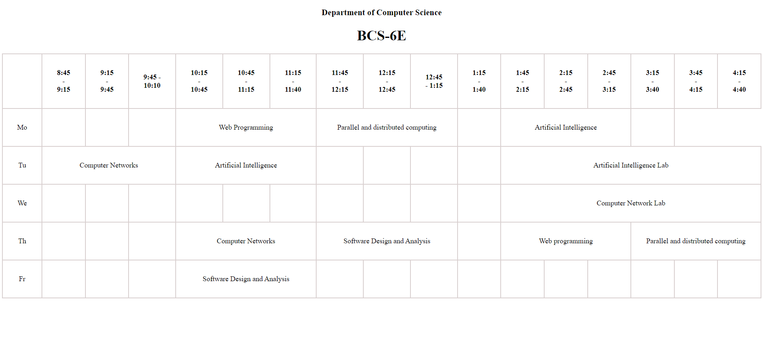

Task 1

<!DOCTYPE html>

<html lang="en">

<head>

<meta charset="UTF-8">

<meta name="viewport" content="width=device-width, initial-scale=1.0">

<title>Simple Calculator</title>

<style>

.calculator input[type="text"],

.calculator input[type="button"] {

width: 20%;

margin-bottom: 5px;

padding: 5px;

border: 1px solid #b74141;

border-radius: 3px;

box-sizing: border-box;

}

.calculator input[type="button"] {

background-color: #76af20;

color: #fff;

cursor: pointer;

}

.calculator input[type="button"]:hover {

background-color: #b6c94c;

}

.calculator{

  padding-left: 50rem;

}

h1{

  padding-left:48rem ;

}

</style>

</head>

<body>

<h1> Simple Calculator</h1>

<div class="calculator">

<input type="text" id="num1" placeholder="Value 1"><br>

<input type="text" id="num2" placeholder="Value 2"><br>

<input type="button" value="Add + "><br>

<input type="button" value="Subtract - "><br>

<input type="button" value="Multiply \* "><br>

<input type="button" value="Divide / "><br>

<input type="button" value="Result = "><br>

</div>

</body>

</html>

</body>

</html>

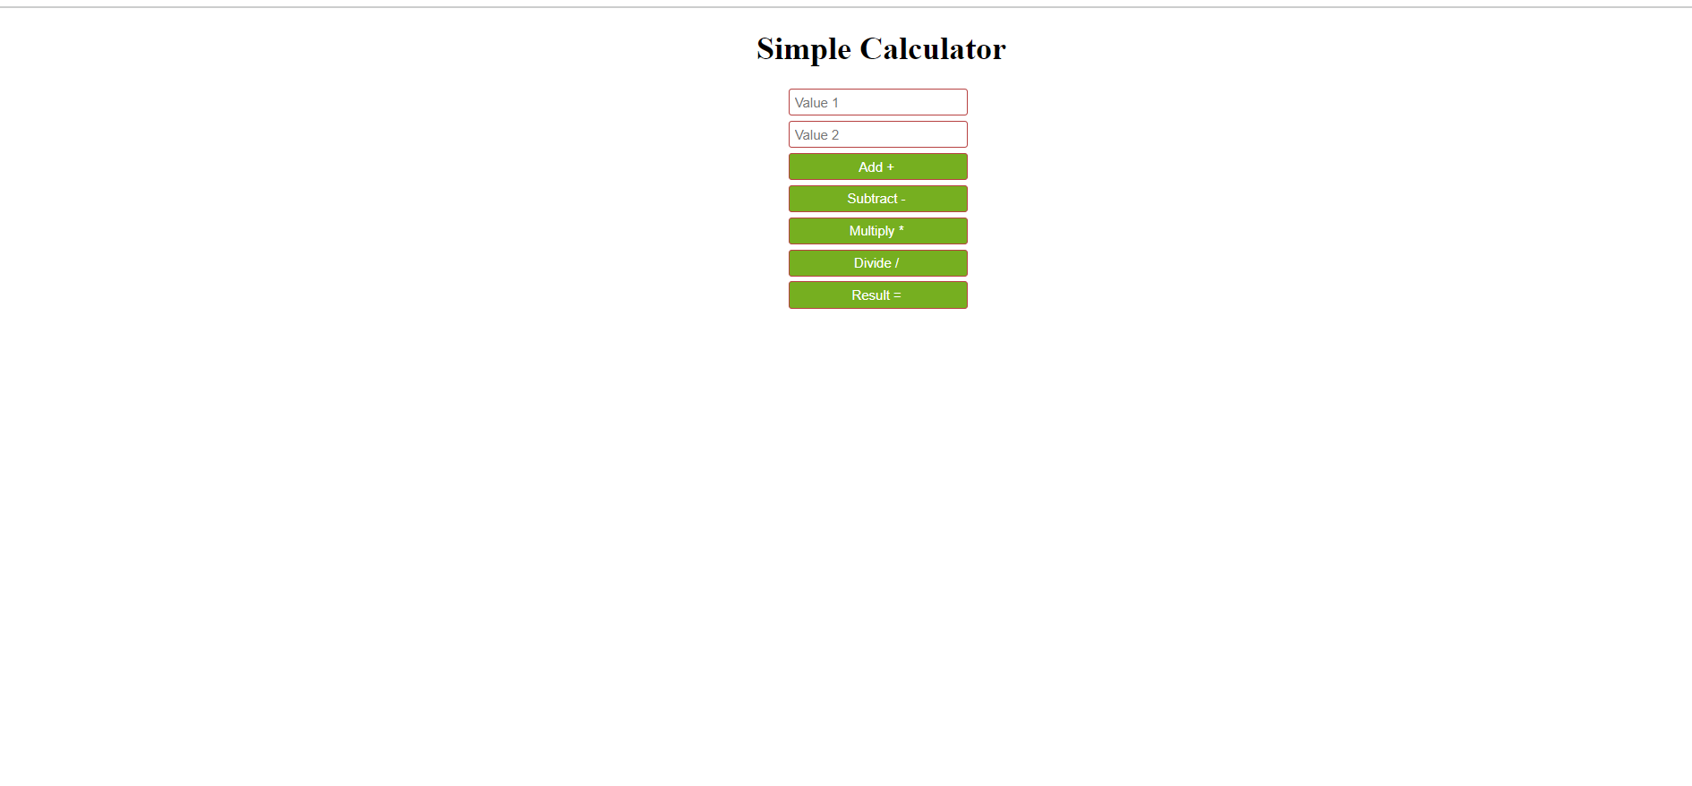

Task 3

<!DOCTYPE html>

<html lang="en">

  <head>

    <meta charset="UTF-8" />

    <meta name="viewport" content="width=device-width, initial-scale=1.0" />

    <title>Document</title>

    <style>

      .flex {

        display: flex;

        /\* padding: 4rem; \*/

        margin: 2rem;

        margin-left: 15rem;

      }

      .div1 {

        background-color: aqua;

        padding: 2rem;

      }

      .div2 {

        padding: 2rem;

        background-color: rgb(175, 169, 169);

      }

    </style>

  </head>

  <body>

    <div class="flex">

      <div class="div1">

        <img src="ddd" alt="profil pic" />

        <h1>Contact</h1>

        <p><span>Email :</span> f219312@cfd.nu.edu.pk</p>

        <p><span>Mobile no: </span> +9233----------</p>

        <ul>

          <li>

            <p>

              <span> Programming languages:</span>Python , C++, C, Javascript

            </p>

          </li>

          <li>

            <p><span>Frontend:</span> Html5 ,CSS3, React.js</p>

          </li>

        </ul>

        <h1>Language</h1>

        <ul>

          <li>

            <p>English</p>

          </li>

          <li>

            <p>Urdu</p>

          </li>

        </ul>

        <h1>Hobbies</h1>

        <ul>

          <li>

            <p>Cricket</p>

          </li>

          <li>

            <p>Football</p>

          </li>

        </ul>

      </div>

      <div class="div2">

        <h1>Muhammad Sohaib Haseeb</h1>

        <h4>Web Developer</h4>

        <h2>Summary</h2>

        <p>

          To secure a challenging position in a reputable organization to expand

          my learning knowledge and skill

        </p>

        <h2>Education</h2>

        <h4>School</h4>

        <p>The punjab school</p>

        <h4>College</h4>

        <p>The punjab college</p>

        <h4>University</h4>

        <p>FAST Nuces University</p>

        <h2>Projects</h2>

        <p>This project is based on html and inline CSS</p>

      </div>

    </div>

  </body>

</html>

