Task 1

<!DOCTYPE html>

<html lang="en">

<head>

    <meta charset="UTF-8">

    <meta name="viewport" content="width=device-width, initial-scale=1.0">

    <title>Document</title>

</head>

<body>

    <h1>

        Self Intro

    </h1>

    <p>

        Sohaib Haseeb

    </p>

    <p>

        21F9312

    </p>

    <p>well hello my name sohaib and i read in class two.i have many friends but arslan is my best friend.</p>

</body>

</html>

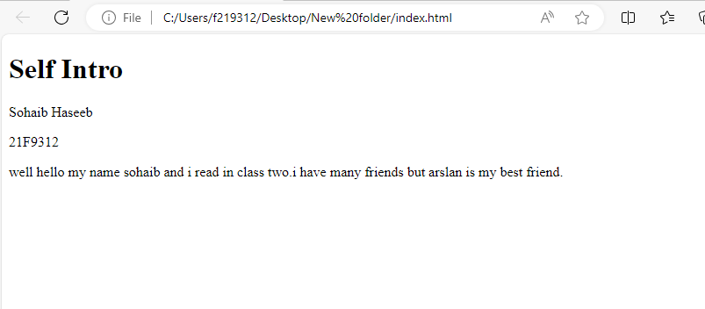

Task 2

<!DOCTYPE html>

<html lang="en">

<head>

    <meta charset="UTF-8">

    <meta name="viewport" content="width=device-width, initial-scale=1.0">

    <title>Document</title>

</head>

<body>

<bold>This text is bold</bold>

<br/>

<strong>This text is strong</strong>

<br/>

<big>This text is big</big>

<br/>

<i>This text is italic</i>

<br/>

<em>This text is emphasized</em>

<br/>

<output>This is computer output</output>

<br/>

<p>This text is <sub>subscript</sub> and <sup>superscript</sup></p>

</body>

</html>

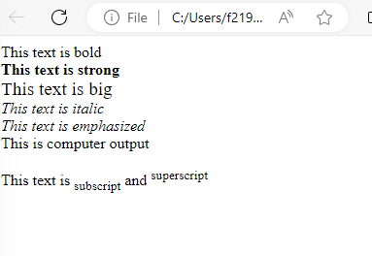

Task 3

<!DOCTYPE html>

<html lang="en">

<head>

    <meta charset="UTF-8">

    <meta name="viewport" content="width=device-width, initial-scale=1.0">

    <title>Document</title>

</head>

<body>

<img src="download.png" alt="img" width="500px" height="500px">

</html>



Task 4

<!DOCTYPE html>

<html lang="en">

<head>

    <meta charset="UTF-8">

    <meta name="viewport" content="width=device-width, initial-scale=1.0">

    <title>Document</title>

</head>

<body>

<a href="https://www.nu.edu.pk/" target="_blank">

<img src="download.png" alt="img" width="500px" height="500px">

</a>

</html>

Task 5

<!DOCTYPE html>

<html lang="en">

<head>

    <meta charset="UTF-8">

    <meta name="viewport" content="width=device-width, initial-scale=1.0">

    <title>Document</title>

</head>

<body>

<h1>HTML Lists</h1>

<h2>Unordered List</h2>

<p>

    We have books on a variety of languages

</p>

<ul>

    <li>

        Oracle

    </li>

    <li>

        Java

    </li>

    <li>

        Html

    </li>

    <li>

        Css

    </li>

</ul>

<h1>

    Ordered List

</h1>

<ol>

    <li>

        Download the software

    </li>

    <li>

        Extract the folder

    </li>

    <li>

        Double click the executable to run

    </li>

</ol>

</html>

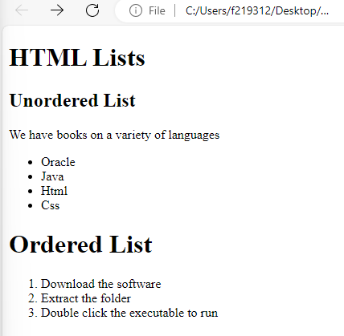

Task 6

<!DOCTYPE html>

<html lang="en">

<head>

    <meta charset="UTF-8">

    <meta name="viewport" content="width=device-width, initial-scale=1.0">

    <title>Document</title>

</head>

<body>

<table border="1">

    <tr>

        <th rowspan="3">April</th>

        <th>may</th>

        <th>june</th>

    </tr>

    <tr>

        <td>may</td>

        <td>june</td>

    </tr>

    <tr>

        <td>may</td>

        <td>june</td>

    </tr>

    <tr>

        <td>April</td>

        <td>may</td>

        <td>june</td>

    </tr>

    <tr>

        <td>April</td>

        <td>may</td>

        <td>june</td>

    </tr>

</table>

</html>

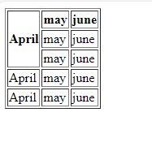

Task 7

<!DOCTYPE html>

<html lang="en">

<head>

    <meta charset="UTF-8">

    <meta name="viewport" content="width=device-width, initial-scale=1.0">

    <title>Document</title>

</head>

<body>

<table border="1">

    <tr>

        <th colspan="3">April</th>

    </tr>

    <tr>

        <td>April</td>

        <td>may</td>

        <td>june</td>

    </tr>

    <tr>

        <td rowspan="2" colspan="2">April</td>

        <td>june</td>

    </tr>

    <tr>

        <td>june</td>

    </tr>

    <tr>

        <td>April</td>

        <td>may</td>

        <td>june</td>

    </tr>

</table>

</html>

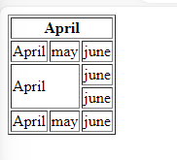

Task 8

<!DOCTYPE html>

<html lang="en">

<head>

    <meta charset="UTF-8">

    <meta name="viewport" content="width=device-width, initial-scale=1.0">

    <title>Document</title>

</head>

<body>

    <h1>

        Sign-up form

    </h1>

<form>

    <lable for="user">User</lable>

    <input type="text" id="user" name="user">

    <br/>

    <lable for="email">Email</lable>

    <input type="email" id="email" name="email">

    <br/>

    <lable for="pa">Password</lable>

    <input type="password" id="pa" name="pa">

    <br/>

    <lable for="co">Confirm Password</lable>

    <input type="password" id="con" name="con">

    <br/>

    <input type="button" value="Reset">

    <input type="submit" value="Submit">

</form>

</html>

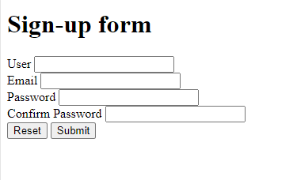

Task 8

<!DOCTYPE html>

<html lang="en">

<head>

    <meta charset="UTF-8">

    <meta name="viewport" content="width=device-width, initial-scale=1.0">

    <title>Document</title>

</head>

<body>

<h1 style="text-align: center;">Pete's Pizza Delivery</h1>

<h2 style="text-align: center;">Online Order Form</h2>

<form style="text-align: center;">

<label>*Name</label>

<input type="text" name="name">

<label>*Tel</label>

<input type="tel" name="name">

<br/>

<label>*Address</label>

<input type="text" name="name">

<label>*Email</label>

<input type="email" name="name">

<br/>

<label>*City/Town</label>

<input type="text" name="name">

<br/>

<label>*Postal code</label>

<input type="text" name="name">

<br/>

<p style="text-align: center;">* required fields

</p>

<table style="text-align: center;">

    <tr>

        <th> Topping</th>

        <th>Size</th>

        <th>Extras</th>

    </tr>

    <tr>

        <td><input type="radio">Margherita</td>

        <td><input type="radio">Small</td>

        <td><input type="radio">Mushrooms</td>

    </tr>

    <tr>

        <td><input type="radio">Four Seasons</td>

        <td><input type="radio">Medium</td>

        <td><input type="radio">Green peppers</td>

    </tr>

    <tr>

        <td><input type="radio">Meat Feast</td>

        <td><input type="radio">Large</td>

        <td><input type="radio">Anchovies</td>

    </tr>

    <tr>

        <td></td>

        <td></td>

        <td><input type="radio">Extra cheese</td>

    </tr>

    <br/>

</table>

<label>Preferred delivery time:</label>

<input type="time">

<br/>

<label>delivery instructions:</label>

<textarea></textarea>

</form>

</html>

