# 

1. Add extension of MetaMask in Google Chrome

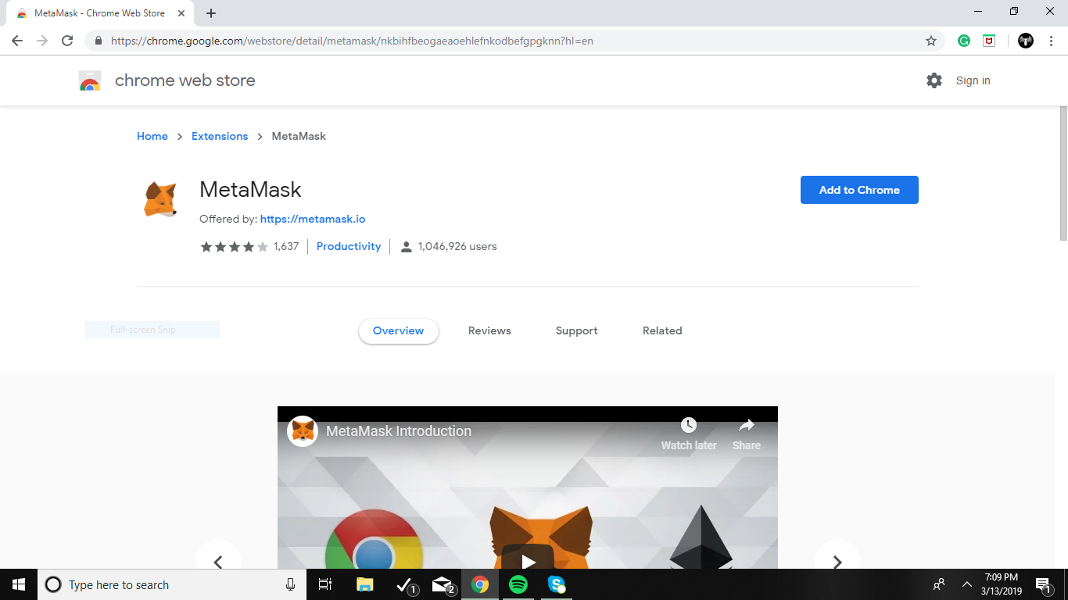

1. Download Visual Studio Code

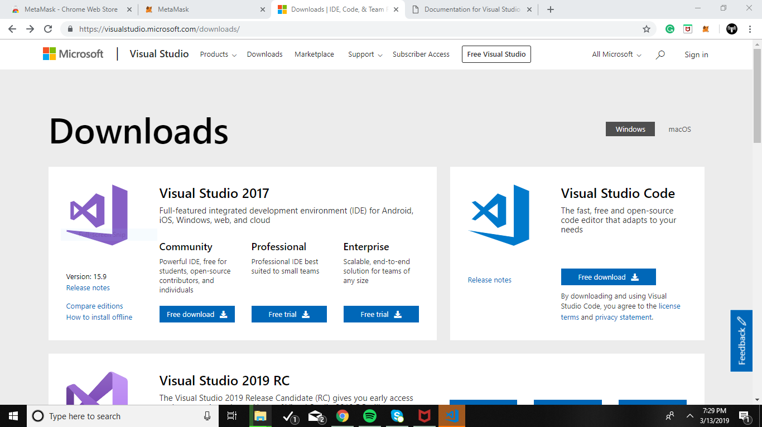

1. Open Visual Studio Code
2. Go to File and Open Folder (add project)

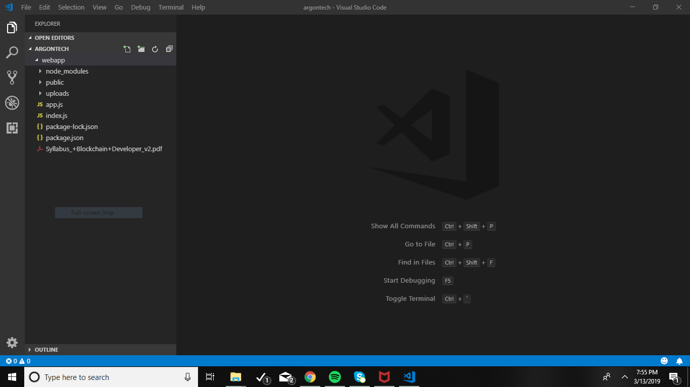

1. Download Nodejs latest version and Install it

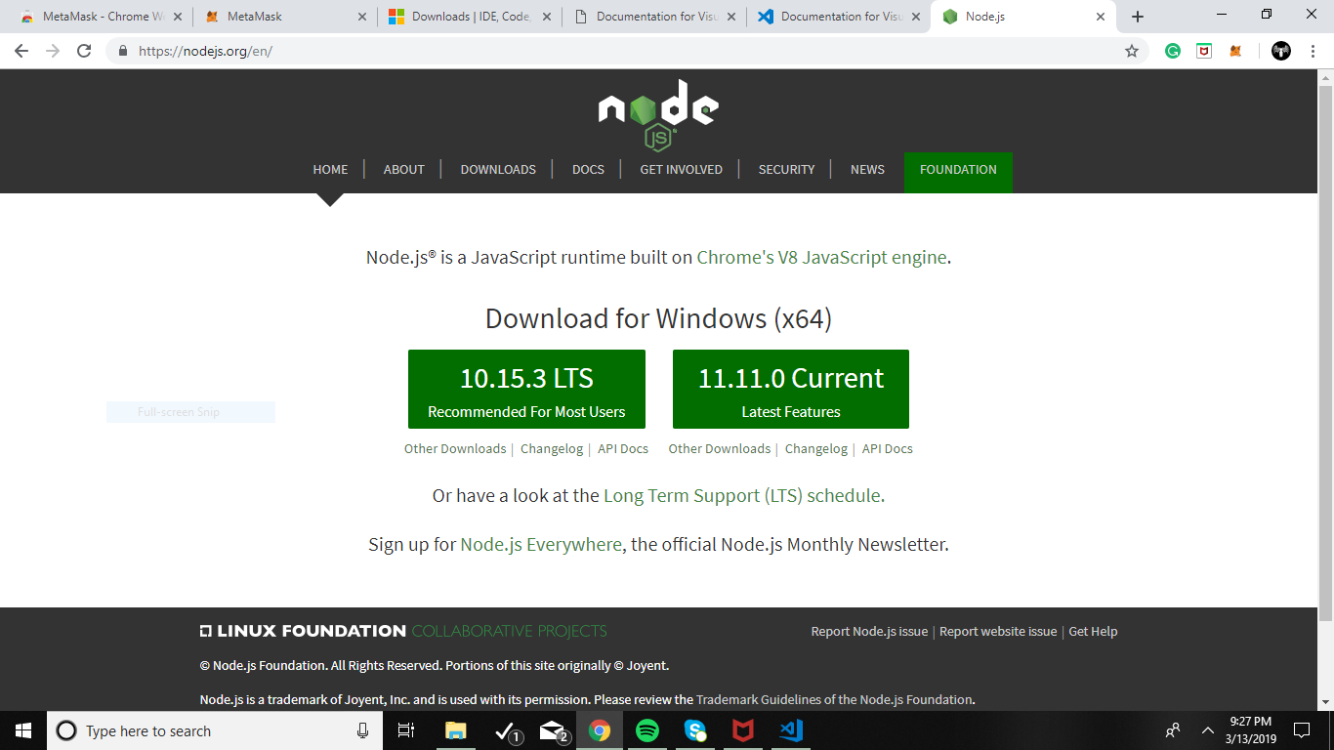

1. Install Solidity and Solidity Extended in visual studio code
2. Write the command in terminal node .\index.js

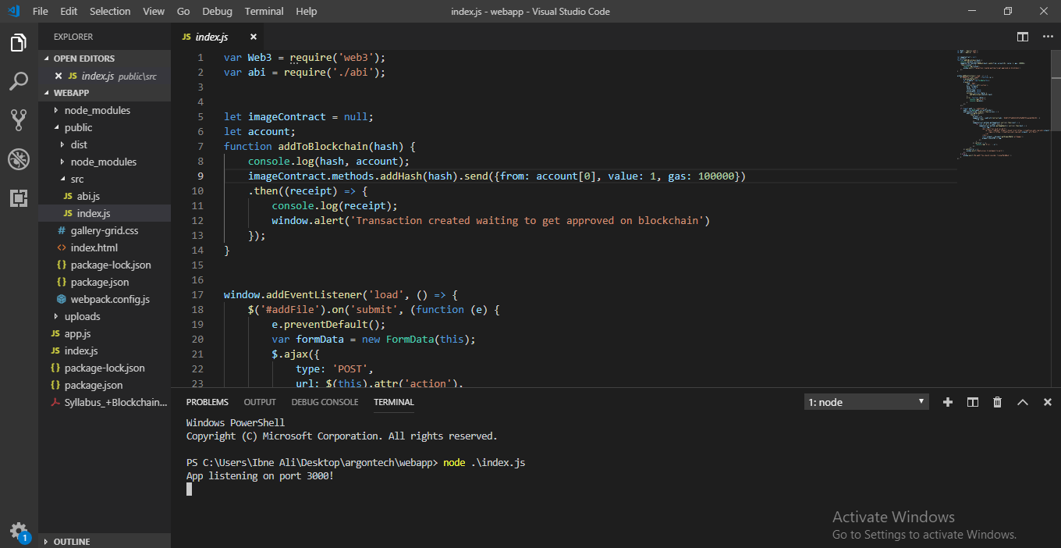

1. Open the Google Chrome at <http://localhost:3000/>
2. Enter the Password of your Metamask

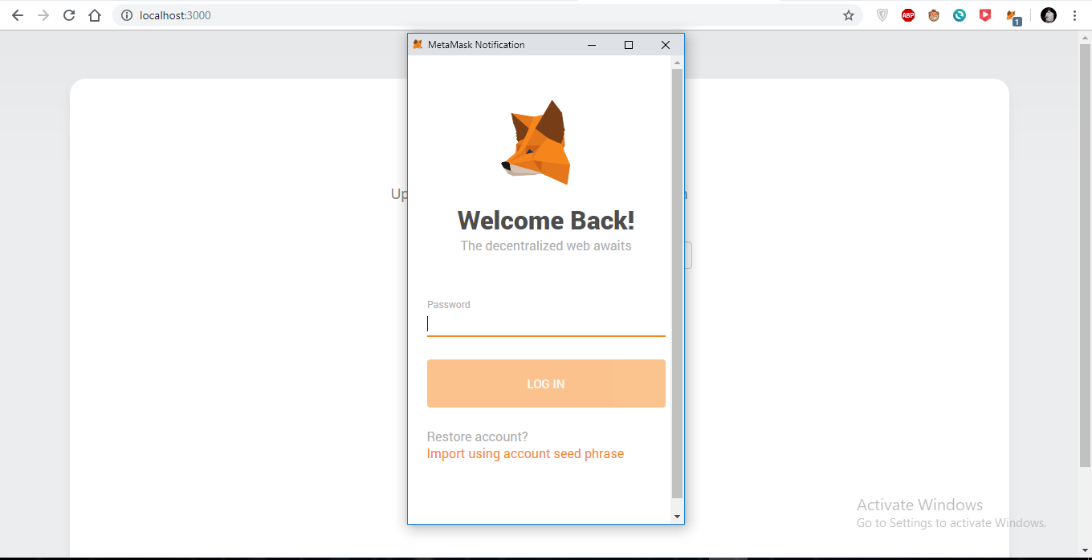

1. You can add or retrieve the Images

