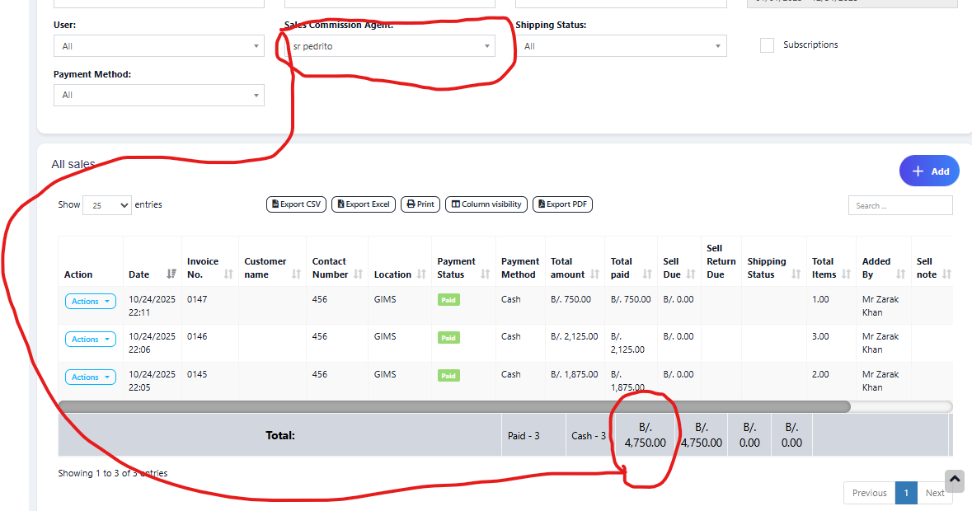
- All sales registered with the agent (Pedrito):

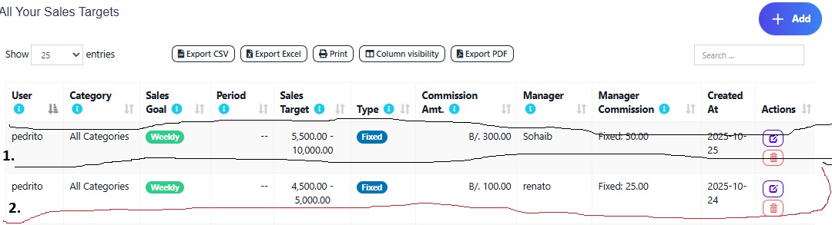
- Pedrito has 2 sales targets

Where you can see according to the sales in the first image, the sales target of 4500-5000 is completed.

- Sales Goal Report this is the information displayed, note that it does not show completed sales goal
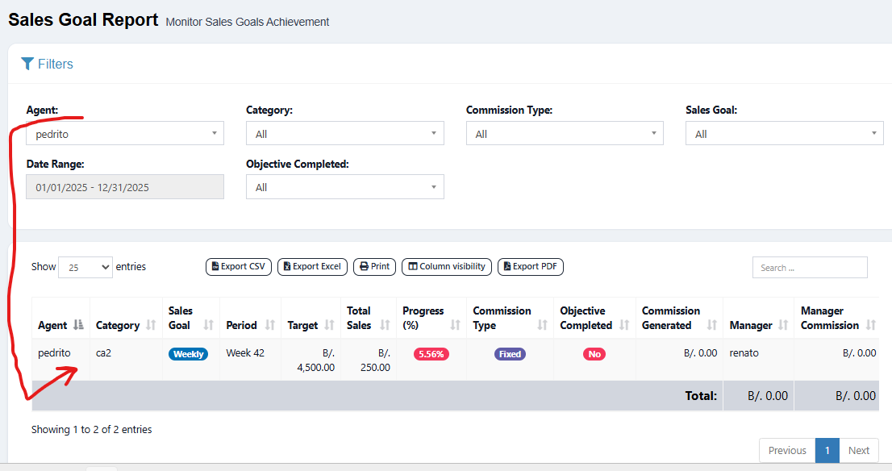

Note: That's why I asked you the question, because I understand that we haven't taken much time to implement the function for all the categories, when I understand that it would be better to implement it in this way that I said before: Global Sales Target
Example: METHOD 1: GLOBAL (TOTAL) SALES OBJECTIVE
Definition
A single sales objective that represents the total revenue the sales agent must generate in a given period (month, quarter, year), without discrimination by product or category.

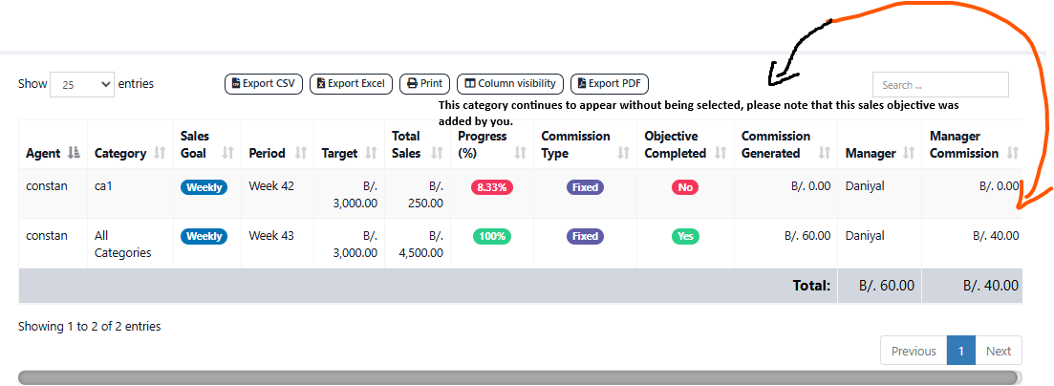
4. An additional category keeps appearing in the report when all categories are selected.

