بسم الله الرحمن الرحيم



PALESTINE POLYTECHNIC UNIVERSITY

College of IT and Computer Engineering

Department of Computer Engineering

Smart Cradle

Team Members

Nagham Nassar Jihan Najjar

Supervisors

Dr. Radwan Tahboub

Eng. Wael Takrouri

# ACKNOWLEDGEMENTS

In the name of “Allah”, the most beneficent and merciful who gives us strength, and knowledge and helped us to get through this study

We would like to express our sincere gratitude to several individuals for supporting us throughout our academic careers. First, we wish to express our sincere gratitude to our supervisors, Dr. Radwan Tahboub and Eng. Wael Takrouri.

We would like to take this opportunity to acknowledge and thank our families and friends for their support and encouragement throughout this journey. Their love and guidance have been a constant source of motivation and strength, and we are truly grateful to have them in our lives. Without their unwavering support, we would not have been able to accomplish all that we have. We are deeply grateful to all of them and will always be thankful for their role in our lives. Thank you, from the bottom of our hearts.

# ABSTRACT

Parents face taking care of their infant especially if both parents are working. Giving 24 hours in such cases is next to impossible. Thus, need to develop something unique which can help parents to detect every activity of the Baby from home and at any distance in the world.

Thus, designing a smart cradle, where the system alerts parents of situations that would alleviate sudden infant death syndrome (SIDS), a condition that occurs in children under the age of 12 months, such as sleeping on the stomach, sleeping on a soft surface, high temperature, and cover the child with heavy blankets. The system will also measure the child's temperature to monitor it, as the system will alert parents of the child's high or low temperature, in addition, it measures the temperature of the surrounding atmosphere, which would provide a suitable atmosphere for him by operating an air conditioning system. When the baby is crying, the system is equipped with a camera and a microphone, the mother can talk to him, thus she may calm him down, or operate the rocking mechanism of the cradle, the system will operate under a certain frequency range. To reduce his crying, play a musical game to entertain the baby.

**Keywords:**

smart cradle, sudden infant death syndrome (SIDS).

# الملخص

يواجه الوالدان صعوبة رعاية طفلهما الرضيع خاصة إذا كان كلا الوالدين يعملان. إن إعطاء 24 ساعة في مثل هذه الحالات هو أقرب

إلى المستحيل. وبالتالي ، تحتاج إلى تطوير شيء فريد يمكن أن يساعد الآباء على اكتشاف كل نشاط للطفل من المنزل وعلى أي مسافة في العالم.

وهكذا ، فإن تصميم مهد ذكي ، حيث ينبه النظام الآباء إلى المواقف التي من شأنها أن تخفف من متلازمة موت الرضع المفاجئ، وهي حالة تحدث عند الأطفال دون سن 12 شهرًا، مثل النوم على المعدة ، والنوم على سطح ناعم. ، ودرجة حرارة عالية ، وتغطية الطفل ببطانيات ثقيلة. كما سيقوم النظام بقياس درجة حرارة الطفل لرصدها ، حيث يقوم النظام بتنبيه الوالدين إلى ارتفاع أو انخفاض درجة حرارة الطفل ، بالإضافة إلى أنه يقيس درجة حرارة الجو المحيط ، مما يوفر له جوًا مناسبًا من خلال تشغيل الهواء. نظام التكييف. عندما يبكي الرضيع ، يكون النظام مزوًدًا بكاميرا وميكروفون ، يمكن للأم التحدث معه ، وبالتالي يمكنها تهدئته ، أو تشغيل آلية التأرجح في المهد ، وسيعمل النظام تحت نطاق تردد معين. للحد من بكائه.

**الكلمات المفتاحية:**

مهد ذكي, الرضيع ,متلازمة موت الرضيع المفاجئ.

### Table of Contents

Contents

ACKNOWLEDGEMENTS 2

ABSTRACT 3

الملخص 4

Table of Contents 5

List of Tables 8

List of Figures 9

CHAPTER ONE 10

INTRODUCTION 10

1.1 Preface 10

1.2 Project Aims and Objectives 10

1.3 Problem Analysis and Statement 11

1.4 Problem Significance and Motivation 12

1.5 Project Requirements 12

1.5.1 Functional Requirements 12

1.5.2 Non-Functional Requirements 13

1.7 Project Schedule 14

1.8 Report Outline 14

CHAPTER TWO 15

THEORETICAL BACKGROUND 15

2.1 Preface 15

2.2 Background 15

2.2.1 Sudden Infant Death Syndrome 15

2.2.2 Introduction to Machine Learning: 17

2.3 Literature Review 18

2.3.1 Literature Survey 18

2.4 Summary 20

CHAPTER THREE 21

SYSTEM DESIGN 21

3.1 Preface 21

3.2 Design Options 21

3.2.1 Storage able system 21

3.2.2 Non-Storable System 22

3.2.3 Summary 22

3.3 System Component 22

3.3.1 Mechanical Design 22

3.3.2 Hardware Components 22

3.3.3 Software Component 25

3.4 Design components options 26

3.4.1 Microcontroller alternative 26

3.4.2 Sensors 27

3.5 Conceptual system description 30

3.5.1 General block Diagram 30

3.5.2 Conceptual Diagram 32

3.6 Algorithms and Methodologies 32

3.6.1 System Flow Chart 32

3.6.2 Sound and Swing Algorithm 33

3.7 Schematic Diagram 35

3.8 Summary and Conclusion 35

CHAPTER FOUR 36

SYSTEM IMPLEMENTATION 36

4.1 Preface 36

4.2 Description of the Implementation 36

4.2.1 Software Implementation Tools: 36

4.2.2 Description of the implementation: 36

4.3 Application Implementation 39

4.4 Implementation Challenges 43

4.5 Summary 43

CHAPTER FIVE 45

TESTING AND DISCUSSION 45

5.1 Preface 45

5.2 Validation and Testing 45

5.2.1 Hardware testing 45

5.2.2 Software Testing 47

5.3 Result and Discussion 49

5.4 Summary 49

CHAPTER SIX 50

CONCLUSION AND FUTURE WORK 50

6.1 Preface 50

6.1 Conclusion 50

6.2 Future Work 50

References 51

### List of Tables

Table 2. 1 Unlabeled Data Examples along with Labeling Issues [8] 18

Table 3. 1 Banana Pi M5 VS Raspberry Pi 4, source [9]. 28

Table 3. 2 DHT11 VS DHT22, source [10]. 29

Table 3. 3 Stepper Motor VS DC Motor, source [11]. 30

Table 5. 1 Unit Test 51

Table 5. 2 System Test 52

Table 5. 3 Application Test 54

### List of Figures

Figure 1. 1 ASSB by baby's age [2] 11

[Figure 2. 1 Bed Sharing [13] 16](https://d.docs.live.net/5b920fdfcd0a63b6/Edit1%20(1).docx#_Toc156074995)

Figure 2. 2 Different machine learning techniques and their required data [8] 17

Figure 3. 1 Raspberry Pi 4 23

Figure 3. 2 Raspberry Pi camera 23

Figure 3. 3 Wiper motor 24

Figure 3. 4 DHT11 Sensor 24

Figure 3. 5 Heater 25

Figure 3. 6 Microphone And Speaker 25

Figure 3. 7 General block diagram 30

Figure 3. 8 General Block Diagram for the Smart Cradle System 31

Figure 3. 9 Conceptual Diagram 32

Figure 3. 10 Raspberry Pi 4 Flow Chart 33

Figure 3. 11 Sound and Swing Algorithm 34

Figure 3. 12 Raspberry Pi 4 Schematic Diagram 35

Figure 4. 1 MCU30205 with Raspberry Pi Pico W 41

Figure 4. 2 HR sensor with Raspberry Pi Pico W 41

Figure 4. 3 Microphone with Raspberry Pi 4 42

Figure 4. 4 Web Camera with Raspberry Pi 4 42

Figure 4. 5 Raspberry Camera with Raspberry Pi 4 43

Figure 4. 6 Wiper motor with Raspberry Pi 4 43

Figure 4. 7 DHT11 Sensor with Raspberry Pi 4 44

Figure 4. 8 Sign-Up Page 45

Figure 4. 9 Log-In page 46

Figure 4. 10 Controlling page 47

Figure 4. 11 Home (video and Record) page 48

Figure 4. 12 Menu Page 49

Figure 5. 1 Final Connection of the System 45

Figure 5. 2 Connection on The Cradle 46

Figure 5. 3 The Smart Cradle 46

# CHAPTER ONE

# INTRODUCTION

## 1.1 Preface

This chapter contains seven sections, the first section is about the motivations and importance of our project. It explains the reasons that make us believe in this project. The second section will be about the problem statement describing the problem we aim to solve. The third section will provide a short description of our project. The fourth section contains the objectives of our project. The fifth section represents the system requirement. The sixth section will provide the system limitations. The seventh section represents the project schedule.

## 1.2 Project Aims and Objectives

The main objectives of this system are:

* The system alerts parents of situations that would alleviate sudden infant death syndrome (SIDS):

o Sleeping on the stomach.

o Cover the baby with heavy blankets.

Accidental suffocation and suffocation in bed are among the most common causes of sudden death syndrome

Accidental Suffocation and Strangulation in Bed (ASSB) occurs when a baby is prevented from breathing due to soft bedding or a mattress and wall. It accounts for three-fourths of all unintentional injury fatalities in infants, with over 85% occurring from birth to six months, you can see this in the figure and how to reduce the risk of Accidental Suffocation and Strangulation in Bed [1].

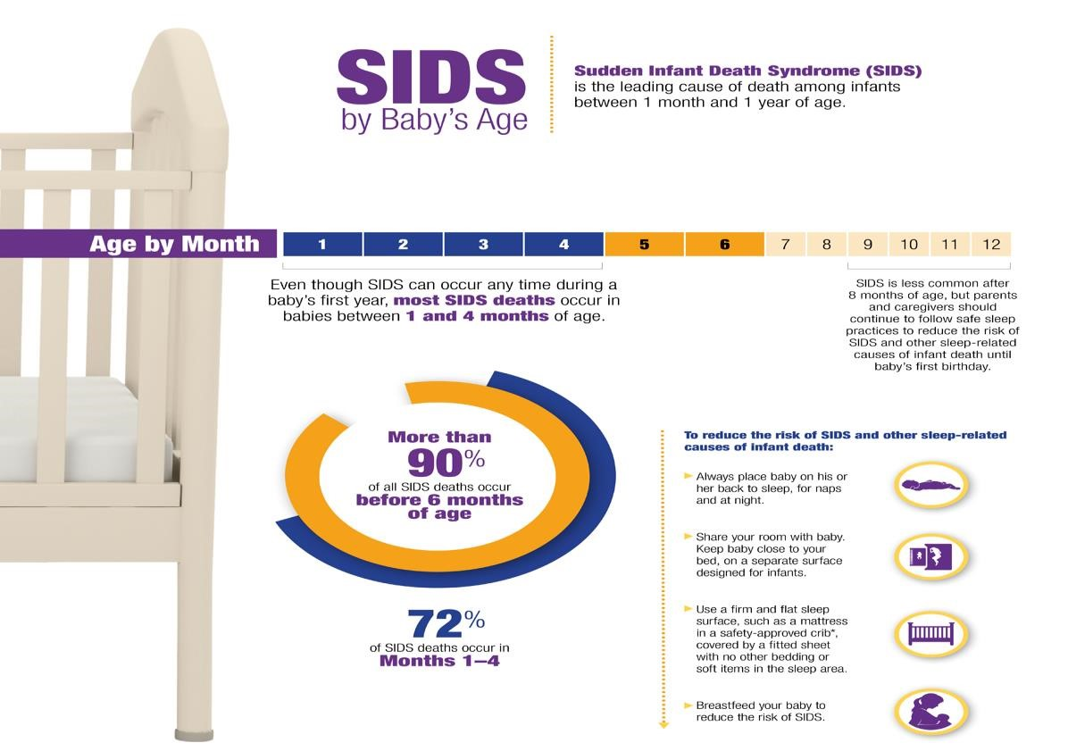

Figure 1. ASSB by Baby's Age [2]

* Measures the temperature of the surrounding atmosphere.
* Operate the rocking mechanism of the cradle

## 1.3 Problem Analysis and Statement

Taking care of the baby when they are months old is a great responsibility for the parents because they need special care and periodic monitoring, so what if the mother or father is working, or they spend time away from the baby? Hence there is a need for a smart system capable of monitoring the movement of the baby in his cradle, and giving reacting to the baby crying by informing his parents through an alarm, and supporting remote control of the baby cradle by moving it when the baby cries. The project aims to solve all the abovementioned problems under the name of a smart cradle.

The project is a smart system that alarms parents when an abnormal situation for to baby occurs, such as sleeping on the stomach, in addition, measures the temperature of the surrounding atmosphere.

## 1.4 Problem Significance and Motivation

Under fast-paced life conditions, everyone, including parents, is busy professionally. They leave the house early in the morning and return before dinner. Even the mothers are working. Thus, they do not have sufficient time to care for their babies. Not all parents can afford a nanny to help them with their babies. Then, after working for long hours, the mothers still have to manage the house and take care of their babies simultaneously. Other parents may be occupied with house chores. Thus, because they cannot hear their baby crying, they cannot attend to them immediately. Sometimes, the baby only needs a little distraction to return to deep sleep.

In cases of a newborn child, the mother may be preoccupied for several reasons, including her health condition, which may not allow her to perform her functions as a mother to the fullest extent, in addition to that even if her health condition is good, housework may distract her from her child, and the wobbly sleep of the baby exposes her to Fatigue increases her need for rest, such as sleep, for example. This may result in exposing the child to danger, such as sudden clinical death, which is caused by

* Placing a baby on his side or stomach to sleep [3].

The aperture of the lungs' tube rests on top of the entrance of the stomach's tube while a newborn is lying on their back. Stomach fluids must overcome gravity to enter the windpipe and induce choking. as you see in Figure 1.2.

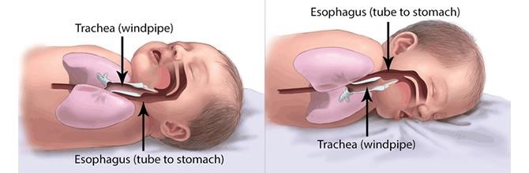

*Figure 1. 2 Back Sleeping and SIDS* [4]

* Premature or low birth weight babies [3].
* Overheating the baby during sleep [3].
* Sleeping on too soft a surface, with loose blankets and bumper pads [3].

The system allows parents to avoid the causes of this condition by monitoring the baby and alerting the parents in cases that may put him at risk.

## 1.5 Project Requirements

The system requirements are summarized as:

### 1.5.1 Functional Requirements

The main functional requirements of the system will:

* Alert parents of situations that would alleviate sudden infant death syndrome (SIDS):
* Run a heater.
* Operate the rocking mechanism of the cradle.
* Remote access to the system.

### 1.5.2 Non-Functional Requirements

* Accuracy: Make sure the system is highly accurate in the position of the baby, such as sleeping on his stomach.
* Scalability: The system's capacity to be based on IOT
* Reliability: The system is intended function to do all it under stated conditions without failure for a given period.
* User-friendly system: Depending on the system's components and the technologies employed, the system and its application should be simple to use and comprehend for users.
* Maintainability: All components are easily serviceable and replaceable.
* Real-time: Real-time specifications include the length of time that must pass before an operation may be considered complete and is not subject to delay Informatics, in a smart cradle system, monitoring the baby’s vital signs and the system’s response to them must be subject to the concept of real-time, as the nature of the system from a medical perspective does not tolerate any delay. One of the most important requirements of this system is monitoring the baby and alerting in cases that may lead to sudden death syndrome. For example, if a child suffocates as a result of sleeping on his stomach, the child endures 30 seconds. When this period is exceeded, the child is exposed to health damage that ranges in severity from minor damage to serious damage such as brain damage or death.

Therefore, this system must apply the concept of real-time by responding immediately to any event that may result in health damage to the baby, it is assumed that the response of this system will be less than the period mentioned, which exposes the baby to danger, within a period ranging from 15-20 seconds. Here, the system must check the child’s condition and take readings such as temperature and pulse rate every 15 seconds.

## 1.7 Project Schedule

The team project started working on the smart cradle system from the planning stage, defining the exact project idea and functional requirements, then analyzing and designing the system through graphs, and finishing documentation in the last weeks. These steps have been traced over the semester, to achieve more effective results.

Table 1. Time Schedule Table

|  |  |  |  |  |  |  |  |  |  |  |  |  |  |  |
| --- | --- | --- | --- | --- | --- | --- | --- | --- | --- | --- | --- | --- | --- | --- |
| Time (each cell represents 2 weeks) | | | | | | | | | | | | | | |
| Tasks | First Semester | | | | | | | Second Semester | | | | | | |
| Planning |  |  |  |  |  |  |  |  |  |  |  |  |  |  |
| Project  requirement |  |  |  |  |  |  |  |  |  |  |  |  |  |  |
| Analyzing  and design |  |  |  |  |  |  |  |  |  |  |  |  |  |  |
| Documentation |  |  |  |  |  |  |  |  |  |  |  |  |  |  |
| Project development |  |  |  |  |  |  |  |  |  |  |  |  |  |  |
| Project test and maintenance |  |  |  |  |  |  |  |  |  |  |  |  |  |  |

## 1.8 Report Outline

The rest of the report is organized as follows: Chapter 2 presents a theoretical background of the project. Chapter 3 introduces the system design.

# CHAPTER TWO

# THEORETICAL BACKGROUND

## 2.1 Preface

This chapter will describe the project's theoretical background and literature review.

## 2.2 Background

## 

### 2.2.1 Sudden Infant Death Syndrome

In 1969, the National Institutes of Health consensus conference led to the first standardized definition of sudden infant death as the "sudden death of an infant or young child, which is unexpected by history, and in which a thorough postmortem examination fails to demonstrate an adequate cause of death" [5]. To identify a group of newborns with comparable features for whom vital data, research, and family counseling were required, the criteria required an autopsy for infants who died from a condition that was classified as SIDS. Many observers continued to consider SIDS as a single entity even though it was described as a syndrome and may thus be the outcome of multiple diseases because of its specific characteristics, which included:

* A peak incidence at 2 to 4 months of age,
* Intrathoracic petechiae are present.
* male predominance.

Further changes to the concept limited its use to infants younger than 12 months old, required an investigation of the death scene, or connected the death to sleep.

parents and caregivers can reduce the risk of SIDS and other sleep-related causes of infant death by guarding against several other sleep environment dangers. Some of these include:

#### 2.2.1.1 Back Sleeping and SIDS

The single most effective action to lower a baby's risk of SIDS is to place the baby to sleep on their back for naps and at night. Stomach sleeping increases the risk of SIDS by 1.7 - 12.9 [4]. The mechanisms by which stomach sleeping might lead to SIDS are not entirely known, but studies suggest that stomach sleeping may increase SIDS risk through a variety of mechanisms, including:

* Increasing the probability that the baby re-breathes his or her own exhaled breath, leading to carbon dioxide buildup and low oxygen levels.
* Causing upper airway obstruction.
* Interfering with body heat dissipation, leading to overheating [4].

Researchers have established the link between stomach sleeping and SIDS by showing that babies who died from SIDS were more likely to be put to sleep on their stomachs compared to babies who lived. Public health campaigns were launched to promote the back sleep position and reduce the use of the stomach sleep position. Public health campaigns have been successful in reducing the prevalence of stomach sleep position among infants.

This has resulted in dramatic decreases in SIDS rates in all countries, particularly in areas where stomach sleeping is rare. Compared to infants who sleep on their backs, and those who sleep on their stomachs.

#### 2.2.1.2 Soft Sleeping Surfaces and Loose Bedding

According to studies, resting on soft surfaces like sofas and soft beds significantly increases the risk of SIDS. For instance, 2003 research found that putting a baby to sleep on soft bedding increased their risk of SIDS by five times compared to resting on solid bedding, such as a crib mattress that has received safety approval. The finding that infants who slept on their stomachs on soft bedding were 21 times more likely to die from SIDS than infants who slept on their backs on hard bedding was more startling.

Additionally, loose, soft bedding raises the chance of asphyxia. The Consumer Product Safety Commission has reported that the majority of sleep-related infant deaths in its database are related to suffocation involving pillows, quilts, and extra bedding [6]

#### 2.2.1.3 Bed Sharing

Many mothers share a bed with their infant because it makes breastfeeding easier and enhances bonding. Studies do not support bed sharing as a protective approach for SIDS, even though some people think it may be since the parent is close to watching the infant.

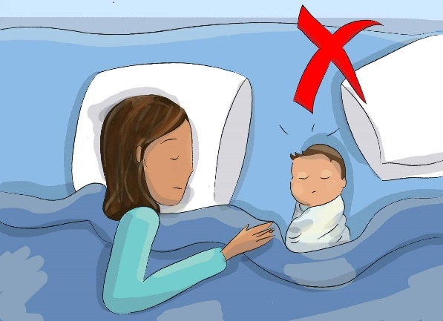Contrarily, mounting data suggest that sharing a bed increases the risk of SIDS and may also put a child in danger of asphyxia, entrapment, or harm. In some circumstances, sharing a bed increases the danger that is already there. When two people share a bed, for instance, the risk of SIDS is larger than either risk factor by itself. A mother who smokes, drinks lately, or feels exhausted. The baby is wrapped in a quilt or blanket. Several people share beds. According to studies, having other kids in bed more than multiplies the risk

Figure 2. Bed Sharing [19]

of SIDS by five. In addition, bed-sharing exposes the newborn to extra hazards for unintentional harm and death, such as entrapment, falls, and strangling in an adult bed that is not intended for an infant. The biggest risk group includes infants under 4 months of age, as well as those who were delivered preterm or with low birth weight. This can be because it's challenging for them to adjust and avoid possible risks due to their weak muscles and motor abilities [7].

### 2.2.2 Introduction to Machine Learning:

Alan Turing's question "Can a machine think?" in 1955 suggested a test to gauge how intelligent a machine is. AI has grown quickly since then, and machine learning is a subset of AI that focuses on teaching algorithms to learn from data and get better over time.

Four machine learning algorithms are shown in Figure 2.2, briefly explaining the type of data each one needs.

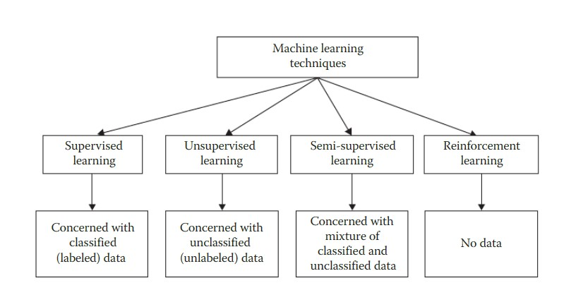

Figure 2. Different Machine Learning Techniques and Their Required Data [8]

The previous figure shows four different machine learning algorithms and the data required for each of them. The following is a definition of each type.

#### 2.2.2.1 **S**upervised Learning [8]

Supervised learning is a type of education that infers a function from labeled training data, with two categories of algorithms: regression and classification.

#### 2.2.2.2 Unsupervised Learning [8]

Unsupervised learning is difficult due to the lack of supervisors and training data, which can be inherently flawed or not enough resources to pay for manual labeling.

#### 2.2.2.3 Semi-Supervised Learning [8]

Semi-supervised learning is a method of combining traditional and unclassified data to create an accurate model for categorization. It is similar to how we learn, with unlabeled information from the environment and labeled data from the supervisor.

#### 2.2.2.4 Reinforcement Learning [8]

Reinforcement learning is an approach to creating intelligent programs that maximize reward or reduce risk using observations acquired through interactions with the environment.

Table 1.1 presents unlabeled data examples, with potential labels described in the third column. Machines can be employed in four scenarios, but their accuracy rates are questionable. Despite advancements in sentiment analysis, picture recognition, and speech detection, more work is needed before comparing their performance to humans. In tumor detection, even normal humans cannot label X-ray data.

Table 2. Unlabeled Data Examples Along with Labeling Issues [8]

|  |  |  |  |
| --- | --- | --- | --- |
| **Unlabeled Data Example** | **Example Judgment for Labeling** | **Possible Labels** | **Possible Supervisor** |
| **Tweet** | The sentiment of the tweet | Positive/negative | Human/machine |
| **Photo** | Contains a house and a car | Yes/No | Human/machine |
| **Audio recording** | The word football is  uttered | Yes/No | Human/machine |
| **Video** | Are weapons used in the video? | Violent/nonviolent | Human/machine |
| **X-ray** | Tumor presence in X-ray | Present/absent | Experts/machine |

## 2.3 Literature Review

In this section, we will talk about some projects similar to the idea of our project. To our knowledge, we did not find any similar projects in D space at Palestine Polytechnic University from 2014 to 2022.

Project outside the Palestine Polytechnic University researching scientific papers and previous articles related to the smart cradle and the smart cradle based on the Internet of Things. The following is a literature survey:

### 2.3.1 Literature Survey

Adults and older people can benefit from a variety of health care and health management systems. Numerous health statuses may be tracked, alerts can be sent automatically, and they have many other functions. However because these systems need to be utilized carefully, they cannot be employed practically for infants. Infants need entirely different healthcare than adults because they are dependent on their parents. Infants cannot comment on their health because they can only cry when they are uncomfortable. Therefore, to care for newborns, a properly constructed healthcare system is required. It would gradually lessen the load on parents, particularly mothers.

some smart health monitoring systems run on Android smartphones and are designed to collect raw data from wearable sensors before sending it to a microcontroller for processing. After that, Bluetooth technology is used to wirelessly communicate the output to an Android smartphone. Some of the current health monitoring systems will use a GSM module to send an SMS message as a notification to the user's mobile phone [9].

Authors [10] developed a Raspberry Pi and Pi camera-based baby monitoring system. The system's design allows it to detect a baby's activity and crying patterns. With the aid of the Pi camera, they employed a condenser MIC to detect the crying state and a PIR motion sensor to detect the baby's movement. The camera is activated only when a sound is detected by the condenser MIC and a signal is sent to the Raspberry Pi. Parents can only view the data on a small number of devices within a fixed region because the output of this system is only visible on monitor display.

A monitoring system for an incubator was created. An infant is fitted with a pulse sensor to gauge their heart rate, and a humidity sensor gauges the relative humidity. The Neonatal Intensive Care Unit (NICU) staff can resort to the recorded data for diagnostic purposes by connecting the computer to the Arduino microcontroller. To avoid the occurrence of a harmful condition, an alarm system is created to send an alarm whenever the data readings reach a dangerous level. The system was tested on infants between the ages of 0 and 3 months, 3-6 months, and 6 to 12 months. However, only direct computer transfers were made of the captured data, Wi-Fi module can be added to this method to send data over the internet to track the newborns' conditions wherever they are.

The author of Paper [11] proposed a new algorithm that is crucial to improving baby care while parents are away has been proposed for our system. The data read by the sensors are gathered by the designed system's Node Micro-Controller Unit (NodeMCU) Controller Board and transmitted via Wi-Fi to the AdaFruit MQTT server. and their system used sensors to monitor the baby’s vital parameters, including temperature, moisture, and crying.

In [12]the authors said that the external environment also serves as a cue when it's time to change a baby's diaper by assisting in the detection of increased body temperature, crying infants' voices, and their constant movements. Suppose any unusual behaviors are noticed in the baby's environment. The parents receive a warning notice. When the motion sensor picks up any sustained motions, the attached video camera, which is controlled by the microcontroller, starts recording a video. The parents are given access to the broadcasted footage through a display, allowing them to watch their child in real time.

Additionally, this system monitors the condition of the baby, shows it, and notifies the appropriate adult by gathering data from sensors like temperature sensors, and ultrasonic sensors, via raspberry pi.

## 2.4 Summary

Our proposed system will be able to track the baby, especially his sleeping position, and give notifications to the parents. In addition, it has a camera that can record live pictures of the baby. It also has switches for turning the condition and the cradle swing on and off. This hybrid model incorporates the ideas suggested in the papers above.

# CHAPTER THREE

# SYSTEM DESIGN

## 3.1 Preface

The following section has a description of the system, a detailed design, and necessary information about the design.

## 3.2 Design options

In this section, will talk about some design options for the system, where we will clarify the design in general and address two of the available options for dealing with video and images that are processed, before clarifying the available designs, the system will be clarified in general, by including it within three levels of input, output, and the control unit.

Turning to the inputs, we have a microphone to hear the baby’s voice, a camera to monitor within the live stream mode, and a remote thermometer to monitor the temperature of the environment.

As for the outputs, we have a vibrating motor to shake the baby's bed, a speaker to hear the mother's voice, which works to calm the baby, a display screen to know the baby's pulse and the state of his sleeping position, an air conditioner that works in cold temperatures to provide a warm environment for the baby.

Finally, the controller, the brain of the system where the processing operations are for what is read to do one or more outputs to manage the system.

When a baby’s crying signal is taken, the vibration motor will work to calm him down, and an alert will be made on the parent’s application, which allows her to speak to the baby to hear his mother’s voice, which works to calm him down until she reaches him, and at cold temperatures in the room, the hot air conditioner will work to raise the temperature surrounding the baby.

As for how to deal with the camera, we have two design options:

### 3.2.1 Storage able system

This system discusses how to deal with the camera in the design of the smart children's bed using a storage unit, where the captured images will be stored in a storage unit attached to the system that can be replaced when it is full.

A picture of the child will be taken during specific periods to process it, know the child's sleeping position, and alert the parents when taking any of the positions that may lead to the child's suffocation and exposure to sudden infant death syndrome.

### 3.2.2 Non-Storable System

This system discusses how to handle the camera in designing a smart children's bed without using a storage unit. The captured images will be processed and a decision will be taken regarding them by ignoring them or giving an alert on the application if a situation applies to them that may lead to the child’s suffocation and exposure to sudden infant death syndrome. Thus, it is an instantaneous processing of the captured image and a decision is taken to deal with it.

### 3.2.3 Summary

Thus, at the end of this section, we explained the design scheme in terms of inputs, outputs, and the controller, and we note the choice of the second design, which is a non-storable system, so that the project is intended to warn of child misfortunes that may result in death, and the lack of importance of having a recorded video, as the video needs a large storage space that may require Replacing the storage unit many times increases the cost, and every moment a parent wants to see the child, he can do so through a live broadcast, and thus the system will be implemented by choosing the second system, which is a system that cannot be stored.

## 3.3 System Component

This section is about the components and software we will use in our system, their alternatives, and the best options among them.

### 3.3.1 Mechanical Design

A baby cradle adapted to be rocked automatically, the action having the same effect as would be achieved by a mother rocking a cradle containing an infant, the cradle being pivotally supported at each end thereof to a support rack and stand. The motor also includes a regulating, reciprocating means for imparting the actuating movement of the crib in a smooth-rocking motion.

The mass of the cradle made of wood is about 15 kg with dimensions of 90cm, 60cm, and 70cm. As for the baby, its mass is estimated at 2.7 kg - 12 kg up to one year of age. The motor used can bear up to 60 kg/cm

### 3.3.2 Hardware Components

This section describes the hardware components used in the system.

###### 1. Raspberry Pi 4

We use a Raspberry Pi 4 microcontroller to control all operations in the system.

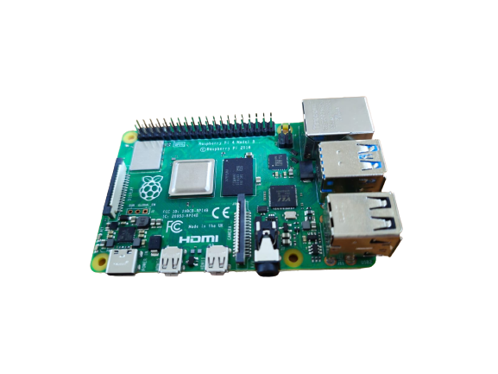

Figure 3. Raspberry Pi 4

###### 2. Raspberry Pi camera

It is used to monitor the baby remotely(streaming).

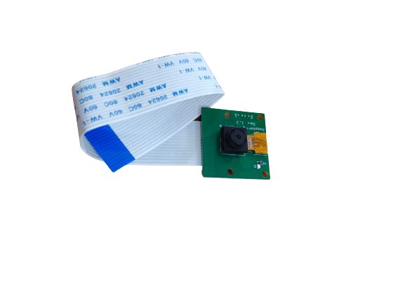

Figure 3. Raspberry Pi Camera

###### 4. Wiper motor

It is used to rock the baby's crib.

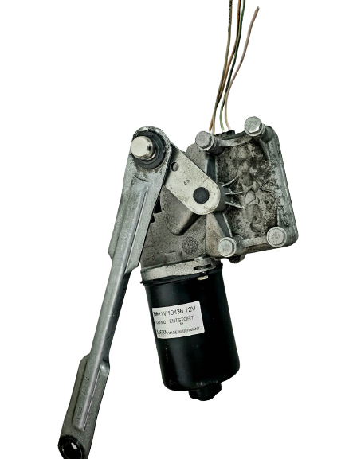

Figure 3. Wiper Motor

###### 5. DHT11 Sensor

It is used to measure the temperature around the baby.

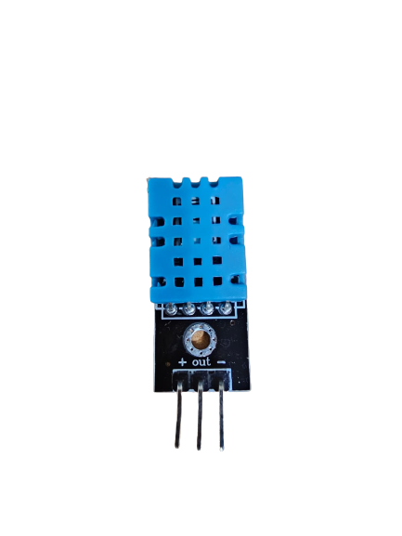

Figure 3. DHT11 Sensor

###### 6. Heater

The heater will raise the temperature if it falls below the ideal level. The heater will turn off when the temperature is at its ideal level.

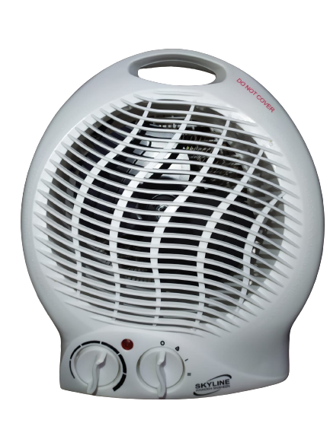

Figure 3. Heater and Fan

###### 9. Microphone and Speaker

Used to communicate between the baby and the parents.

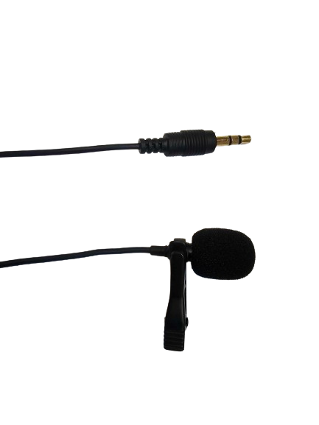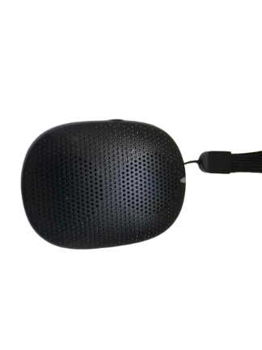

Figure 3. Microphone and Speaker

###### 10. Webcam

It is used in the process of examining the position of the baby.

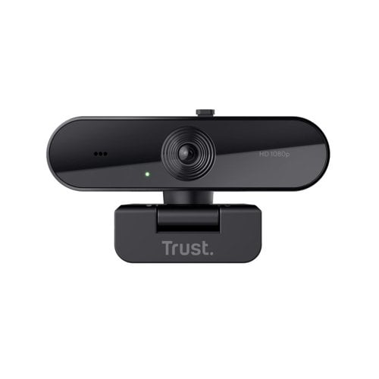

Figure 3. Webcam [13]

### 3.3.3 Software Component

###### 1. Teachable Machine [14]

Is a web-based tool that makes creating machine learning models fast, easy, and accessible to everyone, by training a computer to recognize baby images, sounds, and poses. Then, use the model to detect if SIDS occurs.

###### 2. Thonny [15]

Thonny is a free and open-source IDE for Python, designed for beginners. It supports different ways of navigating through the code, step-by-step expression evaluation, detailed visualization of the call stack, and provides some Raspberry Pi-specific packages and libraries that make it easier to use.

###### 3. MIT App Inventor [16]

MIT App Inventor (App Inventor or MIT AI2) is a high-level block-based visual programming language, originally built by Google. It allows newcomers to create computer applications for two operating systems: Android and iOS, It is free and open-source and provides integration with different online services, such as Google Sheets and Firebase.

###### 4. Google Firebase [17]

Google Firebase is a set of cloud-based development tools that helps mobile app developers build, deploy, and scale their apps. specifically used the real-time database.

Firebase Realtime Database is a cloud-hosted NoSQL database that allows organizations to store and sync data in real time across all user devices. This makes it easy to create applications that are always up to date.

###### 5. Python [18]

Python is used for developing Raspberry PI controller code, Python is an interpreted, object-oriented, high-level programming language with dynamic semantics Its high-level built-in data structures, combined with dynamic typing and dynamic binding, make it very attractive for Rapid Application Development, as well as for use as a scripting or glue language to connect existing components.

## 3.4 Design components options

This section is about the components and software we will use in our system their alternatives and the best option among them.

### 3.4.1 Microcontroller alternative

This subsection illustrates the alternative for Raspberry Pi 4.

**1 . Raspberry Pi 4**

Table 3.1 presents the difference between Raspberry Pi 4 and Banana Pi M5.

Table 3. Banana Pi M5 vs Raspberry Pi 4 [9].

|  |  |  |
| --- | --- | --- |
| **FEATURE** | **Banana Pi M5** | Raspberry Pi 4B |
| **Dimensions & Weight** | 92mm x 60mm,  48g | Single/dual |
| **Memory** | 4GB LPDDR4 | 1GB, 2GB, 4GB, or 8GB LPDDR4-3200  SDRAM |
| **Audio Output(s)** | 3.5 mm analog audio-video (or digital via HDMI) | 3.5 mm analog audio-video jack (or digital via HDMI) |
| **Network** | Gigabit  Ethernet; Wi-Fi and Bluetooth available via expansion boards | Gigabit Ethernet; 2.4  GHz and 5.0 GHz IEEE 802.11ac wireless; Bluetooth  5.0, BLE |
| **GPIO** | 40-pin GPIO header (2x20 pins), 2.54mm  pitch | 40-pin GPIO header (2x20 pins), 2.54mm pitch |
| **Dimension** | 85mm*56mm | 28mm*55mm |
| **price** | $35- $55 | $64 |

### 3.4.2 Sensors

This subsection illustrates the alternative for ESP32.

**1. DHT22 Alternative**

This subsection illustrates the alternative for DHT22:

**● DHT11 VS DHT22**

The DHT11 and DHT22 (AM2302) are Digital temperature sensors that monitor both temperature and humidity.

They have varied specifications but have very similar appearances and functions. As is shown in Table 3.2

Table 3. DHT11 vs DHT22 [10].

|  |  |  |  |
| --- | --- | --- | --- |
| **Specifications** | DHT11 |  | DHT22 |
| **Measurement** | Humidity temperature | and | Humidity and  temperature |
| **Temperature Range** | 0 – 50° C / ± 2° C |  | -40 – 125° C / ± 0.5°  C |
| **Humidity Range** | 20 – 80 / ± 5 % | | 0 – 100 / ± 2.5 % |
| **Sampling Rate** | 1 Hz one reading every second | | 0.5 Hz one readingevery two seconds |
| **Accuracy** | +/- 2ºC (at 0 to 50ºC) | | +/- 0.5ºC (at -40 to  80ºC) |
| **Body size** | 15.5 mm × 12 mm × 5.5 mm | | 15.1 mm × 25 mm × 7.7 mm |
| **Operating Voltage** | 3 – 5 V | | 3 – 5 V |
| **Minimum current** | 2.5 mA | | 2.5 mA |
| **Price** | $6.99 | | $10.99 |

will utilize DHT11 in our project because it will provide the precision we need. We didn't employ a temperature sensor and a humidity sensor separately to cut down on the number of hardware components inside the system.

3.3.1.2 Wiper Motor For Car Alternative

* **stepper motor**: an electric motor whose main feature is that its shaft rotates by performing steps, that is, by moving by a fixed amount of degrees.
* **DC motor**: any of a class of rotary electrical motors that converts direct current (DC) electrical energy into mechanical energy, the wiper motor is an example of a DC motor.

Table 3.3 presents the difference between the Stepper Motor and DC Motor.

Table 3. Stepper Motor vs DC Motor [11].

|  |  |  |
| --- | --- | --- |
| **Characteristics** | **Stepper Motor 24v** | **DC Motor** |
| **Nature of loop** | Open Loop | Closed Loop |
| **Control characteristics** | Easy to control with  microprocessors | Not easy to control |
| **Speed range** | Low (Approximately 200-2000 RPMs) | Moderate (it depends on the motor type) |
| **Reliability** | High | Moderate |
| **Efficiency** | Low | Average |
| **Torque/speed characteristics** | Has maximum torque at low speeds | High torque at relatively low speeds |
| **Cost** | $53 | $54 |
| **Size** | 1.93 x 1.65 x 2.72 inches | small |

Will use a DC motor-specific wiper motor for the car, due to its low cost, small size, and can to connect with microcontrollers, in addition to the need to swing the baby's cradle.

## 3.5 Conceptual system description

In this subsection, diagrams are represented for the understanding of the project concepts and design.

### 3.5.1 General block diagram

In this section, will talk about the General block diagram, the system will be clarified in general, by including it within three levels input, output, and control unit. As shown in the figure below.

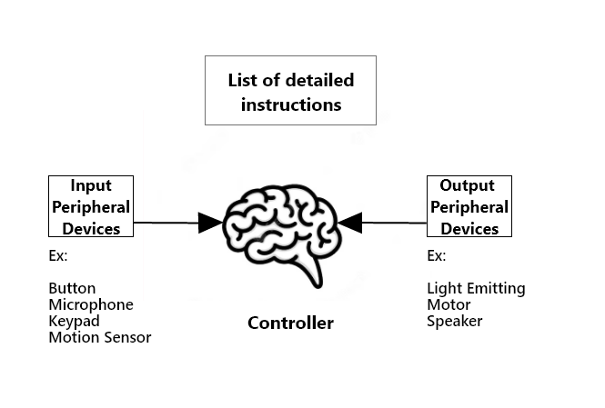

Figure 3. General Block Diagram

Turning to the inputs, we have a microphone to hear the baby's voice, a camera to monitor the baby so that it is within the live stream mode and a remote thermometer to monitor the temperature of the environment.

As for the outputs, we have a wiper motor to rock the baby's bed, a speaker to hear the mother's voice, which works to calm the baby, and the state of his sleeping position, an air conditioner that works in cold temperatures to provide a warm environment for the baby.

Finally, the controller, the brain of the system where the processing operations are for what is read to do one or more outputs to manage the system. The Raspberry Pi 4 microcontroller will use

When a baby crying signal is taken, the vibration motor will work to calm him down, and an alert will be made on the parent’s application, which allows her to speak to the child to hear his mother’s voice, which works to calm him down until she reaches him, and at cold temperatures in the room, the hot air conditioner will work to raise the temperature surrounding the baby, and an alert will be given on When the child's temperature rises from the thermometer, the baby’s pulse status will also be displayed on a window in the application read by the oximeter.

This scenario will reflect on the smart cradle system as Figure 3.11 shows.

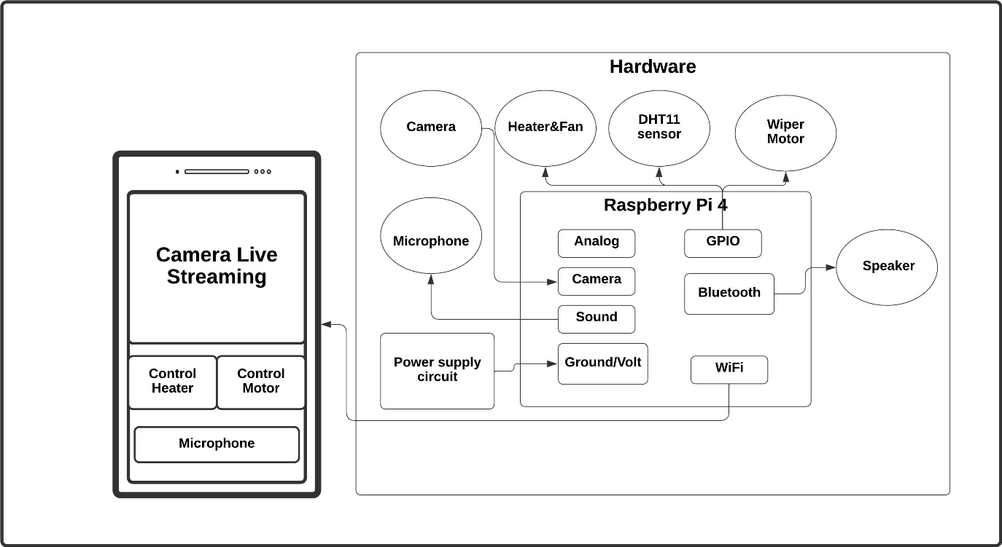



Figure 3. General Block Diagram for The Smart Cradle System

### 3.5.2 Conceptual Diagram

Figure 3.12 represents the concept of the system.

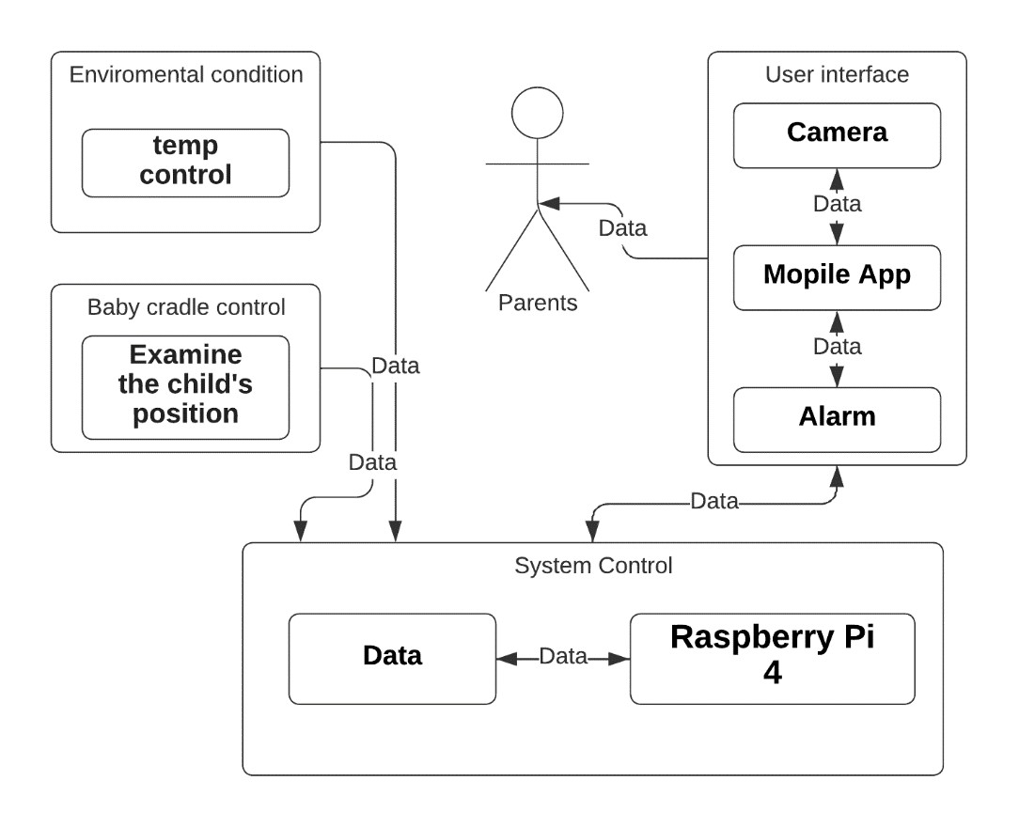

Figure 3. Conceptual Diagram

## 3.6 Algorithms and Methodologies

In this section, we describe our system work by using a flow chart.

### 3.6.1 System Flow Chart

Figure 3.14 below represents the Raspberry Pi 4 flowchart.

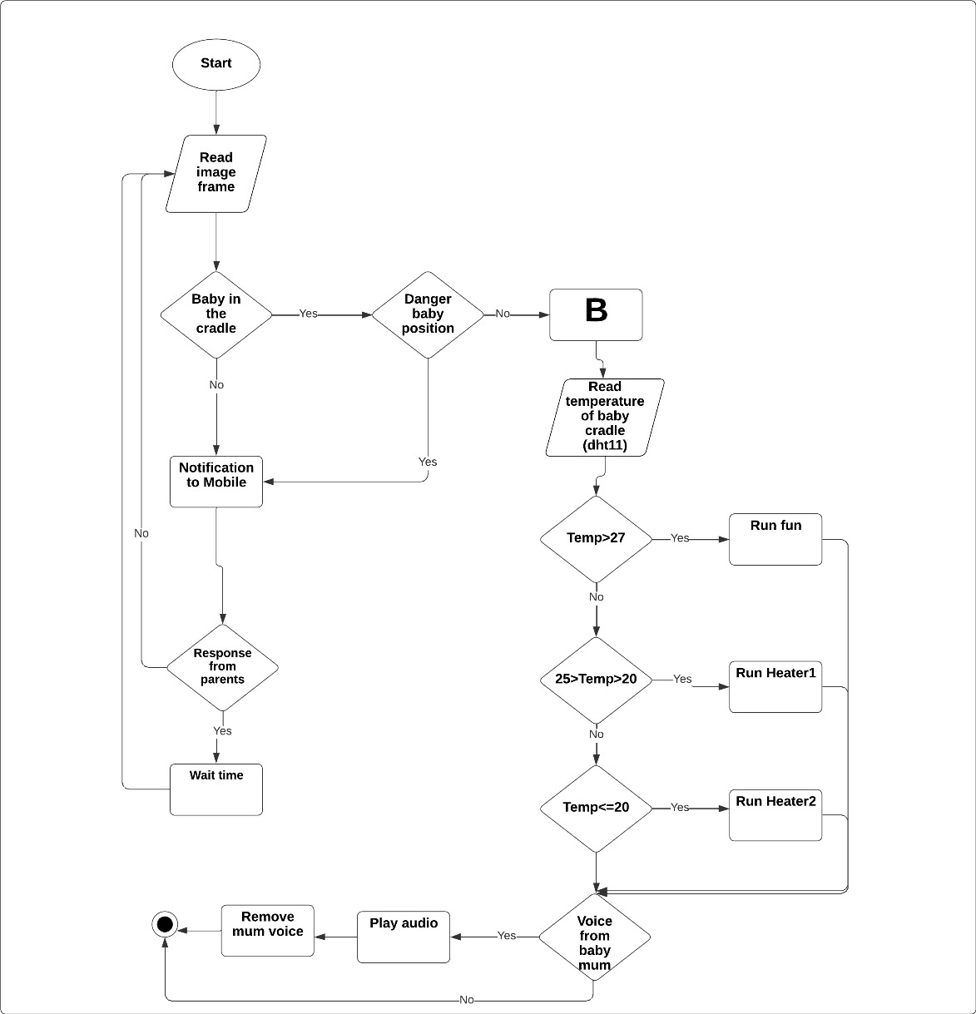

Figure 3. Raspberry Pi 4 Flowchart

### 3.6.2 Sound and Swing Algorithm

Figure 3.15 below represents the sound algorithm of our system using a flowchart.

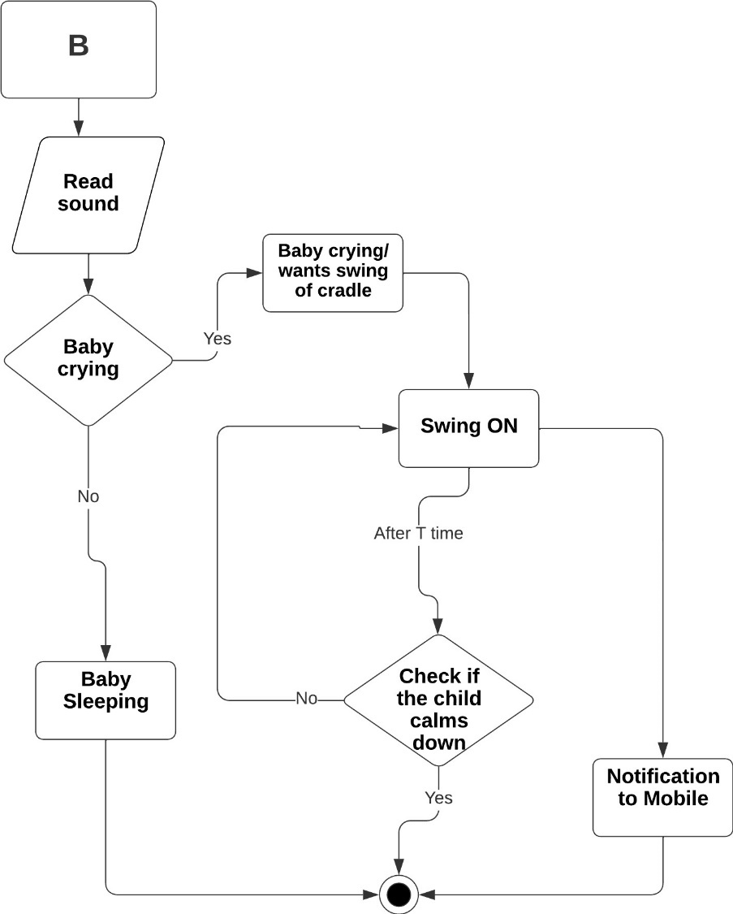

Figure 3. Baby Crying Algorithm

## 3.7 Schematic diagram

Figure 3.16 represents a schematic diagram for Raspberry Pi 4.

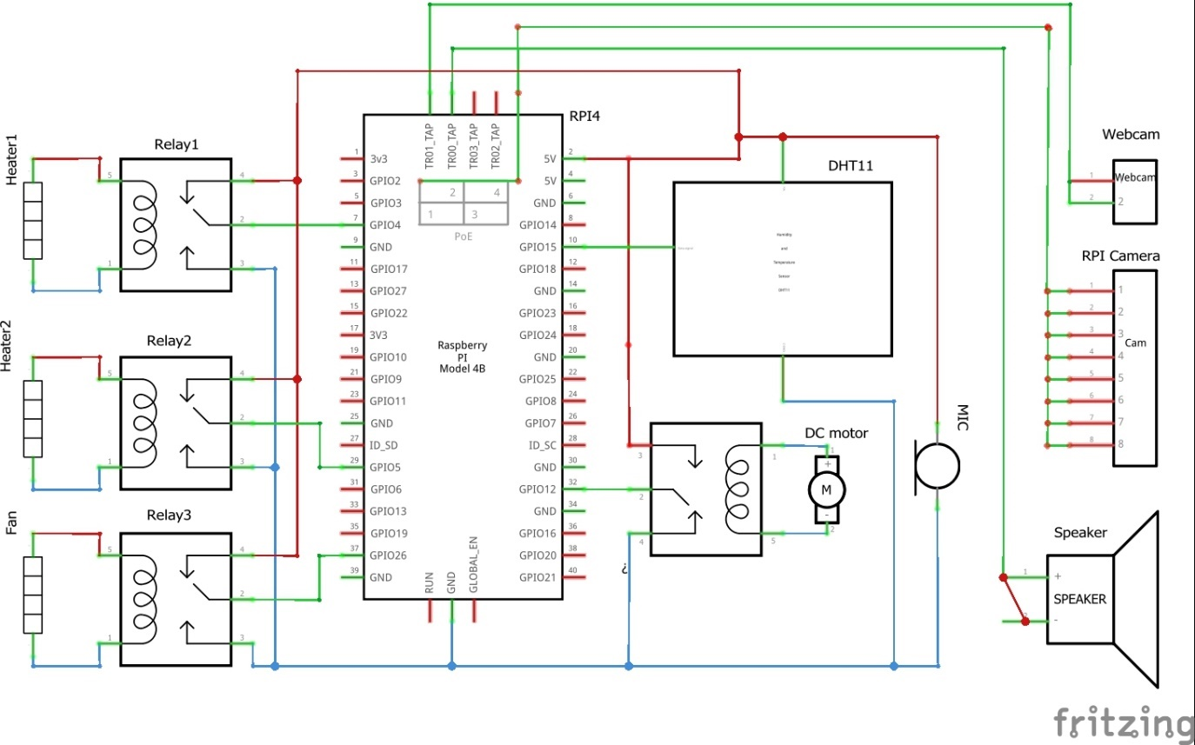

Figure 3. Raspberry Pi 4 Schematic Diagram

## 3.8 Summary and Conclusion

In this chapter, we describe the design option, we talked about alternatives to the memoryless system that we will use in our project, and why we chose them. In the System component, we talk about mechanical design, hardware design, and software design. In mechanical design, we talk about the shape of the crib and the materials used to build it. In hardware design, we talk about components that we want to use and how they work together, and finally, we talk about software design.

In the design components options, we talked about alternatives to the components that we will use in our project and why we chose them. Then we talk about conceptual system description by using a block diagram and conceptual model, and we use a flow chart in the algorithms and methodologies section.

# CHAPTER FOUR

# SYSTEM IMPLEMENTATION

## 4.1 Preface

This Chapter introduces a description of the implementation, implementation issues, implementation challenges, and description of the method used to validate the system.

## 4.2 Description of the implementation

In this section, we explained software implementation tools and described how the system works.

4.2.1 Software Implementation Tools:

Python code is used to program the Raspberry Pi 4 microcontroller that will be on the cradle to perform a control operation like the cradle swing and conditioning.

To implement the application, firebase and MIT App Inventor are used.

4.2.2 Description of the implementation:

The first step was to purchase the necessary parts and sensors, in addition to the microcontroller, Raspberry Pi 4, which tested all sensors and devices in an initial test, after studying the data sheets for each of them.

The Raspberry Pi 4, connects the speaker, a microphone, a webcam, a Raspberry Pi camera, the DC motor, and the DHT11 sensor, this system is placed on the cradle, so that it can take readings from the sensor and camera stream, in addition to taking actions such as swing the cradle and turning on the air conditioning, The following figure shows how to hang Raspberry pi 4 on the cradle.

As for the air conditioner, the user is allowed to control it manually, i.e. cold, hot, or automatically, based on the DHT11 sensor reading. Regarding the motor, also the user is allowed to control it manually, at more than one speed, or automatically, based on the sound model that determines whether it is the sound of a baby crying or a background sound.

Raspberry Pi camera is used for baby positions model so that it determines whether the baby’s position exposes it to danger or is safe. A webcam for video streaming enables the user to monitor the baby at any time, whether the baby exists in the cradle or not, noting that the system only works if the baby exists in the cradle.

The following images represent the interface between a component and Raspberry Pi 4 that was wired and tested.

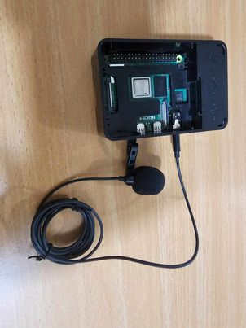

Figure 4. Microphone with Raspberry Pi 4

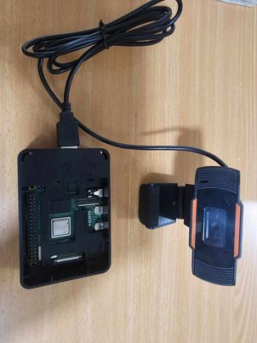

Figure 4. Web Camera with Raspberry Pi 4

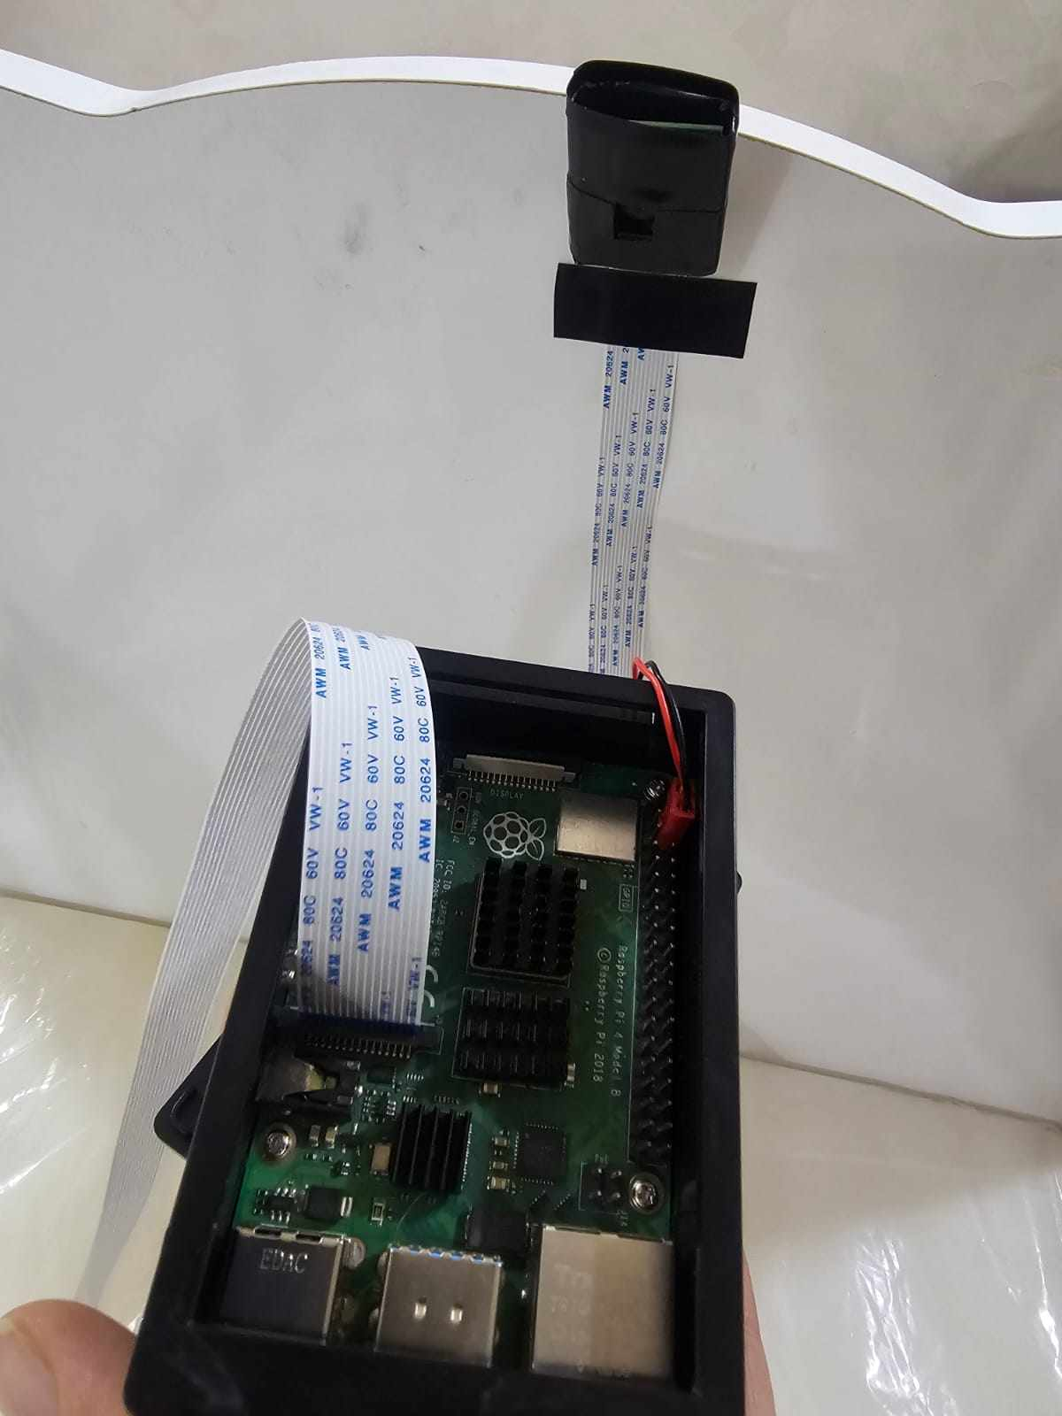

Figure 4. Raspberry Camera with Raspberry Pi 4

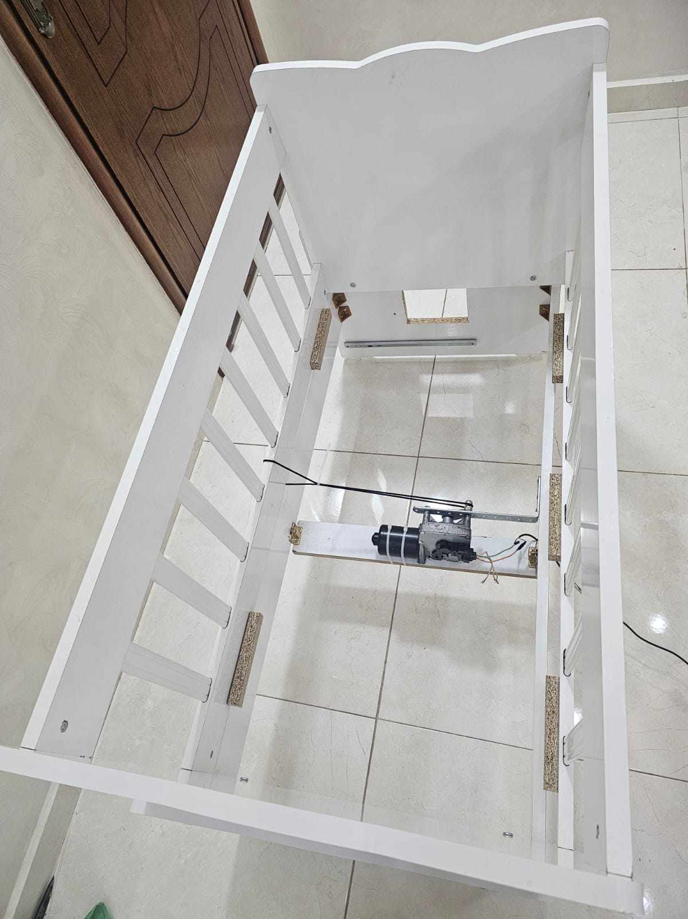

Figure 4. Wiper Motor with Raspberry Pi 4

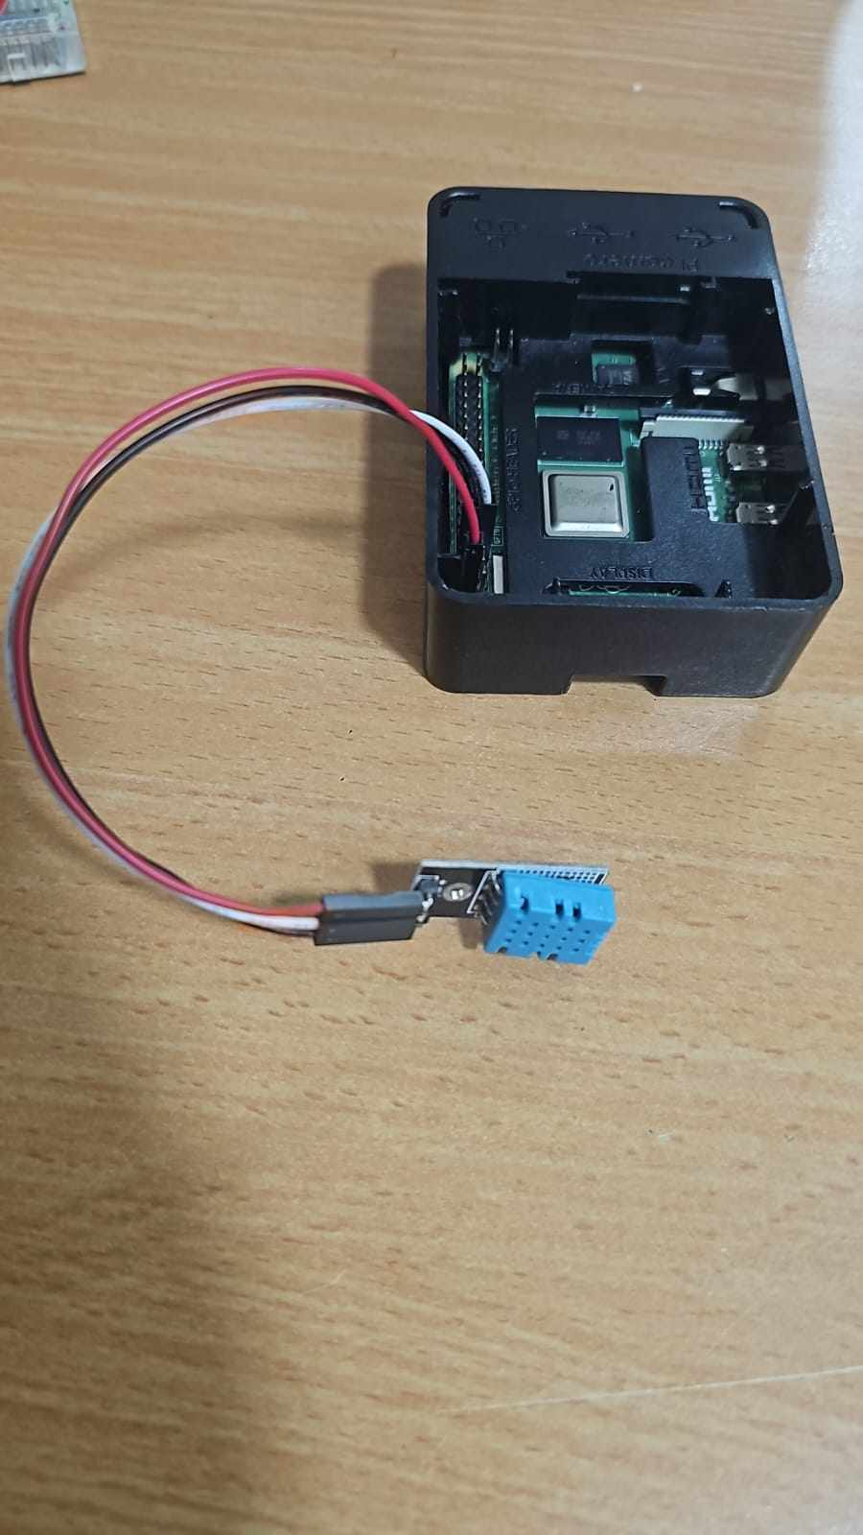

Figure 4. DHT11 Sensor with Raspberry Pi 4

After completing the connections of all sensors and devices, we connected the Raspberry Pi 4 to the Firebase. Specifically, we used Firebase Storage for the user audio and Firebase Realtime for all sensors and devices.

Finally, MIT App Inventor is used to create the application, provide a user interface for monitoring and control, and connect it with Firebase to send notifications such as the baby is in danger, or the baby is crying.

## 4.3 Application implementation

The app was developed using MIT App Inventor, it is a good tool for mobile implementation applications, whether for Android or IOS.

When the user opens the application, the program directs the user to the login page, as each user has an account, so that he can enter the system of Smart Cradle, and this is to enhance security. There is also a Sign-Up page if the user has not previously logged into the system.

After that, the user is taken to the next page, which contains a Web Viewer to view streaming video directed to the cradle, in addition to buttons to control and play a record from the user to the baby.

The fourth and last page enables controlling the air conditioner and the speed of the DC motor.

These are images of our mobile application pages.

1. In first the user should create an account by signing up, as shown in the figure below.

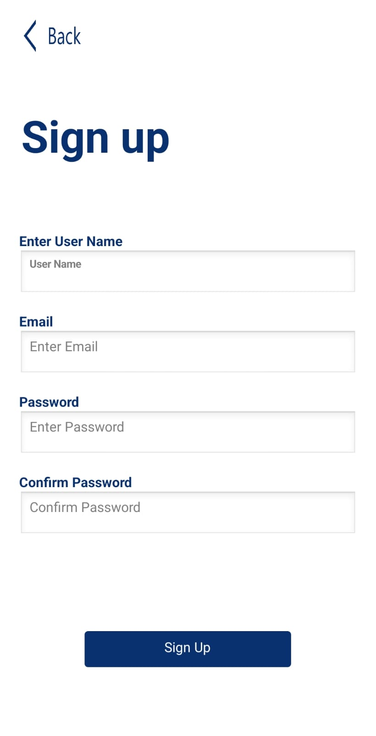

Figure 4. Sign-Up Page

Or if the Parent has an account, he login to it, as shown in the figure below.

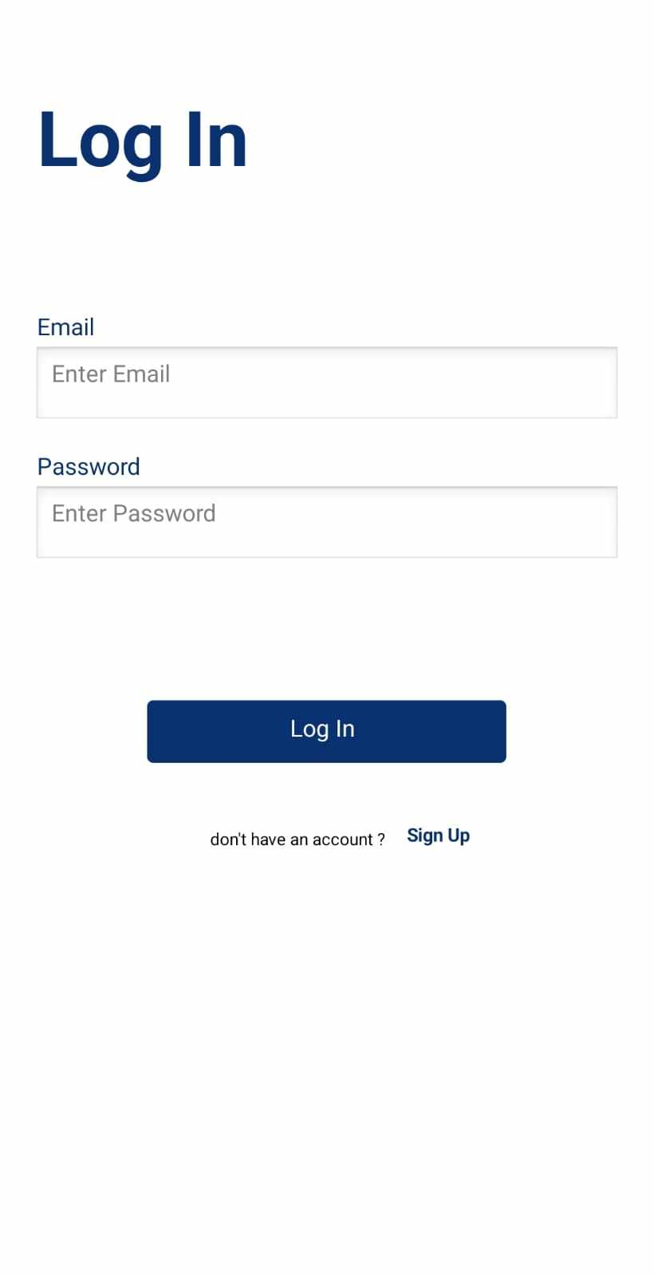

Figure 4. Log-In Page

1. The following figure is the controlling page where a parent can find sensor readings, DC motor, and air conditioner controlling, as shown below.

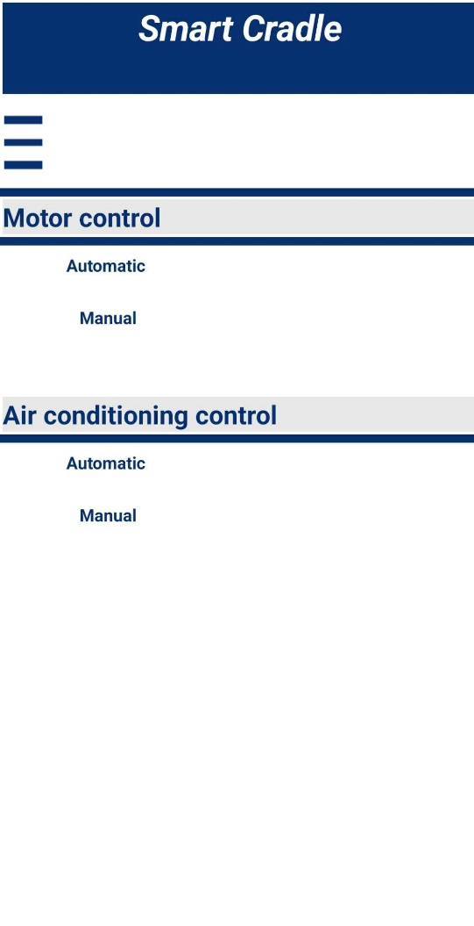

Figure 4. Controlling Page

1. The following figure is a home page containing video streaming and a button to record a voice. as shown below.

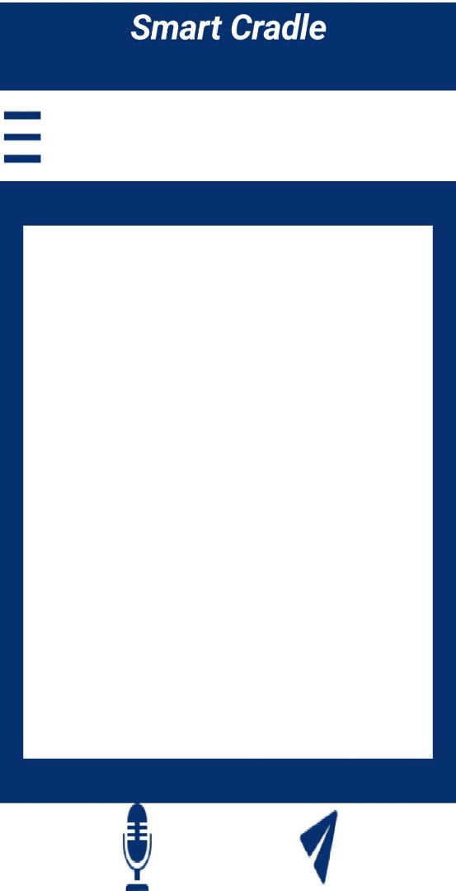

Figure 4. Home (video and record) Page

1. The following figure is the menu page which contains log out, home, and settings, as shown.

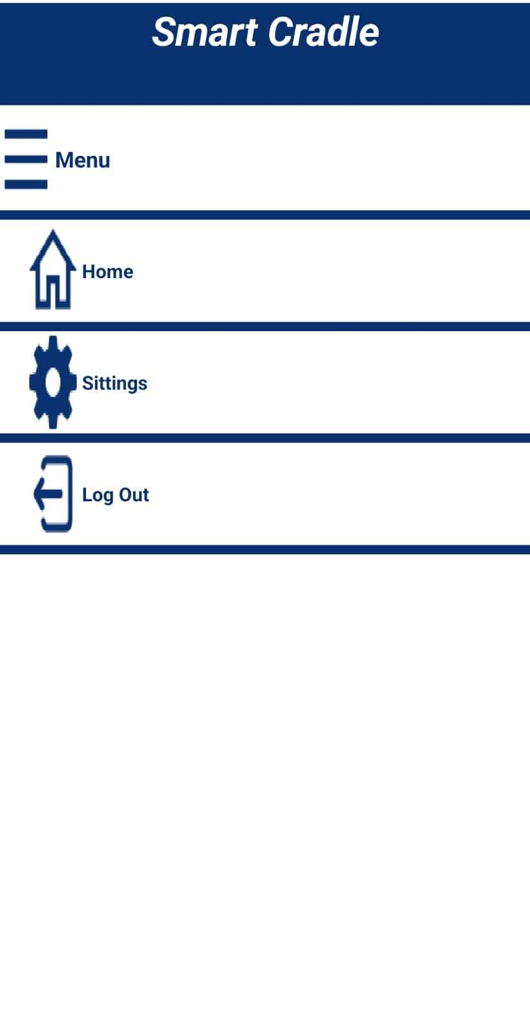

Figure 4. Menu Page

## 4.4 Implementation challenges

1. We faced problems in purchasing some sensors due to the closure of roads because of the aggression in Gaza, so we found an alternative to some sensors.
2. The versions of some libraries were not compatible with the version of the sensor or microcontroller. We solved this problem by creating a virtual environment and downloading all the libraries into it.
3. The Raspberry Pi 4 only has one AUX audio input, so we connected the microphone to it and Bluetooth was the least expensive solution for connecting the speaker.
4. We noticed distortion and lack of clarity in the microphone sound, and it took a while to solve this problem by replacing it.

### 4.5 Summary

In this chapter, software implementation tools and a general description of the working steps of the smart cradle system were explained, and how it works integrated to achieve the previously mentioned functional requirements.

Then we discussed the mobile application, what are its interfaces and contents, and an explanation of each of them. We concluded the chapter with the challenges and problems that we faced during the implementation period and how we worked on them to complete them. and implement the smart cradle project successfully.

## CHAPTER FIVE

## TESTING AND DISCUSSION

5.1 Preface

This chapter includes hardware and software testing, analysis, and discussion about the result and recommendations based on the result.

## 5.2 Validation and testing

In this section, we describe our hardware and software systems.

5.2.1 Hardware testing

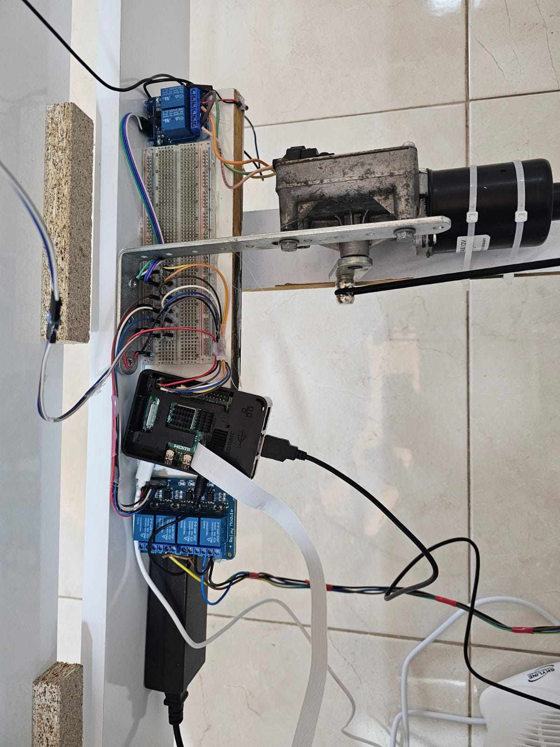We tested the connection of Raspberry Pi 4 and sensors, DC (wiper) motor, web camera, and heater.

Figure . Final Connection of The System

Figure 5. 1 Final Connection of The System

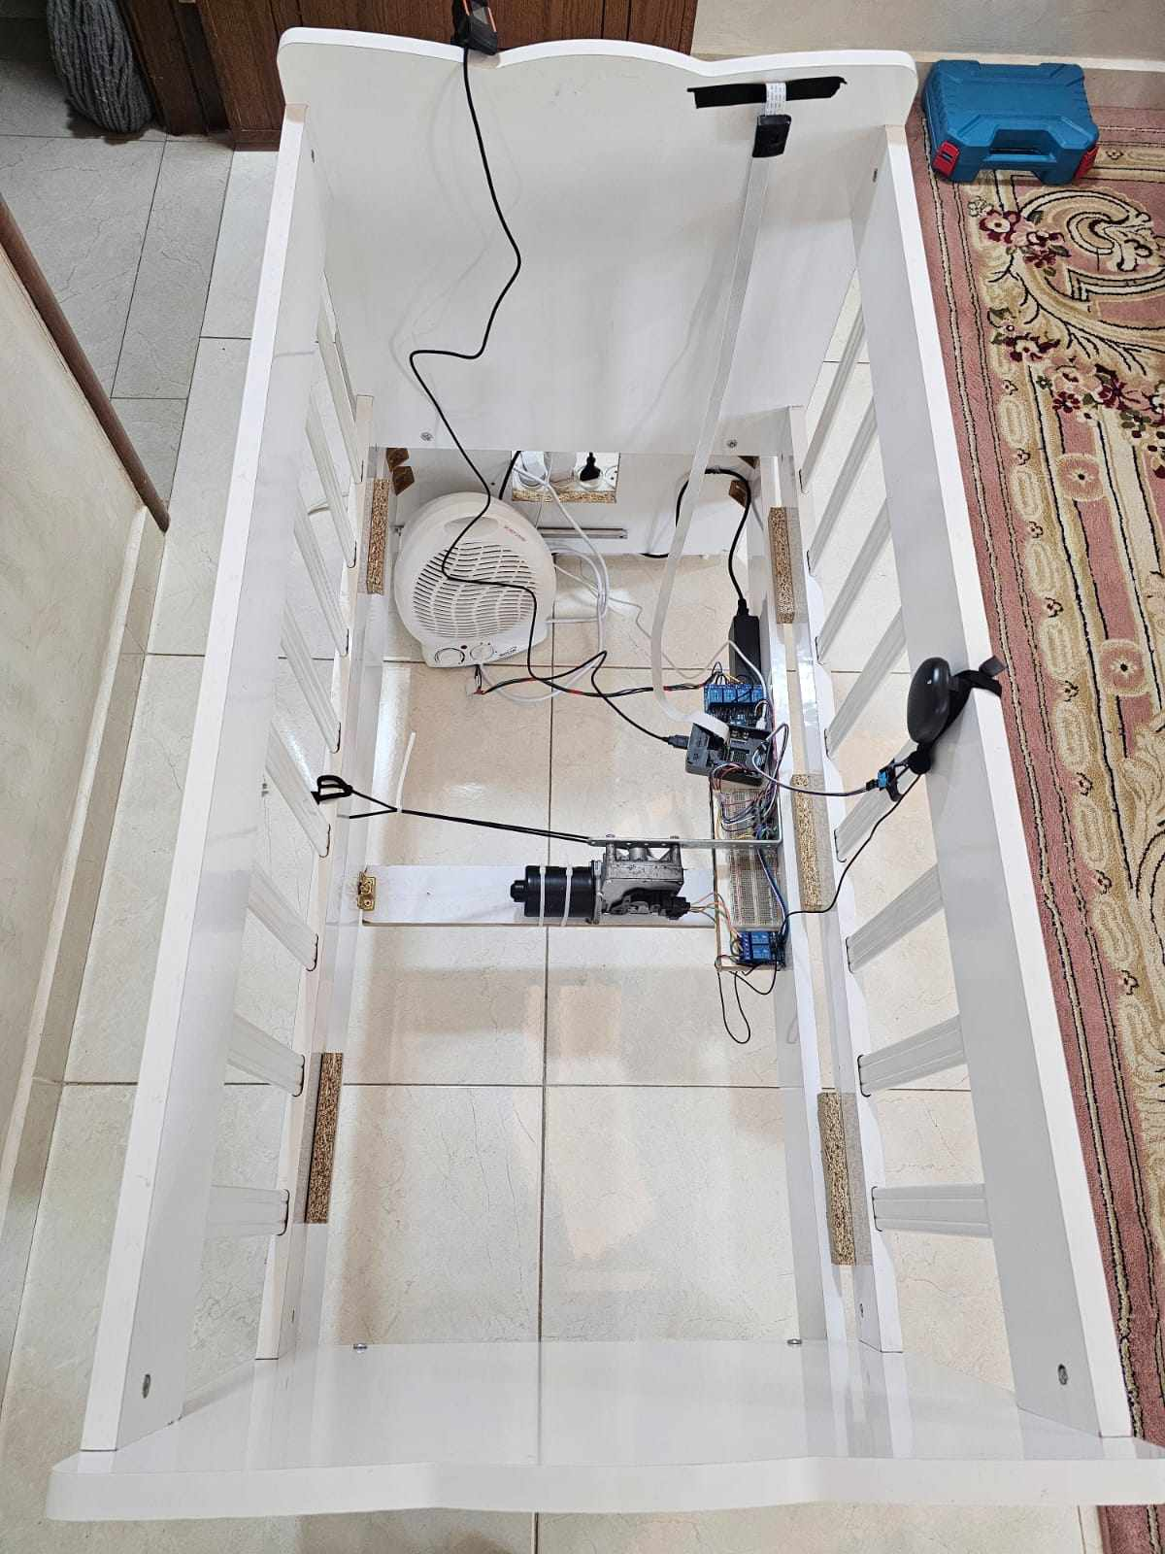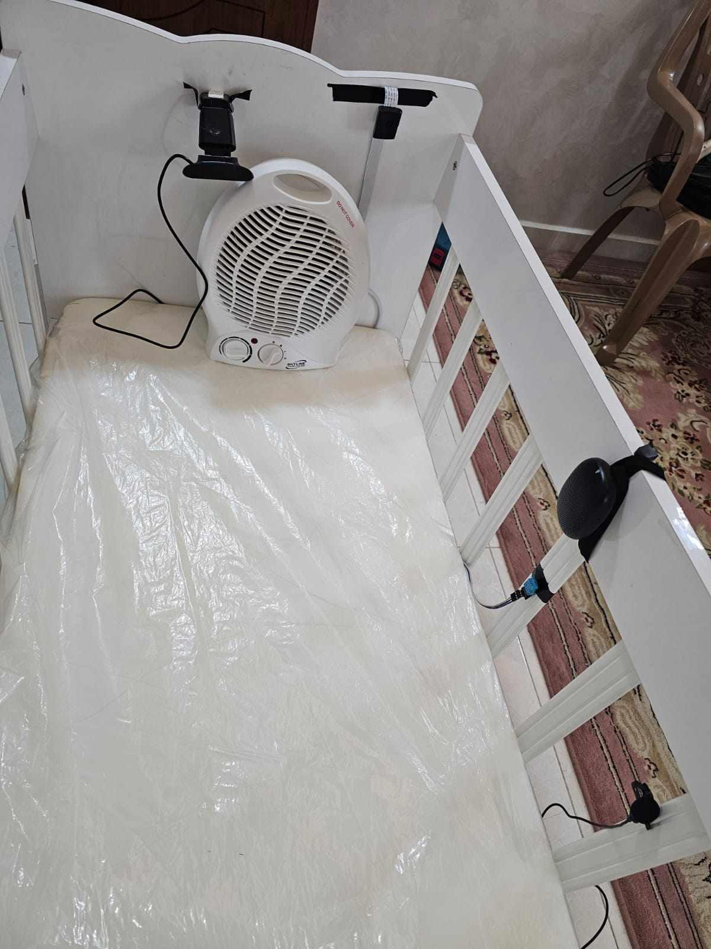

Figure . Connection on The Cradle

Figure 5. Connection on The Cradle

Figure . The Smart Cradle

Figure 5. The Smart Cradle

5.2.2 Software testing

During the software testing process, we conducted various tests to ensure that all of the features of the software were working properly. One of the tests involved connecting to Firebase and sending and receiving data from it.

We also tested the application, Another important test was the ability to display notifications coming from Firebase on the phone. In addition, We also tested the validity of the machine learning results in distinguishing between dangerous and healthy positions for the baby, Testing the speed the DC motor swung the bed was an important test.

all of these tests were successfully passed, which demonstrated the reliability and

robustness of the software. Table 5.1, Table 5.2, and Table 5.3 show some of the tests that we have carried out.

Table 5. Unit Test

|  |  |  |  |  |
| --- | --- | --- | --- | --- |
| Case | Expected Output | Problem while working | Obtained Output | Pass/Fail |
| Connect to the internet | Connect to the internet | The problem when we connect Raspberry to the internet Solving this by writing a set of commands | Connect to the internet  successfully | Pass |
| Connect to firebase | Connect to firebase | Problem with the configuration of the necessary settings, solving this by getting the SDK file | Connect to Firebase successfully | Pass |
| Send and Get data to/ from the database | Send and Get data to/from the DB | Getting API Key by a set of steps to solve the configuration problem | Send and Get data successfully | Pass |
| Get data from sensors | Get data from sensors | Problem in wiring sensors, solving by fixing it well | Get data successfully | Pass |
| Get live stream from the camera | Get live stream | The problem when taking a capture and making a decision this will take time so can't make a live stream, Solve by using another camera | Get live stream  successfully | Pass |
| Get voice from microphone | Get voice | The problem is that the microphone was not receiving a clear sound. Solved by replacing the microphone | Get voice  successfully | Pass |

Table 5. System Test

|  |  |  |  |  |
| --- | --- | --- | --- | --- |
| Case | Expected Output | Problem while working | Obtained Output | Pass/Fail |
| DHT11 sensor measures the temperature around the baby | Read the temperature around the baby | No problem | Read The temperature around the baby successfully | Pass |
| DC motor swing the cradle | Cradle is swinging | No problem | Cradle is swinging  successfully | Pass |
| The heater turns on automatically when the temperature around the baby is under 25c | Heater runs automatically | No problem | when the temperature around the baby is under 25c, the Heater runs successfully | Pass |
| The fan turns on automatically when the temperature around the baby is above 27c | Fan runs Automatically | No problem | when the temperature around the baby is above 27c, the Fan runs successfully | Pass |

Table 5. Application Test

|  |  |
| --- | --- |
| Test | Result |
| Alert parents if the baby is not in the cradle | Pass |
| Alert parents when the baby sleeps on his stomach | Pass |
| Alert parents when the baby cries | Pass |
| Parents can create an account | Pass |
| Parents can log in to their account | Pass |
| Parents can send a voice record to the baby | Pass |
| Parents can control in wiper motor | Pass |
| Parents can control in heater and fan | Pass |

## 5.3 Result and Discussion

Initially, there were several goals in this project to help parents with many of the problems they face in baby care, specifically Sudden Infant Death Syndrome(SIDS). This was achieved through the system, which consists of many sensors, electronic parts, and a microcontroller, which would help parents stay informed of the baby’s status and some of his vital signs, through a mobile application.

These components were programmed to fulfill the requirements of the smart cradle system that were mentioned previously. Each component was examined separately, and then this system was built and the necessary tests were conducted to ensure that it works as required and whether it achieves the goals of its construction or not.

It can be said that the project, which targets babies from one day to six months of age, has achieved the desired goals required by the smart cradle system.

As this system takes data from the sensors correctly, the Raspberry Pi 4 microcontroller controls the environment of the smart cradle, based on the reaction based on the capture that is taken if the baby is in the cradle and a safe position, and if the baby isn't in the cradle, or sleeping on his stomach, or if he is in a danger position, the system sends an alert to the application, and in both cases, the parents can monitor the baby through the live stream.

## 5.4 Summary

In this chapter, the system was tested in three stages. In the first stage, the sensors, electronic parts, and devices were tested separately and after ensuring their correctness, moving to the second stage, which is testing the operation of the system after connecting the electronic parts to the microcontrollers, according to the flow charts in the third chapter. Then, in the final stage, the application was tested to ensure the integration of the entire system

# CHAPTER SIX

# CONCLUSION AND FUTURE WORK

## 6.1 Preface

The chapter introduces a summary of the project, the future directions, and future work.

## 6.1 Conclusion

Smart Cradle system focuses on designing and developing a customized and expandable smart cradle system aimed at helping parents take care of their babies. smart system uses the latest technology to control and monitor a set of parameters necessary to follow the baby's condition by creating an audio and visual model using machine learning.

At the end of the project, we were able to monitor the baby's condition, which might expose him to sudden death syndrome, and the environmental temperature.

We were able to control the temperature around the baby in cold temperatures, vibrate the bed if the baby cried, and create a connection between the baby and the parents where the parents could watch and talk to the baby. Finally, we were able to build a prototype that implements functions that meet the functional requirements of the project. We found that it worked successfully.

## 6.2 Future work

In the future, we look forward to adding important features to the system, the most important can be:

* Adding cases other than sudden infant death syndrome.
* Add memory to the system.
* Further classification of the causes of baby crying.
* Dispense with Wi-Fi service by providing it with a chip.
* Provide the system to be based on IOT.

|  |  |  |
| --- | --- | --- |
| [1] |  | NIH, "Safe to Sleep," 16 9 2023. [Online]. Available: https://safetosleep.nichd.nih.gov/resources/social-digital/accidental-suffocation-and-strangulation-during-infant-sleep-text-alternative. [Accessed 16 9 2023]. |
| [2] |  | NIH, "Safe TO Sleep," 16 9 2023. [Online]. Available: https://safetosleep.nichd.nih.gov/sites/default/files/2023-02/ASSB_timeline_infographic_2700_0.jpg. [Accessed 16 9 2023]. |
| [3] |  | NIH, "Safe TO Sleep," 17 9 2023. [Online]. Available: https://safetosleep.nichd.nih.gov/about/risk-factors. [Accessed 17 9 2023]. |
| [4] |  | NIH, "Safe To Sleep," 23 12 2022. [Online]. Available: https://safetosleep.nichd.nih.gov/reduce-risk/back-sleeping. [Accessed 17 9 2023]. |
| [5] |  | P. B. Lisa A. Degnan, "U.S.Pharmacist," 21 5 2013. [Online]. Available: https://www.uspharmacist.com/article/sudden-infant-death-syndrome-40707. [Accessed 14 4 2023]. |
| [6] |  | F. R. H. S. M. D. M. I. S. M. M. C. D. E. Hauck, "Safe To Sleep," NIH, 3 5 2021. [Online]. Available: https://safetosleep.nichd.nih.gov/reduce-risk/safe-sleep-environment. [Accessed 13 9 2023]. |
| [7] |  | NIH, "Safe To Sleep," 23-HD-7462B , 20 4 2023. [Online]. Available: https://safetosleep.nichd.nih.gov/about/risk-factors. [Accessed 11 9 2023]. |
| [8] |  | M. B. K. E. B. M. B. Mohssen Mohammed, Machine Learning: Algorithms and Applications, CRC Press, 2017. |
| [9] |  | K. A. P. N. D. A. S. a. S. N. N. L. Pratap, Iot-Based Smart Cradle Monitoring System for Newborns, Coimbatore, India: IEEE, 2021. |
| [10] |  | N. H. H. R. I. U. A. a. S. M. T. R. A. F. Symon, Design and development of a smart baby monitoring system based on Raspberry Pi and Pi camera, Dhaka, Bangladesh: IEEE, 2017. |
| [11] |  | H. K. S. S. N. I. S. H. A. A. A. R. M. R. a. M. A. H. A. W. A. Jabbar, IoT-BBMS: Internet of Things-Based Baby Monitoring System for Smart Cradle, vol. 7, IEEE, 2019. |
| [12] |  | A. G. A. K. a. M. K. H. B. S. Joseph, IOT Based Baby Monitoring System Smart Cradle, Coimbatore, India: IEEE, 2021. |
| [13] |  | TANNAS, "tannas," [Online]. Available: https://www.tannas.co.uk/trust-tw-200-1920-x-1080-pixels-full-hd-usb-eco-webcam--1. [Accessed 1 5 2023]. |
| [14] |  | teachablemachine, "teachablemachine," [Online]. Available: https://teachablemachine.withgoogle.com/?fbclid=IwAR3S5lWR_7Xjw6dv4J6sGxVgSzy5k9UWfj-YdtZ8OOIx4PQsyieGCTNYyX0. [Accessed 14 4 2023]. |
| [15] |  | thonny, "thonny," [Online]. Available: https://thonny.org/?fbclid=IwAR2iYEceqstCksnm3J_66_knWEveAoSikRWtcaGhuFN7WjCD7wGfj2qpCmU. [Accessed 5 3 2023]. |
| [16] |  | M. F. Hal Abelson, "wikipedia," June 2018. [Online]. Available: https://en.m.wikipedia.org/wiki/MIT_App_Inventor?fbclid=IwAR0CHAYrkvPuUhXftEDfvtV9L6BwlYjs09tF4vA8nlnF3etjU6zsc9tt_5I. [Accessed 3 5 2023]. |
| [17] |  | firebase, "firebase," [Online]. Available: https://firebase.google.com/?fbclid=IwAR3-KmCEZmJX_lwS4mJIqpuEL35dH6eiIVSfAid_UNMEY0-XDgNk3IU1bCg. [Accessed 29 4 2023]. |
| [18] |  | G. v. Rossum, "wikipedia," 6 9 2022. [Online]. Available: https://en.m.wikipedia.org/wiki/Python_(programming_language)?fbclid=IwAR0XqIv-rrR7IilpCSn7FMrF-ht2y-WfDiLdJxPn4tWCYh6vmOZxFrX7-Rc. [Accessed 20 4 2023]. |
| [19] |  | ח. גדסי, "איך גדלת," 6 1 2021. [Online]. Available: https://gadalta.org.il/ar/wrapping_a_baby_in_pictures_arb/. [Accessed 3 5 2023]. |