**DETECTING DIABETIC RETINOPATHY USING DEEP LEARNING**

**ABSTRACT**

Diabetic Retinopathy (DR) is a human eye disease that occurs in diabetics and causes retinal damage, which can lead to blindness in the long run. DR is currently being manually screened by ophthalmologists, which is a time-consuming procedure. And from now on, this task (project) will concentrate on analysing various DR stages using Deep Learning (DL), a subset of Artificial Intelligence (AI). We trained a model called MobileNet on a massive dataset of 3662 train images to detect the DR stage and classify them into high resolution fundus images. Kaggle hosts the dataset that we are using (APTOS). There are five DR stages: zero, one, two, three, and four.

In this paper, fundus eye images from patients are used as input parameters. A trained model will then extract features from fundus images of the eye, and an activation function will provide the output. This architecture detected DR with an accuracy of 0.9611 (quadratic weighted kappa score of 0.8981). Finally, we compare the two MobileNet architectures.

**Keywords** - Deep learning, diabetic retina path, dataset, MobileNet.

**SYSTEM ANALYSIS & FEASIBILITY STUDY**

**Existing Method:**

This model emphasizes an existing method that which is designed using the some of the algorithms of machine learning. Here the process is performed using the ANN, which is one of the transfer learning methods, but this could not get the high accuracy.

**Disadvantages:**

• Less feature compatibility

• Low accuracy

**Proposed System:**

In purposed method we are performing the classification of either the diabetic retinopathy identification using MobileNet of deep learning along with the machine learning methods. As image analysis based approaches for diabetic retinopathy detection. Hence, proper classification is important for the proper retinopathy that which will be possible by using our proposed method. Block diagram of proposed method is shown below.

**Advantages**:

* Accurate classification
* Less complexity
* High performance
* Easy Identification

**Block Diagram:**

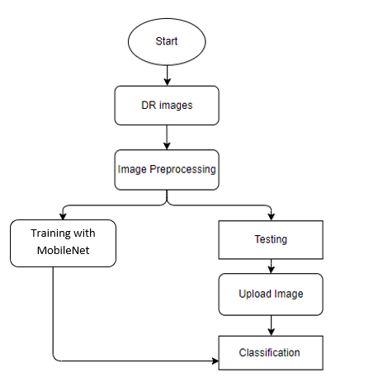

**Fig. Block Diagram of Proposed System**

**SYSTEM SPECIFICATIONS:**

# H/W Specifications:

# Processor : I5/Intel Processor

# RAM : 8GB (min)

# Hard Disk : 128 GB

**S/W Specifications:**

* Operating System : Windows 10
* Server-side Script : Python 3.6
* IDE : PyCharm, Jupyter notebook
* Libraries Used : Numpy, IO, OS, Flask, Keras, pandas, tensorflow

**MODULES:**

**SYSTEM**

**USER**

**1. System:**

1.1 Create Dataset:

The dataset containing images of the diabetic retinopathy images with the human health or not i.e., normal are to be classified is split into training and testing dataset with the test size of 30-20%.

1.2 Pre-processing:

Resizing and reshaping the images into appropriate format to train our model.

1.3 Training:

Use the pre-processed training dataset is used to train our model using MobileNet Deep learning and machine learning algorithms.

1.4 Classification:

The results of our model are display of diabetic retinopathy images are either with different labels.

**2. User:**

2.1 Upload Image

The user has to upload an image which needs to be classified.

2.2 View Results

The classified image results are viewed by user.