INTERNSPARK MERN STACK INTERNSHIP
TASK 1: BUILD A RESTFUL API USING NODE.JS, EXPRESS.JS AND MONGODB
Project Name:
InternHub – Internship Management Portal
Submitted By: MD Sohail Ahmed
InternSpark MERN Stack Internship
Objective:
The objective of this project is to develop a RESTful API for an Internship Management Portal using Node.js, Express.js, and MongoDB. The API provides CRUD operations for managing internship records and demonstrates backend development concepts including database integration, request handling, validation, logging, and error management.
The project stores internship records in MongoDB Atlas and exposes endpoints for creating, retrieving, updating, and deleting intern information.

Technologies Used:
Node.js
Express.js
MongoDB Atlas
Mongoose
Morgan
Postman
GitHub

Project Architecture:
internhub-backend/
│
├── config/
├── controllers/
├── middleware/
├── models/
├── routes/
├── postman/
├── .env.example
├── README.md
├── server.js
└── package.json
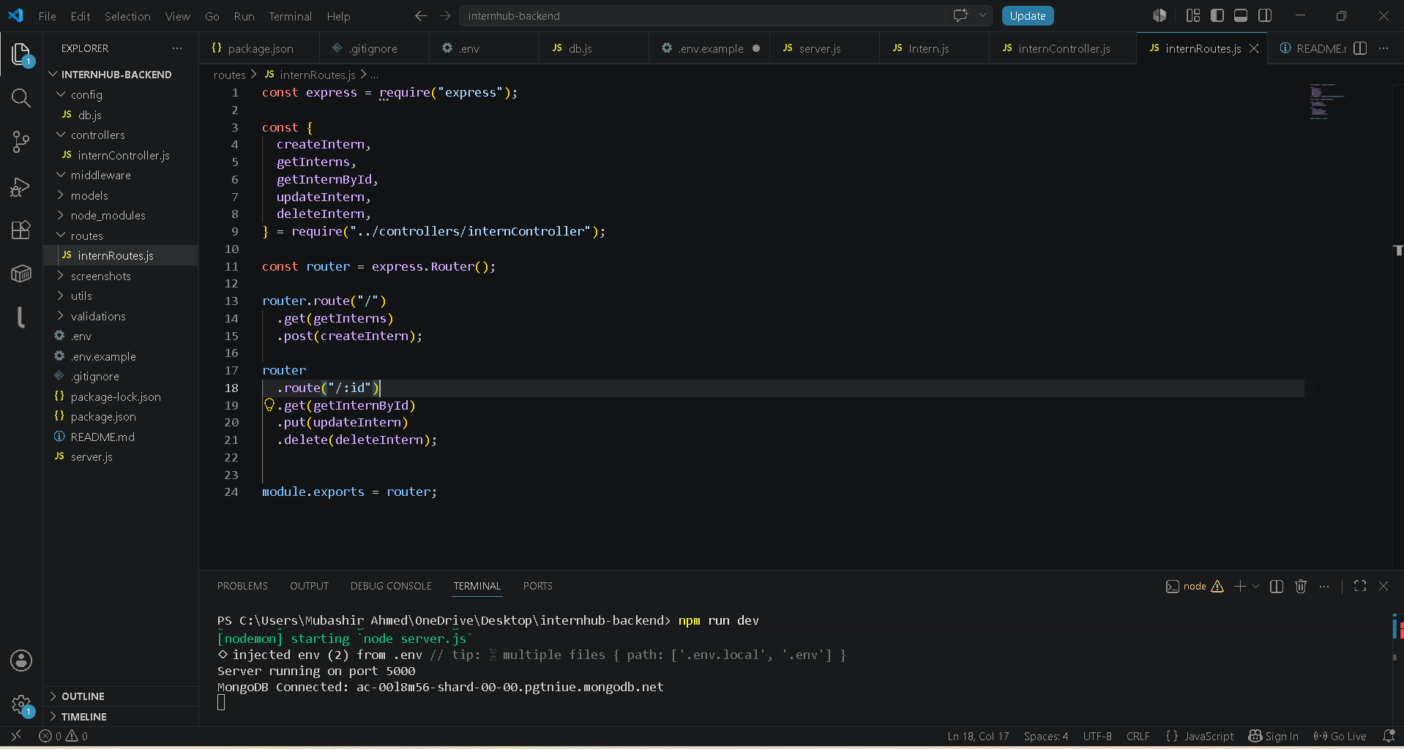
Features:
• Create Intern
• Get All Interns
• Get Single Intern
• Update Intern
• Delete Intern
• MongoDB Atlas Integration
• Mongoose Validation
• Error Handling
• Request Logging using Morgan
API Endpoints:
Method | Endpoint | Purpose
POST | /api/interns | Create Intern
GET | /api/interns | Get All Interns
GET | /api/interns/:id | Get Single Intern
PUT | /api/interns/:id | Update Intern
DELETE | /api/interns/:id | Delete Intern
MongoDB Connection:
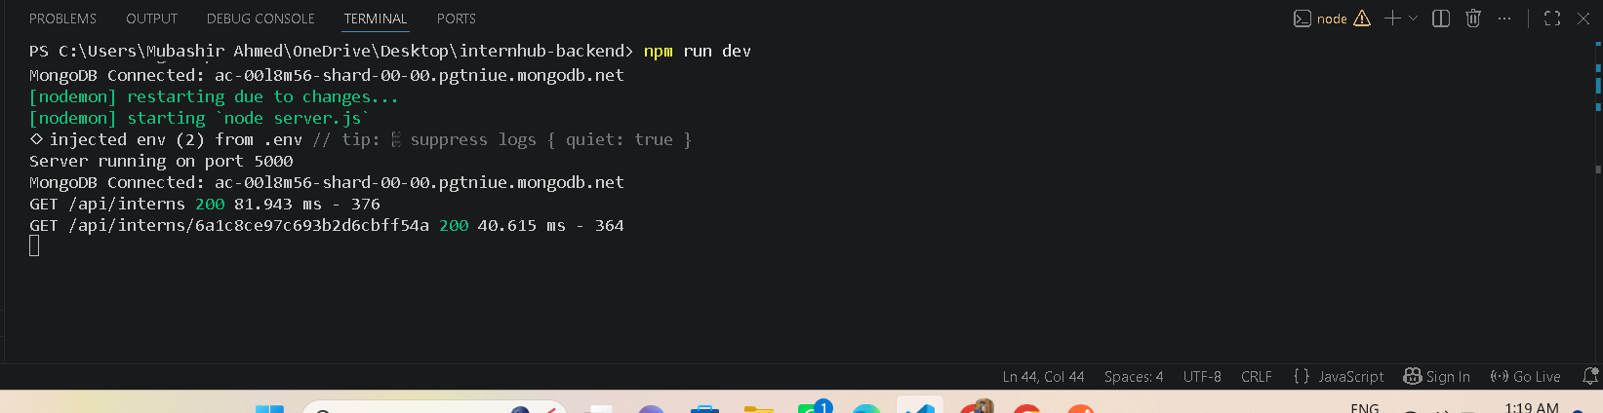
MongoDB Atlas was used as the cloud database. The application successfully connects using Mongoose and stores internship records.

CRUD Operations:

Create Intern
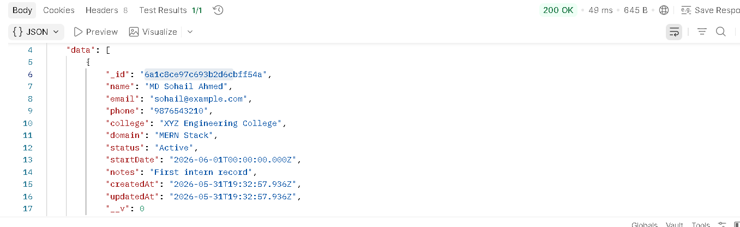

Get All Interns
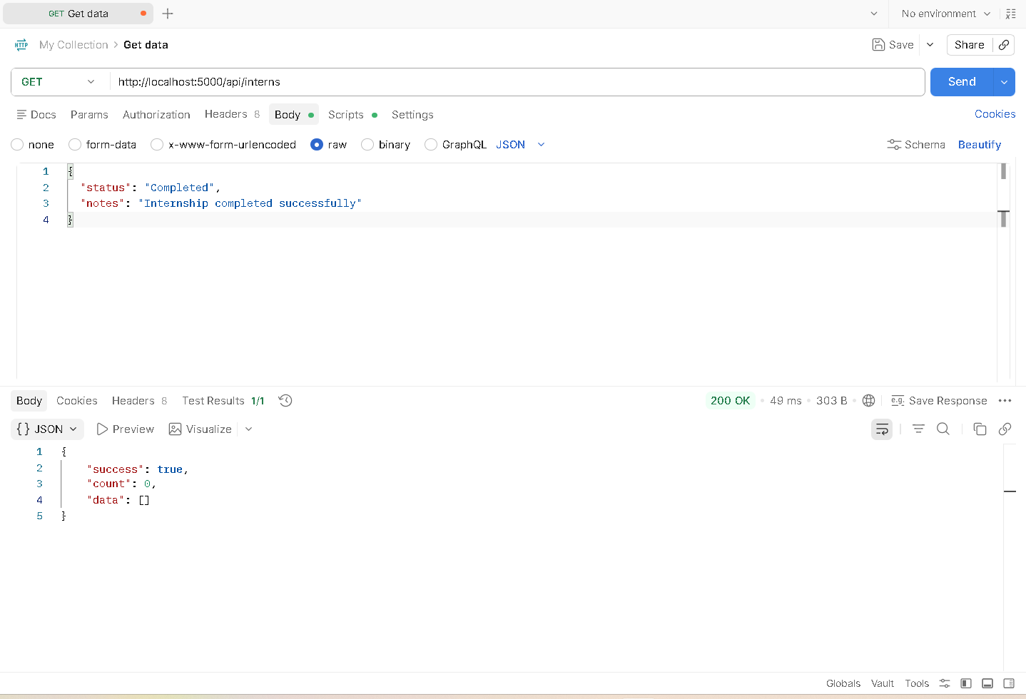

Get Single Intern
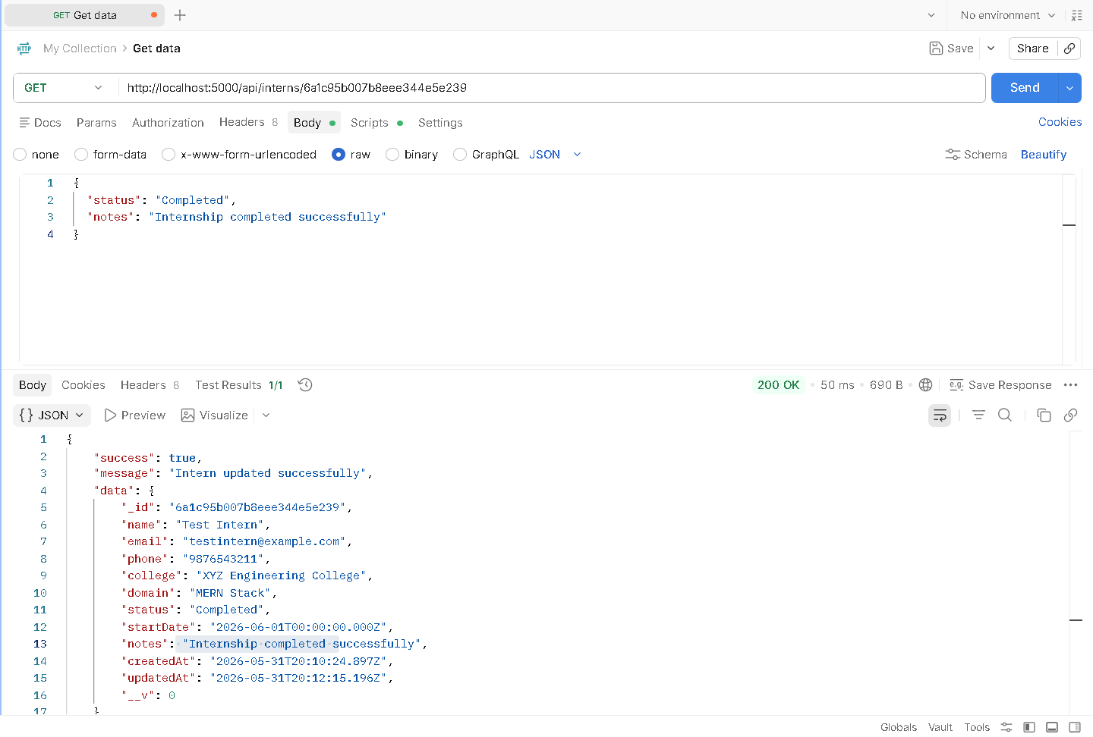

Update Intern
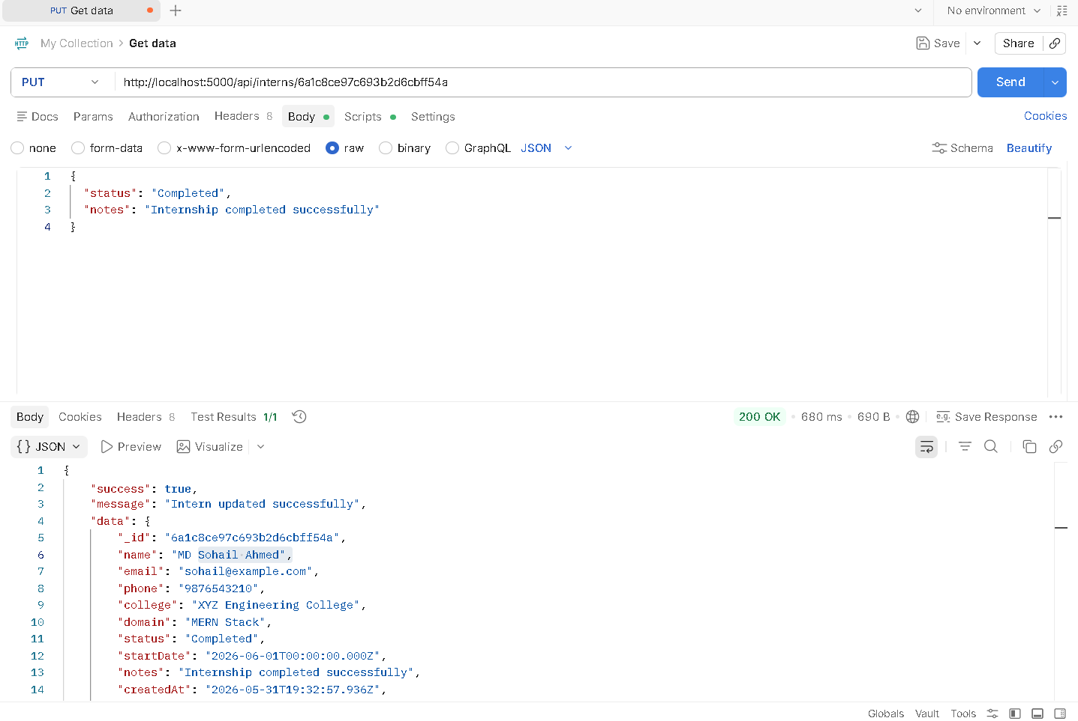

Delete Intern
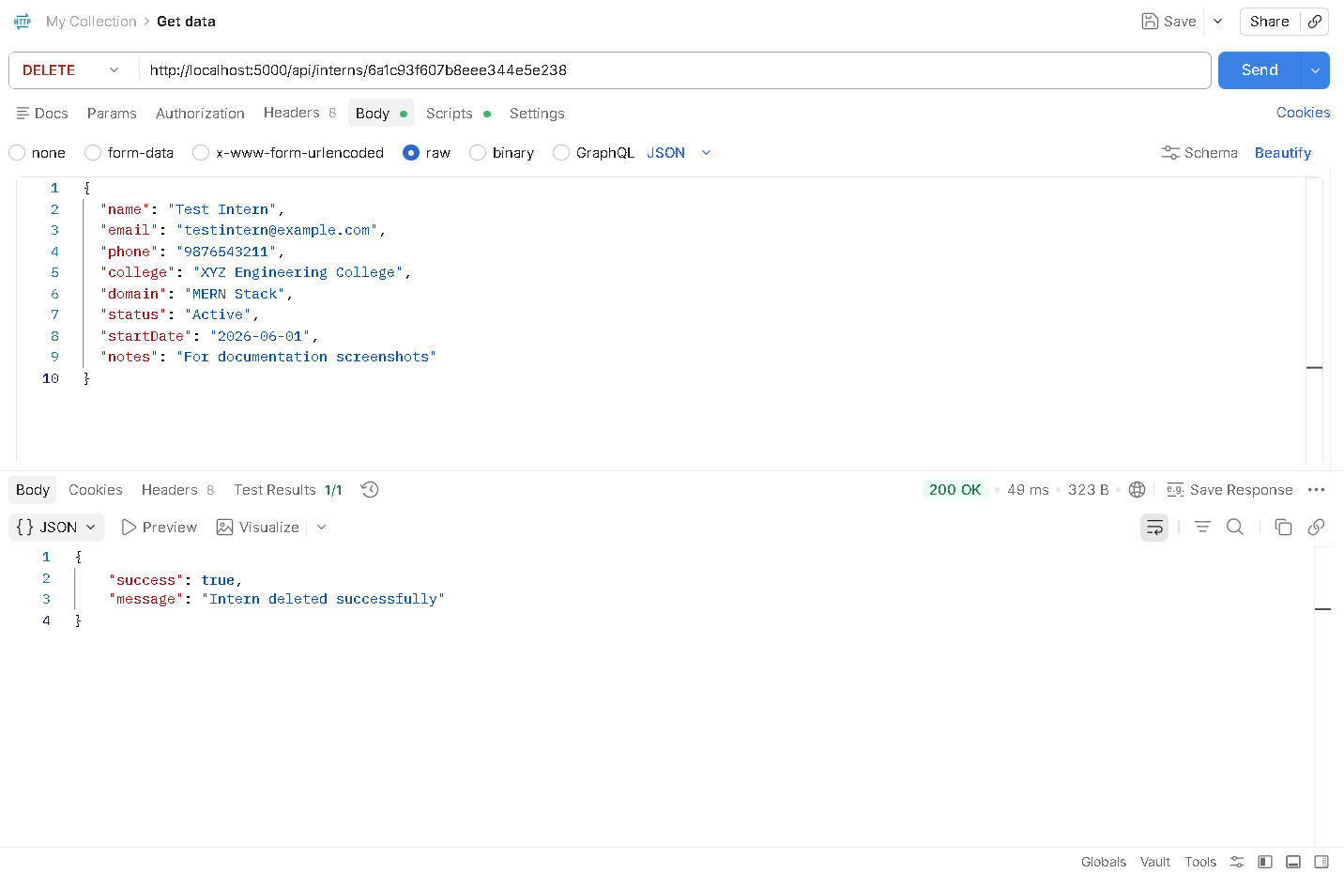

MongoDB Data Storage
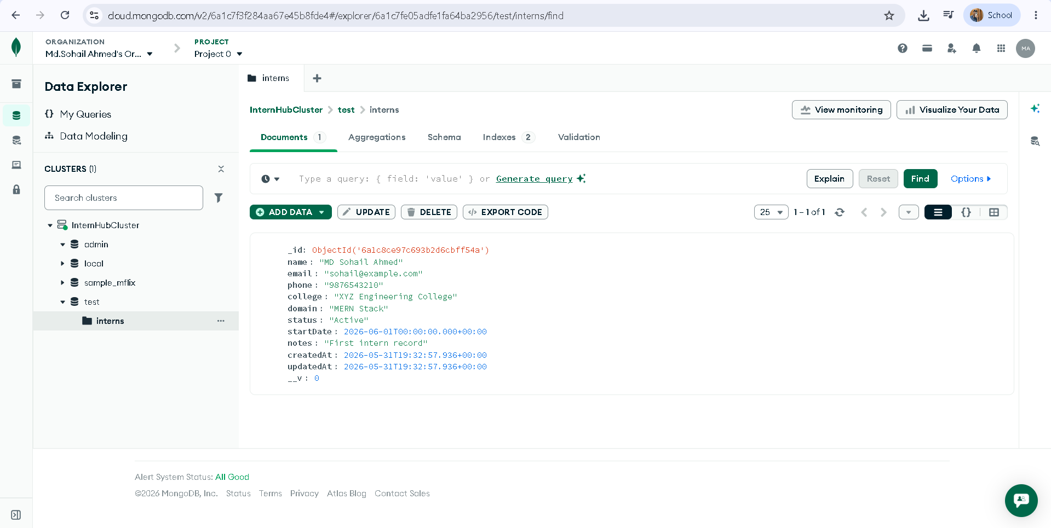
The API successfully stores intern records in MongoDB Atlas and retrieves them through REST endpoints.

Validation and Error Handling
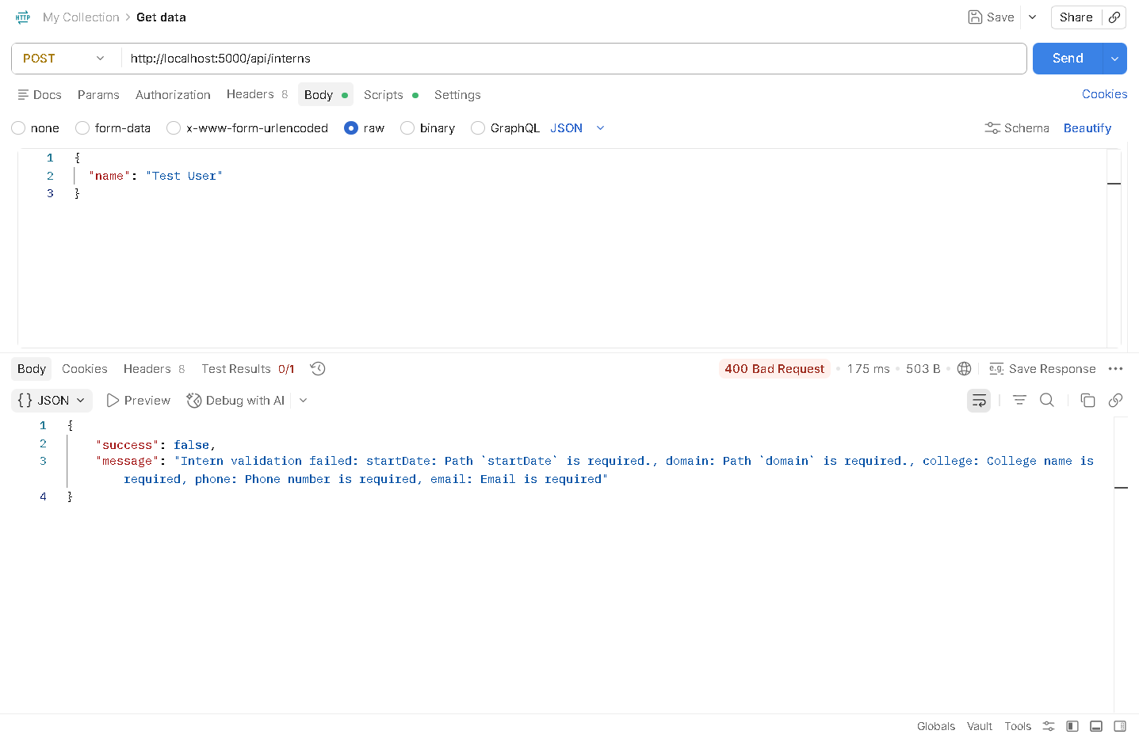
Mongoose schema validation ensures that required fields are provided before storing records. Invalid requests are rejected with appropriate error messages.
Postman Collection
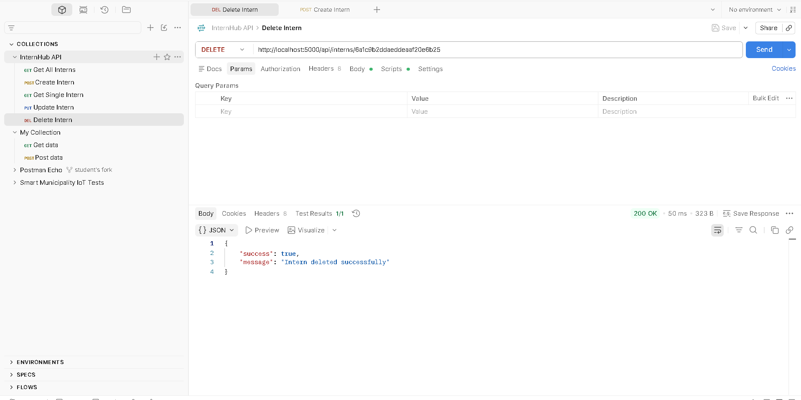
All CRUD API requests were organized into a Postman Collection and exported for testing and documentation purposes.
GitHub Repository
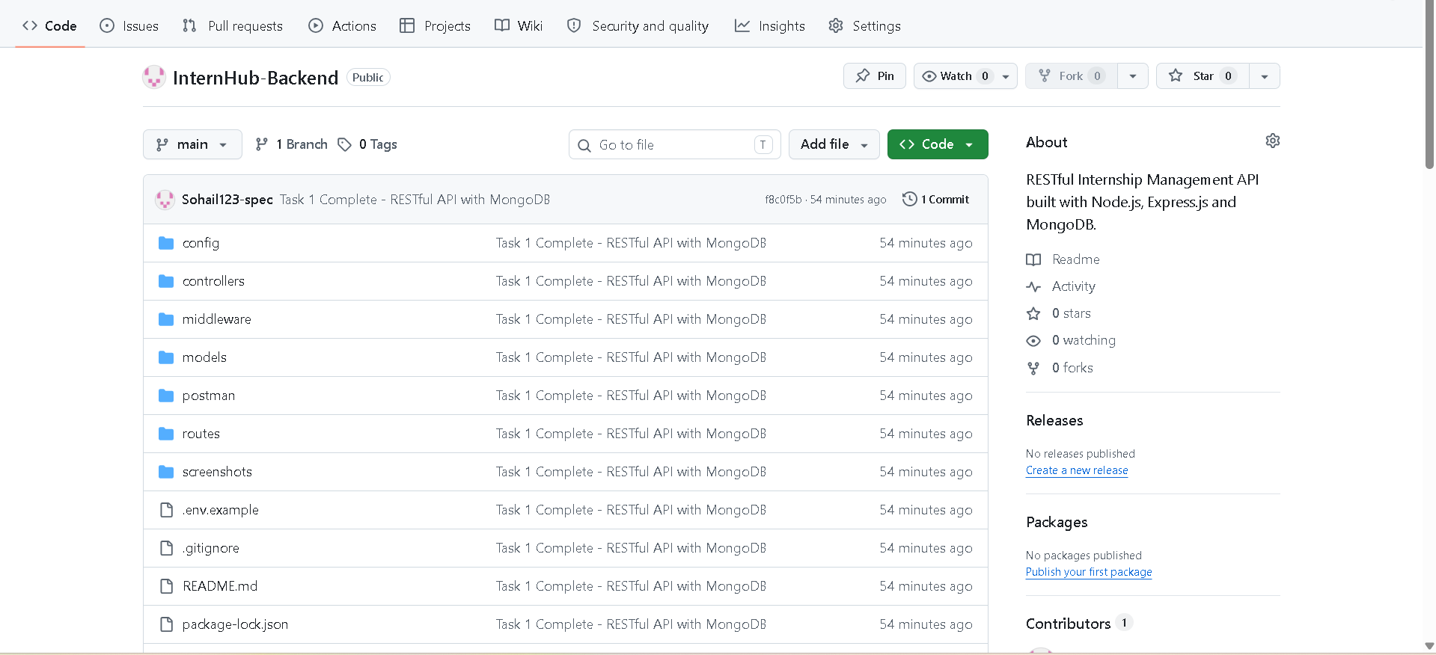
GitHub Repository Link: https://github.com/Sohail123-spec/InternHub-Backend
Conclusion:
The Internship Management Portal backend was successfully developed using Node.js, Express.js, and MongoDB. The application provides complete CRUD functionality, database integration, validation, logging, and error handling. The project satisfies all requirements specified in Task 1 and establishes a strong backend foundation for future frontend integration and authentication features.

Submitted By: MD Sohail Ahmed
Submission Date: 01/06/2026

