**Energy Consumption using Dashboard in Power BI**

**Problem Statement**

Develop an interactive Power BI dashboard to analyze energy consumption data for a business, providing insights into total costs, unit consumption, and trends across different energy types (gas, electricity, water).

**Aim**

The aim of this project is to create a comprehensive and interactive Power BI dashboard that enables users to visualize, analyze, and understand energy consumption patterns within a business. By leveraging data on energy consumption, rates, and building information, the dashboard will provide valuable insights into cost optimization, trend analysis, and potential areas for improvement.

**Learning Objectives**

The objectives of this project are to:

1. **Explore and visualize trends** in energy consumption for different energy types (gas, electricity, water) over time.
2. **Analyze energy consumption patterns** across different buildings, cities, and countries.
3. **Identify key metrics** such as total cost, total unit consumed, and rates for each energy type.
4. **Compare energy consumption data** across different time periods and identify anomalies or outliers.
5. **Develop and interpret key performance indicators (KPIs)** to assess energy efficiency and identify areas for improvement.
6. **Utilize data mining techniques** to discover hidden patterns and correlations within the energy consumption data.
7. **Create interactive visualizations** using Power BI to effectively communicate insights and findings to stakeholders.
8. **Gain a deep understanding of energy consumption patterns** and identify opportunities for cost reduction and optimization.
9. **Explore the potential of using machine learning algorithms** for anomaly detection, predictive modeling, and automated insights generation.
10. **Investigate the benefits of incorporating NLP features** for conversational data exploration and analysis.
11. **Identify additional dimensions** that can be added to the analysis to provide deeper insights into specific areas (e.g., customer behavior, cost analysis, energy utilization, market trends).

**About Project**

This project aims to develop a Power BI dashboard to analyze energy consumption data for a business. By visualizing key metrics, comparing consumption patterns, and identifying trends, the dashboard will provide valuable insights into optimizing energy usage and reducing costs. The project will also explore the potential of using machine learning and NLP techniques for advanced analysis and automated insights.

**Data Source Link**

The data for this project is based on the energy consumption dataset, which can be accessed from various internal sources, utility providers, or government agencies. Please note that the specific link may vary depending on your organization's data management practices and the availability of the dataset at the time of your access.

Link: [Energy Consumptions Dataset.xlsx](https://edunetfoundationorg-my.sharepoint.com/:x:/g/personal/namra_edunetfoundation_org/ERZmaJ9EVntLooa4E4Xn63kB6r0Qf3Xadw4ZWHvnO1o2DQ?e=cDGIST)

**Tools Used**

**Power BI:**

* Power BI is a business intelligence (BI) platform by Microsoft that allows users to connect to various data sources, analyze data, create interactive visualizations, and share findings.
* The platform's optimized structure, intuitive interface, and rich visual capabilities enable users to gain deeper insights from their data, driving better decision-making and improved business outcomes.

**Findings and Insights**

**Overall Energy Consumption:**

* **Total Cost:** The total cost of energy consumption over the analyzed period is $15.84 million.
* **Unit Consumed:** A total of 210 million units of energy were consumed.

**Total Cost by City:**

* **City Comparison:** New York has the highest Total Cost at $4,335,044.42, followed by Chicago and Los Angeles.
* **Cost Range:** Across all five cities, Total Cost ranged from $1,440,927.74 to $4,335,044.42.

**Total Cost by Date & Consumption Type:**

* **Trend Analysis:** The line chart shows fluctuations in energy consumption costs over time, with peaks and troughs for different consumption types.
* **Consumption Type:** Electricity and gas seem to be the dominant consumption types, with water accounting for a smaller portion.

**Unit Consumed by Type:**

* **Consumption Breakdown:** Water accounts for 88.49% of total unit consumption, followed by electricity and gas.
* **Type Comparison:** Electricity and gas consumption appear relatively balanced compared to water consumption.

**Unit Consumed by Building:**

* **Building Comparison:** Building 81007 has the highest unit consumption, followed by 81006 and 81008.
* **Outlier Detection:** Buildings 81001 and 81002 seem to be outliers with significantly lower consumption compared to others.

**Additional Insights:**

* **Seasonal Variations:** Analyzing the data by quarter or month can reveal seasonal patterns in energy consumption.
* **Correlation Analysis:** Exploring correlations between energy consumption and other factors (e.g., temperature, occupancy) can provide deeper insights into consumption patterns.
* **Cost Optimization:** Identifying areas of high consumption can help implement measures to reduce energy usage and associated costs.

**Overall, the dashboard provides a valuable tool for analyzing energy consumption patterns and identifying opportunities for optimization and cost reduction.** By understanding the trends, variations, and key factors influencing energy consumption, businesses can make informed decisions to improve their energy efficiency and sustainability.

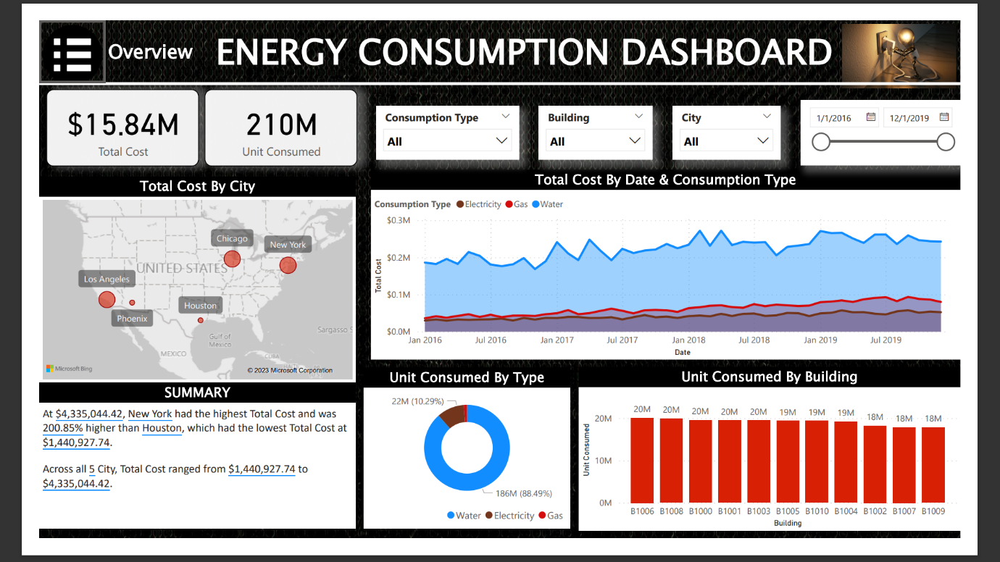

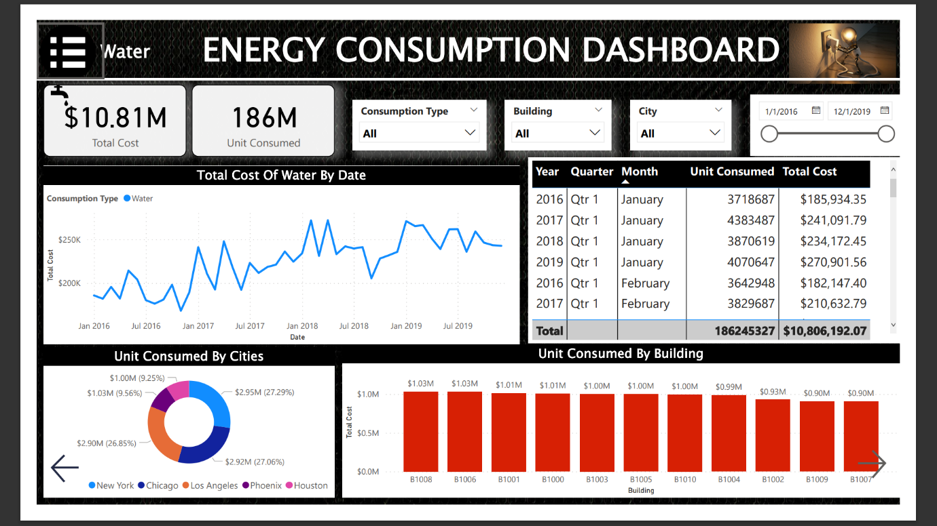

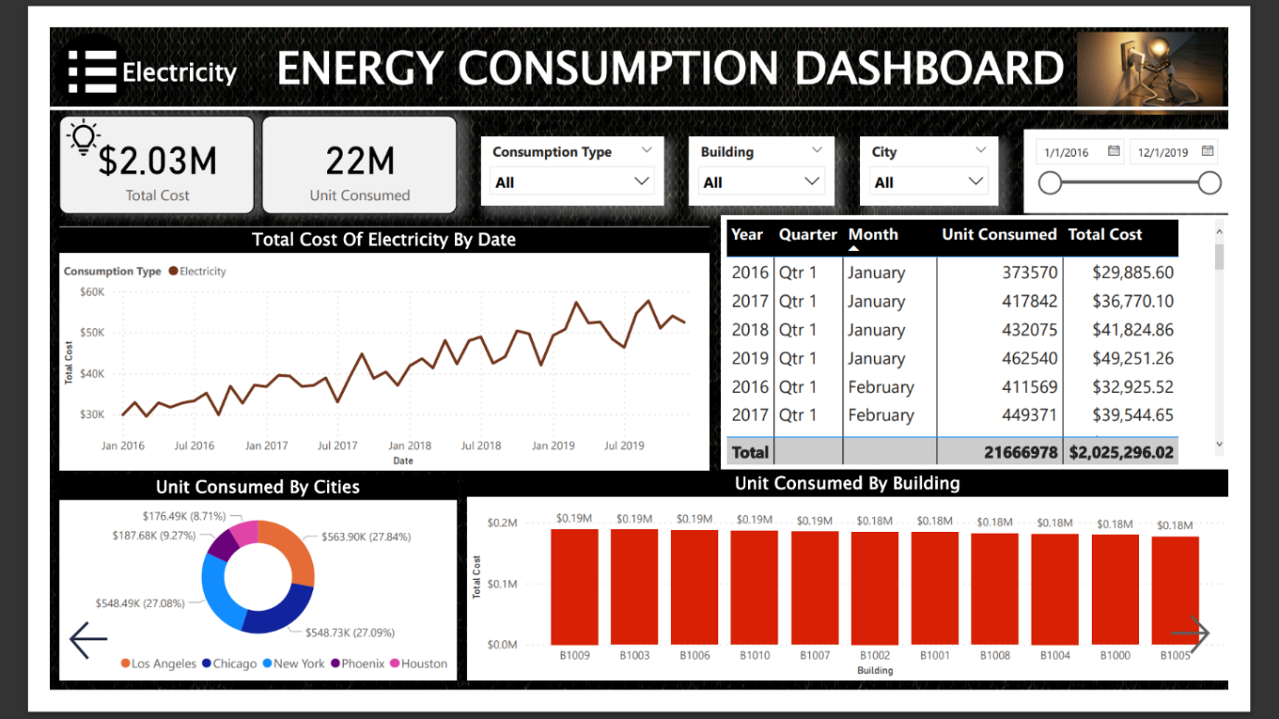



**Conclusion**

The Energy Consumption Dashboard provides valuable insights into energy usage patterns and identifies opportunities for optimization. By understanding trends, variations, and key factors, businesses can make informed decisions to reduce costs and improve sustainability.