| **Ex No: 1**  **Date: 16th August 2024** | **Implementing a Multi-Class Classification Model using Gradient Descent** |
| --- | --- |

**Objective:** To build a softmax regression classifier to recognize different types of flowers using gradient descent implementation.

**Descriptions:**  
 Multi-class classification is the task of classifying elements of a given set into more than two groups. Softmax regression, also known as multinomial logistic regression, is a generalization of logistic regression that we use when there are more than two classes. The objective is to classify images of flowers into one of several categories.

Given an input image *x*, the output *y* is a label that indicates the type of flower. Each class corresponds to a specific flower category. The model's goal is to output the prediction which is the estimated probability that the image belongs to each flower category.

The softmax regression model doesn't have a hidden layer, and its output is computed by applying the softmax function to the linear combination of input features. The parameters are optimized using the gradient descent algorithm.

**Model:**

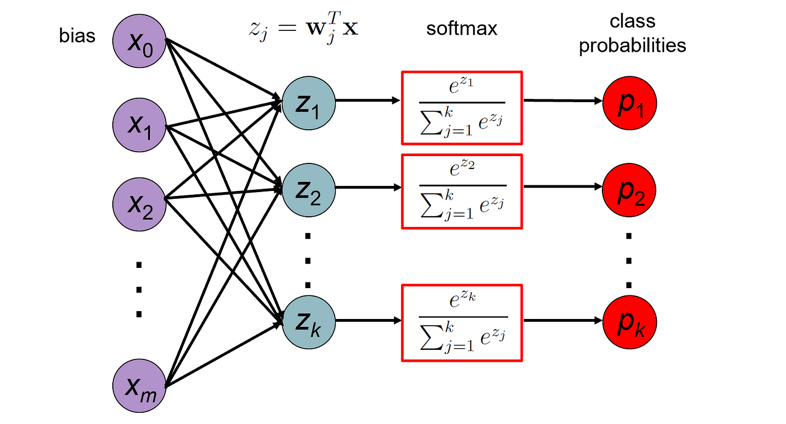

Image Source : [Click here](https://towardsdatascience.com/deep-dive-into-softmax-regression-62deea103cb8)

**Building the parts of the algorithm**

The main steps for building the Softmax Regression Model are:

1. Define the model structure (such as number of input features and classes).

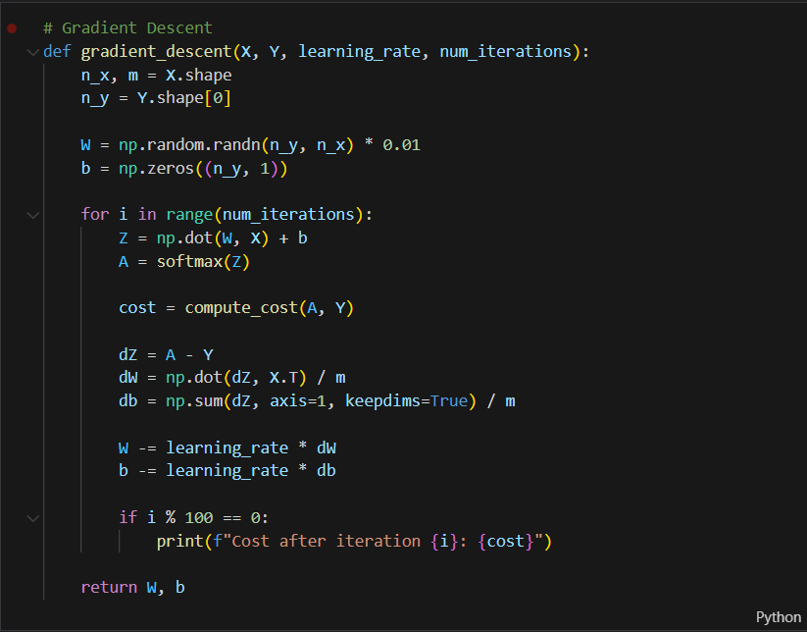

1. Initialize the model's parameters.



1. Loop:

* Calculate current loss (forward propagation using the softmax activation function).

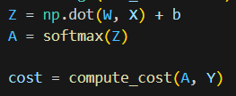

* Calculate current gradient (backward propagation).

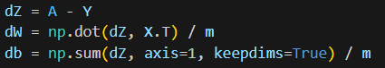

* Update parameters (gradient descent).



**GitHub Link:** [**https://github.com/SohailAnsari77/DeepLearning**](https://github.com/SubramanyaPReddy/DeepLearning)