Abstract :

Sooner or later, business will need more space for data storage. Information in the form of Emails, documents, presentations, databases, graphics, audio files and spreadsheets is the lifeblood of most companies, and the applications that runs and protects your business requires a lot of disk space.

**What are the available options ?**

1. Flash memory thumb drives
2. External hard drives
3. Online storage
4. Network-attached storage (NAS)

**Network Attached Storage**

* NAS solutions are suitable for small and mid-sized businesses needing large amounts of economical storage that multiple users can share over a network.
* Network-attached storage (NAS) provides fast, simple, reliable access to data in an IP networking environment.
* NAS solutions are easy to deploy, centrally manage and consolidate.

NAS solutions can be as basic as a single hard drive with an Ethernet port or built-in Wi-Fi connectivity costing around $200 for 300GB or more. Moving up in sophistication, NAS solutions can also provide additional USB and FireWire ports, enabling you to connect external hard drives to scale your business's overall storage capacity.

Implementation

**Node.js**

The first part of creating a web server that can handle user requests and can be used to store user files was to create a Node.js server. Node.js is an [open-source](https://en.wikipedia.org/wiki/Open-source_software), [cross-platform](https://en.wikipedia.org/wiki/Cross-platform) [JavaScript](https://en.wikipedia.org/wiki/JavaScript) [run-time environment](https://en.wikipedia.org/wiki/Runtime_system) that executes JavaScript code outside of a browser.

Node.js was used to handle all the back-end operations required for the project from storing data of the users in a database( MySQL) to handle uploading and downloading of files. With the help of Node,js, we can create a local server running at any port which can be accessed by any device knowing the ip address of the server. For security purposes, the ip of the server is hidden and users can be connected to the server with the help of a reverse-proxy server using Nginx.

**Advantages of using Node.js** :

### Node.js offers an Easy Scalability: One of the key advantages of Node.js is that developers find it easy to scale the applications in horizontal as well as the vertical directions. The applications can be scaled in horizontal manner by the addition of additional nodes to the existing system.

### Known for Offering High Performance: It has been mentioned earlier that Node.js interprets the JavaScript code via Google’s V8 JavaScript engine. This engine complies the JavaScript code directly into the machine code. This makes it easier and faster to implement the code in a effective manner.

### Handles the Requests Simultaneously: Since the Node.js is providing the option of non-blocking I/O systems, it relatively helps you to process several requests concurrently.

The basic block diagram of the whole system can be seen below:

* The clients ie. users can connect to the Nginx server using ip address of the Nginx server.
* The Nginx server then connects to the Node.js server to serve web pages as well handle user-requests on demand.
* For the storage of user data, we have used MySQL as our database which is connected to our Node.js server.

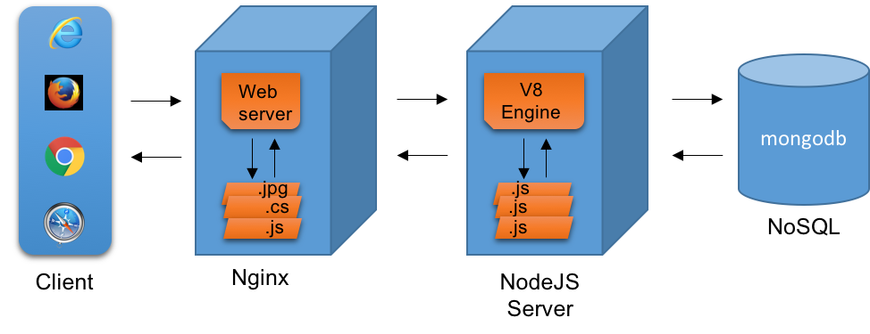

**Reverse Proxy Server** :

A proxy server is a go‑between or intermediary server that forwards requests for content from multiple clients to different servers across the Internet. A **reverse proxy server** is a [type of proxy server](https://buy.fineproxy.org/eng/) that typically sits behind the firewall in a private network and directs client requests to the appropriate backend server. A reverse proxy provides an additional level of abstraction and control to ensure the smooth flow of network traffic between clients and servers.

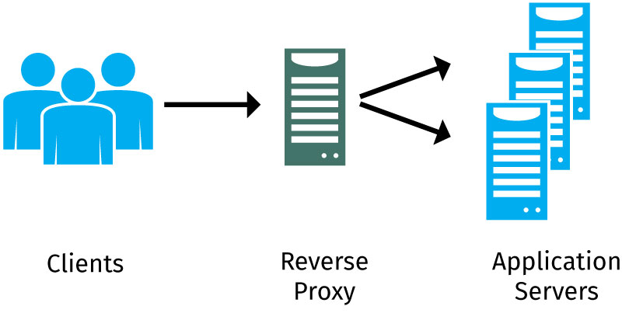

# Node.js connectivity with database

**Database used:**

We have used MySQL in our project. The following is the relational table used :

**Database name** : users

**Table name** : userDetails:

|  |  |  |  |
| --- | --- | --- | --- |
| Username | Email | Password | Date |
| sohail | sohail10@gmail.com | @$utrvcfhsurtfhy | 10-4-2019 |
| abhishek | abhishek@gail.com | kfcnivntvjtvynlftv | 10-4-2019 |
| shreyas | adani@gmail.com | Incfhdinrcifg | 10-4-2019 |

Result

The following are the images of the website. The users are provided with the following functionalities:

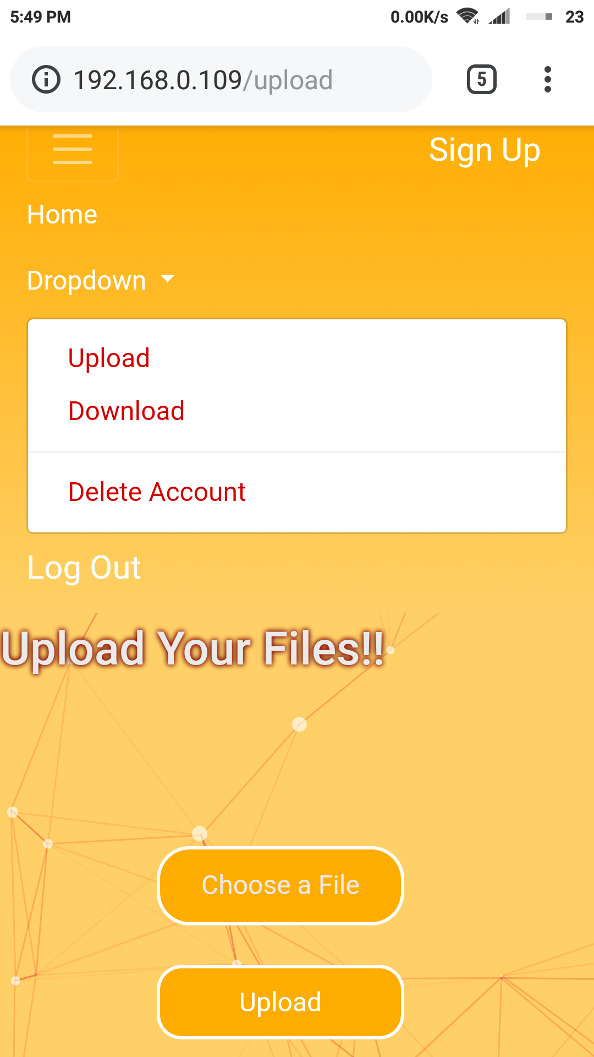

**Upload and Download**: Users can upload any number of files without the limitation on size and can also download any-time on demand.

**Rename**: Users are allowed to rename their stored files any number of times.

**Delete**: Users can delete any number of files at any time on the go.

**Delete Account**: Users can also permanently delete their account resulting in the lost of their account details and their stored files.

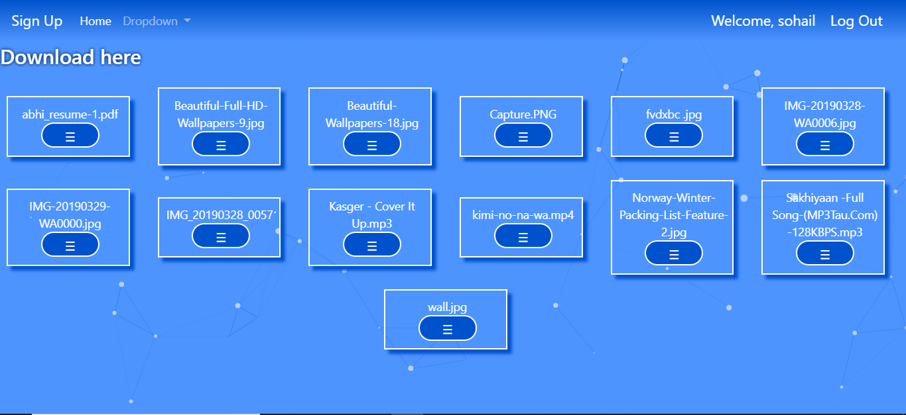

Future Scope

Since the application was developed keeping in mind the requirement of a small or medium sized business, there are various ways in which the application can be extended. Some of these are :

1. Handling growing userbase :

As the number of users continue to grow, more servers can be added and the configuration of the proxy changed to distribute the load to different servers.

2. Security :

The setting in a proxy server can be adjusted according to needs of an

Organisation.

3. Node.js offers an easy scalability :

One of the key advantages of Node.js is that developers find it easy to

scale the applications in horizontal as well as the vertical directions.

The applications can be scaled in horizontal manner by the addition of

additional nodes to the existing system.

4. Easy Integration of new features :

Since Node.js has a large number of modules both built in and third

Party various new features can be easily integrated into the application

as per the requirements.

Description

The intranet storage application can be used to store files on a server in a small private network, which isn’t necessarily connected to the internet. The only requirements to use the application are connection to the network and an account. The application is web based, thus making it possible for everyone to use it easily.

The various technologies used in the application are as follows :

1. Node.js
2. HTML, CSS (bootstrap)
3. MySQL
4. Nginx Server

The website can be accessed by entering the ip address of the server and can be accessed from any device connected to network. The website is optimised for mobile devices also.

Features of the application :

1. Registration is simple and only unique email-id and username are needed.
2. Password is stored in hashed format and main server is hidden from the users by use of a proxy server.
3. File upload and download capability is provided, with no constraint on the size of file.
4. The stored files can be viewed and can be renamed or deleted.
5. User account can be deleted as well.

**Performance:**

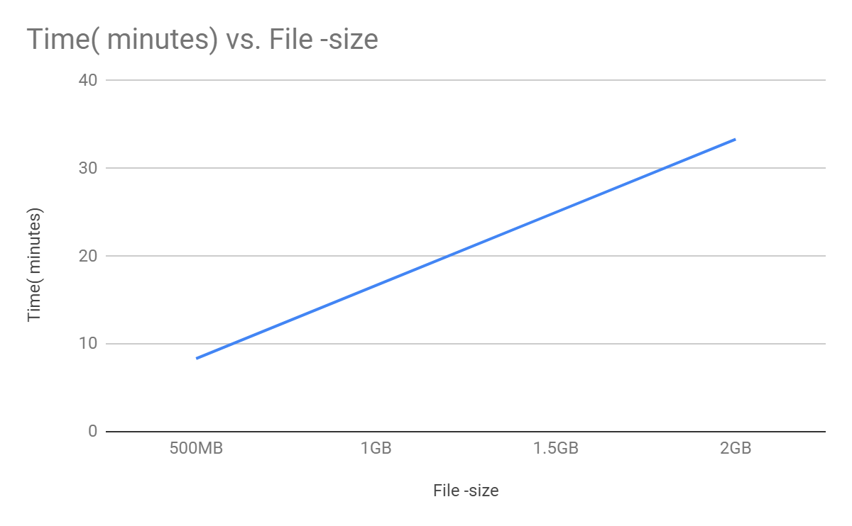

**Conclusion:**

The following data was recorded considering a constant upload speed of 1 Mb/s which is what we have observed in upload testings. We have uploaded file sizes of up to 600Mb and the data we have recorded put forth the same. The following results are drawn

1. Users are getting upload and download speeds of upto 1 Mbps which is generally the speed achieved in wifi transfer in applications like ShareIt.

2. As the speed is about 1 Mbps, small files such as images, mp3 files, documents are uploaded in an instant.

**Future Development:**

1. If the users are transferring large files, it becomes important to show the progress made in uploading the file i.e how much file is uploaded, we have decided to add this feature in later developments.

