**The simulation in Tinker Cad**

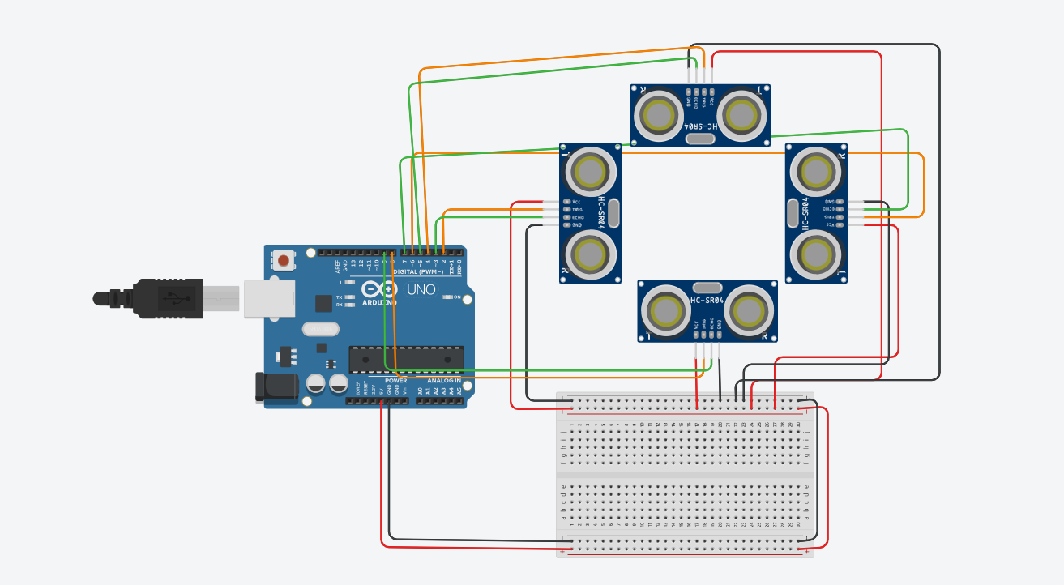

**BONUS**

To localize the position of an object in a chamber using ultrasonic sensors, a specific algorithm can be implemented. This algorithm involves initializing the sensors, measuring the distance from the object to each sensor, calculating the coordinates of the object based on the distances measured by the sensors, updating the position of the object based on its movement, and continuously repeating these steps to track the position of the object in real-time. To localize a robot in an unknown map, additional sensors and algorithms may be required. These include a laser range finder to create a map of the environment, an inertial measurement unit (IMU) to estimate the robot's position, odometry sensors to measure wheel rotation, a simultaneous localization and mapping (SLAM) algorithm to create a map while estimating the robot's position, and a particle filter algorithm to estimate the robot's position using a set of particles representing possible locations. By utilizing a combination of these sensors and algorithms, it is possible to accurately localize a robot in an unknown map and reach a specific position.