Sohaila Mohammed Mohammed Alahmady Sec2
Homework_6: PDA
Question_1:
Construct PDA for L = a^{n} b^{m} c^{k} : n,m,k ≥ 0 and n=m or n=k

(Q , ∑ , Γ , δ , q0 , $ , F)

Q = {q0, q1, q2, q3, q4, q5, q6}
∑ = {a, b, c}
Γ = {a, b, c, $}
Initial state q0
Stack start symbol $
F = {q6}

Transition function
δ( q0 , ε , ε ) = { ( q1 , $ ) }
δ( q1 , a , ε ) = { ( q1 , a ) }
δ( q1 , ε , ε ) = { ( q2 , ε ) }
δ( q1 , ε , ε ) = { ( q4 , ε ) }
δ( q2 , b , a ) = { ( q2 , ε ) }
δ( q2 , ε , ε ) = { ( q3 , ε ) }
δ( q3 , c , ε ) = { ( q3 , ε ) }
δ( q3 , ε , $ ) = { ( q6 , ε ) }
δ( q4 , b , ε ) = { ( q4 , ε ) }
δ( q4 , ε , ε ) = { ( q5 , ε ) }
δ( q5 , c , a ) = { ( q5 , ε ) }
δ( q5 , ε , $ ) = { ( q6 , ε ) }
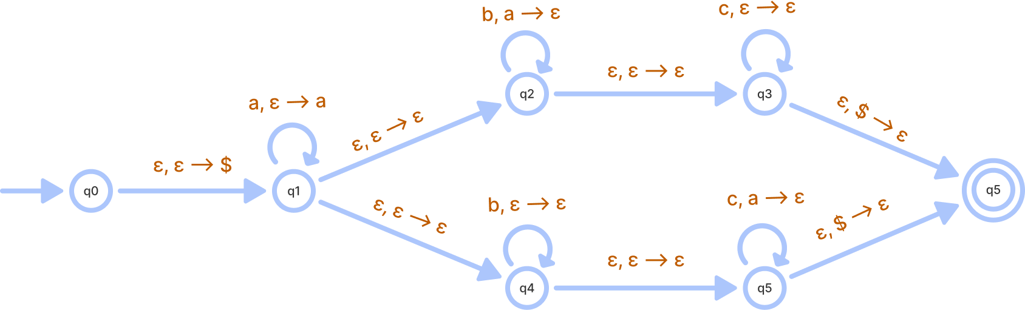

Question_2:
Construct PDA for grammar
S → aBc | ab
B → SB | ε
