**Name**: Sohaila yasser Nasr abd El Rahman

**B.N**: 403

**Topic**: Programming languages

**GitHub Link:** https://github.com/SohailaYasser/ece001

**GitHub Pages:** https://sohailayasser.github.io/ece001/

*Programming languages:*

Programmers use programming languages to communicate with computers. Many different languages exist, and each one has its own unique features, though they all share some similarities. Because each language is different, each may be best suited for a certain purpose or purposes within certain industries. Some programming languages are used to create programs to solve problems or interpret data.

*Applications of Programming languages:*

-Procedural Programming Language. ...

- Functional Programming Language. ...

- Object-oriented Programming Language. ...

- Scripting Programming Language. ...

- Programming Language. ...

- C++ Language. ...

- C Language. ...

-Pascal Language.

*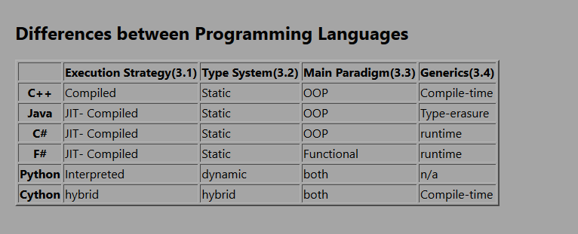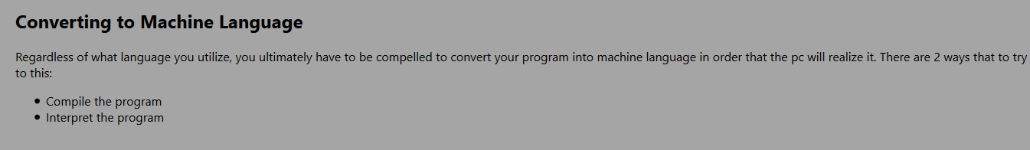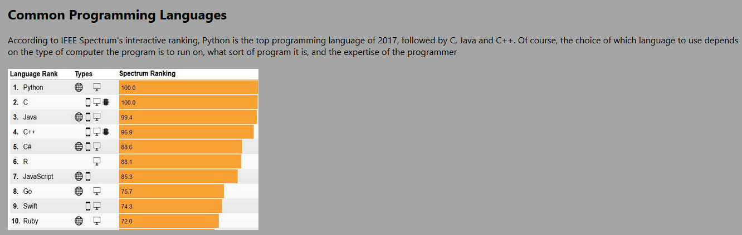Screenshots*

*ر*

*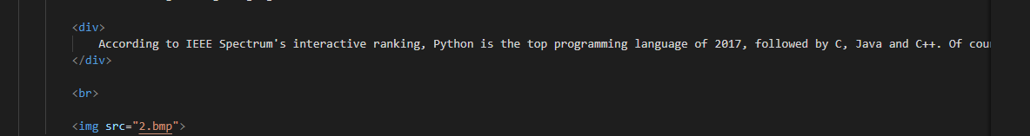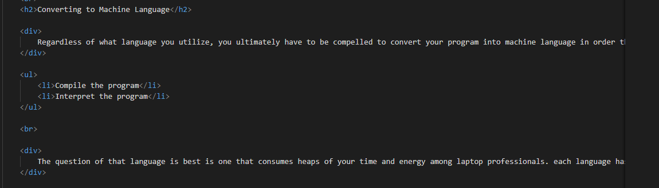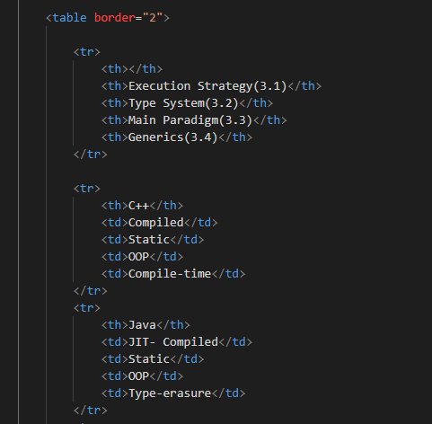Source Code:*

*References:*

**• <https://www.computerscience.org/resources/computer-programming-languages>**

**• <https://www.inc.com/larry-kim/10-most-popular-programming-languages-today.html>**

**• [14 Different Programming Languages and Their Uses Explained](https://mikkegoes.com/14-programming-languages-explained/)**

**• [Applications of Java](https://www.educba.com/applications-of-java/)**

**• <https://www.theserverside.com/definition/Java>**

**• [What Big Companies Still Code in Java: Do Major Corporations Still Use Java?](https://www.freelancinggig.com/blog/2018/08/29/what-big-companies-still-code-in-java-do-major-corporations-still-use-java/)**

**• [Functional Programming vs OOP](https://www.educba.com/functional-programming-vs-oop/)**

**• <https://techbeacon.com/app-dev-testing/13-programming-languages-defining-future-coding>**

**• <https://en.wikipedia.org/wiki/Ruby_(programming_language)>**

**•** [**https://medium.com/sololearn/why-is-c-among-the-most-popular-programming-languages-in-the-world-ccf26824ffcb**](https://medium.com/sololearn/why-is-c-among-the-most-popular-programming-languages-in-the-world-ccf26824ffcb)