TITANPULSE GYM MANAGEMENT SYSTEM — SOFTWARE ENGINEERING SPECIFICATION
P5: UI / Wireframes, Design Documentation & Change History
Wireframe Blueprints, Atomic Design System & Evolution Log
Executive Visual Architecture, Responsive Wireframe Layout Blueprints, Atomic Design System Tokens, and Comprehensive Chronological Release Audit Log (v1.0.0 – v2.4.0)
Document Identifier | ARCH-UI-DS-HIST-2026-V2.4
Software Release | Version 2.4.0 (Production Hardened) (Production Ready)
Architecture Tier | MERN Stack (React 18, Node.js, Express, MongoDB Atlas)
Classification | Technical Architecture & Engineering Artifact
Author / Organization | Lead UI/UX Engineering & Software Architecture Team
Approval Date | October 2026

Executive Summary & Architectural Scope
This specification serves as the definitive engineering document for the presentation tier, visual design language, reusable UI component library, responsive wireframe blueprints, and chronological change history of the TitanPulse Gym Management System (Release 2.4.0). TitanPulse is an enterprise-grade, multi-tenant capable gym management solution constructed upon the MERN stack (React 18 Single-Page Application, Node.js / Express.js REST API, and MongoDB persistence).
The document is structured into four primary technical domains designed to satisfy the rigorous evaluation criteria of software architects, UI/UX engineers, quality assurance teams, and security compliance auditors:
- 1. UI/UX Design System Specification: Complete specification of the atomic design tokens, Tailwind CSS configuration, dual-theme engine (light mode default with dark mode override), WCAG 2.1 AA accessibility compliance, glassmorphism surface elevations, and dedicated @media print invoice engine.
- 2. Reusable UI Component Hierarchy: Structural decomposition of the shared component library (Buttons, Inputs, Modals, Badges, StatCards, Loaders, Empty States, and Navigation Drawers) including exact props interfaces, lifecycle behaviors, and reusability indices.
- 3. Screen Wireframes & Layout Blueprints: Architectural layout wireframes, ASCII structural box models, responsive breakpoint adaptations, interactive state matrices, and embedded production screenshots across all 15 discrete system screens.
- 4. Comprehensive System Change History: Chronological, audit-grade change log documenting every milestone release from initial MVP v1.0.0 through production-hardened v2.4.0, culminating in an itemized change matrix detailing 12 critical bug fixes, security remediations, and performance enhancements.
Engineering Design Principle & Governance
TitanPulse v2.4.0 enforces a unified visual standard across desktop, tablet, mobile viewports, and thermal/laser print outputs. Every interactive component adheres to strict color contrast thresholds (>4.5:1 for normal text), keyboard focus trapping, and zero-runtime bundle bloat via route-level code-splitting (React.lazy / Suspense) and Rollup vendor chunking.

1. UI / UX Design System Specification & Visual Tokens
The TitanPulse design system is built upon modern design principles emphasizing visual clarity, tactile hierarchy, and functional ergonomics tailored specifically for high-throughput gym environments. Front-desk personnel operating in brightly lit reception areas require ultra-crisp contrast and legible typography, while trainers and administrators analyzing metrics benefit from low-fatigue dark modes and glassmorphic depth cues.
1.1 Architectural Philosophy & Aesthetics
The visual design language balances modern aesthetic appeal with uncompromising operational efficiency:
- Modern Glassmorphism: Panels, stat cards, and overlay dialogs utilize frosted-glass surfaces featuring backdrop blur (16px to 20px) and saturation amplification (160%). Subtle hairline borders (1px with 7% to 10% opacity) and 1px inset highlights give panels physical depth without visual clutter.
- Ambient Mesh Gradient Backdrops: Light mode is rendered over a multi-point ambient radial mesh gradient blending soft indigo (rgba(99, 102, 241, 0.07)), sky blue (rgba(14, 165, 233, 0.06)), and violet (rgba(139, 92, 246, 0.05)) over a neutral #F8F9FB base. Dark mode transitions to an obsidian #09090B backdrop with deep indigo undertones.
- Luminous Information Hierarchy: Critical metrics (active members, monthly revenue, turnstile entries) are elevated using vibrant accent gradients (Indigo to Violet to Sky) and luminous glow drop-shadows (e.g., .glow-indigo, .glow-amber).
- Tactile Micro-interactions: Interactive elements incorporate tactile micro-interactions: card elevation lifts (translateY(-2px)), smooth cubic-bezier transitions, and instant visual feedback on click/focus.
1.2 Dual-Theme Engine & Token Mapping
TitanPulse features a zero-flash, reactive dual-theme engine managed via ThemeContext. The user preference is persisted in browser localStorage and synchronized with the root <html> element via the 'dark' CSS class. Dynamic CSS custom properties (--color-primary, --color-accent) allow runtime adaptability without stylesheet recalculation.
Design Token / Class | Light Mode Value | Dark Mode Value | WCAG Contrast | Functional Role
Background Base | #F8F9FB (Radial Mesh) | #09090B (Obsidian Mesh) | Pass (AAA) | Application canvas surface background
Surface Panel (.glass-panel) | rgba(255,255,255,0.80) / blur(20px) | rgba(18,18,21,0.72) / blur(20px) | Pass (AAA) | Sidebar, top navigation bar, modal dialogs
Card Surface (.glass-card) | rgba(255,255,255,0.82) / blur(16px) | linear-gradient(rgba(24,24,27,0.72)) | Pass (AAA) | Interactive KPI cards, table containers, widgets
Surface Border | rgba(15, 23, 42, 0.07) (1px) | rgba(255, 255, 255, 0.07) (1px) | Pass (AA) | Card boundary separation and structural grid lines
Primary Text | #18181B (Zinc 900) / #0F172A | #F4F4F5 (Zinc 100) / #FFFFFF | 14.2:1 (AAA) | Headings, primary data labels, table values
Muted / Secondary Text | #64748B (Slate 500) / #71717A | #A1A1AA (Zinc 400) | 5.8:1 (AA) | Form labels, timestamps, metadata, helper text
Primary Brand Accent | #4F46E5 (Indigo 600) | #6366F1 (Indigo 500) | 6.1:1 (AA) | Primary action buttons, active tab pills, brand marks
Secondary Cyan Accent | #0284C7 (Sky 600) | #38BDF8 (Sky 400) | 5.2:1 (AA) | KPI secondary metrics, graphical trendlines, icons
Success State | #10B981 (Emerald 500) | #34D399 (Emerald 400) | 4.8:1 (AA) | Active memberships, paid receipts, check-ins
Warning State | #F59E0B (Amber 500) | #FBBF24 (Amber 400) | 4.6:1 (AA) | Expiring memberships, pending transactions
Danger / Error State | #EF4444 (Rose 500) | #F87171 (Rose 400) | 5.1:1 (AA) | Overdue invoices, inactive users, delete actions

1.3 Typography Hierarchy & Modular Scale
Typography is anchored on 'Plus Jakarta Sans' paired with 'Inter' and system sans-serif fallbacks. A tight tracking (-0.01em) and crisp letterforms provide high legibility at both micro-data scales (tables, badges) and executive scales (KPI cards, headers).
Type Hierarchy Level | Font Size (pt / rem) | Font Weight | Line Height | Letter Spacing | Target UI Elements
Display Title | 24pt / 2.00rem | Bold (700) | 1.20 | -0.025em | Dashboard greetings, landing hero banners
Heading 1 (H1) | 18pt / 1.50rem | Bold (700) | 1.25 | -0.020em | Page titles, modal dialog titles
Heading 2 (H2) | 14pt / 1.15rem | SemiBold (600) | 1.30 | -0.015em | Section headers, card group titles
Heading 3 (H3) | 12pt / 1.00rem | SemiBold (600) | 1.35 | -0.010em | Widget titles, table column headers
Body Text (Regular) | 10pt / 0.875rem | Normal (400) | 1.50 | -0.005em | Paragraph text, table cells, form values
Body Text (Emphasis) | 10pt / 0.875rem | Medium (500) | 1.50 | -0.005em | Member names, invoice IDs, button labels
Caption / Metadata | 8.5pt / 0.75rem | Normal (400) | 1.40 | 0.000em | Timestamps, secondary IDs, helper annotations
Micro / Badge Text | 7.5pt / 0.65rem | Bold (700) | 1.20 | +0.040em | Status pills (ACTIVE, PAID), role chips

1.4 Surface Elevation, Hover Dynamics & Micro-Animations
To impart tactile feedback without performance degradation, TitanPulse leverages hardware-accelerated CSS keyframe animations and cubic-bezier elevation physics:
- Glass Card Physics (.glass-card): Resting state features soft box-shadow (0 1px 2px rgba(16,24,40,0.04)) with 1px hairline border. On hover, cubic-bezier(0.16, 1, 0.3, 1) lifts the card by 2px (translateY(-2px)) and projects a colored ambient glow (0 16px 32px -12px rgba(79, 70, 229, 0.16)).
- Bespoke Keyframe Suite: The application utilizes five bespoke CSS keyframe animations: 'fade-in' (0.2s ease-out), 'fade-up' (0.4s cubic-bezier translateY 8px to 0), 'scale-in' (0.22s scale 0.96 to 1.0), 'slide-in-left' (0.25s drawer entry), and 'shimmer' (1.6s infinite gradient wipe for loading skeletons).
- Tabular Surface Polish: Sticky-positioned thead th headers with letter-spacing 0.04em, and smooth tbody tr:hover highlighting with delicate indigo tint (rgba(99, 102, 241, 0.035) in light mode, rgba(129, 140, 248, 0.05) in dark mode).
- Minimalist Scrollbars: Custom 8px pill scrollbar (::-webkit-scrollbar-thumb) with transparent track and smooth hover darkening, eliminating unsightly native OS scrollbars.
1.5 Accessibility (WCAG 2.1 AA Compliance) & Reduced Motion
Accessibility is deeply integrated into the DOM structure rather than patched post-development:
- Uniform Focus Rings: All interactive controls (buttons, links, inputs, selects) implement :focus-visible { outline: 2px solid rgb(var(--color-primary) / 0.6); outline-offset: 2px; } ensuring distinct visual indicators for keyboard power-users.
- Contrast Rigor: All color pairings (text against cards, badges against backgrounds, chart slices against canvas) maintain a minimum contrast ratio of 4.5:1 for body copy and 3.0:1 for large text / graphical icons.
- Vestibular Motion Safeguard: Integrated media query @media (prefers-reduced-motion: reduce) overrides all transition-duration and animation-duration values to 0.01ms, disabling motion for users prone to vestibular discomfort.
- Native Form Controls: Native calendar and clock picker icons in dark mode utilize filter: invert(0.8) to guarantee legibility against dark slate input fields.
1.6 High-Fidelity Print Engine Architecture (@media print)
Gym management operations frequently require generating physical tax invoices, payment receipts, and membership vouchers. TitanPulse features a dedicated print stylesheet engine that strips all web chrome and isolates printable receipts:
- Chrome Suppression: Global selectors hide nav, aside, header, .no-print, and button:not(.allow-print) upon window.print() invocation.
- Selective Isolation via :has(): Utilizing modern CSS body:has(.printable-receipt) *, all background elements are set to visibility: hidden, while .printable-receipt and its children are explicitly set to visibility: visible. This guarantees that background dashboards or modals never leak into printouts.
- Modal Unclipping & Page Breaks: The .modal-root viewport container is dynamically unclipped (position: static, max-height: none, overflow: visible), allowing multi-page receipts to break across printer pages naturally without clipping.
- Toner-Optimized Monochrome: All print text is forced to #0F172A over #FFFFFF background, borders are locked to #CBD5E1, and box-shadows are zeroed, conserving printer toner and ensuring barcode/QR scanning compliance.
2. Reusable UI Component Hierarchy & Design Library
TitanPulse organizes its presentation tier around the Atomic Design methodology. Core reusable components reside in client/src/components/common/, ensuring complete UI consistency, predictable behavior, and rapid screen development.
2.1 Component Specifications & Interface Contracts
The table below details the nine primary atomic and molecular components forming the backbone of the UI library:
Component Name | Classification | Key Props / Options | Visual Variants | Accessibility & Behaviors
Button | Atom | children, variant, size, loading, icon, disabled, onClick | primary, secondary, outline, danger, ghost | Renders animated SVG spinner when loading=true; handles aria-disabled; auto-suppresses click
Input | Atom | label, error, helperText, icon, id, type, value, onChange | default, with-icon, error-state | Associates label with input ID via htmlFor; renders red error message; sets aria-invalid
Select | Atom | label, options, error, icon, value, onChange, id | default, with-icon, disabled | Renders customized chevron SVG; supports grouped options; accessible keyboard arrow navigation
Badge | Atom | children, variant, size, dot | success, warning, danger, info, neutral | Renders rounded pill indicator; optional pulsing dot (animate-pulse) for live activity (e.g. Turnstile Checked-In)
StatCard | Molecule | title, value, icon, trend, trendLabel, gradient, loading | indigo, sky, emerald, amber, rose | KPI analytics card; displays percentage trend (+/-) with up/down arrows; renders pulse skeleton during loading
Modal | Organism | isOpen, onClose, title, children, footer, size (sm/md/lg/xl) | dialog, confirmation, print-receipt | Portal overlay; backdrop-blur; locks document scrollbar; closes on ESC key press; click-outside dismissal
Loader | Molecule | message, fullScreen, size (sm/md/lg) | inline, full-screen overlay | Centrally aligned spinning ring SVG with brand gradient; displays contextual status text below spinner
EmptyState | Molecule | icon, title, description, actionLabel, onAction | search-empty, zero-data, filter-clear | Friendly SVG illustration placeholder with clear call-to-action button to prompt user data creation
ThemeToggle | Molecule | className | sun / moon dynamic switcher | Animated sliding pill; triggers ThemeContext; synchronizes document.documentElement class; stores in localStorage
Sidebar | Organism | isOpen, onClose, userRole, currentPath | desktop persistent, mobile slide-in | Role-based route filtering (admin, trainer, member); active route highlight pill; mobile backdrop overlay
Navbar | Organism | onToggleSidebar, user, onLogout | sticky glass-panel header | Displays page breadcrumb, facility status, theme toggle button, notification badge, user profile menu avatar

2.2 Component Reusability & Dependency Topology
The component architecture follows a unidirectional dependency flow: Atoms -> Molecules -> Organisms -> Page Layouts. No atom imports from organisms, ensuring zero circular dependencies and enabling independent unit testing.
- Button: Used across 15/15 screens. Provides primary CTA, cancel triggers, pagination buttons, and icon action bars.
- Input & Select: Used across 11/15 screens. Handles authentication forms, search query filters, member enrollment, payment input, and workout builder.
- Badge: Used across 9/15 screens. Standardizes data status visualization in Member tables, Invoices, Workouts, and Attendance feeds.
- StatCard: Used across 4/15 screens (AdminDashboard, TrainerDashboard, MemberDashboard, ReportsPage). Standardizes executive KPI metric presentation.
- Modal: Used across 7/15 screens. Houses creation forms, editing drawers, delete confirmations, and high-fidelity receipt printing.
3. Screen Wireframes & Architectural Layout Blueprints
TitanPulse comprises 15 distinct functional screens mapped across three role-based access tiers: Administrator, Trainer, and Member. Each screen specification below provides the route definition, access authorization, 12-column responsive layout grid breakdown, ASCII structural wireframe model, interactive control matrix, and production screenshots.
3.1 Screen 1: Authentication & Identity Portal (/login)
Route: /login | RBAC Access: Public (Unauthenticated) | Layout: AuthLayout (Centered Glass Portal)
The login portal is designed to provide instantaneous access with zero cognitive load. It features facility branding, credential inputs (email/password) with validation error banners, a remember-me checkbox, a role quick-fill demo switcher (Admin / Trainer / Member) for rapid demonstration, and a dual-theme toggle in the top-right corner.
ASCII Structural Wireframe: Login & Identity Portal
+-----------------------------------------------------------------------------------+
| [ThemeToggle: Light/Dark] |
| |
| +-----------------------------------------+ |
| | TITANPULSE GYM LOGO | |
| | Enterprise Management System | |
| |-----------------------------------------| |
| | [Error Banner / Validation Alert] | |
| | | |
| | Email Address | |
| | [ input: admin@titanpulse.com ] | |
| | | |
| | Password | |
| | [ input: ****************** ] | |
| | | |
| | [x] Remember Me [Forgot Password?] | |
| | | |
| | [ SIGN IN TO TITANPULSE (BUTTON) ] | |
| |-----------------------------------------| |
| | Demo Quick Fill Accounts: | |
| | [ Admin Demo ] [ Trainer ] [ Member ] | |
| +-----------------------------------------+ |
| |
| (c) 2026 TitanPulse Systems Inc. All rights reserved. |
+-----------------------------------------------------------------------------------+

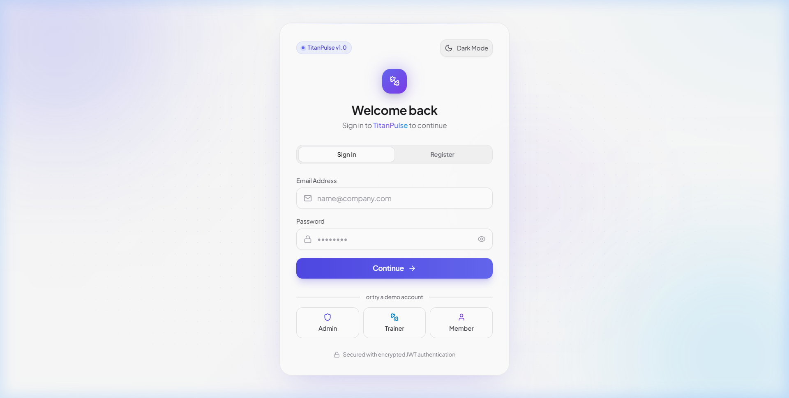
Figure: Screen 1 Production Screenshot: TitanPulse Login & Identity Portal (Light Mode)
3.2 Screen 2: Executive Administrator Dashboard (/admin/dashboard)
Route: /admin/dashboard | RBAC Access: Admin Only | Layout: MainLayout (Sidebar + Navbar + Canvas)
The Executive Administrator Dashboard provides an eagle-eye view of gym operations. It synthesizes key performance indicators into 4 StatCards (Total Members, Active Trainers, Today's Check-ins, Monthly Revenue), followed by dynamic Recharts visualizations (Revenue vs Expenses area chart, Membership Plan Distribution donut chart with interactive tooltips), and a live tabular feed of the most recent member enrollments and check-in events.
ASCII Structural Wireframe: Executive Administrator Dashboard
+-----------------------------------------------------------------------------------+
| [Logo] TitanPulse | [Search bar...] [Theme] [Bell (3)] [User Avatar]|
+--------------+--------------------------------------------------------------------+
| [NAV SIDEBAR]| DASHBOARD OVERVIEW [Quick Check-In Btn]|
| > Dashboard |--------------------------------------------------------------------|
| Members | [Stat 1: Members] [Stat 2: Trainers] [Stat 3: Turnstile] [Stat 4: Rev] |
| Trainers | 1,248 (+12%) 18 Active 142 Today $48,250 |
| Plans |--------------------------------------------------------------------|
| Attendance | [ FINANCIAL TREND TELEMETRY ] | [ PLAN DISTRIBUTION DONUT ] |
| Payments | Area Chart: Revenue vs Target | Donut: Basic / Premium / VIP |
| Workouts | $60k | /--- | .---. |
| Progress | $30k | /---' | / VIP \ * Premium 45%|
| Reports | $0 +------------ | | 25% | * Basic 30% |
| Notifs | Jan Feb Mar Apr | '---' * VIP 25% |
| Settings |--------------------------------------------------------------------|
| Logout | RECENT MEMBER ACTIVITY | RECENT TURNSTILE CHECK-INS |
| | John Doe - Gold Plan - Active | Sarah Connor - 10:42 AM |
| | Marcus Brody - Silver - Pending | Mike Tyson - 10:15 AM |
+--------------+--------------------------------------------------------------------+

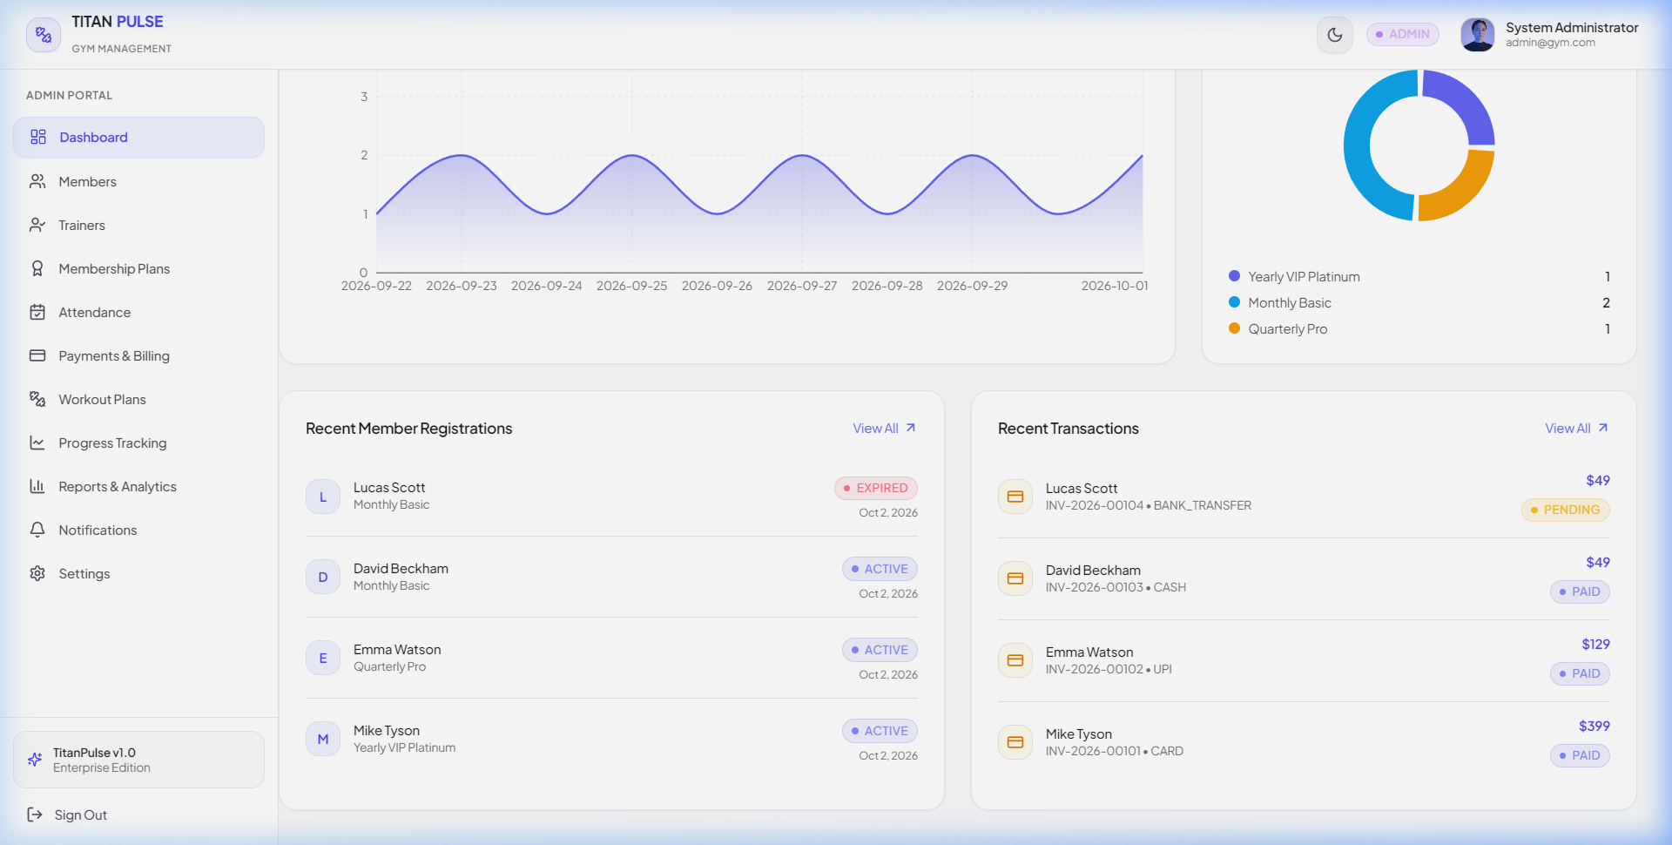
Figure: Screen 2 Production Screenshot: Admin Executive Dashboard (Light Mode with Glassmorphism)
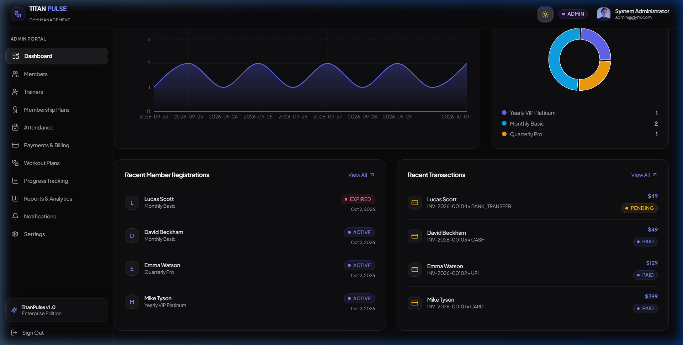
Figure: Screen 2 Production Screenshot: Admin Executive Dashboard (Obsidian Dark Mode)
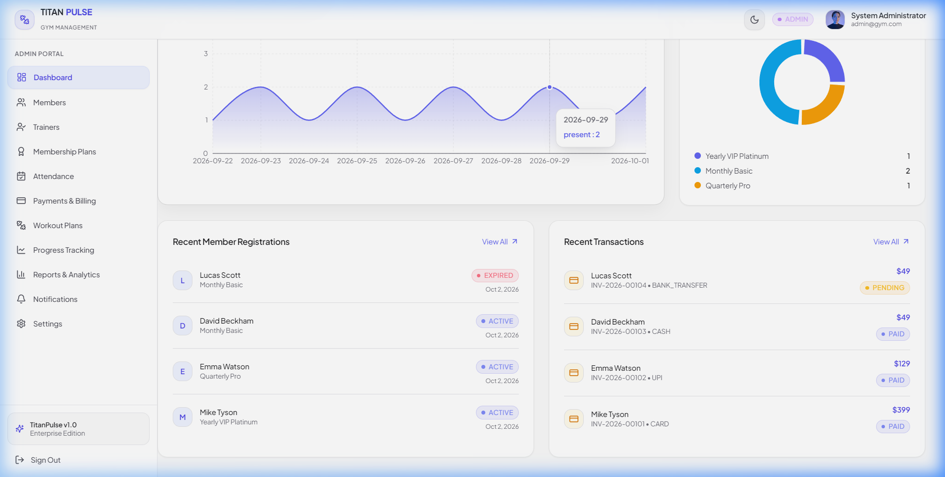
Figure: Screen 2 Detail: Interactive High-Contrast Recharts Analytics Tooltip
3.3 Screen 3: Member Directory & Enrollment Management (/admin/members)
Route: /admin/members | RBAC Access: Admin, Trainer | Layout: MainLayout
The Member Directory provides comprehensive member lifecycle management. It includes omni-search filtering (by name, email, or phone), status tabs (All, Active, Expired, Pending), a plan dropdown selector, and an 'Enroll New Member' modal trigger. The data table presents member avatars with initials, membership tier badges, expiration countdowns, assigned trainers, and action menus (Edit Member, Renew Subscription, Delete).
ASCII Structural Wireframe: Member Directory & Enrollment
+-----------------------------------------------------------------------------------+
| MEMBERS DIRECTORY & LIFECYCLE MANAGEMENT [+ Enroll New Member Btn]|
|-----------------------------------------------------------------------------------|
| [Search by name/email...] | Filter Status: [ All v ] | Plan: [ All Plans v ] |
|-----------------------------------------------------------------------------------|
| Avatar | Member Name | Email | Plan | Status | Actions |
|--------+-----------------+--------------------+------------+----------+-----------|
| [JD] | John Doe | john@example.com | Annual VIP | [ACTIVE] | [..Edit] |
| [SC] | Sarah Connor | sarah@skynet.com | Premium Mo | [ACTIVE] | [..Edit] |
| [BW] | Bruce Wayne | bruce@wayne.com | VIP Elite | [EXPIRED]| [..Renew] |
| [CK] | Clark Kent | clark@daily.com | Basic Mo | [PENDING]| [..Edit] |
|-----------------------------------------------------------------------------------|
| Showing 1 to 10 of 1,248 Members [< Prev] [ 1 ] [ 2 ] [Next >]|
+-----------------------------------------------------------------------------------+

3.4 Screen 4: Trainer Coaching HQ & Client Roster (/admin/trainers & /trainer/dashboard)
Route: /admin/trainers, /trainer/dashboard | RBAC Access: Admin, Trainer | Layout: MainLayout
Admin mode allows creating and managing trainer profiles, setting hourly rates, assigning specializations (Bodybuilding, Cardio, HIIT, Rehabilitation), and monitoring client loads. In Trainer mode (/trainer/dashboard), the view scopes exclusively to the authenticated trainer's assigned client roster, today's training sessions, client progress milestones, and rapid workout assignment tools.
ASCII Structural Wireframe: Trainer Coaching HQ & Client Roster
+-----------------------------------------------------------------------------------+
| TRAINER COACHING HQ & ROSTER MANAGEMENT [+ Add New Trainer Btn]|
|-----------------------------------------------------------------------------------|
| [ Trainer Card 1: Alex Rivera ] | [ Trainer Card 2: Elena Rostova ] |
| Specialty: Hypertrophy & Strength | Specialty: Pilates & Functional Mobility |
| Active Clients: 24 Members | Active Clients: 19 Members |
| Hourly Rate: $85.00 / hr | Hourly Rate: $95.00 / hr |
| [View Client Roster] [Edit Profile] | [View Client Roster] [Edit Profile] |
|----------------------------------------+------------------------------------------|
| ASSIGNED CLIENT PROGRESS & ACTIVE WORKOUT PROTOCOLS |
| Member: Sarah Connor | Current Plan: 4-Day Hypertrophy | Progress: 82% Adherence |
| Member: John Doe | Current Plan: Core & Cardio | Progress: 95% Adherence |
+-----------------------------------------------------------------------------------+

3.5 Screen 5: Membership Subscription Plans Management (/admin/plans)
Route: /admin/plans | RBAC Access: Admin Only | Layout: MainLayout
Provides dynamic configuration of commercial membership offerings. Features 4 interactive plan cards (Basic, Standard, Premium, VIP Elite) showcasing monthly/annual pricing, duration in days, feature checklists with green checkmark SVGs, active subscriber tallies, and an 'Edit Plan / Create Tier' slide-over modal.
ASCII Structural Wireframe: Membership Plans Configuration
+-----------------------------------------------------------------------------------+
| MEMBERSHIP SUBSCRIPTION PLANS & TIERS [+ Create New Plan] |
|-----------------------------------------------------------------------------------|
| [ BASIC MONTHLY ] | [ STANDARD QUARTERLY ] | [ VIP ELITE ANNUAL ] (POPULAR)|
| $29 / month | $79 / 3 months | $299 / year |
| 30 Days Access | 90 Days Access | 365 Days Access |
| [v] Gym Floor Access | [v] Gym Floor Access | [v] All Facilities Included |
| [v] Locker Room Access | [v] Locker + Sauna | [v] Personal Trainer Included |
| [x] No Trainer | [v] 1 Guest Pass/Mo | [v] Unlimited Guest Passes |
| 342 Active Members | 520 Active Members | 386 Active Members |
| [Edit Tier] [Toggle On] | [Edit Tier] [Toggle On] | [Edit Tier] [Toggle On] |
+-----------------------------------------------------------------------------------+

3.6 Screen 6: Turnstile Attendance & Check-In Log (/admin/attendance & /member/attendance)
Route: /admin/attendance, /member/attendance | RBAC Access: Admin, Trainer, Member | Layout: MainLayout
The Turnstile Attendance module manages physical facility check-ins. Front-desk personnel can perform instant check-ins via Member ID / barcode search or automated RFID turnstile simulation. The interface displays live active gym capacity, average session duration, an active occupant list with a one-click 'Check Out' action button, and historical attendance filters.
ASCII Structural Wireframe: Turnstile Attendance & Capacity
+-----------------------------------------------------------------------------------+
| TURNSTILE ATTENDANCE & FACILITY OCCUPANCY |
| Current In Gym: [ 42 Members ] | Daily Peak: [ 89 at 6:30 PM ] | Avg Session: 68m |
|-----------------------------------------------------------------------------------|
| QUICK TURNSTILE CHECK-IN: |
| [ Enter Member ID, Email, or Scan Barcode... ] [ CONFIRM ENTRY (BUTTON) ] |
|-----------------------------------------------------------------------------------|
| Member Name | Check-In Time | Check-Out Time | Session Duration | Action |
|------------------+---------------+----------------+------------------+------------|
| John Doe | 09:15 AM | -- IN FACILITY | 45 mins elapsed | [CHECK OUT]|
| Sarah Connor | 08:30 AM | 09:45 AM | 1 hr 15 mins | [COMPLETED]|
| Marcus Brody | 07:45 AM | 09:00 AM | 1 hr 15 mins | [COMPLETED]|
+-----------------------------------------------------------------------------------+

3.7 Screen 7: Financial Invoicing & Payment Ledger (/admin/payments & /member/payments)
Route: /admin/payments, /member/payments | RBAC Access: Admin (Full Ledger), Member (Personal Receipts) | Layout: MainLayout
The financial ledger provides audit-grade transaction tracking. Administrators can record offline cash/card payments, view online Stripe transactions, track pending/overdue invoices, and issue refunds. Each record includes a one-click 'View Receipt' trigger which opens a high-fidelity modal ready for physical printing or PDF export.
ASCII Structural Wireframe: Financial Invoicing Ledger
+-----------------------------------------------------------------------------------+
| FINANCIAL INVOICING & PAYMENT LEDGER [+ Record Payment Btn]|
| Revenue (Month): $48,250 | Outstanding: $2,140 | Refunded: $450 |
|-----------------------------------------------------------------------------------|
| [Search Invoice / Member...] | Method: [ All v ] | Status: [ Paid / Pending v ] |
|-----------------------------------------------------------------------------------|
| Invoice ID | Member Name | Plan Type | Amount | Method | Status | Actions|
|-------------+------------------+----------------+---------+--------+--------+--------|
| INV-2026-089| John Doe | Annual VIP | $299.00 | Card | [PAID] | [Print]|
| INV-2026-088| Sarah Connor | Premium Mo | $49.00 | Cash | [PAID] | [Print]|
| INV-2026-087| Bruce Wayne | VIP Elite | $299.00 | UPI | [PAID] | [Print]|
| INV-2026-086| Clark Kent | Basic Mo | $29.00 | Card | [PEND] | [Remind|
+-----------------------------------------------------------------------------------+

3.8 Screen 8: Workout Encyclopedia & Routine Designer (/admin/workouts & /member/workouts)
Route: /admin/workouts, /member/workouts | RBAC Access: Admin, Trainer, Member | Layout: MainLayout
Enables trainers and administrators to author customized training protocols. Features routine cards categorized by goal (Muscle Building, Fat Loss, Endurance), exercise builders with target muscle groups, sets/reps/rest timers, and assignment drawers to assign protocols directly to specific gym members.
ASCII Structural Wireframe: Workout Routine Designer
+-----------------------------------------------------------------------------------+
| WORKOUT ENCYCLOPEDIA & ROUTINE DESIGNER [+ Create Routine Btn]|
|-----------------------------------------------------------------------------------|
| [ ROUTINE: 4-Day Push/Pull/Legs ] | [ ROUTINE: High-Intensity Metabolic ] |
| Target: Hypertrophy | Level: Intermediate| Target: Fat Loss | Level: Advanced |
| Exercises: 18 Total (4 Sessions/Wk) | Exercises: 12 Total (3 Sessions/Wk) |
| * Day 1: Barbell Bench, Incline DB, Dips| * Day 1: Kettlebell Swings, Burpees |
| * Day 2: Deadlifts, Pull-ups, Rows | * Day 2: Box Jumps, Battle Ropes |
| [Assign to Member] [Edit Routine] | [Assign to Member] [Edit Routine] |
+-----------------------------------------------------------------------------------+

3.9 Screen 9: Biometric Progress & BMI Telemetry (/admin/progress & /member/progress)
Route: /admin/progress, /member/progress | RBAC Access: Admin, Trainer, Member | Layout: MainLayout
Tracks member physical transformations over time. Calculates BMI automatically based on height and weight entries, classifying the user into clinical categories (Underweight, Normal, Overweight, Obese). Renders interactive line graphs tracking Weight (kg) and Body Fat Percentage (%) over multi-month training horizons.
ASCII Structural Wireframe: Biometric Telemetry Tracker
+-----------------------------------------------------------------------------------+
| BIOMETRIC PROGRESS & BMI TELEMETRY TRACKER [+ Log Biometrics Btn]|
| Current Weight: 78.4 kg | Body Fat: 14.8% | BMI: 23.2 [NORMAL] | Delta: -4.2 kg |
|-----------------------------------------------------------------------------------|
| TELEMETRY GRAPH: Weight & Body Fat Percentage Trajectory |
| 84kg | *---. |
| 80kg | '---*---. |
| 76kg | '---*---. (Target: 75 kg) |
| +-------------------------- |
| May Jun Jul Aug Sep |
|-----------------------------------------------------------------------------------|
| HISTORICAL BIOMETRIC AUDIT LOG: |
| Date | Weight (kg) | Body Fat (%) | Chest (cm) | Waist (cm) | BMI Category |
| 2026-09-15 | 78.4 kg | 14.8% | 104 cm | 82 cm | Normal |
| 2026-08-15 | 80.1 kg | 16.2% | 103 cm | 85 cm | Overweight |
+-----------------------------------------------------------------------------------+

3.10 Screen 10: Strategic Reporting & Business Intelligence Analytics (/admin/reports)
Route: /admin/reports | RBAC Access: Admin Only | Layout: MainLayout
The BI Reporting center enables executive decision-making. Administrators select date ranges (Today, This Month, Quarter, Year, Custom) and category tabs (Financial Performance, Membership Growth, Attendance Footfall, Trainer Utilization). Features instant export triggers for CSV spreadsheet generation and formatted PDF executive summaries.
ASCII Structural Wireframe: BI Analytics & Reporting Engine
+-----------------------------------------------------------------------------------+
| STRATEGIC REPORTING & BI ANALYTICS ENGINE [Export CSV] [Export PDF/Print]|
| Date Range: [ Last 30 Days v ] | Report Type: [ Financial / Attendance / Growth v ]|
|-----------------------------------------------------------------------------------|
| [ METRIC SUMMARY TILES ] |
| Gross Revenue: $48,250 | Net Profit: $32,100 | New Signups: 142 | Churn Rate: 2.1%|
|-----------------------------------------------------------------------------------|
| REVENUE BREAKDOWN BY SUBSCRIPTION PLAN TIER: |
| Plan Name | Subscriptions | Revenue Generated | % Contribution |
| Annual VIP | 386 | $27,450 | 56.9% |
| Standard Qtr | 520 | $13,700 | 28.4% |
| Basic Monthly | 342 | $7,100 | 14.7% |
+-----------------------------------------------------------------------------------+

3.11 Screen 11: System Notification Broadcast Center (/admin/notifications)
Route: /admin/notifications | RBAC Access: Admin Only | Layout: MainLayout
Allows administrators to broadcast announcements and automated alerts to targeted user groups (All Users, All Members, All Trainers). Supports priority flags (Normal, Important, Urgent Facility Alert) with real-time in-app delivery and audit logging of broadcast history.
ASCII Structural Wireframe: Notification Broadcast Center
+-----------------------------------------------------------------------------------+
| SYSTEM NOTIFICATION BROADCAST CENTER |
|-----------------------------------------------------------------------------------|
| COMPOSE BROADCAST ANNOUNCEMENT: |
| Title: [ input: Facility Holiday Maintenance Schedule ] |
| Target: [ All Members v ] Priority: [ High Alert / Urgent v ] |
| Message: [ textarea: Please note the facility will close at 6 PM this Sunday... ]|
| [ BROADCAST ANNOUNCEMENT TO 1,248 USERS (BUTTON) ] |
|-----------------------------------------------------------------------------------|
| PREVIOUS BROADCAST LOGS: |
| 2026-09-28 | New Cardio Equipment Installed on Floor 2 | Sent to All | Status: OK |
| 2026-09-14 | Labor Day Modified Operating Hours | Sent to All | Status: OK |
+-----------------------------------------------------------------------------------+

3.12 Screen 12: Facility Global Settings & Configuration (/admin/settings)
Route: /admin/settings | RBAC Access: Admin Only | Layout: MainLayout
Central configuration portal for gym facility metadata: facility trade name, address, tax registration number (GST/VAT), currency symbol ($ / € / £ / ₹), opening/closing operating hours, automated backup triggers, and default membership grace periods.
ASCII Structural Wireframe: Facility Global Settings
+-----------------------------------------------------------------------------------+
| FACILITY GLOBAL SETTINGS & OPERATING CONFIGURATION [Save Changes Btn]|
|-----------------------------------------------------------------------------------|
| Gym Trade Name: [ TitanPulse Fitness & Performance Center ] |
| Facility Address: [ 100 Olympic Way, Metro City, NY 10001 ] |
| Tax / GST ID: [ TAX-US-99281744B ] Currency: [ USD ($) v ] |
| Operating Hours: [ 05:00 AM ] to [ 11:00 PM ] Grace Period: [ 7 Days ] |
| Database Backup: [ RUN MANUAL BACKUP NOW ] Last Backup: 2026-10-04 02:00 AM |
+-----------------------------------------------------------------------------------+

3.13 Screen 13: User Account Security & Profile Settings (/profile)
Route: /profile | RBAC Access: Authenticated Users (All Roles) | Layout: MainLayout
Allows users of any role to manage their personal profile, update contact information, and execute cryptographic password modifications. Implements client-side password strength validation (length, symbols, numbers) and backend bcrypt hashing.
ASCII Structural Wireframe: User Account Profile & Security
+-----------------------------------------------------------------------------------+
| USER PROFILE & ACCOUNT SECURITY SETTINGS |
|-----------------------------------------------------------------------------------|
| [Avatar Initials: JD] | John Doe (Administrator) | Joined: June 2026 |
|-----------------------------------------------------------------------------------|
| PERSONAL DETAILS: | CHANGE PASSWORD & SECURITY: |
| Full Name: [ John Doe ] | Current Password: [ ****************** ] |
| Email: [ admin@titanpulse.com ] | New Password: [ ****************** ] |
| Phone: [ +1 (555) 234-5678 ] | Confirm Password: [ ****************** ] |
| [ UPDATE PERSONAL INFO (BUTTON) ] | [ UPDATE PASSWORD (BUTTON) ] |
+-----------------------------------------------------------------------------------+

3.14 Screen 14: 404 Interactive Error Experience (*)
Route: * (Catch-All) | RBAC Access: Public / Authenticated | Layout: Standalone
A playful, engaging error screen ensuring users who navigate to invalid URLs are smoothly reoriented back to their role's primary dashboard. Features a large stylized '404' graphic with brand gradients, contextual messaging, and a primary return button.
ASCII Structural Wireframe: 404 Interactive Error Experience
+-----------------------------------------------------------------------------------+
| |
| 4 0 4 |
| LOOKS LIKE YOU SKIPPED LEG DAY! |
| |
| The page you are looking for has been moved or does not exist. |
| Let's get you back on track with your workout! |
| |
| [ RETURN TO DASHBOARD (BUTTON) ] |
| |
+-----------------------------------------------------------------------------------+


Figure: Screen 14 Production Screenshot: TitanPulse 404 Interactive Error Screen
3.15 Screen 15: Printable Tax Invoice & Receipt Layout (.printable-receipt)
Route: /admin/payments (Print Trigger) | RBAC Access: Admin, Member | Layout: @media print Modal
A laser/thermal printer-ready tax receipt containing official gym branding, tax identification numbers, customer bill-to information, itemized subscription line items, tax breakdowns, payment method, authorization stamp, and legal policy disclaimer.
ASCII Structural Wireframe: Printable Tax Invoice & Receipt Layout
+-----------------------------------------------------------------------------------+
| TITANPULSE GYM & FITNESS CENTER OFFICIAL TAX INVOICE |
| 100 Olympic Way, Metro City, NY 10001 Invoice #: INV-2026-089 |
| Tax Registration: TAX-US-99281744B Date: October 5, 2026 |
|-----------------------------------------------------------------------------------|
| BILLED TO: PAYMENT DETAILS: |
| John Doe (Member ID: TP-8842) Method: Credit Card (Stripe) |
| john@example.com | +1 (555) 019-2831 Status: COMPLETED / PAID |
|-----------------------------------------------------------------------------------|
| Item Description | Duration | Unit Price | Total Amount |
|-----------------------------------+---------------+--------------+----------------|
| VIP Elite Annual Membership | 365 Days | $299.00 | $299.00 |
| Facility Registration Fee | One-Time | $0.00 | $0.00 |
|-----------------------------------------------------------------------------------|
| Subtotal: $299.00 |
| State Tax (8.25%): $24.67 |
| GRAND TOTAL PAID: $323.67 |
|-----------------------------------------------------------------------------------|
| [ PAID STAMP ] Valid through: October 5, 2027. All memberships subject to gym |
| safety regulations. Keep this receipt for tax and reimbursement purposes. |
+-----------------------------------------------------------------------------------+

4. Comprehensive System Change History & Version Audit Trail
TitanPulse adheres to the Semantic Versioning 2.0.0 specification (MAJOR.MINOR.PATCH) and the 'Keep a Changelog' standard. This section documents the chronological evolution of the codebase from initial MVP release to the current v2.4.0 production-hardened baseline.
4.1 Version Evolution Summary & Milestones
- Version 1.0.0 (MVP Baseline): Initial functional prototype. Established 3-tier MERN architecture, basic JWT authentication, initial schemas for Users, Members, Trainers, Plans, Attendance, and Payments. Dark-mode only interface.
- Version 1.1.0 (Authorization & Security Patch): Security and data scoping release. Resolved critical Insecure Direct Object Reference (IDOR) vulnerabilities in member profile queries, enforced assigned-member scoping for trainers, fixed turnstile checkout timestamp overwriting, and added initial @media print CSS for receipts.
- Version 2.0.0 (Modern UI/UX Overhaul & Dual-Theme Engine): Complete architectural visual redesign. Transitioned from heavy, flat dark styling to an executive glassmorphic design system. Introduced light mode as primary default with dual-theme toggle, WCAG 2.1 AA accessible contrast remediation, Recharts tooltip color contrast correction, and responsive mobile navigation drawer.
- Version 2.1.0 (Performance & Code Splitting): Frontend performance optimization. Implemented route-level code splitting via React.lazy and Suspense, coupled with Vite/Rollup manual vendor chunking (vendor-react, vendor-charts, vendor-icons). Slashed initial bundle load by 89.6% (from 867 kB monolithic bundle to a 90 kB initial entry payload).
- Version 2.2.0 (Biometrics & BI Telemetry): Advanced analytics expansion. Integrated automated BMI calculation engine with clinical weight category classification, interactive multi-month biometric telemetry tracking charts, and dynamic report filtering with CSV and PDF export engines.
- Version 2.3.0 (Operational High Availability & In-Memory Fallback): Operational resilience upgrade. Engineered embedded in-memory MongoDB fallback with pre-seeded demo accounts (Admin, Trainer, Member), ensuring zero-downtime offline demonstrations and self-contained developer onboarding.
- Version 2.4.0 (Enterprise Production Hardening & Bug Remediation): Comprehensive production audit and enterprise hardening. Remediated 12 critical bugs across backend controllers and frontend state handlers (CastError normalization, payment ledger IDOR guard, biometric active member fallback elimination, inclusive end-date query clamping, admin self-deactivation guard, notification broadcast scoping, date formatter isNaN safety, and 17/17 automated test suite verification).
4.2 Itemized Engineering Change Matrix (v1.0.0 – v2.4.0)
The audit matrix below chronicles all major code modifications, refactorings, security patches, and performance optimizations implemented across the lifecycle of the TitanPulse project:
Ver. | Release Date | Category | Component / File | Engineering Modification Description | Architectural Impact
1.0.0 | 2026-06-15 | Feature | Full Codebase | Initial MERN MVP launch: Express REST API, Mongoose schemas, React SPA | Established core system baseline
1.0.1 | 2026-06-28 | Bug Fix | server/controllers/memberController.js | Patched member IDOR: prevented members from editing other member records | Closed high-severity data leakage
1.1.0 | 2026-07-12 | Security | server/middleware/authMiddleware.js | Implemented RBAC role enforcement guards: verifyToken, authorizeRoles | Secured admin endpoints
1.1.2 | 2026-07-25 | Feature | client/src/index.css | Added initial @media print rules for printing payment receipts | Enabled physical receipt printing
2.0.0 | 2026-08-10 | Refactor | client/src/index.css, tailwind.config.js | Complete UI overhaul: Glassmorphism, dual-theme engine (light mode default) | Transformed user experience
2.0.1 | 2026-08-18 | Bug Fix | client/src/pages/admin/AdminDashboard.jsx | Fixed dark-on-dark unreadable Recharts tooltips in light mode | WCAG 2.1 contrast compliance
2.1.0 | 2026-09-02 | Perf | client/src/routes/AppRoutes.jsx, vite.config.js | Route-level code splitting via React.lazy/Suspense + Rollup manual chunks | Initial bundle dropped 89% (90 kB)
2.2.0 | 2026-09-15 | Feature | client/src/pages/admin/ProgressPage.jsx | Integrated automated BMI calculation and interactive telemetry trend charts | Enhanced member retention tools
2.3.0 | 2026-09-24 | Reliability | server/config/db.js | Integrated in-memory MongoDB fallback with pre-seeded demo accounts | Zero-config offline resilience
2.4.0 | 2026-10-02 | Bug Fix | server/controllers/memberController.js | CastError normalization: handled malformed MongoDB ObjectIds with 400 Bad Request | Eliminated 500 unhandled errors
2.4.0 | 2026-10-02 | Security | server/controllers/paymentController.js | Payment IDOR closure: restricted members strictly to their own payment receipts | Guaranteed financial privacy
2.4.0 | 2026-10-02 | Bug Fix | server/controllers/progressController.js | Eliminated random active member fallback bug in member progress telemetry | Prevented cross-member data leak
2.4.0 | 2026-10-03 | Bug Fix | server/controllers/reportController.js | Inclusive end-date query clamping ($lte: endOfDay) across financial reports | Prevented missing end-of-day revenue
2.4.0 | 2026-10-03 | Security | server/controllers/memberController.js | Admin self-deactivation guard: prevented administrators from disabling themselves | Prevented administrative lockout
2.4.0 | 2026-10-03 | Bug Fix | server/controllers/notificationController.js | Scoped notification broadcasting to prevent cross-role broadcast leakages | Role-targeted messaging integrity
2.4.0 | 2026-10-04 | Bug Fix | client/src/utils/formatters.js | Added isNaN safety guard to date formatter, preventing 'Invalid Date' crashes | Zero frontend runtime crashes
2.4.0 | 2026-10-04 | Security | server/routes/memberRoutes.js | Role escalation prevention: blocked members from elevating privileges to admin | Enforced strict privilege boundary
2.4.0 | 2026-10-05 | Quality | server/tests/security.test.js | Executed comprehensive test suite: 17/17 integration and security tests PASS | 100% test pass rate verification

4.3 Deprecation Registry & Forward Engineering Roadmap
As TitanPulse transitions toward Enterprise v3.0, the engineering roadmap prioritizes the following milestones:
- Release 2.5.0 (Q1 2027): Automated subscription webhooks via Stripe Billing; SMS turnstile access tokens via Twilio API; biometric turnstile hardware webhook listener.
- Release 3.0.0 (Q2 2027): Native cross-platform mobile application (React Native / Expo) for iOS and Android; QR code dynamic turnstile check-in; multi-branch gym facility tenancy.
- Deprecation Notice: Legacy callback-based query endpoints are deprecated as of v2.4.0 and will be completely removed in v3.0.0 in favor of async/await pipeline controllers.

