**InviteEase - Invites made Easy**

## **📦 Tech Stack**

* **HTML5** for semantic, accessible markup
* **CSS3** (Flexbox, Grid, custom properties) for modern, responsive styling
* **JavaScript (ES6+)** for dynamic interactivity, DOM manipulation, and localStorage
* **Swiper.js v11** for the DJI-style infinite carousel
* **Google Fonts** (‘Playfair Display’ & ‘Open Sans’) for typographic hierarchy

## **🗂️ 1. Landing Page (index.html)**

### **Purpose & User Flow**

* **First impression**: Hero banner with headline, subtext, and “Get Started” CTA
* **Visual showcase**: Full-height Swiper carousel (.event-carousel) displays event-type slides
* **Preview**: “My Invites” teaser shows most recent 3 invites (pulled from localStorage)
* **Guidance**: “How It Works” intro section before footer

### **Key HTML Snippets**

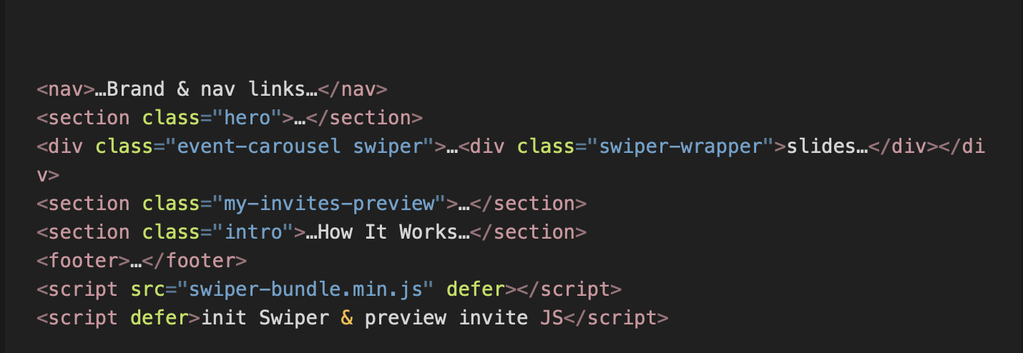

### 

### **CSS Highlights**

* **Global reset & variables** (:root { --primary:… }) for consistent theming
* **Hero**: height:80vh; background:cover; ::after overlay; animated headline (fadeInUp)
* **Carousel**:
  + .event-carousel { width:80%; margin:auto; }
  + .swiper-slide { min-height:520px; border-radius:18px; overflow:hidden; }
  + .slide-label over-image gradient overlay, opacity transitions on hover
  + Navigation arrows hidden until hover
* **My Invites teaser**:
  + .invite-card styled cards, delete button on hover
* **Intro**: Elevated card with hover lift effect

### 

### 

### **JavaScript Overview**

**Swiper initialization**:

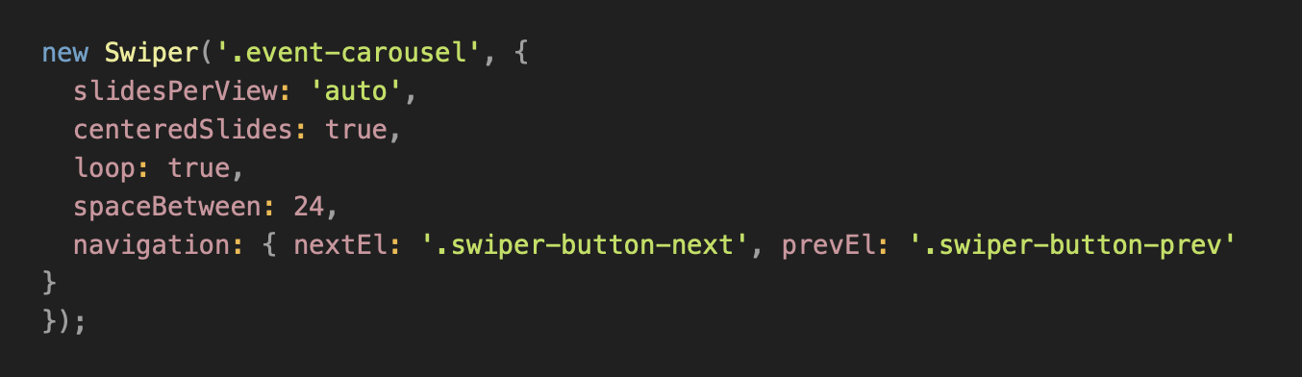

* **Invite preview** (latest 3 invites):
  + Reads myInvites from localStorage
  + Renders .invite-card entries or “No invites yet” message
* **Navigation & responsive**: All scripts deferred until DOM ready

## **📝 2. Invitation Form (inviteForm.html)**

### **Purpose & User Flow**

* **Data entry**: Select category & type, and fill title, subtitle, date/time, venue, address, dress code
* **Validation**: HTML5 required, JS-enforced date ≥ today
* **Invite generation**: Builds a query-string link to eventInvite.html and saves invite object to localStorage

### **Key HTML Snippets**

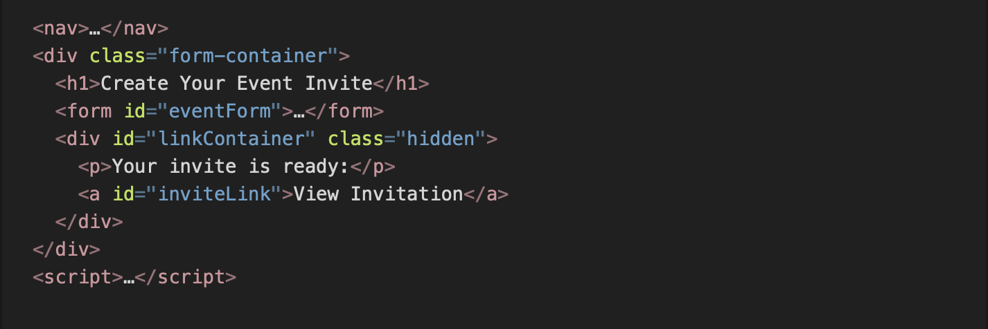

### 

### 

### **CSS Highlights**

* **Form container**: centered card (max-width:720px), rounded corners, box-shadow
* **Inputs & selects**: unified padding, focus border-color change (border-color: var(--primary))
* **Buttons**: pill-shaped, hover lift effect

### 

### 

### 

### 

### **JavaScript Overview**

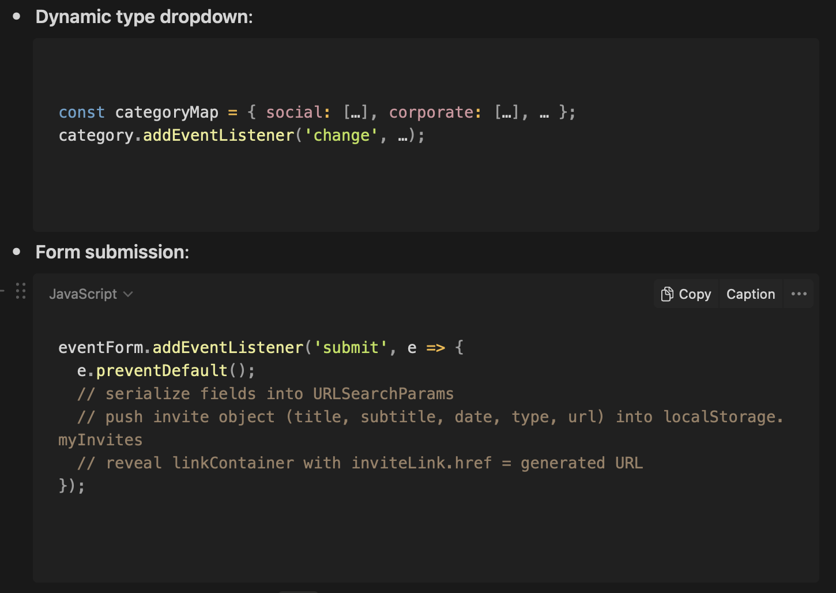

* **Date picker constraint**: sets min to today’s date on DOMContentLoaded

## 

## 

## 

## **🎉 3. Generated Invite (eventInvite.html)**

### **Purpose & User Flow**

* **Populate**: Parses URL parameters to replace placeholders
* **Engage**: Dynamic header background (by eventType) and live countdown
* **RSVP**: Simple form that alerts and redirects to “My Invites”

### **Key HTML Snippets**

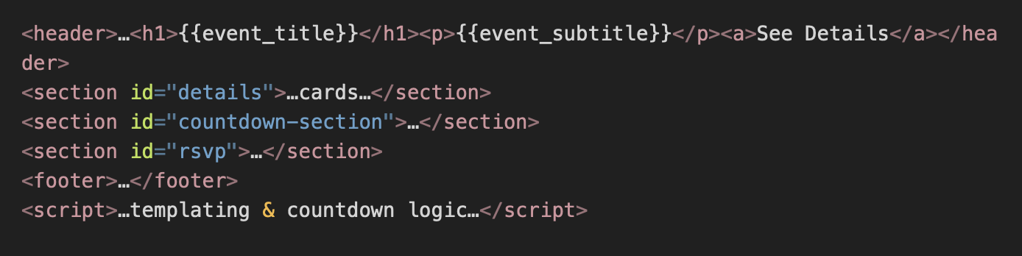

### **CSS Highlights**

* **Header**: height:100vh; background-image:var(--mapped-url); ::after for dark tint
* **Detail cards**: CSS Grid for three .detail-card items
* **Countdown**: Flex layout, mobile stacks via media query
* **RSVP form**: consistent with form styling, centered

### **JavaScript Overview**

**Placeholder replacement**:  
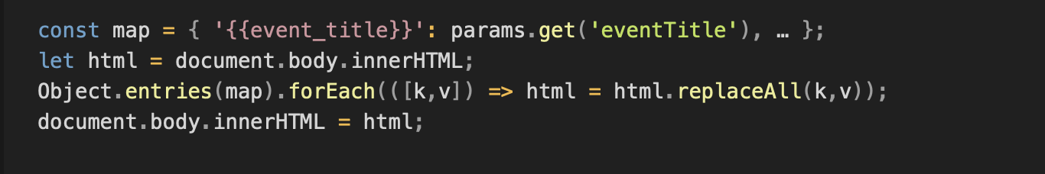

* **Background mapping**: selects from eventImageMap[eventType] or default
* **Countdown**: calculates diff to eventDateTime, updates spans every second
* **RSVP handler**: alert() + reset + 1.2 s redirect to dashboard

## **📋 4. My Invites Dashboard (myInvite.html)**

### **Purpose & User Flow**

* **Overview**: Lists all saved invites from localStorage.myInvites
* **Actions**: View (link) or Delete (× button)

### **Key HTML Snippets**

### 

### **CSS Highlights**

* **Invite cards**: .invite-card with white background, rounded corners, box-shadow, hover scale
* **Delete button**: small × at top-right, appears on hover
* **Empty state**: .empty message with link to form

### **JavaScript Overview**

**CRUD** in client:  
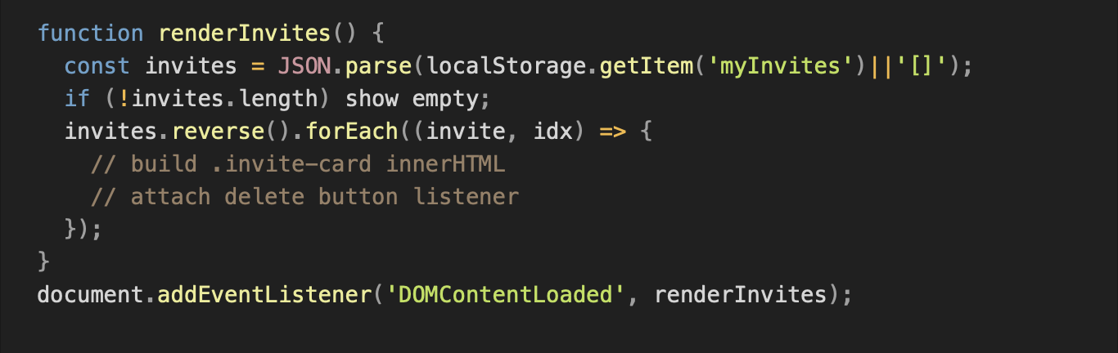

* **Deletion**: removes by index, writes back to localStorage, re-renders

## **🎯 Conclusion**

InviteEase is a **modular, client-only** invitation builder:

* **Landing**: immersive intro + Swiper carousel (PIX-inspired layout)
* **Form**: dynamic inputs, validation, link generation, persistent storage
* **Invite**: templating, themed backgrounds, live countdown, RSVP
* **Dashboard**: full CRUD of invites via localStorage

By separating **markup**, **styles**, and **behavior**, and leveraging **Swiper.js** for high-perf carousels, we deliver a polished, maintainable experience—crafted by **Soham & Rayan**.