Assignment 5: Regression Mini-Project
CO3 — House Price Predictor (Linear Regression)

1. Dataset
Dataset: California Housing dataset (sklearn.datasets.fetch_california_housing).
Shape: 20,640 rows × 9 columns (8 features + 1 target).
Features: MedInc (median income), HouseAge, AveRooms, AveBedrms, Population, AveOccup, Latitude, Longitude.
Target: MedHouseVal — median house value for a block group, in units of $100,000s.
Missing values: None — dataset is pre-cleaned by scikit-learn.

2. Model Pipeline
- Split features (X) and target (y = MedHouseVal).
- Train/test split: 80/20 (train_test_split, random_state=42) → 16,512 training rows, 4,128 test rows.
- Model: sklearn.linear_model.LinearRegression, trained with model.fit(X_train, y_train).
- Predictions generated on the held-out test set with model.predict(X_test).

3. Evaluation Metrics
Mean Squared Error (MSE): 0.556
R-squared (R²): 0.576
An R² of 0.576 means the model explains roughly 58% of the variance in median house values using a linear combination of the 8 features. The remaining ~42% reflects patterns Linear Regression cannot capture — real housing prices depend on nonlinear factors (e.g. neighborhood desirability, interaction effects between income and location) that a straight-line model inherently cannot represent. This is a realistic, expected result for plain Linear Regression on this dataset, not a sign of an implementation error.

4. Visualization: Actual vs. Predicted
The scatter plot compares actual house values (x-axis) against the model's predicted values (y-axis), with a red dashed diagonal line marking where perfect predictions would fall.
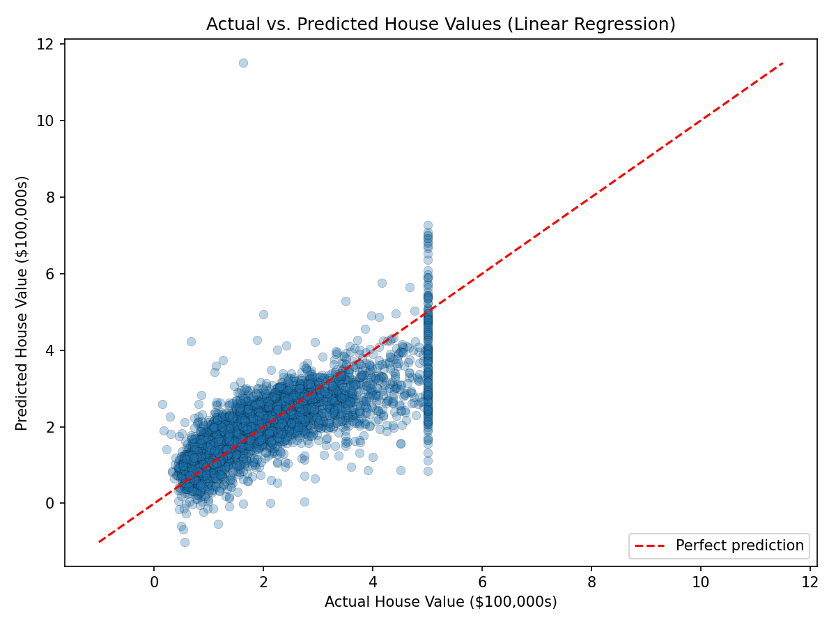

5. Visual Diagnosis
Most points cluster fairly close to the red diagonal, especially for lower and mid-range house values (roughly $0-$300k), indicating reasonably accurate predictions in that range. As actual values increase, however, predictions become more scattered and increasingly underestimate true value — points fall further below the diagonal at the high end.
Notable artifact: a dense vertical band of points appears at an actual value of exactly 5.0 ($500,000). This is not a modeling error — the California Housing dataset caps all house values above $500,000 at exactly 5.0 during data collection. The model, unaware of this artificial ceiling, still predicts a natural range of values for these capped houses, which produces the vertical scatter visible in the plot. This is a good example of a data limitation that a visualization reveals but a metric alone (MSE/R²) would not obviously explain.

6. Deliverables
- regression_project.py / .ipynb — full model pipeline code.
- California Housing dataset — loaded directly via sklearn.datasets.fetch_california_housing().
- actual_vs_predicted.png — scatter plot (included above).

