Problem Statement

AI/ML For Networking
Problem Statement Description: Modern networks face increasing challenges in monitoring and securing traffic due to the exponential growth of data, encrypted communication, and sophisticated cyber threats. Traditional rule-based security measures and deep packet inspection (DPI) techniques are becoming less effective in detecting and classifying threats, especially in encrypted traffic. Manual intervention in network traffic classification is inefficient, leading to delayed threat detection and security vulnerabilities. To address these issues, AI-driven solutions can analyze traffic patterns, detect anomalies, classify applications, and enhance security in real-time, ensuring adaptive and intelligent network defense.
Expected Outcomes:
• Automated Network Traffic Analysis using AI/ML models to detect and classify traffic in real time.
• Improved Threat Detection & Security, identifying anomalies, malware, and encrypted attacks with higher accuracy.
• Reduced False Positives & False Negatives, enhancing the efficiency of network security operations.
• Scalability & Performance Optimization, ensuring AI models can handle high-traffic environments with minimal latency.
• Privacy-Preserving Traffic Analysis, leveraging AI for encrypted traffic analysis without decryption.
Deliverables:
1. AI-Powered Traffic Classification Model – A system that categorizes network traffic (e.g., APP ID detection) based on behavior and patterns.
2. Threat Detection & Anomaly Identification Framework – AI-driven security mechanism to detect suspicious or malicious activity.

Solution

1)Traffic Classification
To address the critical challenge of real-time, automated network traffic classification—especially for encrypted and high-volume environments—our solution leverages advanced machine learning techniques to accurately identify application-level traffic and support adaptive network defense.
1. Data Preparation and Preprocessing
- Robust Data Handling: The system ingests network traffic data in ARFF format, decoding categorical labels and systematically handling missing values by replacing them with median values, ensuring data integrity for downstream processing.
- Privacy-Preserving Approach: By focusing on flow-level and statistical features, the model operates effectively even on encrypted traffic, without requiring payload inspection, thus maintaining user privacy.
2. Feature Engineering for Encrypted Traffic
- Temporal and Behavioral Features: We engineer sophisticated features that capture temporal patterns (e.g., flow duration per packet, burstiness), throughput characteristics, and packet timing ratios. These features are specifically designed to differentiate between various application types in encrypted traffic scenarios, where traditional DPI is ineffective.
- Domain-Informed Selection: Features are chosen based on their relevance to encrypted traffic analysis, maximizing classification accuracy while minimizing reliance on protocol-specific or payload data.
3. Model Architecture: Ensemble Learning Pipeline
- Stacked Ensemble Model: The core of our classification system is a robust ensemble pipeline, combining Support Vector Machines (SVM) and XGBoost classifiers within a stacking framework. This architecture captures both linear and complex nonlinear patterns in network traffic, enhancing generalization across diverse application types.
- Data Balancing and Feature Selection: The pipeline integrates SMOTE for synthetic oversampling to address class imbalance, and SelectKBest with mutual information for optimal feature selection, ensuring both fairness and efficiency in training.
- Scalability and Modularity: The modular pipeline, built with imbalanced-learn and scikit-learn, is designed for scalability and efficient deployment in high-throughput network environments.
4. Hyperparameter Optimization
- Automated Tuning: We employ GridSearchCV to optimize key parameters across the ensemble, including the number of selected features, SVM regularization, XGBoost tree depth and learning rate, and the number of estimators in the final classifier. This systematic search ensures peak model performance tailored to the specific characteristics of the traffic dataset1.
5. Evaluation and Visualization
- Comprehensive Metrics: The model’s performance is rigorously evaluated using accuracy, precision, recall, F1-score, and confusion matrices. Precision-recall curves are generated for each class to assess discriminative power, especially in multi-class and imbalanced scenarios.
- High Performance: On the test dataset, the optimized ensemble achieved an overall accuracy of 89%, with macro-averaged F1-scores above 0.88 across all traffic categories, including challenging VPN-based applications such as browsing, chat, file transfer, mail, P2P, streaming, and VoIP.
- Interpretability: Visualizations such as confusion matrices and precision-recall curves provide actionable insights for network operators and security analysts.
6. Model Deployment and Automation
- Serialization and Integration: The trained model is serialized using joblib for seamless integration into production environments, enabling real-time inference on live traffic streams.
- Automation Ready: The pipeline is fully automated from data ingestion to prediction, supporting continuous learning and adaptation as new traffic patterns emerge.
Key Advantages
- Encrypted Traffic Support: By relying on statistical and behavioral features, the solution classifies traffic accurately even when payload content is inaccessible due to encryption.
- Reduced Manual Intervention: The end-to-end automation minimizes the need for manual rule creation or protocol-specific tuning.
- Scalable and Adaptable: The architecture supports deployment in large-scale, high-speed networks with minimal latency impact.
- Foundation for Threat Detection: Accurate traffic classification enables more precise anomaly and threat detection in subsequent stages of the project.
This solution forms the backbone of our AI-powered network security suite, ensuring intelligent, adaptive, and privacy-preserving traffic analysis for modern enterprise and service provider environments.

2)Threat Detection
To provide robust, automated threat detection in modern network environments, our solution employs a GPU-optimized deep learning model to classify URLs as benign or malicious, further distinguishing among specific threat types such as phishing, defacement, and malware. This approach enables rapid, accurate identification of web-based threats, even as attackers continuously evolve their tactics.
1. Data Acquisition and Preprocessing
- Comprehensive Dataset: The system ingests a large, labeled dataset of URLs, each annotated as benign, phishing, defacement, or malware. This diverse labeling supports nuanced threat categorization and reflects real-world attack vectors.
- Feature Extraction: For each URL, a suite of lexical and structural features is extracted, including:
  - URL length, domain length, and path length
  - Number of digits, special characters, and subdomains
  - Presence of HTTPS, port numbers, or IP addresses
  - Shannon entropy (measuring randomness)
  - Frequency of suspicious keywords (e.g., “login”, “verify”)
  - Redirection patterns and file extensions123
- Label Encoding: Target labels are encoded for efficient model training, and the label encoder is preserved for future inference compatibility.
2. Model Architecture and Training
- GPU-Accelerated Deep Ensemble: The core model is a ForestNet—a PyTorch-based neural ensemble that mimics the behavior of a Random Forest through multiple parallel neural sub-networks. This design harnesses GPU acceleration for both training and inference, enabling real-time threat detection at scale.
- Training Regimen: The model is trained using cross-entropy loss and the AdamW optimizer, with extensive epochs to ensure convergence. Batch processing and stratified train-test splits maintain class balance and maximize generalization.
- Automated Feature Learning: Unlike traditional rule-based systems, the neural ensemble autonomously learns complex, non-linear relationships between URL features and threat categories, adapting to new and evolving attack patterns.

3. Evaluation and Performance
- Comprehensive Metrics: The model’s performance is measured using precision, recall, F1-score, and overall accuracy for each threat class. Results from the test set demonstrate:
  - Overall accuracy: 90%
  - Macro-averaged F1-score: 0.85
  - High precision and recall for benign, defacement, and malware classes; phishing detection remains challenging, reflecting industry-wide trends in adversarial evasion.
- Interpretability: Feature importance analysis and confusion matrices provide actionable insights for security analysts, supporting explainable AI requirements7.
4. Deployment and Automation
- Model Serialization: The trained model and label encoder are saved for seamless deployment in production environments, supporting real-time URL scanning and integration with broader security platforms.
- Scalability: GPU optimization ensures the system can process high volumes of URLs with minimal latency, making it suitable for enterprise-scale and cloud-native deployments.
- Continuous Learning: The modular pipeline supports periodic retraining with new threat data, ensuring resilience against emerging attack vectors and zero-day threats.
Key Advantages
- Real-Time, Automated Detection: The system eliminates manual URL vetting and static blacklists, providing adaptive, immediate protection against web-based threats.
- Granular Threat Categorization: By distinguishing between phishing, malware, and defacement, the solution enables tailored incident response and prioritization.
- Privacy-Preserving: Only URL metadata and structure are analyzed—no user content or payload inspection—ensuring compliance with privacy standards.
- Scalable and Future-Proof: GPU acceleration and neural ensemble design ensure the solution remains effective as threat volumes and complexity grow.
This AI-powered threat detection framework forms a critical pillar of our network security suite, enabling organizations to proactively defend against sophisticated, fast-evolving cyber threats in real time.

Architecture Diagram

Traffic Classification
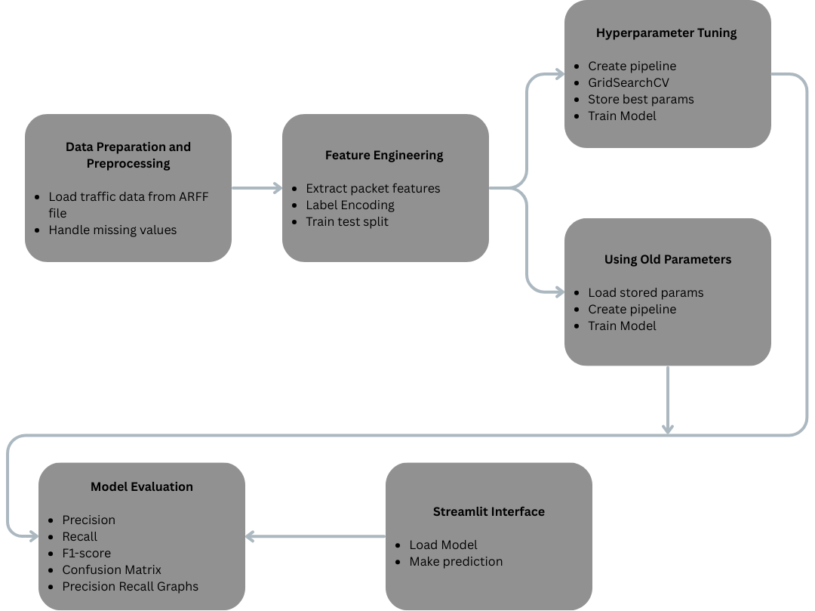

Threat Detection

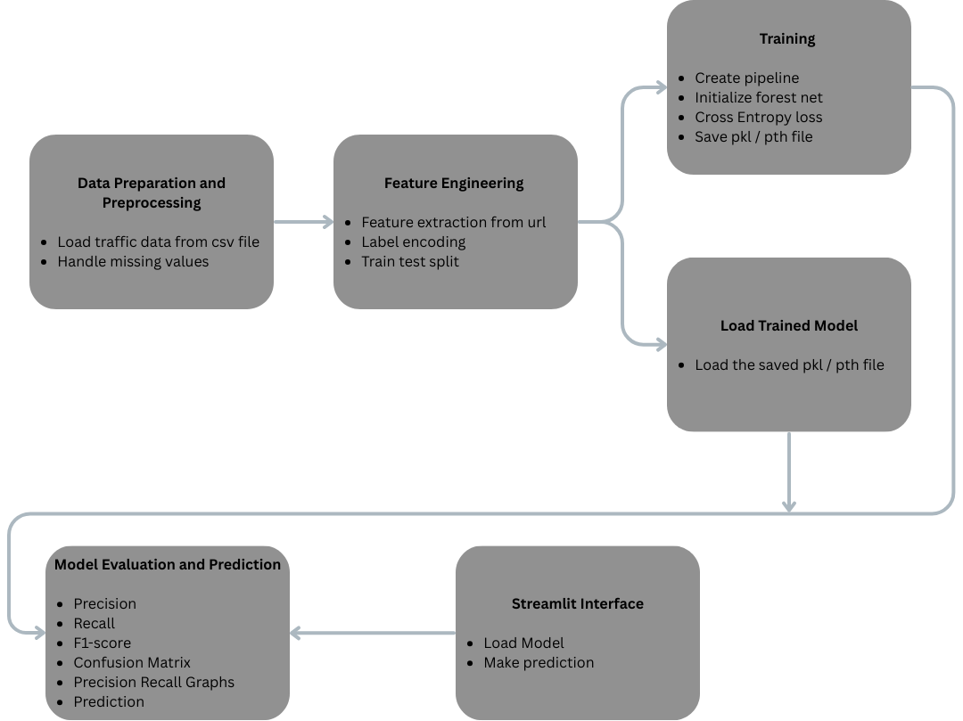

Traffic Classification: Code Explanation

Cell 0–2: Installation of Required Packages
These initial cells ensure that all necessary Python packages are installed in the environment. The following libraries are installed:
- imbalanced-learn, xgboost, and joblib for advanced machine learning workflows.
- matplotlib for data visualization.
- seaborn for enhanced statistical plotting.
Purpose:To guarantee that all dependencies required for data processing, modeling, and visualization are available before executing the main code.

Cell 3: Importing Libraries
- This cell imports all the essential libraries used throughout the notebook:
- Data handling: pandas, numpy, scipy.io.arff
- Preprocessing: StandardScaler, LabelEncoder
- Model selection: train_test_split, GridSearchCV
- Pipeline and feature selection: Pipeline (from imblearn), SelectKBest, mutual_info_classif
- Machine learning models: SVC (Support Vector Machine), XGBClassifier (Extreme Gradient Boosting)
- Ensemble learning: StackingClassifier
- Evaluation metrics: classification_report, precision_recall_curve, confusion_matrix, PrecisionRecallDisplay, RocCurveDisplay
- Data balancing: SMOTE
- Visualization: matplotlib.pyplot, seaborn
- Model persistence: joblib, json
Purpose:
To import all necessary modules for data processing, model building, evaluation, and result visualization.

Cell 4: Data Preparation Function
def load_and_preprocess(file_path):
"""Load and preprocess ARFF file with network traffic data"""
data, meta = arff.loadarff(file_path)
df = pd.DataFrame(data)
df['class1'] = df['class1'].str.decode('utf-8')
df.replace(-1, np.nan, inplace=True)
df = df.apply(lambda x: x.fillna(x.median()) if x.dtype != 'O' else x)
return df
Purpose:
- Loads network traffic data from an ARFF file.
- Decodes class labels from byte strings to standard strings.
- Replaces missing values (denoted by -1) with NaN, then imputes them using the median for each column.
- Returns a clean DataFrame ready for further processing.

Cell 5: Feature Engineering Function
def engineer_features(df):
"""Create time-based features for encrypted traffic analysis"""
df = df.copy()
# Temporal pattern features
df['flow_duration_per_packet'] = df['duration'] / (df['total_fiat'] + df['total_biat'] + 1e-6)
df['active_idle_ratio'] = df['mean_active'] / (df['mean_idle'] + 1e-6)
df['burstiness'] = (df['std_flowiat'] / (df['mean_flowiat'] + 1e-6))
# Throughput features
df['fwd_throughput'] = df['total_fiat'] / (df['duration'] + 1e-6)
df['bwd_throughput'] = df['total_biat'] / (df['duration'] + 1e-6)
# Packet timing features
df['fwd_bwd_timing_ratio'] = df['mean_fiat'] / (df['mean_biat'] + 1e-6)
return df
Purpose:
- Constructs additional features that capture temporal patterns, throughput, and packet timing characteristics of network traffic.
- These engineered features are designed to enhance the model's ability to distinguish between different types of encrypted traffic.

Cell 6: Model Pipeline Construction
def create_ensemble_pipeline():
"""Create optimized ensemble pipeline with feature selection and balancing"""
base_estimators = [
('svm', SVC(class_weight='balanced', probability=True, kernel='rbf')),
('xgb', XGBClassifier(eval_metric='mlogloss'))
]
return Pipeline([
('scaler', StandardScaler()),
('smote', SMOTE(sampling_strategy='auto', k_neighbors=3)),
('feature_selector', SelectKBest(mutual_info_classif, k=15)),
('stack', StackingClassifier(
estimators=base_estimators,
final_estimator=XGBClassifier(eval_metric='mlogloss'),
stack_method='predict_proba'
))
])
Purpose:
- Defines a machine learning pipeline that standardizes features, balances classes using SMOTE, selects the most informative features, and applies a stacking ensemble of SVM and XGBoost classifiers.
- The stacking ensemble combines the strengths of both base models, with an XGBoost classifier as the final estimator.

Cell 7: Hyperparameter Grid Definition
def get_parameter_grid():
"""Return optimized parameter grid for network traffic classification"""
return {
'feature_selector__k': [10, 15],
'stack__svm__C': [0.1, 1, 10],
'stack__svm__gamma': ['scale', 'auto'],
'stack__xgb__max_depth': [3, 5],
'stack__xgb__learning_rate': [0.1, 0.2],
'stack__final_estimator__n_estimators': [50, 100]
}

Purpose:
- Specifies a grid of hyperparameters for tuning the pipeline using cross-validation.
- This grid is used to identify the optimal combination of feature selection, SVM, and XGBoost parameters for the classification task.

Cell 8: Evaluation and Visualization Function
def visualize_results(model, X_test, y_test, le):
"""Generate comprehensive model evaluation visuals"""
y_pred = model.predict(X_test)
y_proba = model.predict_proba(X_test)
# Confusion matrix
plt.figure(figsize=(12,8))
sns.heatmap(confusion_matrix(y_test, y_pred),
annot=True, fmt='d',
xticklabels=le.classes_,
yticklabels=le.classes_,
cmap='Blues')
plt.title('Encrypted Traffic Classification Matrix\n', fontsize=14)
plt.xlabel('Predicted Traffic Type')
plt.ylabel('Actual Traffic Type')
plt.tight_layout()
plt.show()
# Precision-Recall curves (One-vs-Rest)
n_classes = len(le.classes_)
plt.figure(figsize=(10, 7))
for i in range(n_classes):
precision, recall, _ = precision_recall_curve(y_test == i, y_proba[:, i])
plt.plot(recall, precision, label=f'PR curve for {le.classes_[i]}')
plt.xlabel('Recall')
plt.ylabel('Precision')
plt.title('Precision-Recall Curves (One-vs-Rest)')
plt.legend()
plt.show()

Purpose:
- Provides visual evaluation of the model's performance using a confusion matrix and precision-recall curves for each class.
- These visualizations help in understanding the classification accuracy and the trade-off between precision and recall for each traffic type.

Cell 9: Main Execution Block
This cell orchestrates the entire workflow:
- Data Loading and Preprocessing:
- Loads the ARFF dataset and applies preprocessing and feature engineering.
- Label Encoding and Feature Selection:
- Encodes class labels and selects relevant features for model training.
- Data Splitting:
- Splits the dataset into training and testing sets with stratification to preserve class distribution.
- Model Training:
- (Commented out) Optionally performs grid search for hyperparameter tuning.
- Loads previously determined best parameters from a JSON file.
- Constructs the pipeline and sets the optimal parameters.
- Trains the pipeline on the training data.
- Model Persistence:
- Saves the trained model and label encoder for future use.
- Model Evaluation:
- Prints the best parameters and a detailed classification report.
- Visualizes results using the previously defined function.
- Displays the importance scores of the top features used in classification.
Purpose:
- To execute the complete machine learning workflow, from data preparation to model training, evaluation, and result interpretation, in a reproducible and organized manner.

Summary
This notebook implements a robust machine learning pipeline for encrypted network traffic classification. It systematically handles data preprocessing, feature engineering, model construction (using a stacking ensemble), hyperparameter optimization, and comprehensive evaluation. The code is modular, with each function dedicated to a specific stage of the workflow, ensuring clarity, maintainability, and reproducibility.

Threat Detection: Code Explanation

1. Importing Required Libraries
- The notebook begins by importing essential Python libraries for data processing, machine learning, and deep learning:
- pandas, numpy: For data manipulation and numerical operations.
- joblib: For saving and loading Python objects, such as the label encoder.
- re, urllib.parse: For regular expressions and URL parsing.
- torch, torch.nn, torch.optim, torch.utils.data: For building and training neural network models using PyTorch.
- sklearn.preprocessing, sklearn.model_selection, sklearn.metrics: For label encoding, splitting data, and evaluating model performance.
- os: For operating system interactions.

2. Device Selection
device = torch.device("cuda" if torch.cuda.is_available() else "cpu")
print(f"Using device: {device} (RTX 4060)")
The code checks for the availability of a CUDA-enabled GPU and sets the computation device accordingly. This ensures that, if available, computations are performed on the GPU for faster processing.

3. Feature Extraction Functions
a. extract_features(url)
def extract_features(url):
"""Extract URL security features"""
parsed = urlparse(url)
domain = parsed.netloc
path = parsed.path

features = {
'url_length': len(url),
'domain_length': len(domain),
'num_digits': sum(c.isdigit() for c in url),
'special_chars': sum(url.count(c) for c in ['@', '?', '=', '.', '-', '_', '/']),
'has_https': 1 if parsed.scheme == 'https' else 0,
'num_subdomains': domain.count('.') - 1 if domain.count('.') > 1 else 0,
'path_length': len(path),
'num_params': path.count('?') + path.count('&'),
'has_port': 1 if ':' in domain else 0,
'is_ip': 1 if re.match(r'\d+\.\d+\.\d+\.\d+', domain) else 0,
'file_extension': 1 if '.' in path.split('/')[-1] else 0,
'entropy': calculate_entropy(url),
'num_redirects': url.count('//') - 1,
'has_phish_keywords': 1 if any(kw in url.lower() for kw in ['login', 'verify', 'secure', 'account']) else 0
}
return features
This function parses a given URL and extracts a set of handcrafted features relevant for security analysis.
b. calculate_entropy(string)
def calculate_entropy(string):
"""Calculate Shannon entropy of URL string"""
prob = [float(string.count(c)) / len(string) for c in set(string)]
return -sum(p * np.log2(p) for p in prob)
Calculates the Shannon entropy of a string, which is a measure of randomness or unpredictability in the URL.

4. Loading and Preparing the Dataset
The code attempts to load the dataset malicious_phish.csv using pandas. If the file is not found, it prints an error and exits. Upon successful loading, it prints the column names to confirm the structure.
try:
df = pd.read_csv("malicious_phish.csv")
print("Dataset loaded successfully.")
except FileNotFoundError:
print("Error: File 'malicious_phish.csv' not found in current directory")
print("Please ensure the file is in the same directory as this script")
exit()

print("Columns in dataset:", df.columns.tolist())
url_column = 'url' # Column containing URLs
label_column = 'type' # Column containing attack types

5. Feature Extraction from URLs
The URLs in the dataset are processed using the extract_features function, and the resulting features are converted into a NumPy array (X). The corresponding labels are extracted into y.
print("Extracting features from URLs...")
features = df[url_column].apply(extract_features).apply(pd.Series)
X = features.values.astype(np.float32)
y = df[label_column].values

6. Label Encoding
A LabelEncoder is used to convert the categorical attack type labels into numerical values suitable for model training. The encoder is saved to disk for future use.
le = LabelEncoder()
y_encoded = le.fit_transform(y)
joblib.dump(le, 'label_encoder.pkl')

7. Train-Test Split
The dataset is split into training and testing sets using an 80-20 split, with stratification to preserve the distribution of classes.
X_train, X_test, y_train, y_test = train_test_split(
X, y_encoded, test_size=0.2, stratify=y_encoded, random_state=42
)

8. Tensor Conversion and DataLoader Creation
The feature and label arrays are converted into PyTorch tensors and moved to the selected device (CPU or GPU). A TensorDataset and DataLoader are created for efficient batch processing during training.
X_train_tensor = torch.tensor(X_train).float().to(device)
y_train_tensor = torch.tensor(y_train).long().to(device)
X_test_tensor = torch.tensor(X_test).float().to(device)

train_dataset = TensorDataset(X_train_tensor, y_train_tensor)
train_loader = DataLoader(train_dataset, batch_size=1024, shuffle=True)
9. Model Definition: ForestNet
A custom neural network class, ForestNet, is defined to mimic the behaviour of a random forest using an ensemble of neural networks.
class ForestNet(nn.Module):
"""PyTorch implementation of Random Forest equivalent"""
def __init__(self, input_size, num_classes, num_trees=100, tree_depth=10):
super().__init__()
self.trees = nn.ModuleList([
nn.Sequential(
nn.Linear(input_size, 64),
nn.ReLU(),
nn.Linear(64, 32),
nn.ReLU(),
nn.Linear(32, num_classes)
) for _ in range(num_trees)
])

def forward(self, x):
outputs = [tree(x) for tree in self.trees]
return torch.stack(outputs).mean(dim=0)

10. Model Initialization
An instance of ForestNet is created with the appropriate input size, number of output classes, number of trees, and tree depth. The model is moved to the selected device.
model = ForestNet(
input_size=X_train.shape[1],
num_classes=len(le.classes_),
num_trees=300,
tree_depth=5
).to(device)

11. Loss Function and Optimizer
The model uses cross-entropy loss for multi-class classification and the AdamW optimizer for training.
criterion = nn.CrossEntropyLoss()
optimizer = optim.AdamW(model.parameters(), lr=0.001)

12. Training Loop
The model is trained for 50 epochs. For each epoch, the training data is processed in batches.
model.train()
for epoch in range(50):
for batch_x, batch_y in train_loader:
optimizer.zero_grad()
outputs = model(batch_x)
loss = criterion(outputs, batch_y)
loss.backward()
optimizer.step()
if epoch % 10 == 0:
print(f"Epoch {epoch+1}, Loss: {loss.item():.4f}")

13. Model Evaluation
After training, the model is set to evaluation mode. Predictions are made on the test set, and the results are compared to the true labels using classification_report from scikit-learn.
model.eval()
with torch.no_grad():
test_outputs = model(X_test_tensor)
y_pred = test_outputs.argmax(dim=1).cpu().numpy()

print("\n=== Model Evaluation ===")
print(classification_report(y_test, y_pred, target_names=le.classes_))

14. Model Saving
The trained model's state dictionary, input size, number of classes, and label encoder are saved to a file named gpu_forest_model.pth for future inference or deployment.
torch.save({
'model_state_dict': model.state_dict(),
'input_size': X_train.shape[1],
'num_classes': len(le.classes_),
'label_encoder': le
}, 'gpu_forest_model.pth')
print(" GPU-optimized model saved as 'gpu_forest_model.pth'")

Summary
This notebook implements a GPU-optimized, neural network-based ensemble model for multi-class URL attack classification. It covers the entire pipeline from data loading and feature extraction to model training, evaluation, and saving, leveraging PyTorch for deep learning and scikit-learn for data preprocessing and evaluation. The approach is designed to efficiently utilize GPU resources for large-scale security analytics.

Future Scope
This project can be extended by deploying the trained models in real-time environments using tools such as CICFlowMeter or Wireshark to analyze live network traffic. Further enhancements can include integrating deep learning models like character-level CNNs or LSTMs to improve detection of obfuscated or zero-day attacks. Incorporating threat intelligence feeds and online learning mechanisms would allow the system to adapt to evolving threats. Additionally, deploying the solution in cloud or edge environments could enable scalable, low-latency threat detection for high-throughput networks.

References
• Canadian Institute for Cybersecurity, ISCX VPN-nonVPN Dataset, University of New Brunswick. Available online: https://www.unb.ca/cic/datasets/vpn.html
• Canadian Institute for Cybersecurity, ISCX URL 2016 Dataset, University of New Brunswick. Available online: https://www.unb.ca/cic/datasets/url-2016.html
• Scikit-learn Developers, Support Vector Machines, Scikit-learn Documentation. Available online: https://scikit-learn.org/stable/modules/svm.html
• Kaggle, Malicious URLs Dataset. Available online: https://www.kaggle.com/datasets/sid321axn/malicious-urls-dataset

• M. A. Ferrag, L. Maglaras, H. Janicke, J. Jiang, and L. Shu, “A comprehensive survey on machine learning for networking: evolution, applications and research opportunities,” Journal of Internet Services and Applications, vol. 9, no. 1, pp. 1–37, 2018. https://link.springer.com/article/10.1186/s13174-018-0087-2
• I. Sharafaldin, A. H. Lashkari, and A. A. Ghorbani, “Toward Generating a New Intrusion Detection Dataset and Intrusion Traffic Characterization,” ICISSP, 2018. https://www.scitepress.org/Papers/2018/66398/66398.pdf

Contributions

Soham Chandrashekhar Bhanap | - Traffic classification stacking classifier model  - Threat Detection model  - Streamlit Interface for Threat Detection  - Architecture Diagram
Nishanya N Rao | - Traffic Classification Random Forest Model  - Streamlit Interface for Threat Detection  - Streamlit Interface for Traffic Classification  - Report  - Architecture Diagram
Dhruv Joshi | - Traffic Classification Decision Trees Model  - Report  - Dataset Preparation and Preprocessing  - Architecture Diagram

