CSRF ATTACK DEMOMSTRATION
Lab Assignment 4

Field | Details
Name | Aryan Srivastava
Roll Number | IIT2024501
Group | Group 4
Variant | GET-based CSRF via hidden <img> tag

Objective
To demonstrate a Cross-Site Request Forgery (CSRF) attack by building two websites: a legitimate profile app and a malicious attacker page. Then show how the attack can be blocked with a simple server-side fix.

Setup
Two sites are involved:
Site | URL | Role
Profile App | http://localhost:3000 | Victim's legitimate website
Attacker Site | http://localhost:3001 | Malicious page controlled by attacker

How the Attack Works
- Step 1: The user logs into the profile app at http://localhost:3000/login. The server creates a session cookie in the browser.
- Step 2: The user then opens the attacker's page, which looks like a fake prize page ("You've won $500!").
- Step 3: Hidden on the attacker's page is a zero-pixel <img> tag pointing to the victim's server.
- Step 4: The browser loads this invisible image, which fires a GET request — and automatically includes the session cookie.
- Step 5: The server sees a valid session and silently changes the user's email to hacked@attacker.com.
- Step 6: The user never notices anything happened.

The hidden attacker image tag:

<img
src="http://localhost:3000/api/change-email?email=hacked@attacker.com"
width="0" height="0" style="display:none"
/>

Methods / Implementation
Component Overview
Component | What It Does
Profile (Next.js) | The victim site with login, profile display, and a vulnerable change-email API
Attacker Site (HTML) | A static page that embeds a hidden <img> to trigger the attack
Session cookie | Used to authenticate the user sent automatically by the browser
Sec-Fetch-Site / Origin check | Fixes by blocking requests that come from a different website

Key Code Snippets
1. The vulnerable endpoint, accepts any GET request that has a valid session:

const session = await getSession();
const newEmail = searchParams.get("email");
await updateSession({ email: newEmail });

2. Session cookie setup, sameSite is commented out, leaving it open to cross-site requests:

cookieStore.set("session", JSON.stringify(user), {
httpOnly: true,
// sameSite: "strict",
path: "/",
maxAge: 60 * 60,
});

3. Login route which uses plain POST form authentication (no CSRF token):

const user = USERS[username];
if (!user || user.password !== password) {
return NextResponse.redirect(new URL("/login?error=invalid", request.url));
}
await setSession({ username, email: user.email, ... });

Screenshots of Output

Step | Screenshot | Observed Result
User logged into profile app | 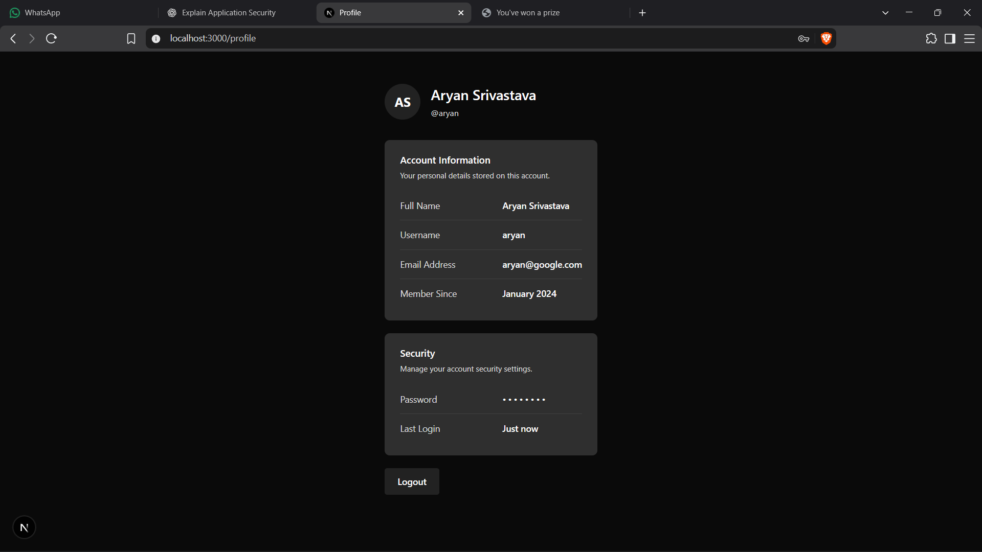 | Email shows aryan@google.com
Attacker page visited | 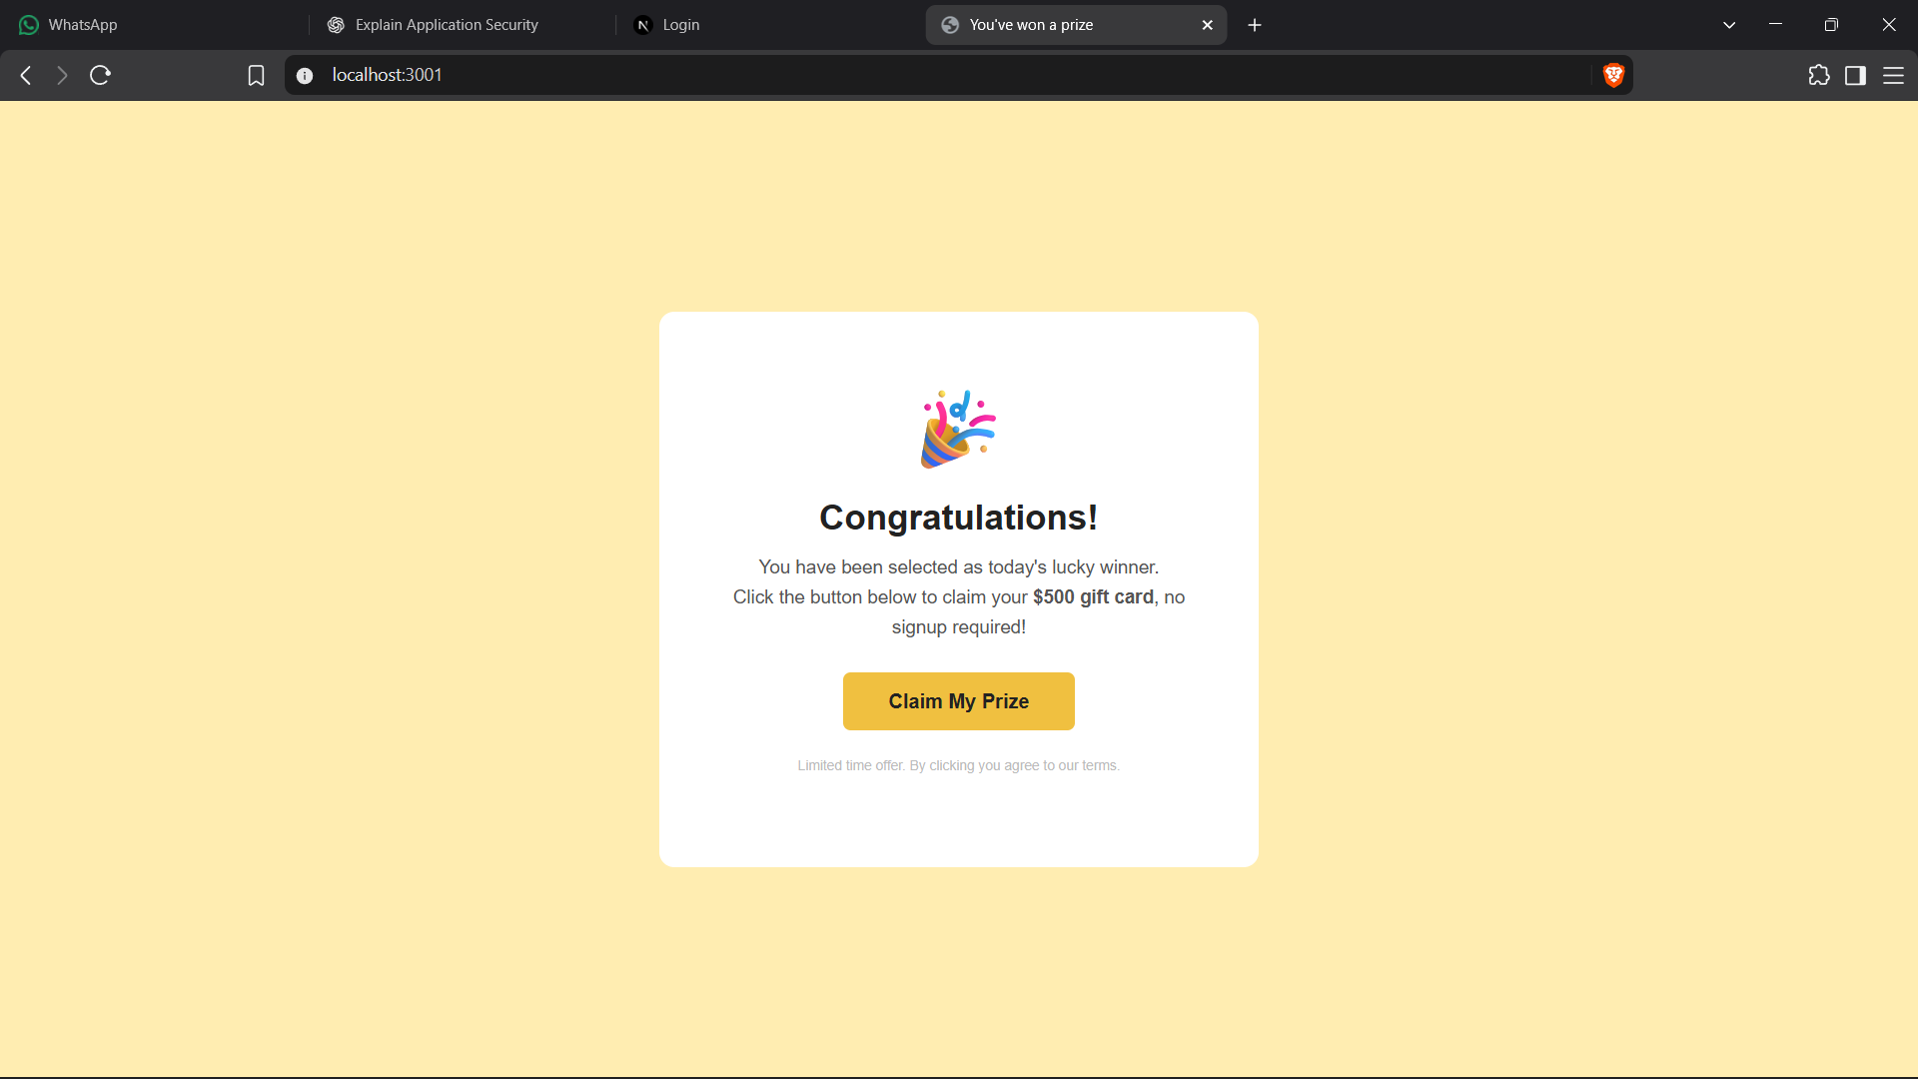 | Fake prize page displayed
Profile page after attack | 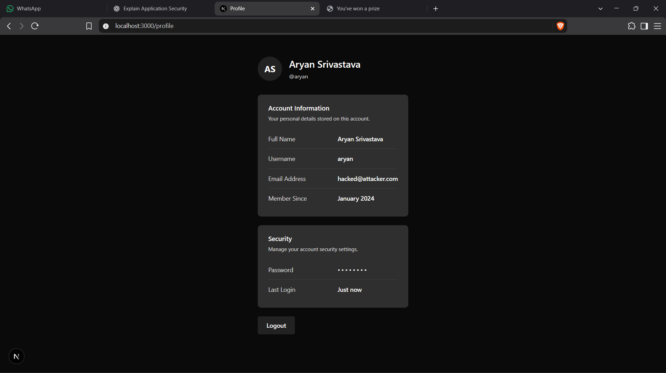 | Email changed to hacked@attacker.com

The Fix
The attack is blocked by checking where the request came from before processing it. Uncomment this block in profile/app/api/change-email/route.ts:

const fetchSite = request.headers.get("sec-fetch-site");
const source = request.headers.get("origin") ?? request.headers.get("referer");
const sameOrigin = source
? new URL(source).host === new URL(request.url).host
: false;

if (fetchSite ? fetchSite !== "same-origin" : !sameOrigin) {
return NextResponse.json(
{ error: "cross site request blocked" },
{ status: 403 }
);
}

Conclusion
This assignment demonstrates the CSRF attack in a two-site setup. The attack works because browsers automatically send cookies with every request, regardless of which website triggered it. A sensitive change-email endpoint that only checks whether the user is logged in, but not where the request came from makes it fully vulnerable.

The fix is straightforward. Check the Sec-Fetch-Site header and reject requests that originate from a different site. An even simpler alternative is to set sameSite: "strict" on the session cookie, which prevents the browser from sending it with cross-site requests altogether.

