PALANTIR FOUNDRY
Low-Code Data Engineering Assignment
Insurance Operations — Authoritative Dataset Build

Modules Covered | Pipeline Builder | Ontology | Lineage | Scheduling | Data Health
Assignment | Week 1
Estimated Time | 8 – 12 hours: individual basis

1. BUSINESS CONTEXT & SCENARIO
You have been engaged as a Foundry Data Engineer for NorthStar Insurance Group, a mid-sized Property & Casualty insurer operating across three legacy business units that were acquired over the past decade. Each unit maintains its own operational systems, data formats, and naming conventions. Senior leadership has mandated a Single Source of Truth (SSOT) for all active insurance policies to enable consistent reporting, claims processing automation, and regulatory compliance.
Your mission: ingest, clean, harmonise, join, and union five disparate source datasets into one authoritative Policies dataset, publish it as an Ontology Object Type, schedule daily refreshes, and validate data health — all within Palantir Foundry using Pipeline Builder (low-code transforms).

Business Problem Statement
Current Pain Points: Claims adjusters are manually reconciling three policy lists each morning. Duplicate policy IDs have caused double-payments exceeding $2M last year. Regulatory submissions (State DOI filings) are being delayed 4–6 weeks because no one knows which system is authoritative for a given policy type.
Desired Outcome: A single, clean, daily-refreshed dataset — ns_authoritative_policies — that can be trusted as the sole input for downstream dashboards, claims workflow triggers, and compliance exports.
⚠ Regulatory Note: Under NAIC guidelines, any dataset used for statutory filings must have documented data lineage. The lineage graph you build in this assignment will serve as that documentation.

2. SOURCE DATASETS
The five source datasets are pre-loaded into your Foundry Project under the folder
/NorthStar_Training/Raw_Sources/. Do not modify the raw sources — all work happens in transforms.

2.1 Dataset Catalogue
Dataset Name | Source System | Format | Rows (approx) | Business Unit
legacy_policies_northeast.csv | PolicyPro v3 (2009) | CSV | ~48,000 | Northeast (NE)
active_policies_southwest.xlsx | Guidewire PC 9 | Excel | ~31,000 | Southwest (SW)
acquired_midatlantic_policies.csv | BriteCore export | CSV | ~19,500 | Mid-Atlantic (MA)
agent_broker_registry.csv | Salesforce CRM | CSV | ~4,200 | Enterprise-wide
coverage_reference_table.csv | Internal Actuarial | CSV | ~850 | Enterprise-wide

2.2 Schema Profiles

legacy_policies_northeast.csv
Column Name | Data Type | Known Issues
pol_id | STRING | Format: NE-XXXXXX. Some rows use NE_XXXXXX (underscore). ~200 nulls.
insured_name | STRING | ALL CAPS. Trailing spaces common.
policy_type_code | STRING | Values: HO, AUTO, COMMER — 'COMMER' should map to 'COMMERCIAL'
effective_dt | STRING | Mixed formats: MM/DD/YYYY and YYYY-MM-DD
expiry_dt | STRING | Same mixed formats. ~600 rows where expiry < effective (data entry error).
annual_premium_usd | FLOAT | Some values negative (credits recorded incorrectly). ~150 nulls.
agent_id | STRING | References agent_broker_registry.agent_code
state_code | STRING | Two-letter USPS codes. 12 rows have invalid codes (e.g., 'XX', 'ZZ').
status | STRING | Values: ACTIVE, INACTIVE, PEND, CANCELLED — 'PEND' = 'PENDING'

active_policies_southwest.xlsx
Column Name | Data Type | Known Issues
PolicyNumber | STRING | Format: SW-XXXXXXX. Generally clean.
CustomerFullName | STRING | Mixed case. Middle initials sometimes included.
LineOfBusiness | STRING | Free text: 'Home Owner', 'Homeowners', 'Auto', 'Commercial Lines'
StartDate | DATE | Clean ISO 8601.
EndDate | DATE | ~90 rows with null EndDate (open-ended policies — valid).
GrossPremium | DECIMAL | Includes $ symbol and commas: '$1,250.00'. Must be cast.
ProducerCode | STRING | References agent_broker_registry.agent_code
RiskState | STRING | Full state names ('California') — must map to 2-letter codes.
PolicyStatus | STRING | Values: Active, Inactive, Pending, Non-Renewed

acquired_midatlantic_policies.csv
Column Name | Data Type | Known Issues
record_id | INTEGER | Auto-increment. NOT the policy number.
policy_ref | STRING | Format: MA-XXXXXXXX. ~300 duplicates (system migration artefact).
named_insured | STRING | Correctly cased. Some entries have 'DBA' suffix.
product_category | STRING | Values: Residential, Vehicle, Business, Marine — needs mapping.
inception_date | STRING | Unix epoch timestamps in some rows, ISO date in others.
termination_date | STRING | Same mixed timestamp issue.
total_premium | FLOAT | Annual premium. Generally clean.
writing_agent | STRING | References agent_broker_registry.agent_code. ~500 nulls (direct-written).
risk_location_state | STRING | 2-letter codes. Clean.
policy_status | STRING | Values: active, inactive, cancelled, lapsed — lowercase

agent_broker_registry.csv (Lookup / Dimension)
Column Name | Data Type | Notes
agent_code | STRING | Primary key. Join key for all policy tables.
agent_full_name | STRING | Clean.
agency_name | STRING | Clean.
license_state | STRING | 2-letter code.
license_expiry_date | DATE | ISO format.
channel | STRING | Values: INDEPENDENT, CAPTIVE, DIRECT, BROKER
active_flag | BOOLEAN | True/False.

coverage_reference_table.csv (Reference / Dimension)
Column Name | Data Type | Notes
coverage_code | STRING | Standardised code: HO, AUTO, COMMERCIAL, MARINE, RESIDENTIAL
coverage_description | STRING | Full description.
lob_category | STRING | Personal Lines / Commercial Lines / Specialty
regulatory_filing_required | BOOLEAN | Whether DOI filing is mandatory.
min_premium_threshold | FLOAT | Minimum allowable annual premium.

3. ASSIGNMENT TASKS
📋 Work through tasks in sequence. Each task builds on the previous. Create a new Pipeline Builder transform for each major task group unless instructed otherwise.

Task 1 — Data Ingestion & Initial Profiling
Estimated time: 30 minutes

1.1 Import Raw Sources
- Navigate to your Foundry project workspace. Confirm all five CSV/Excel files are visible under
- /NorthStar_Training/Raw_Sources/.
- If any file is missing, use the Files import panel to upload from the provided training ZIP archive.
- Register each dataset as a Foundry Dataset. Do not enable any automatic type inference at this stage.

1.2 Profile Each Dataset in Pipeline Builder
For each of the three policy source tables, create a separate Pipeline Builder transform named:
- profile_ne_policies | profile_sw_policies | profile_ma_policies
Within each profiling transform, add the following steps and document findings in the transform description field:
- Add a Row Count step. Record total row count.
- Add a Column Statistics step for all columns. Identify null %, min, max, and distinct count.
- Add a Duplicate Detection step on the primary key column (
- pol_id / PolicyNumber / policy_ref). Record number of duplicates.
- Add a Value Distribution step on the status/policy_status column. Document all distinct values observed.

Deliverable 1.2
📝 Complete the Data Profiling Summary table in Appendix A of your submission document. You must fill in every cell before proceeding to Task 2.

Task 2 — Data Cleaning: Northeast Policies
Estimated time: 90 minutes | Output dataset:
clean_ne_policies

2.1 Standardise Policy ID Format
- Add a Find & Replace or Expression Transform step. Replace all underscores (_) in pol_id with hyphens (-) to enforce the NE-XXXXXX format.
- Filter out rows where pol_id is null. Add a transform description comment explaining the business rule: policy records without a policy ID cannot be reconciled and must be excluded.
- Add a Validate step asserting that all remaining pol_id values match the regex pattern ^NE-[0-9]{6}$. Flag non-conforming rows in a new column id_validation_flag.

2.2 Normalise Insured Name
- Add a String Transform step to convert insured_name from ALL CAPS to Title Case.
- Add a Trim Whitespace step to remove leading and trailing spaces.

2.3 Standardise Policy Type Code
- Add a Map Values step on policy_type_code. Apply the following mapping:
Input Value | Output Value | Rationale
HO | HOMEOWNERS | Align to enterprise standard coverage_code vocabulary
AUTO | AUTO | Already conformant
COMMER | COMMERCIAL | Legacy abbreviation — expand to full code
(any other) | UNKNOWN | Flag for manual review

2.4 Parse & Standardise Dates
- Add a Date Parse step on effective_dt. Configure it to handle both MM/DD/YYYY and YYYY-MM-DD input formats. Output as ISO DATE type effective_date.
- Repeat for expiry_dt → expiry_date.
- Add a Filter / Computed Column step to flag rows where expiry_date < effective_date. Store the flag in a column date_integrity_flag. Do NOT drop these rows — set them aside by setting status to DATA_ERROR for review.

2.5 Clean Annual Premium
- Add a Filter step to remove rows where annual_premium_usd is negative. Log count of removed rows in transform description.
- Add a Fill Null step for annual_premium_usd nulls, replacing with -1 as a sentinel value and setting premium_null_flag = true.

2.6 Validate State Codes
- Add a Lookup / Join step joining on a static valid-states reference (you may hardcode the 50 US state codes as a reference list). Rows with invalid state_code values get state_validation_flag = 'INVALID'.

2.7 Standardise Status Values
- Add a Map Values step on status. Map PEND → PENDING, CANCELLED → CANCELLED (unchanged), all others pass through. Uppercase all values.

2.8 Add Source Metadata Columns
Add the following computed constant columns to every clean policy table — this is essential for post-union traceability:
- source_system = 'PolicyPro_NE'
- business_unit = 'NORTHEAST'
- ingestion_date = current_date()
- record_hash — MD5 hash of key fields (pol_id + effective_date + annual_premium_usd) for change detection

Rename columns to enterprise standard schema (see Appendix B for the full canonical schema).

Task 3 — Data Cleaning: Southwest Policies
Estimated time: 90 minutes | Output dataset:
clean_sw_policies

3.1 Clean GrossPremium — Currency String to Float
- Add an Expression Transform step. Use a regex or string-replace expression to strip $ and , characters from GrossPremium, then cast to FLOAT as annual_premium_usd.
- Validate: confirm no negative or null values after cast. Document any exceptions.

3.2 Normalise Line of Business
Apply a Map Values transform on LineOfBusiness using this mapping:
Input Value | Output Value
Home Owner | HOMEOWNERS
Homeowners | HOMEOWNERS
Auto | AUTO
Commercial Lines | COMMERCIAL
(anything else) | UNKNOWN

3.3 Convert Full State Names to Abbreviations
- Create a static lookup dataset (inline reference table) mapping full US state names to 2-letter USPS codes.
- Add a Left Join on RiskState = state_name. Output: state_code (the 2-letter code). For unmatched rows, state_code = 'UNKNOWN'.

3.4 Handle Open-Ended Policies
- Null EndDate rows represent open-ended policies. Add a Fill Null step replacing null EndDate with 9999-12-31 (conventional far-future sentinel). Add column open_ended_flag = true for these rows.

3.5 Rename to Canonical Schema + Add Source Metadata
Rename PolicyNumber → policy_id, CustomerFullName → insured_name, LineOfBusiness → coverage_code, StartDate → effective_date, EndDate → expiry_date, PolicyStatus → policy_status, ProducerCode → agent_code, RiskState → state_code.
Add: source_system = 'Guidewire_SW', business_unit = 'SOUTHWEST', ingestion_date, record_hash.

Task 4 — Data Cleaning: Mid-Atlantic Policies
Estimated time: 90 minutes | Output dataset:
clean_ma_policies

4.1 Remove Duplicate Records
- Add a Deduplicate step on policy_ref. Keep the row with the latest inception_date where duplicates exist. Log the count of removed duplicates.

4.2 Normalise Mixed Timestamp/Date Columns
The inception_date and termination_date columns contain a mix of Unix epoch integers and ISO date strings.
- Add a Conditional Expression Transform:
  - If value is numeric (epoch), convert: from_unixtime(CAST(inception_date AS BIGINT))
  - If value is a string, parse as ISO date: to_date(inception_date, 'yyyy-MM-dd')
  - Output column: effective_date (DATE type)
- Repeat logic for termination_date → expiry_date.

4.3 Map Product Category to Coverage Code
product_category Input | coverage_code Output | lob_category
Residential | HOMEOWNERS | Personal Lines
Vehicle | AUTO | Personal Lines
Business | COMMERCIAL | Commercial Lines
Marine | MARINE | Specialty
(other) | UNKNOWN | Unknown

4.4 Standardise Policy Status
The policy_status column is lowercase and includes 'lapsed', which has no enterprise equivalent.
Input | Output | Note
active | ACTIVE
inactive | INACTIVE
cancelled | CANCELLED
lapsed | INACTIVE | Business decision: lapsed = inactive for reporting

4.5 Handle Direct-Written (Null Agent) Records
- For rows where writing_agent is null, set agent_code = 'DIRECT'. This will join to a DIRECT placeholder row you must add to the agent_broker_registry reference in Task 6.

4.6 Rename to Canonical Schema + Add Source Metadata
Rename policy_ref → policy_id, named_insured → insured_name, writing_agent → agent_code, risk_location_state → state_code, total_premium → annual_premium_usd.
Add: source_system = 'BriteCore_MA', business_unit = 'MIDATLANTIC', ingestion_date, record_hash.

Task 5 — Union: Combine Three Clean Policy Datasets
Estimated time: 30 minutes | Output dataset:
unioned_policies_raw
All three cleaned datasets now conform to the same canonical schema (see Appendix B). You will now union them into a single table.
- Create a new Pipeline Builder transform named union_policy_sources.
- Add each of the three clean datasets as input sources.
- Add a Union step (Union All — preserve all rows including potential cross-source duplicates at this stage).
- Add a Row Count assertion to confirm the output row count equals the sum of the three input row counts (minus the MA duplicates removed in Task 4.1).
- Add a Computed Column step: union_sequence_id = ROW_NUMBER() OVER (ORDER BY source_system, policy_id). This provides a stable ordering for audit trails.

5.1 Cross-Source Duplicate Detection
It is possible that the same policy was entered in two systems during acquisition transitions.
- Add a Group By + Count step grouping on insured_name, effective_date, annual_premium_usd, state_code. Flag groups with count > 1 as cross_source_duplicate_flag = true.
- Do NOT drop these automatically. Route them to a side output dataset cross_source_review_queue for business review. Keep one copy in the main dataset.
💡 Tip: Use a conditional branch in Pipeline Builder — one path keeps flagged rows in main output with the flag set; the other writes flagged rows to the review queue. Both paths receive all flagged rows.

Task 6 — Enrichment Joins
Estimated time: 60 minutes | Output dataset:
enriched_policies

6.1 Join Agent/Broker Information
- Create a new transform: join_agent_enrichment.
- Input 1: unioned_policies_raw. Input 2: agent_broker_registry.
- Join type: Left Join on unioned_policies_raw.agent_code = agent_broker_registry.agent_code.
- Left join is mandatory — policies without a valid agent code must still appear in the output (direct-written policies).
- Bring through from the registry: agent_full_name, agency_name, channel, active_flag (rename to agent_active_flag), license_state.
- Add a Validation Column: agent_match_flag = 'MATCHED' where agent joined successfully, 'UNMATCHED' where join returned null (agent_code not in registry).

6.2 Join Coverage Reference Data
- Add a second Left Join on coverage_code = coverage_reference_table.coverage_code.
- Bring through: coverage_description, lob_category, regulatory_filing_required, min_premium_threshold.
- Add a Business Rule Validation computed column: premium_below_minimum_flag = (annual_premium_usd < min_premium_threshold AND annual_premium_usd != -1)

6.3 Final Business Rules on Enriched Dataset
Rule ID | Rule Description | Column Output | Action
BR-01 | Active policies must have a valid agent OR be DIRECT channel | br01_flag | FLAG
BR-02 | Regulatory filing required + premium < minimum = compliance risk | br02_flag | FLAG
BR-03 | Expiry date > 3 years from today on a non-open-ended policy | br03_flag | FLAG for review
BR-04 | Policy ID must be unique across the combined dataset | br04_flag | FLAG duplicates
BR-05 | State code must be valid 2-letter USPS code | br05_flag | FLAG; route to state_review

Task 7 — Publish Authoritative Dataset
Estimated time: 20 minutes | Output dataset:
ns_authoritative_policies
- From enriched_policies, add a Filter step: policy_status IN ('ACTIVE', 'PENDING') AND date_integrity_flag IS NULL OR date_integrity_flag = false.
- This is your authoritative active policies dataset. Name it ns_authoritative_policies.
- Add a final Row Count assertion and document expected count range in transform description.
- Add column descriptions (hover → Edit description) on all columns in ns_authoritative_policies. At minimum describe: policy_id, coverage_code, annual_premium_usd, agent_code, lob_category, regulatory_filing_required.
- Publish the dataset (mark as Published in Foundry Dataset settings).

7.1 Create Ontology Object Type
- Navigate to Ontology Manager.
- Create a new Object Type named InsurancePolicy.
- Set policy_id as the Primary Key property.
- Map the following properties to Ontology properties with appropriate types:
Dataset Column | Ontology Property Name | Property Type
policy_id | policyId | String (ID)
insured_name | insuredName | String
coverage_code | coverageCode | String
effective_date | effectiveDate | Date
expiry_date | expiryDate | Date
annual_premium_usd | annualPremiumUsd | Double
state_code | riskState | String
policy_status | policyStatus | String
lob_category | lineOfBusiness | String
business_unit | businessUnit | String
agent_full_name | agentName | String
regulatory_filing_required | regulatoryFilingRequired | Boolean
source_system | sourceSystem | String
ingestion_date | ingestionDate | Date

- Set the Object Type icon to a shield or document icon to represent insurance.
- Save and sync the Ontology. Verify object count matches ns_authoritative_policies row count.

Task 8 — Data Lineage Documentation
Estimated time: 20 minutes
- Navigate to the Data Lineage view for ns_authoritative_policies.
- Confirm all five source datasets appear as upstream nodes.
- Take a screenshot of the full lineage graph (raw sources → profiling → cleaning → union → enrichment → authoritative output → ontology).
- Answer the following questions in your submission document:
  - Lineage Q1: If legacy_policies_northeast.csv is updated with new rows tonight, which downstream datasets will be impacted? List them in order.
  - Ans: clean_ne_policies → unioned_policies_raw → enriched_policies → ns_authoritative_policies → InsurancePolicy Ontology
  - Lineage Q2: How many transform steps exist between agent_broker_registry.csv and ns_authoritative_policies?
  - Ans: Total: 8 transform steps, of which 3 are Joins
  - Lineage Q3: A compliance officer asks: 'Where did the annual_premium_usd value for policy NE-002847 come from, and what cleaning steps touched it?' Trace and answer using lineage.
  - Ans: Origin: legacy_policies_northeast.csv, imported as DOUBLE. The value itself was never altered; only rows were filtered. Two filters touched it: the 2.1 null-ID removal (which took out all 150 null premiums and 50 negatives) and the 2.5 negative-premium removal (70 more).
  - Lineage Q4: If you needed to remove all Mid-Atlantic data from the authoritative dataset, which single transform would you modify, and what downstream transforms need re-execution?
  - Ans: Modify the Union in union_policy_sources to drop clean_ma_policies. Re-run unioned_policies_raw, enriched_policies, ns_authoritative_policies, then re-sync the Ontology. Note that union_sequence_id values will change.

Task 9 — Pipeline Scheduler Setup
Estimated time: 15 minutes
- Navigate to the Scheduler for your project.
- Create a daily schedule named: NorthStar_Policies_Daily_Refresh.
- Schedule: 02:00 AM Eastern Time, Monday–Saturday.
- Set the trigger to run the full pipeline: from raw import through to ns_authoritative_policies and Ontology sync.
- Configure failure notifications: email alert to the training group email list on any pipeline failure.
- Answer in submission document:
  - Scheduler Q1: Why schedule at 02:00 AM rather than business hours?
  - Ans: Source systems are idle overnight, so data is stable and compute is free. Data is ready before the business day starts, and a 2am failure leaves several hours to fix it before anyone needs the reports.
  - Scheduler Q2: The SW Guidewire system has a maintenance window every Sunday 01:00–04:00 AM. How would you adjust the schedule to prevent failures?
  - Ans: No change needed. The schedule already runs Monday–Saturday, so it never hits the Sunday 01:00–04:00 window. This is likely why Mon–Sat was specified rather than daily. If the window moved to a weekday, the options would be to shift the run to 05:00 or add a retry.
  - Scheduler Q3: A new source dataset (Pacific Northwest region) will be added next quarter. What changes to the pipeline and schedule would be required?
  - Ans: Register and profile the new source, build clean_pnw_policies to the Appendix B schema with its own source_system and business_unit constants, and add it as a fourth union input. It joins the schedule automatically through the dependency chain. Two health checks would also need updating: Source Completeness expects exactly three source_system values, and the row count threshold would need raising.

Task 10 — Data Health Checks
Estimated time: 30 minutes

10.1 Configure Health Checks on ns_authoritative_policies
In the Dataset Health / Data Expectations panel, configure the following checks:
Check Name | Check Type | Threshold / Rule | Severity
Total Row Count | Row Count | ≥ 85,000 rows (warn if below) | WARNING
Policy ID Uniqueness | Column Uniqueness | policy_id must be 100% unique | ERROR
Null Premium | Column Null % | annual_premium_usd null % < 1% | WARNING
Invalid Coverage Code | Value Set | coverage_code ∈ {HOMEOWNERS, AUTO, COMMERCIAL, MARINE, UNKNOWN} | WARNING
Date Integrity | Column Expression | expiry_date >= effective_date (for non-open-ended) | ERROR
Compliance Risk Flag | Row Count | br02_flag (compliance risk) < 0.5% of total rows | WARNING
Source Completeness | Value Set | source_system has all 3 values present | ERROR

10.2 Run Health Checks and Document Results
- Trigger a manual health check run.
- Screenshot the health check dashboard showing all pass/warn/fail statuses.
- For any failing checks: investigate root cause and either (a) fix the pipeline, or (b) document why the failure is a known data quality issue in the source system with a remediation plan.

10.3 Create a Data Quality Summary
In your submission document, complete the Data Quality Scorecard (Appendix C). The scorecard should report:
- Total input records across all three sources
- Records removed at each cleaning stage (with reason)
- Records flagged but retained (with flag type)
- Final authoritative record count
- Overall Data Quality Score = (clean records / total input records) × 100

4. BONUS CHALLENGE TASKS
🏆 Complete any of the following for additional recognition. These are optional but highly recommended for learners targeting a Data Engineer role on Foundry projects.

Bonus A — Incremental Load Pattern
Modify the NE cleaning pipeline to support incremental loads. Use the record_hash column to detect only new or changed records in each pipeline run, rather than reprocessing the entire dataset. Configure the union step to append new rows and update changed rows.

Bonus B — Agent Licence Expiry Alert
Add a business rule transform that identifies active policies where agent_active_flag = true but license_expiry_date < current_date(). Route these records to a new dataset expired_agent_licence_alert and configure a Data Health check that fails if this dataset contains any rows.

Bonus C — Pipeline Parameterisation
Refactor the cleaning transforms to use Pipeline Parameters for the 'direct-written agent code' sentinel value and the 'open-ended policy sentinel date'. Demonstrate how these can be changed at run-time without modifying the pipeline logic.

Bonus D — Contour / Workshop Visualisation
Using the InsurancePolicy Ontology Object Type, build a simple Workshop dashboard showing: (1) policy count by business unit, (2) total premium by line of business, (3) count of policies with active compliance risk flags, and (4) a filterable table of policies with expiring agent licences.

5. SUBMISSION REQUIREMENTS

5.1 Foundry Deliverables
Share your Foundry project with the instructor account. The project must contain:
Item | Name / Location | Required
Profiling transforms (×3) | /NorthStar_Training/Transforms/ | ✅
Clean NE dataset + transform | /NorthStar_Training/Cleaned/ | ✅
Clean SW dataset + transform | /NorthStar_Training/Cleaned/ | ✅
Clean MA dataset + transform | /NorthStar_Training/Cleaned/ | ✅
Union transform + output | /NorthStar_Training/Union/ | ✅
Cross-source review queue | /NorthStar_Training/Review/ | ✅
Enrichment join transform | /NorthStar_Training/Enriched/ | ✅
ns_authoritative_policies | /NorthStar_Training/Authoritative/ | ✅
InsurancePolicy Ontology Object | Ontology Manager | ✅
Pipeline Scheduler | Scheduler | ✅
Data Health Checks configured | Dataset Health panel | ✅

5.2 Submission Document
Submit a completed version of this document (rename it: Foundry_Assignment_[YourName].docx) with all appendices filled in:
- Appendix A — Data Profiling Summary (Table)
- Appendix B — Canonical Schema (pre-filled; add your column descriptions)
- Appendix C — Data Quality Scorecard

5.3 Grading Rubric
Section | Max Points | Criteria
Task 1 — Profiling | 10 | All 3 profiles complete; issues documented accurately
Tasks 2-4 — Cleaning | 30 | All required transforms present; logic correct; metadata columns added
Task 5 — Union | 10 | Row count assertion passes; cross-source duplicates handled
Task 6 — Joins | 15 | Left joins used correctly; all BR flags implemented
Task 7 — Publish & Ontology | 10 | Dataset published; Ontology synced; column descriptions present
Task 8 — Lineage | 10 | All 4 lineage questions answered accurately
Task 9 — Scheduler | 5 | Schedule configured correctly; all 3 questions answered
Task 10 — Health Checks | 10 | All 7 checks configured; results documented; scorecard complete
Bonus Tasks | 10 (each) | Full credit for each complete bonus task
TOTAL | 100 + 40 bonus

APPENDIX A — Data Profiling Summary
Complete this table after Task 1.2. Fill in every cell.
Metric | NE (PolicyPro) | SW (Guidewire) | MA (BriteCore)
Total row count | 47,800 | 31,000 | 19,500
Duplicate primary keys (#) | 0 | 0 | 300 keys
Null primary keys (#) | 200 | 0 | 0
Distinct policy_status values | 5 | 4 | 4
Null annual_premium rows (#) | 150 | 0 (String) | 0
Negative premium rows (#) | 120 | 0 (String) | 0
Date format issues (#) | Contains / and - format | 0 | Dates have unix timestamp
Invalid state codes (#) | 12 | 0 | 0

APPENDIX B — Canonical Schema
All three cleaned datasets must confirm to this schema before union.
Column Name | Data Type | Nullable | Description
policy_id | STRING | No | Unique policy identifier from source system
insured_name | STRING | No | Full name of insured party, Title Case
coverage_code | STRING | No | Enterprise standard: HOMEOWNERS/AUTO/COMMERCIAL/MARINE/UNKNOWN
effective_date | DATE | No | Policy start date (ISO 8601)
expiry_date | DATE | Yes | Policy end date; 9999-12-31 for open-ended
annual_premium_usd | FLOAT | No | Annual premium in USD; -1 if originally null
agent_code | STRING | No | Agent identifier; 'DIRECT' for direct-written
state_code | STRING | No | 2-letter USPS state code for risk location
policy_status | STRING | No | ACTIVE/INACTIVE/PENDING/CANCELLED/DATA_ERROR
source_system | STRING | No | Source system name (constant per business unit)
business_unit | STRING | No | NORTHEAST / SOUTHWEST / MIDATLANTIC
ingestion_date | DATE | No | Date row was processed by pipeline
record_hash | STRING | No | MD5 of key fields for change detection
id_validation_flag | STRING | Yes | Set if policy_id fails format validation
date_integrity_flag | BOOLEAN | Yes | True if expiry < effective
premium_null_flag | BOOLEAN | Yes | True if premium was originally null
state_validation_flag | STRING | Yes | INVALID if state code not in valid set
open_ended_flag | BOOLEAN | Yes | True if original expiry was null (SW only)

APPENDIX C — Data Quality Scorecard
Complete after Task 10.
Stage | Input Count | Records Removed | Removal Reason | Records Flagged
NE Raw Ingest | 47800 | - | - | -
NE — Null policy_id removal | 47800 | 200 | No reconcilable identifier | -
NE — Negative premium removal | 47600 | 70 | Invalid financial data | -
NE — Date integrity flagging | 47530 | 0 | (flagged, not removed) | 330
SW Raw Ingest | 31000 | - | - | -
SW — State code unmapped | 31000 | 0 | (flagged, not removed) | 0
MA Raw Ingest | 19500 | - | - | -
MA — Duplicate removal | 19500 | 300 | System migration artefact | -
Union (all 3 sources) | 97730 | 0 | - | -
Cross-source duplicate flagging | 97730 | 0 | (flagged, not removed) | 0
Active policies filter (Task 7) | 97730 | 29790 | Inactive/cancelled excluded from SSOT | -
ns_authoritative_policies FINAL | 67940 | - | - | -

In Terms of Removal which we have to do to make data clean except the active policy filter is
Total – 98300-570/98300=0.994
Overall Data Quality Score: 99.4 % (clean records / total input records × 100)

Screenshot Health Checks

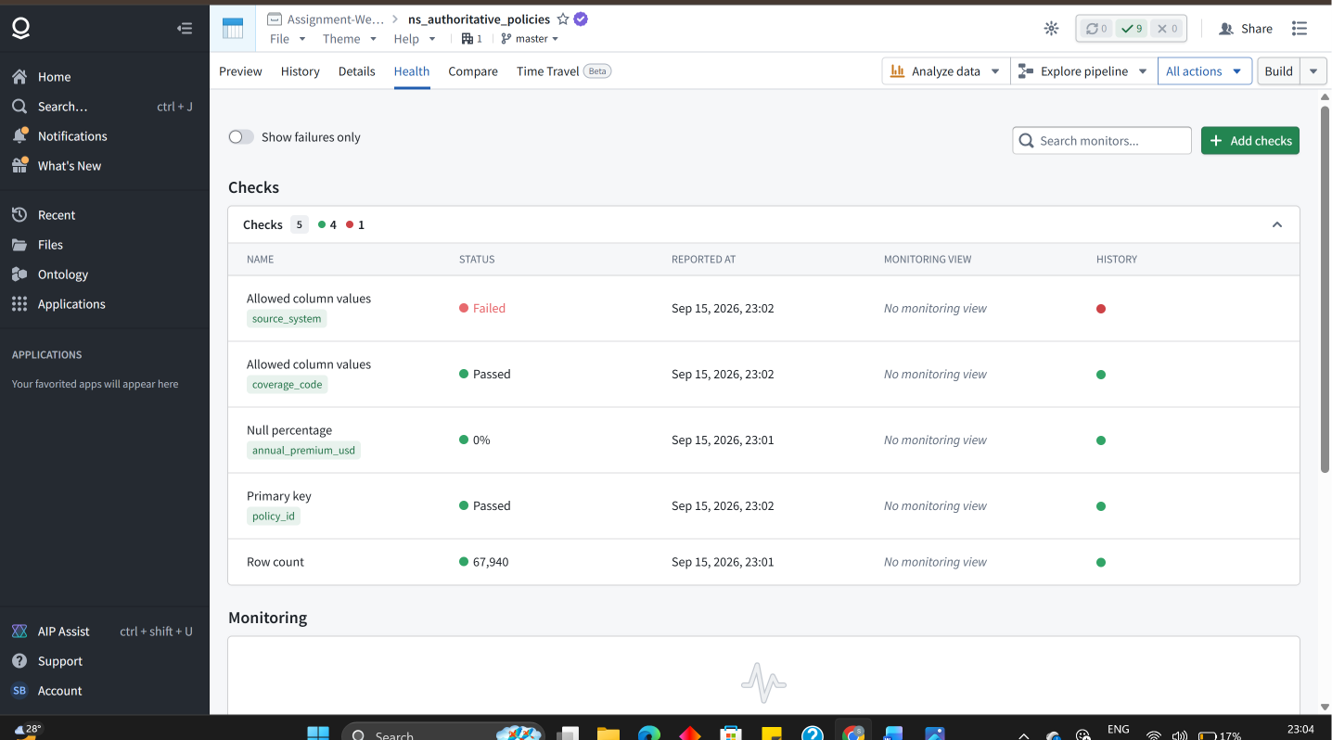
Screenshots Data Lineage
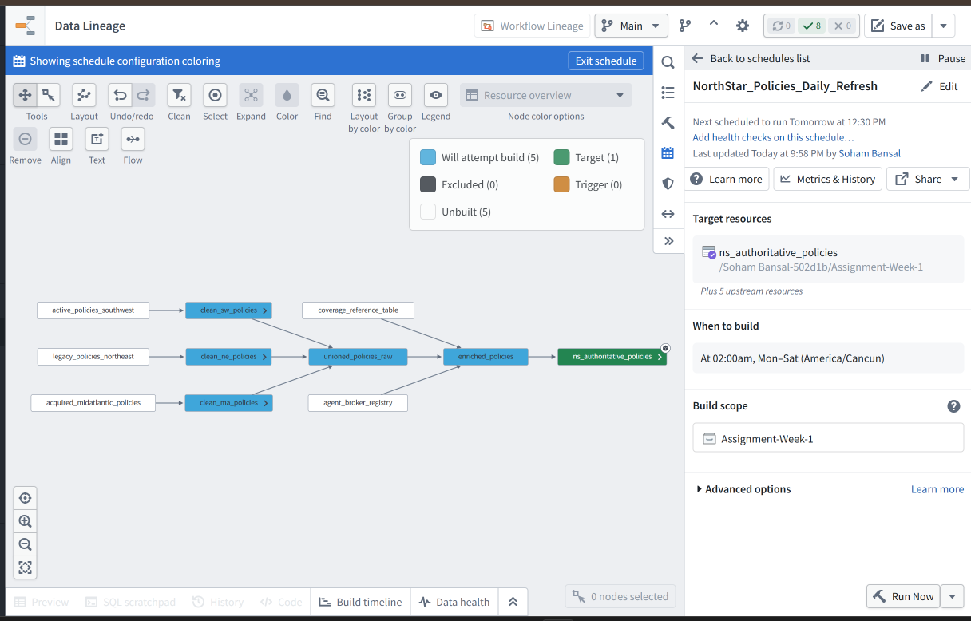
DATASET-NorthEast Policies (Profilling)
Total Row count is 47,800
pol_id
NULL 200
distinct 47600
All uppercase
- How I Found Duplicates
Aggregate over using policy id and applied row count over it and then applied filter where count is >1
And now doing this get policies which are duplicates as aggregate make group of policies
Result—no as such duplicated there is only null values

insured name
NULL 0
All uppercase 47800
All distinct

policy type code
4 Distinct Classes
HO 23892
AUTO 16715
COMMER 5738
LIFE 1455
No NULL

Effective dt
Format issues-- two types yyyy-mm-dd dd/mm/yyyy
No NULL

Annual premium usd
Values in negative as well
Min -497
Negative values 120
NULL 150

Agent id
No NULL
All uppercase
Distinct 200
State-code
Uppercase all
distinct 13
4 classes are having same both letter are same (so their wrong) XX 00 ZZ QQ
Status
No NULL
Distinct 5 classes
ACTIVE INACTIVE PEND CANCELLED EXPIRED

DATASET-SouthWest Policies (Profilling)
Totol row count-31000
PolicyNumber
No NULL
Distinct 31000
No duplicates

Customer Full Name
No NULL
Distinct 3700 (means there are customer having multiples policies )

LineOfBusiness
No NULL
Distinct 5
Classes Found
Auto
Homeowners
Home Owner
Commercial Lines
Commercial

StartDate
No NULL
Format- Same yyyy-mm-dd

EndDate
NULL 90
Format- yyyy-mm-dd

GorssPremium
NO NULL
Format-- $9,540.98

ProducerCode
No NULL
Distinct 200
All uppercase

RiskState
No NULL
Distinct 7

Policy Status
No NULL
Distinct 4
Active Inactive Pending Non-Renewed

DATASET-MidAtlantic Policies (Profilling)
Total row count 19500
Policy_ref
No NULL
ALL uppercase
Distinct 19200 (means 300 are duplicates record)

Named_insured
No NULL
Distinct-1400 (customer have multiples insurances)

Product_category
No NULL
Distinct 5
Residential
Vehicle
Business
Marine
Freight

Inception_date
No NULL
Format two (yyyy-mm-dd/ unix timestamp (total seconds till now)

Termination_date
No NULL
Format two (yyyy-mm-dd/ unix timestamp (total seconds till now) y

Total_premium
All positive
No NULL
No negative

Writing_agent
NULL 508 (they are direct )
Distinct 200

Risk_location_state
No NULL
Distinct 6

Policy_status
NO NULL
Distinct 4
Active
Inactive
Cancelled
lapsed

PENDING TASK’s
Two Health Checks to Implement
Date Integrity Check
Compliance Risk Flag
How to enable email notifications when schedule failed

