**Project Proposal - MeltMonitor**

Team 6

Chance Kissel, Lwin Moe

Paul Lewis Marcos, Soham Bhowmick

Prof. Dominic Abucejo

FA25: CS-160 Sec 03 - Software Engr

Department of Computer Science, San Jose State University

Sep 22, 2025

**Project Proposal**

# **Description**

We are here to propose a web application dashboard that will visualize the direct relationships between global temperature fluctuations, CO2 levels, and glacier mass. Our project aims to provide an educational visualization of what these metrics mean in regards to one another and increase awareness of climate change’s effects to Earth’s glacial environments.

# **Objectives**

Our main objective is to create an impact in the educational sphere by having an accessible platform that will help users understand the importance of climate change through the visualization of data. Addressing the user needs through our survey, we will develop an intuitive interface that will boost user engagement, exploration, and understanding of climate change data relationships. We want to push for climate change awareness by making the complex climate data more understandable and readable through creating a web application with modern technology and frameworks.

# **Comparisons**

From our research, we have found these reliable resources.

1. <https://www.noaa.gov/climate> (National Oceanic and Atmospheric Administration)
2. <https://www.un.org/en/climatechange> (United Natinos Climate Change (UNFCCC))

Through comparisons, NOAA has provide data, tools and information to help individuals understand the importance of climate change. However, NOAA have limited data visualization. In conjunction, the UNFCCC also lacks data visualization. Instead UNFCCC pushes climate change awareness through their name tabs. Their navigation tabs include science , solution, get involve, events, and resources.

# **Feature List**

The features we are seeking to implement and integrate into this project are as follows:

1. A main dashboard that displays a visualization of the relation between CO2, Temperature, and the Earth’s Glacier mass/loss.
   1. We chose this to be our main feature because we felt it best represented the information we want to convey to the viewer.
   2. It was also ranked 8 and higher by 75% of our survey participants from a scale of 1-10 (least to most important).
2. A menu bar allowing easy transition between views.
   1. This feature was ranked 8 and higher by 72.2% of survey participants from a scale of 1-10 (least to most important).
3. Real-time data updates.
   1. We want to implement this in order to provide a consistent and up to date model of information.
   2. This was ranked 8 and higher by 75% of our survey participants from a scale of 1-10 (least to most important).
4. Slider to display past statistics and future prediction paths.
   1. Ranked 8 or higher by 72.3% of survey participants from a scale of 1-10 (least to most important).
5. Unit conversion toggle between Celsius and Fahrenheit units.
   1. We want to implement this for better clarity and application to those who use either unit of measurement.
6. Color coded mapping to display locations and how much they are affected.
   1. This was ranked 8 and higher by 82.9% of survey participants from a scale of 1-10 (least to most important).
7. Integration of access links to data sources underneath information displays.
   1. This is sought to be implemented in order to give credit to our sources and validate our data.

The features we will **not** plan to include but would be nice to have are as follows:

1. Implementation of data and model updates ONLY at the end of each day for more apparent fluctuations in statistics.
   1. This did not make it on to our list as it would need robust API management.
2. Creation of a snapshot feature allowing users to save the current chart/mapping and share it with others?
   1. This feature did not make it because of the lack of feedback from the survey. The other features were liked better than having a snapshot feature.
3. Creation of breakdown of the leading causes for CO2 and temperature level increases by hovering over the respective data point?
   1. This feature did not make it as it would be too difficult to add in a single sprint. The complex data modeling would potentially require ML algorithms to be incorporated into.
4. Implementation of button leading to separate page that includes ways to help prevent and mitigate further CO2 and temperature increases and related organizations?
   1. This feature did not make it as feedback from other features were received better.
5. "About Us" page explaining the background and uses for the web application?
   1. We deferred from this as feedback from other features were received better. Using user feedback we decided to prioritized functionality that the users were interested in.

**Survey Outcome Statistics**

# **Participants**

A total of 36 participants were recorded for the survey.

# **Question Results**

1. Creation of a main dashboard showing the relation between CO2/Temperature levels to Glacier health/mass?

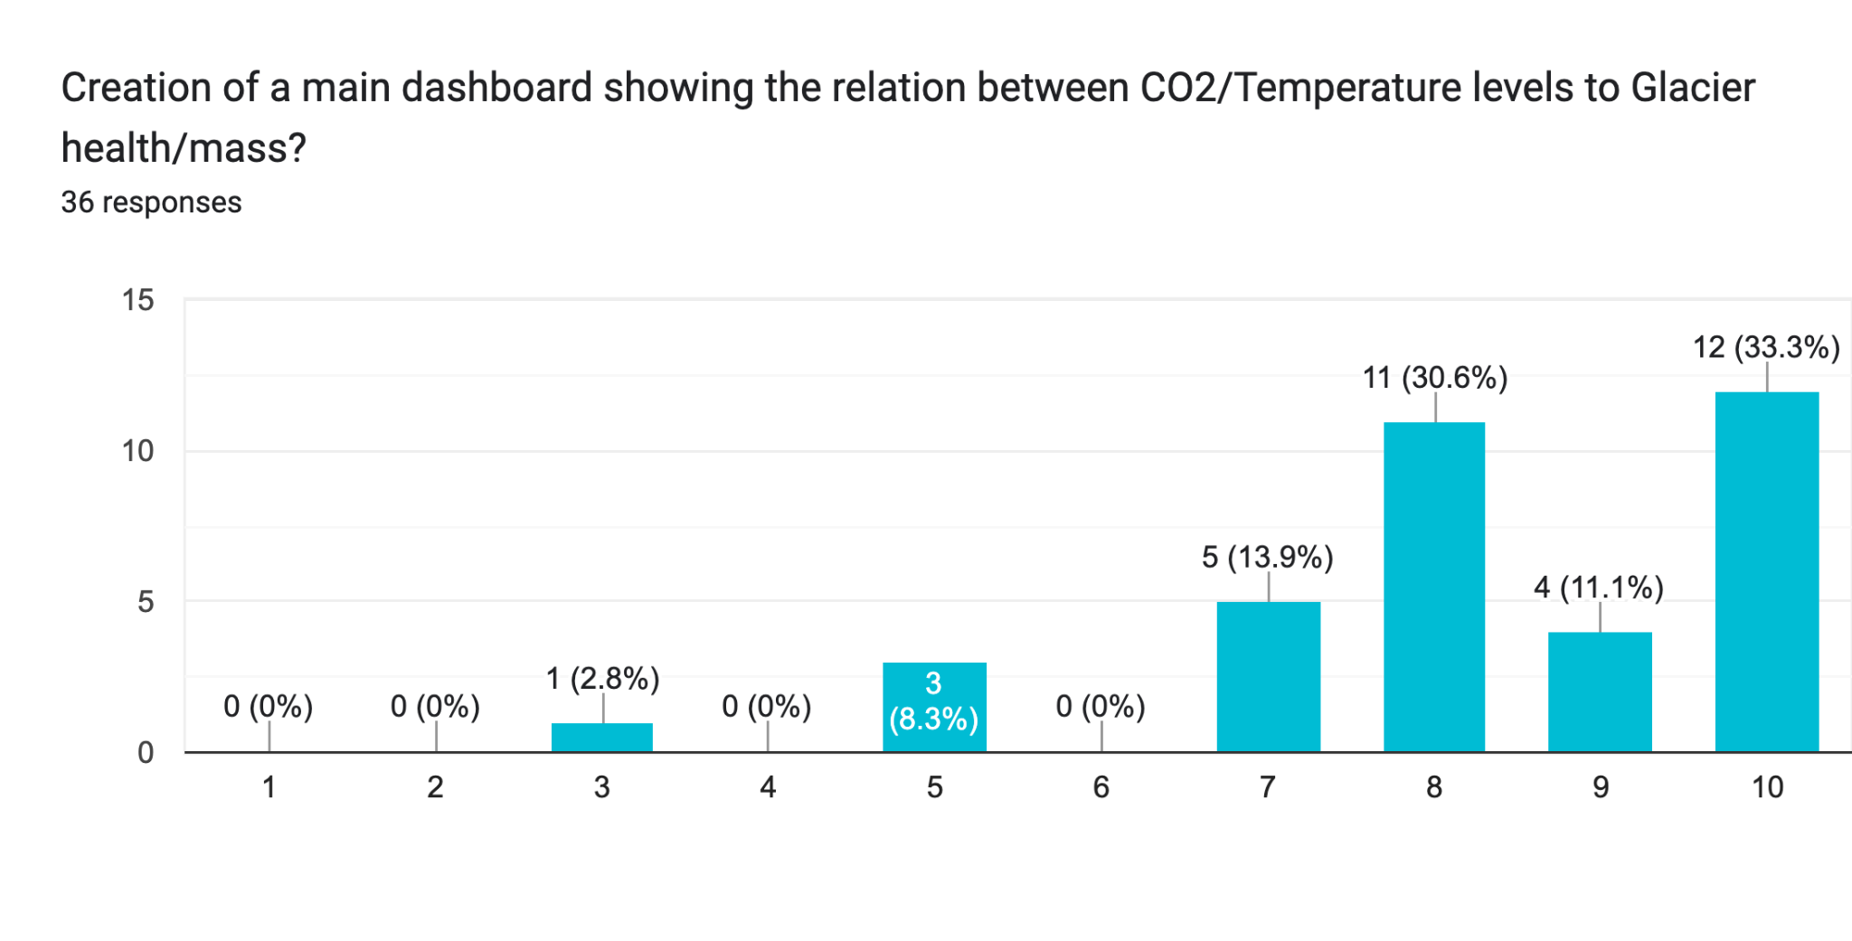

1. Creation of a menu bar to allow for easy transition between different maps and views?

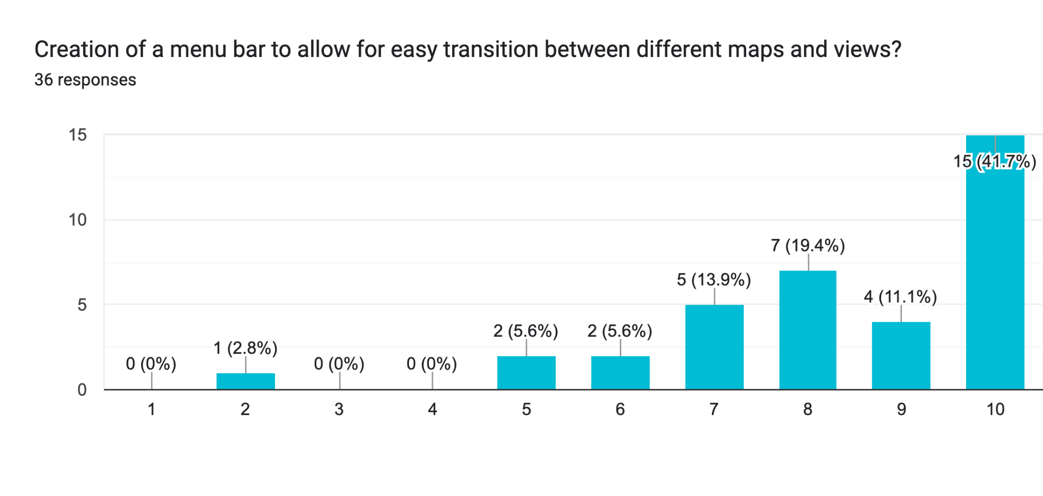

1. Implementation of real time data and model updates to constantly provide accurate and trustworthy statistics?

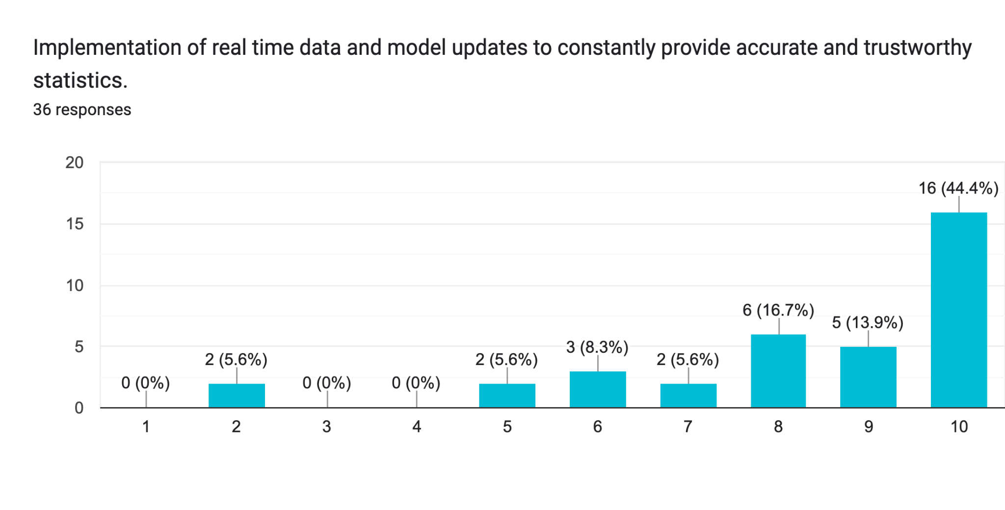

1. Implementation of data and model updates ONLY at the end of each day for more apparent fluctuations in statistics?

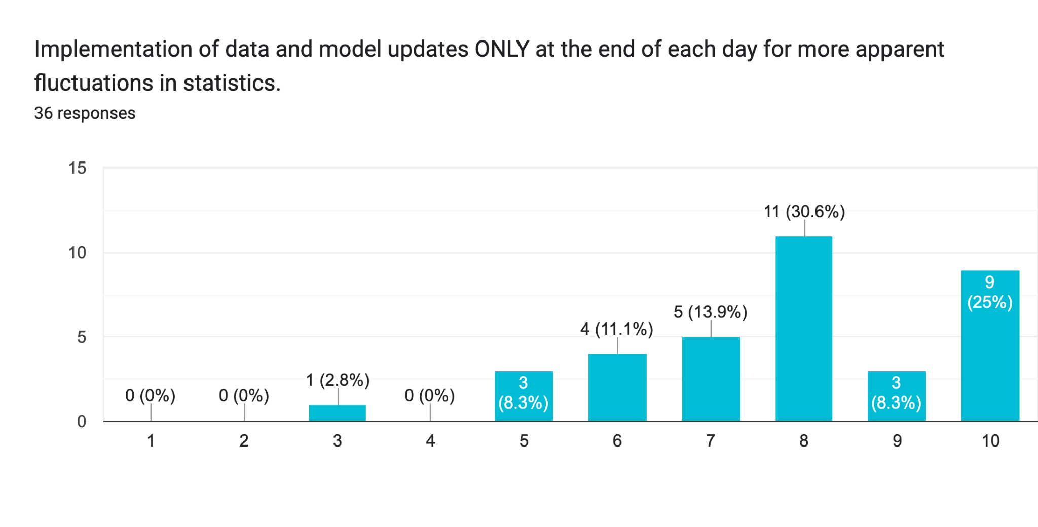

1. Implementation of a slider allowing for visualization of past numbers and future predictions?

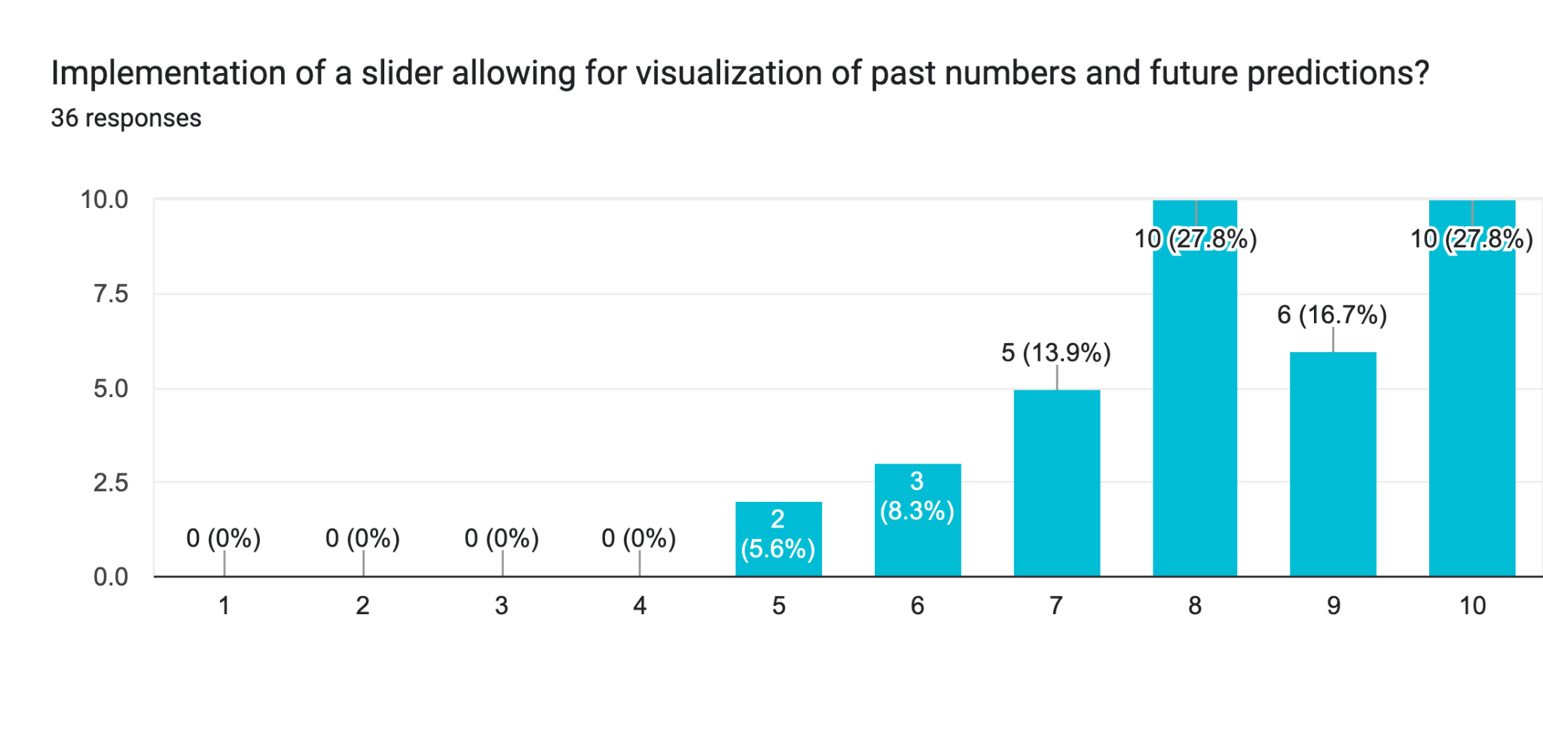

1. Creation of a simulation feature allowing users to test different outcomes based on adjustable CO2 and temp levels?

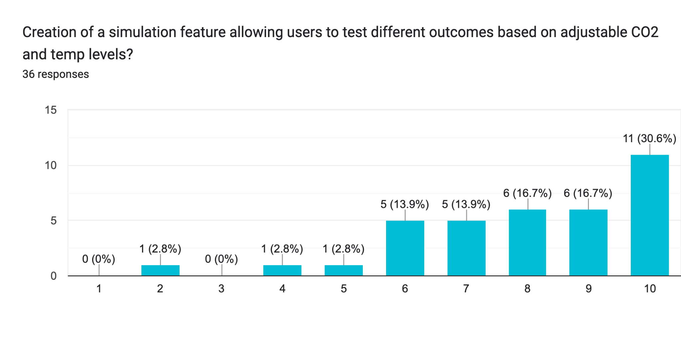

1. Implementation of a unit conversion toggle to switch between Celsius and Fahrenheit units?

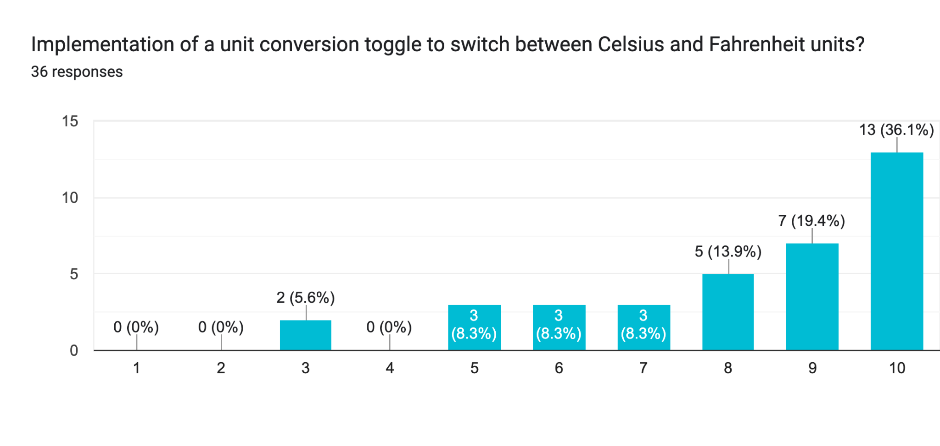

1. Creation of a snapshot feature allowing users to save the current chart/mapping and share it with others?

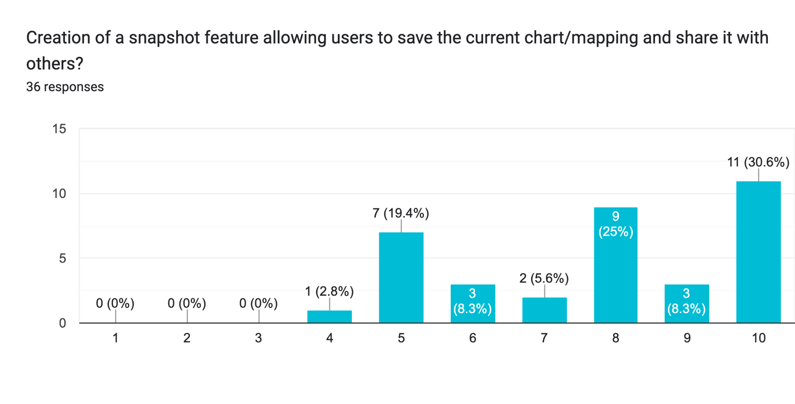

1. Creation of color coded mapping to display locations and how much they are affected?

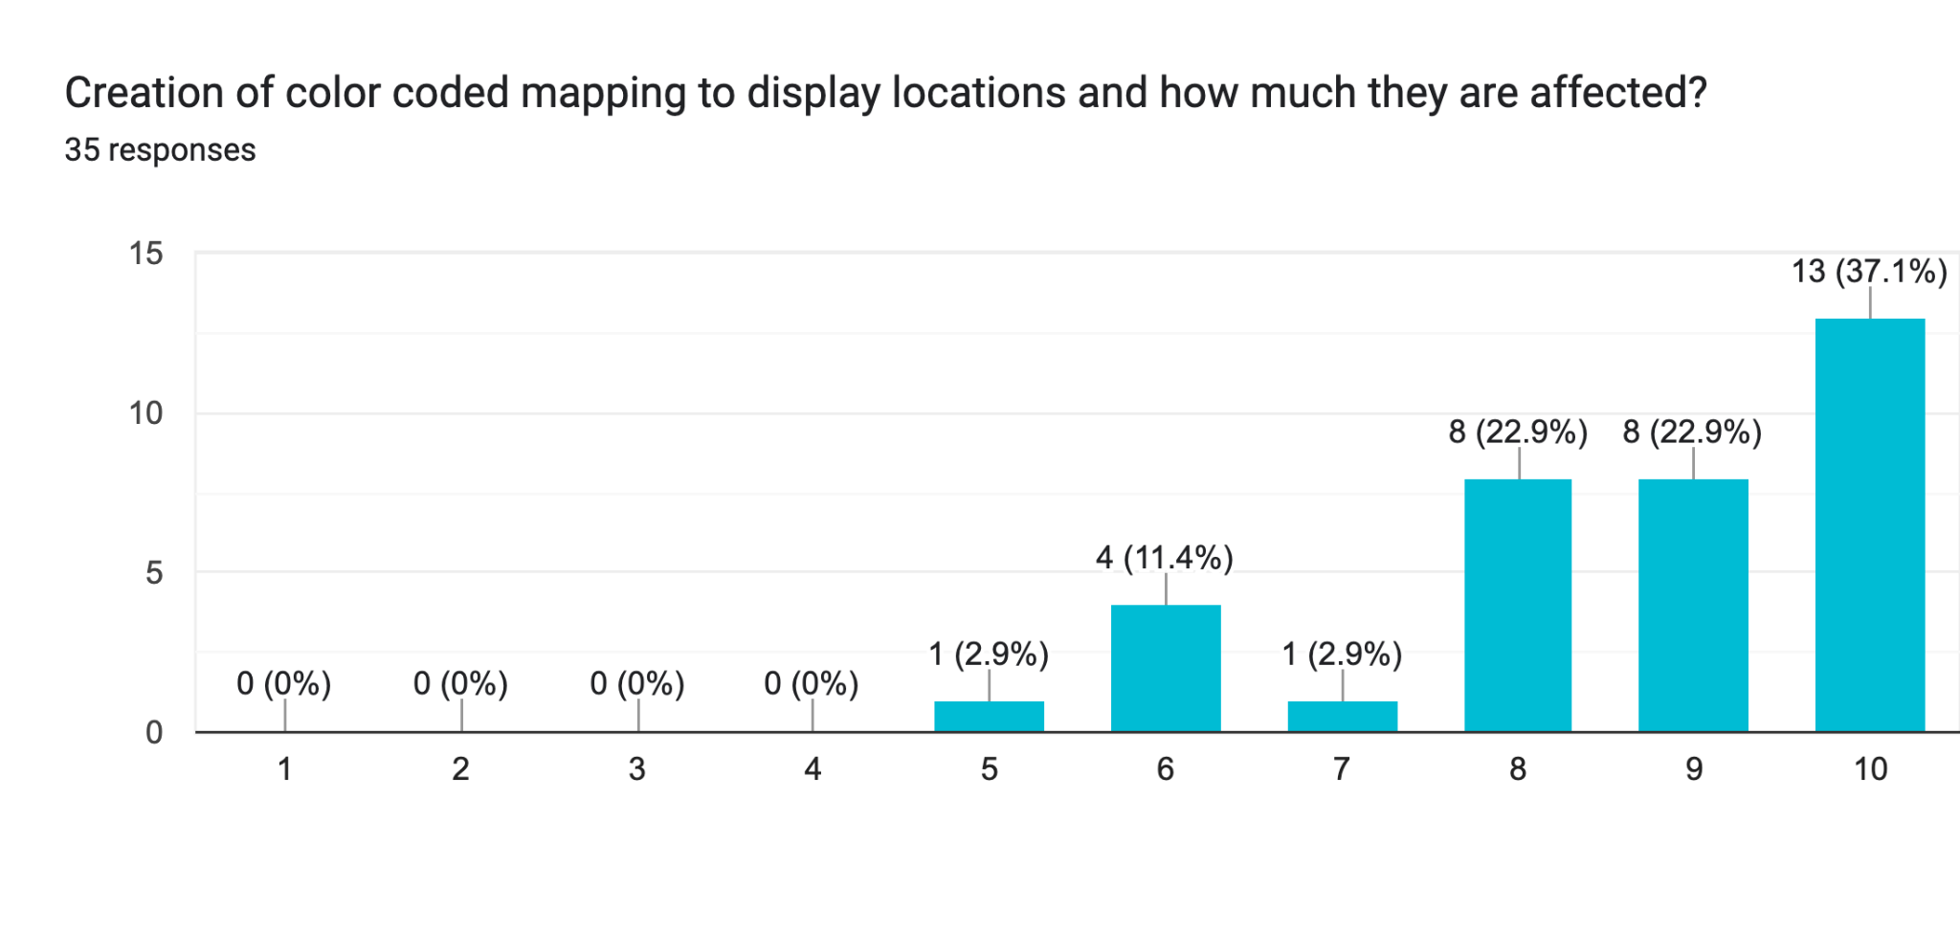

1. Integrated access links to data sources underneath displays of information?

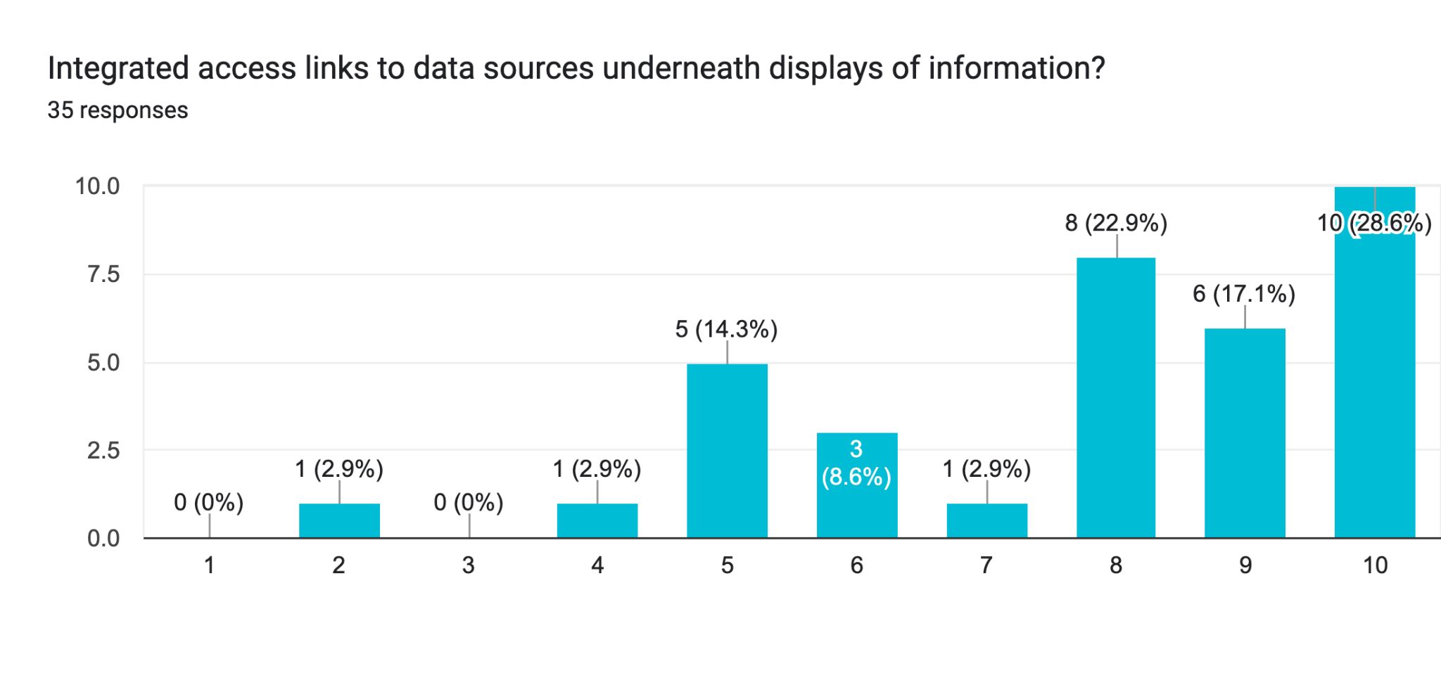

1. Creation of breakdown of the leading causes for CO2 and temperature level increases by hovering over the respective data point?

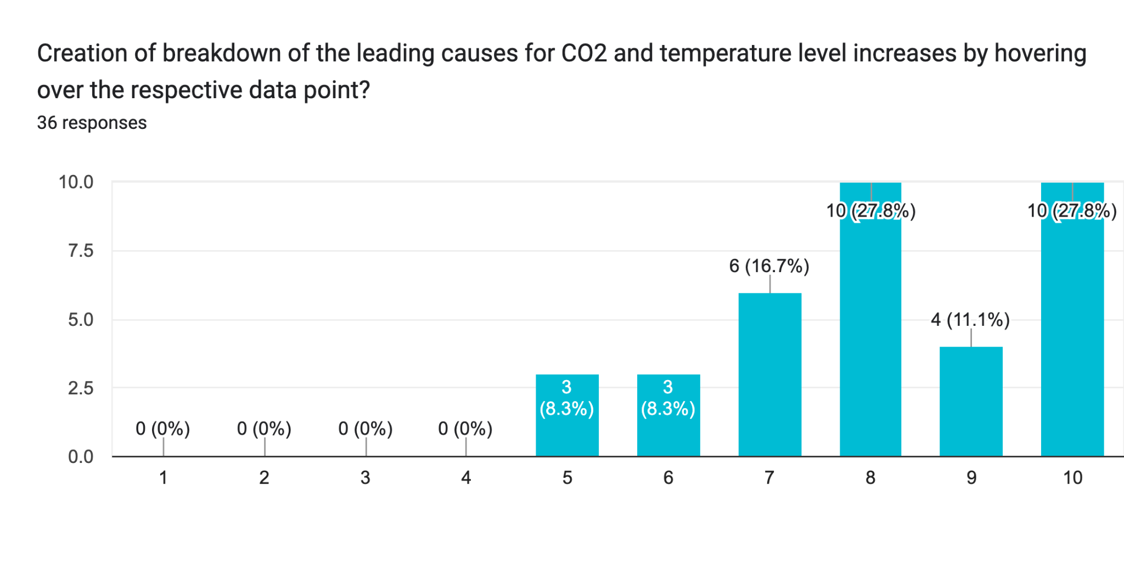

1. Implementation of button leading to separate page that includes ways to help prevent and mitigate further CO2 and temperature increases and related organizations?

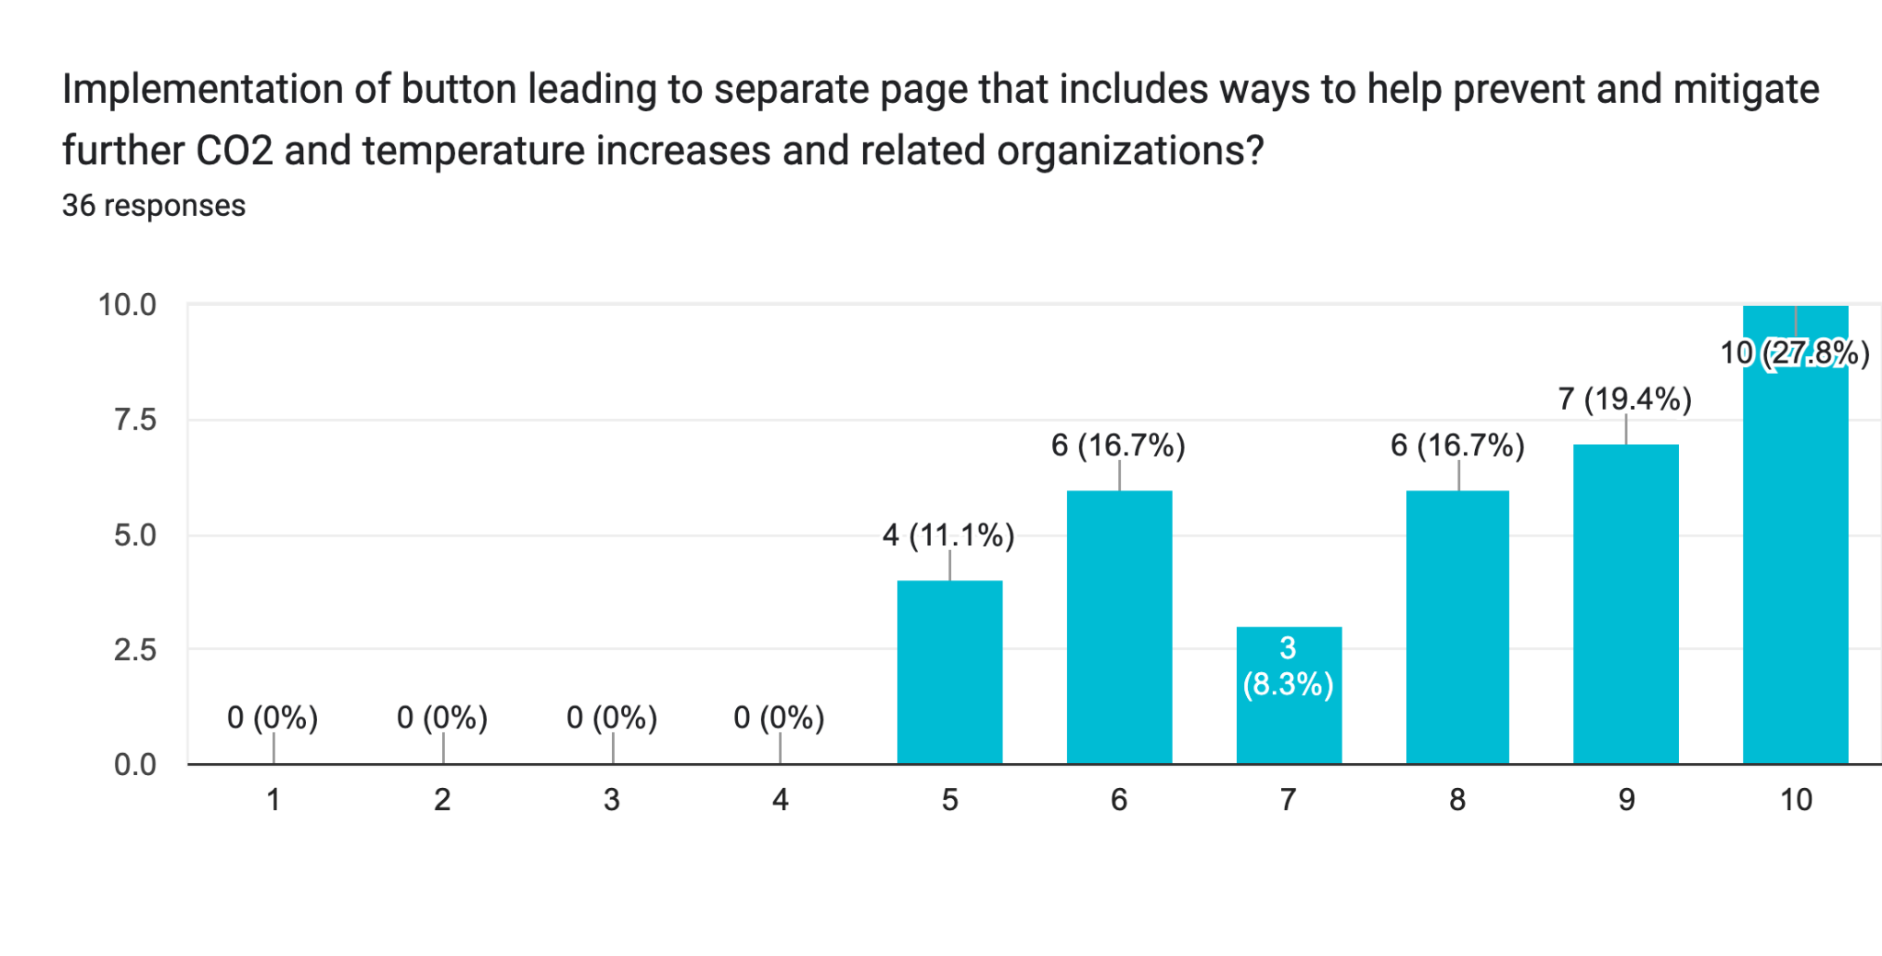

1. "About Us" page explaining the background and uses for the web application?

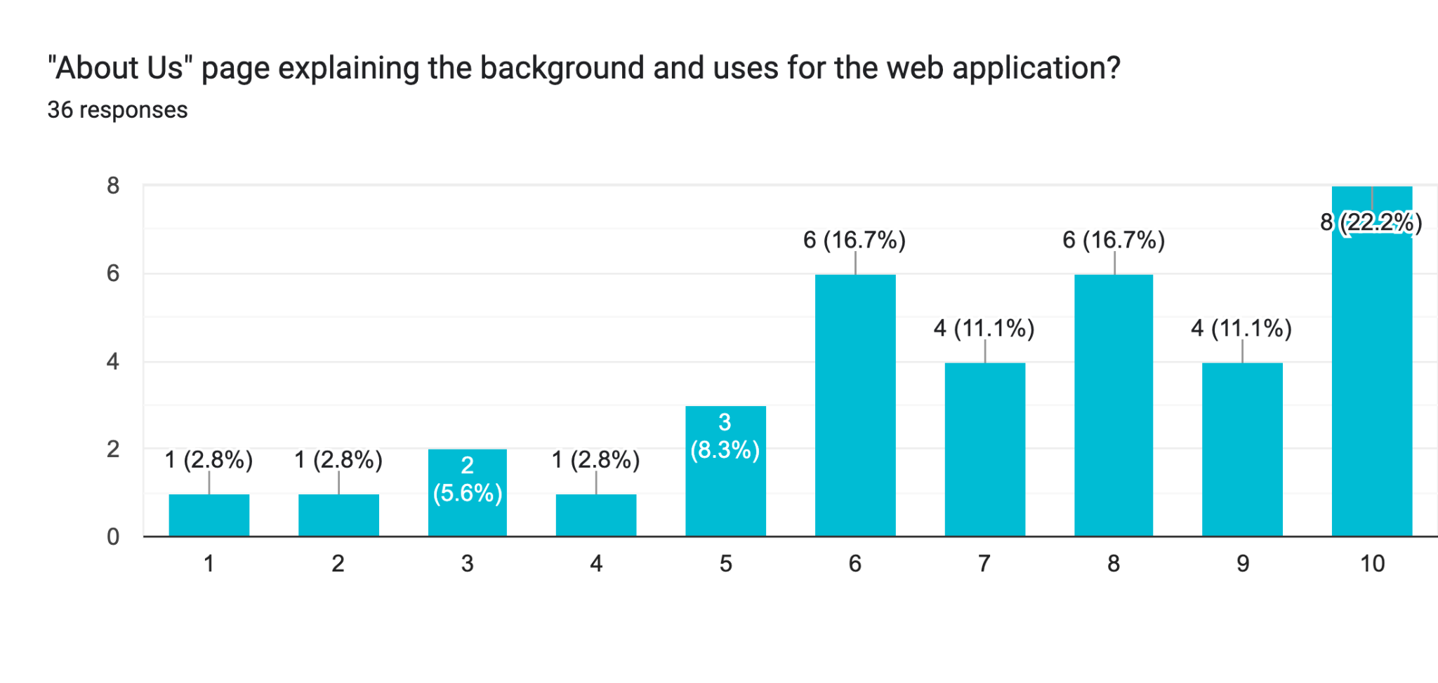

1. Any other suggestions for features that you feel should be implemented?

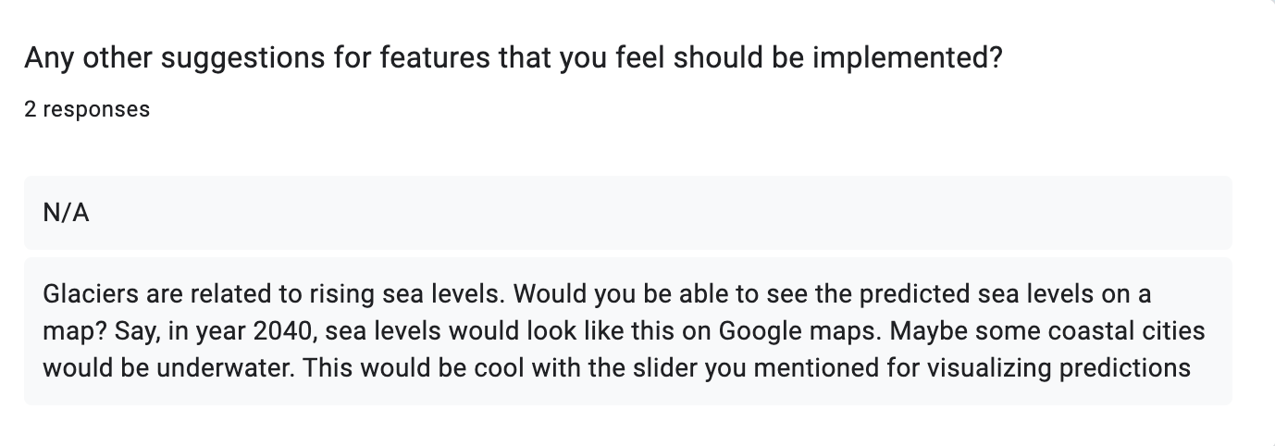

**Contributions**

1. **Chance Kissel**

* Description
* Included Feature List
* Survey Statistics

1. **Lwin Moe**

* Product Backlog
* Final edit

1. **Paul Lewis Marcos**

* Objective
* Comparison
* Non-Included Feature List

1. **Soham Bhowmick**

* Product Backlog