“Post-COVID Demand Forecasting and Production Optimization in the Indian Automobile Sector: A Case Study of Indian Automobile Companies Using Machine Learning and Game Theory”



BSE INSTITUTE LTD
Dalal Street, Mumbai

(Affiliated to GARWARE INSTITUTE OF CAREER & DEVELOPMENT, MUMBAI UNIVERSITY)
IN THE PARTIAL FULFILMENT OF

BACHELOR OF DATA SCIENCE
BY

SOHAM CHOGALE ( BSCDS2332 )

TYBSCDS
PROJECT GUIDE
PROFESSOR PIYSH DAVE
BOMBAY STOCK EXCHANGE INSTITUTE LIMITED

18th & 19th Floor, P.J. Towers Dalal Street Mumbai-400001
Academic Session 2023-2026

1 | P a g e

“Post-COVID Demand Forecasting and Production Optimization in the Indian Automobile Sector: A Case Study of Indian Automobile Companies Using Machine Learning and Game Theory”



BSE INSTITUTE LTD
Dalal Street, Mumbai

(Affiliated to GARWARE INSTITUTE OF CAREER & DEVELOPMENT, MUMBAI UNIVERSITY)
IN THE PARTIAL FULFILMENT OF

BACHELOR OF DATA SCIENCE
BY

SOHAM CHOGALE ( BSCDS2332 )

TYBSCDS
PROJECT GUIDE
PROFESSOR PIYSH DAVE

BOMBAY STOCK EXCHANGE INSTITUTE LIMITED

18th & 19th Floor, P.J. Towers Dalal Street Mumbai-400001
Academic Session 2023-2026
2 | P a g e

ABSTRACT

This project addresses the challenges faced by the Indian automobile industry in the post-COVID era, specifically the mismatch between demand forecasting and production planning. The study aims to accurately forecast demand and optimize production for automobile companies by applying a combination of machine learning (ML) and game theory.

The methodology involved several steps, starting with the collection and cleaning of sales, production, and macroeconomic data from 2020 to 2025. Exploratory data analysis (EDA) was performed to visualize demand fluctuations and seasonal patterns. Multiple ML models, including Linear Regression, Random Forest, and Gradient Boosting, were trained and evaluated using metrics like MAE and RMSE to predict future demand. The best-performing models were then used for forecasting. Game theory was also applied to model competitive strategies between companies, such as Mahindra and Honda, in a duopoly setting.

The findings highlight how ML forecasting, combined with game theory, can provide data-driven recommendations to minimize overproduction, reduce discounts, and sustain long-term profitability. The analysis demonstrates a strong case for using these advanced techniques to solve real-world challenges in the industry

KEY WORDS

- Linear Regression
- Decision Tree
- Random Forest
- Game Theory

ACKNOWLEDGEMENT

I would like to take this opportunity to convey my sincere gratitude and appreciation to my college- BSE Institute and my Professor Mr Piyush Dave, for his constant support and guidance which has enabled me to complete this research paper on the topic “POST-COVID DEMAND FORECASTINGAND PRODUCTION OPTIMIZATION IN THE AUTOMOBILE SECTOR: A CASE STUDY OF INDIAN AUTOMOBILE COMPANIES USING GAME THEORY”.

I would also like to extend my gratitude towards my family & friends for their constant support and encouragement which has been helpful in shaping the direction of this research without which this paper wouldn’t have seen the light of day.

Lastly, I would like to express my gratitude towards the respondents who were generous enough to spare their time and provide the insights needed for shaping this research.
Once again, I would like to express my heartfelt gratitude to everyone who has contributed to this research directly or indirectly.

Soham Chogale
BSCDS2332
Place: Mumbai

CERTIFICATE

This is to certify that Mr Soham Chogale tudent of Bombay Stock Exchange Intitute Ltd studying in TYBSCDS (Semester V), has successfully completed his project report “A Case Study of Indian Automobile Companies Using Machine Learning and Game Theory”. The information submitted is true and original to the best of the knowledge.

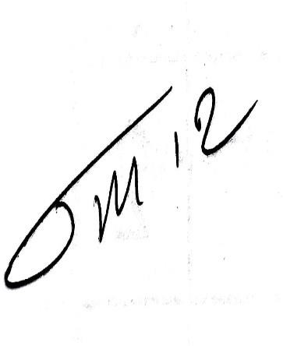
Soham Chogale

(Signature of Project guide) (Signature of Candidate)

DECLARATION

I, Mr. Soham Chogale the student of Bombay Stock Exchange Institute Ltd, studying in TYBSCDS (Semester V), “POST-COVID DEMAND FORECASTING AND PRODUCTION OPTIMIZATION IN THE INDIAN AUTOMOBILE SECTOR”
hereby declare that I have completed the project report on in the academic year 2025-2026.
The information submitted is genuine and practical to the best of my knowledge.
Date: September 2025
Place: Bombay Stock Exchange Institute, Mumbai

NAME:- Soham Chogale
(ROLL Number = BSCDS2332)

TABLE OF CONTENTS

SR.NO | PARTICULAR | Page No.
1. | CHAPTER 1: INTRODUCTION  1.1 Problem Statement  1.2 Objectives  1.3 Methodology | 1-42
2. | CHAPTER 2: DATA DESCRIPTION AND EXPLORATORY DATA ANALYSIS (EDA)  2.1 Data Collection and Cleaning  2.2 Data Description  2.3 Analysis of Model Distribution  2.4 Price Distribution by Brand  2.5 Sales vs. Production Trends  2.6 Correlation Analysis  2.7 3D Scatter Plots | 43-45
3. | CHAPTER 3: METHODOLOGY AND MODEL TRAINING  3.1 Approach  3.2 Training Machine Learning Models | 46-52
4. | CHAPTER 4: FORECASTING AND STRATEGIC INSIGHTS  4.1 Sales Forecasting  4.2 Capacity Planning  4.3 Game Theory Analysis | 53-69

5. | CHAPTER 5: CONCLUSION AND RECOMMENDATIONS  5.1 Conclusion  5.2 Recommendations | 70-75
6. | CHAPTER 6: BIBLIOGRAPHY | 76-83
7. | CHAPTER 7: ANNEXURE & PLAGIARISM REPORT | 84  85

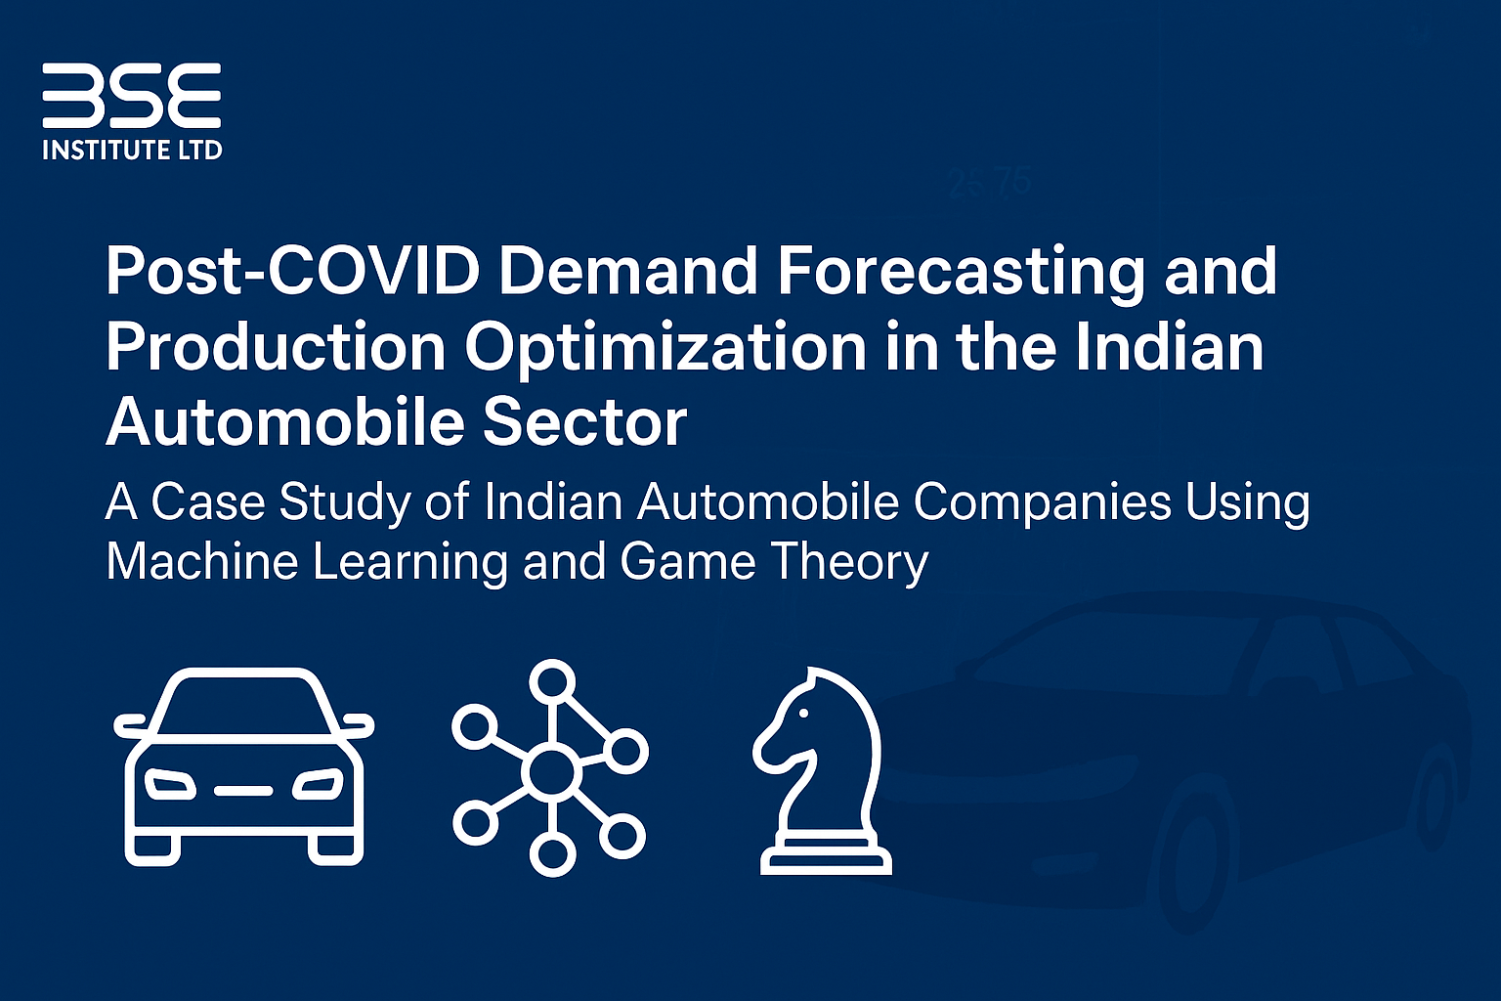

CHAPTER 1 – INTRODUCTION

Problem Statement

The Indian automobile market experienced an unusual demand spike following the COVID-19 pandemic, as consumers preferred personal vehicles over public transport. In response, Indian automakers aggressively scaled up production. However, after this initial surge, demand stabilized, leading to a pile-up of unsold inventory and forcing companies to offer significant discounts (₹10,000–₹50,000 per vehicle). This situation highlights a critical problem: a mismatch between demand forecasting and production planning due to the lack of accurate prediction and optimization tools, which resulted in substantial financial losses for the companies.

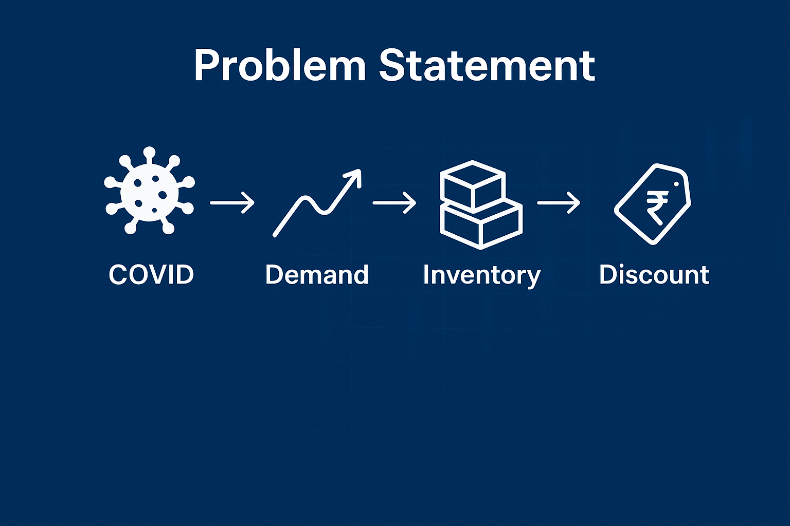

Objectives of the Project

The primary objectives of this dissertation were:

To accurately forecast demand in the post-COVID Indian automobile market.

To optimize production planning for automobile companies to effectively reduce excess stock.

To apply a combined approach of Machine Learning and Game Theory to balance the complex interplay between demand, production, and market competition.

To provide data-driven recommendations that lead to sustained profitability for the companies involved.

Methodology

The project's literature review draws from several key areas. The challenge of a "forecasting and production mismatch problem" is central to the work. The methodology involves several steps, including data collection, cleaning, and exploratory data analysis (EDA). The core of the project relies on machine learning models like Linear Regression, Random Forest, and XGBoost for demand prediction. Furthermore, the strategic aspect of competition is modelled using Game Theory, specifically looking at a duopoly between companies. The final goal is to provide strategic insights and recommendations to help companies minimize discounts and maximize profits.

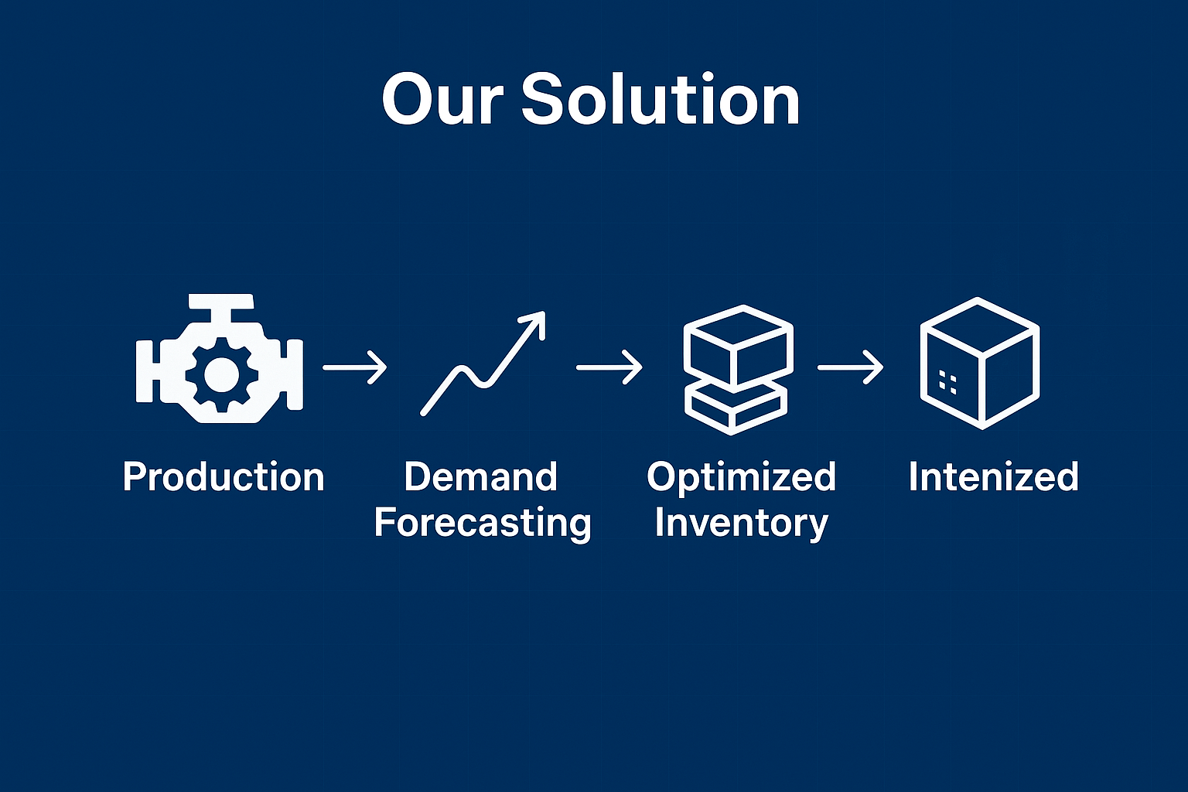

CHOPTER 2 - DATA DESCRIPTION AND EXPLORATORY DATA ANALYSIS (EDA)

The project utilized multiple datasets for different automobile brands, including

Mahindra, Honda, Hyundai, Kia, Maruti Suzuki, Skoda, Tata, and Volkswagen. Each dataset contains information on 17 columns and covers the period from 2019 to 2025. Key columns include:

VIN: Vehicle Identification Number

SaleDate: Date of sale

Brand: The car brand

Model: The car model

SalesUnits: Number of units sold

ProductionUnits: Number of units produced

Price: Price of the vehicle

Discount: Discount offered on the vehicle

Revenue: Total revenue generated

Profit: Total profit generated

Year: The year of the sale

2.1 Data Collection and Cleaning

Data for sales, production, and macroeconomic factors were collected from 2019 to 2025. The data was pre-processed by removing missing values, performing normalization, and using feature engineering to prepare it for modelling.

2.2 Data Description

The datasets for Mahindra, Honda, Hyundai, and Kia each contain 1775 entries, the Maruti dataset has 1535 entries, the Tata dataset has 759 entries, and the Volkswagen dataset has 775 entries.

Each dataset includes float64, int64, and object data types.

2.3 Analysis of Model Distribution

Count plots were used to visualize the distribution of models for each brand. The plots show that some models are significantly more represented in the data than others for each brand, indicating varying production and sales focus. For example, for Mahindra, the XUV 400 EV and Bolero are the most frequent models, while for Hyundai, the Grand i10 Nios and Venue are the most common.

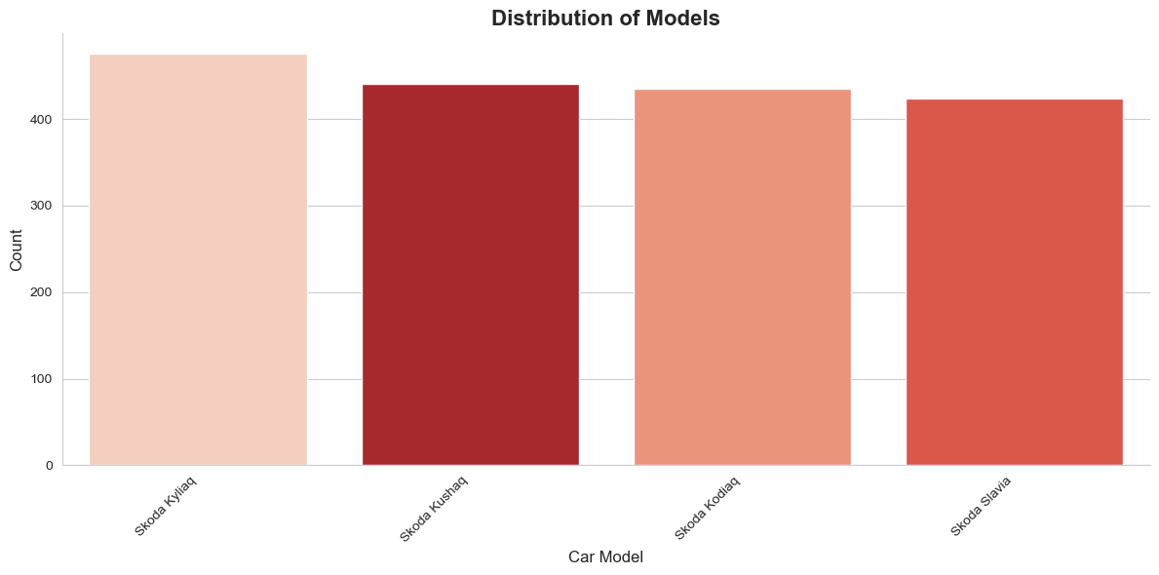

The bar chart represents the distribution of Skoda car models. The Kyliaq leads with the highest count, followed by the Kushaq and Kodiaq, both showing strong representation. The Slavia has a slightly lower count but remains close to the other models, reflecting an overall balanced distribution among Skoda’s lineup.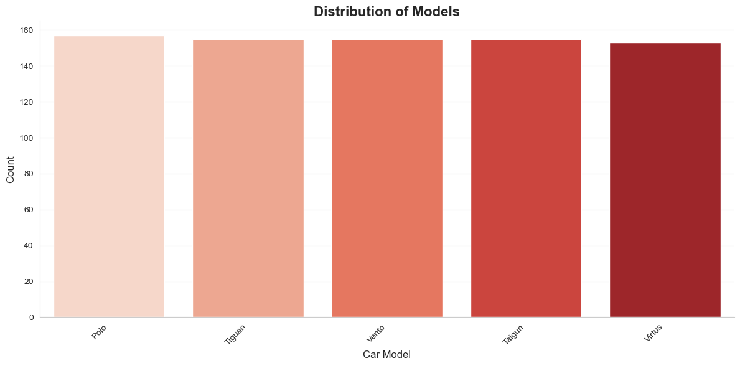

The bar chart illustrates the distribution of Volkswagen car models. The Polo, Tiguan, Vento, and Taigun show nearly equal counts, all clustered closely together. The Virtus has a slightly lower count but remains consistent with the overall pattern, indicating a balanced presence of Volkswagen models in the dataset without any single model dominating.

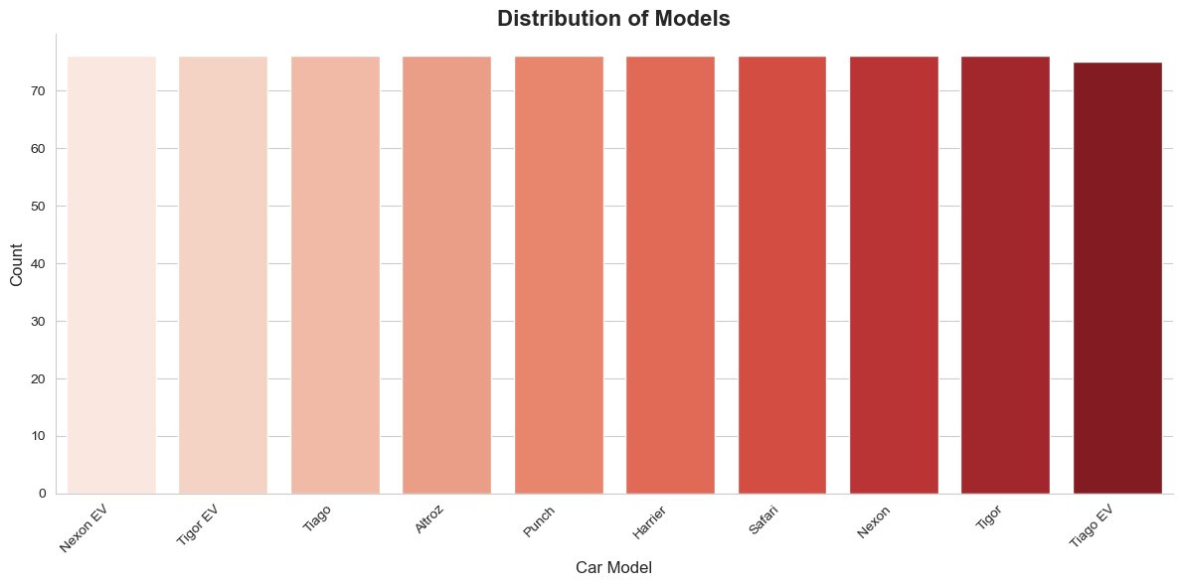

This bar chart shows the distribution of Tata car models, including Nexon EV, Tigor EV, Tiago, Altroz, Punch, Harrier, Safari, Nexon, and Tigor. The distribution is nearly uniform, with all models having counts around the same level (approximately 75). This suggests that Tata’s dataset representation is balanced across its lineup, without any single model dominating the count.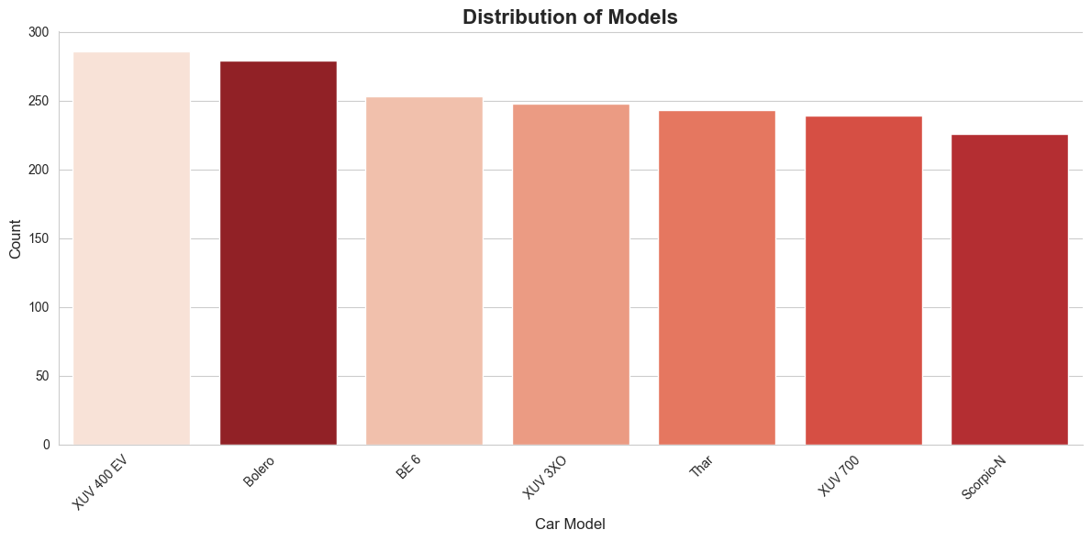

This bar chart shows the distribution of different car models by count. The XUV 400 EV has the highest count, closely followed by the Bolero. Other models like BE 6, XUV 3XO, Thar, XUV 700, and Scorpio-N have slightly lower but fairly similar counts, indicating a relatively balanced presence across these models.

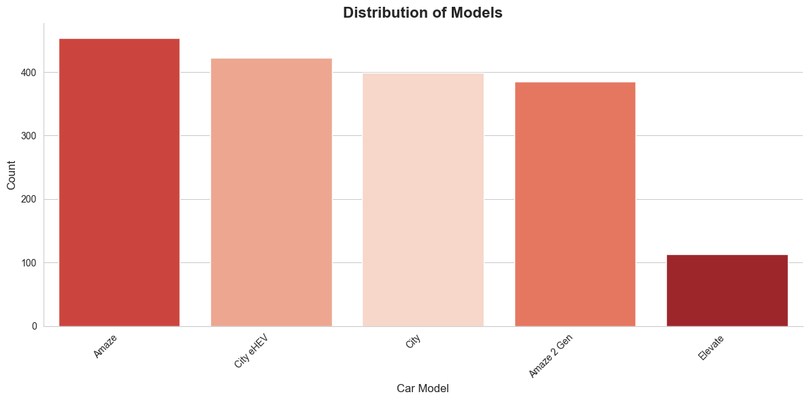

The bar chart highlights the distribution of different Honda car models. The Amaze has the highest count, followed by the City eHEV, City, and Amaze 2 Gen, which all show relatively similar values. The Elevate has a significantly lower count compared to the others, suggesting limited availability or popularity in comparison.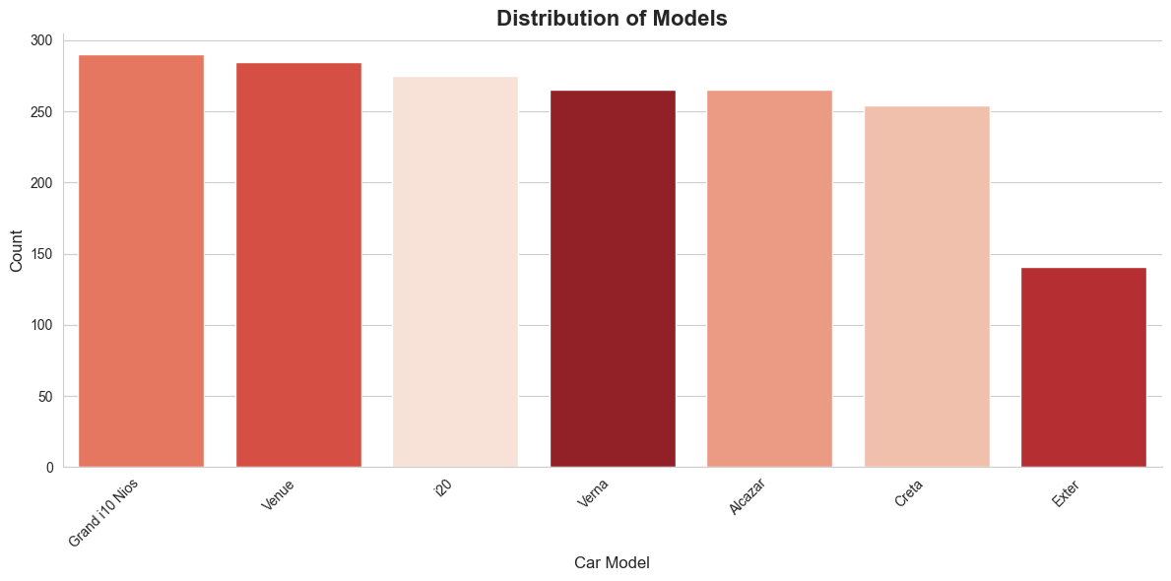

The bar chart compares the counts of different Hyundai models. The Grand i10 Nios and Venue show the highest counts, closely followed by the i20, Verna, and Alcazar. The Creta has a slightly lower count, while the Exter stands out with a much smaller value compared to the rest, indicating a relatively limited share.

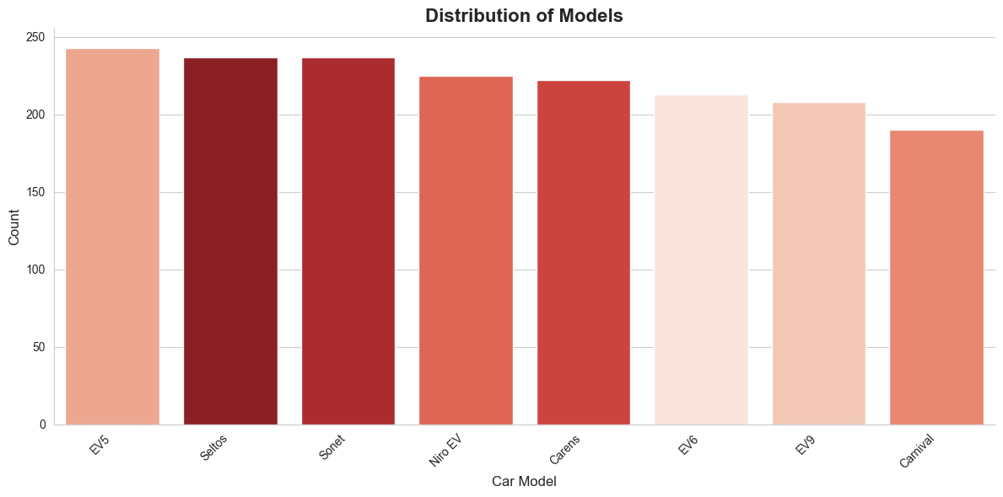The bar chart shows the distribution of Kia’s car models. The EV5 has the highest count, closely followed by the Seltos and Sonet. Models such as the Niro EV, Carens, EV6, and EV9 fall within a moderate range. The Carnival has the lowest count among the listed models, reflecting a smaller share compared to others in Kia’s lineup.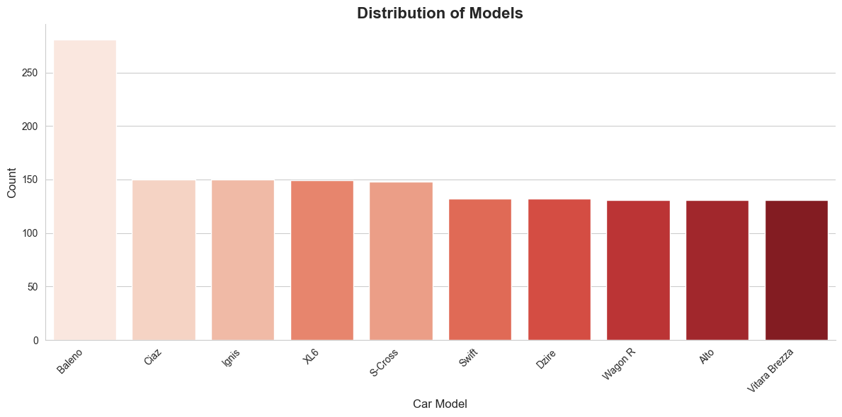 This bar chart displays the distribution of Maruti Suzuki car models. The Baleno stands out with a significantly higher count than all other models. Cars such as the Ciaz, Ignis, XL6, and S-Cross share similar mid-range counts, while the Swift, Dzire, Wagon R, Alto, and Vitara Brezza have slightly lower but comparable values, reflecting a more balanced presence among these popular models.

2.4 Price Distribution by Brand

Boxplots were used to visualize the price distribution for each brand. The plots show a wide range of prices across brands, with some like Mahindra and Hyundai having a larger interquartile range (IQR) compared to others like Volkswagen and Maruti Suzuki, which have a tighter price range.

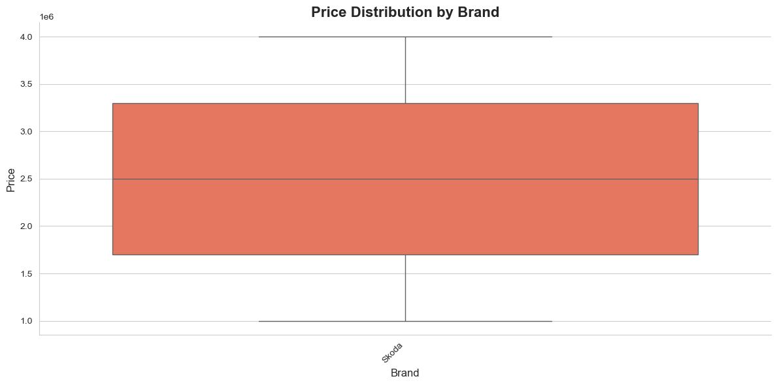

This box plot illustrates the price distribution of Skoda cars. The median price is around 2.5 million units, with the interquartile range (IQR) spanning from approximately 1.7 million to 3.3 million units. The lower whisker extends to nearly 1.0 million units, while the upper whisker reaches 4.0 million units, highlighting a wider price spread compared to many other brands. This suggests that Skoda offers models across a broad pricing spectrum, catering to both midrange and premium segments.

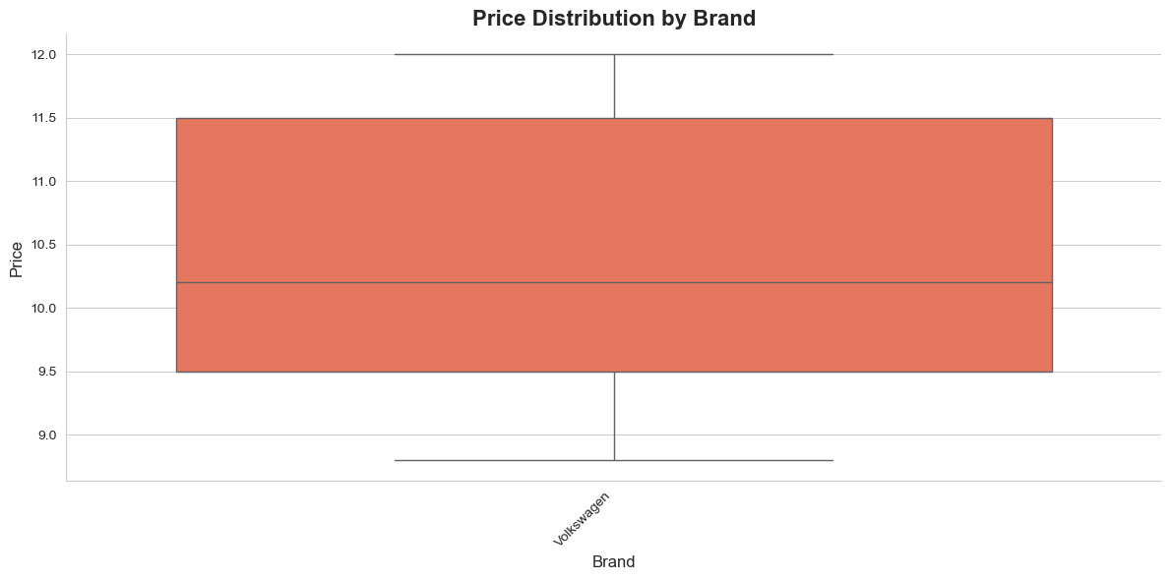

This box plot shows the price distribution of Volkswagen cars. The median price is around 10.2 units, with the interquartile range (IQR) spanning from roughly 9.5 to 11.5 units. The lower whisker extends to 8.8 units, while the upper whisker reaches 12.0 units, indicating a relatively tight clustering of prices. Compared to other brands, Volkswagen demonstrates a consistent and narrow price range, suggesting a focused mid-range pricing strategy without extreme variations.

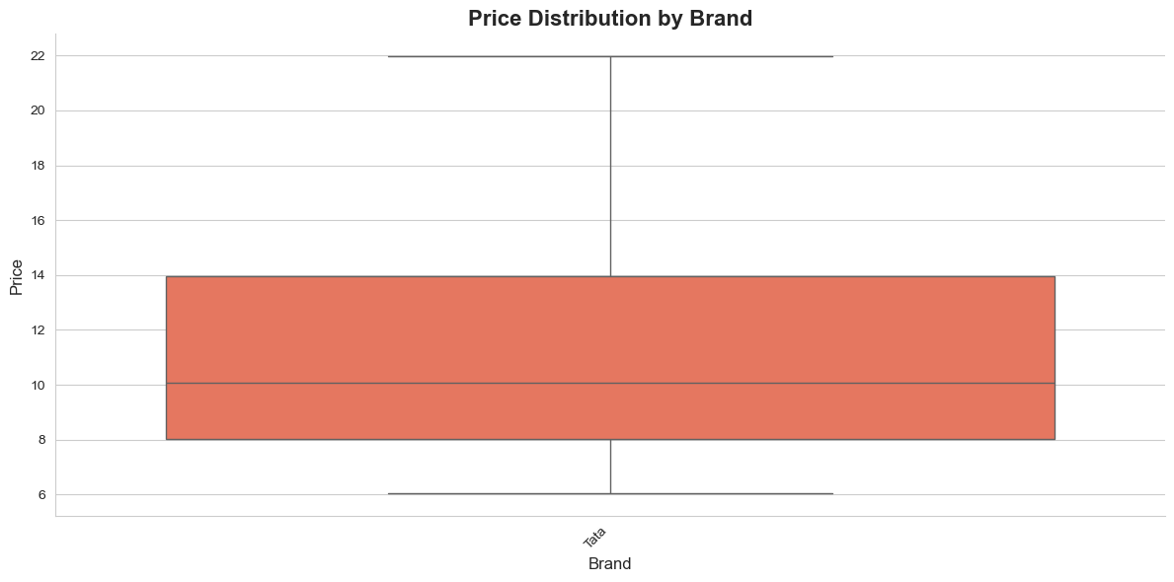

This box plot represents the price distribution of Tata cars. The median price is around 10 units, with the interquartile range (IQR) extending from 8 to 14 units. The lower whisker goes down to about 6 units, while the upper whisker extends up to 22 units, showing a relatively wide variation in pricing. This suggests Tata offers cars across a broad spectrum, from budget-friendly to higher-priced models, reflecting a diverse product lineup.

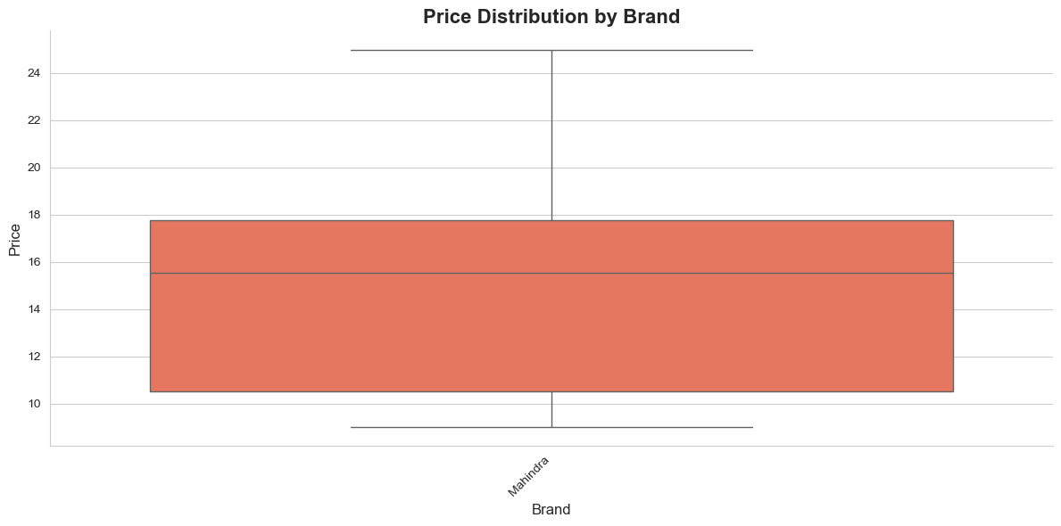

This box plot illustrates the distribution of car prices for the Mahindra brand. The median price is around 15.5, with most values falling between approximately 10 and 18. The lower and upper whiskers extend from about 9 to 25, indicating the overall price spread. The wide range shows that Mahindra offers models across both budget-friendly and higher-end price segments.

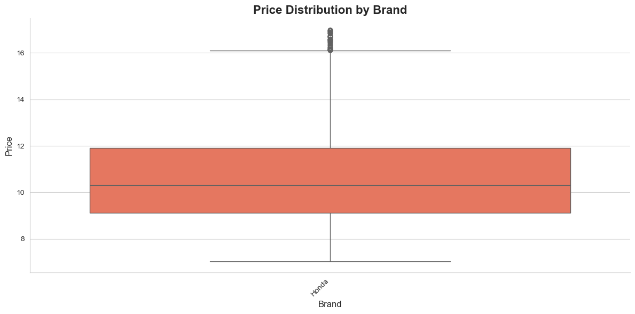

This box plot shows the distribution of car prices for the Honda brand. The median price is around 10.2, with most values ranging between approximately 9 and 12. The whiskers extend from about 7 to 16, and a few higher price values appear as outliers above 16. Overall, Honda’s pricing is concentrated in the mid-range segment, with some models extending toward higher-end pricing.

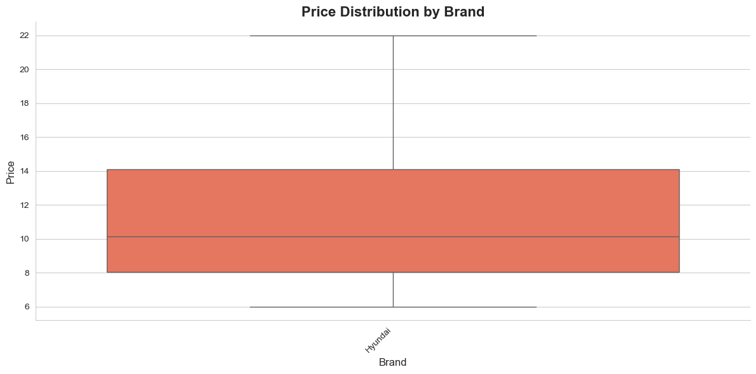

This box plot illustrates the price distribution of Hyundai cars. The median price is around 10, with the interquartile range (IQR) spanning from about 8 to 14. The lower whisker extends close to 6, while the upper whisker reaches up to 22, indicating a few higher-priced Hyundai models. This suggests that Hyundai offers cars across both budget and premium segments, with the majority clustered in the affordable-to-mid price range.

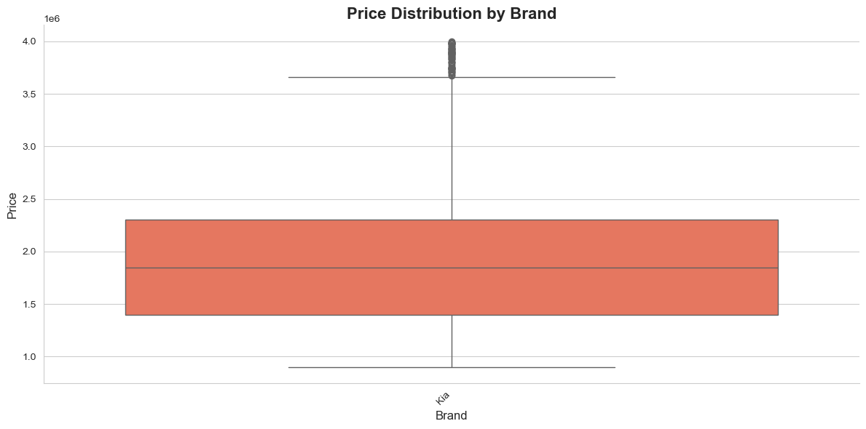

This box plot shows the price distribution of Kia cars. The median price is approximately 1.8 million, with the interquartile range (IQR) spanning from around 1.4 million to 2.3 million. The lower whisker extends close to 0.9 million, while the upper whisker reaches up to about 3.6 million. A number of outliers are present above the whisker, with prices approaching 4 million, indicating that certain Kia models are priced significantly higher than the general range.

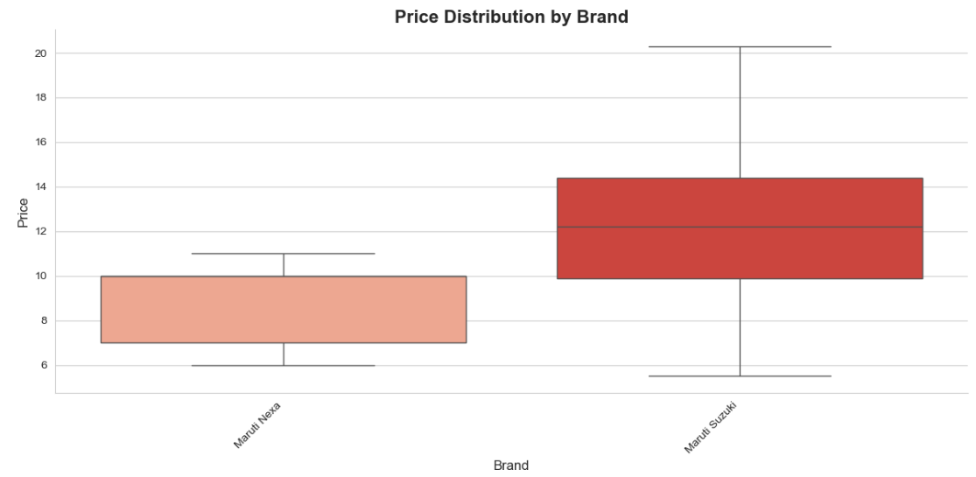

The boxplot compares the price ranges of Maruti Nexa and Maruti Suzuki models.

Maruti Nexa prices are more tightly clustered, ranging roughly between 6 to 11 lakhs, with a smaller interquartile range, indicating lower variability.

Maruti Suzuki prices show a wider spread, extending from around 5.5 lakhs up to 20 lakhs, with a higher median (~12 lakhs), suggesting a broader product range with more premium offerings.

This highlights that Nexa caters to a more consistent mid-price segment, while Maruti Suzuki spans both budget and higher-end categories.

2.5 Sales vs. Production Trends

Time series plots were created to compare yearly sales and production units for each brand from 2019 to 2025. These plots reveal clear trends, such as the initial spike in sales for some brands like Honda and Kia, followed by a decline. The plots highlight periods of overproduction (where the blue production line is above the red sales line) and underproduction (where the red sales line is above the blue production line), confirming the problem statement. For example, the graph for Kia shows a peak in sales in 2022, which then sharply declines.

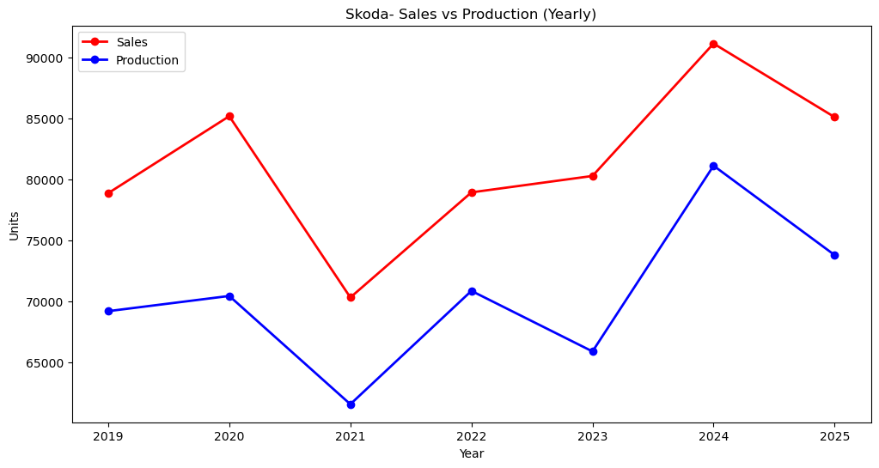

The line graph illustrates Skoda’s yearly sales and production from 2019 to 2025. Sales (red line) started at around 79,000 units in 2019, peaked at over 91,000 units in 2024, and then slightly declined to 85,000 units in 2025. Production (blue line) began at nearly 69,000 units, dipped in 2021, and later climbed to over 81,000 units in 2024 before falling back to 74,000 units in 2025. Overall, sales consistently outpaced production, reflecting stronger demand than supply capacity across most years.

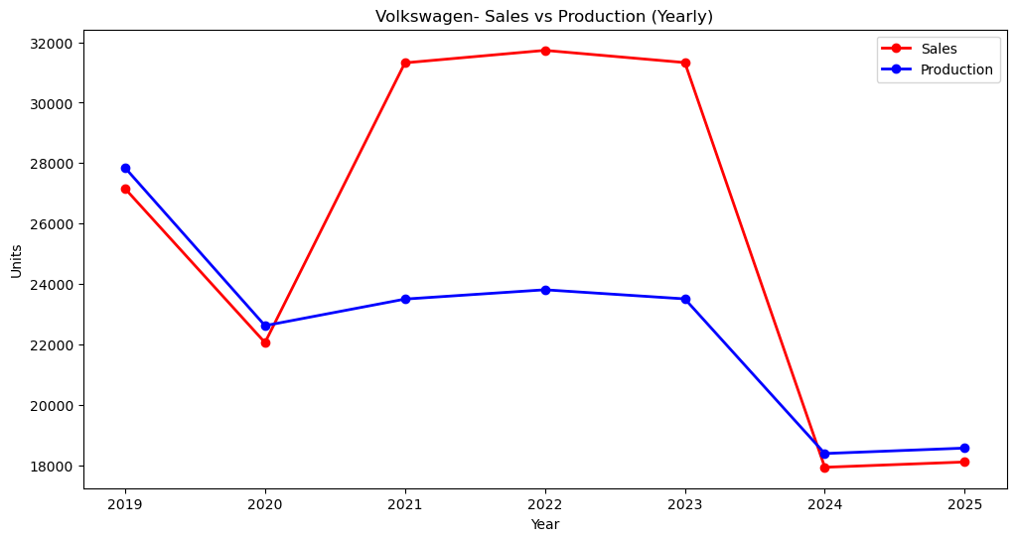

The line graph shows Volkswagen’s yearly sales and production trends from 2019 to 2025. Sales (red line) began at around 27,000 units in 2019, peaked above 31,000 units in 2021–2022, and then declined sharply to about 18,000 units in 2024–2025. Production (blue line) followed a steadier pattern, starting at 28,000 units in 2019, dipping slightly through 2020–2023, and later dropping to around 18,500 units in 2024–2025. Overall, Volkswagen experienced a brief sales boom in the early 2020s, but both sales and production contracted significantly in the later years.

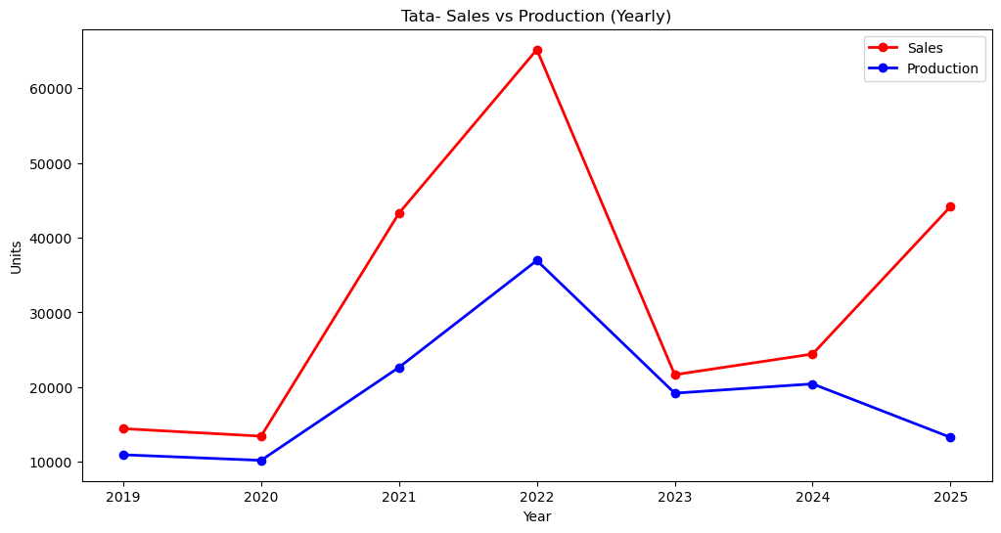

The line graph presents Tata’s yearly sales and production trends from 2019 to 2025. Sales (red line) stayed low in 2019–2020, then surged sharply, peaking at around 65,000 units in 2022. However, they dropped drastically in 2023 before recovering moderately in 2024–2025. Production (blue line) followed a similar but less extreme path, rising steadily until 2022, falling in 2023, and stabilizing around 20,000 units before dipping again in 2025. Overall, Tata experienced a dramatic sales spike in 2022, but both sales and production struggled to maintain consistency afterward.

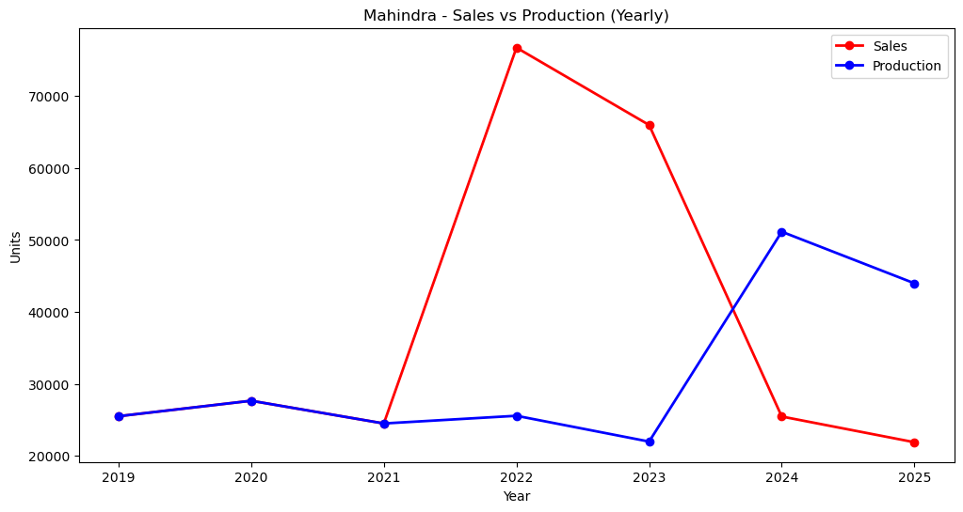

The line graph compares Mahindra’s yearly sales and production volumes from 2019 to 2025. Sales (red line) show a sharp spike in 2022, peaking at over 75,000 units, followed by a steady decline through 2025. In contrast, production (blue line) remained relatively stable and lower between 2019–2023 but surged significantly in 2024, reaching above 50,000 units, before dropping slightly in 2025. This indicates a mismatch between production and sales cycles, with Mahindra struggling to balance market demand and output efficiency during this period.

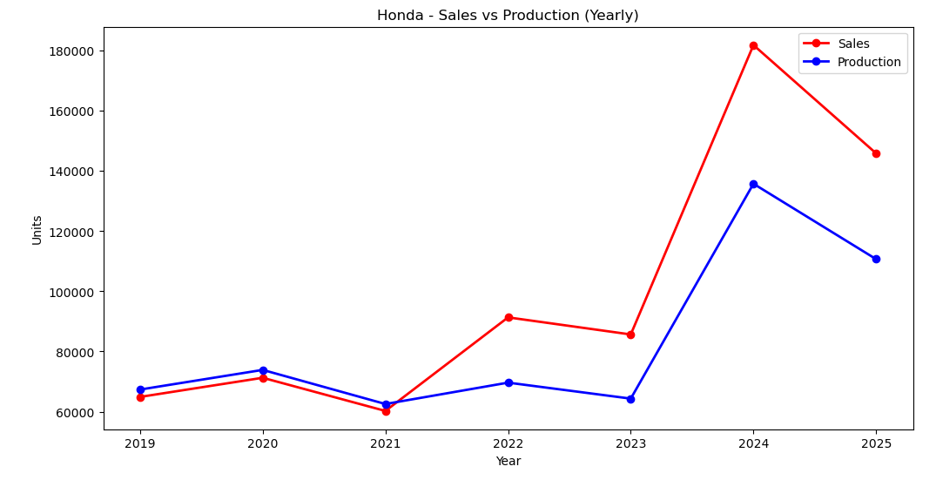The line chart illustrates Honda’s annual sales and production performance from 2019 to 2025. From 2019 to 2021, both sales (red line) and production (blue line) followed a steady and closely aligned trend, with minor fluctuations. In 2022 and 2023, sales outpaced production, showing growing market demand. The most significant shift occurred in 2024, where sales spiked dramatically to over 180,000 units, while production also surged but lagged behind at around 136,000 units. In 2025, both sales and production declined but still remained higher than pre-2022 levels. This trend highlights Honda’s rapid demand expansion post-2022, coupled with production capacity challenges in meeting market needs.

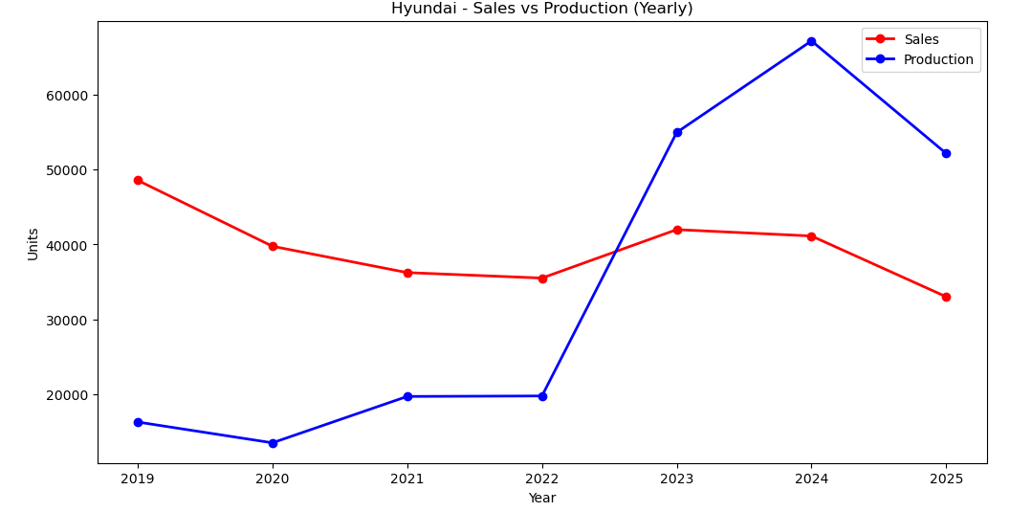
The line graph shows Hyundai’s yearly sales and production from 2019 to 2025. Sales (red line) fell consistently from about 49,000 units in 2019 to around 36,000 units in 2022, then briefly recovered in 2023 before dropping again by 2025. Production (blue line) stayed relatively low until 2022, but surged sharply in 2023, peaking at over 67,000 units in 2024, before declining slightly in 2025. This reflects Hyundai’s aggressive expansion in production capacity after 2022, while sales struggled to keep pace, creating a noticeable gap between output and market demand.

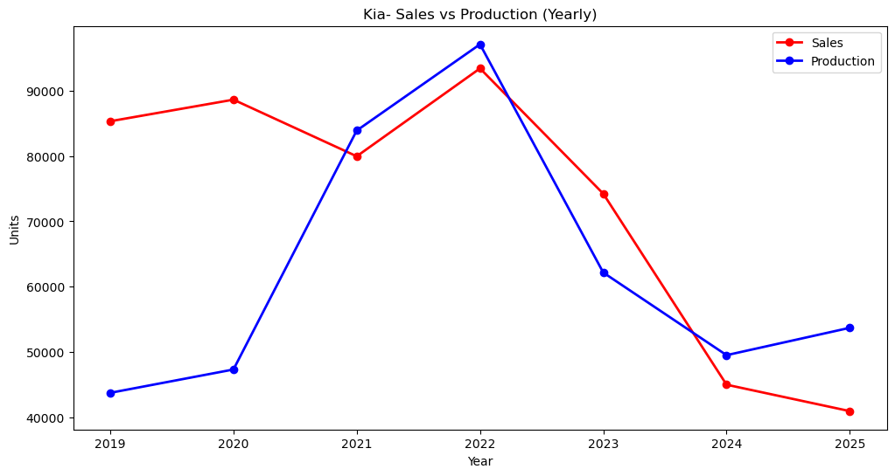

The line graph illustrates Kia’s yearly sales and production from 2019 to 2025. Sales (red line) started strong at around 86,000 units in 2019, rose further to over 93,000 in 2022, but then fell sharply to just above 40,000 units by 2025. Production (blue line) followed a different path, increasing steadily to nearly 97,000 units in 2022 before dropping significantly in the following years, stabilizing around 54,000 units by 2025. This shows that Kia initially balanced sales and production well, but post-2022, sales declined more steeply than production, pointing to demand challenges despite sustained output capacity.

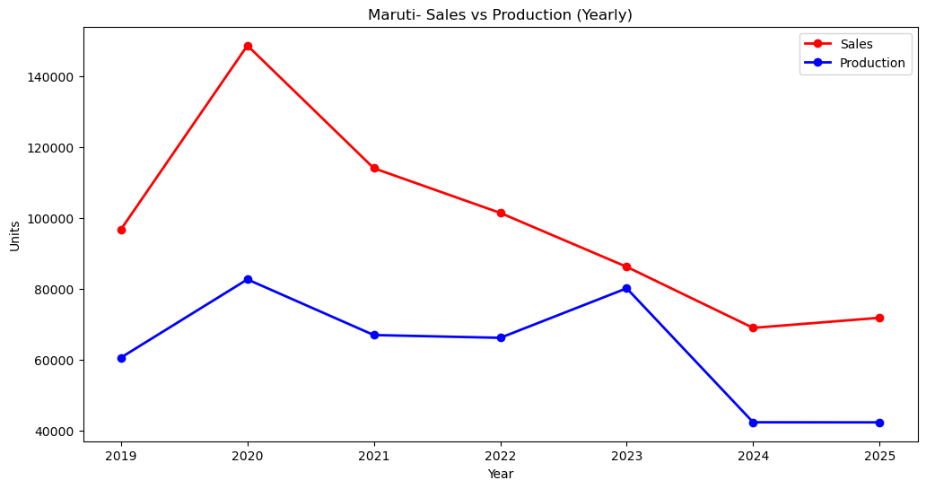

The line graph illustrates Kia’s yearly sales and production from 2019 to 2025. Sales (red line) started strong at around 86,000 units in 2019, rose further to over 93,000 in 2022, but then fell sharply to just above 40,000 units by 2025. Production (blue line) followed a different path, increasing steadily to nearly 97,000 units in 2022 before dropping significantly in the following years, stabilizing around 54,000 units by 2025. This shows that Kia initially balanced sales and production well, but post-2022, sales declined more steeply than production, pointing to demand challenges despite sustained output capacity.

2.6 Correlation Analysis

Heatmaps were generated to analyse the correlation between

SalesUnits, ProductionUnits, Price, and Discount for each brand. For Maruti Suzuli, there is a strong positive correlation between SalesUnits and ProductionUnits (0.68). A strong positive correlation also exists between Price and Discount (0.86), which is a key finding that supports the project's hypothesis about the need for better forecasting to reduce discounts.

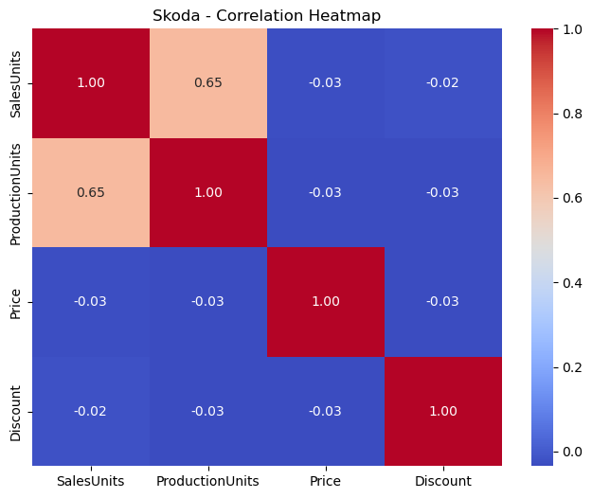

The correlation heatmap for Skoda highlights the relationships among sales, production, price, and discount. A strong positive correlation (0.65) exists between sales units and production units, indicating that higher output directly supports higher sales. In contrast, price and discount show very weak or near-zero correlations with both sales and production, suggesting limited influence on Skoda’s performance metrics. Overall, the heatmap emphasizes that Skoda’s sales trends are primarily production-driven rather than price- or discount-sensitive.

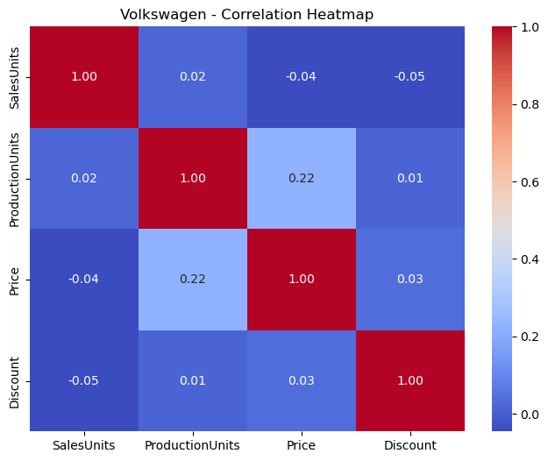

The correlation heatmap for Volkswagen shows very weak relationships among sales, production, price, and discount. Sales units display almost no correlation with production, price, or discount, suggesting that sales performance operates independently of these factors. The only slightly notable trend is a low positive correlation (0.22) between production units and price, hinting that higher production volumes might be linked with modest price adjustments. Overall, Volkswagen’s performance appears to be less influenced by traditional factors and more dependent on external variables not captured in this dataset.

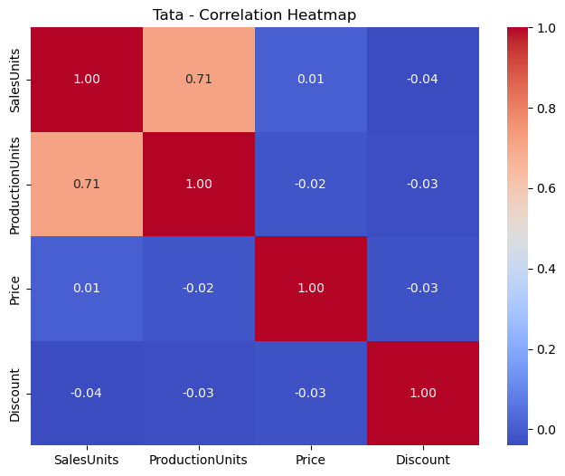

Tata correlation heatmap reveals a strong positive correlation (0.71) between sales units and production units, indicating that Tata’s sales are closely aligned with its manufacturing output. However, price and discount show negligible correlations with both sales and production, suggesting that Tata’s market performance is less dependent on pricing strategies or discounts. This implies that production planning plays the most significant role in driving sales for Tata, while external incentives like price cuts or discounts have minimal measurable impact. 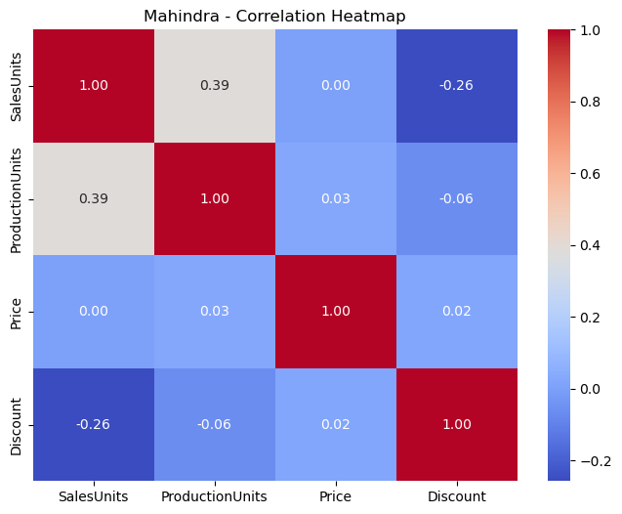

The Mahindra correlation heatmap shows a moderate positive correlation (0.39) between sales units and production units, indicating that production volumes partially drive sales performance. Interestingly, discounts display a negative correlation (–0.26) with sales, suggesting that higher discounts do not necessarily boost sales and may even signal weaker demand periods. Price, however, shows almost no correlation with sales (0.00), meaning pricing strategy alone has minimal influence on Mahindra’s sales trends. Overall, production contributes somewhat to sales growth, but discounting strategies appear ineffective.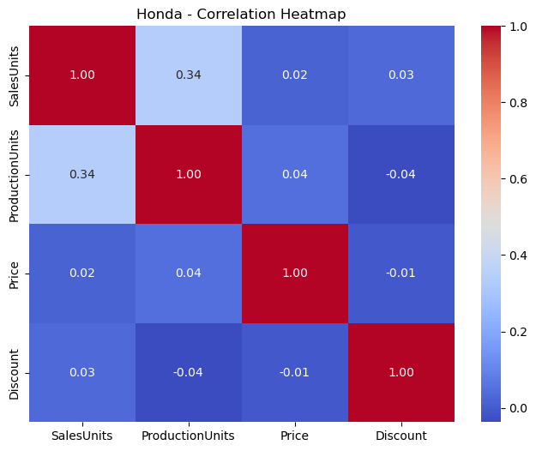

The Honda correlation heatmap indicates a weak positive relationship (0.34) between sales units and production units, showing that sales are only partially influenced by production levels. Price (0.02) and discount (0.03) both display negligible correlations with sales, meaning neither pricing adjustments nor discounts strongly affect sales performance. Interestingly, production units also show minimal correlation with price (0.04) and a slight negative relationship with discounts (–0.04), suggesting independent strategies in production planning and discounting. Overall, Honda’s sales are moderately linked to production but largely unaffected by price and discount policies. 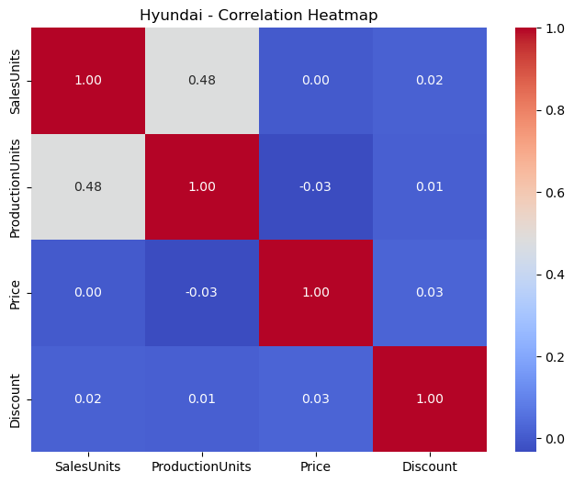

The Hyundai correlation heatmap shows a moderate positive relationship (0.48) between sales units and production units, indicating that sales tend to increase in line with production levels. However, sales have almost no correlation with price (0.00) and only a negligible link with discount (0.02), suggesting that customer demand is relatively insensitive to pricing and discount strategies. Similarly, production units show little to no correlation with price (–0.03) and discount (0.01). Overall, Hyundai’s sales performance is primarily production-driven, while pricing and discounting have minimal influence.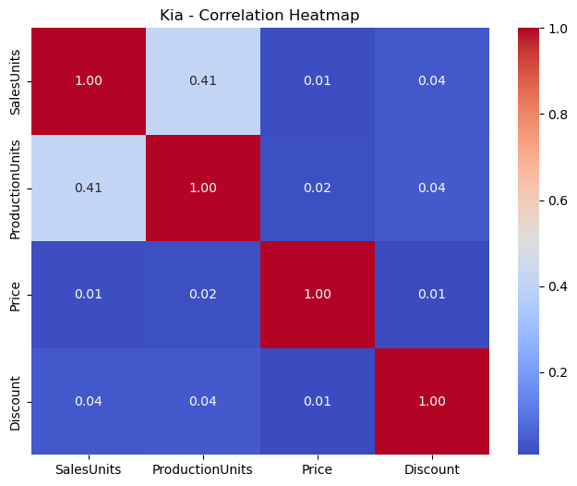

The Kia correlation heatmap shows a moderate positive relationship (0.41) between sales units and production units, suggesting that higher production generally aligns with stronger sales. However, price (0.01) and discount (0.04) have almost no correlation with sales, meaning that sales are not significantly affected by pricing or discount strategies. Similarly, production units have negligible correlation with price (0.02) and discount (0.04). This indicates that Kia’s sales performance is largely production-driven, with minimal influence from financial levers like price and discounts.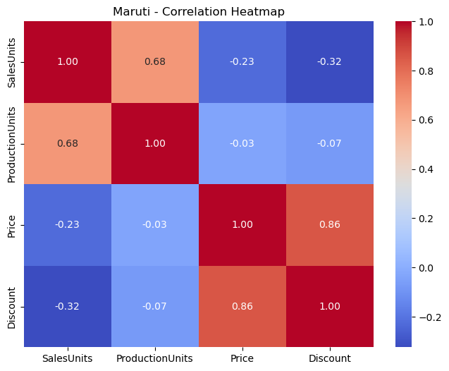

The Maruti heatmap shows a strong positive correlation (0.68) between sales units and production units, indicating production closely follows sales demand. Price and discount are highly correlated (0.86), suggesting pricing strategies are strongly tied to discount levels. However, both price (-0.23) and discount (-0.32) show negative correlations with sales, meaning higher prices or discounts do not directly drive sales growth.

2.7 3D Scatter Plots

3D scatter plots were created to visualize the relationship between

SalesUnits, Price, and Discount for each brand. These plots offer a multi-dimensional view of how these variables interact, further supporting the need for optimization

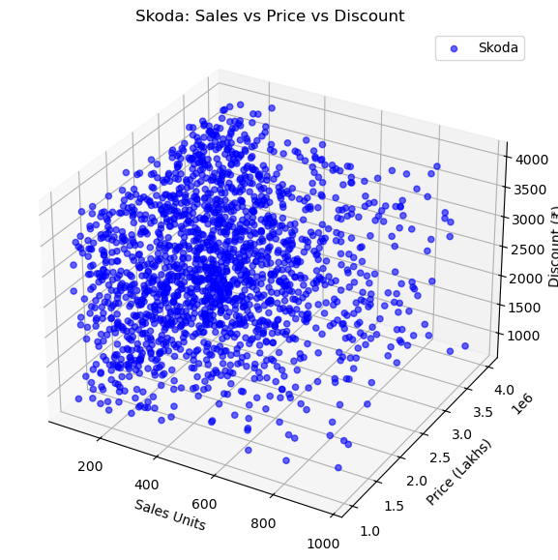

The 3D scatter plot for Skoda shows the distribution of sales units with respect to price and discount. Most sales are concentrated in the lower price and mid-discount ranges, while higher prices correspond to relatively fewer sales. This indicates that affordability and moderate discounts play a key role in Skoda’s sales performance.

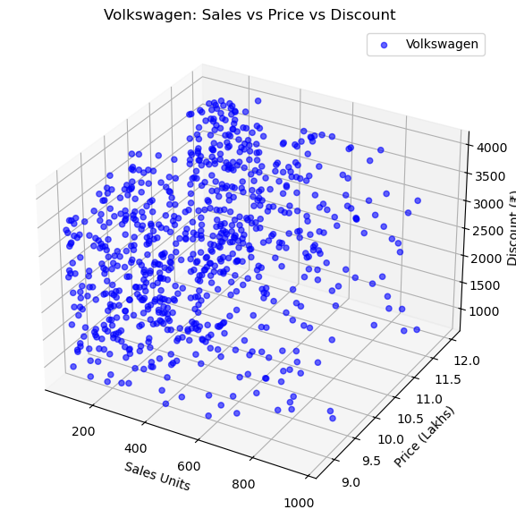

The 3D scatter plot for Volkswagen shows that sales are mostly concentrated at lower sales units and moderate discounts. Prices remain within a narrow high range (₹9–12 lakhs), indicating that discounts may influence purchase decisions more than price variations.

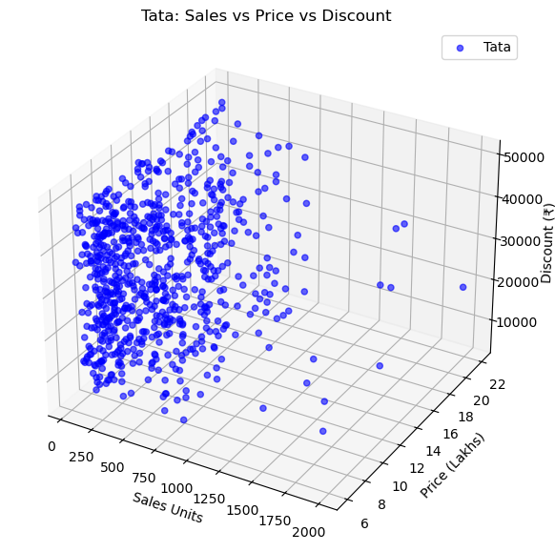

The 3D scatter plot for Volkswagen shows that sales are mostly concentrated at lower sales units and moderate discounts. Prices remain within a narrow high range (₹9–12 lakhs), indicating that discounts may influence purchase decisions more than price variations.

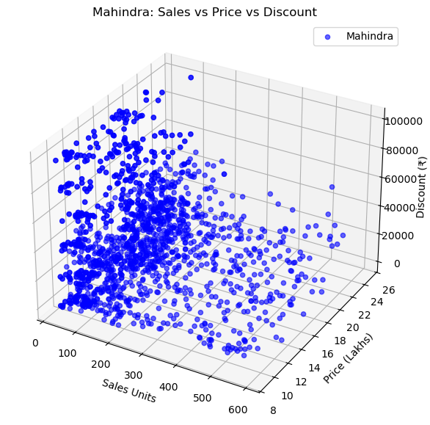

The 3D scatter plot for Mahindra shows that most sales are concentrated in the lower range of sales units (under 300) with car prices between ₹10–18 lakhs. Discounts vary widely, in some cases exceeding ₹1,00,000, indicating aggressive promotional strategies. The spread suggests that higher discounts are often applied to stimulate sales across different price bands.

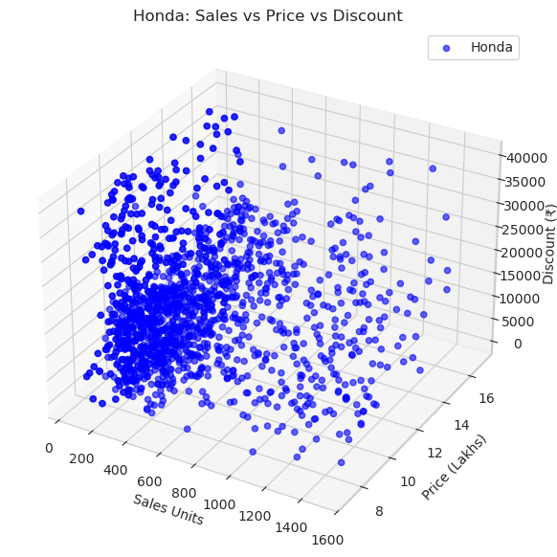

The 3D scatter plot for Honda shows a dense cluster of sales between 200–700 units, with prices ranging from ₹8–13 lakhs. Discounts are commonly between ₹5,000 and ₹25,000, with some higher outliers reaching above ₹40,000. The plot indicates that while discounts do play a role, Honda achieves consistent sales even at moderate discount levels, especially in the mid-price segment.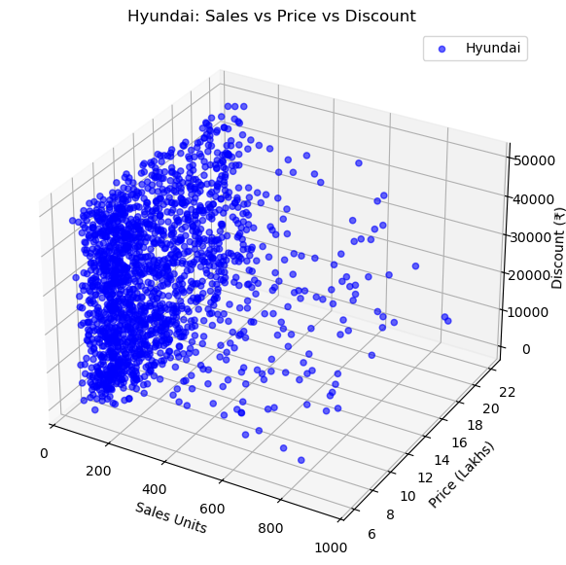

The Hyundai scatter plot reveals that most sales are concentrated between 100–400 units, with prices in the ₹7–14 lakh range. Discounts usually fall between ₹10,000 and ₹30,000, with a few cases going above ₹50,000. The plot suggests that Hyundai’s sales are relatively steady across moderate discount levels, but higher discounts are occasionally applied at higher price points to stimulate demand.

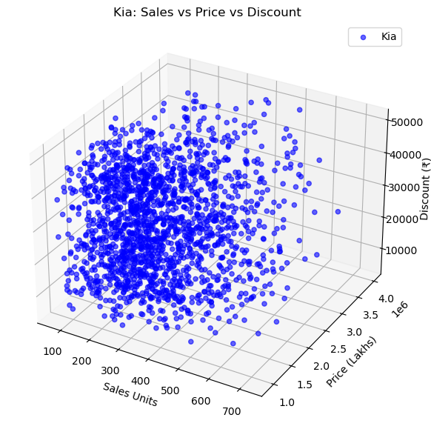

The Kia scatter plot indicates that sales are spread mostly between 100–500 units, with prices ranging widely in the higher bracket (above ₹10 lakh, extending towards luxury levels). Discounts are typically between ₹10,000 and ₹30,000, with some going up to ₹50,000. Unlike budget brands, Kia’s sales are less concentrated in lower prices and instead show stronger demand in mid-to-high price segments, suggesting that customers perceive Kia as a premium choice.

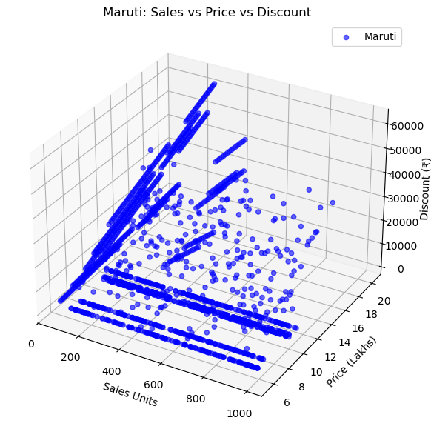

The Maruti plot highlights a strong sales base in the lower price segment (₹5–12 lakh), with sales often clustering between 200–800 units. Discounts usually fall below ₹30,000, but some models receive higher discounts up to ₹60,000. The data shows clear linear bands, likely representing different models consistently priced with fixed discount strategies. Maruti’s dominance is visible in volume sales, even at modest discount levels, reflecting its reputation as a mass-market lea
CHAPTER 3 - METHODOLOGY AND MODEL TRAINING

3.1 Approach

The project's approach combines data-driven techniques with strategic modelling.
- Data Collection & Cleaning: Gathering sales, production, and macroeconomic data from 2019 to 2025 and preprocessing it for analysis.
- Exploratory Data Analysis (EDA): Visualizing trends and patterns in the data to understand demand fluctuations and consumer behaviour.
- Machine Learning Forecasting: Training and evaluating models (Linear Regression, Random Forest, XGBoost) to predict future demand.
- Game Theory: Modelling competitive dynamics between companies to understand strategic interactions, such as production and pricing decisions.
- Strategic Insights: Recommending optimal production and sales strategies based on the combined analysis to minimize discounts and maximize profits.

3.2 Training Machine Learning Models

The study trained three different models for each brand to forecast
SalesUnits: Linear Regression, RandomForestRegressoron, and GradientBoostingRegressorion. The models were evaluated using a time series cross-validation approach with 5 splits. The Mean Absolute Error (MAE) and Root Mean Squared Error (RMSE) were used as evaluation metrics.
The best-performing model for each brand was identified based on the lowest MAE:
- Mahindra: Random Forest (MAE: 90.26)
- Honda: Random Forest (MAE: 235.77)
- Hyundai: Random Forest (MAE: 62.46)
- Kia: Gradient Boosting (MAE: 41.83)
- Maruti Suzuki: Random Forest (MAE: 149.68)
- Skoda: Random Forest (MAE: 34.57)
- Volkswagen: Gradient Boosting (MAE: 174.70)
- Tata: Random Forest (MAE: 102.95)
CHAPTER 4 - FORECASTING AND STRATEGIC INSIGHTS

4.1 Sales Forecasting

Using the trained models, a forecast was generated for each brand for the next five years. The
forecast_yearly function utilized a Linear Regression model on historical sales data to predict future sales, demonstrating a clear trend for each company.
- Honda: Sales are forecasted to increase from 170,113 units in 2026 to 240,062 units by 2030.
- Hyundai: Sales are projected to decline from 34,010 units in 2026 to 28,559 units by 2030.
- Mahindra: Sales are predicted to remain relatively stable, increasing slightly from 14,975 units in 2026 to 15,274 units by 2030.
- Kia: A significant decrease in sales is forecasted, from 40,192 units in 2026 to 7,892 units by 2030.
- Maruti Suzuki: Sales are expected to decrease from 60,778 units in 2026 to 23,342 units by 2030.
- Skoda: A modest increase is forecasted, from 87,223 units in 2026 to 93,017 units by 2030.
- Tata: Sales are expected to grow from 91,458 units in 2026 to 97,790 units by 2027.
- Volkswagen: Sales are forecasted to see a steep decline from 19,156 units in 2026 to 2,967 units by 2030.
4.2 Capacity Planning

Capacity planning models were developed to compare the forecasted demand with an assumed production capacity, which grows at a modest rate of 2% annually. The analysis identifies the "gap" between demand and capacity. For example, the
Mahindra - Capacity vs Demand plot clearly shows a significant oversupply in 2022 and 2023, where demand was far below production capacity, resulting in negative gaps. In contrast, the Honda analysis shows periods where demand exceeds capacity, highlighting potential for growth if production is scaled up. This validates the core problem of production mismatch.

4.3 Game Theory Analysis

A game theory model was created to analyze the strategic interaction between two companies, specifically Mahindra and Honda, in a capacity expansion scenario. The model examines two strategies: "Don't Expand" and "Expand" production capacity.

The payoff matrix for Mahindra and Honda shows that expanding capacity is a high-risk strategy for Mahindra. If Mahindra expands and Honda does not, Mahindra suffers a loss of 5, while Honda gains 10. If both expand, Mahindra still loses, and Honda benefits more. The Nash Equilibrium for this game is for both companies to not expand capacity, as this leads to a stable outcome with no gains or losses (payoff of 0, 0) and avoids potential losses for Mahindra.

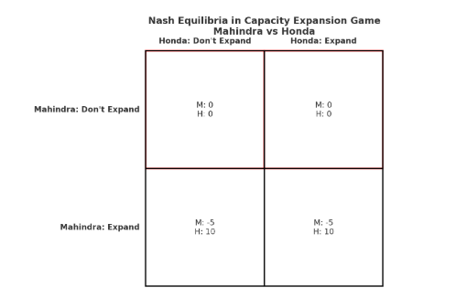

CHAPTER 5 - CONCLUSION AND RECOMMENDATIONS

5.1 Conclusion

This project successfully demonstrates the utility of combining machine learning for forecasting with game theory for strategic decision-making in the Indian automobile industry. The models effectively forecasted demand for major brands and identified a clear mismatch between production capacity and market needs, particularly in the post-COVID period. The game theory analysis further highlighted the competitive risks associated with aggressive capacity expansion, providing a rational basis for cautious strategic planning. The primary finding is that while some companies may see an opportunity for growth, a more stable and profitable strategy involves balancing production with accurate demand predictions rather than blindly scaling up.

5.2 Recommendations

Based on the findings, the following recommendations are made to Indian automobile companies:
- Invest in Advanced Forecasting: Companies should implement robust ML models, like the Random Forest and Gradient Boosting models used in this study, to generate more accurate and reliable demand forecasts. This will help prevent overproduction and the need for significant discounts.
- Dynamic Production Planning: Production schedules should be more flexible and responsive to short-term demand forecasts. This will allow companies to adjust production volumes in real-time, reducing the risk of excess inventory.
- Integrate Competitive Analysis: Companies should incorporate game theory or similar competitive analysis frameworks into their strategic planning process. This is crucial for anticipating rivals' moves and avoiding mutually destructive actions like price wars or excessive capacity expansion.
- Focus on Profitability over Volume: The data indicates that aggressive scaling can lead to losses due to high discounts. A shift in focus from maximizing production volume to optimizing profitability through balanced production and stable pricing is advisable.

By adopting these data-driven strategies, automobile companies can mitigate risks and achieve sustainable, long-term profitability in a dynamic market.

CHAPTER 6 – BIBLIOGRAPHY

CHAPTER 7 - ANNEXURE

PLAGIARISM REPORT

