Semester: V Name of Student: Soham Dalvi

Academic Year: 2022-23 Student ID: 21104010 Class / Branch: TE IT(B1)

Subject: Advanced Devops Lab (ADL) Name of Instructor:Prof. Manjusha K.

EXPERIMENT NO. 06

Aim: To Build, change, and destroy AWS infrastructure Using Terraform.

OUTPUTS: -

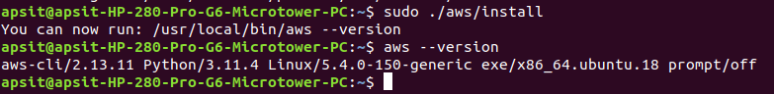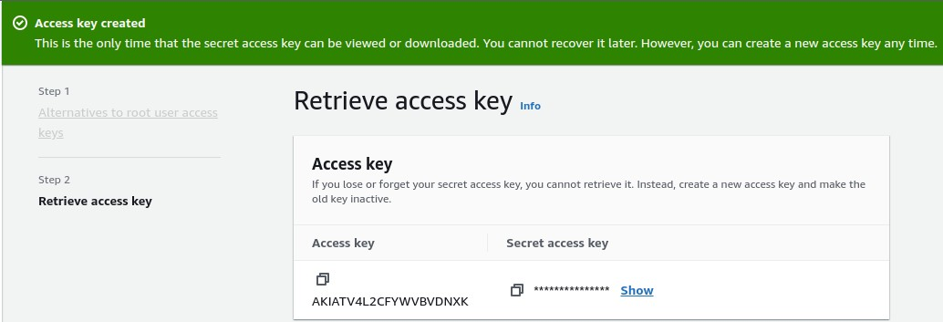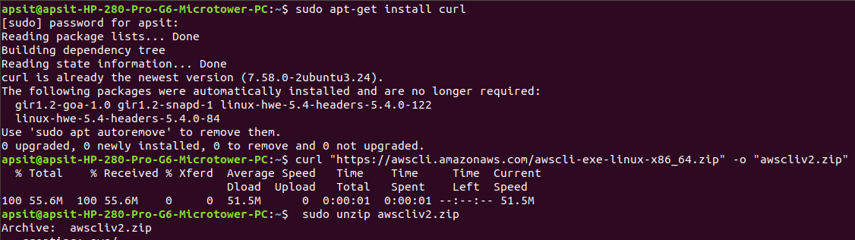

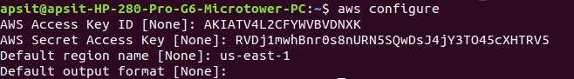

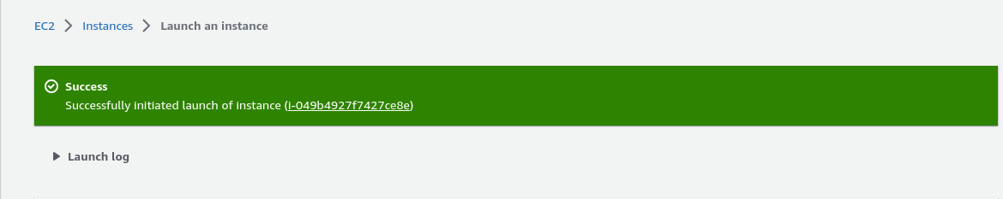

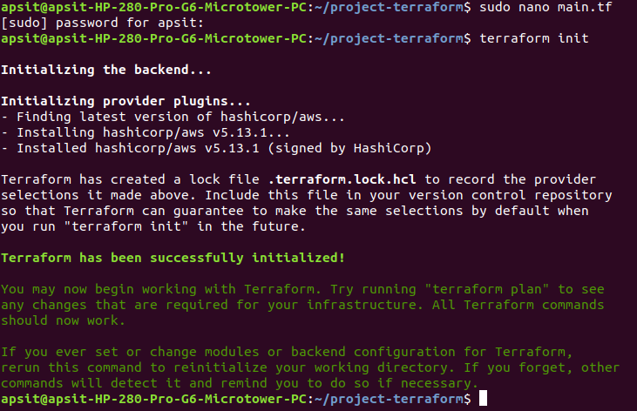

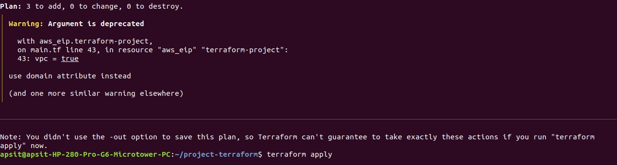

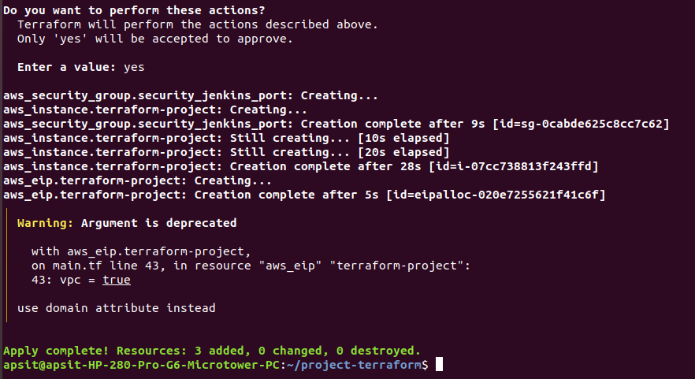

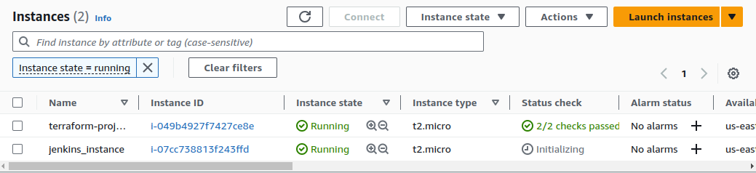

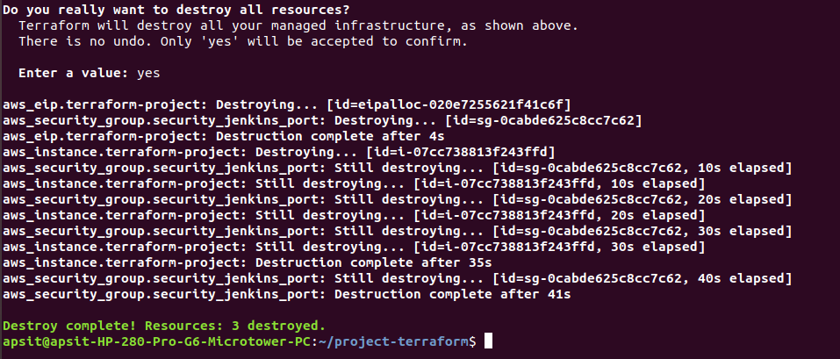

Conclusion: -

Thus, we have successfully Build, change, and destroy AWS infrastructure Using Terraform.