

Department of Information Technology

Academic Year: 2021-22 Name of Student: Soham Dalvi
Semester: V Student ID: 21104010
Class / Branch: IT Date of Performance: 5/10/23
Subject: DevOps Lab Date of Submission: 5/10/23
Name of Instructor: Prof. Sonal Jain

Experiment No. 11
Aim: To learn Software Configuration Management and provisioning using Puppet Blocks

In the terminal, type the following command to display a list of Puppet relevant subcommands:
Puppet --help

In the terminal, type any of the following commands to display a list of actions associated with the puppet subcommand “resource “:
Puppet help resource
Puppet resource –help

In the terminal, type the following command to display a list of available inbuilt puppet resource types:
puppet resource –types
To find out all the attributes associated with the puppet resource type, use the following command:
puppet describe <resource type name>

Parameters will list all the available attributes for that resource type.
puppet describe package

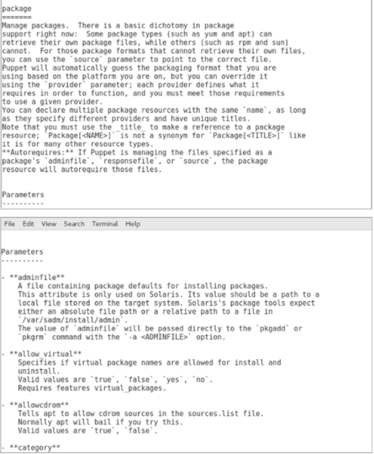

First, make sure the NTP package is not already present on the server, the following command will return nothing if the telnet is not present on the server:
rpm -qa | grep -i ntp

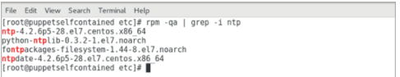

As we can see, the NTP package is already present on the server. Let’s remove the existing NTP package:
yum remove ntp

Verify the ntp service does not exist by running the following command:
systemctl status ntp

Create a new .pp file to save the code. From the command line:
vi demontp.pp

Change to insert mode by pressing i from the keyboard.
Type the following code to create a new file:
# Class Definition
class ntpconfig {
# Installing NTP Package
package {"ntp":
ensure=> "present",
}
# Configuring NTP configuration file
file {"/etc/ntp.conf":
ensure=> "present",
content=> "server 0.centos.pool.ntp.org iburst\n",
}
# Starting NTP services
service {"ntpd":
ensure=> "running",
}
}

After done with editing : press esc
To save the file, press :wq!
Next step is to check whether the code has any syntax errors. Execute the following command:
puppet parser validate demontp.pp

Make sure that you switched to the root to be able to complete the test without any error, by executing the command :
su root

Test is the next step in the code creation process. Execute the following command to perform a smoke test:
Puppet applies demontp.pp --noop
Last step is to run the puppet in real mode and verify the output.
puppet apply demontp.pp

Verify the ntp service has been started by running the following command:
systemctl status ntpd

OUTPUT:
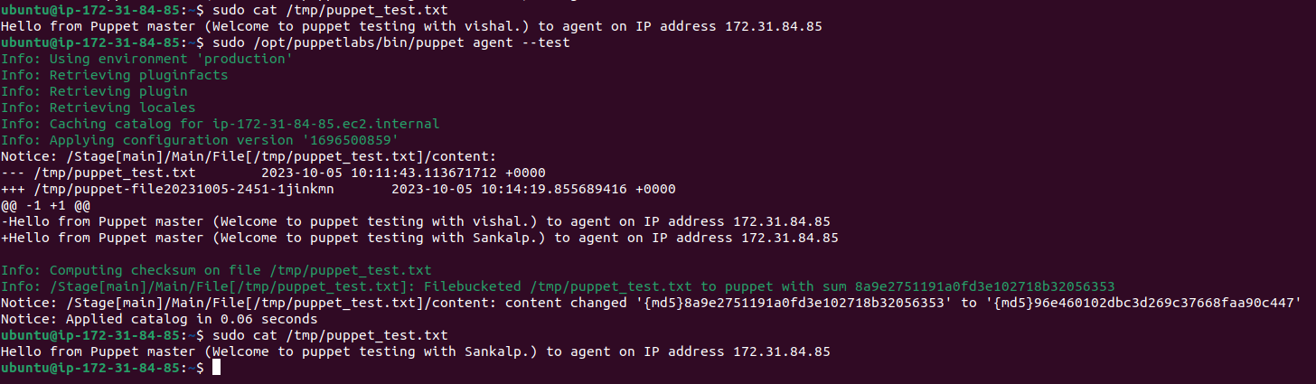
Conclusion: Hence we have learnt the Software Configuration Management and provisioning using Puppet Blocks.

