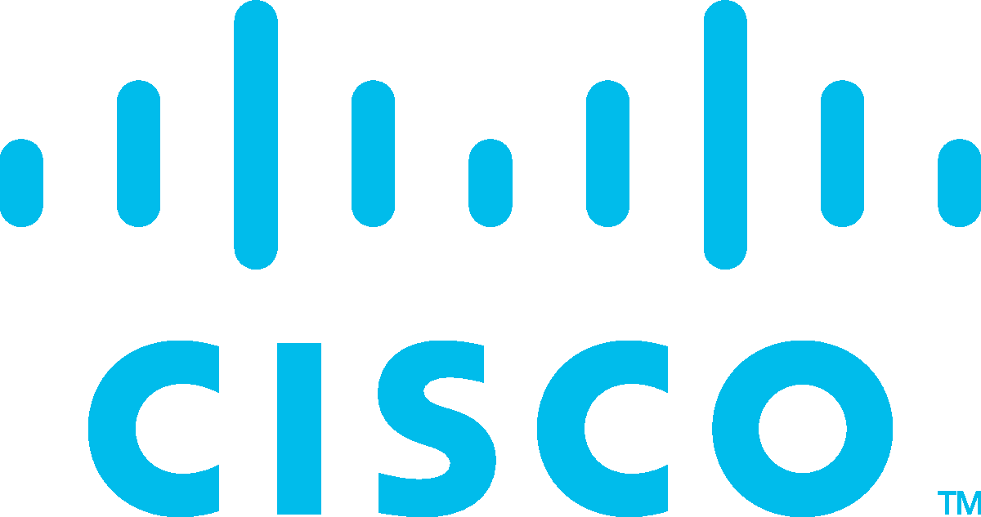Corporate Social Responsibility

Certificate of Course Completion

IT Essentials

Cisco Networking Academy

The student has successfully achieved student level credential for completing IT Essentials course administered by the undersigned instructor. The student was able to proficiently:

Select and install the appropriate computer components to build, repair, or upgrade personal computers.

Demonstrate safe lab procedures.

Appropriate use of tools to perform preventive maintenance and troubleshooting on personal computers.

Perform installation, repair, maintenance, and troubleshooting of Windows operating systems.

Explain the operation of local area networks and configure devices to connect to LANs and the Internet.

Configure devices to connect to the Internet and Cloud services. Explain how to configure, repair, upgrade, maintain, and troubleshoot laptops and mobile devices.

Explain how to configure, secure and troubleshoot mobile, OS X, and Linux operating systems.

Install and share a printer to meet requirements. Implement basic host, data, and network security.

Explain the roles and responsibilities of the IT professional.

**Random Name**

Student

**A.P. Shah Institute of Technology**

Academy Name

**India 19 Apr 2022**

Location Date



Laura Quintana

VP & General Manager, Cisco Networking Academy