[1]

Gyrobike: Self Balancing Bike

Chetan S.Shinde , Aryan G.Shinde,Sanskruti S. Shimple, Gayatri V. Shinde, Mohiddin K. Shikalgar, Ranjeetsingh S. Suryawanshi

Department of Engineering, Sciences and Humanities (DESH)

*Abstract— The research paper details the implementation of the principle of Control Motor Gyro (CMG) on a bike to make it able to balance itself without any support. The contribution of two-wheeler vehicles to the road accidents has been a key concern nowadays. The main reason behind the contribution of two-wheeler bikes to the road accidents is the instability of bike which makes it difficult for the rider to balance it without any support. This is due to the reason that the dynamic model of the bike is designed in a way that the rider has to struggle more to balance the two wheeled vehicle as compared to other module vehicles.[2]So, the main objective of the project is to develop a technology to improve the dynamic model of the bike so that it can be able to self stabilize itself without any support. Due to development of this type of a prototype not only the learners but the common riders will also be benefited. Thus in order to develop such a prototype the technology which has been used is called as Control Motor Gyro (CMG).*

***Keywords*** *— Gyrobike, Self-stabilizing bike, Control Motor Gyro (CMG), Gyroscopic Torque Applications, Self-balancing bike.*

# INTRODUCTION

B

ikes have been providing transportation and supporting human mobility since many decades. The first bicycle was invented in 1817 by German inventor Karl Von Drais while the first motorcycle was invented in 1885 by a German Engineer Gottlieb Daimler.[7] Further many research, analytical developments and findings have resulted to the advanced bike technologies we can see today.

Today a two wheeler vehicle is one of the most common mode of transportation. Bringing developments to the dynamic nature of two wheeled vehicles has been found to be a key interest of the research community due to the complex dynamics of the bike. The two wheeled vehicles show variant behavior. They are unstable in static motion while they are found to gain stability in forward motion. This has resulted in larger number of two wheelers in road accidents nowadays. Thus a lot of development is required to be put in order to ensure safety of the rider.[2] An accident occurs when the bike loses its stability. Thus there is a need of technology which can help balancing the bike on its own in order to ensure reduction in these accident rates.

So, overall we can conclude that a bike is generally unstable in a standstill condition and stable during motion. The purpose of the research paper arises here. The bike can be balanced in static condition using a Gyroscopic principle device called as Control Motor Gyro (CMG). For this CMG is mounted on the two wheeled vehicle. It consists of a motor which rotates the heavy mass. This entire unit is the combination of mechanical and electronic components.[2] This Gyroscopic Torque balances the change in the center of gravity of the bike to a large extent ensuring the upright motion of the vehicle.

Thus with the help of the gyroscopic technology we can develop a prototype which could prove helpful in reducing the unstable nature of bikes.

# Literature Review

Many theories have been proposed to explain the use of C.M.G. in the development of the self balancing bike model. Most of these theories explain the use of the new technologies to enhance the development of the prototype that would help to balance a bike without any support. It concludes that the use of gyroscopic principle can be helpful in developing a prototype which would help the learners to learn riding bikes without any obstruction.[1]

The concept Control Motor Gyro (CMG) which when applied to a normal bike can make it stabilize on its own without any support. The Gyroscopic Torque developed by the Control Motor Gyro balances the change in the center of gravity of the bike to a large extent ensuring the upright motion of the vehicle.[2] Thus, a Control Motor Gyro can be effectively used on bikes for self balancing purpose inspired from its use in the ships and airplanes. The Control Motor Gyro (CMG), which can be used as momentum exchange actuator to balance a bike, is effective torque amplification device and has short response time.[3]

A gyroscope can play a crucial role in balancing a body without any support.[4]

The use of this technology thus results in stabilizing a two wheeler against any impact and in zero velocity as well with the use of two rotating disks with a hub motor at the chassis. The gyroscopic bike has many more safety features than normal motorcycle which make it more reliable.[5]

# Methodology

## Materials/Components/Flowchart/Block Diagram/Theory:

a. Components:

1) High rpm DC motor.

2) Flywheel

i) Tapered Disk Flywheel.

ii) Rim Type Flywheel.

3) Low rpm high torque DC motor.

4)12 V DC Battery.

5) Switch.

b. Tools:

1) HTML-5

2) CSS-3

3) JAVASCRIPT.

c. Flowchart of methodology:

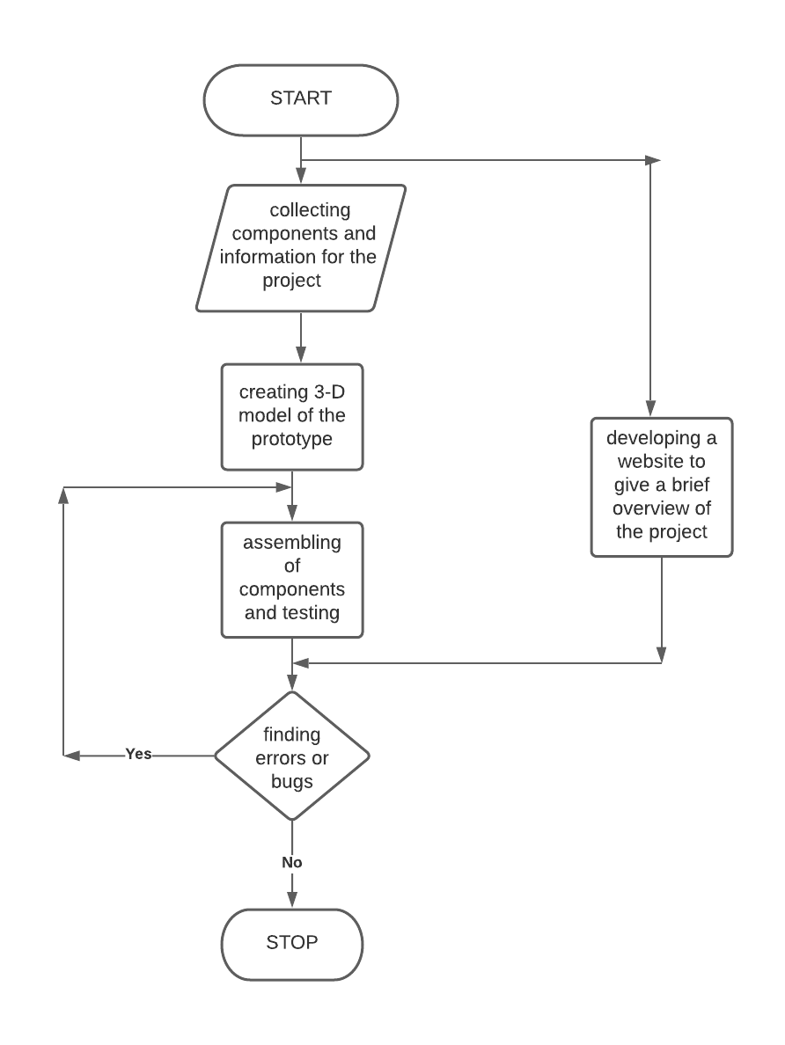

# . Results and Discussions

Thus, a self-stabilizing two wheeler bike model was successfully developed by using the concept of Gyroscopic Torque. The model created has been tested and has shown remarkable improved dynamics in comparison with the normal two wheeler models.

The design of the 3D model of the prototype for self stabilizing gyro bike model is as shown in the following figure:

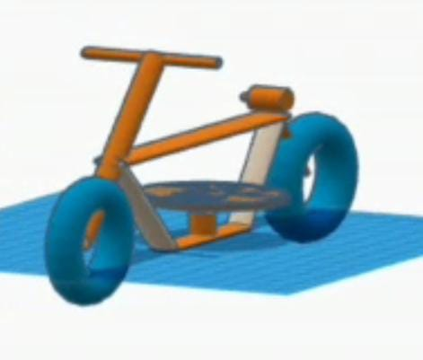

Fig.2. 3D model of the self stabilizing gyrobike model.

The actual working model of the prototype of self balancing gyroscopic bike can be seen in the following figure:

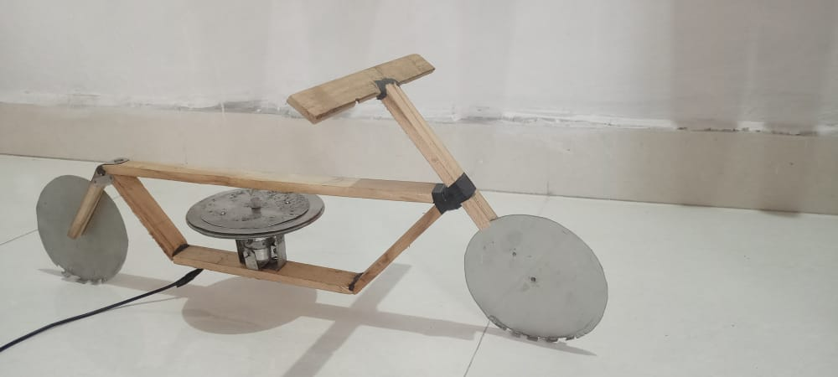

Fig.3. Actual working model of Gyrobike.

The website was developed in order to explain the informative theories and statistical analysis about the concerned project. In fig.4 the overlook of the website home page can be seen.

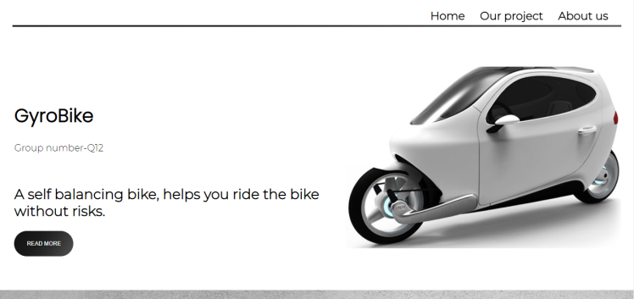

Fig.4. Homepage of the developed website.

# Limitations

Through this project we have so far been successful in developing a technology which could balance the two wheeler on its own without any support. However the two wheeled prototype finds difficult to maintain stability for a longer time as a force is created to a certain direction. Also the bike gains a lot of extra weight due to addition of the gyroscopic components which leads to another limitation. Due to the addition of the gyroscope the accommodation of the bike eventually becomes one unlike other bikes having dual accommodation.

# FUTURE SCOPE

The prototype is designed to provide safety to the rider riding the bike. However only the rider is able to use the bike with no other accommodation. There is a scope to design a model of gyroscopic bike which could accommodate two passengers rather than one.

Also, future scope to this topic involves the development of a sensor based adaptive technology so that the orientation can be changed according to the requirements and thus efficiency can be subsequently maintained.

# CONCLUSION

As discussed earlier the unstable nature of the bike is point of concern for this project. So in order to overcome it the Gyrobike can be used as an alternative. So while considering safety as one of the top priorities it can be finally concluded that the dynamic model of Gyrobike thus proposed can help to minimize the accident rates of two wheeler vehicles by providing an appropriate balance of the bike. Also this type of module can be beneficial to the new learners to learn to ride bikes without any stress of misbalance.

In short, we can conclude the self-balancing gyroscopic vehicle is capable of balancing itself without any support. Thus the proposed system would be much helpful in reducing two-wheeler accidents or unwanted falls and increasing safety of the rider.

# REFERENCES

[1] Pratik D. Tak, “Self Stabilizing Bike Using Gyroscope.”, IJRET Nov.2017.

[2] Pallavi Gogoi, Manish Nath, BumiTruemanDoley, Abhijeet Boruah, Hirok Jan Barman, “Design and Fabrication of Self Balancing Two Wheeler Vehicle Using Gyroscope.”, IJET Jun-Jul 2017.

[3] Pom Yuan Lam, “Design and Development of a Self-balancing Bicycle using CMG.

[4] Sheikh Mohibul Islam Rumi, Shanamul Islam, Mehdi Fakid Hossain, “System Design of a Two Wheeler Self Balanced Vehicle.”

[5] Daniel Raviv, Anthony Radzins, MoradRahmani, “From Observation to Prototyping: A Hands-on UG Research.”

[6]R.S.Khurmi, J.K.Gupta, “Theory Of Machines.” S.Chand Publications.

# ACKNOWLEDGEMENT.

We would like to express our heartfelt gratitude to our Capstone Project Guide, Shri. Ranjeetsingh S. Suryawanshi for his valuable guidance and suggestions and to Dr. Sachin Sawant who provide all the necessary information about the completion of the project and to Mr. Sunil Choughule for his valuable guidance.

1.