[1]

Gyrobike: Self Balancing Bike

Ranjeetsingh S. Suryawanshi, Chetan S.Shinde , Aryan G.Shinde,Sanskruti S. Shimple, Gayatri V. Shinde, Mohiddin K. Shikalgar.

Department of Engineering, Sciences and Humanities (DESH)

*Abstract— The research paper details the implementation of the principle of Control Motor Gyro (CMG) on a bike to make it able to balance itself without any support. The contribution of two-wheeler vehicles to the road accidents has been a key concern nowadays.The main reason behind the contribution of two-wheeler bikes to the road accidents is the instability of bike which makes it difficult for the rider to balance it without any support.This is due to the reason that the dynamic model of the bike is designed in a way that the rider has to struggle more to balance the two wheeled vehicle as compared to other module vehicles.[2]So, the main objective of the project is to develop a technology to improve the dynamic model of the bike so that it can be able to self stabilize itself without any support. Due to development of this type of a prototype not only the learners but the common riders will also be benefited.Thus in order to develop such a prototype the technology which has been used is called as Control Motor Gyro (CMG).*

***Keywords*** *— Gyrobike, Self-stabilizing bike, Control Motor Gyro (CMG), Gyroscopic Torque Applications, Self-balancing bike.*

# INTRODUCTION

B

ikes have been providing transportation and supporting human mobility since many decades. The first bicycle was invented in 1817 by Germaninventor Karl Von Draiswhile the first motorcycle was invented in 1885 by a German Engineer Gottlieb Daimler.[7] Further many research, analytical developments and findings have resulted to the advanced bike technologies we can see today.

This widespread vehicle is one of the most common mode of wheeled transportation. Modeling, analysis and control of bike dynamics has attracted the attention of the automatic control research community due to its non-intuitive nature.[2] The bike displays interesting dynamics behaviour. It is statically unstable like an inverted pendulum while it is stable in forward motion under certain circumstances.[4]Due to these reasons, nowadays maximum road accidents are of the two-wheelers. Needless to say, a lot of investment goes into manufacturing and development of state-of-art high technology motor bikes but none can guarantee road safety and it solely depends on the rider and hence road accidents occur when a rider loses control over the bike.[2] This is when the bike loses its stability. Thus there is a need of technology which can help balancing the bike on its own

in order to ensure reduction in these accident rates.

So, overall we can conclude that a bike is generally unstable in a standstill condition and stable during motion. The purpose of the research paper arises here. The bike can be balanced in static condition using a Gyroscopicprinciple device called as Control Motor Gyro (CMG).CMG controls the angular direction of the entire device to which this CMG

is mounted according to the input given to the heavy rotational mass rotating inside it at a high speed.[3] In-built motor is fixed inside it which rotates that heavy mass. This entire unit is the combination of mechanical and electronic components which make it possible. CMG is made up of spinning rotor and motored gimble that tilt the angular momentum of the rotor. As the rotor tilts, gyroscopic precession torque is generated caused by changing angular momentum.[2] This Gyroscopic Torque balances the change in the centre of gravity of the bike to a large extent ensuring the upright motion of the vehicle.

Thus, the gyroscopic principle can be successfully used for creating the prototype of a two-wheeled vehicle, and thus observing gyroscopic phenomenon on the same.

# Literature Review

Many theories have been proposed to explain the utilization of C.M.G. in the development of the self balancing bike model.Most of these theories explain the use of the new technologies to enhance the development of the prototype that would help to balance a bike without any support. It concludes that the use of gyroscopic principle can be helpful in developing a prototype which would help the learners to learn riding bikes without any obstruction.[1]

The concept Control Motor Gyro (CMG) which when applied to a normal bike can make it stabilize on its own without any support.The Gyroscopic Torque developed by the Control Motor Gyro balances the change in the centre of gravity of the bike to a large extent ensuring the upright motion of the vehicle.[2] Thus, a Control Motor Gyro can be effectively used on bikes for self balancing purpose inspired from its use in the ships and airplanes.The Control Motor Gyro (CMG), which can be used as momentum exchange actuator to balance a bike, is effective torque amplification device and has short response time.[3]

A body can be balanced only on two parallel spin axis wheels in idle or running condition with the help of mechanical gyroscope. The gyroscopic principle can be successfully used for creation of the prototype of the two wheeled vehicle.[4]

The use of this technology thus results in stabilizing a two wheeler against any impact and in zero velocity as well with the use of two rotating disks with a hub motor at the chassis.The gyroscopic bike has many more safety features thannormal motorcycle which make it more reliable.[5]

# Methodology

## Materials/Components/Flowchart/Block Diagram/Theory:

a. Components:

1) High rpm DC motor.

2) Flywheel

i) Tapered Disk Flywheel.

ii) Rim Type Flywheel.

3) Low rpm high torque DC motor.

4)12 V DC Battery.

5) Switch.

b. Tools:

1) HTML-5

2) CSS-3

3) JAVASCRIPT.

c. Flowchart of methodology:

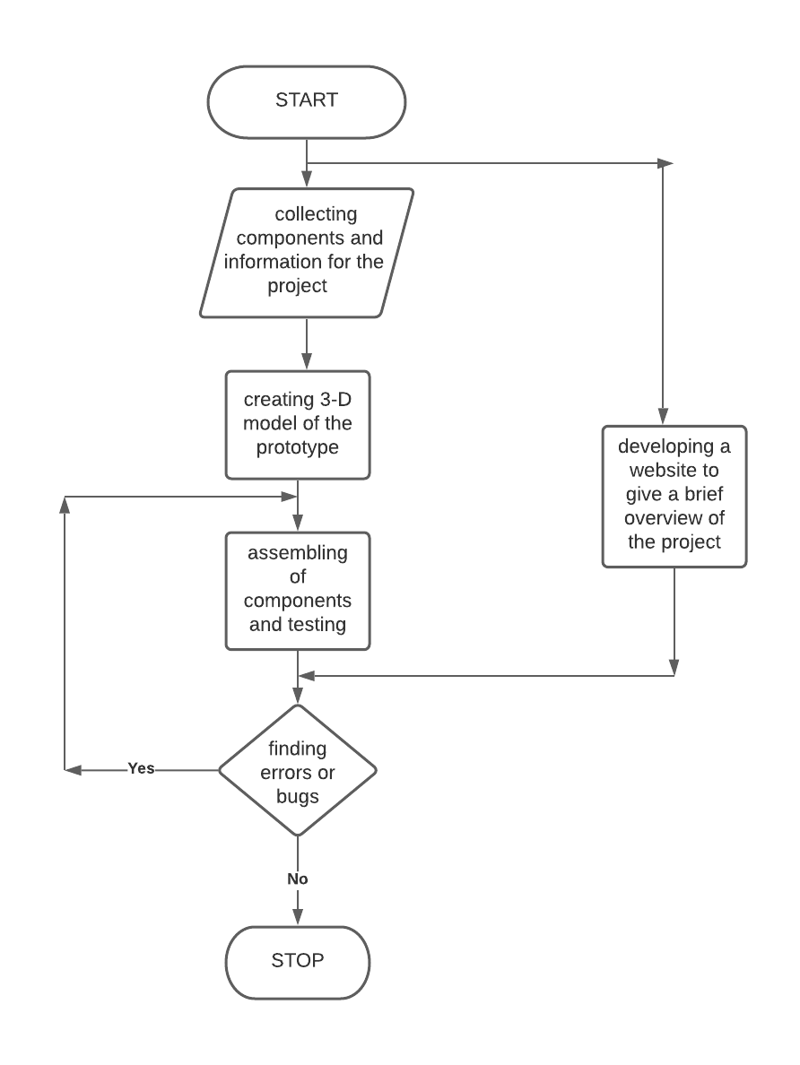

# . Results and Discussions

Thus, a self-stabilizing two wheeler bike model was successfully developed by using the concept of Gyroscopic Torque. The model created has been tested and has shown remarkable improved dynamics in comparison with the normal two wheeler models.

The design of the 3D model of the prototype for self stabilizing gyro bike model is as shown in the following figure:

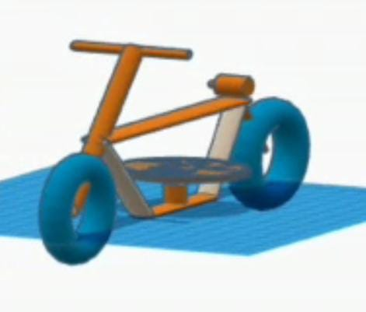

Fig.2. 3D model of the self stabilizing gyrobike model.

The actual working model of the prototype of self balancing gyroscopic bike can be seen in the following figure:

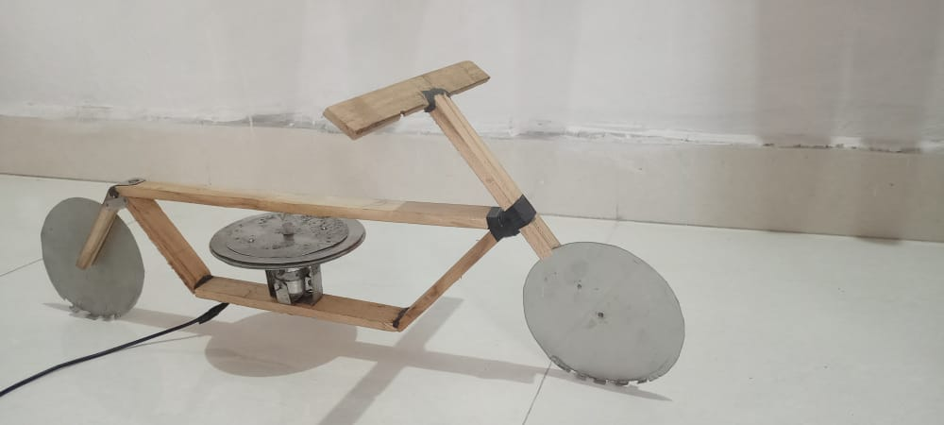

Fig.3. Actual working model of Gyrobike.

The website was developed in order to explain the informative theories and statistical analysis about the concerned project. In fig.4 the overlook of the website home page can be seen.

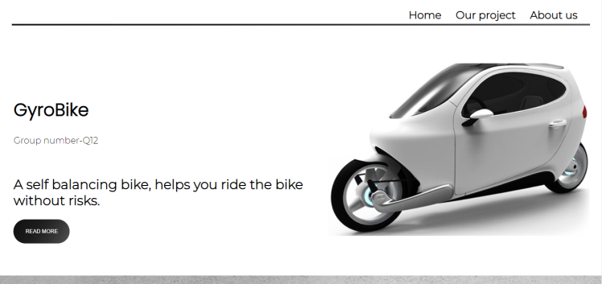

Fig.4. Homepage of the developed website.

# Limitations

The project has so far managed to discover the principle of self balancing. It has managed to design anway to keep the frame stable all the time. However, the bike is not quite able to balance fully on its own. It creates force to a certain direction on the change of the orientation of motors.But the motor becomes overweight after the addition of flywheel to the motor. This large weight along with the force due to change of orientation of the rotating disk creates such a momentum with the frame to a particular side rather than keeping it straight. The initial impact of the force is enough to create the sort of momentum that can push the frame beyond our expected limit.

# FUTURE SCOPE

The prototype is designed to provide safety to the rider riding the bike. It is designed to accommodate a single passenger due to its compact size. The thesis has emphasized on the self-stabilization technology. There is a scope to design a model of gyroscopic bike which could accommodate two passengers rather than one. The passenger can be accommodated behind the rider.

Also, further studies on the topic include compensating the speed of the rotating mass in accordance to the weight of the rider and developing adaptive control to the system so that the system can react to the changes to the payloads.

# CONCLUSION

As discussed earlier the unstable nature of the bike is point of concern for this project. So inorder to overcome it the Gyrobike can be used as an alternative. So while considering safety as one of the top priorities it can be finally concluded that the dynamic model of gyrobike thus proposed can help to minimize the accident rates of two wheeler vehicles by providing an appropriate balance of the bike. Also this type of module can be beneficial to the new learners to learn to ride bikes without any stress of misbalance.

In short, we can conclude that the two-wheeler self-balancing vehicle is capable of balancing itself under application of external forces and loads. The vehicle balances itself under various conditions like forced tilt of the vehicle. Thus the proposed system would be much helpful in reducing two-wheeler accidents or unwanted falls and increasing safety of the rider.

# REFERENCES

[1] Pratik D. Tak, “Self Stabilizing Bike Using Gyroscope.”, IJRET Nov.2017.

[2] Pallavi Gogoi, Manish Nath, BumiTruemanDoley, Abhijeet Boruah, Hirok Jan Barman, “Design and Fabrication of Self Balancing Two Wheeler Vehicle Using Gyroscope.”, IJET Jun-Jul 2017.

[3] Pom Yuan Lam, “Design and Development of a Self-balancing Bicycle using CMG.

[4] Sheikh Mohibul Islam Rumi, Shanamul Islam, Mehdi Fakid Hossain, “System Design of a Two Wheeler Self Balanced Vehicle.”

[5] Daniel Raviv, Anthony Radzins, MoradRahmani, “From Observation to Prototyping: A Hands-on UG Research.”

[6]R.S.Khurmi, J.K.Gupta, “Theory Of Machines.” S.Chand Publications.

# ACKNOWLEDGEMENT.

We would like to express our heartfelt gratitude to our Capstone Project Guide, Shri. Ranjeetsingh S. Suryawanshi for his valuable guidance and suggestions and to Dr. Sachin Sawant who provide all the necessary information about the completion of the project and to Mr. Sunil Choughule for his valuable guidance.

1.