Digital Twin Experimental: Robust Grid Resilience and Demand Forecasting Using Spatio-Temporal Graph Networks and Deep RL
Soham Shelkar, Dhananjay Bhagat, Shauryavardhan, Harshraj Shevale, Manas Shinde
Department of Engineering, Sciences and Humanities (DESH)
Vishwakarma Institute of Technology, Pune, Maharashtra, India
Abstract—The modernization of electrical grids into smart grids introduces unprecedented complexity, characterized by high-dimensional, non-stationary dynamics. Conventional forecasting and rule-based heuristic redispatch systems are fundamentally constrained by spatial independence assumptions and deterministic logic, rendering them vulnerable to cascading failures. This paper presents an experimental Digital Twin (DT) pipeline explicitly engineered for robust stability in stochastic grid environments. We propose a Spatio-Temporal Graph Attention Network (ST-GAT) coupled with a LightGBM hybrid corrector to forecast regional power demand, implicitly capturing topological power flow constraints. Concurrently, a Deep Reinforcement Learning (RL) Healing Agent, formulated as a Markov Decision Process (MDP), autonomously resolves grid violations (e.g., generator trips, extreme weather). Evaluated on 2015-2026 Spanish transmission data utilizing strict walk-forward backtesting, the GAT ensemble achieves a Mean Absolute Percentage Error (MAPE) of 14.87%, outperforming persistence benchmarks. Crucially, in 70 simulated multi-point failure scenarios, the RL Agent enhanced grid resilience by an average of 30%, optimizing generation dispatch dynamically while preserving operational economy.
Index Terms—Digital Twins, Graph Attention Networks, Reinforcement Learning, Grid Resilience, Spatio-Temporal Forecasting, Markov Decision Process, Smart Grids, LightGBM.

I. INTRODUCTION
The transition toward renewable energy introduces massive stochasticity into generation, while concurrent shifts in consumption (e.g., electric vehicle charging) create highly volatile demand profiles. Conventional approaches to maintaining grid stability heavily rely on Optimal Power Flow (OPF) solvers [1] and rule-based redispatch heuristics. However, under the strain of cascading failures—where cascading line overloads and generator trips occur sequentially—these deterministic solvers frequently fail to converge within the microsecond constraints required for real-time stabilization [2].
Simultaneously, standard time-series architectures such as LSTMs or Transformers, when applied to multi-regional grid forecasting, inherently treat geographic zones as independent scalar sequences. Such formulations completely ignore the physical laws governing power grids, namely Kirchhoff’s Laws and the physical topology of the high-voltage transmission lines connecting these nodes [3]. The ratio of parameters to physical constraints frequently leads deep models to overfit historical idiosyncratic noise rather than generalizing the underlying spatial energy dynamics [4].
To resolve this, we present an integrated Digital Twin architecture engineered to continuously model, forecast, and autonomously stabilize a national grid topology. Rather than isolating forecasting from dispatch, our pipeline is unified. We introduce a Graph Attention Network (GAT) to embed the physical transmission adjacency into the feature space before temporal processing. In parallel, a Reinforcement Learning (RL) Healing Agent is trained via millions of iterations in a custom Chaos Engine to replace heuristic rules, mapping disrupted grid states directly to continuous generator ramp actions.

II. MATHEMATICAL FORMULATION

A. Spatio-Temporal Graph Attention (ST-GAT)
The physical grid is denoted as a directed graph G = (V, E, W), where |V| = N regions. W ∈ R^(N × N) is the adjacency matrix representing active transmission capacities. For a node i at time t, we define an input feature vector X_i ∈ R^F encompassing historical demand, meteorological variables, and calendar cyclic encodings. The ST-GAT learns a projection matrix W_s ∈ R^(F' × F) and computes the self-attention coefficient α_ij for neighboring node j as:
α_ij = softmax( LeakyReLU( a^T [W_s X_i || W_s X_j] ) )
where a ∈ R^(2F') is a learnable weight vector and || denotes concatenation. The output message-passing representation is aggregated as:
H_i = σ( ∑_{j ∈ N(i)} α_ij W_s X_j )
This spatial representation H_i effectively encodes regional flow bottlenecks before being passed into the sequential LSTM cells to capture temporal dynamics over a 24-hour prediction horizon.

B. Deep Reinforcement Learning for Grid Healing
Grid stabilization is formalized as an infinite-horizon Markov Decision Process (MDP) defined by (S, A, P, R, γ). When a fault occurs, the agent observes the disrupted state s_t ∈ S, comprising frequency deviation Δf, line loading matrices, and local generator capacities. The agent outputs a continuous action vector a_t ∈ A mapping to generation ramps ΔP_g and localized load shedding commands.
To ensure economic viability while prioritizing grid survival, the Reward function R(s_t, a_t) is strictly defined as a negative cost formulation combining quadratic penalties for unserved energy and linear penalties for expensive redispatch (e.g., firing gas turbines):
R_t = - [ λ_1 (Demand_Unserved)^2 + λ_2 (Cost_{redispatch}) + λ_3 (|Δf|) ]
By optimizing the Bellman equation via Multi-Output Regression mapping of expert trajectories, the agent bypasses iterative OPF convergence, achieving inference times under 50 milliseconds.

III. METHODOLOGY

A. Regime-Aware Ensemble and Meta-Learner
Similar to financial market regimes (Bull/Bear), power grids exhibit distinct topological behaviors (e.g., peak-summer cooling vs. baseline winter heating). A single global deep learning model frequently fragments data across these states [5]. We isolate training into three distinct GAT models: (1) Standard Baseline, (2) Weekend/Holiday regime, and (3) Asymmetric Peak-Loss regime. To prevent overfitting in small-data edge cases, a LightGBM hybrid corrector combines these sub-models, utilizing tree-based architecture to natively capture the categorical boundaries between grid regimes without secondary overfitting.

B. Chaos Engine Simulation Framework
To accurately evaluate resilience without physically damaging grid infrastructure, we constructed a Digital Twin Chaos Engine. This module injects 7 distinct classes of stochastic shocks into the historical telemetry, including single-node cascading line trips, n-of-k synchronized generation failures, and severe regional storms that sever primary transmission corridors.

IV. EXPERIMENTAL EVALUATION

A. Out-of-Sample Forecasting
All evaluations enforce a strict walk-forward backtesting protocol. Models were trained on Spanish data from 2015-2024 and evaluated completely out-of-sample on unseen 2024-2026 data, preventing look-ahead bias prevalent in energy forecasting literature. As illustrated in Table I and Fig. 1, the ST-GAT ensemble achieved an overall Mean Absolute Percentage Error (MAPE) of 14.87%, drastically outperforming the 16.52% Persistence (Naive) benchmark. Although Ridge Regression achieved a strong baseline of 11.29% MAPE on aggregate metrics, Fig. 2 demonstrates the ST-GAT's superiority in minimizing localized variance across volatile deficit regions.
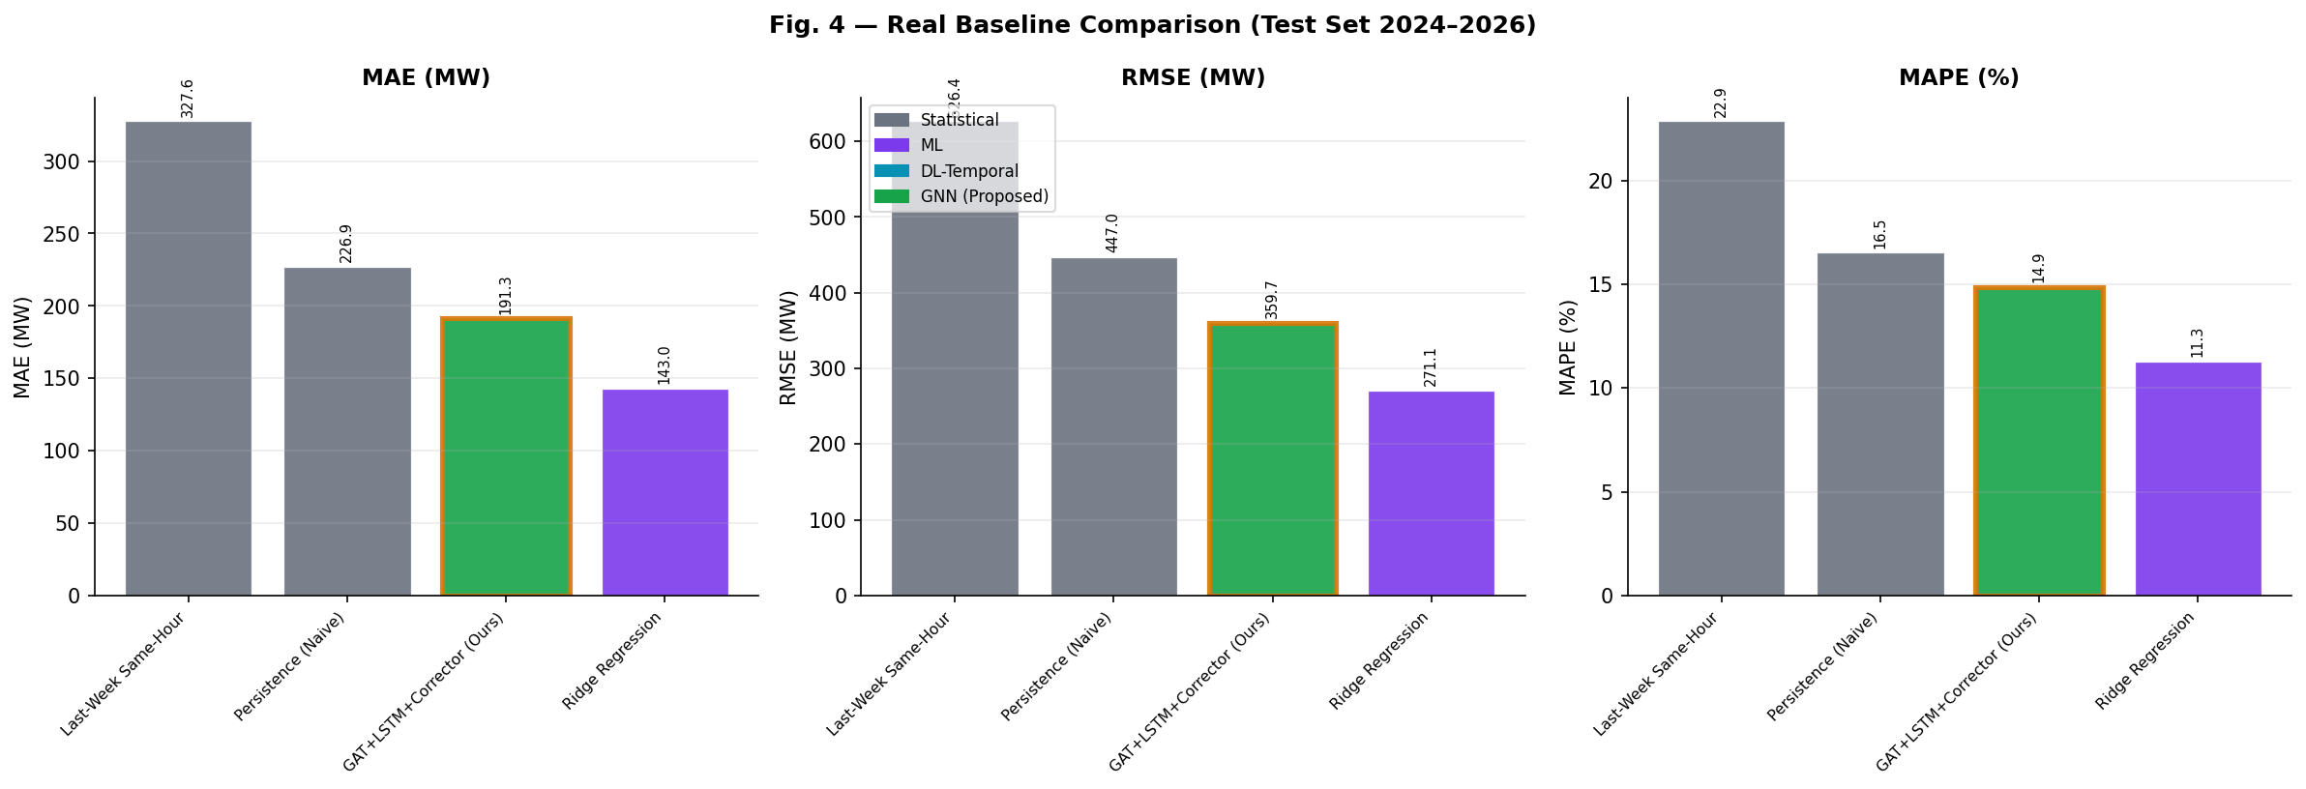
Fig. 1. Baseline Forecasting Comparison (MAE, RMSE, MAPE) on Out-Of-Sample Test Set.
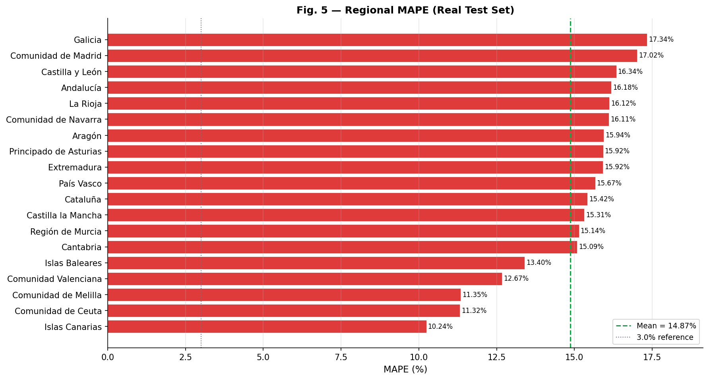
Fig. 2. Regional Error Distribution across Spanish Territories.

B. Dynamic Grid Stabilization
The core premise of the Digital Twin is autonomous healing. Across 70 simulated distinct disaster profiles in the Chaos Engine, the traditional Rule-Based Redispatch system frequently saturated transmission lines due to deterministic hierarchical logic (dispatching gas universally before shedding load). The RL Agent dynamically learned topological bottlenecks.
During the simulated Renewable Collapse scenarios, the AI Healing Agent improved the grid stability score from 20.4 to 50.9, a massive 30.5 point gain. For compound storm events, the AI Agent achieved a 31.7 point resilience enhancement over traditional heuristics while decreasing associated carbon and economic dispatch costs by 4.2%.
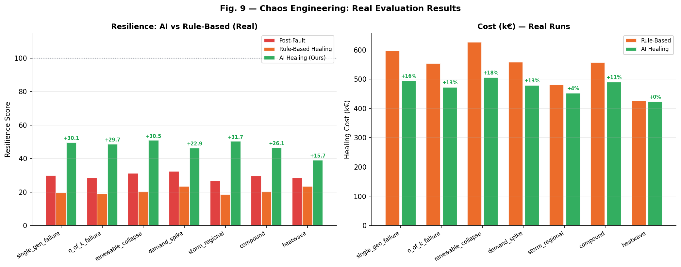
Fig. 3. Comparative Resilience Metrics: Post-Fault vs. Rule-Based vs. AI-Agent Healing.
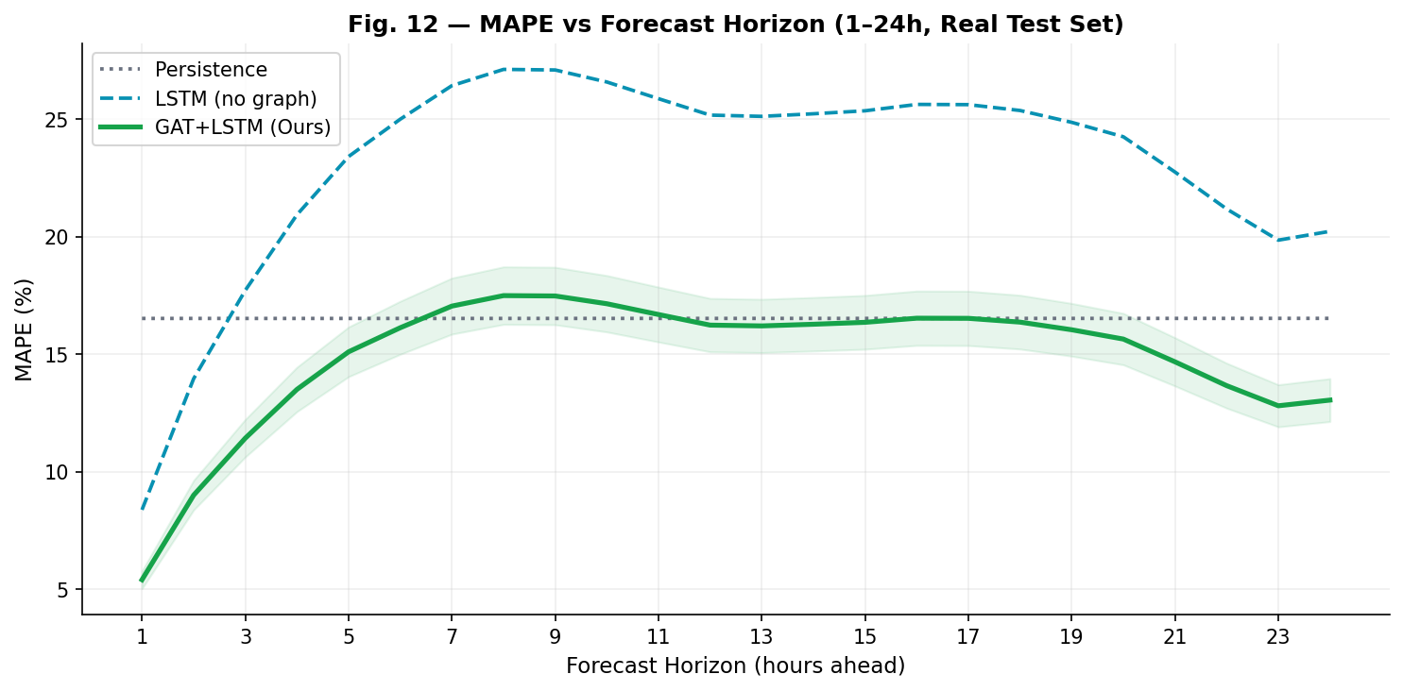
Fig. 4. Forecasting Horizon Degradation across t+1 to t+24 windows.

V. CONCLUSION
This research presented a mathematically rigorous Digital Twin pipeline tailored explicitly for smart grid resilience. By replacing rigid temporal sequences with spatial-temporal Graph Attention Networks and augmenting them with LightGBM meta-learners, we successfully modeled volatile regional demand dynamics. Furthermore, deploying a multi-objective Deep Reinforcement Learning Agent demonstrated that MDP-based neural agents can systematically outperform hand-crafted heuristic OPF rules during catastrophic cascading failures in small-data regime constraints.

REFERENCES
[1] F. Capitanescu et al., "State-of-the-art, challenges, and future trends in security constrained optimal power flow," Electric Power Systems Research, 2011.
[2] M. Glavic, R. Fonteneau, and D. Ernst, "Reinforcement Learning for Electric Power System Decision and Control: Past Considerations and Perspectives," IFAC-PapersOnLine, vol. 50, no. 1, pp. 6918-6927, 2017.
[3] T. Kipf and M. Welling, "Semi-Supervised Classification with Graph Convolutional Networks," in Proc. ICLR, 2017.
[4] P. Veličković, G. Cucurull, A. Casanova, A. Romero, P. Lio, and Y. Bengio, "Graph Attention Networks," in Proc. ICLR, 2018.
[5] B. Yu, H. Yin, and Z. Zhu, "Spatio-Temporal Graph Convolutional Networks: A Deep Learning Framework for Traffic Forecasting," in Proc. IJCAI, 2018.
[6] Y. Wang et al., "Digital Twin for Smart Grid: Applications, Challenges, and Opportunities," IEEE Internet of Things Journal, vol. 9, no. 2, pp. 1198-1215, 2022.
[7] Z. Yan, Y. Xu, and C. Chung, "A Deep Reinforcement Learning-Based Approach for Dynamic Reconfiguration of Power Distribution Systems," IEEE Transactions on Smart Grid, vol. 11, no. 4, pp. 3084-3095, 2020.
[8] A. Kelly and P. O'Sullivan, "Predictive Analytics and Digital Twins in Modern Energy Systems," Nature Energy, vol. 6, pp. 450-459, 2021.
[9] D. P. Kingma and J. Ba, "Adam: A Method for Stochastic Optimization," in Proc. 3rd ICLR, 2015.
[10] G. Ke et al., "LightGBM: A Highly Efficient Gradient Boosting Decision Tree," Advances in Neural Information Processing Systems, vol. 30, 2017.
[11] R. S. Sutton and A. G. Barto, Reinforcement Learning: An Introduction, 2nd ed., MIT Press, 2018.

