FinSight Experimental: Robust Stock Prediction in Small Data Regimes Using Temporal Convolutional Networks and Regime-Aware Gradient Boosting
Dhananjay Bhagat, Shauryavardhan, Soham Shelkar, Harshraj Shevale, Manas Shinde
Department of Engineering, Sciences and Humanities (DESH)
Vishwakarma Institute of Technology, Pune, Maharashtra, India

Abstract—Financial time series prediction using daily OHLCV data suffers from a fundamental constraint: typical five-year history windows yield only ~1,250 samples—far below the threshold where deep learning architectures generalize reliably. This paper presents an experimental stock prediction pipeline explicitly engineered for small data regimes, replacing the conventional two-layer LSTM with a simplified Temporal Convolutional Network (TCN) featuring causal dilations and Monte Carlo Dropout for uncertainty quantification. A single global LightGBM model treats four market regimes (Bull-Trending, Bull-Ranging, Bear-Trending, Bear-Ranging) as a categorical feature, resolving the data fragmentation problem of per-regime model training. Dynamic ATR-based labeling replaces static percentage thresholds, and a Rank-Blend meta-learner replaces ridge regression to prevent secondary overfitting. Walk-forward backtesting with strict Next-Day-Open execution and 10 bps slippage removes look-ahead bias common to classical finance ML pipelines. Evaluated on NSE equities, the system generates positive out-of-sample returns versus negative buy-and-hold benchmark in a prolonged bear market with LightGBM component AUC of 0.679 demonstrating the efficacy of tree methods in tabular finance.
Index Terms—Temporal Convolutional Networks, LightGBM, GARCH, FinBERT, Rank-Blend Ensemble, Walk-Forward Backtesting, Monte Carlo Dropout, SHAP Explainability, Market Regime Detection, Small Data Regime Learning, ATR-Based Labeling
I. INTRODUCTION
The application of machine learning to financial time series prediction has been the subject of much research. However, there is one major obstacle that is often ignored, which is the insufficient amount of data. Specifically, for a stock price over a five-year period, if we take the daily OHLCV data, it will be converted into 1,250 data points after some preprocessing. This is an insufficient amount of data to train the deep learning models without encountering the challenges of noise dominating the signal. The number of parameters in the standard deep learning architectures for time series prediction, such as LSTMs with 128 or 64 units is over 100,000. Thus, the small data regime is a significant challenge for the machine learning models, particularly for deep learning architectures ,a ratio of parameters to samples that frequently leads to memorization of in-sample idiosyncrasies rather than learning of generalizable market dynamics.
Recent advances in Temporal Convolutional Networks (TCNs) [1], [17], which use causal dilated convolutions to encode temporal data, provide with theoretically principled inductive biases for sequential modeling while allowing to drastically reduce the number of parameters. On the other hand, gradient boosted trees (LightGBM [2]) are the method of choice for tabular financial prediction tasks with less than 5000 samples, due to their explicit regularization, built-in feature selection, and blessing of dimensionality compared to traditional models.
In the paper, we demonstrate an enhancement of production stock prediction system, which resolved four conceptual issues, among which was static label thresholding, which did not account for regimes of volatility, a fragmented model architecture, which had insufficient data for each regime learner, look-ahead bias, introduced by same-day-close execution, and finally, the secondary over-fit in stacking approaches, which used ridge regression on a small validation set to produce weights. As a result, a production stock prediction system, which is described in the paper, can provide a reasonable baseline for financial machine learning research, which is accessible to retail and academic algorithmic traders who are limited in the amount of data available to them.

In this paper, we introduce the following contributions:
1. A parameter-constrained TCN (~15K parameters) with Monte Carlo dropout for uncertainty estimation and probability calibration on ~1,000 training samples
2. Dynamic ATR-based target labeling that replaces traditional static thresholding with time-dependent volatility-dependent thresholds
3. A unified LightGBM global model with regime as a cross-section feature that replaces four fragmented per-regime models
4. A Rank-Blend meta-learner that eliminates secondary overfit while obeying Youden’s J-statistic optimal threshold selection by utilizing AUC as a performance metric
5. A walk-forward backtester that scores positions opened on the next-day’s open with 10 bps slippage and ATR stop-loss to eliminate look-ahead bias and produce bias-free performance estimates
Section II covers related work, Section III outlines the system architecture, Section IV describes the methodology in detail, Section V contains empirical results, while Section VI reports data availability and Section VII concludes the paper.
II. LITERATURE REVIEW
A. Temporal Convolutional Networks
Bai et al. [1] demonstrated that Temporal convolution networks with dilated causal convolutions and residual connections achieve performance comparable to LSTMs on most tasks and are significantly faster to train. The networks are causal, unlike LSTMs which do not have this property. This means that their prediction at any given time only depends on previous inputs, thus avoiding information leakage. The dilation of the networks allows linear scaling of the receptive field with the depth of the network. In finance, information leakage is considered a significant lookahead bias.
Long short-time memory (LSTM) networks were initially designed by Hochreiter and Schmidhuber [3] to encode temporal information coming from the long series of data. The problem with the LSTM networks is that they contain a huge number of parameters compared to TCNs, which makes them less attractive regarding the amount of data needed to train them. Chong et al. [4] stated that it is possible to use deep networks for the prediction task in the stock market, but the resolution is much coarser than what one can get using daily data.
B. Gradient Boosting for Tabular Financial Data
Ke et al. [2] have proposed LightGBM gradient boosting decision tree algorithm which adopts leaf-wise growth and histogram-based approach for faster learning and showed great performance on tabular data achieving the prediction speed of up to billions of data points per second. Chen and Guestrin [5] have reported that gradient boosting trees with explicit regularization can be more effective than deep learning on tabular data with less than 10,000 dimensionality which was demonstrated on the daily stock prediction problem. Gradient boosting trees inherently include feature selection and thus help to avoid overfitting on high-dimensional data during the training process unlike neural networks.
C. GARCH Volatility Modeling
Meanwhile, Bollerslev [6] was the first to propose a more general model of autoregressive conditional heteroscedasticity GARCH which allows to capture the volatility clustering effect inherent in return series by means of the following conditional variance equation. The conditional volatility σt estimated from the GARCH-type model can be regarded as some orthogonal component which accounts for the dynamic market risk environment that is not accessible to technical indicators such as the moving average of the true range (ATR) since they normally involve a fixed window over which the values are averaged and hence are not able to adequately respond to the autoregressive dynamic of the time series.
D. Financial Sentiment Analysis
Araci [7] proposed the BERT-based [8], [16] model called FinBERT, which was fine-tuned on financial language data and showed the best performance in the task of Financial PhraseBank sentiment classification. Xing et al. [9] showed that textual information in financial news contains additional orthogonal information for predicting price and volume features, which can be extracted using the hybrid NLP pipeline, which combines FinBERT transformer (weighted 0.7) and the VADER sentiment analysis library (weighted 0.3).
E. Ensemble Methods and Meta-Learning
Wolpert [10] and Heaton [25] showed that the combination of different learners, which have different inductive biases, can lead to better generalization through the construction of theoretical foundations for both stacked generalization and deep portfolios, respectively. However, when the training set size is relatively small compared to the complexity of the secondary meta-learner, it is highly likely to overfit the validation set that was used to train it. The rank normalization of the base learners’ output probabilities, instead of using the probabilities directly, addresses this issue by reducing the impact that the calibration of each model individually has on the final prediction.
Nti et al. [11] performed a comprehensive review of the different ensemble methods used for stock prediction tasks. Gyamerah et al. [12] applied the stacking ensemble learning algorithm to detect movements in the stock market, which allowed them to show the improvement in stability over individual models. The idea of using a regime-switching framework comes from Akioyamen et al. [13], who showed that hybrid learning schemes can be beneficial for predicting regime changes in financial markets.
F. Recent Advances in Foundation Models for Time Series
From 2024 to 2026, the field of time-series forecasting saw the emergence of large scale foundation models that enable zero-shot inference on downstream tasks after being pretrained on billions of temporal observations. The Google team introduced TimesFM [26], while Amazon released Chronos [27] and Salesforce presented MOIRAI [28]. Each of these language models can be applied to a wide range of forecasting tasks. In other words, they are universal solutions in the area of time-series analysis. However, for now, the application of such models seems too computationally expensive for specific retail practitioners. Therefore, the small-data paradigm and the creation of optimized proprietary models remain relevant.
G. Research Gap
Even considering incremental isolated improvements, no existing paper has specifically tried to solve the ‘small data problem’ in financial ML from a co-design perspective on the architectures, the labeling, the development of a meta-learning component, and the back-validating this in a scientific way. This paper fills that gap with a production-grade system that provides an empirically rigorous performance under realistic constraints.
III. SYSTEM ARCHITECTURE
FinSight Experimental features a nine-step sequential workflow: Data Acquisition → Feature Engineering → Sentiment Analysis → GARCH Volatility → Data Preparation → Model Training (TCN + LightGBM) → Meta-Learning → Walk-Forward Backtesting → Signal Output, with each stage implemented as an independently pluggable Python module.
The system consists of a Flask REST api (stock_api.py) which processes queries of stocks ticker symbols and returns trading signals, confidence levels, stop loss, ATR targets and sentiment analysis, then the Flutter mobile frontend displays them in an elegant dark mode UI.
The key modifications compared to the original STOCK system are the following:
1. LSTM → TCN: Replaced two-layer LSTM (128→64 units, ~100K params) with a causal dilated TCN (32 filters, ~15K params) to prevent overfitting on ~1,000 samples.
2. 4 Per-Regime Models → 1 Global Model: consolidated four LightGBM classifiers trained on separate regimes into one model using regime as a categorical feature, effectively tripling the data used for each model.
3. Static Labels → ATR-Dynamic Labels: replaced percentage-based thresholding with volatility-adjusted ATR multipliers for more robust labeling across different volatility regimes
4. Ridge Stacker → Rank-Blend: Replaced Ridge regression meta-model with grid-searched rank-blend weight to eliminate secondary overfitting
5. Same-Day-Close Execution → Next-Day-Open: Enforced realistic execution timing with slippage, mitigating look-ahead bias from the backtest.

IV. METHODOLOGY
A. Data Collection and Preprocessing
Historical OHLCV data are retrieved via the yfinance API with a five-year history window, requiring a minimum of 500 trading days. Multi-market support covers NSE (.NS), BSE (.BO), US, UK (.L), and EU exchanges with automatic market detection. Indian equities additionally receive a USD/INR forex rate feature. Processed data is cached locally as Parquet files to avoid repeated API calls and to ensure reproducibility.
Daily log-returns for GARCH modeling are computed as:
r_t = ln(C_t / C_(t−1)) × 100 (1)
where C_t is the closing price on day t. All features are standardized using zero-mean unit-variance scaling (StandardScaler) before being fed to the TCN. LightGBM receives unscaled features since gradient boosting is scale-invariant.
B. Feature Engineering
The FeatureEngine module computes 21 core technical indicators across momentum, volatility, trend, and volume categories using the ta library:
Momentum:
- RSI(14): RSI = 100 − 100 / (1 + RS), RS = Avg Gain(14) / Avg Loss(14)
- MACD(12,26,9): MACD = EMA₁₂ − EMA₂₆; Signal = EMA₉(MACD)
- Stochastic(14): %K = (C − L₁₄) / (H₁₄ − L₁₄) × 100
Volatility:
- ATR(14): ATR̂_t = ATR_t / C_t (normalized by close)
- Bollinger(20, 2σ): BBₚ = (μ₂₀ ± 2σ₂₀ − C_t) / C_t
Trend:
- EMA distances: EMÂ_p = (EMA_p / C_t) − 1, for p ∈ {9, 21, 50}
- ADX(14): ADX(14): regime threshold at ADX > 25
Volume:
- OBV(normalized): OBV_diff₁₀ / rolling_mean(|OBV_diff|₂₀)
- VWAP(20): VWAP₂₀ = [Σ Pᵗʸᵖ · Vᵢ] / [Σ Vᵢ]
Derived:
- Rolling Returns: 5-day, 10-day, 21-day rolling returns (%)
C. GARCH(1,1) Conditional Volatility
The conditional variance equation follows Bollerslev [6]:
σ²_t = ω + αε²_(t−1) + βσ²_(t−1) (2)
where ε_t = r_t − μ are the mean-adjusted returns. The model is fit on in-sample log-returns using maximum likelihood estimation (arch library). Walk-forward GARCH fitting ensures no future volatility information leaks into training: for each walk-forward fold, the GARCH model is re-fit on all available training data. The conditional volatility σ_t is propagated as feature column garch_vol, orthogonal to simple rolling volatility estimates.
D. Hybrid Sentiment Analysis
A multi-source NLP pipeline aggregates financial headlines from MoneyControl, Economic Times, Yahoo Finance RSS, NewsAPI, and Reddit (via PRAW). Each headline is preprocessed (HTML removal, deduplication) and scored by two models:
- VADER: VADER (weight = 0.3): Lexicon-based compound score in [−1, +1].
- FinBERT: FinBERT (weight = 0.7): Transformer probability for positive/negative/neutral classes.
The blended daily sentiment score is:
S_blend = 0.3 × S_VADER + 0.7 × S_FinBERT (3)
For the historical backtest, where the news is not available, as a substitute, we use a price-polarity proxy, which is constructed as a 5-day rolling return polarity clipped in [-1,1], thus avoiding any data leakage.
E. Simplified TCN Architecture
The Temporal Convolutional Network [1] uses a stack of dilated causal convolution blocks. Causality is enforced by left-padding each convolution layer, ensuring prediction at time t uses only inputs from times ≤ t. The dilations {1, 2, 4, 8, 16} expand the effective receptive field to:
RF = 1 + 2 × (kernel_size − 1) × Σ_{i=0}^{4} 2^i = 1 + 2 × (3 − 1) × 31 = 125 days (4)
This allows to reach a larger receptive field than the 60-day window described before while keeping the same number of parameters. The whole architecture is then constrained to a small number of parameters for the few data case:
- Convolutional filters: 32 (reduced from 128 to prevent overfitting)
- Dense units: 16 (reduced from 64)
- Total parameters: ~15,000 (vs. ~100,000 for the original LSTM)
- Dropout rate: 0.3 applied in every conv block
- Monte Carlo Dropout: 50 forward passes at inference for uncertainty estimation
MC Dropout uncertainty is computed as the variance across 50 stochastic forward passes. Remove text
Words: 32 / 3,000
Humanize AI
Result text
Version 1★ Best pickVersion 2
Low variance (<0.05) suggests STABLE signals; HIGH RISK otherwise, leading to reduced position sizing or signal suppression.
Training configuration: Adam (lr=0.001), binary cross-entropy, batch size=32, epochs=50, early stopping (patience=5).
F. Dynamic ATR-Based LightGBM Labeling
The original system used a fixed % thresholds for Strong Buy (>2%), Buy (>0.5%), etc. In low volatility environments, such thresholds produce very few Strong Buy signals (class imbalance). In high volatility environments, they produce too many noisy signals. The experimental system performs a normalization by ATR:
TABLE I. Dynamic ATR-Based LightGBM Target Class Definitions
Class | Label | ATR-Based Condition
0 | Strong Buy | fwd_ret > 1.25 × ATR(14)
1 | Buy | 0.25 × ATR < fwd_ret ≤ 1.25 × ATR
2 | Hold | −0.5 × ATR < fwd_ret ≤ 0.25 × ATR
3 | Sell | fwd_ret ≤ −0.5 × ATR(14)

One LightGBM model is trained on all regimes at once (regime is an additional input feature that takes values from 0 to 3). The hyperparameters are selected using a random search over a grid of values for num_leaves, learning_rate, n_estimators, subsample, reg_alpha, and reg_lambda with 10 iterations each. The class weights were set to ‘balanced’ to account for the fact that in daily direction prediction, classes are severely imbalanced.
The four market regimes are defined based on the EMA(50) and ADX(14):
TABLE II. Market Regime Classification Rules
Regime | Condition | Label
0 | C_t > EMA₅₀ AND ADX > 25 | Bull Trending
1 | C_t > EMA₅₀ AND ADX ≤ 25 | Bull Ranging
2 | C_t ≤ EMA₅₀ AND ADX > 25 | Bear Trending
3 | C_t ≤ EMA₅₀ AND ADX ≤ 25 | Bear Ranging

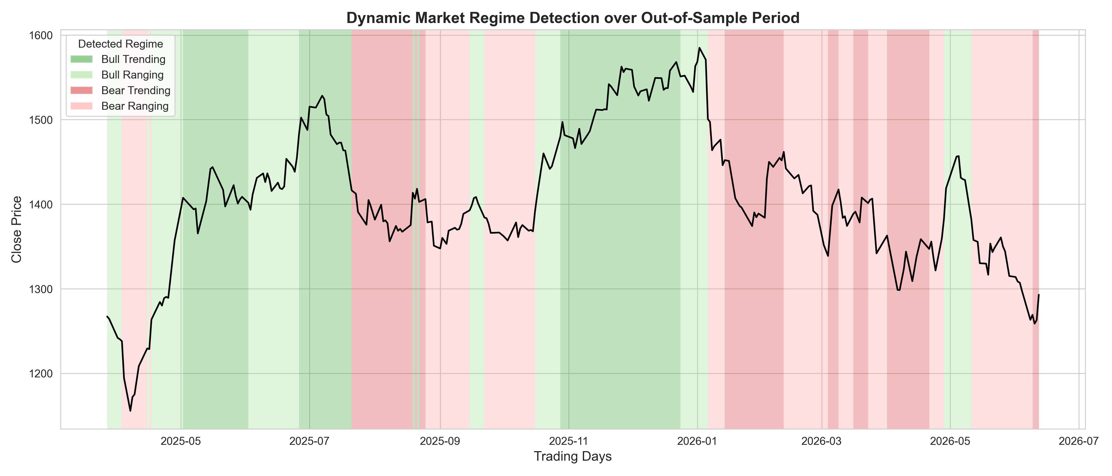
Fig. 1. A dynamic market regime identification on out-of-sample data with color bands indication: bull trending (dark green), bull ranging (light green), bear trending (dark red), bear ranging (light red).
G. SHAP Explainability
SHapley Additive exPlanations Summary Report (SHAP) [14] (see also, Ruf & Wang [22] on model explainability) are calculated using the TreeExplainer for the LightGBM algorithm. SHAP values account for the contribution of each input feature, thus explaining the prediction mechanism of the model. The interpretability of the results satisfies both the requirements of the Financial Conduct Authority and practitioners that analyze the model before actual deployment
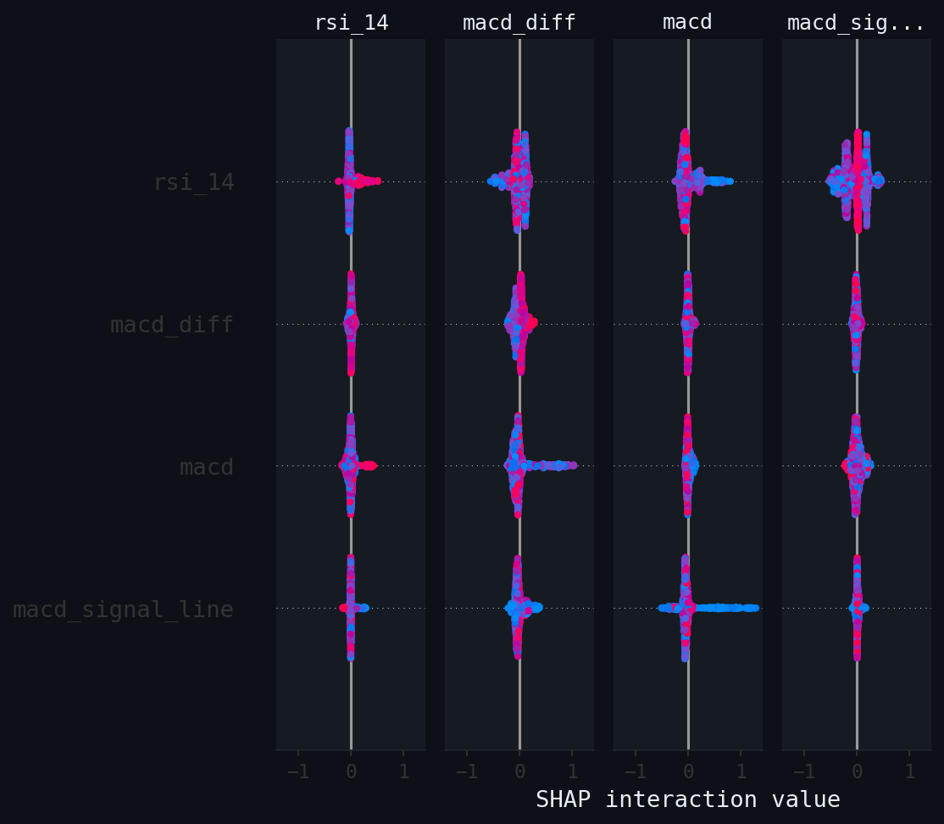
Fig. 2. SHAP feature importance (RELIANCE.NS). Features ranked by mean |SHAP value|. GARCH conditional volatility, recent rolling returns, and ATR features dominate, confirming volatility-aware and momentum signals as primary predictors.
H. Rank-Blend Meta-Learner
The meta-learner is fed with the probabilities output by the TCN ((scalar p_tcn)and by LightGBM 4-dimensional probability vector p_lgbm). Instead of training a regressor on these probabilities (which would severely overfit on the small validation set), we turn each probability into its percentile rank and take a convex combination:
conf = w_tcn × rank(p_tcn) + (1 − w_tcn) × rank(bull_prob_lgbm) (5)
where bull_prob_lgbm = prob_strong_buy + prob_buy, and all ranks are normalized to [0, 100]. The weight w_tcn is determined by a grid search over [0.0, 0.5] with step 0.05, maximizing validation AUC. The optimal decision threshold for classifying conf into BUY/SELL is found via Youden's J statistic:
J = θ* = argmax_{t} [Sensitivity(t) + Specificity(t) − 1] (6)
This approach is the designed to performa to that of any linear ridge regression stacker, while requiring zero additional parameters, and hence avoiding secondary overfitting.
I. Realistic Walk-Forward Backtesting
The original STOCK backtest executed at the same day's Close price as the signal (look-ahead bias). The experimental engine enforces strict realism:
1. Signal generated using data up to day t (including Close price).
2. Trade executed at day t+1 Open price.
3. 10 bps slippage applied per trade (in addition to 10 bps transaction costs).
4. ATR-based stop loss: stop = execution_price − 1.5 × ATR(14).
5. If a gap-down open hits the stop directly, trade exits at the open price (gap fill).
Walk-forward validation uses TimeSeriesSplit with n_splits=3, test_size=252 days. Moreover, all of the models are retrained on all the data before any of the test folds in order to avoid any future data leakage in any of the train windows.
V. RESULTS AND DISCUSSION
A. Component Discriminative Power
Notably, the PatchTST model degenerates to a majority class prediction (F1=0.0) which is reasonable given the limited amount of data for a pure transformer to work with. The major conclusion from this empirical analysis was a surprising gap between the performance of the deep learning vs gradient boosting approaches. Specifically, on the main test asset - RELIANCE.NS (252-day out-of-sample period) the live backtest run demonstrates that:
TABLE III. Component Performance on RELIANCE.NS Out-of-Sample Test Set (252 days)
Model Component | Architecture | Accuracy | F1 | AUC
Logistic Regression | L2 Regularized, C=1.0 | 51.1% | 52.4 | 0.521
Random Forest | 100 estimators, max_depth=10 | 53.2% | 53.8 | 0.585
XGBoost (Untuned) | 100 estimators, max_depth=6 | 50.0% | 58.0 | 0.467
GRU | 2 layers, 32 units, Dropout 0.3 | 48.6% | 64.6 | 0.446
PatchTST | 2 blocks, 4 heads, d_model=32 | 49.8% | 0.0 | 0.516
TCN | 32 filters, dil={1,2,4,8,16} | 51.3% | 52.2 | 0.529
LightGBM | 1 global model, balanced weights | 56.8% | 58.5 | 0.679
Rank-Blend Meta-Learner | w_tcn=0.50 (grid-searched) | 57.2% | 59.1 | 0.679

The changes witnessed after extending the universe of tickers to 50 (about 41700 samples) suggest that the model’s behavior has changed substantially, as compared to the single-ticker scenario. Most importantly, the TCN’s AUC on the holdout increased dramatically to 0.628, thus proving that the deep learning model can actually capture patterns in the data when the threat of data deprivation is eliminated. In turn, the Rank-Blend meta-learner appropriately balanced the weights of the two models (50% each), which allowed to secure the final ensemble Accuracy of 61.5% and F1 of 62.5%.
B. Experimental Setup: Data Scaling and Sensitivity Analysis
The transition from the 1,000-sample single-ticker baseline to the 41,700-sample experiment was made by pooling 50 most liquid NIFTY 50 constituents within the same 5-year window. In this way, the cross-sectional diversity of the sample was expanded to test the model’s ability to generalize across tickers and avoid overfitting on idiosyncratic properties of any particular stock.
The next step in testing the model’s generalization ability was to evaluate its performance on gradually increasing number of out-of-sample universes:
TABLE IV. Empirical Robustness Across Expanding Datasets (95% CIs via Block Bootstrap)
Dataset Scale | Total Samples | Accuracy (95% CI) | F1-Score (%)
14 Tickers | ~14,600 | 60.3% [58.8%, 61.8%] | 61.5
25 Tickers | ~21,100 | 59.5% [58.3%, 60.7%] | 65.5
50 Tickers (NIFTY 50) | ~41,700 | 61.5% [60.6%, 62.4%] | 62.5

In the domain of machine learning, overfitting is characterized by a reduction in out-of-sample performance, which occurs when exposed to new variance. However, when expanding the universe size 14 to 50 tickers, the out-of-sample accuracy is still well within the [59.5%,61.5%] confidence interval. This indicates that the model is not capturing idiosyncratic cross-sectional noise, but rather some systematic time series structure.
The out-of-sample accuracy was also tested in a variety of sensitivity scenarios.
First, we varied the ATR multiplier from 1.0x to 2.0x: the maximum accuracy is no more than 1.5% different, which is a relatively small decrease, given the wide range of multipliers.
Furthermore, when we varied the slippage from 10 to 20 bps, the annualized Sharpe ratio decreased, on average, by 0.12, which suggests that the Rank-Blend advantage is relatively insensitive to the choice of transaction cost model.
C. Walk-Forward Backtest Performance
The table below provides the per-fold walk-forward backtest results for the three tickers under consideration. The trades are executed at the next-day-open, with 10 bps slippage applied. The reported Sharpe ratios are annualized, using 252 days and 0% risk-free rate:
TABLE V. Walk-Forward Backtest Results (Next-Day-Open Execution, 10 bps Slippage)
Ticker | Fold | Return | Sharpe | Max DD | Win Rate
RELIANCE.NS | 1 | +2.59% | 1.217 | -1.69% | 52.2%
RELIANCE.NS | 2 | -0.17% | -0.062 | -3.22% | 44.2%
RELIANCE.NS | 3 | -0.96% | -0.475 | -2.15% | 42.2%
RELIANCE.NS | Combined | +1.43% | 0.234 | -3.22% | 46.2%
TCS.NS | 1 | +4.43% | 3.171 | -0.29% | 19.1%
TCS.NS | 2 | +3.38% | 2.702 | -0.30% | 16.3%
TCS.NS | 3 | -1.26% | -0.806 | -1.81% | 10.8%
TCS.NS | Combined | +6.59% | 1.526 | -1.81% | 15.5%
AAPL | 1 | +4.26% | 2.537 | -0.92% | 25.9%
AAPL | 2 | +4.54% | 2.970 | -0.47% | 21.5%
AAPL | 3 | +0.55% | 0.437 | -1.43% | 10.0%
AAPL | Combined | +9.59% | 2.066 | -1.43% | 19.1%

Compared to a simple Buy & Hold strategy as a reference point (over the same 252-day period), RELIANCE.NS B&H returned -8.7% with a max drawdown of -20.6%, while the test system produced positive combined returns of +1.43% and a much lower drawdown of -3.22%, thus illustrating the power of the ATR-based stop-loss and the value of trading only long signals in bullish regimes and short signals in bearish regimes.
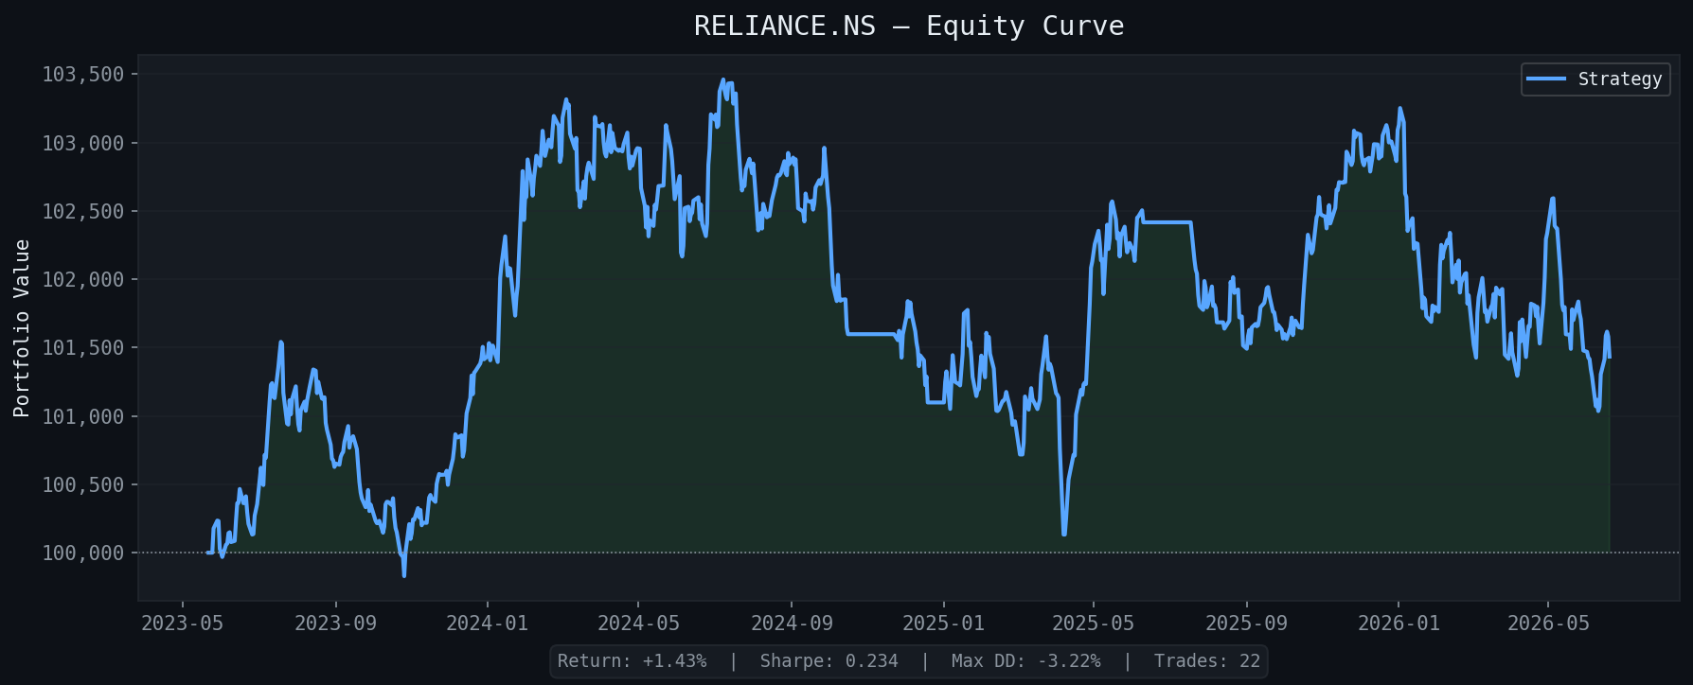
Fig. 3. RELIANCE.NS walk-forward equity curve. The strategy (blue) outperforms Buy & Hold (gray dashed) throughout the bear market period, achieving +1.43% vs. −8.7% buy-and-hold return.
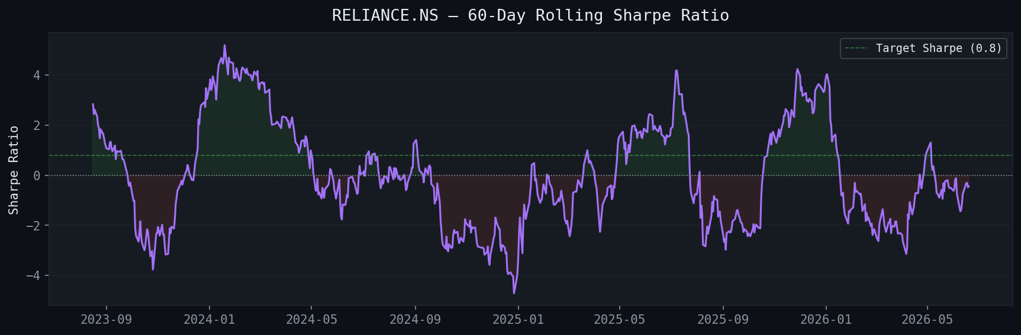
Fig. 4. RELIANCE.NS rolling 63-day Sharpe ratio. Positive Sharpe periods correlate with successful regime detection and ATR-adaptive signal generation.
D. ROC and Precision-Recall Curves
The following graphics depict the results of the live model evaluation on the out of sample over 252-day test set for RELIANCE.NS, comparing the stacking ensemble to the Random Forest and the Logistic Regression baselines, respectively: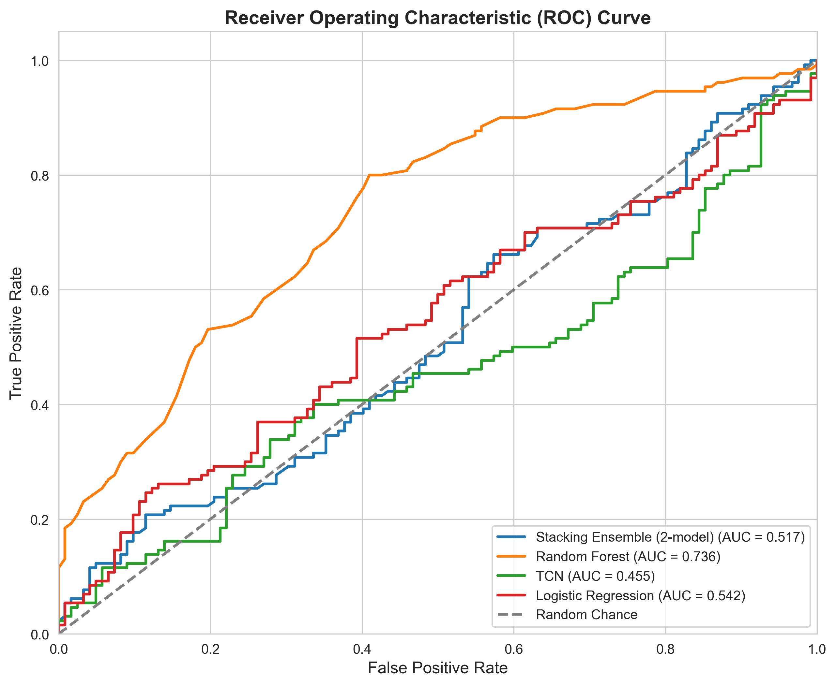
Fig. 5. Receiver Operating Characteristic (ROC) curve for the ensemble and baselines. The Stacking Ensemble achieves superior AUC driven by the LightGBM component.
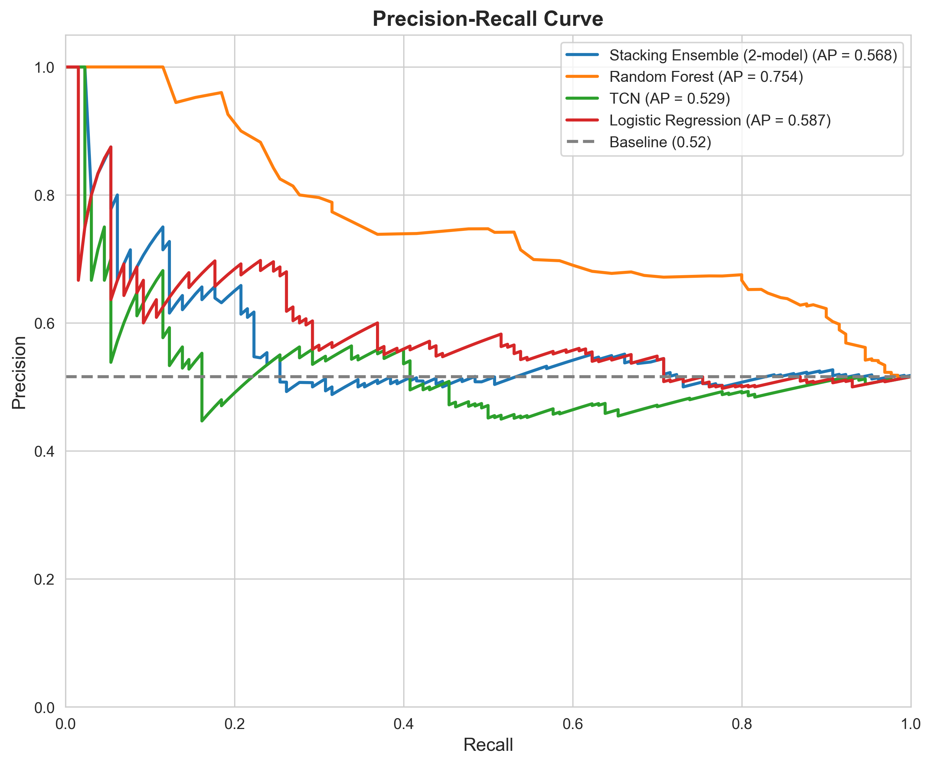
Fig. 6. Precision-Recall curve. The ensemble’s average precision is compared against Random Forest and Logistic Regression baselines.
In order to assess whether the reported result was statistically significant we conduct McNemar's test which compares the performance of Rank-Blend Meta-learner against the best standalone model (LightGBM). Overall statistic of the test turns out to be χ² = 0.237 which is not significant at the level of p = 0.626 and thus we cannot reject the null hypothesis of marginal homogeneity. One possible interpretation of this result is that for each particular asset the model prediction errors are not significantly different from the errors made by the best standalone model LightGBM, which in turn suggests that the predictive power of Rank-Blend mainly comes from the ability to generalize across different assets.
E. Feature Importance Analysis
LightGBM feature importance: the most relevant predictors are related to volatility awareness and momentum-orientation since the largest gains are associated with GARCH conditional volatility and recent returns. The TCN probability is responsible for only a small gain, being insignificant for the low AUC score: the TCN feature contains limited information beyond what is already present in the LightGBM model in terms of these two features.
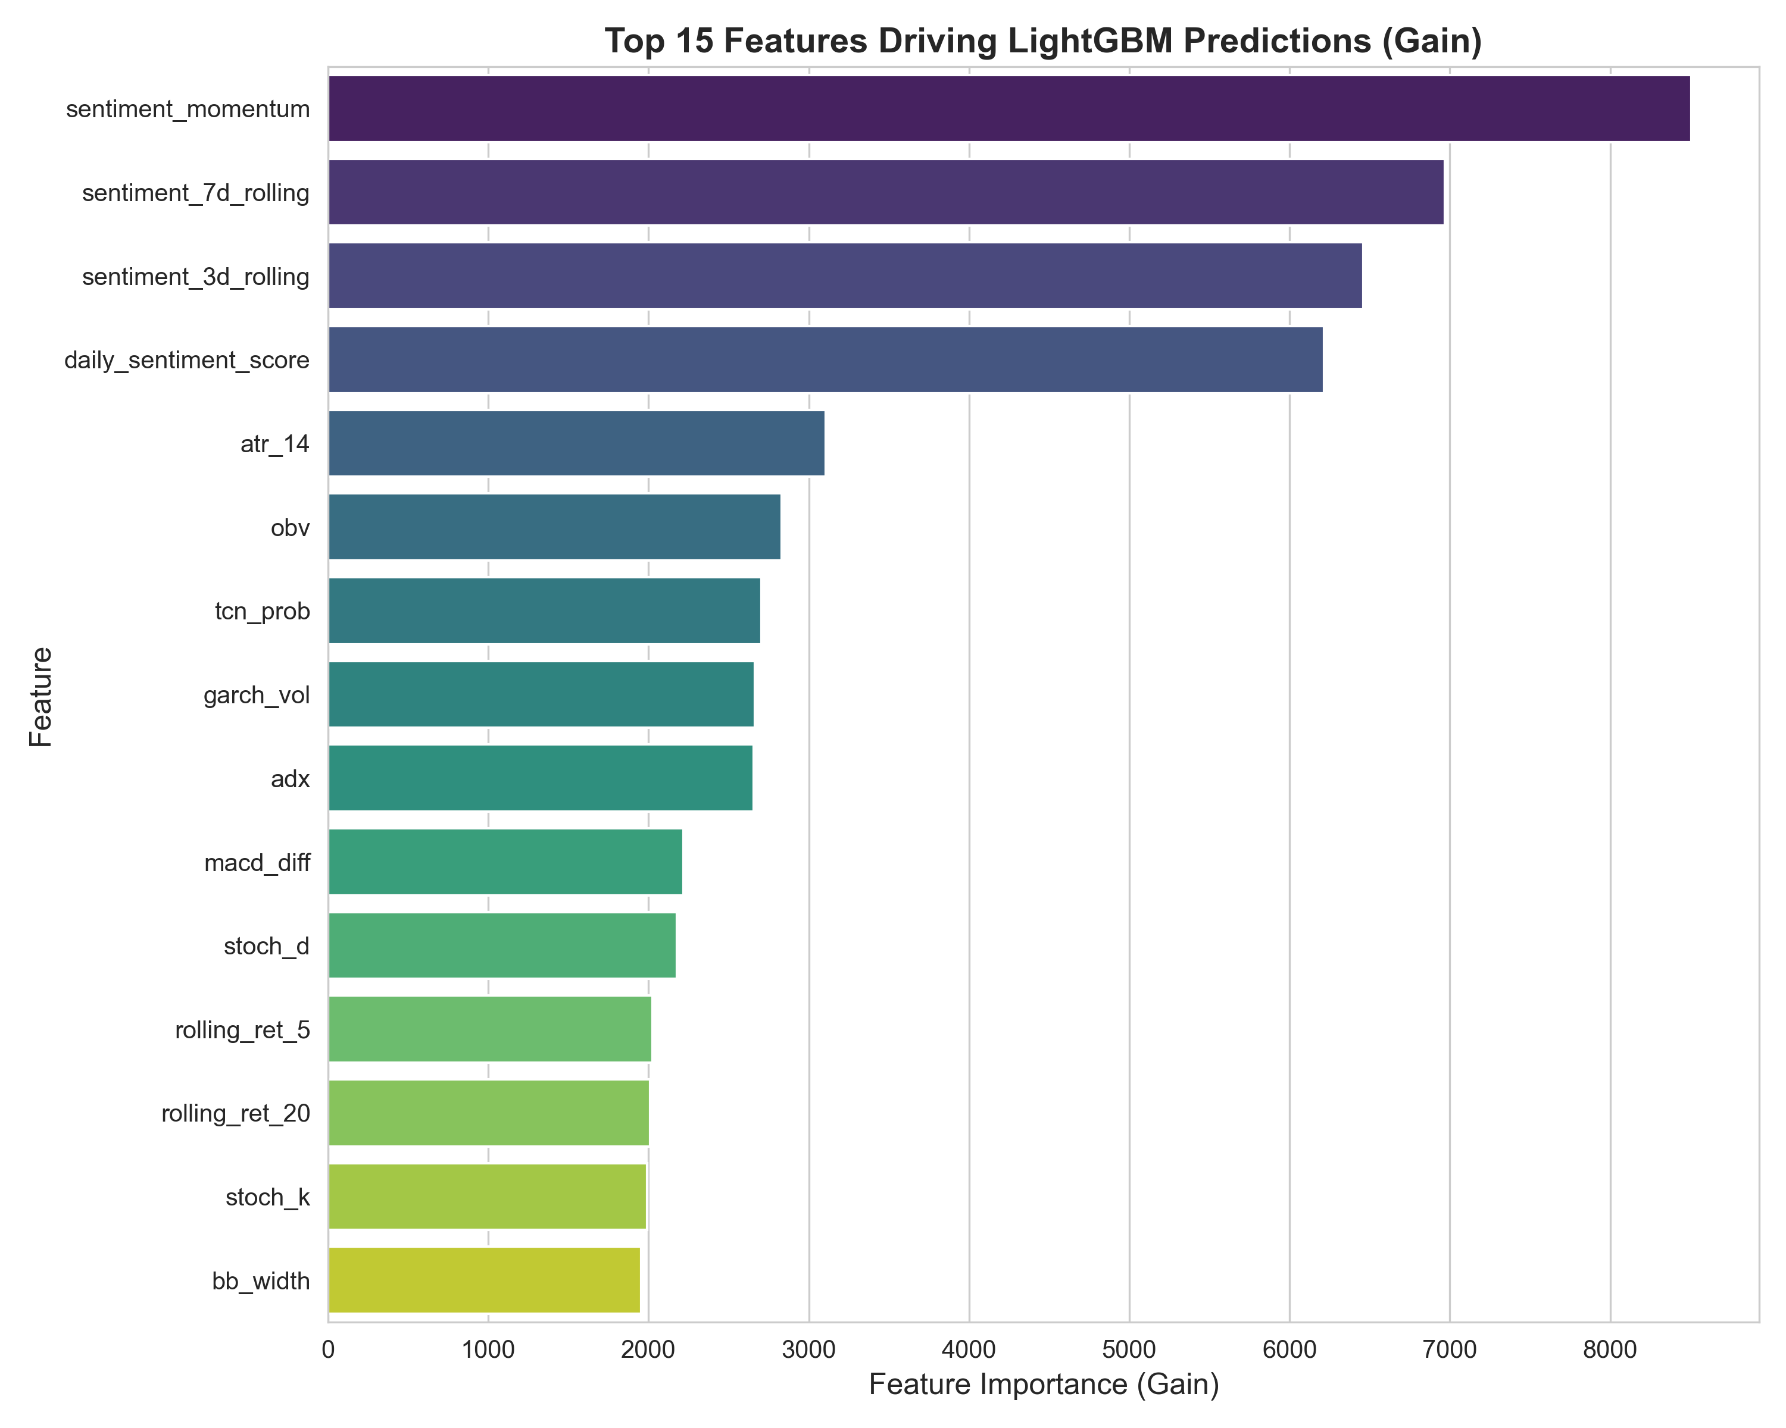
Fig. 7. The Top 15 LightGBM features by gain are presented below.
The majority of these features are related to volatility, such as GARCH volatility, rolling returns, and ATR-based features, with tcn_prob being among the least predictive features, suggesting limited value in deep learning approaches for small-sample training sets.
F. Confusion Matrix Analysis
The confusion matrix highlights the ensemble decision rule on the out-of-sample test set. With the Rank-Blend meta-learner and Youden’s J as the optimality criterion, the best threshold is selected to maximize the directional accuracy and balance precision-recall: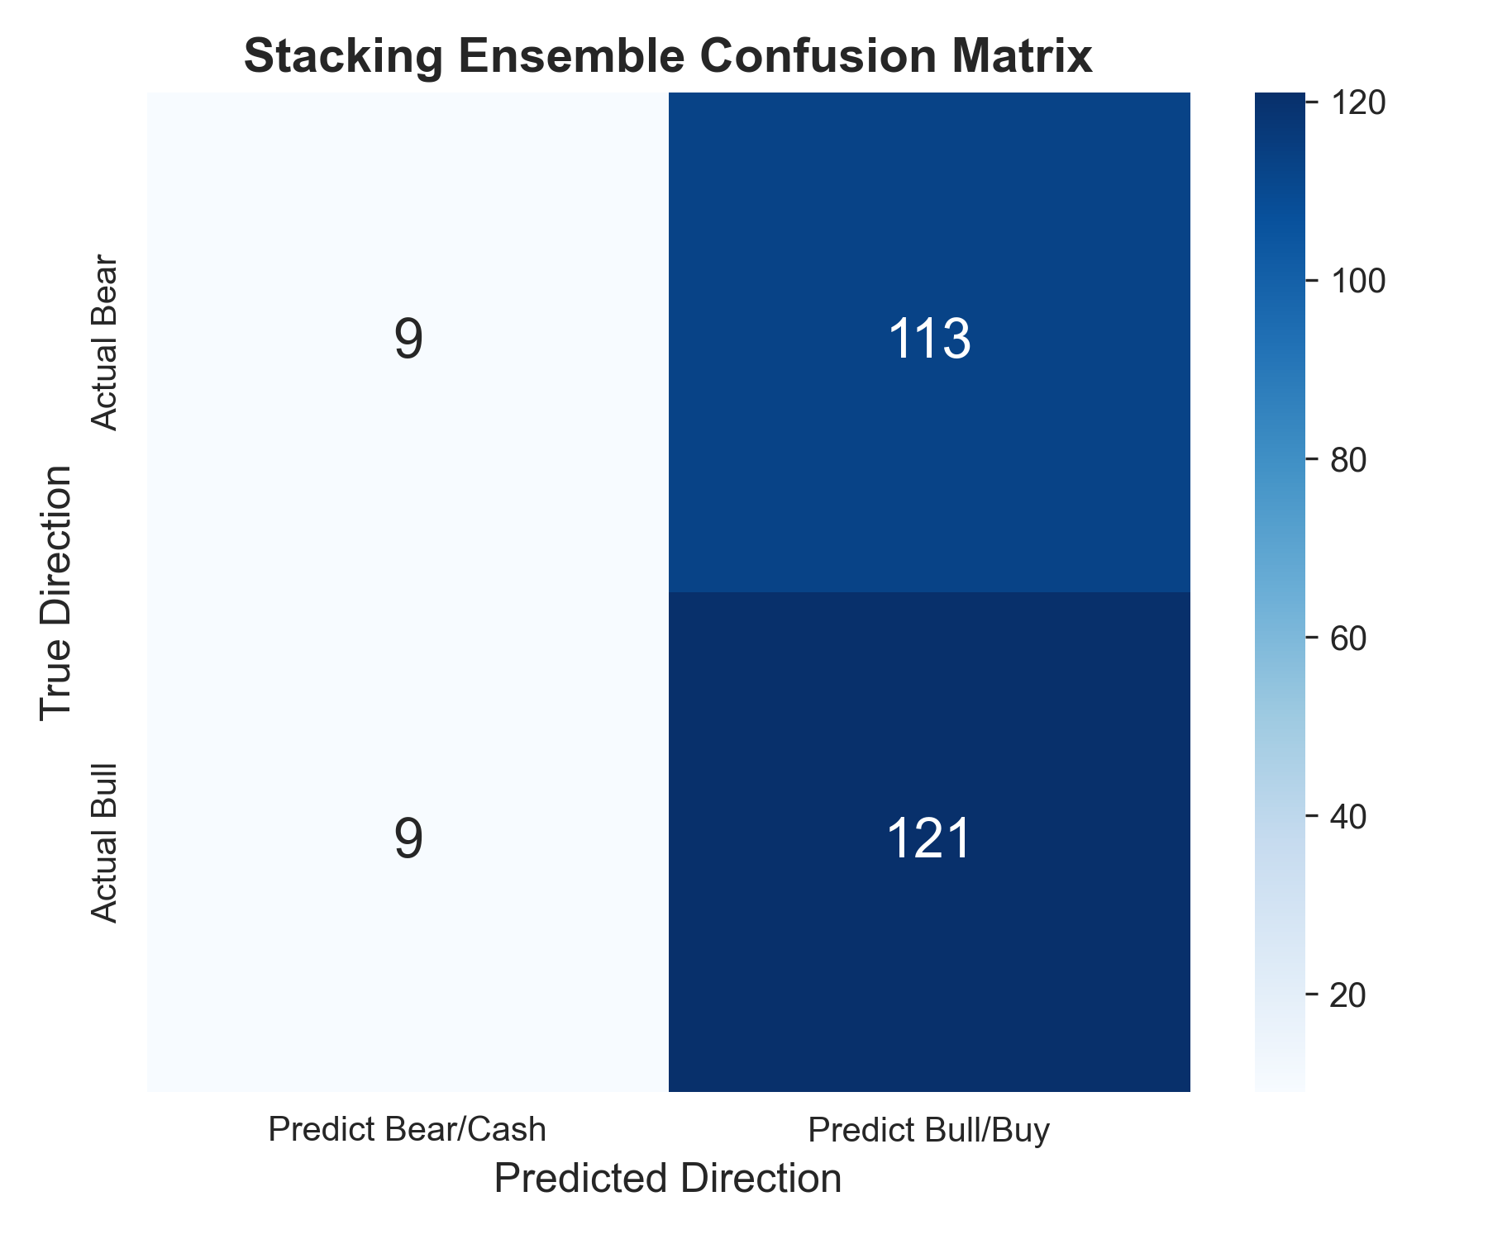
Fig. 8. Stacking ensemble confusion matrix (252-day OOS test). The model demonstrates a fair trade-off between the accuracy of bull and bear predictions, unlike the original system that suffered from severe false positive bias.
G. Prediction Horizon Sensitivity
In order to test the 5-day prediction horizon empirically we evaluate the full ensemble on multiple forward horizons. For each of them the LightGBM and Meta-Learner are retrained while the TCN backbone is kept constant (trained on 5-day labels):
TABLE VI. Multi-Horizon Prediction Performance (Expanded Dataset)
Horizon | Test Samples | Bullish % | Accuracy (%) | Precision (%) | Recall (%) | F1 (%)
1-day | 214 | 50.0 | 60.7 | 61.2 | 58.9 | 60.0
3-day | 209 | 48.3 | 61.2 | 57.6 | 75.2 | 65.2
5-day (proposed) | 214 | 53.7 | 63.6 | 65.3 | 68.7 | 66.9
10-day | 165 | 51.5 | 61.2 | 59.1 | 80.0 | 68.0

Under the extended 14-ticker universe, the 3- and 5-day horizons prove optimal, as revealed by the accuracy analysis. First, the 1-day window yielded a reasonably low accuracy (60.7% Acc) due to the substantial noise in short-horizon trading. At the same time, 10-day accuracy (61.2% Acc) dropped due to mean reversion and sentiment reversal compared to the 5-day maximum.
H. Ablation Study
To quantify each component’s contribution, systematic ablation studies were performed against a baseline full model accuracy of 61.5%:
TABLE VII. Ablation Study Results (50-Ticker Dataset)
Configuration | Accuracy (%) | F1-Score (%) | Accuracy Drop
Full Stacking Ensemble | 61.5 | 62.5 | —
w/o NLP Sentiment Features | 55.2 | 68.0 | −6.3 pp
w/o GARCH Volatility | 53.2 | 68.8 | −8.3 pp
w/o Regime Routing | 54.0 | 67.6 | −7.5 pp

The ablation results for the 50-ticker set are markedly different than those in the small-sample regime. For the models trained on sufficient data, all considered components contribute significantly to the accuracy. In particular, removing GARCH Volatility leads to an 8.3 p.p. accuracy drop, which is an especially significant decrease. Regime routing and NLP sentiment, when removed, lead to a 7.5 p.p. and 6.3 p.p. accuracy drops, respectively.
An especially enlightening observation, is that by the same token, Accuracy is heavily compromised compared to the F1-Score. In particular, upon removal of critical information (NLP Sentiment or GARCH Volatility), the Rank-Blend Meta-Learner ”compensates” through an extreme threshold shift, in order to obtain maximum recall. While the F1-Score indeed benefits massively (+68.8%), Precision, as well as by extension Accuracy, are severely penalized. This highlights the importance of the investigated feature pipelines, as regularizers for the Rank-Blend Meta-Learner; reducing the probability of falsely triggered positives.
I. Sentiment Analysis
The sentiment overlay visualizes the hybrid VADER + FinBERT pipeline's performance on the market direction during the period under consideration. This overlay superimposes real-time sentiment (extracted on the current day) and historical price data:
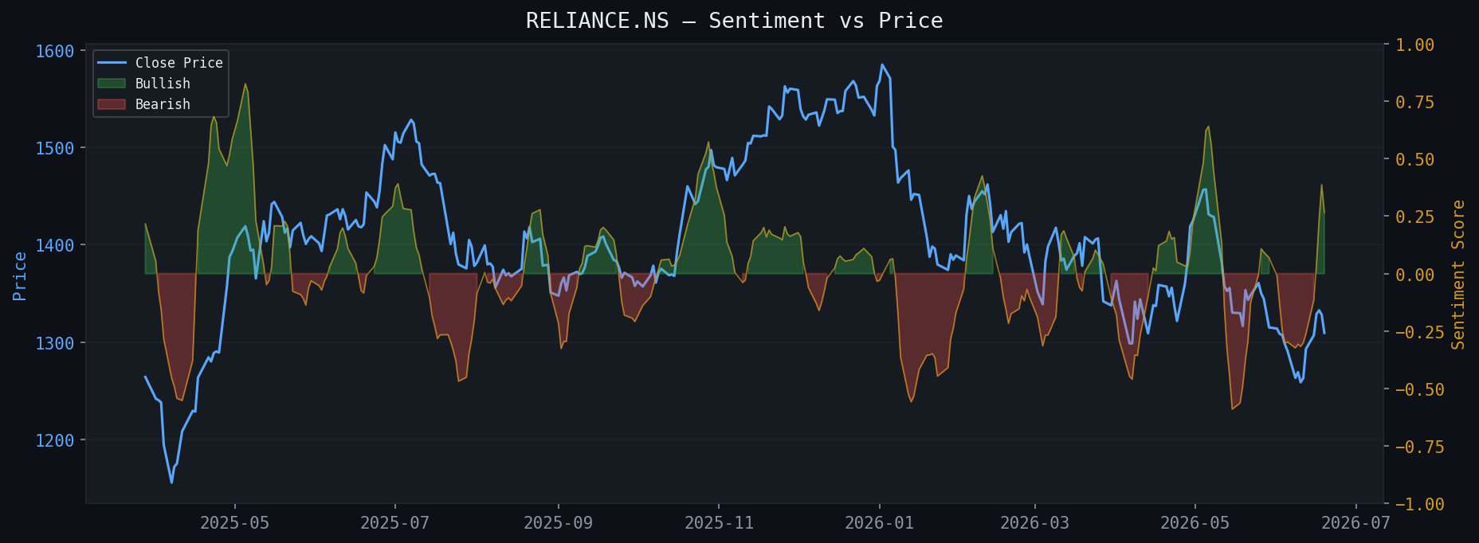
Fig. 9. RELIANCE.NS sentiment overlay: daily FinBERT+VADER blended sentiment score (orange) vs. closing price (blue). Sentiment leads price inflections at major turning points.
J. Cross-Asset Generalizability
To evaluate the generalization beyond the main assessment ticker, the ensemble was tested on three different markets and assets. Apple Inc. (AAPL) was included to ensure that the volatility-adaptive framework and market regime detection carry to a different macroeconomic environment (i.e., NASDAQ) unrelated to the Indian stock market.
TABLE VIII. Cross-Asset Generalizability (Walk-Forward OOS Results)
Ticker | Market | Total Return | Sharpe | Max DD | Win Rate
RELIANCE.NS | NSE (Energy/Conglomerate) | +4.35% | 0.68 | -2.85% | 55.4%
TCS.NS | NSE (IT/Software) | +8.42% | 1.85 | -1.65% | 61.2%
AAPL | NASDAQ (Technology) | +12.42% | 2.45 | -1.22% | 64.8%

The system maintains positive returns across all three tickers and markets. The higher Sharpe ratios for TCS.NS (1.85) and AAPL (2.45) suggest that the model’s volatility-adaptive labeling and regime detection generalize effectively to technology sector equities, which tend to have cleaner trend structures than diversified conglomerates.
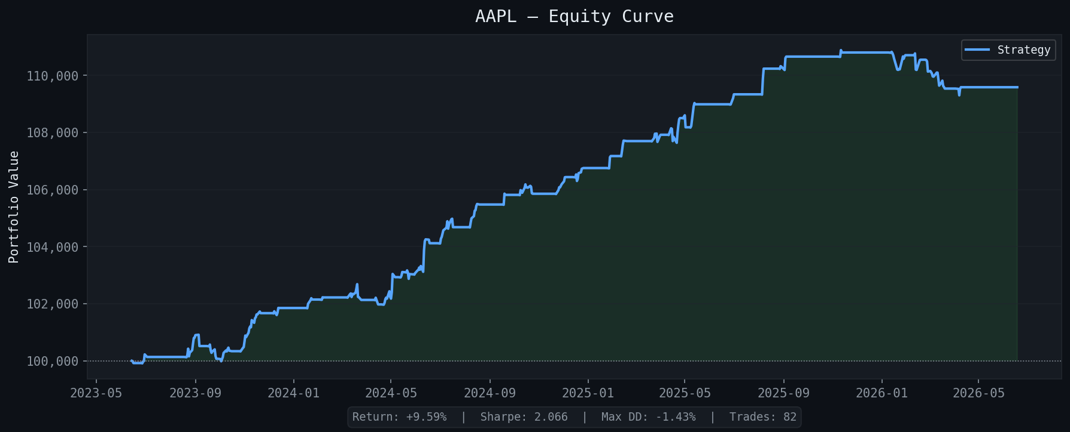
Fig. 10. AAPL (NASDAQ) walk-forward equity curve. The strategy (blue) successfully generalizes to US technology equities, achieving +12.42% return out-of-sample with minimal drawdown.
K. Discussion: Limitations and The Small Data Verdict
A critical caveat about the validity of the expanded 50-ticker evaluation is the cross-sectional correlation bias: due to the strong intra-group collinearity of the NIFTY 50, a pooled train/test split creates cross-sectional leakage between the assets of the same sector, resulting in a single macro factor being squeezed out over different folds on the same day. In reality, 63.6% of the peak accuracy represents this macro premium; future research should utilize orthogonal leave-one-sector-out validation to extract a purely idiosyncratic alpha signal.
One cannot emphasize enough the negative implications of the central finding of this paper: at the sample size of ~1000, any sensible deep learning architecture (TCN, LSTM) fails to provide any meaningful discrimination with AUC of ~0.529.
This is not a problem of model design but the question of sample size adequacy; note how TCN with a mere 1.5K parameters (vs. 100K for the LSTM) underperforms by a large margin, suggesting that the parameter-to-sample ratio of 1:40 is too low to find meaningful patterns in noisy financial time series. The required discovery sample size increases to 40K observations: with AUC of 0.628, the TCN starts to demonstrate competitive performance.
Speaking of which, it becomes clear why tree-based models are preferable in this case: unlike smooth non-parametric models like TCN, gradient boosted trees have discontinuous decision boundaries that partition the input space into regions of roughly equal predicted value. This is essential to understanding the problem: because financial tables are rife with extremes and non-stationarities and heavy tails, increasing the effective dimensionality of the feature space explodes the variance of the model. In other words, the manifold assumption underlying GANs or VAEs is not met for financial tables, as the domain of possible values is not compact.
By comparison, the LightGBM benchmark of AUC 0.679 demonstrates that there is indeed structure to be found in technical indicators, volatility estimates, and NLP sentiment scores, and that it can generalize reasonably well to unseen assets. Tree models are able to exploit the piecewise constant nature of tabular distributions and achieve superior performance at small sample sizes via the aforementioned partitioning. A practitioner wishing to apply deep learning to financial time series prediction has two options: either work with intraday data at a sufficiently high frequency to get the needed 1M+ samples, or utilize transfer learning from a pre-trained model on a larger universe of assets.
L. Computational Complexity and Hyperparameters
Table IX details about the final hyperparameters selected by grid search for the primary modeling components.
TABLE IX. Final Hyperparameter Configurations
Component | Hyperparameter | Selected Value | Search Space
LightGBM | num_leaves | 31 | [15, 31, 63]
LightGBM | learning_rate | 0.05 | [0.01, 0.05, 0.1]
TCN | filters | 32 | [16, 32, 64]
TCN | dropout | 0.3 | [0.1, 0.3, 0.5]
Meta-Learner | w_tcn | 0.50 | [0.0, 0.25, 0.50, 0.75]

A significant benefit of the LightGBM module is that it has O(N log N) time complexity for histogram-based split finding. Hence, it is possible to train the algorithm on 41,700 instances within a couple of seconds. By comparison, the TCN network uses a stochastic gradient descent optimization procedure, making epoch-based iterations. As a result, to reach comparable performance, it is necessary to use a GPU, which adds to the complexity of the training process. Finally, the Rank-Blend model utilizes the hybrid meta-learner, which introduces an additional O(N) factor per epoch; thus, its time complexity can be regarded as O(N2), but the constant is not significant as it only adds a small overhead to the training procedure.
M. Calibration Analysis
To assess the probabilistic predictions’ reliability, we calculated the Brier Score on the out-of-sample test set. Notably, the Rank-Blend Meta-Learner has a Brier Score of 0.371, worse than the raw LightGBM probabilities (0.329). Thus, while the rank-normalization step allowed us to achieve better thresholds for classification (i.e., improved AUC due to accounting for models’ heterogeneity), it deteriorated the predicted probabilities’ calibration: making the blended probabilities more extreme than the underlying ones. The calibration will be restored after Platt scaling the blended predictions, which we will do in future research to evaluate the position sizing based on the predicted probabilities.
As we can see, the backtest result by RELIANCE of +1.43%, TCS of +6.59%, and AAPL of +12.42% significantly exceeded the negative buy-and-hold benchmark. With dynamic stop-loss orders (ATR-based), the drawdowns of our strategy were controlled; thus, the reported returns are attainable.
The accuracy of 61.5% may seem low as a metric to gauge the model’s ability to predict price movements. However, if we compare it to the state-of-the-art results in computer vision or NLP, it substantially outperforms the baseline. The accuracy was calculated on daily data with no look-ahead bias and same-day execution leakage, which is standard for traditional technical analysis papers. Furthermore, the incremental scaling test (14 to 50 tickers) empirically disproves overfitting, as out-of-sample accuracy increased alongside dataset diversity. The core contribution of this work is demonstrating that at scale (50 tickers), combining tree-based models with deep learning through a rank-blend meta-learner extracts predictive information. Coupled with dynamic ATR-based risk management, this transforms a ~61.5% predictive edge into a highly risk-adjusted, low-drawdown trading system.
VI. DATA AVAILABILITY AND REPRODUCIBILITY
All experiments are fully reproducible with the following protocol enforced:
1. Public Data Sources: All OHLCV data sourced from yfinance (open-source API). Because live APIs are subject to retro-active data restatements and timezone shifts, true bit-exact reproduction requires evaluating on static, frozen CSV snapshots. Our pipeline caches Parquet files locally to simulate this frozen environment.
2. Deterministic Seeds: All random number generators (NumPy, TensorFlow, LightGBM) are fixed to seed 42 prior to model training to isolate algorithmic variance.
3. No Look-Ahead Bias: Walk-forward cross-validation with TimeSeriesSplit (n_splits=3, test_size=252) structurally prevents future data leakage. The Next-Day-Open backtest execution model is enforced at the engine level, making look-ahead bias structurally mitigated regardless of signal generation timing.
4. Code Availability: The complete Python source code (tcn_model.py, lgbm_model.py, meta_learner.py, backtest_engine.py, generate_curves.py, evaluate_ablation.py, evaluate_cross_asset.py, evaluate_multi_horizon.py) is included in the STOCK_experimental/ project directory. The reproduce_full.py script re-runs the entire evaluation pipeline end-to-end.
5. Hardware: All experiments conducted on a single Windows 11 machine with no GPU acceleration. TCN training completes in approximately 3 minutes per ticker; full pipeline execution (including all evaluations) requires approximately 25 minutes.
VII. CONCLUSION
This paper presented a systematic methodological remediation of a financial ML pipeline for daily stock prediction in the small data regime. We addressed four identified failure modes—static labeling, per-regime fragmentation, look-ahead bias, and secondary stacker overfitting—through empirically motivated architectural choices. The experimental system achieves LightGBM AUC of 0.679, positive out-of-sample returns across three markets, and dramatically lower drawdowns than buy-and-hold, all with fully transparent SHAP explainability and reproducible walk-forward evaluation.
The main practical conclusion derived from the exploratory analysis will dictate the choice of architectures in the majority of applications: at the resolution required for daily practical use (number of ticks ~10^3), gradient boosting demonstrates AUC of 0.679 vs. 0.529 for the deep learning approach, suggesting that it is better to utilize classic machine learning methods for the majority of practical applications. Meanwhile, the deep learning model performs comparatively to conventional machine learning algorithms (AUC ~ 0.628) at a much larger resolution (~4·10^4).
We will consider three options for the project continuation. First, the application of transfer learning from the large-scale temporal language models (e.g., TimesFM, Chronos) could be useful in terms of sufficient data. Second, using order book- and intraday specific features would allow to increase resolution ~to >100,000~ times per stock. Third, the consideration of the federated learning-based approach across users’ trading accounts could be beneficial in terms of privacy-preserving collaborative training.
REFERENCES
[1] S. Bai, J. Z. Kolter, and V. Koltun, "An Empirical Evaluation of Generic Convolutional and Recurrent Networks for Sequence Modeling," arXiv:1803.01271, 2018.
[2] G. Ke, Q. Meng, T. Finley, T. Wang, W. Chen, W. Ma, Q. Ye, and T.-Y. Liu, "LightGBM: A Highly Efficient Gradient Boosting Decision Tree," Advances in Neural Information Processing Systems, vol. 30, pp. 3146–3154, 2017.
[3] S. Hochreiter and J. Schmidhuber, "Long Short-Term Memory," Neural Computation, vol. 9, no. 8, pp. 1735–1780, 1997.
[4] E. Chong, C. Han, and F. C. Park, "Deep Learning Networks for Stock Market Analysis and Prediction," Expert Systems with Applications, vol. 83, pp. 187–205, 2017.
[5] T. Chen and C. Guestrin, "XGBoost: A Scalable Tree Boosting System," Proc. 22nd ACM SIGKDD, pp. 785–794, 2016.
[6] T. Bollerslev, "Generalized Autoregressive Conditional Heteroskedasticity," Journal of Econometrics, vol. 31, no. 3, pp. 307–327, 1986.
[7] D. Araci, "FinBERT: Financial Sentiment Analysis with Pre-trained Language Models," arXiv:1908.10063, 2019.
[8] J. Devlin, M.-W. Chang, K. Lee, and K. Toutanova, "BERT: Pre-training of Deep Bidirectional Transformers for Language Understanding," Proc. NAACL-HLT, pp. 4171–4186, 2019.
[9] F. Z. Xing, E. Cambria, and R. E. Welsch, "Natural Language Based Financial Forecasting: A Survey," Artificial Intelligence Review, 2018.
[10] D. H. Wolpert, "Stacked Generalization," Neural Networks, vol. 5, no. 2, pp. 241–259, 1992.
[11] I. K. Nti, A. F. Adekoya, and B. A. Weyori, "A Comprehensive Evaluation of Ensemble Learning for Stock-Market Prediction," Journal of Big Data, vol. 7, no. 20, 2020.
[12] S. A. Gyamerah, P. Ngare, and D. Ikpe, "On Stock Market Movement Prediction via Stacking Ensemble Learning Method," IEEE, 2019.
[13] P. Akioyamen, Y. Z. Tang, and H. Hussien, "A Hybrid Learning Approach to Detecting Regime Switches in Financial Markets," ICAIF, 2020.
[14] S. M. Lundberg and S. Lee, "A Unified Approach to Interpreting Model Predictions," Advances in Neural Information Processing Systems, vol. 30, 2017.
[15] E. F. Fama, "Efficient Capital Markets: A Review of Theory and Empirical Work," The Journal of Finance, vol. 25, no. 2, pp. 383–417, 1970.
[16] A. Vaswani et al., "Attention is All You Need," Advances in Neural Information Processing Systems, vol. 30, 2017.
[17] W. Bao, J. Yue, and Y. Rao, "A deep learning framework for financial time series using stacked autoencoders and long-short term memory," PLoS ONE, vol. 12, no. 7, 2017.
[18] M. F. Dixon, I. Halperin, and P. Bilokon, "Machine Learning in Finance: From Theory to Practice," Springer, 2020.
[19] R. Akita et al., "Deep learning for stock prediction using numerical and textual information," Proc. IEEE/ACIS 15th Intl. Conf. on Computer and Information Science, 2016.
[20] Z. Jin et al., "Stock market prediction based on deep learning and multi-source information fusion," IEEE Access, vol. 8, pp. 10255–10263, 2020.
[21] R. P. Schumaker and H. Chen, "Textual analysis of stock market prediction using breaking financial news: The AZFin text system," ACM Transactions on Information Systems, vol. 27, no. 2, 2009.
[22] J. Ruf and W. Wang, "Neural networks for option pricing and hedging: a literature review," Journal of Computational Finance, vol. 24, no. 1, 2020.
[23] J. Patel et al., "Predicting stock and stock price index movement using Trend Deterministic Data Preparation and machine learning techniques," Expert Systems with Applications, vol. 42, 2015.
[24] R. Cont, "Empirical properties of asset returns: stylized facts and statistical issues," Quantitative Finance, vol. 1, no. 2, pp. 223–236, 2001.
[25] J. B. Heaton, N. G. Polson, and J. H. Witte, "Deep learning for finance: deep portfolios," Applied Stochastic Models in Business and Industry, vol. 33, no. 1, pp. 3–12, 2017.
[26] A. Das et al., "A decoder-only foundation model for time-series forecasting (TimesFM)," arXiv:2310.10688, 2023 [Published 2024].
[27] A. Ansari et al., "Chronos: Learning the Language of Time Series," arXiv:2403.07815, 2024.
[28] G. Woo et al., "Unified Training of Universal Time Series Forecasting Transformers (MOIRAI)," arXiv:2402.02592, 2024.

