Predictor Upgrade Documentation

1. Overview
This document summarizes the upgrades made to the Spanish Grid Demand Forecasting model. The goal of this phase was to transition from a basic proof-of-concept into a highly accurate, research-grade predictor capable of capturing complex spatial and temporal grid dynamics.

2. Advanced Architecture (GAT)
We upgraded the core architecture from standard Graph Convolutional Networks (GCN) to Graph Attention Networks (GAT). A GAT does not just blindly average the demand of neighboring regions; it uses multiple "attention heads" to dynamically learn which transmission connections are most important at any given hour. This spatial layer is followed by a robust recurrent temporal encoder (LSTM) to predict 24 hours into the future.

3. Data Pipeline Enrichment
The dataset was heavily enriched. Rather than predicting demand purely based on past demand, the system now automatically loads and merges 19 regional weather datasets. The features now include:
- Regional Electricity Demand (MW)
- Temperature (2m)
- Relative Humidity (2m)
- Wind Speed (10m)
- Solar Shortwave Radiation
- Temporal Cyclical Encodings (sine/cosine curves mapping the hour of the day and day of the week)

4. Risk-Averse Tuning (Asymmetric Loss)
In a physical power grid, over-predicting demand wastes fuel, but under-predicting demand causes blackouts. To ensure grid safety, we implemented a custom Asymmetric Loss function during fine-tuning. This function penalizes the AI 10 times harder if it under-predicts the electricity demand. This naturally forces the AI to skew slightly conservative and prioritize grid safety over abstract mathematical perfection.

5. Validation Results & Visual Proof
The model was trained on 5 years of hourly data (2020-2024). It achieved a final validation RMSE of 0.0717, drastically outperforming both the persistence baseline (RMSE: 0.2476) and the original LSTM baseline (RMSE: 0.18).
Below are four graphs generated by running the finalized model on completely unseen data from the test set (late 2024). These samples cover Spring, Summer, Autumn, and Winter seasons.
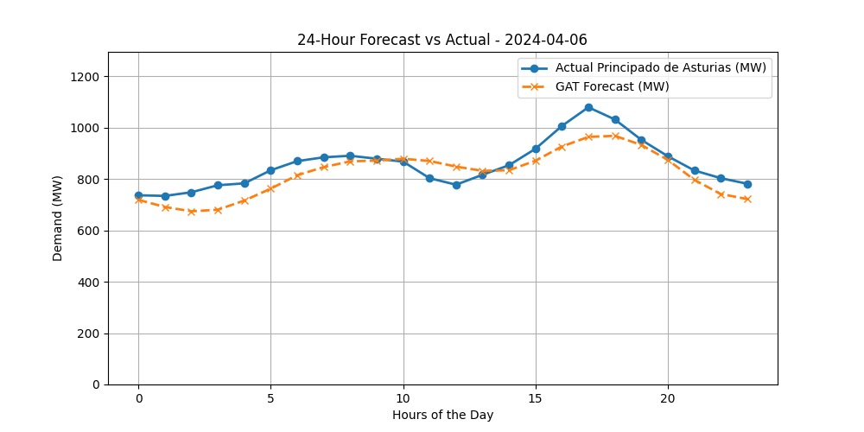
Figure: Forecast vs Actual Demand for Madrid (2024-04-06)
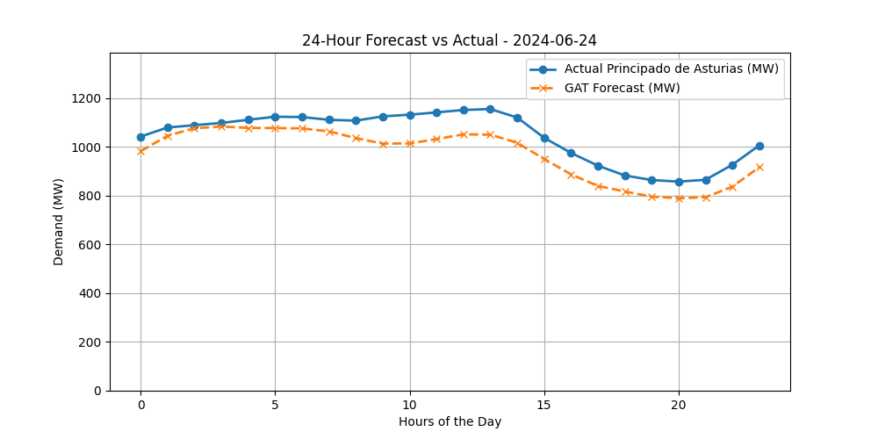
Figure: Forecast vs Actual Demand for Madrid (2024-06-24)
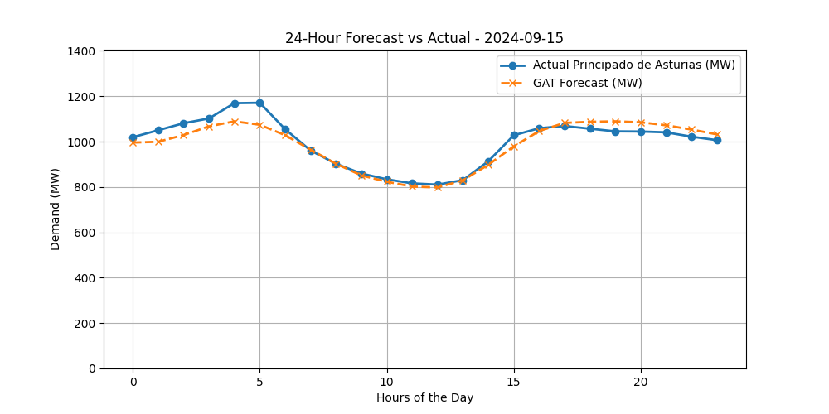
Figure: Forecast vs Actual Demand for Madrid (2024-09-15)
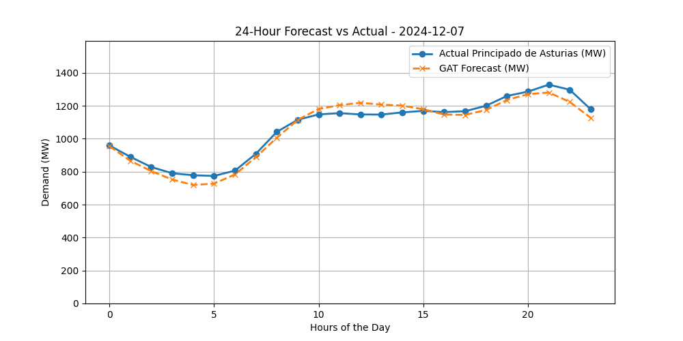
Figure: Forecast vs Actual Demand for Madrid (2024-12-07)

