Name: Soham Ladgaonkar

Roll No: 9616

Experiment No 11

Aim: Write queries to sort and aggregate the data in a table using HiveQL

Objective:
The objective of this experiment is to demonstrate how to write queries to sort and aggregate data stored in a Hive table using HiveQL.

Tools and Technologies:

- Hive: A data warehouse infrastructure built on top of Hadoop for providing data summarization, query, and analysis.
- HiveQL: Hive Query Language, which is similar to SQL and used for querying and managing data in Hive.

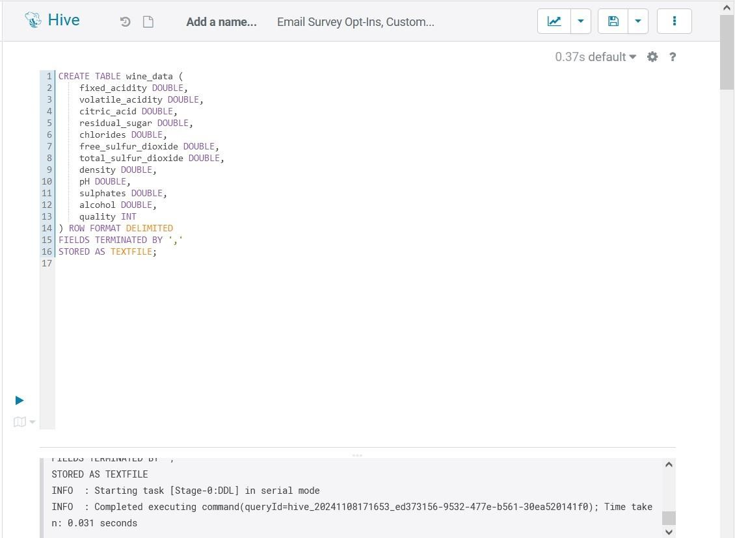
- Creating the Table in Hive

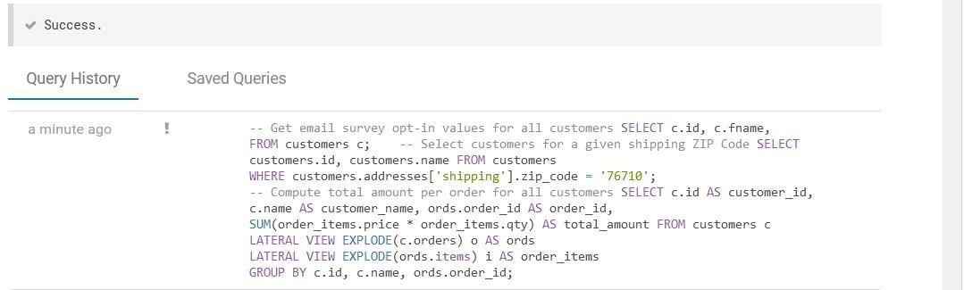
- Inserting data into Hive

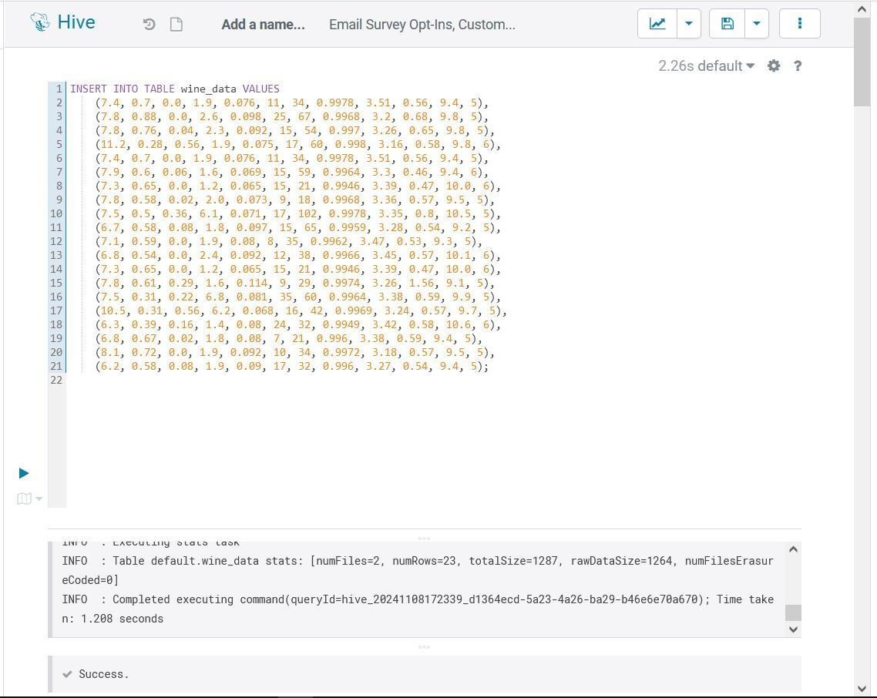

- Sorting Data in the Hive Table

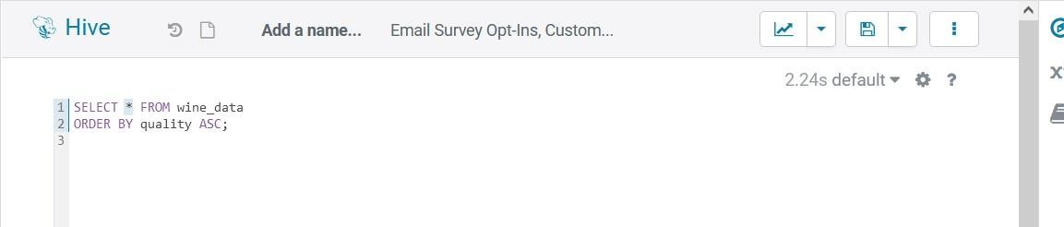

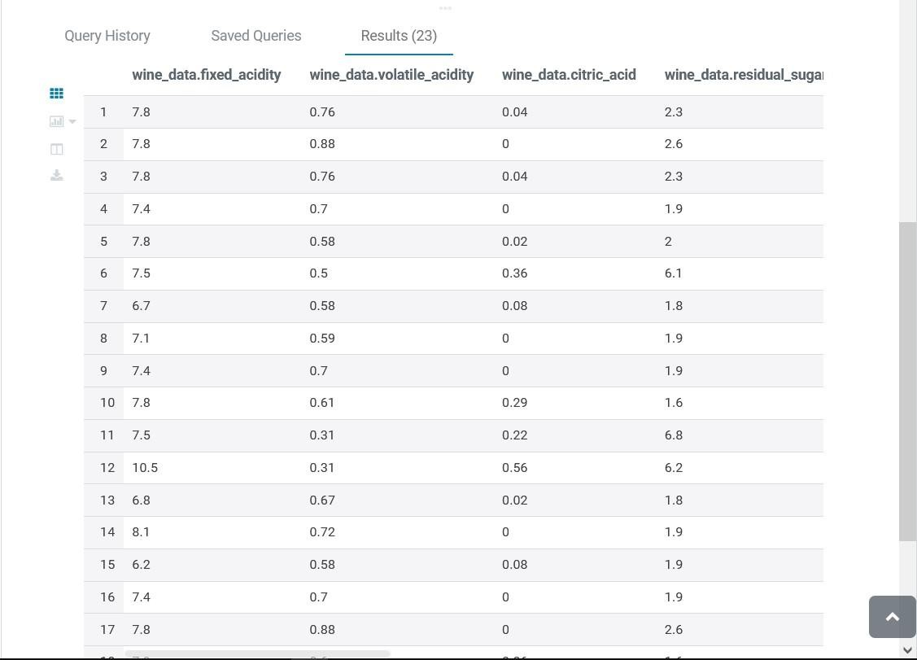

Sort in Descending Order by Multiple Columns (alcohol and quality):

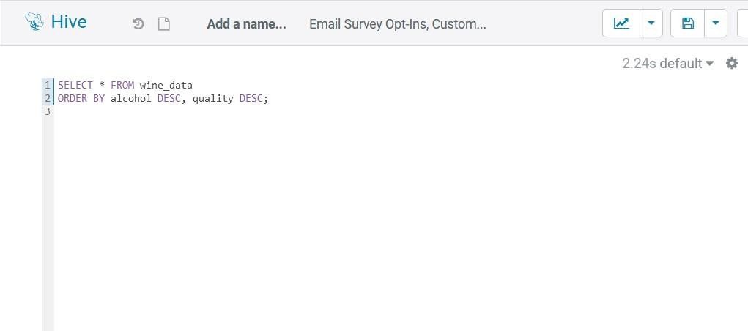

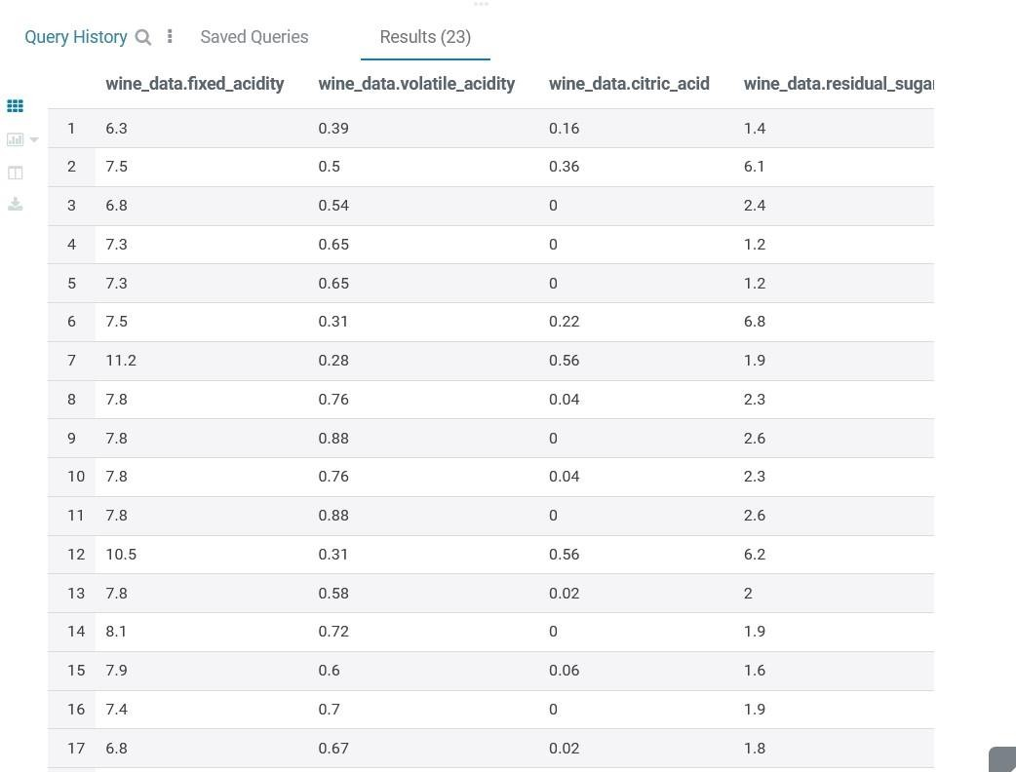

- Aggregating Data in the Hive Table

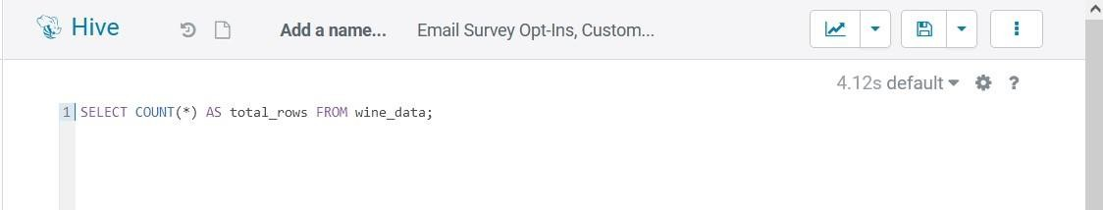
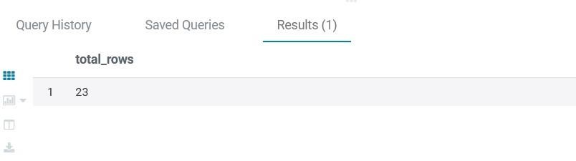

Calculate the Sum of a Column (fixed_acidity):

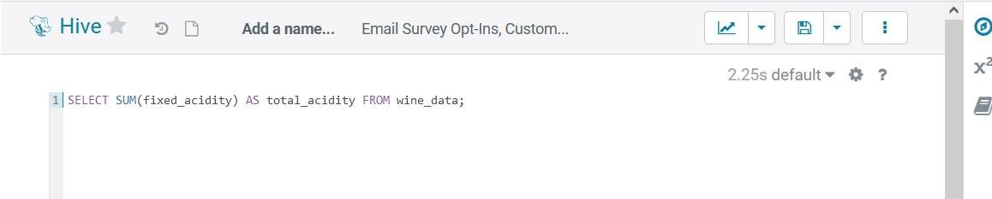

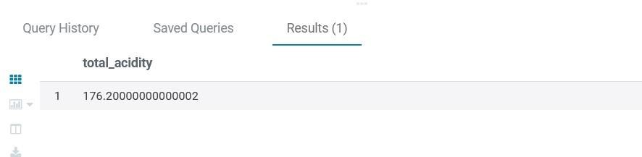

Find the Average of a Column (alcohol):

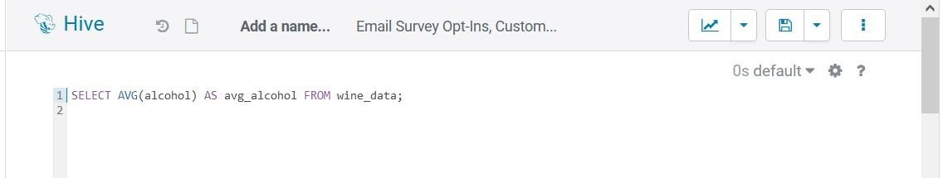
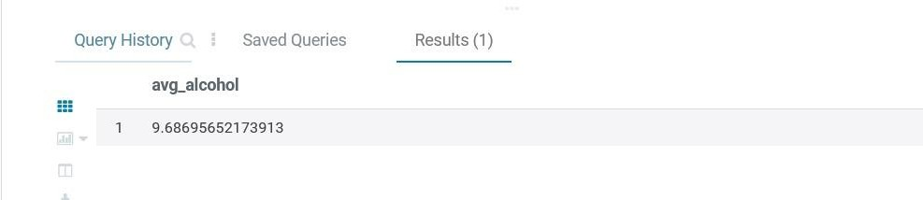

- Combining Sorting and Aggregation

Count Records Grouped by quality and Sort by Count in Descending Order:

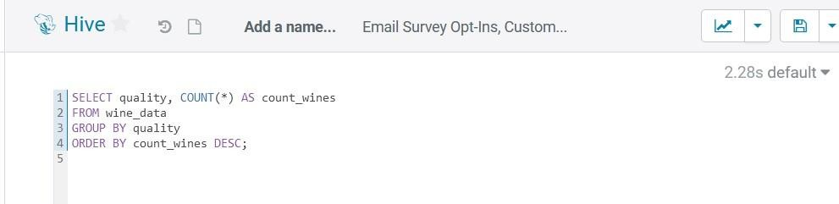

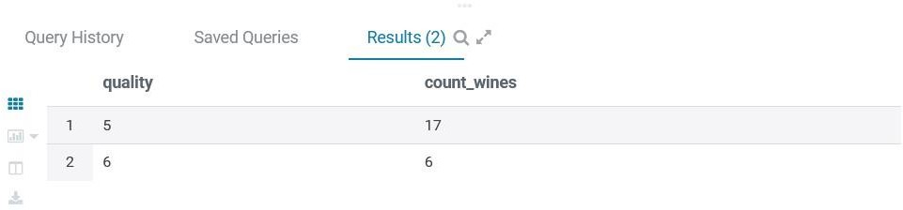

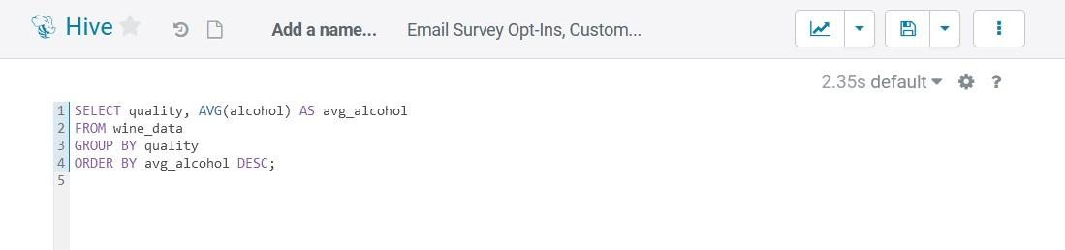
Calculate Average alcohol Content per quality and Sort by Average in Descending Order:

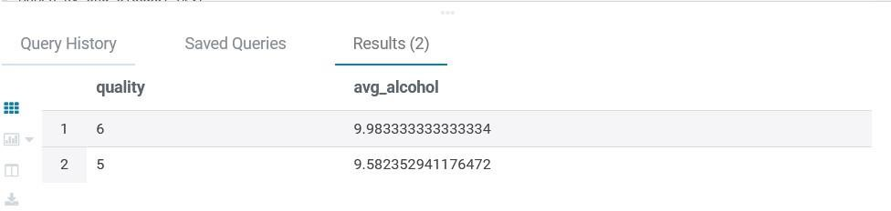

POSTLAB:

- Explain the difference between Managed and External tables in HiveQL.

Ans:

Managed Table
  - Hive manages the table data and metadata.
  - Data is stored in a default location within Hive’s warehouse directory (e.g.,
/user/hive/warehouse).
  - When you drop a managed table, both data and metadata are deleted.
  - Suitable for temporary or intermediate data where Hive should manage data lifecycle.

External Table
  - Hive manages only the metadata, not the data itself.
  - Data can be stored in any specified location, like HDFS or external storage.
  - When you drop an external table, only the metadata is deleted; the data remains intact.
  - Ideal for shared or persistent data that might be accessed by other applications outside Hive.

- How do you optimize HiveQL queries?
Ans:
Partitioning:
  - Split large tables into partitions based on columns (e.g., date) to reduce the amount of data scanned.
Bucketing:
  - Group data within partitions into buckets, which improves performance for joins and sampling.
Use Appropriate File Formats:
  - Use columnar formats like ORC or Parquet for better compression and faster reads.
Compression:
  - Enable compression for intermediate data to reduce data transfer time.

Avoid SELECT *:
  - Select only necessary columns to minimize data read and processed.
Use Vectorized Query Execution:
  - Enable vectorization for certain operators to process batches of rows, which speeds up operations.
Optimize Joins:

  - Use map-side joins for small tables and sort-merge joins for large tables.
Increase Parallelism:
  - Adjust configuration to increase the number of mappers and reducers for better parallel processing.

