Experiment No.10

1)Write a program to create a simple GUl window using Tkinter.
Program :-
import tkinter as tk
# Create main window
window = tk.Tk()
# Set window title
window.title("Simple GUI Window")
# Set window size
window.geometry("400x300")
# Add a label
label = tk.Label(window, text="Hello, Tkinter!", font=("Arial", 16))
label.pack(pady=20)
# Add a button
button = tk.Button(window, text="Click Me")
button.pack(pady=10)
# Run the application
window.mainloop()

OUTPUT :-
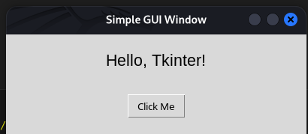

2)Write a program to create a GUI calculator.
Program :-
import tkinter as tk

def press(num):
global expression
expression += str(num)
equation.set(expression)

def equalpress():
global expression
try:
result = str(eval(expression))
equation.set(result)
expression = result
except:
equation.set("Error")
expression = ""

def clear():
global expression
expression = ""
equation.set("")

root = tk.Tk()
root.title("Calculator")
root.geometry("300x400")

expression = ""
equation = tk.StringVar()

entry = tk.Entry(root, textvariable=equation, font=("Arial", 18), bd=10, relief="sunken", justify="right")
entry.grid(row=0, column=0, columnspan=4)

buttons = [
('7',1,0), ('8',1,1), ('9',1,2), ('/',1,3),
('4',2,0), ('5',2,1), ('6',2,2), ('*',2,3),
('1',3,0), ('2',3,1), ('3',3,2), ('-',3,3),
('0',4,0), ('.',4,1), ('=',4,2), ('+',4,3),
]

for (text, row, col) in buttons:
if text == "=":
tk.Button(root, text=text, width=5, height=2, command=equalpress).grid(row=row, column=col)
else:
tk.Button(root, text=text, width=5, height=2, command=lambda t=text: press(t)).grid(row=row, column=col)

tk.Button(root, text="C", width=22, height=2, command=clear).grid(row=5, column=0, columnspan=4)

root.mainloop()

OUTPUT :-
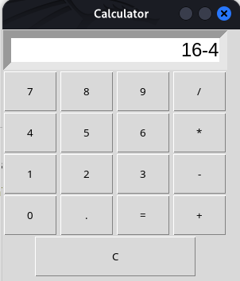

3)Write a program to create GUI for student information form.
Program :-
import tkinter as tk
from tkinter import messagebox

# Function to display entered data
def submit():
name = entry_name.get()
age = entry_age.get()
gender = gender_var.get()
course = entry_course.get()

info = f"Name: {name}\nAge: {age}\nGender: {gender}\nCourse: {course}"
messagebox.showinfo("Student Information", info)

# Main window
root = tk.Tk()
root.title("Student Information Form")
root.geometry("400x350")

# Labels and Entries
tk.Label(root, text="Name").grid(row=0, column=0, padx=10, pady=10)
entry_name = tk.Entry(root)
entry_name.grid(row=0, column=1)

tk.Label(root, text="Age").grid(row=1, column=0, padx=10, pady=10)
entry_age = tk.Entry(root)
entry_age.grid(row=1, column=1)

tk.Label(root, text="Gender").grid(row=2, column=0, padx=10, pady=10)
gender_var = tk.StringVar()
tk.Radiobutton(root, text="Male", variable=gender_var, value="Male").grid(row=2, column=1)
tk.Radiobutton(root, text="Female", variable=gender_var, value="Female").grid(row=2, column=2)

tk.Label(root, text="Course").grid(row=3, column=0, padx=10, pady=10)
entry_course = tk.Entry(root)
entry_course.grid(row=3, column=1)

# Submit Button
tk.Button(root, text="Submit", command=submit).grid(row=4, column=0, columnspan=2, pady=20)

# Run application
root.mainloop()

OUTPUT :-
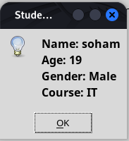
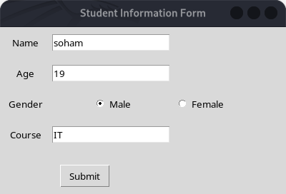

4)Write a program to draw line plot using matplotlib.
Program :-
import matplotlib.pyplot as plt

x = []
y = []

# Open and read file
with open("ExpNo10/data.txt", "r") as file:
for line in file:
values = line.split()
x.append(int(values[0]))
y.append(int(values[1]))

# Plot graph
plt.plot(x, y, marker='o')

# Labels and title
plt.xlabel("X-axis")
plt.ylabel("Y-axis")
plt.title("Graph from File Data")

# Show grid
plt.grid(True)

# Show plot
plt.show()

OUTPUT :-
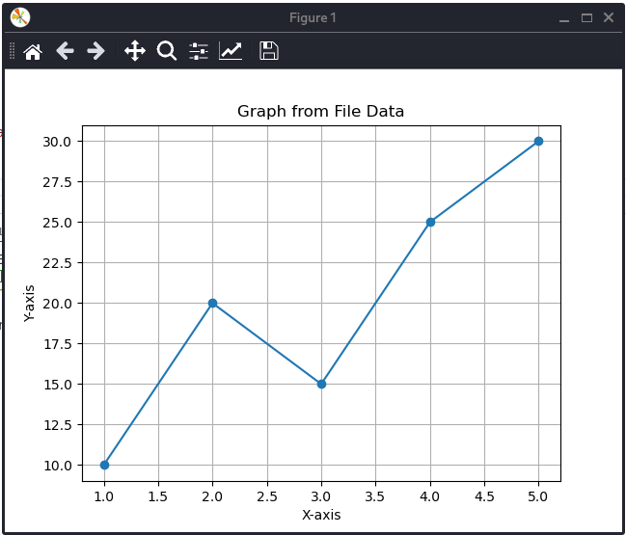

5)Write a program to draw bar chart.
Program :-

import matplotlib.pyplot as plt

categories = ['A', 'B', 'C', 'D', 'E']
values = [10, 25, 15, 30, 20]

plt.bar(categories, values)

plt.xlabel("Categories")
plt.ylabel("Values")
plt.title("Simple Bar Chart")

plt.show()

OUTPUT :-
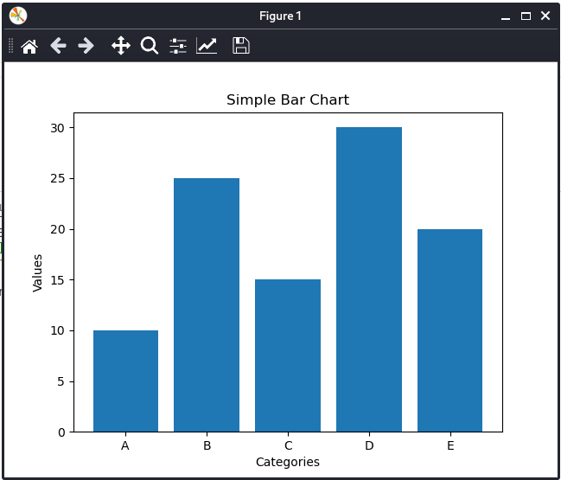

6)Write a program to draw histogram.
Program :-

import matplotlib.pyplot as plt

# Data
data = [10, 12, 15, 20, 22, 25, 30, 35, 40, 45, 50]

# Create histogram
plt.hist(data, bins=5)

# Labels and title
plt.xlabel("Values")
plt.ylabel("Frequency")
plt.title("Histogram Example")

# Show plot
plt.show()

OUTPUT :-
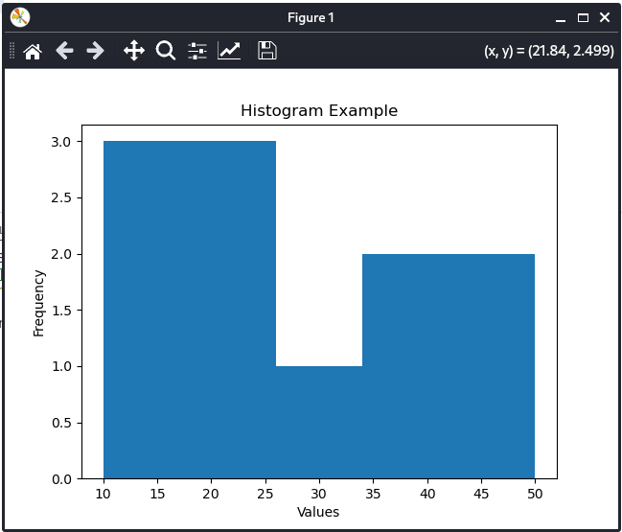

7)Write a program to draw pie chart.
Program :-
import matplotlib.pyplot as plt

labels = ['A', 'B', 'C', 'D']
sizes = [30, 20, 25, 25]
colors = ['gold', 'lightblue', 'lightgreen', 'pink']

plt.pie(sizes, labels=labels, colors=colors, autopct='%1.1f%%')

plt.title("Simple Pie Chart")

plt.show()
OUTPUT :-
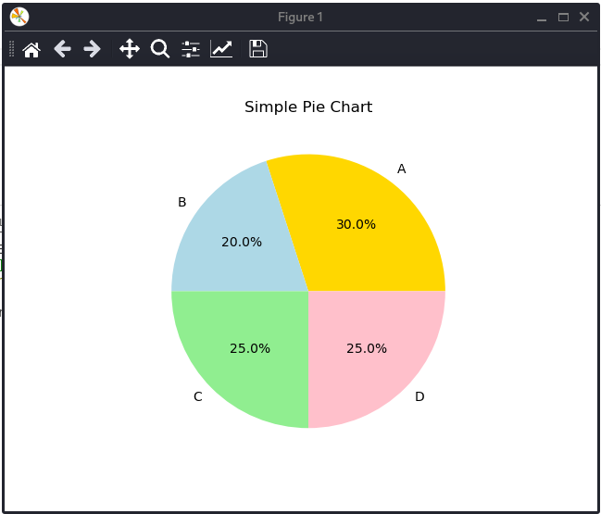

8)Write a program to customize plots using labels and legends.
Program :-

import matplotlib.pyplot as plt

x = [1, 2, 3, 4, 5]
y1 = [10, 15, 20, 25, 30]
y2 = [5, 10, 15, 20, 25]

plt.plot(x, y1, label="Series 1", marker='o')

plt.plot(x, y2, label="Series 2", marker='s')

plt.xlabel("X-axis")
plt.ylabel("Y-axis")
plt.title("Customized Plot with Labels and Legends")

plt.legend()

plt.grid(True)

plt.show()

OUTPUT :-
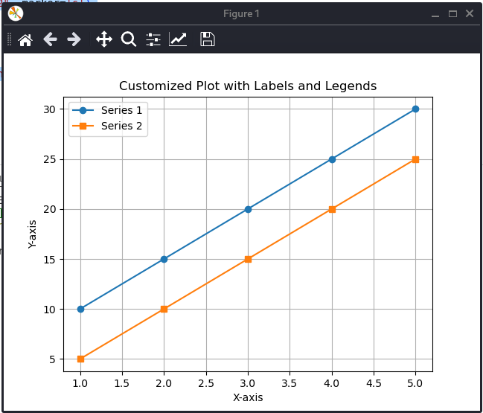

9)Write a program to read data from file and plot graph.
Program :-

import matplotlib.pyplot as plt

x = []
y = []

with open("ExpNo10/data.txt", "r") as file:
for line in file:
values = line.split()
x.append(int(values[0]))
y.append(int(values[1]))

plt.plot(x, y, marker='o')

plt.xlabel("X-axis")
plt.ylabel("Y-axis")
plt.title("Graph from File Data")

plt.grid(True)

plt.show()

OUTPUT :-

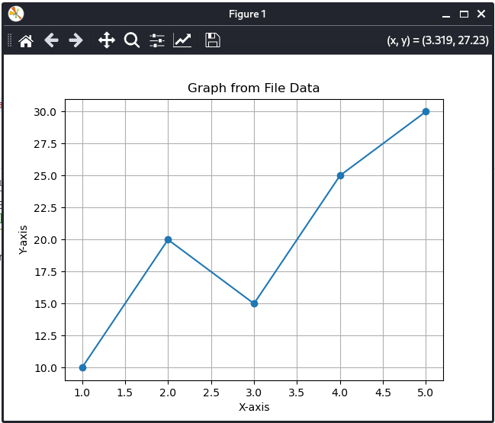

10)Write a program to draw box-and-whisker plot
Program :-

import matplotlib.pyplot as plt

data = [12, 15, 18, 22, 25, 28, 30, 35, 40, 45, 50]

plt.boxplot(data)

plt.title("Box-and-Whisker Plot")
plt.ylabel("Values")

plt.show()

OUTPUT :-

